LASER INTERFEROMETER GRAVITATIONAL WAVE OBSERVATORY
- LIGO -
CALIFORNIA INSTITUTE OF TECHNOLOGY
MASSACHUSETTS INSTITUTE OF TECHNOLOGY

LIGO-E0900047-v7 Nov 23, 2009

aLIGO Contamination Control Plan

B. Bland
for the LIGO Project

Distribution of this draft: LIGO Observatory Staff

This is an internal working note
of the LIGO Project.

California Institute of Technology  LIGO Project - MS 18-34  Pasadena CA 91125  Phone (626) 395-2129  Fax (626) 304-9834  E-mail: info@ligo.caltech.edu  WWW: http://www.ligo.caltech.edu/ | Massachusetts Institute of Technology  MIT LIGO Laboratory  NW 22-295  185 Albany Street  Cambridge, MA 01239  Phone (617) 253-4824
LIGO Hanford Observatory  127124 North Route 10  Richland, WA 99354  Phone (509) 372-8106  Fax (509) 372-8137  E-mail: info@ligo.caltech.edu | LIGO Livingston Observatory  19100 LIGO Lane  Livingston, LA 70754  Phone (225) 686-3100  Fax (225) 686-7189  E-mail: info@ligo.caltech.edu

Tab

1 ABSTRACT

The LIGO interferometers are extremely sensitive to optical scattering or absorption losses induced by both particulate and hydrocarbon contamination. In order to minimize the likelihood of contamination of optical surfaces, numerous operational practices have been implemented at the LIGO Observatories. The purpose of this document is to describe the operational practices that have been implemented so that it can serve as a reference for observatory staff and visitors. It is expected that this document will be continuously updated as practices evolve as we gain experience with the interferometer hardware.

2 CONTAMINATION-SENSITIVE HARDWARE

CLASS A hardware is defined as any item that will be temporarily or permanently mounted inside of or on the inner surfaces of the interferometer vacuum equipment and will be exposed to vacuum.

CLASS B hardware is defined as any item that will come into contact with CLASS A hardware or the surfaces of the interferometer vacuum equipment that will be exposed to vacuum (including the o-rings).

2.1 CLASS A Hardware

Included in this category are the interferometer optics and suspensions and all in-vacuo interferometer hardware that has been prepared for installation. All CLASS A hardware is to be manufactured, cleaned, baked, and packaged in accordance with the specifications detailed in LIGO-E960022 LIGO Vacuum Compatibility, Cleaning Methods, and Qualification Procedures.

2.2 CLASS B Hardware

Included in this category are tools and fixtures that will come into contact with CLASS A hardware OR be used inside the interferometer vacuum envelope. Follow cleaning and baking procedures dictated in LIGO-E960022 LIGO Vacuum Compatibility, Cleaning Methods, and Qualification Procedures, but substitute the airbake oven for the vacuum bake oven.

Please do not bring Class B tools to the sites. There are standard Class B tool sets on site that should be used for most Class A assembly work. Below is a list of Class B tools available at the sites in limited quantities. Please check with your site liaison to see if such a kit is available for your use. If not, team leads should procure tools which should be sent to the sites for proper Class B cleaning. Make sure to buy tools which are compatible with the Class B processing steps – ie. no oiled or plastic components. If you have a special tool or fixture that you will need, please coordinate with your site liaison to arrange for the tool to be properly prepared as Class B in advance. Your site liaison should be able to arrange for a specific subset of tools to be placed in a kit for you.

Site Supplied Class B Tools:
Allen Key Sets
T-Handled Allen Key Sets
Metric Allen Key sets
Flat head screw driver (all metal, S-shaped)
Scissors
Wire cutters
Metal Rulers
Open end wrench sets (Imperial)
Dental Mirrors
Tweezers – various sizes
Helicoil insertion tools (various sizes)
Helicoil removal tools (various sizes)

Ratchets – TBD

2.3 Washer and oven use

Parts washers and ultrasonic cleaners are maintained by site staff. Cleaning requests should be coordinated with this staff.

The vacuum bake ovens and large air bake ovens are maintained by site staff. Class A bake requests should be coordinated with this staff.

Small countertop Air bake ovens are for general use, provided the user is familiar with the equipment and Class B cleaning and handling. See LIGO-E960022 Vacuum Compatibility, Cleaning Methods, and Qualification Procedures.

There are a few specialty ovens dedicated for specific subsystem use and are labeled as such. Do not use these unless authorized by that subsystem.

2.4 Handling

CLASS A and CLASS B hardware should never come into contact with anything except other
CLASS A or CLASS B hardware, UHV Gloves, UHV Aluminum Foil, Lint-free Wipes, or the in-vacuo surfaces of the interferometer vacuum equipment. CLASS A and CLASS B hardware are to be unwrapped and handled only in a contamination sensitive area (see Section 6). All persons handling or working in the vicinity of CLASS A and CLASS B hardware shall at all times wear contamination control garb, see chart below for details. While working with CLASS A and CLASS B hardware, UHV Gloves should contact only CLASS A or CLASS B hardware; they must be changed immediately after contacting any other surfaces.

Use only the approved supplies as listed in Appendix 1.

Note: When the white clean room fabric similar to that used for the chamber door soft covers
(Burlington C3, white static-dissipative, clean room fabric) is contacting or will come into contact with Class A or Class B hardware, it should be handled as Class B hardware.

2.4.1 UHV FOIL

While E960022 specifically calls for Class A and Class B processed hardware to be wrapped in UHV foil and then double-bagged in CPStat bags, it is preferred to store Class A hardware in Class B hard enclosures. Stainless steel tool pans and small glass dishes with lids are very useful for storing some hardware. This type of storage is best suited for fastener stock and other small parts in bulk quantities. For larger items, use the UHV foil for wrapping the part before bagging.

If possible shear the foil off the roll, as opposed to tearing, as we have some data which indicates that shearing might reduce the particulate generated during the cutting. Use UHV foil dispensers mounted to areas which will not shed foil particulate onto contamination sensitive hardware and surfaces.

When setting Class A and B components onto work surfaces, first wipe the surface clean with isopropanol, then utilize Class B trays or metal sheets as a barrier between the table and the Class or B parts.

    - MAINTAINING CLEANLINESS

In order to maintain cleanliness over the coming months and years, inspect outer packages as often as possible for tears and holes. These are most likely to occur after moving or transporting items. If at any time any Class A or Class B hardware is contamination compromised, reprocess the part to restore its Class, or obtain a waiver from the VRB. Inspect inner-foil bags for abrading foil. If inner foil bags are worn, as typically happens when the foil is wrapped and unwrapped numerous times, re-wrap item with new foil.

Inspect equipment periodically for cleanliness. Check horizontal surfaces for particulate. See Section 6 for cleaning schedule. Check internal areas of equipment, such washer tanks, for particulate. Flush or cleanout, such areas as needed.

3 CONTAMINATION-SENSITIVE AREAS AND
ACCESS PROTOCOL

Contamination sensitive areas are locations where personnel will be working in the vicinity of exposed Class A or Class B hardware. The contamination-sensitive areas in the corner station are the Optics Laboratory, the Vacuum Prep. and Assembly Area, the Vacuum Bake Oven Room, the Active Storage Area, the Laser and Vacuum Equipment Area (LVEA), and the Portable Clean Room Enclosures in the LVEA. The contamination-sensitive areas in the mid and end stations are the Cleaning Areas, the Vacuum Equipment Areas (VEA), and the Portable Clean Room Enclosures in the VEAs. All of these areas have HEPA-filtered air supplies. Access to all of these areas is restricted. Each person entering any of these areas must wear the required clean area clothing described below and follow the required procedures for handling and working in the vicinity of contamination-sensitive hardware as described in Section 2.
3.1 Work Areas

Table 1 summarizes what garb is to be worn in what contamination sensitive areas at the LIGO sites. Following the table are layout diagrams of some of the areas.

TABLE 1 - GARB
Where | Over shoe covers | Frock | Bouff. Cap | Mask | Hood | Suit | Over shoe boots
LSB Fiber/Optics Lab (LHO) | X | X | X | X
OSB Optics Labs | X | X | X | X
Vacuum Prep Warehouse  Lab Spaces (VPWs) | X | X | X | X
aLIGO cleanroom  support areas | X | X | X | X
aLIGO assembly cleanrooms |  |  |  | X | X | X | X
L/VEAs | X
L/VEAs staging clean rooms | X | X | X | X
L/VEA clean rooms with exposed vacuum chamber |  |  |  | X | X | X | X
L/VEA clean rooms with cloth covered vacuum openings | X | X | X | X

Diagram 1: LLO Staging Building (aLIGO Assembly Building)
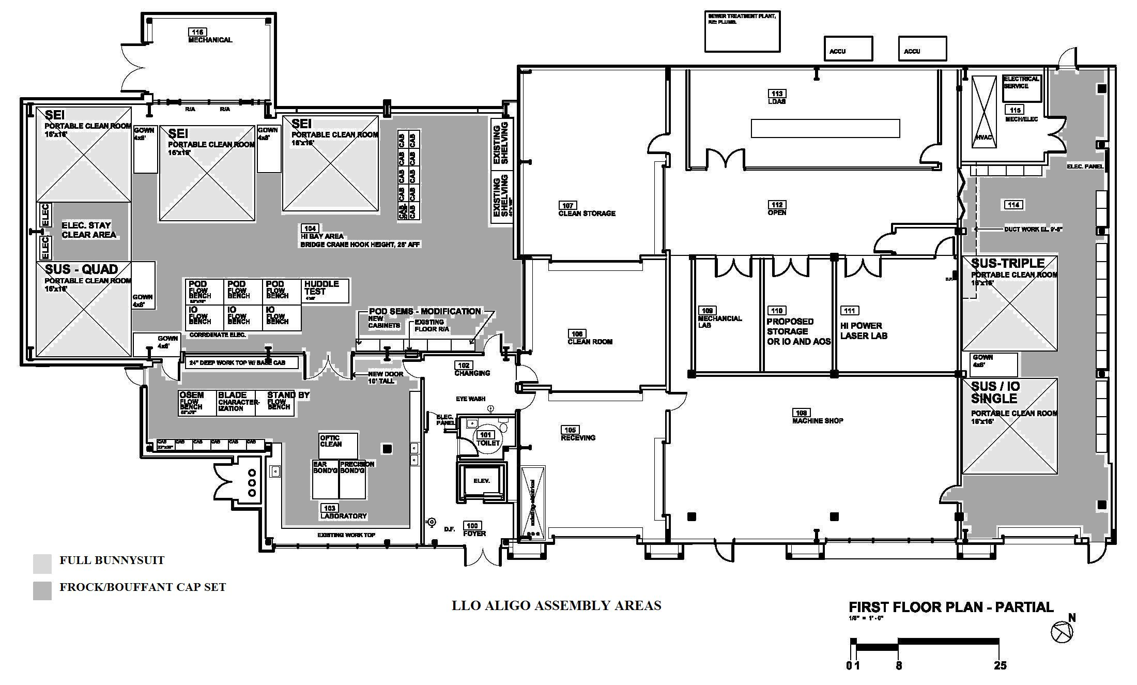
Diagram 2: LHO Staging Building (aLIGO Assembly building)

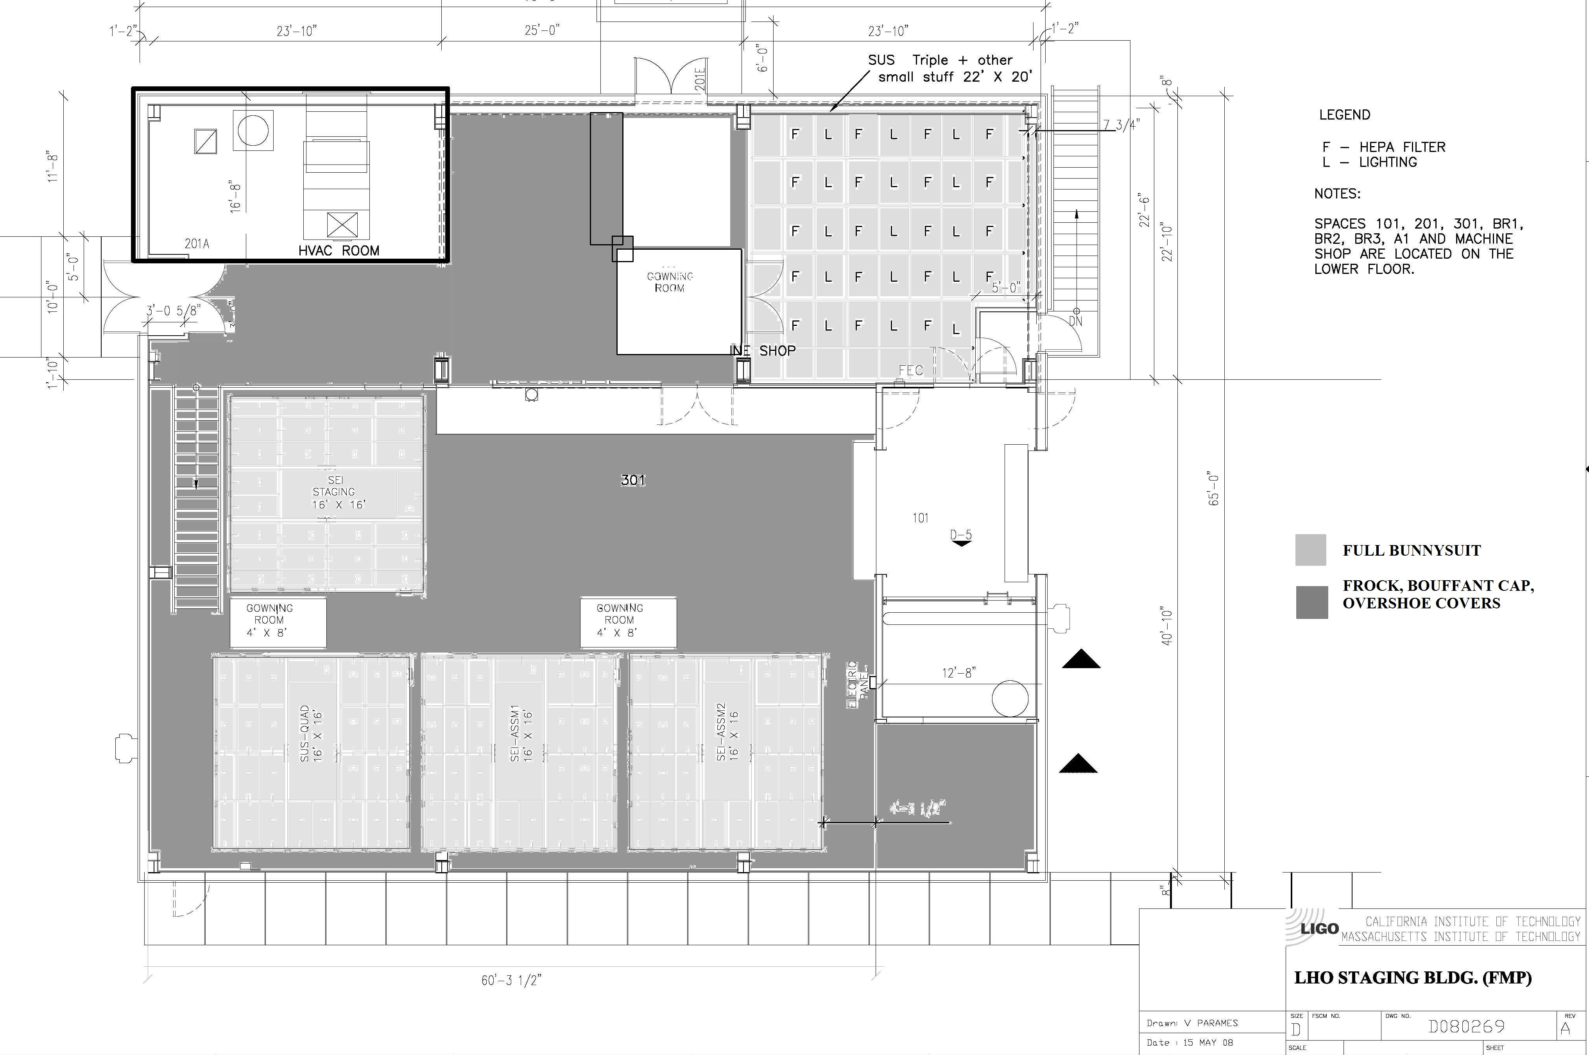

  - General Practices

UHV Gloves are required when handling or working in the immediate vicinity of contamination-sensitive hardware.

Whenever CLASS A or CLASS B hardware is left unattended, the area will be clearly marked. Exposed items will be covered with UHV Aluminum Foil.

There is an advisable method of donning the clean room garb. Always put garb on from top to bottom. Start with gloves, then mask, then hood (or cap), then suit (or frock), and finally boots (or clean room shoe covers). Change gloves, or put on a second clean outer pair, before touching Class A and B equipment.

Dedicated clean-area shoes can be worn instead of the Overshoe Covers. It is the responsibility of the wearer to ensure that the dedicated clean-area shoes are kept clean. These shoes should be kept in the garb rooms.

HEPA filtered Garb rooms are to be placed just outside of all lab spaces, VEAs, assembly cleanrooms, and staging cleanrooms. Utilize hangers and racks for reuseable items. Users are responsible for getting fresh garb at appropriate intervals. Rough cumulative durations for use before laundering are as follows:

- Frocks – 16 hours (less if working in dirty or strenuous conditions)
- Bouffant Caps – 8 hours
- Overshoe covers - 8 hours (unless inspection shows particulates or soiling)
- Suit/Hood – 4-8 hours, depending on work conditions
- Cleanroom Boots - 4-8 hours, depending on work conditions
- In-Chamber Boots - 4-8 hours, depending on work conditions

Paper products are prohibited in all Contamination-Sensitive Area. Laptops should be utilized for note taking, etc. Drawings should be laminated before brought into the areas in order to contain particulate that the paper generates. Items that will be transported into the areas (including laptops, carts, equipment, etc) should be wiped down with damp wipes. Items which are being received from shipping, must be unpacked outside the area and particulates should be removed by vacuuming or wiping down with damp wipes. For vacuuming in the aLIGO buildings, use only HEPA filtered vacuums, or ones which exhaust to the outside of the building. Plastic baskets and carts are available on site and should be used to transport bagged items into the contamination sensitive areas instead of cardboard boxes.

3.3 Portable Staging Clean Room Enclosures

Portable clean rooms are utilized to stage CLASS A and B equipment outside of chambers for installation preparation. Once portable clean rooms are positioned over work areas, but before contamination sensitive equipment is loaded into the room, the room should be cleaned and inspected top to bottom. If the room is positioned such that vacuum equipment is inside of the room, the equipment must also be cleaned top to bottom. Any missing softwall curtains or broken HEPA filters should be replaced. The HEPA filter fan units must run continuously from 24 hours before work starts through the completion of the task.

During periods of work inside the portable clean room enclosures, an “outside helper” is usually utilized to avoid the need for gowned workers to exit the enclosure to retrieve supplies or perform other functions outside the enclosure. Portable radios also facilitate communication between portable clean rooms and reduce the need to physically transition between them.

3.4 Working Inside Interferometer Vacuum Chambers

Many times, a worker must get fully into the chamber to gain access to equipment. In these cases, aside from the standard garb shown in Table 1, an additional Inside-chamber Overshoe Cover is required. These Inside-chamber Overshoe Covers must not contact
any surface outside the vacuum chambers.

4 SPECIFIC WORK PRACTICES

4.1 UHV Gloves
Maintaining the cleanliness of UHV gloves is particularly challenging. First, it takes care and practice to get the UHV gloves on without touching the outside surfaces of them except at the very top of the cuff. Second, it is often difficult to avoid accidentally touching surfaces that are neither Class A nor Class B when wearing UHV gloves intended for handling of contamination sensitive hardware. UHV gloves must be changed after such incidents.

4.2 Wipes
The sites supply a few types of wipes which can be used for a variety of purposes. See the chart below to identify which wipe to use for what task.

TABLE 2 - WIPES
Wipe | Use | Example
Contec Polyester wipe | General purpose – most widely used | Cleaning equipment, work surfaces, Class A or Class B  Lint free
LensX 90 wipe | Optics | iLIGO wet cleaning of optics  NOT lint free
Berkshire Polysorb wipes | Optics | iLIGO wet cleaning of optics  NOT lint free

4.3 Solvents

Acetone, Isopropanol and Methanol are available at the sites and are stored in yellow cabinets marked “FLAMMABLE”. Do not bring any solvents to sites. These cabinets are located throughout the VEAs and labs. Copies of Material Safety Data Sheets (MSDS) for all chemicals on site are available in the site MSDS notebooks.

It is best to use a fresh bottle of solvent for many applications.

If you need solvents for optic cleaning purposes, please see the site optics liaison. There are special cleaning procedures for optics.

Site usage for solvents can be categorized in the following table:

TABLE 3 - SOLVENTS
Solvent needed for | Examples | What to use | Solvent type | Handling
Cleaning Equipment | Wiping down work surfaces | Isopropanol | Reagent Grade | Use standard, labeled, nalgene bottled solvent
Cleaning Class A and Class B | In-vacuum hardware and tool prep | Isopropanol  Methanol  Acetone | Reagent Grade | See E960022 for proper usage
Cleaning non UHV optics | Drag wiping ISC table optics | Methanol | Reagent Grade | Use standard, labeled, Nalgene bottled solvent
Cleaning UHV Optics | Drag wiping an IFO cavity optics | Methanol | Spectral Grade | Use new, unopened 50mL bottle. Mark with opening date so solvent can be used in less critical application by another user.

5 PROCUREMENT AND DISTRIBUTION OF CONTAMINATION-CONTROL SUPPLIES

Numerous items related to contamination control are procured and stocked at the observatories. Reasonable quantities of each item will be on hand at all times. ONLY Observatory personnel should procure and stock these supplies. Anyone expecting to require an unusually large quantity of a stocked item should contact site liaison in advance to ensure availability. Likewise, if there is something not stocked at the sites which you will need, your liaison can help you get it stocked appropriately.

The specific items stocked are described in detail in Appendix 1

The following rules apply to the procurement, receiving, stocking, and distribution of these supplies:
- Do not procure items which are not on the following list, as some items need proper approval.
- Supplies which have been delivered but not yet unboxed and inspected are to be stored in the Long-term Storage room or Receiving Areas. Remove items from the cardboard boxes before introducing them to the clean areas.

- Solvents are to be stored in the outside Chemical Storage Area located between the Operations Support Building (OSB) and the water tank. Small quantities of solvents are to be stored in the Flammable cabinets located in any one of the VEAs or lab spaces.

- Contaminated items are to be discarded or placed in garment cleaning receptacles located in the Change Rooms.
- Do not introduce opened stock into back into the fresh stock of supplies. For example, do not pour smaller dispenser bottles of solvents back into the larger distributor containers of solvents. If supplies can be used for lesser controlled applications, bag and label as such and then return to the storage area. An example of this would be a stack of wipes which had been exposed to VEA Class 10,000 for a few weeks could be used to wipe down table top surfaces and cleanroom equipment.

6 MAINTENANCE OF CONTAMINATION SENSITIVE AREAS

All contamination sensitive areas should be cleaned with specialty cleanroom cleaning equipment. As well, cleaning staff will need to be trained on what garb to wear in which areas when cleaning.

TABLE 4
Activity |  |  | Assembly Building Clean Spaces around cleanrooms |  |  | Assembly Cleanrooms | Bake Facility Clean Spaces
Trash Removal |  |  | Daily |  |  | Daily | Daily
Vacuum/Damp Mop Floors |  |  | Weekly |  |  | Weekly | Weekly
Wipe down horizontal countertops/tables/handrail surfaces |  |  | Weekly |  |  | Weekly | Weekly
Wipe down horizontal hard-to-reach surfaces (tops of flowbenches, parts washer, cabinets, etc.) |  |  | Monthly |  |  | TBD  As scheduled | Monthly
Wipe down extremely hard-to-reach places (Crane rails, ceiling ledges, tops of cleanrooms) |  |  | TBD  As scheduled |  |  | TBD  As scheduled | TBD  As scheduled
Wipe down cleanroom curtains |  |  | Bi-weekly |  |  | Monthly | Bi-weekly
Wipe down walls |  |  | Monthly |  |  | Monthly | Monthly

Recommended sequence for cleaning:
1. Ceilings
2. Walls
3. Equipment
4. Floor

Wipe from top to bottom and in linear, overlapping strokes. Circular wiping re-contaminates area just cleaned. Refold wiper or replace as needed to expose a fresh surface.

7 GENERAL WORKING GUIDELINES
To the maximum extent practicable, persons working in the vicinity of contamination-sensitive hardware should strive to reduce the possibility of particulate and hydrocarbon contamination introduced by themselves, their clothes, or items that they transport into the contamination-sensitive areas. Personal hygiene is a very important factor to contamination control.

APPENDIX 1 CONTAMINATION-CONTROL SUPPLIES
AND CLOTHING

Item | Description | Vendor
Acetone | BDH ACS Grade  VWR Part # BDH1101-4LG  4 L bottles | VWR Scientific
Acrylic Tape | Long life clean room tape  1” x 60 yd  #1164 | UltraTape  2814 19th St., SE  Salem, OR 97302  (503) 540-8946  www.ultratape.com
Acrylic Tape | General use clean room tape  1” x 60 yd  #1154 | UltraTape  see above
Beard Covers | Worklon 1177 | UniClean Cleanroom Services  14321 NE Whitaker Way  Portland OR 97230  (503) 256-5224  Fax: (503) 256-5254  Superior Uniform  800-298-7896  ACC# 10836381
Bouffant Cap  (Interim) | Blue Polypropylene  VTBFCBL-24 | Value-Tek  1005 North 50th Street  Phoenix AZ 85008  (602) 256-0540  Fax: 602.252.1972  www.valuetek.com
Bouffant Cap  (Permanent) | Worklon 1066 – Polyester  White C3  clean-room material | UniClean  Superior Uniform
Clean Room Boots | White C3, knee-high, polyester  clean-room overshoe  Worklon 1117 - 939 sole (LHO) | UniClean  Superior Uniform
CP Stat 100 Bags | Static control bags cleaned/assembled in Class 100 environment  NO ZIPPERS  (40m uses these) | Caltex Plastics  (323) 583-4140  http://www.caltexplastics.com
Clean & Static Sensitive Bags | Static control bags cleaned/assembled in Class 100 environment  WITH ZIPPERS | Seco Industries/Gramatech  6909 E Washington Blvd  Montebello, CA 90649-5425  (373) 726-9721  Sales@Seco-Ind.com
UHV Aluminum Foil | Part # ASTM B 479  0.015” x 24” x 500’  and 0.015” x 48” x 500’  UHV Certified Aluminum  Foil | All Foil  4597 Van Epps Road  Brooklyn Heights, Ohio 44131  (216)661-0211 Voice  (216)398-4161 Fax
Coverall | White C3 polyester clean-room  coverall  Sizes S, M, L, XL, XXL | UniClean
Carbon Dioxide | Instrument grade  50 lb. refill  Part # X35530 | Oxarc  716 South Oregon Street  Pasco, Wa 99301  (509)547-2494
Frock | White C3 polyester clean-room  frock (knee-length coat)  Worklon 3442 (LHO)  Worklon 3400 (LLO) | UniClean  Superior Uniform
Gloves(UHV use) | Ansell AccuTech Ultra-Clean latex gloves  Sizes 6 ½, 7, 7 ½, 8, 8 ½, 9  Part# 91-300 | VWR  Grainger  Magid Glove & Safety Co.
Glove Liners  (under latex gloves) | ValueTek  VTGNLR-1/2 | www.valuetek.com
Hood | White C3 polyester clean-room  Hood  Worklon 1050 (LHO)  Worklon 1056 (LLO) | UniClean  Superior Uniform
Inside-chamber Overshoe  Covers | Non-marking shoe covers  for standing inside the vacuum  chambers (worn over  the Clean Room Boots)  Part #LD-100 style 1096 | UniClean  Superior Uniform
Isopropanol | BDH ACS Grade  VWR Part # BDH1133-4LG  4 liter bottles | VWR
Mask | Kimberly Clark  VWR Part # 10843-197 | VWR
Methanol | BDH ACS Grade  VWR Part # BDH1135-4LG  4 liter brown glass bottles | VWR
Methanol | Sigma-Aldrich Gradient Grade,  Chromasolv for HPLC  34885-100ML-R | VWR Scientific
Mop heads (cleanroom) | ValuTek  VTCRMOP-716 | ValuTek Corp
Nitrogen | UHP Nitrogen  C34380 | Oxarc
Overshoe Covers | C3 white polyester slip on  overshoe covers with rubber  soles  Hypalon Sole (LHO)  McM-C # 54165T78 (LLO) | UniClean  McMaster-Carr
Soft Cover-HAM Door C3 | white polyester with  elastic drawcord. For HAM  door flanges. | UniClean
Soft Cover-BSC Dome-  Flat | C3 white polyester with  elastic drawcord. For BSC  dome flange. | UniClean
Soft Cover-BSC Dome  Tall | C3 white polyester with  elastic drawcord. For BSC  dome flange, with stack installed | UniClean
Soft Cover-68” O.D. | C3 white polyester with  elastic drawcord. For BSC  door flanges. | UniClean
Ultra-high-purity Compressed  Nitrogen | Cylinders of compressed gas.  Oxarc Part # C34380 | Oxarc
Vacuum (HEPA)

Wipe (Lint-free)  Lab use  Contec | Multi-knit polyester wipe,  9”x 9”  Part # 1022-00699  Contec PNHS 99 | VWR
Wipe (Lint free)  Lab use  Alpha 10 | 9”x 9” wipe  VWR# TWTX8547 | VWR
Wipe - Lens 90 Tissue | Berkshire Lens 90  9” x 9” lens tissue  VWR Part # 52847-150 | VWR
Wipe – Absorbant  (replacement product of Berkshire FastSorb) | VWR Spec-Wipe 7 Wipers  9”x 9”  VWR Part # 21913-214 | VWR
Wipe
Facility cleaning use

