Replacement Flexures for the GS-13 Seismometer

For use by the LIGO Seismic Isolation sub-system on the BSC and HAM in vacuum seismic isolation platforms

Daniel Clark, Brian Lantz
Stanford University
LIGO-T0900089-v1,
March 24, 2009

Summary:
Recent work at Stanford University has led to the development of a new flexure for the GS-13 seismometer. This flexure is a direct replacement for the 6 ‘delta-rod’ flexures which currently come with the instrument and constrain the test-mass of the seismometer to move in the seismometer’s sensitive direction. The new flexures are designed to be much more rugged than the original delta-rods, so that normal handling of the seismometers will not damage them – even with the test-mass unlocked. By retrofitting the seismometers for use in the Advanced LIGO seismic isolation system with these new flexures, we will obviate the need for the internal remote locker / unlocker motors. This document describes the design of the new flexures, the flexure testing to demonstrate the shock-loading, the noise performance of instruments with the new flexures, the testing of the self-damping system to protect the seismometer in the sensitive axis direction, and some background on other flexure designs which were considered but not chosen.

The proposed flexure is machined entirely out of beryllium copper stock of the C17200 alloy with the H (TD04) temper. The machining operation consists of standard drilling, milling and reaming with no part flips or repositioning necessary. After the machining operations the flexure is then aged in atmospheric air for 2 hours at 330° C. This results in the HT (TH04) temper and increases the yield stress level and hardness of the flexure. The new flexure is calculated to withstand a static loading of 551 N (124 lbf) which equates to 33.8 g loading on the seismometer. Several tests indicate that the flexure is able to withstand compressive static loads of 18 g, 23 g, and, in one case, over 27 g and still not reach the failure point (the original delta-rods go into buckling at 3.4 g of loading). Several drop tests of the podded instrument on a concrete floor from the height of 25.4 mm did not effect the instrument and yielded instantaneous accelerations around 55 g. The signal and noise of a test instrument was compared against other un-modified GS-13 and was found that the signal level was not degraded and the noise level was not increased. The modified GS-13 was compared to two un-modified instruments and the Q factor was found to increase from around 28 for the unmodified instruments to just over 40 for the new flexure. This indicates that the new flexure has not introduced unwanted losses into the instrument. Also, the natural frequency of the instrument, was measured to be at or below the level of instruments equipped with the original delta-rods.

It is believed that the above mentioned flexures could drastically improve the robustness of the GS-13 seismometers as used in the seismic isolation sub-system while maintaining the same signal levels and not degrading the noise performance. By installing these flexures, the currently specified test-mass remote locking motor and associated electronics would not have to be installed – further increasing the reliability of the GS-13 sensor chain.

1. Introduction:
The GS-13 seismometers are single degree-of-freedom seismometers that have excellent performance in the 10⁻¹ to 10 Hz frequency band. These instruments are in use on both the HAM and BSC seismic isolation platform systems. Currently these instruments incorporate remote electric locker / unlocker motors that are installed by LIGO prior to installation of the GS-13 in its vacuum pod D048593-A. These motors allow the internal test-mass of the seismometer to be left locked until the entire HAM or BSC isolation stage is in its final place. These motor lockers are required because the existing delta-rod flexures that constrain the internal test-mass go into Euler buckling at about 3.4 g of loading. Once these delta-rods buckle the instrument has to be taken apart and the delta-rods straightened or replaced.

The locking motors are expensive to implement both in terms of hardware costs and in terms of man hours of installation and testing. Through designing a new, more robust, flexure the GS-13 sensing chain could become more dependable with savings in both hardware costs, and labor for both initial installation and maintenance.

2. Design Objectives:
The design objectives that were considered to define the new flexure design are listed below. These were the main drivers when considering alternative designs and influenced the final design specifications.
- Remove the remote, in-vacuum, test-mass locking / unlocking motor. This is driven by possible reliability issues and extra costs associated with motor hardware, associated electronics and labor for both primary installation as well as maintenance and repair.
- The replacement flexures should survive at least a 20 g half sine-wave load with even larger load capability being desired. The 20 g objective was chosen because that is the stated value on the Trillium T-240 instrument specification shee. The T-240 can be shipped, with custom packaging, without any test-mass locks or locking motors. We anticipate with careful packaging that we can design to 20 g loading and ship the seismometers without locking the test-masses.
- The replacement flexure must have the same attachment mounting points as the existing delta-rods so that installation will not require any modifications to the support structure on either the test-mass or the seismometer support structure.
- The instrument’s natural frequency must also remain the same or slightly lower than that provided by the original delta-rods. This is the first step to ensuring that the instrument meets or exceeds its original sensitivity
- The flexures should not degrade the seismometer’s noise performance.
- The Flexure should be designed for manufacturability. Choices of geometry, material, machining methods, and hardening procedure should all be consistent with ease of production and installation.

3. Design Background:
The test-mass of the GS-13 has a mass of 5 kg. This mass is constrained to move in the instrument’s sensitive axis by 6 flexures that form equilateral triangles (or delta configuration) in two planes. This effectively over-constrains the mass, which requires that tolerances of the system be held higher to ensure that the over-constraint does not pose a problem and introduce unwanted stresses and “binding” of the system. The test-mass has a motion of +/- 3 mm along its sensitive axis. The arrangement is such however, that there is also a slight motion out of plane of the order of 60 microns. This means that whatever flexure is used has to provide appropriate compliance in two directions, at each end (4 DOF total).

The original delta-rod can be seen in the lower flexure position of the seismometer in Figure 1. A removed delta-rod is also located on the table below the seismometer. This rod consists of a 0.53 mm (21 mil) diameter round wire with properties similar to A228 – a type of spring steel. This wire provides flexing in both directions and is stiffened in the middle by a brass sheath. The existing flexure arrangement was calculated to go into Euler buckling around 3.4 g of static loading. This was also verified in testing with a load cell and clamp arrangement.

Because the design requires a greater compliance in one direction than the other, it was thought that the round wire design was not optimal for the design specifications. Instead, a crossed flexure design was pursued. This requires 4 flexing points each of which allows rotation about only one axis. Two of these flexing elements are located at one end with the other two at the other end of a replacement flexure. This allows for the translation of the test-mass to be supported through the replacement flexure.

The failure method for the original delta-rods was Euler buckling with a slenderness ratio of 90 (see calculations - Appendix 1). If the slenderness ratio is reduced to below 40, Euler buckling supposedly does not occur. However, if the existing delta-rod flexing wire were reduced to a length where buckling will not occur at 20 g load on the instrument, the stress induced by the test-mass motion will exceed the yield stress of the material. So a round flex element is not a solution.

The designs investigated mainly focused on circular notch flexures. These flexures are much more resistant to buckling, are relatively easy to machine, and seem to be well suited for this application.
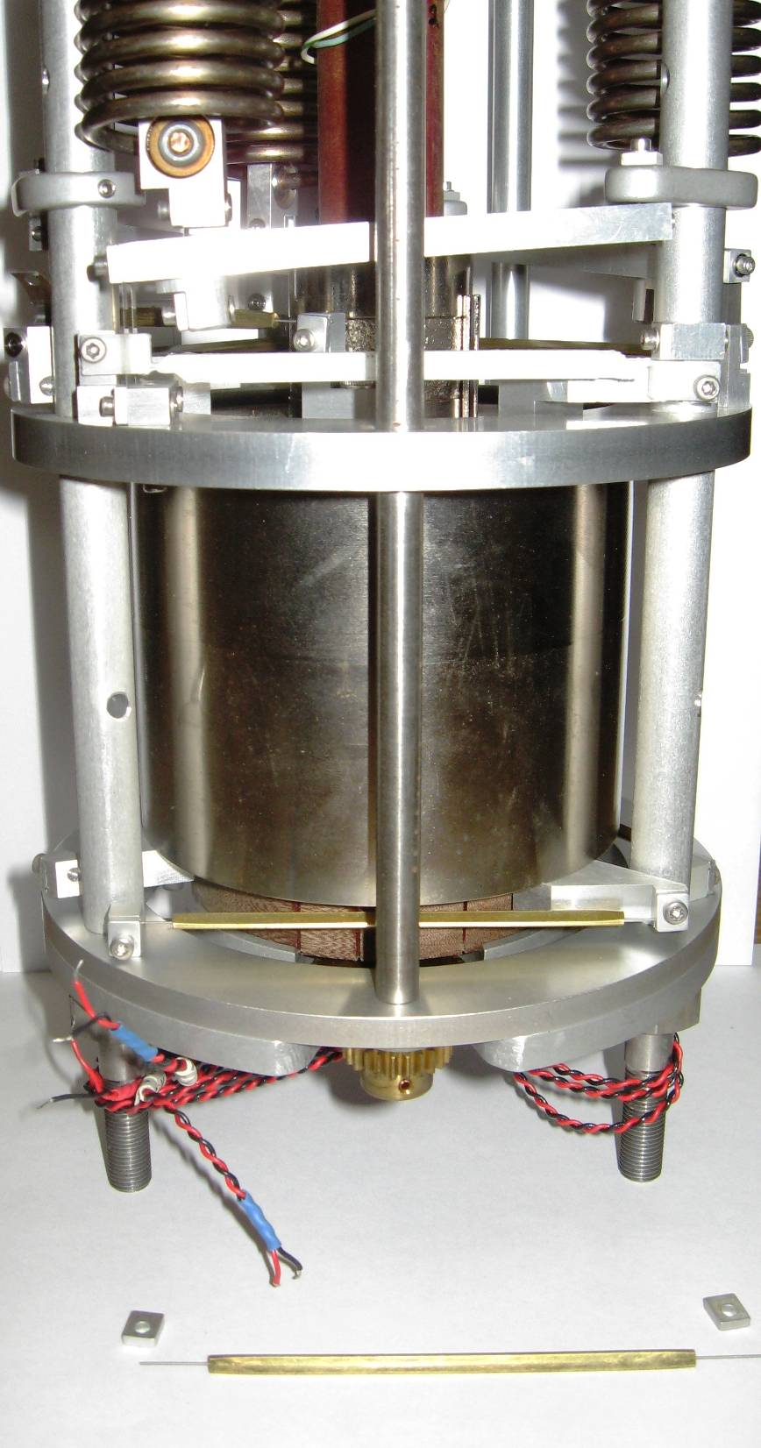
Figure 1, Seismometer with Original Delta-Rod Flexure

4. Recommended Flexure Design:
The following section describes the proposed flexure design – including design reasoning and justifications for some of the implemented features. In the subsequent section other previous iterations of the design are documented along with the reasons why they were abandoned.

4.1 Material Selection:
A beryllium copper alloy C17200 (also known as alloy 25) was chosen as the base material for the design with an H temper (TD04). This was chosen for several reasons including, high yield stress, availability, minimal interaction with magnetic fields around the test-mass, and the ability to easily age it after machining. After aging (2 hours air bake at 330°C) this material is brought to the temper properties of HT (TH04) with ultimate yield stresses of 1.10 to 1.38 GPa (160 to 200 ksi). The fatigue properties of the BeCu alloy are excellent with a 10⁸ cycle limit at 310 MPa (45 ksi).

4.2 Geometry / Design:
The actual design consists of two precise round-notch flexures in the sensitive axis with 0.250 in. radii each and two 0.125 in. radii round notch flexures which can be held to less strict tolerances for the out of sensitive axis direction. The ends of each flexure have a geometry such that they fit into both ends of the existing mounting structure and can be attached with the existing screws. Because of form factor constraints, the design for the top 3 vs. bottom 3 flexures are slightly different. This is due to the fact that the upper flexures need to fit between existing flex strips used by the cantilevers for the test-mass offload springs.

The size of the 0.250 in. radius flexure elements was chosen because the larger the radius the less stress is induced when the flexure undergoes bending. However, there is also a point when the element loses its buckling resistivity. This is thought to be very close to this tradeoff and has been shown to be close in subsequent acceptance testing.

The large notch flexure has a web thickness of 0.0040 in. – this is a critical dimension in order to match the original delta-rod’s stiffness. This stiffness is critical in maintaining the natural frequency of the instrument and, ultimately, instrument sensitivity. The smaller notch flexure web thickness is much larger at 0.015 in. and its dimensions are not as critical. The static loading for this flexure design was predicted through the calculations to be 33 g.

Figure 2 shows a CAD rendering for the top version of the flexure. Refer to Appendix 2 for dimensioned CAD drawings of both the top and bottom versions.

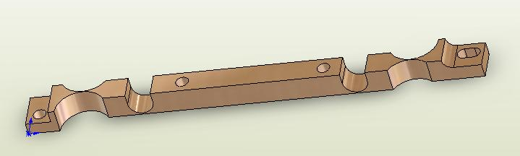
Figure 2, BeCu Flexure

4.3 Manufacturing Process:
The design of the BeCu flexure was optimized for manufacturability on a 3-axis CNC milling machine. Because of this, round notch flexures were used instead of elliptical elements. The manufacturing process is very straightforward with no part flips. The process used for the prototype flexures is as follows – it could also be useful to note that multiple flexures can be milled out of the same piece of stock thereby saving setup time (Figure 3):
- Face the 0.250 in. nominal thickness BeCu stock to 0.250 in. (the actual dimensions of our stock was 0.270 in.)
- Drill the central mounting holes and mount stock to fixture plate
- Mill down the left and right edge creating the proper overall left-right length
- Mill the mounting recess on the left and right side. This was accomplished with both a standard and ball end-mill
- Drill the left end mounting hole and mill the right end mounting slot – then fix these ends to the fixture plate
- With a 0.250 in. diameter ball end mill machine the two smaller round-notch flexure elements
- Drill and then precision ream the 0.500 in. diameter holes that define the larger round notch flexures. The web thickness for this operation needs to be closely controlled to 0.0040 in.
- Mill around the contour of the flexure to release it from the BeCu stock

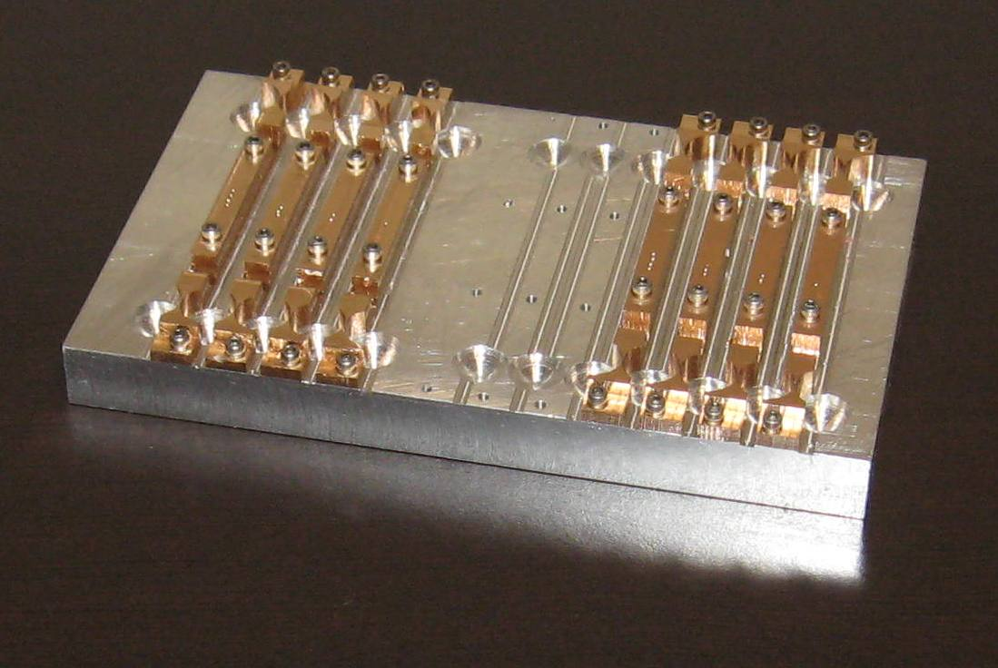
Figure 3, Machined BeCu Flexures on Fixture Plate

Next the flexure needs to be cleaned of any machining lubricants in preparation for aging. The flexures are then placed in a preheated oven at 330ºC oven and left to bake in air for 2 hours. After they are removed and allowed to cool they can be installed.

4.4 Installation:
The installation of the flexures is fairly straightforward with the following procedure:
- Ensure the manual test-mass lock is engaged.
- Remove the GS-13 can by removing the three bottom nuts and gaskets with a 9/16 in. wrench.
- Unscrew and completely remove the 4-40 screws and clamps on each end of the 6 delta-rods.
- Remove the 6 delta-rods.
- Position and start the screws to hold the new flexures in place. Making sure to distinguish between upper and lower flexure variations. Tighten the screws on the left end of the flexures which attach the flexures to the frame. Leave the screws on the the right end of the flexure loose.
- Slightly release and carefully re-engage the test-mass lock.
- Tighten all 4-40 screws that hold the flexures in place
- If needed readjust the natural frequency adjustment knob to be in the neutral position with the knob indicating ‘0’. Do this by loosening the 4-40 screws that clamp onto the torsion spring wire that is attached to the knob. Then re-tighten these screws.
- Replace the can and associated hardware.
- Unlock the test-mass and test the instrument for freedom of movement.

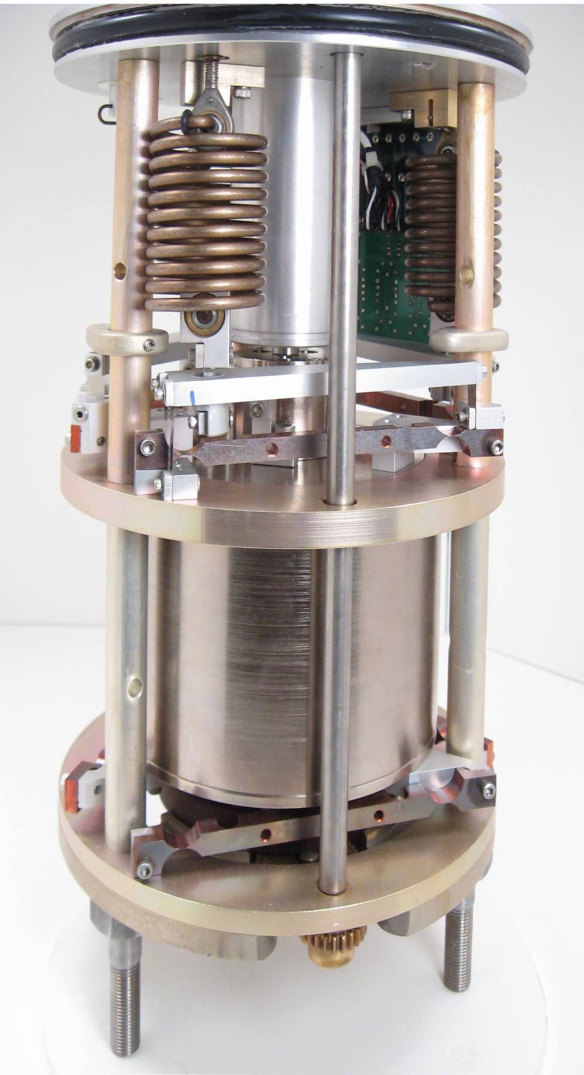
Figure 4, BeCu Flexures as Installed

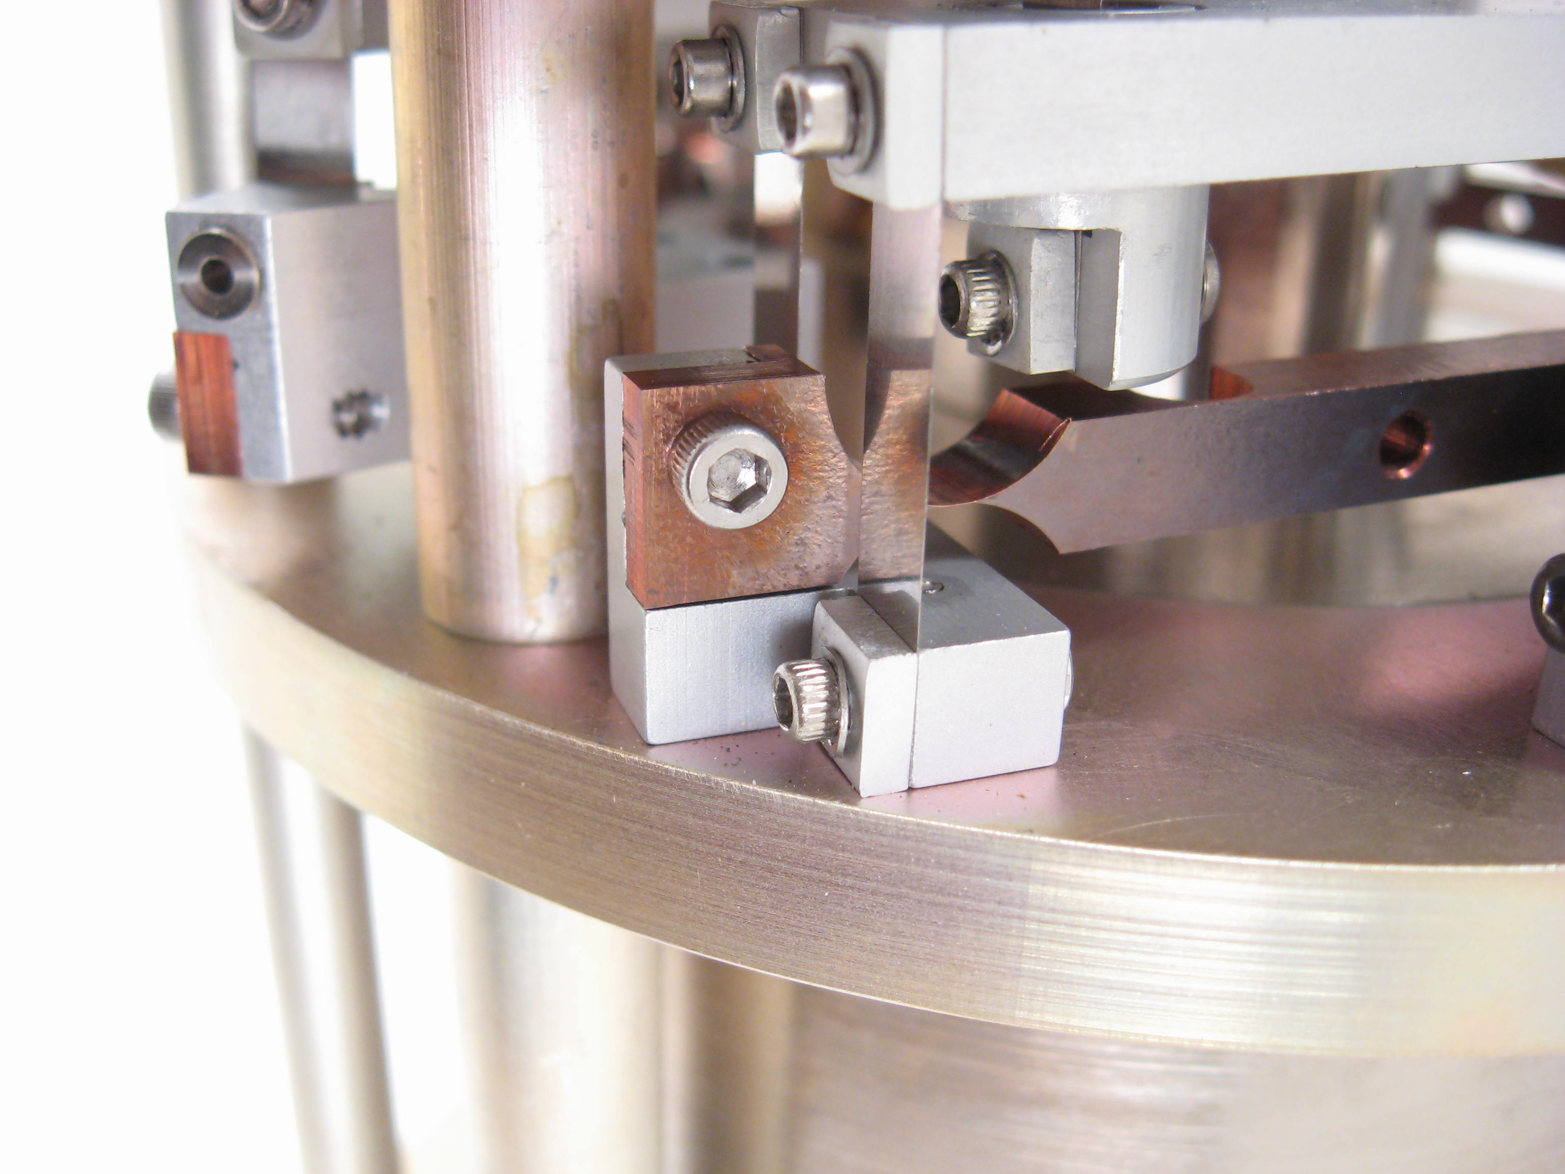
Figure 5, Detail View of Left End Attach Point for Upper Flexure

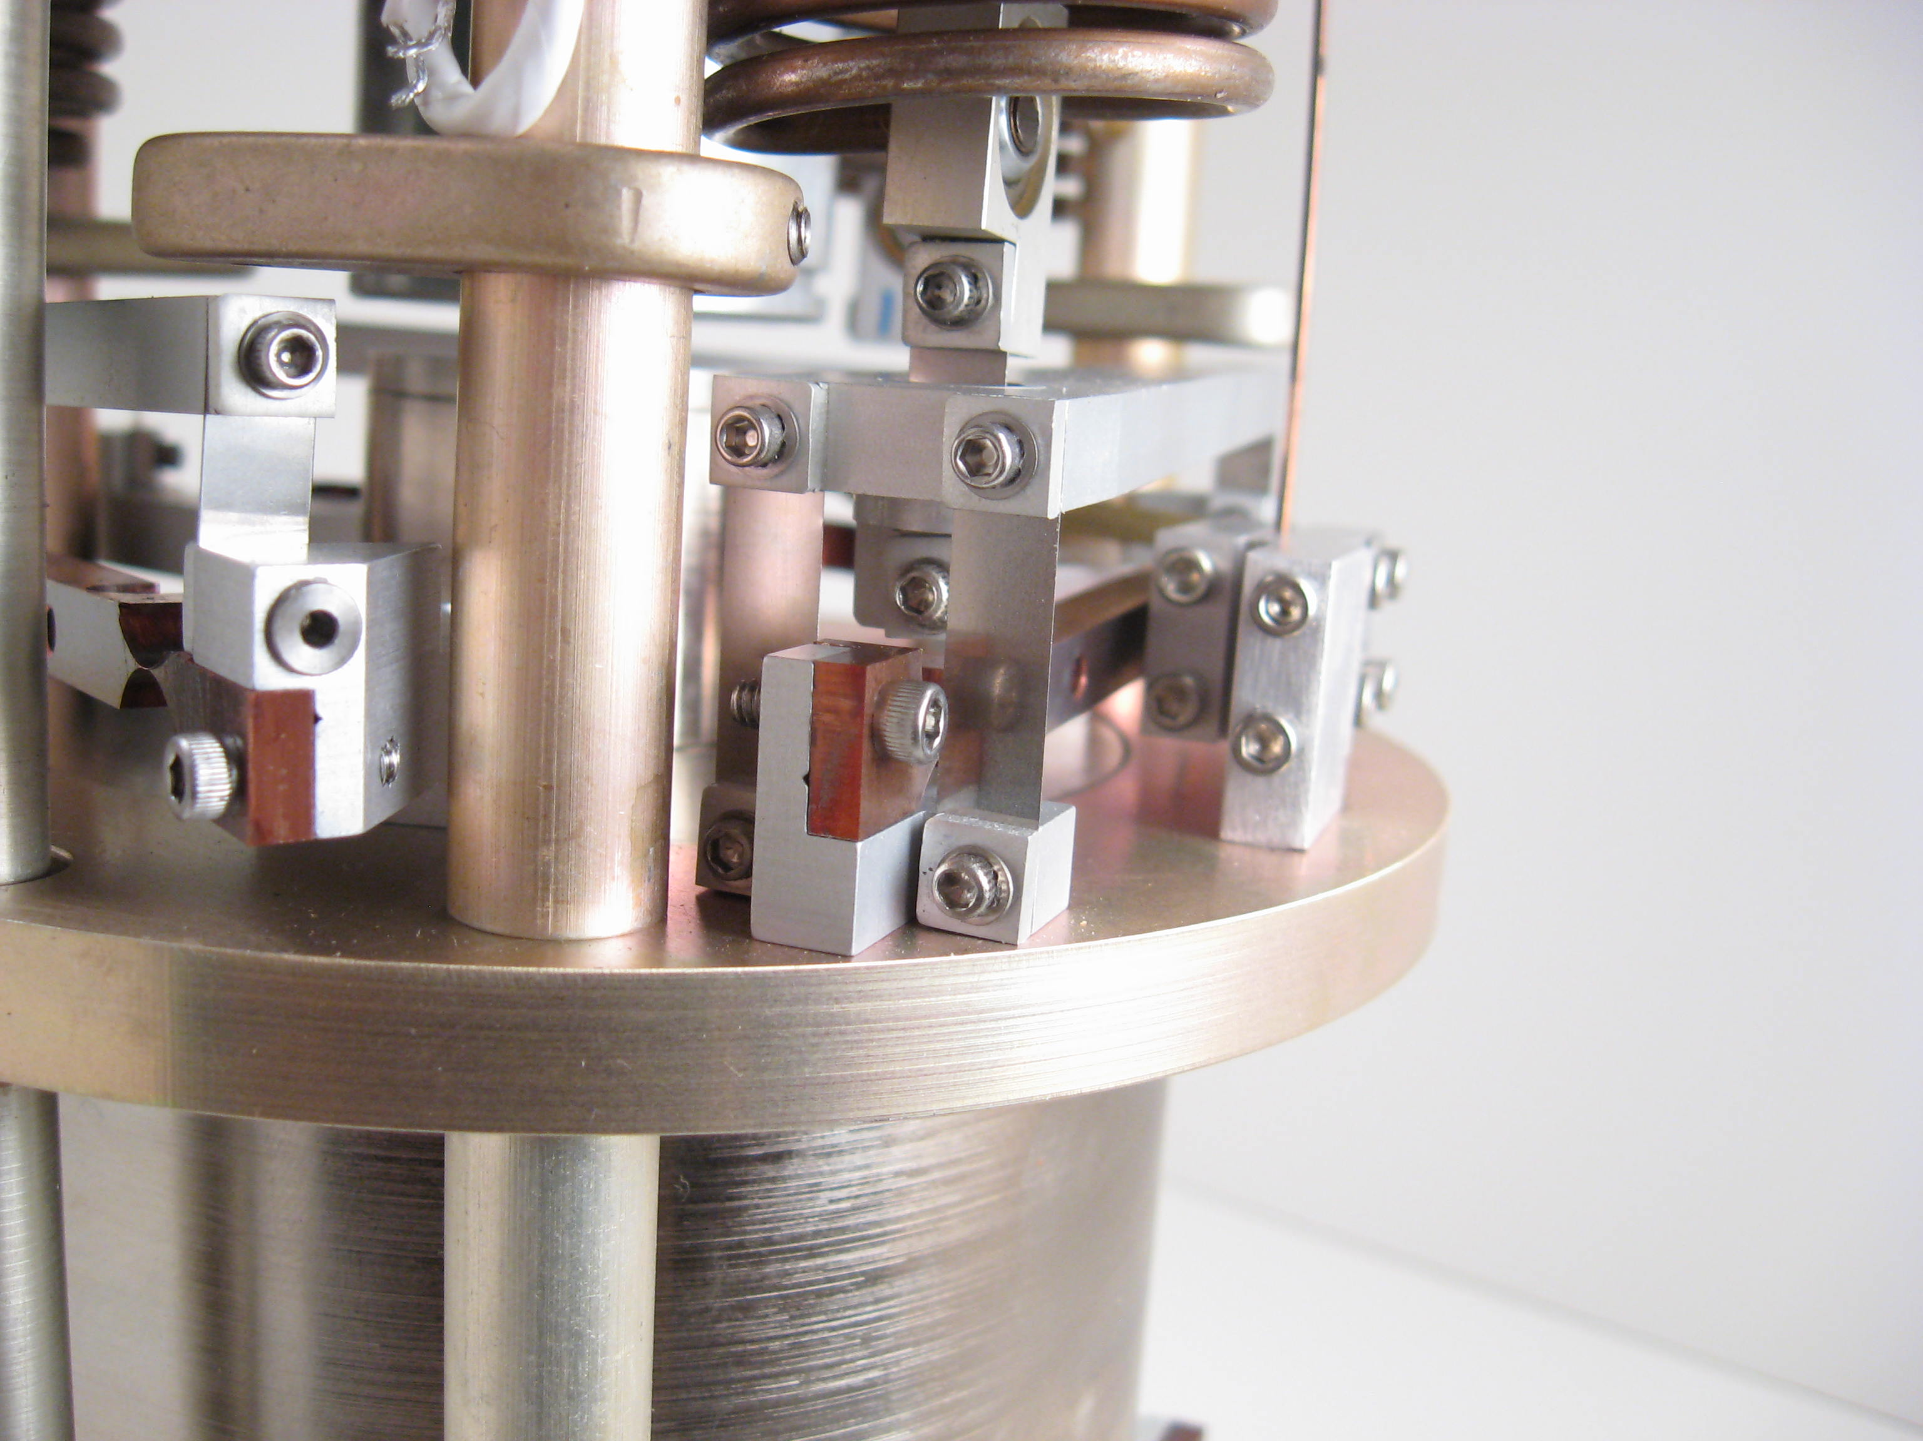
Figure 6, Detail View Highlighting Clearance with other Parts

5. Other Designs Considered:

5.1 Maraging Steel Flexure:
A flexure design made out of maraging steel 350 was first attempted. This design utilized small diameter (0.125 in.) round notch flexure points in both the vertical and horizontal directions. The design was promising by having a predicted static load rating of 45 g. Unfortunately, this design had several drawbacks, including difficult in acquiring stock material in any geometry other than round stock, relatively poor machinability, and extensive hardening procedure including over 100 hours bake in an argon backfilled oven. Ultimately, the flexure proved to become magnetic when installed on the seismometer. With the flexure in place, it was noted that on more than one occasion when the test-mass traveled to one limit of motion, the maraging steel flexure would attract the test-mass and capture it. This is not acceptable for the seismometer as free, uninterrupted motion is critical to the instrument’s operation.

Figure 7 shows one of the maraging steel flexures in place on the test seismometer.

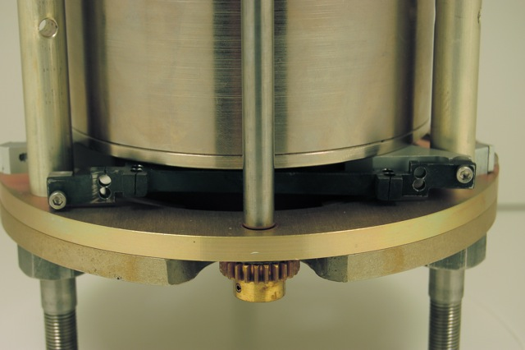
Figure 7, Maraging Steel Flexure Design

5.2 BeCu / Brass Flexures:
Another design that was pursued was that of making brass parts and then soldering in thin 0.006 in. BeCu sections to make the flex points. The material cost was very low for this design but the maximum strength obtained could not meet the goal of 20 g static loading. Several prototypes were made, and it became apparent that maintaining the required tolerances while soldering together the 9 individual pieces (5 brass elements and 4 flexure joints) would be very difficult to achieve in a production setting. Figure 8 shows the design and Figure 9 shows a prototype installed on the seismometer.

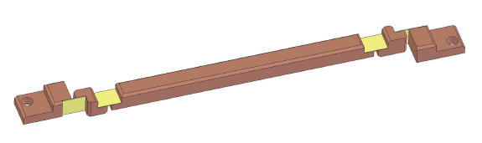
Figure 8, 3D CAD Rendering of BeCu / Brass Flexure

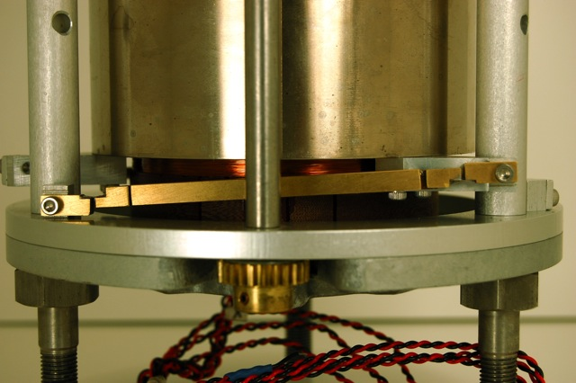
Figure 9, BeCu / Brass Flexure as Installed

6. Testing:

6.1 Performance Validation:
The testing of the GS-13 equipped with the recommended BeCu flexures was carried out by doing several tests comparing it to two GS-13 seismometers that had the original delta-rods. The first test consisted of comparing the response of the instrument to a “weight lift” procedure. In this procedure the test-mass of the instrument is pushed down to the lower limit of travel and then released while the time response of the system is recorded. Figure 10 (also reproduced in Appendix 3) shows the 3 response plots for each of three GS-13 instruments. The first row, displayed in red, correspond with the seismometer equipped with the new flexure design. The natural frequency of the seismometer and the Q factor can then both be measured and compared. The seismometer with the new flexures had a natural frequency of 0.94 Hz and a Q factor of 41.5. This compares to natural frequencies of 1.01 Hz and 1.09 Hz respectively for each of the stock GS-13 seismometers with both of them having a Q factor of 28.6. In order to maintain instrument sensitivity, it is important that the natural frequency be at or below that which the delta-rods provide while maintaining a Q factor at or above what a stock seismometer gives.

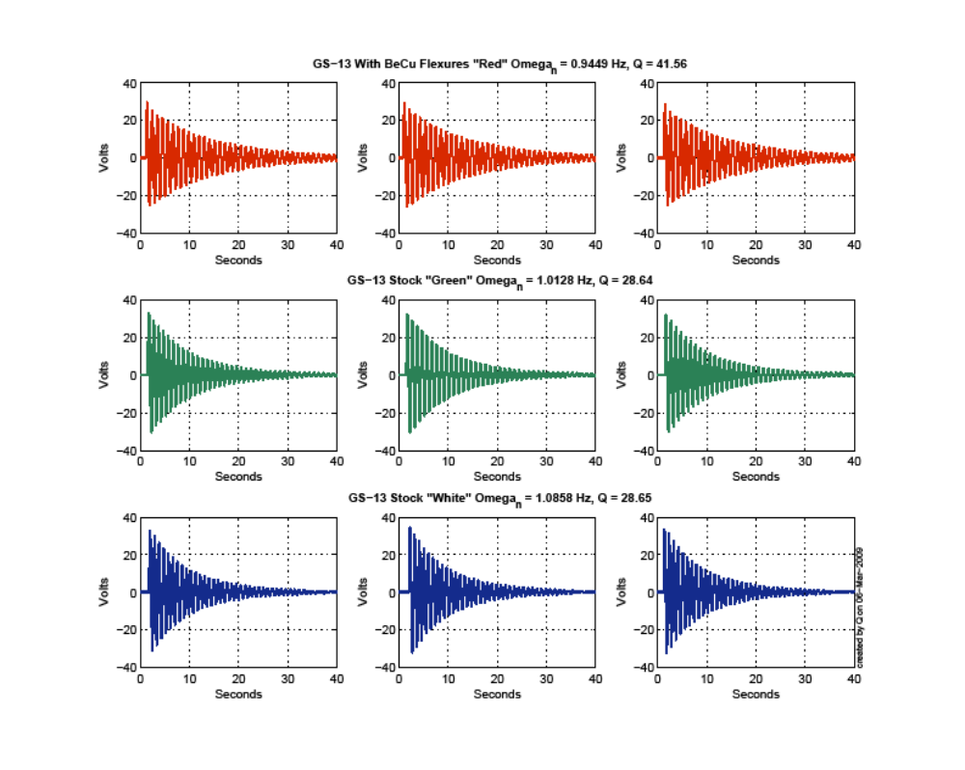
Figure 10, Weight-lift Response of Seismometers

The second portion of the performance testing involved placing the seismometer up on the Stanford ETF platform. Figure 11 shows the table top where the seismometer’s performance can be compared against 6 feedback GS13s, 2 stock witness GS-13s, 2 witness Streckeisen STS-2s, and a Trillium T-240 seismometer.

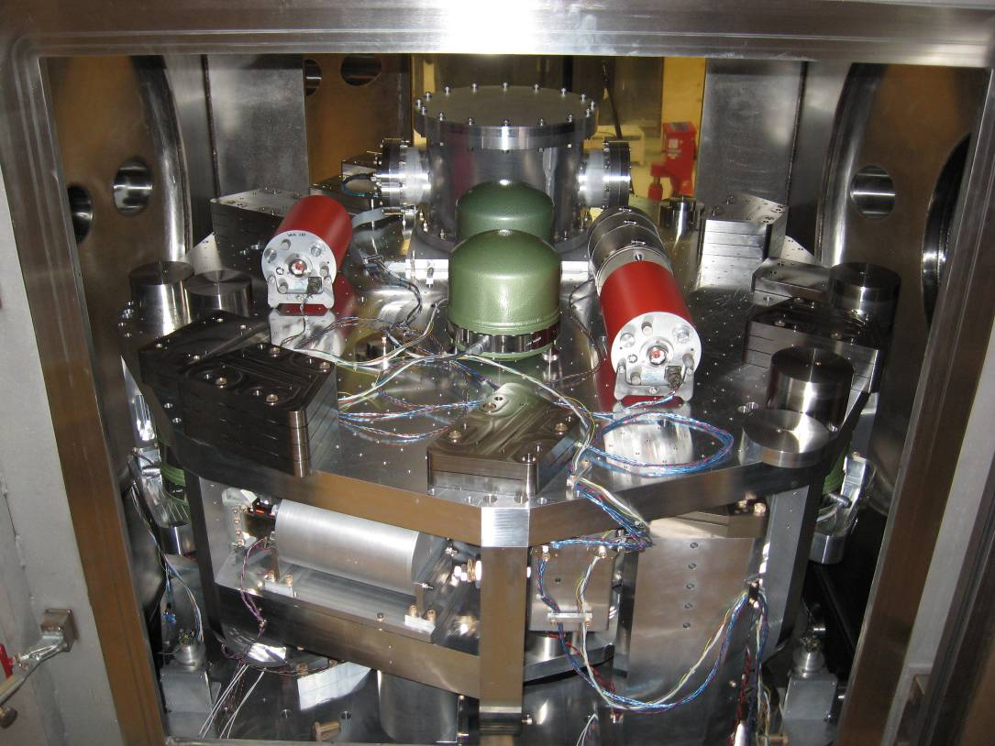
Figure 11, Stanford ETF Platform and Seismometers

The results of this test can be seen in Figure 12. Here it is important to note that the signal of the GS-13 with the modified flexures corresponds with that of both the witness STS-2, and closely to the two witness GS-13 seismometers. The noise floor also closely matches one of the witness GS-13 seismometers and is actually better at higher frequency than the other stock GS-13.
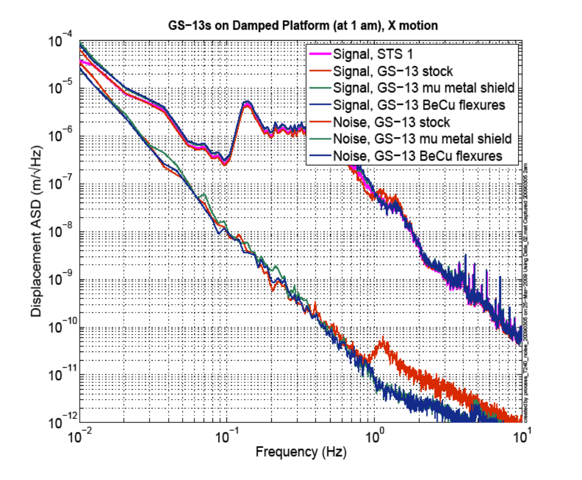
Figure 12, Noise Performance of the New Flexure Design

This is very helpful in showing that the new flexure design does not degrade the instrument’s performance. For this test, the chamber was at air pressure with the doors closed and only the stage 2 damping loops engaged. The noise was estimated using Hua’s multichannel coherent subtraction method using the 6 feedback GS-13s, the 3 low frequency seismometers (2 STS-2s, 1 T240) and the other 2 witness GS-13s as references.

6.2 Ruggedness Testing:
The flexures were also subjected to testing to establish their overall strength and resilience. The flexure has two main methods of failure. The first is due to the overall yield stress of the material being exceeded and the second to that of buckling. As the round-notch flexures go to bigger and bigger diameters the buckling failure mode takes over, on the other hand, if the notch diameter is small the yield stress level is quickly exceeded.

The calculations were carried out with a static loading assumption. It is not entirely clear how this differs from shock loading of the flexure. So that was also verified later. For the static load tests, the flexures where placed in a vise equipped with a load cell and compressed while recording their value. Figure 13 shows one such test of a flexure.

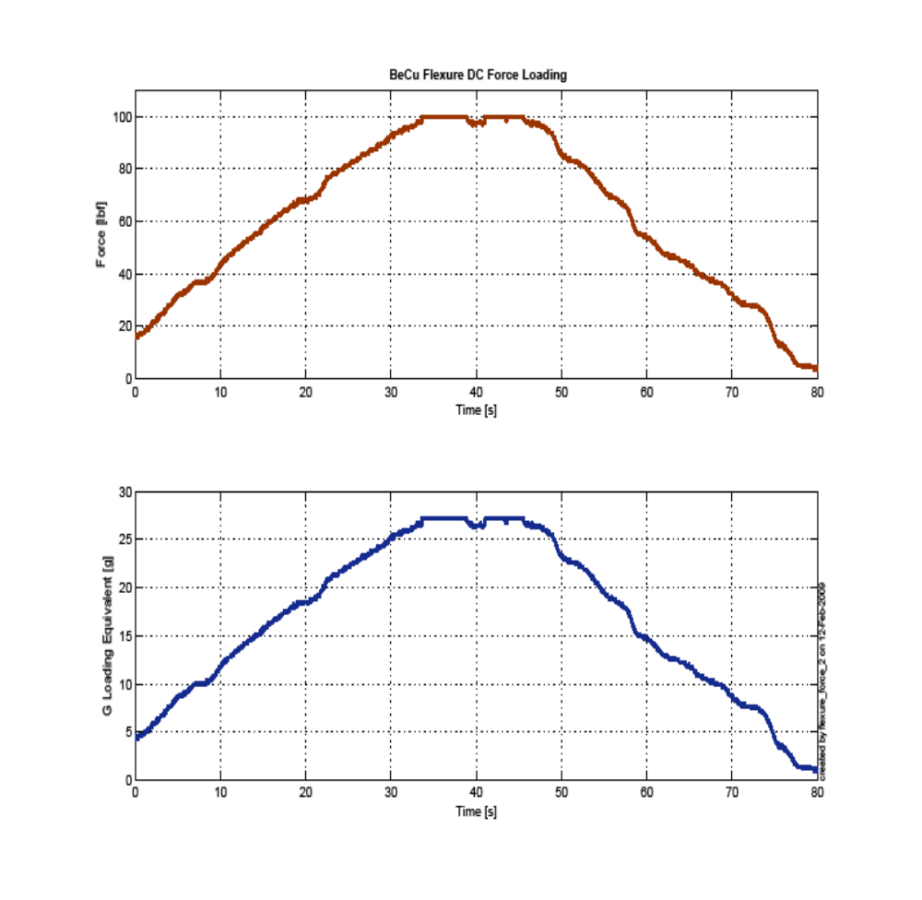Figure 13, Static Loading of Flexure

In this test the flexure element did not fail before the load cell saturated at 27 g force equivalent of static loading. In two other tests to failure however, flexures have failed at 18 g and 23 g of equivalent loading. The actual failure point is very dependent on the initial offset of the flexure itself and the stress loading from flexure bending. All of the static tests were carried out with the flexure in its maximum range of travel, and all displayed buckling failure indicating that there is no merit in going to a larger round notch diameter bigger than 0.500 in.

The second method of testing involved actual drop tests of the seismometer equipped with an accelerometer onto a concrete floor and also into a concrete wall. The seismometer was first mounted inside its vacuum pod before being tested. This was for two reasons: first, the seismometer should be locked manually if it is not inside the vacuum pod because the locking knob is accessible; secondly, the added mass of the pod helps reduce the accelerations that the seismometer is subjected to for any given drop. The instrument was then dropped from various heights onto different surfaces: a solid wood lab table, a stainless steel cleanroom table, cardboard, and ultimately the concrete floor. Of the drop surfaces it was determined that the stainless steel table provided the most compliance and thus the most energy absorbing and best surface for the instrument to land on. The worst case was a 25.4 mm drop onto the concrete floor which had max accelerations on the order of 55 g. The peak loading duration was very small, measured between 2 and 5 milliseconds. Figure 14 shows the corresponding accelerations recorded for these drops onto concrete – without any degradation of the flexures.

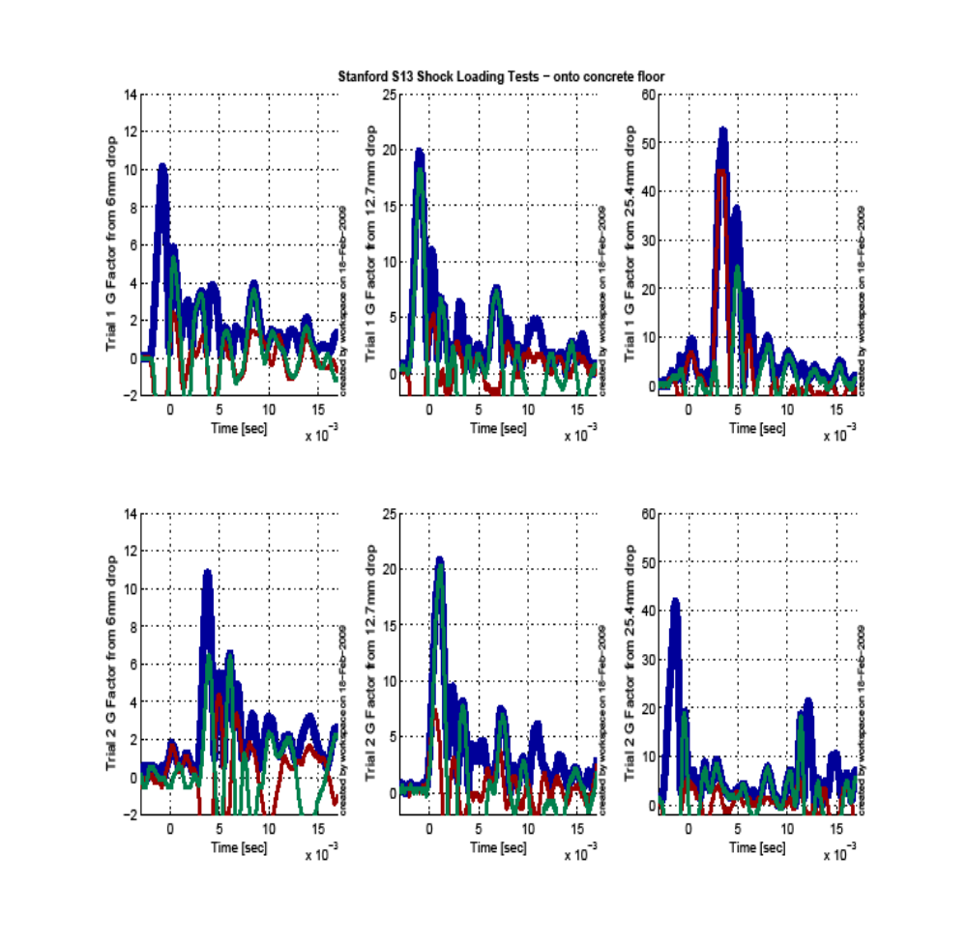Figure 14, Impact Drop Tests of Seismometer onto Concrete Floor

The setup to ram the seismometer into the concrete wall is shown in Figure 15. These tests involved impacting the instrument along its sensitive axis. In operation, the LIGO preamp board will be installed in the seismometers. This allows the excess voltage that is generated by rapid movements of the seismometer’s test-mass in the sensitive direction to be dumped across diodes and the energy be taken up as heat in the diodes and main coil. One of the goals of the test was to measure the amount of current the instrument produces on impact and make sure that this does not exceed what the seismometer can handle. Figure 16 shows the results of one of the ram tests and shows that the maximum current is around 60 mA which is well below the maximum that that the seismometer can absorb.

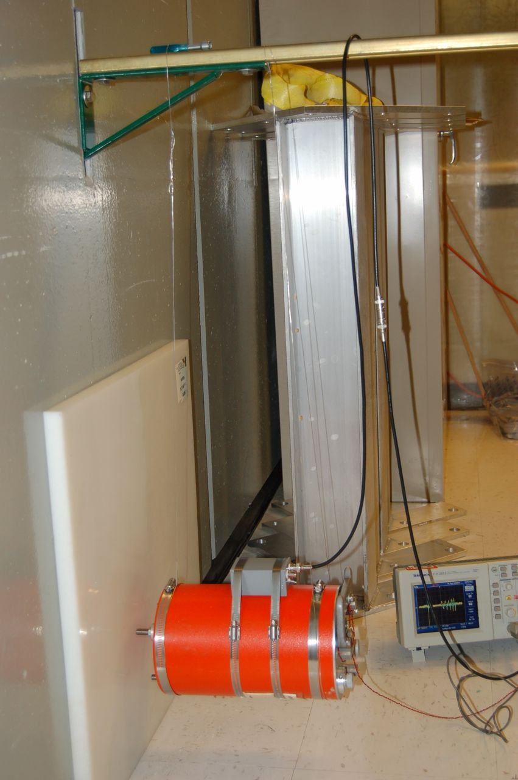
Figure 15, Ram Test Setup of GS-13 into Concrete Wall

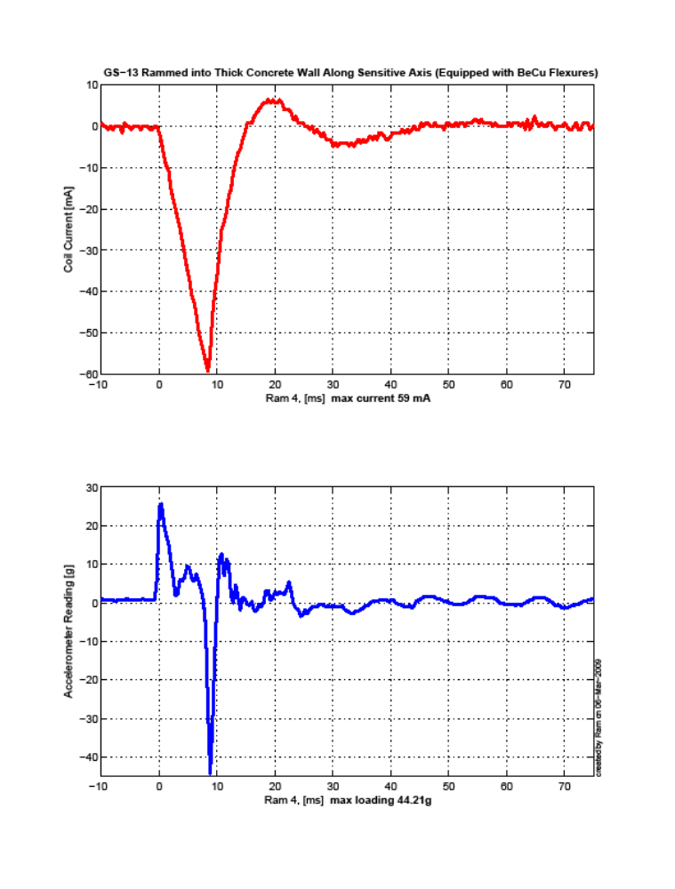
Figure 16, Ram Test Results into Concrete Wall

7. Use Recommendations:
The recommendations for the implementation of the more rugged flexure design are threefold.
- We recommend that the manual test-mass lock be left in place on the instrument. This manual locker will be accessible, and we recommend its use, up to the point when the seismometer is installed in the vacuum pod. At the point of podding the manual lock would then be placed in the unlocked position.
- When the podded seismometer is shipped we recommend that the seismometer and pod be placarded to orient the instrument’s nameplate and ‘top’ to be down. This is recommended for both horizontally and vertically configured instruments. The internal geometry of the seismometer is such that if placed in this orientation the test-mass slides into a cone that helps reduce the effect of impacts to the instrument, thus providing a greater degree of protection to the instrument and flexures.
- Finally, once the instrument is podded, we recommend that further work be carried out on a semi-compliant work surface. In brief testing, a stainless steel cleanroom table provided much better shock damping than solid wood or concrete surfaces. Care in handling should be in accordance with standard care taken when using and handling sensitive scientific instruments.

8. Conclusions:
The BeCu flexure design, as described in this report, is a promising alternative to costly and sometimes unreliable test-mass locking motors. Our testing indicates that the flexure maintains the original seismometer’s sensitivity and noise floor while creating a much more robust instrument.

It is recommended that future LIGO installations of the GS-13 seismometer as used by the seismic isolation subsystem install these flexures. It is also important that the Use Recommendations section be followed to ensure proper, sustained instrument performance.

9. Appendices

1. Supporting Calculations

2. CAD Drawings of Top and Bottom Flexures

3. Time Response of the GS-13 Instruments

Appendix 1. Supporting Calculations
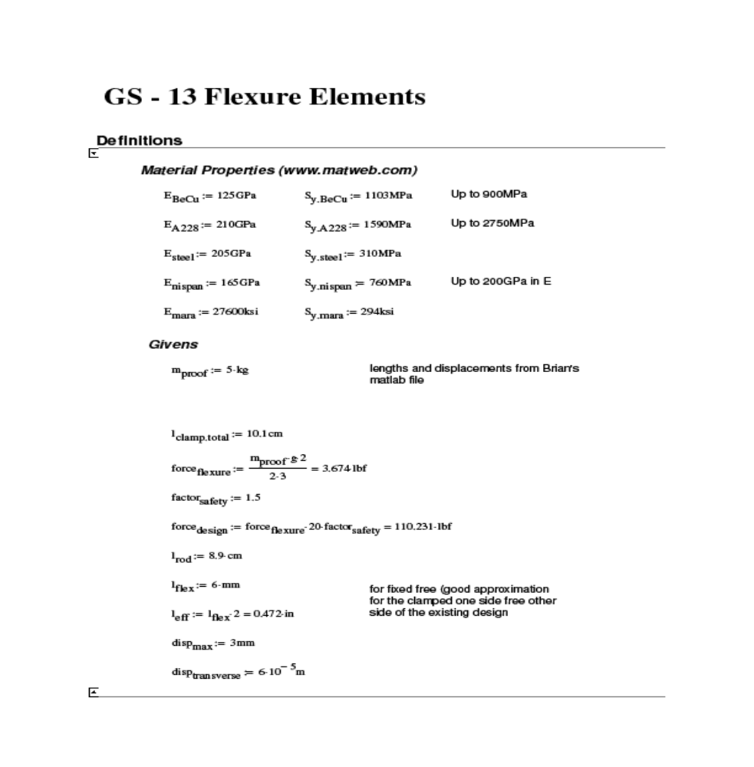

Appendix 1. Supporting Calculations

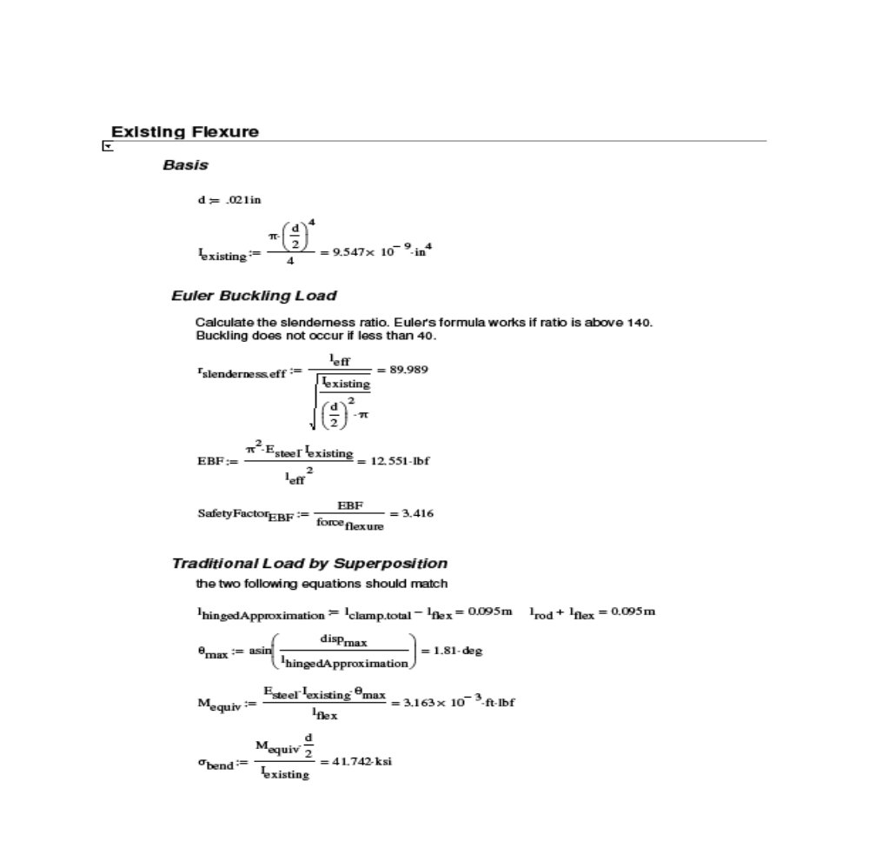



Appendix 1. Supporting Calculations

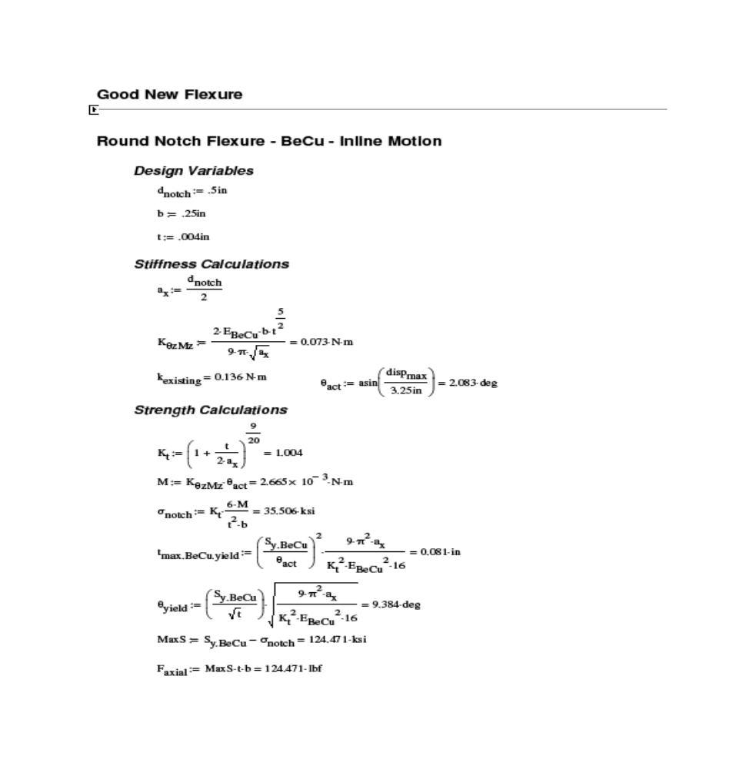



Appendix 1. Supporting Calculations

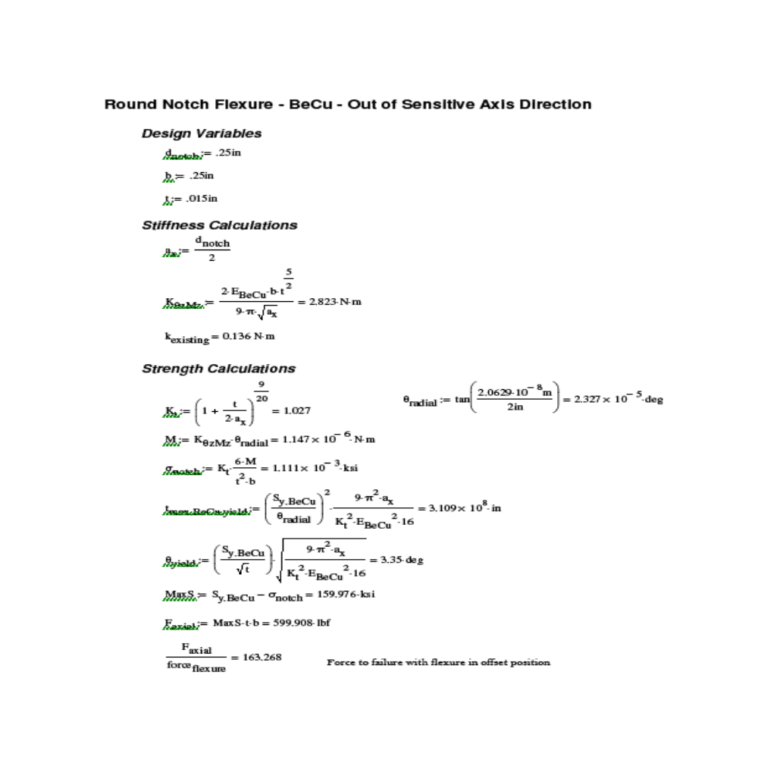

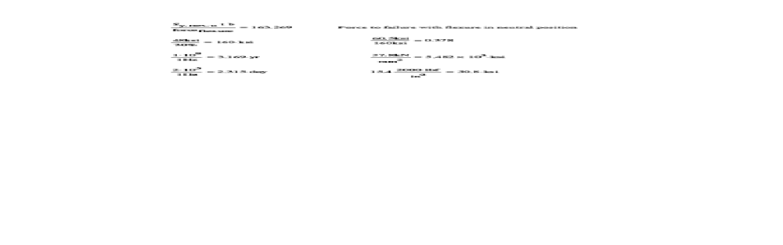

Appendix 2. CAD Drawings – Top Flexure
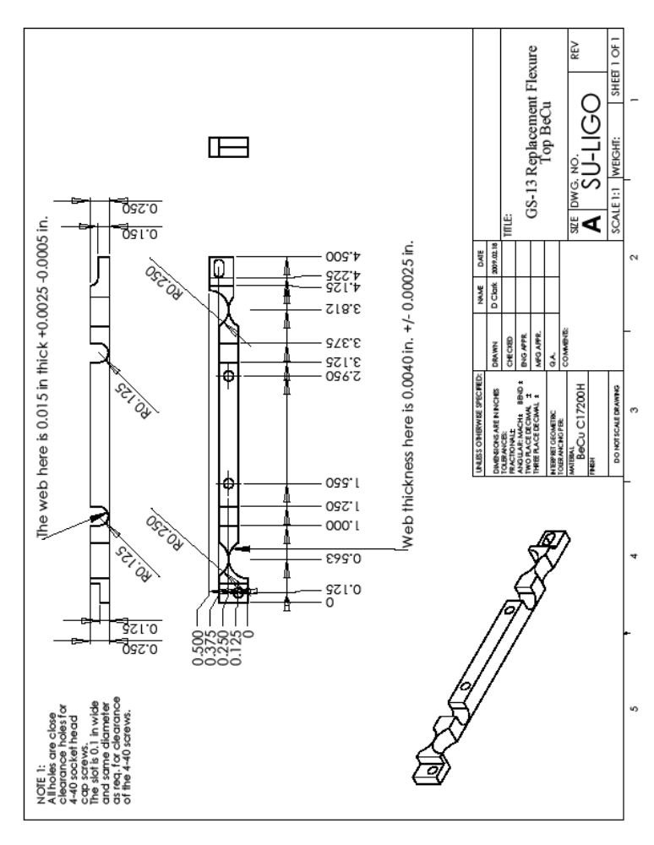

Appendix 2. CAD Drawings – Bottom Flexure
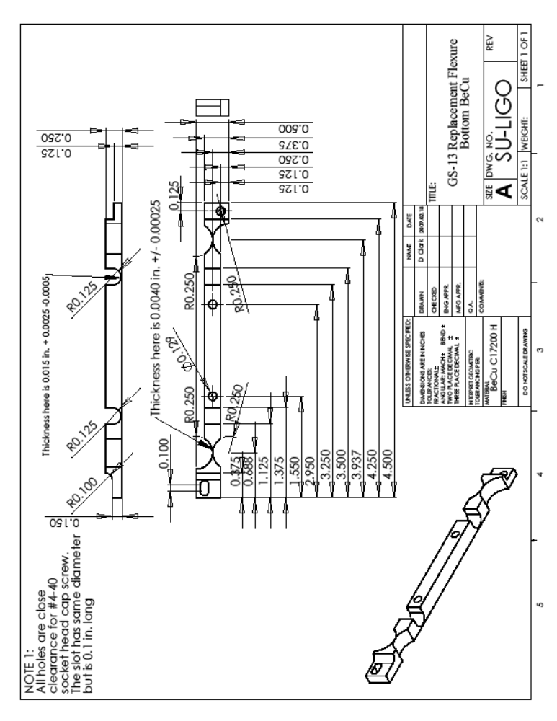

Appendix 3. Time Response to Weight-Lift Test



