LIGO Laboratory / LIGO Scientific Collaboration

LIGO-T050111-06-K Advanced LIGO UK February 2014

BOSEM
Design Document & Test Report

Stuart Aston

Distribution of this document:
Inform aligo_sus

This is an internal working note
of the Advanced LIGO Project, prepared by members of the UK team.

Institute for Gravitational Research  University of Glasgow  Phone +44 (0) 141 330 5884  Fax +44 (0) 141 330 6833  E-mail k.strain@physics.gla.ac.uk | School of Physics and Astronomy University of Birmingham  Phone +44 (0) 121 414 6447  Fax +44 (0) 121 414 3722  E-mail av@star.sr.bham.ac.uk
Engineering Department  CCLRC Rutherford Appleton Laboratory  Phone +44 (0) 1235 445 297  Fax +44 (0) 1235 445 843  E-mail J.Greenhalgh@rl.ac.uk | Department of Physics  University of Strathclyde  Phone +44 (0) 1411 548 3360  Fax +44 (0) 141 552 2891  E-mail N.Lockerbie@phys.strath.ac.uk

http://www.ligo.caltech.edu/
http://www.physics.gla.ac.uk/igr/sus/
http://www.sr.bham.ac.uk/research/gravity/rh,d,2.html
http://www.eng-external.rl.ac.uk/advligo/papers_public/ALUK_Homepage.htm
1 Introduction and Scope 4
1.1 Version History 4
1.2 Document Organization 4
1.3 System Overview 5
1.4 Acronym List 5
1.5 References 6
2 BOSEM Mechanical Overview 7
2.1 Optical Sensor 8
2.1.1 Optical Sensor Properties 8
2.1.2 Sensor Study 8
2.1.3 Sensor Assembly 9
2.2 Electromagnetic Actuator 11
2.2.1 Actuator Properties 11
2.2.2 Actuator Wind-off Assembly 12
2.3 Magnet and Flag Assembly 13
2.4 Mounting and Adjustment Assemblies 14
3 BOSEM Electrical Overview 15
3.1 Interconnect Design 15
3.1.1 BOSEM Connector 16
3.1.2 Flexi-Circuit 16
3.2 BOSEM Cable Harness 17
3.2.1 BOSEM Mating Connector 17
3.2.2 SEI Mating Connector 17
3.2.3 BOSEM Cable Harness Lengths 17
3.2.3.1 IMC Triple Suspension 18
3.2.3.2 OMC Double Suspension 18
3.2.3.3 RM Triple Suspension 18
3.2.3.4 ITM Quad Suspension 18
3.2.3.5 FM / BS Triple Suspension 19
3.2.3.6 ETM Quad Suspension 19
4 BOSEM Design Philosophy 20
4.1 Magnetic Materials Restriction 20
4.2 Pitch Adjustment Magnet (PAM) Provision 21
4.3 Unwanted Eddy Current Damping 22
4.4 Burn-In Tests 22
4.4.1 Degradation of Emitter Output 22
4.4.2 IRLED Screening 24
4.4.3 Breakdown of Coil Winding 24
4.5 Thermal Considerations 25
5 UHV Requirements 26
5.1 Material List and UHV Conformance 26
5.2 OSEM Cleaning Procedure 27
6 BOSEM Support Equipment 28
6.1 Automatic Test Equipment 28
7 Test Results 29
7.1 Off-Axis Emission 29
7.2 Emitter MTBF Results 29
7.3 Prototype OSEM Fabrication 31
7.4 Noise Prototype OSEM Test Results 32
7.4.1 Operating Range 32
7.4.2 Sensitivity Performance 33
7.4.3 In-Vacuum Thermal Performance 34

Introduction and Scope
This document, which should be read in conjunction with reference [1], discusses the design of the BOSEM, to be installed in the Advanced LIGO Suspensions. The final section details the results of testing being conducted on Noise Prototype units. The electronics design, satellite box and coil drivers, are discussed elsewhere (see reference [2]). To summarize, this document focuses on the in-vacuum deliverables (BOSEMs and harnesses).

Version History
Rev. 00 - Initial release. July 2005 (SMA / DMH)
Rev. 01 - Revised to include changes prior to PDR. June 2006 (SMA)
Rev. 02 - Revised to include changes prior to FRR. January 2008 (SMA)
Rev. 03 - Updated to address feedback generated during FRR / FDR review. April 2008 (SMA)
Rev. 04 - Harness section updated, confirming no shielding to be provided. March 2009 (SMA)
Rev. 05 - Harness section updated to include layouts and drawings. OSEM cleaning procedure
refined and references to harnesses removed. February 2014 (SMA)
Rev. 06 - Updated section 2.3 to capture change in production flag design. February 2014 (SMA)

Document Organization
The document is organized as follows:
- Section 2, details the fundamental subsystems incorporated within the BOSEM. The following subsections then go on to discuss the key mechanical assemblies in more detail.
- Section 3, discusses the development of the electronic aspects of the BOSEM including the interconnection assembly and BOSEM harness.
- Section 4, describes the design philosophy that has driven BOSEM development, such as magnetic constraints and thermal considerations etc.
- Section 5, lists all the materials required for construction of the BOSEM and harness assembly, as well as its vacuum qualification status. An overview of the intended BOSEM cleaning procedure is also illustrated.
- Section 6, discusses the Automated Test Equipment (ATE) that will accompany delivery of the BOSEMs to the observatory sites.
- Section 7, reports on the results of testing undertaken on Noise Prototype units and associated parts.

System Overview
It is the function of an OSEM to provide Optical Sensing and Electro-Magnet actuation to enable active control at various stages of the Advanced LIGO multiple stage pendulum suspensions. OSEMs provide low frequency damping of resonance’s (local control) and also allow a means to maintain arm lengths of the interferometer (global control).
An investigation has previously been carried out to determine the optimal sensing and actuation approach e.g. geometric shadow sensors vs. interferometric sensors. It was concluded that a hybrid damping scheme utilizing active OSEMs and passive ECD would provide the best solution. This approach is documented in references [3] and [4], and the review outcome documented in reference [5].

Acronym List
ALUK Advanced LIGO UK
BOSEM Birmingham Optical Sensor and Electro-Magnetic actuator
BS Beam Splitter
DRD Design Requirement Document
ECD Eddy Current Damping
ETM End Test Mass
FM Fold Mirror
ID Inner Diameter
ICD Interface Control Document
IMC Input Mode Cleaner
IRLED Infrared Light Emitting Diode
ITM Input Test Mass
LIGO Laser Interferometer Gravitational Wave Observatory
MTBF Mean Time Between Failure
OMC Output Mode Cleaner
OSEM Optical Sensor and Electro-Magnetic actuator
PAM Pitch Adjustment Magnet
PD Photodiode
PFA Perfluoroalkoxy fluoropolymer (Du Pont)
PM Penultimate Mass
RM Recycling Mirror
SEI Seismic
SUS Suspensions Working Group
TM Top Mass
TO Transistor Outline
UHV Ultra High Vacuum
UIM Upper Intermediate Mass
UK United Kingdom
US United States

References
- D. Coyne et al, “(ICD) Suspension, UK Scope – Suspension, US Scope ”, E050160-01
- D. Hoyland, “Electronics Preliminary Design & Test Report”, T050110-01-K
- K. Strain, “Input to the OSEM selection review decision”, T040110-01-K
- K. Strain, “Response to OSEM review points 2-5”, G040280-00-K
- P. Fritschel, “Report on Advanced LIGO OSEM Follow-Up Review”, L040074-00-E
- P. Fritschel “Characterization and comparison of a potential new local sensor”, T990089-00
- N. Lockerbie, “Measurement of LIGO Hybrid OSEM Sensitivity”, T040106-01-K
- N. Lockerbie, “Measurement of shadow-sensor displacement sensitivities”, T040136-00-K
- M. Barton, “Analysis of the sweet spot for the coil”, Mathematica Notebook
- M. Zucker, “LIGO Interferometer Electronics EMC Requirements”, E020986-01-D
- K. Strain, “Eddy current damping in OSEM bodies…”, T050102-00-K
- D. Coyne, “LIGO Vacuum Compatible Materials List”, E960050-B-E
- D. Coyne, J. Romie “Universal Suspension Subsystem DRD”, T000053-02
- D. Coyne, “Generic Requirement & Standards for Detector Subsystems”, E010613-01-D
- N. Lockerbie, “Radiation patterns from OP232 infrared LEDs”, T040210-00-K
- K. Strain, “Increased strength Advanced LIGO ITM/ETM suspension PM and UIM
Actuators”, T060001-00-K
- RODA “To eliminate OSEM sensors for global control in the ETM and ITM”, M060043-00
- R. Taylor, “Cleaning procedure for magnet wire with ML/HML insulation”, T040127-00-D
- LIGO Systems Engineering, “LIGO Vacuum Compatibility, Cleaning Methods and
Qualification Procedures”, E960022-B-E
- S. M. Aston, “BOSEM Assembly Specification”, T060233-02-K
- D. Lodhia, “BOSEM Test Specification”, T070107-04-K
- S. Miyoki, “Maximum Current of the Suspension Actuator Coil”, T960148-01

BOSEM Mechanical Overview
The work undertaken here builds upon previous work carried out by Caltech and the University of Glasgow on the Controls Prototype OSEM (also known as the “Hybrid OSEM”). We have developed this design further to facilitate the production and integration of similar, but more refined units (BOSEMs) into the Advanced LIGO Suspensions.

The BOSEM comprises of the following key assemblies:-
- Optical Sensor (incorporating IRLED emitter and PD detector)
- Electromagnetic Actuator (coilformer and coil winding)
- Mounting and Adjustment
- Electrical Interconnect (sensor components, coil winding and BOSEM interface connector)
- Magnet and Flag

Some of these key assemblies can be seen highlighted in Figure 1.

Figure 1: BOSEM Assembly (D060218)
Rear isometric view
Front isometric view
Mounting Locations
(×4)
Coilformer (front-face)
Adjustment Assembly
Coilformer Clamp
Electrical Interconnect
Sensor Devices
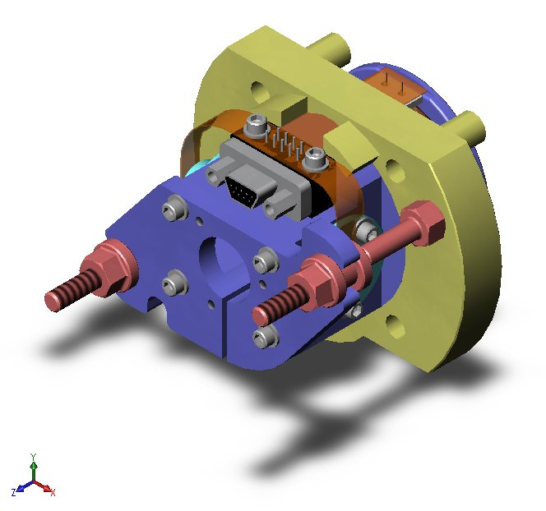 | 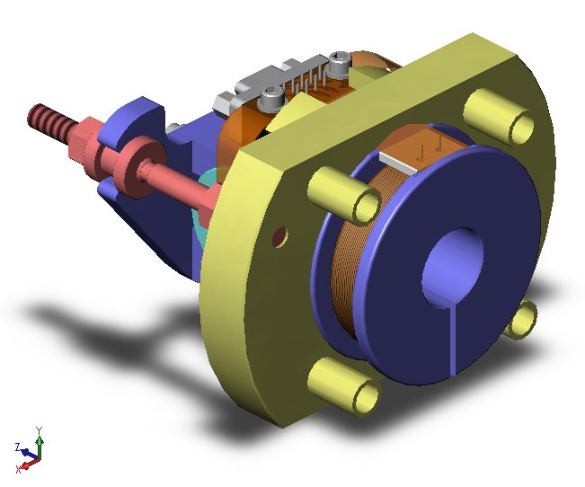

These subassemblies are discussed in more detail in subsequent sections. For further details regarding the BOSEM local coordinate system, envelope dimensions, and mass properties refer to reference [1].

Optical Sensor
Both Initial LIGO OSEMs and the Controls Prototype OSEM sensor assemblies have employed Honeywell surface mount IRLED & PD device bonded in place with Ceramabond. However, concerns have been raised with this approach, regarding misalignment that can result from the Ceramabond curing process. This process can also be considered a time consuming and complex production task. We intend to mitigate the risk associated with this approach by instead considering using a standard TO metal-can package. This enables alternative mounting schemes to be utilized.

Optical Sensor Properties
The optical sensor shall have the following properties:-
- Target Sensing Range = 0.7mm (peak-peak)
- Worst Case Noise (1-10Hz) = 3×10⁻¹⁰m/√Hz
- Worst Case Noise (10-20Hz) = 1×10⁻¹⁰m/√Hz
(n.b. noise figures given are in conjunction with the sensor electronics, see reference [2])

The science requirements driving these figures are discussed in references [3], [4] and [5]. Also note, the requirements given above agree with the performance as demonstrated by the Controls Prototype OSEM in tests carried out by P. Fritschel (reference [6]), and more recently by N. Lockerbie (reference [7]).

Sensor Study
An investigation has been conducted to identify alternative sensor components. This was undertaken in collaboration with Nick Lockerbie (University of Strathclyde). Candidate leaded devices were actively sought, so long as they could achieve a level of performance at least equivalent to the Honeywell devises. Alternative flag geometries were investigated as well various optical schemes, such as light pipes and lenses etc. One outcome of this work was that the Honeywell emitter device was identified as a likely candidate of excess noise at 1Hz (see reference [8]).

The final scheme selected utilized an addition mask and lens integral to the emitter assembly to enhance its performance. Figure 2 shows the angular emission pattern from an OP232 IRLED n.b this figure is reproduced from ALUK report by N. Lockerbie 15 October 2004.

Figure 2: Sensor Characterization
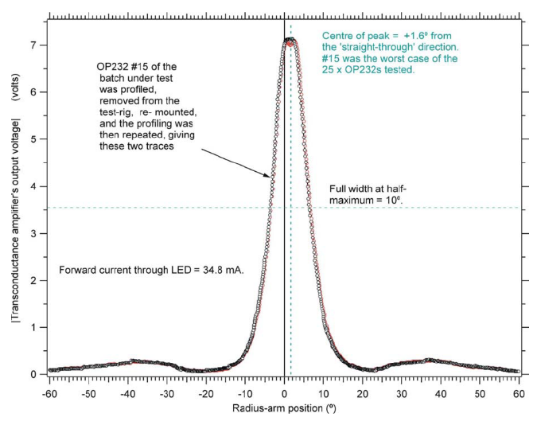
Angular emission pattern

The outcome of the investigation was to propose the devices shown in Figure 3 as direct replacements for the Honeywell components.

Figure 3: Leaded Sensor Devices
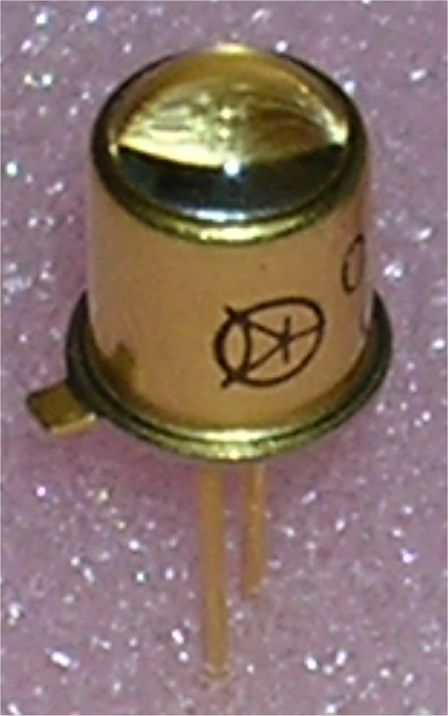  - Manufacturer: Optek  - TO-46 Kovar Package (An-to-case)  - Hermetic Seal (∅ 0.186” [4.7mm])  - Peak emission: 890nm  - Max forward current: 100mA  - Operating forward current: 35mA  - Max radiant power: 8mW (@100mA) | 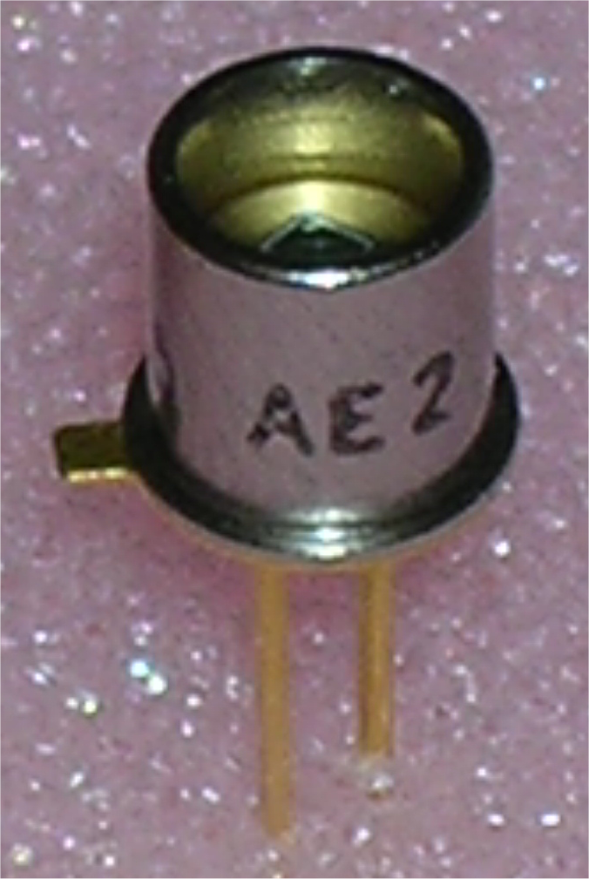  - Manufacturer: Centronic  - TO-18 Steel Package (Ca-to-case)  - Hermetic Seal (∅ 0.189” [4.8mm])  - Peak sensitivity 850nm  - Responsivity: 0.55A/W (@900nm)  - Capacitance: 15pF  - Dark Current: 5nA
PD (BPX65)

IRLED (OP232)

Sensor Assembly
One objective of the Noise Prototype OSEM design was to minimize the use of Ceramabond during construction, ideally to eliminate it completely from the assembly process. Moreover, our intention is to machine parts to well defined tolerances, so as to ensure confidence in the alignment of the sensor, thus ensuring ease of assembly and optimal performance.

Electrical isolation requirements (see reference [1]) state that the device package should be insulated from its aluminum carrier and hence the rest of the structure. To ensure this requirement is met, each device is insulated from the carrier by a ceramic sleeve, into which the device is push-fit. A recess machined in this sleeve accommodates the flange and tag located on the sensor package. A flat machined on the sleeve outer diameter, which corresponds to an aperture (pin-hole) on the carrier enables the orientation of the device to be fixed during the assembly process (this ensures the anode & cathode are correctly orientated). This technique is employed in both IRLED and PD assemblies. Figure 4 shows the assembled IRLED carrier and a component part explosion. Figure 5 shows the equivalent scheme for the PD assembly.

Figure 4: IRLED Assembly (D060216)
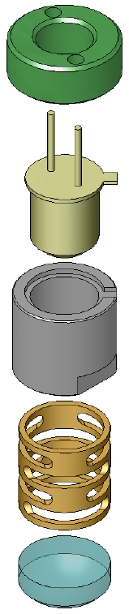  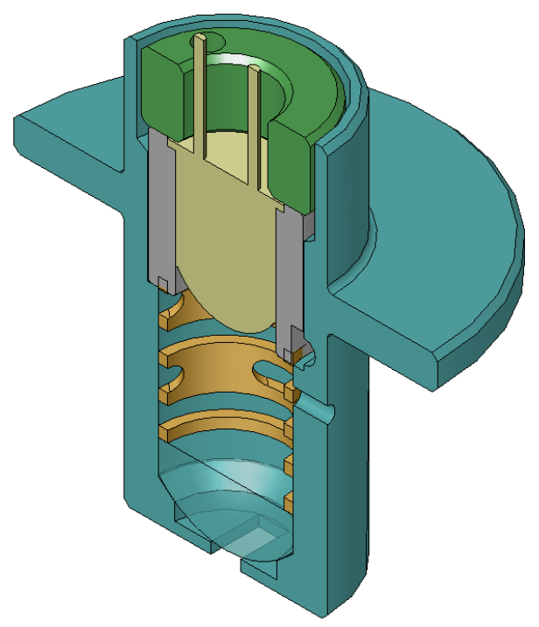  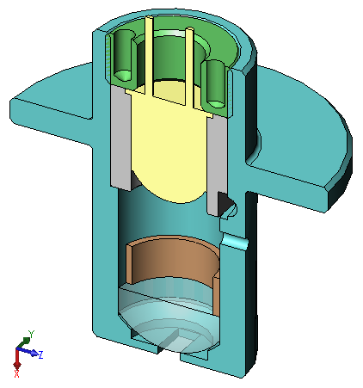  IRLED part explosion  Section through assembled IRLED carrier  Mask  [1.4×4.5mm]  Pin-hole Locator  IRLED Retainer  IRLED (OP232)  IRLED Sleeve  IRLED Lens Retainer  IRLED Lens (∅ 0.248” [6.3mm]) | 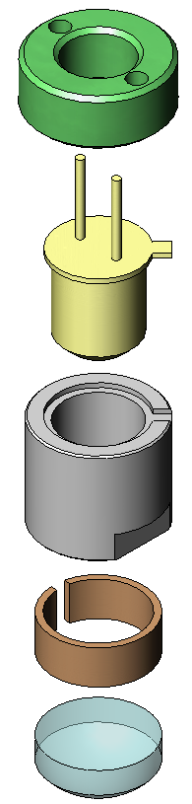

Figure 5: PD Assembly (D060217)
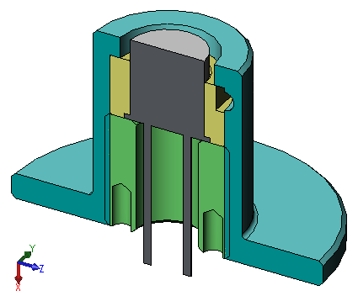  PD part explosion  Section through assembled PD carrier  Pin-hole Locator  PD Sleeve  PD (BPX65)  PD Retainer | 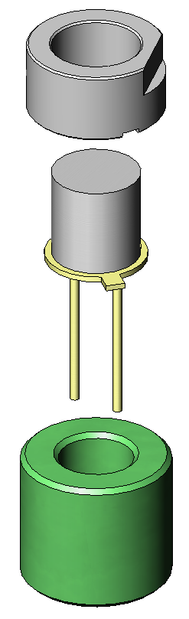

Note that, Initial LIGO OSEMs included a 1064nm filter coating on the receiver side assembly. This was included due to the OSEMs close proximity to the main interferometer beam and overcame the concern that the receiver could observe scattered light. However, Advanced LIGO makes use of multiple suspension stages which implies that locations where BOSEMs will be installed will be far removed from the beam axis (with no direct view factor). Hence, the filter feature has been deemed unnecessary and will not be installed.

The complete sensor assembly, and relative separation of the emitter and receiver sub-assemblies is shown in section in Figure 6.

Figure 6: IRLED and PD Carrier Assemblies
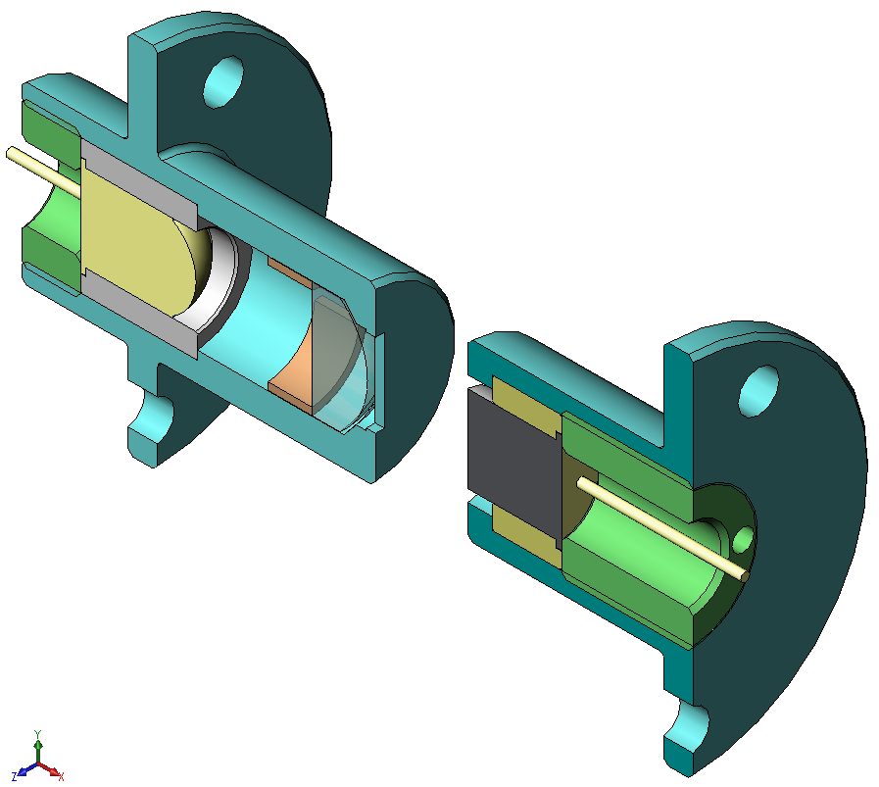
Section through complete sensor assembly
0.20” [5.0mm]
IRLED Carrier
PD Carrier

Electromagnetic Actuator
The electromagnetic actuator for the BOSEM is closely based upon the existing Controls Prototype OSEM design. However, the dimensions of the coil winding slot feature have been revised (see next section 2.2.1).

Actuator Properties
The properties for the actuation coil have evolved from the Controls Prototype design. It was determined that the coil dimensions would have to be revised to enable stronger actuator forces. The recommendations put forward in reference [16] have been adopted (i.e. to double the length of the coil winding). i.e. all BOSEMs supplied will have the stronger (double length) actuator windings.

Following are the properties of the electromagnetic actuator:-
- Wire Type = 32QML, 32 gauge copper wire + quad layer coating of polyimide-ML
- Coilformer material = Aluminum (6082)
- Coil Inner Diameter = 0.7” [17.78mm]
- Coil Length = 0.315” [8.00mm]
- Number of Turns on Coil = 800

Further characteristics, such as electrical properties, of the actuator coil are detailed in reference [1]. Figure 7 shows the key dimensions for the coilformer.

Figure 7: Coilformer
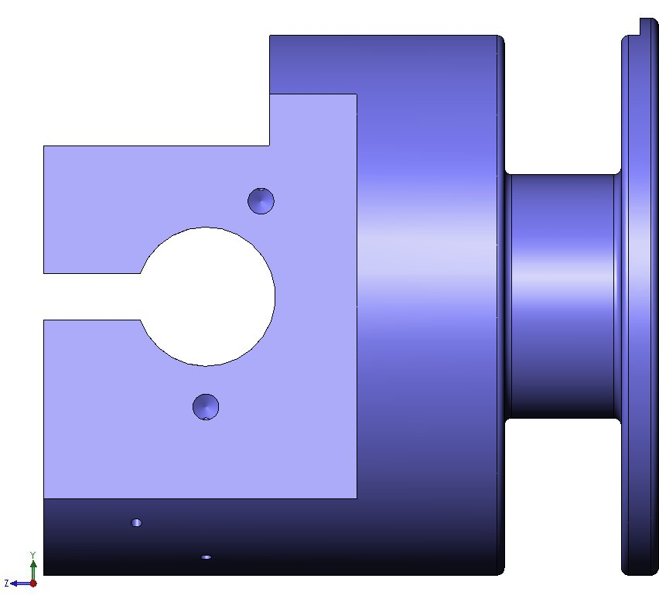  0.315”  0.7”  1.50”  Profile of coilformer  Normal to front face of coilformer | 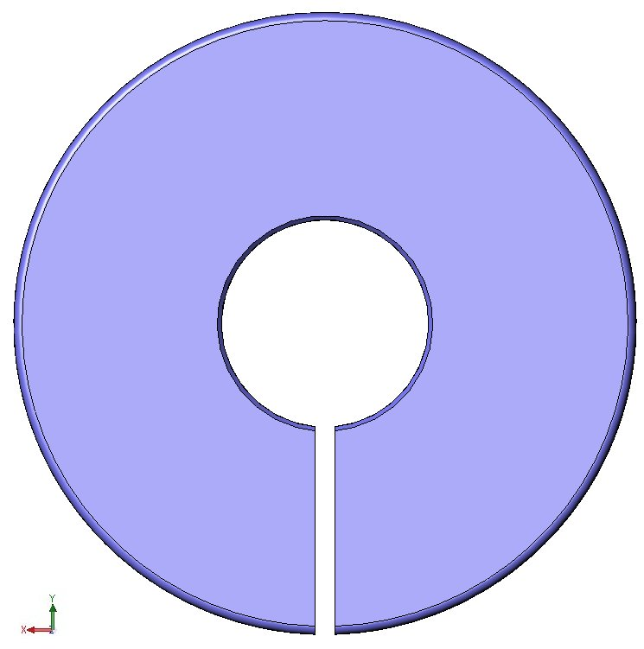

Actuator Wind-off Assembly
During assembly, the coil is to be wound onto the former and the loose ends temporarily secured in place by means of a PFA 440HP windoff spacer (no Ceramabond is used in the process). Figure 8 shows the coilformer, coil and windoff spacer in-situ. This reduces the amount of routing of the coil wire, increasing the reliability of the process and mitigating concerns such as shorting the coil to body of the BOSEM.

Figure 8: Coilformer and Coil Assembly
Rear isometric view

PFA 440HP Windoff Spacer
Coil Winding
Coil- former
Secured coil ends
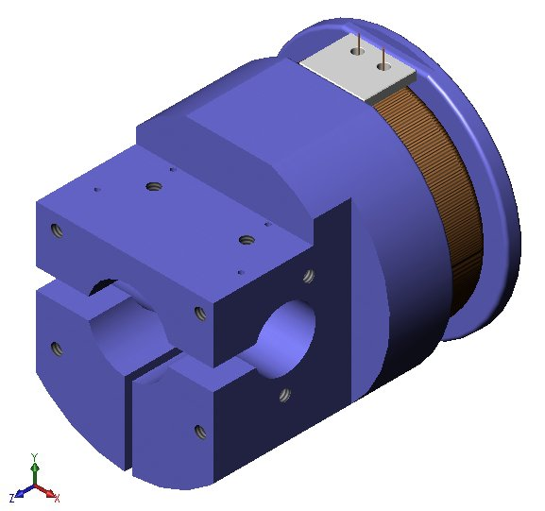

Magnet and Flag Assembly
The operating point or ‘sweet-spot’ of the magnet and actuator coil has to be redefined due to the revised coil geometry. This has been calculated using a similar method to that which was used for the Controls Prototype OSEMs, see reference [9]. Suggestions regarding magnet dimensions for stronger actuator forces are discussed in reference [16]. For the quad suspension, ∅10mm × 10mm long magnets have been selected for TM and UIM locations. ∅2mm × 6mm long magnets have been chosen for the PM. Given that the separation between the sensor and actuator has changed for the Noise Prototype sensor design, new flag dimensions are required. The proposed magnet and flag assembly is shown in Figure 9. For the final production effort, the flag geometry has changed from cylindrical, to a rectangular design, as shown in D1001695.
Figure 9: Magnet and Flag Assembly
Isometric view of flag assembly

Section through BOSEM and flag assemblies

Flag [∅3mm]
Magnet [∅10 × 10mm]
Spacer [∅10mm]
Magnet Centre Line
0.29” [7.4mm]
1.05” [26.64mm]
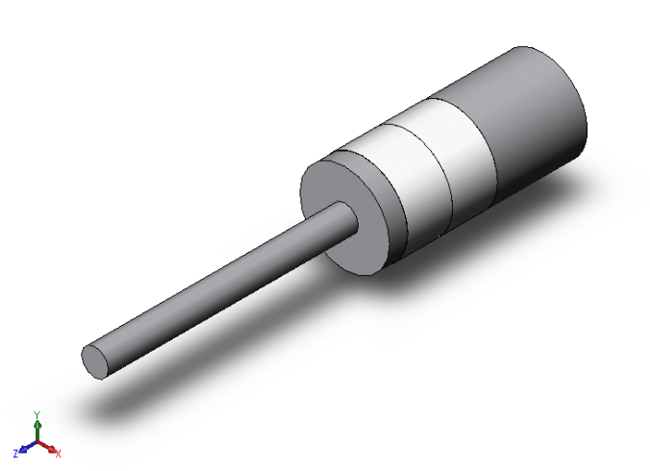 | 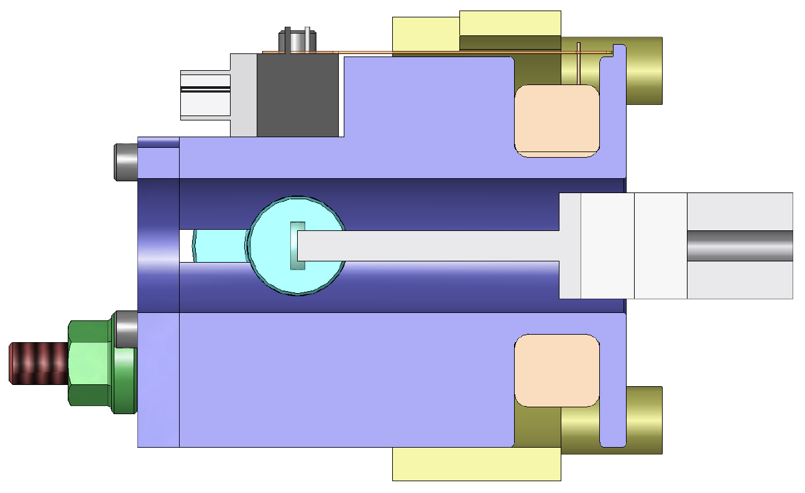

Mounting and Adjustment Assemblies
Four mounting locations are available to attach the BOSEM to the suspension or structure. These mounts also allow for some adjustment to be made in the x and y axes to locate the BOSEM. This is described in more detail in the reference [1].

Adjustment is also required axially, along the z-axis. The Controls Prototype OSEM design incorporated a “push-pull” assembly to enable the positioning of the coilformer along the z-axis. The scheme utilizes four screw fixings, two of which react off the coilformer bracket, the other two serve to lock the mechanism against the reacting screws, effectively clamping the coilformer in place. This provides a satisfactory solution but we have had the opportunity to develop it further for the BOSEM.

For example, a shoulder on the backplate can be machined to an interference fit about an adjuster ‘nut’ which is free to travel along a threaded shaft. Figure 10 highlights the key features of this approach. Since there are only two adjustments to be made, it makes BOSEM adjustment more intuitive and therefore saves time. The adjustment procedure is as follows; each nut can travel a few mm along the threaded shaft, before the operator needs to switch to adjusting the other nut. This process is repeated a number of times until the BSOEM is in the desired location.

Figure 10: Adjustment Assembly
Adjustment Nuts
Rear isometric view
Threaded Shaft
(5/32-40 ME)
Backplate
Shoulder

The full axial adjustment range (peak-peak) provided by this arrangement is equivalent to 0.44” [11.18mm]. This can clearly be seen in Figure 11, where the distance between the plane of the front face of the coilformer and the front face of the coilformer clamp are coincident on the left figure and displaced on the right figure.

Figure 11: Axial Adjustment
Profile view of BOSEM - maximum adjustment
Profile view of BOSEM - nominal adjustment
0.44”
0.00”
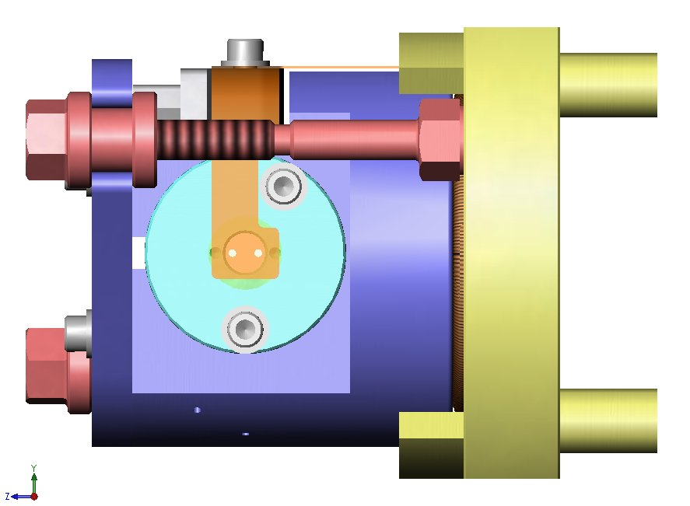 | 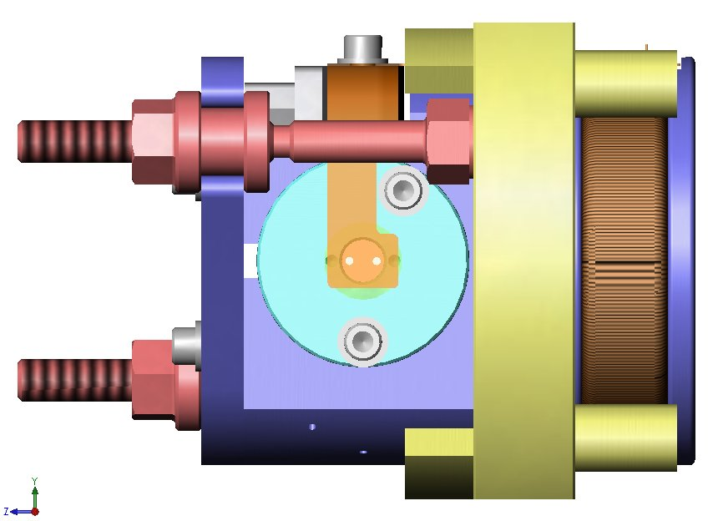

BOSEM Electrical Overview

Interconnect Design
The “interconnect” encompasses all of the circuit routing and connections required to link together the various electrical components of the BOSEM, as well as provide an external interface for external connection. Figure 12 shows the interconnect assembly, including all the individual parts to be connected. For completeness, the sensor devices also have there anode and cathode denoted by A and K respectively. The start (S) and end (E) pins of the coil winding are also indicated.

Figure 12: Interconnect Assembly
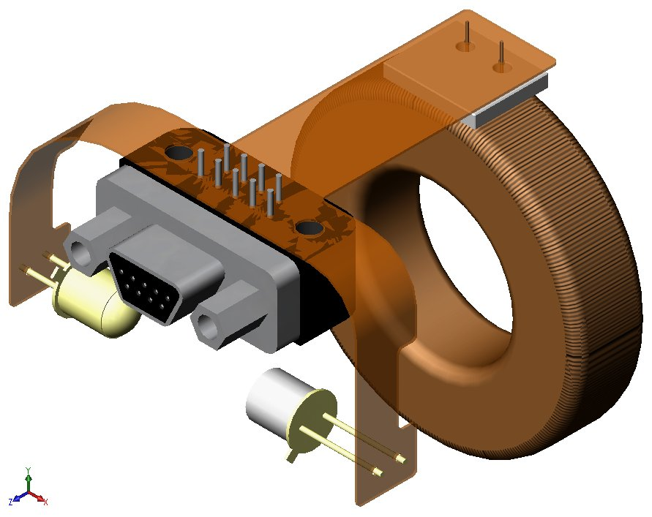
Rear isometric view

PFA-440HP Tab
Flexi-circuit
IRLED (OP232)
PD (BPX65)
9W micro-D PCB connector
Secured coil ends
A
K
K
A
S
E

BOSEM Connector
The connector located on the BOSEM head is specified as follows:-
- Description: Right angle PCB mounting 9 way male Micro D
- Part Number (GlenAir): MR7590-9P-1BSN-MC225
Modification Code (MC) 225 denotes no marking
The pin-outs of this connector can be found in reference [1]. A materials list for this part can be found in section 5.1 of this document.

Flexi-Circuit
A flexible circuit has been developed to replace the discrete wiring harness of the Initial LIGO and Controls Prototype OSEMs. This flexi-circuit forms the foundation of the interconnect assembly. A conventional dual layer flexi-rigid composite circuit is utilized. However, in this application no rigid sections are necessary. A diagram of the multiple layers is shown in figure 13. This double sided structure is approximately 210µm thick.

Figure 13: Flexi-Circuit Multi-Layer Structure
Kapton (25μm)
Adhesive (25μm)
Copper (18μm)
Adhesive (25μm)
Kapton (25μm)
Adhesive (25μm)
Copper (18μm)
Adhesive (25μm)
Kapton (25μm)
Coverlay
(DuPont LF0110)
Copper Clad Laminate
(DuPont LF8515)
Coverlay
(DuPont LF0110)

n.b. Adhesive is DuPont LF0100

BOSEM Cable Harness

BOSEM Mating Connector
The connector mating to the BOSEM head is specified as follows:-
- Description: Straight solder cup 9 way female Micro D
- Part Number (GlenAir): DCDM9S-S-MC194-216-225-240
Modification Code (MC) 194 denotes low profile socket-head jackscrew
Modification Code (MC) 216 denotes part supplied without gasket
Modification Code (MC) 225 denotes no marking
Modification Code (MC) 240 denotes electroless nickel plated shell

The pin-outs of this connector can be found in reference [1]. A materials list for this part can be found in section 5.1 of this document.

SEI Mating Connector
The connector mating to the SEI table can be specified as follows:-
- Description: UHV Connector - 25D - Male
- Connector Part Number: (Accu-Glass) 100420
- Pins Part Number: (Accu-Glass) 100170

The pin-outs of this connector can be found in reference [1]. A materials list for this part can be found in section 5.1 of this document.

BOSEM Cable Harness Lengths
Cable harnessing shall comply with the requirements of reference [10] where appropriate. Each cable harness shall have the following properties:-
- Cable Type: CZ1104 clear teflon coated copper wire
- Outer copper braided shield: None
- Outer PEEK braided insulator: None
Cables are to be manufactured to suit the locations of OSEMs within the suspension stages of the different suspension designs. Details in the following sections are approximated, pending completion of suspension designs and cable routing proposals. Cable clamping details and locations are to be agreed with the SUS design team.

IMC Triple Suspension

Location | Qty | OSEM Type | Cable Layout | Cable Drawing
Top Mass | 6 | BOSEM | T1200318 | D1000234
Penultimate Mass | 4 | iLIGO OSEM | T1200318 | D1000234
Bottom Mass | 4 | iLIGO OSEM | T1200318 | D1000234
Table 3.2.3.1-1

OMC Double Suspension

Location | Qty | OSEM Type | Cable Layout | Cable Drawing
Top Mass | 6 | BOSEM | T080117 | D1000234
Table 3.2.3.2-1

RM Triple Suspension

Location | Qty | OSEM Type | Cable Layout | Cable Drawing
Top Mass | 6 | BOSEM | T1200318 | D1000234
Penultimate Mass | 4 | iLIGO OSEM | T1200318 | D1000234
Bottom Mass | 4 | iLIGO OSEM | T1200318 | D1000234
Table 3.2.3.3-1

ITM Quad Suspension

Location | Qty | OSEM Type | Cable Layout | Cable Drawing
Top Mass | 12 | BOSEM | T1100327 | D1000234
Upper Intermediate Mass | 4 | BOSEM | T1100327 | D1002523
Penultimate Mass | 4 | iLIGO OSEM | T1100327 | D1002524
Table 3.2.3.4-1

Notes regarding ITM Quad suspension:-
- Cable length will be split by one in–line 25 way micro D connector to allow suspension to be assembled in 2 sections. The additional split being located between the Top Mass and the UIM.
- Initial LIGO OSEMs are to be utilized for the PM (see section 4.3), therefore a harness adapter is required to interface a 9 way micro D to the Initial LIGO OSEM “pin-plate”.
- For the Noise Prototypes, OSEMs capable of utilizing both sensor & actuator will be provided.

FM / BS Triple Suspension

Location | Qty | OSEM Type | Cable Layout | Cable Drawing
Top Mass | 12 | BOSEM | E1000686 | D1000234
Intermediate Mass | 4 | BOSEM | E1000686 | D1000234
Table 3.2.3.5-1

ETM Quad Suspension

Location | Qty | OSEM Type | Cable Layout | Cable Drawing
Top Mass | 12 | BOSEM | T1100327 | D1000234
Upper Intermediate Mass | 4 | BOSEM | T1100327 | D1002523
Penultimate Mass | 4 | iLIGO OSEM | T1100327 | D1002524
Table 3.2.3.6-1

Notes regarding ETM Quad suspension:-
- Cable length will be split by one in–line 25 way micro D connector to allow suspension to be assembled in 2 sections. The additional split being located between the Top Mass and the UIM.
- Initial LIGO OSEMs are to be utilized for the PM (see section 4.3), therefore a harness adapter is required to interface a 9 way micro D to the Initial LIGO OSEM “pin-plate”.
- For the Noise Prototypes, OSEMs capable of utilizing both sensor & actuator will be provided.

BOSEM Design Philosophy

Magnetic Materials Restriction
The use of magnetic materials in the construction of the BOSEM shall be restricted to ensure that the residual actuation force (with actuator coil unbiased and actuator magnet positioned on the BOSEM z-axis in line with the front face of the coilformer) is less than 5mN (10% of the original peak actuation force).

Measurements taken of the magnetic coupling between the metallic packages of the sensor components and the front face of a ∅10mm × 10mm Nd-B-Fe Nickel plated magnet are shown in Figure 14.
Figure 14: Sensor and Actuator Magnetic Coupling
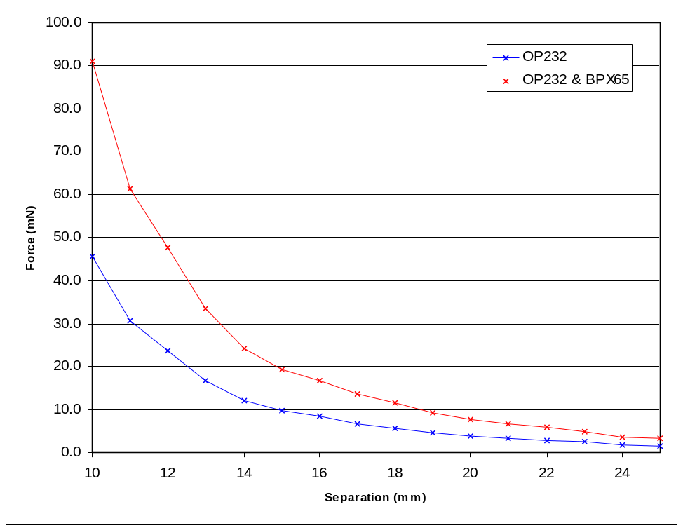

The BOSEM design incorporates 1.126” [28.6 mm] separation between the front face of the coilformer and the outer diameter of the sensor package, as shown in figure 15. This implies a residual actuation force <5mN. However, it should be noted that with the stronger actuators, this residual actuation force now represents ~1% of the peak force.

Figure 15: Sensor and Actuator Separation
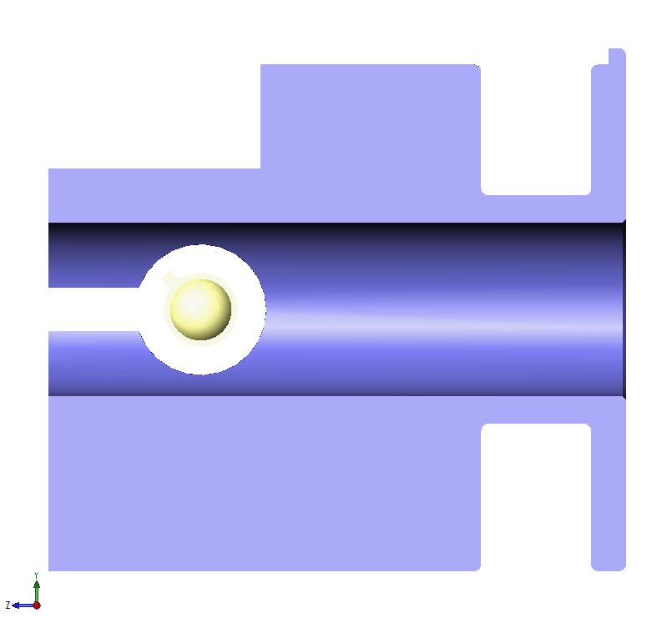
Section through Coilformer

1.126” [28.6 mm]
Emitter Device

Pitch Adjustment Magnet (PAM) Provision
There has been a request to include the provision to retro-fit PAM screws to the BOSEM, if possible. It is envisaged that the PAM screw assembly will mount on the rear of the coilformer in a similar fashion to how they attach to the Initial LIGO OSEMs.

However, there is an increased separation between the sensor and actuator in the BOSEM when compared to the Initial LIGO OSEM. Initial LIGO PAMs used small (approximately ∅3mm) magnets, with an operating point approximately 10mm away from the front face of the magnet / flag assembly. The proximity of the PAM magnet and magnet / flag assembly are restricted in the BOEM by the sensor assembly. Hence, a larger aperture has been opened out in the backplate at the rear of the BOSEM, as can be seen in Figure 16. This is to accommodate a large (∅10mm) PAM magnet if necessary. Measurements suggest a bias force of approximately 100mN is achievable, at closest approach between two ∅10mm × 10mm magnets.

Figure 16: PAM Screw Provision
Section through coilformer and backplate

Rear isometric view
PAM Fixings (3 × 2-56 UNC)
Coilformer Backplate
Emitter Carrier
0.41” [10.41 mm]
ID 0.50” [12.7 mm]
1.42” [36.7 mm]
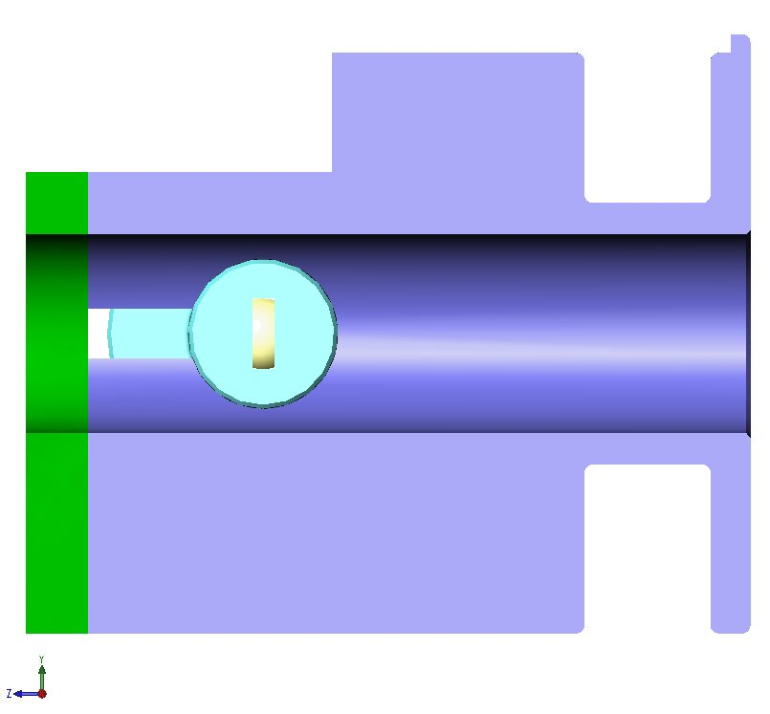

Unwanted Eddy Current Damping
It has been documented by K. Strain (reference [11]), that at the penultimate stage, aluminum BOSEM bodies provide an unwanted level of eddy current damping. Calculations show that an insulating coilformer is required, i.e. similar to the Initial LIGO OSEM design. However, there is no concern about the amount of unwanted eddy current damping at any other stages.

Therefore our baseline approach is to use Initial LIGO OSEMs at the penultimate stages of the ITM / ETM quad suspensions. The alternative solution would be for the UK to provide a variant of the BOSEM with a non-conducting coilformer (e.g. Macor, Alumina or PEEK). However, we foresee that the baseline scheme would provide the preferred lowest-risk approach.

A RODA has been generated to clarify that sensors will not be fitted to the penultimate stage OSEMs for the ITM / ITM suspensions, but will be included for the Noise Prototype delivery (see reference [17]).

Burn-In Tests

Degradation of Emitter Output
Degradation of the sensor output power can be attributed to a reduction in the efficiency of the emitter over time. MTBF testing has also indicated that there is a spread in of-the-shelf device-to-device output power (see section 7.2).

The burn-in process over-rates the devices by running them at their maximum specified forward current of 100mA i.e. above the nominal operating value of 35mA. The duration of the burn-in process is to be 50 hours. This burn-in process minimizes the risk of premature OSEM breakdown by also providing a test for of-the-shelf failure of the devices.

The format of this test is as follows; IRLEDs will be plugged into DIL sockets on a eurocard array containing 10 x 5 devices. A total of 4 eurocard arrays are to be used, enabling a total of 200 units to be driven at any time. The devices (plus a series resistor) are all connected in parallel across a suitable PSU, capable of delivering the required current. Forced-air cooling is also recommended to ensure devices do not exceed their operational temperature limits (+125⁰C).

At the beginning of the burn-in process the current through each ‘chain’ is measured and adjusted via the PSU to be maintained at 100mA. The current draw can then monitored via the PSU displays at regular intervals throughout the duration of the burn-in. Any change ≥ 100mA in the current draw should be noted. A visual inspection of the devices is conducted both at the beginning and end of the burn-in process. This inspection can be aided by an IR viewing device or CCD camera. Figure 17 shows the equipment set-up for the IRLED burn-in tests (n.b. in this image, the first three boards can be observed driving the IRLEDs).

Figure 17: IRLED Burn-in Equipment
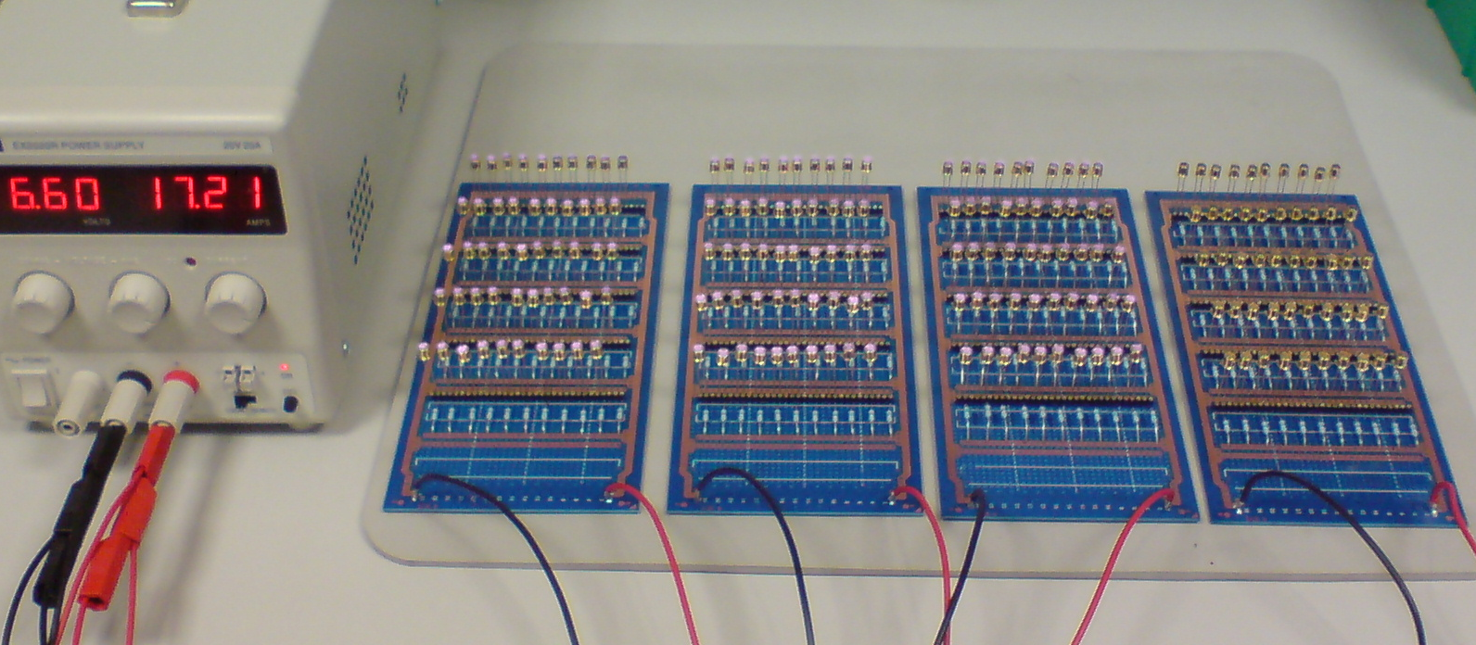

When the burn-in process is complete, the devices are to be removed from the eurocard arrays, whilst taking the necessary ESD handling precautions. The devices are then clearly labeled as processed and stored ready for use.

IRLED Screening
The datasheet provided by the manufacturer of the IRLED specifies the apertured radiant incidence for the device in the range 2-6mW/cm². Unfortunately, we have been unable to procure these devices already graded from the manufacture. It is therefore necessary for us to screen the devices prior to installation into the OSEM.

Our initial solution was to fit a small surface mount resistor local to the OSEM (i.e. onboard the flexi-circuit). This resistor would be a select-on-test component and would shunt any excess IRLED drive current, thus enabling us to normalize the optical power output. However, under further investigation this approach was observed to generate stability concerns with the OSEM sensor.

So a more orthodox approach is taken towards screening the IRLED devices. A clear aperture is drilled straight through a piece of aluminum; the length of the aperture is consistent with the separation of the PD and IRLED components in the OSEM. A single PD device is mounted at one end of the aperture whilst at the other end the IRLED device-under-test is mounted. The IRLED is driven at the nominal 35mA and the PD current measured. This process is repeated for the 2000 IRLED devices, and their statistical distribution of optical outputs characterized.

Breakdown of Coil Winding
Concerns have been raised over the breakdown of the coil winding insulation. It may therefore be necessary that ‘burn-in’ tests are conducted on the wound coilformer to immediately identify any failures. The format of the burn-in test is that a high potential (approximately 1kV) is applied across the coil for a duration of 10s of seconds.

Note that, on the fully assembled Noise Prototype OSEM, the maximum potential that can be applied across the coil winding is limited by the breakdown voltage specified for the micro D connector, i.e. 300V.

Thermal Considerations
The OSEM shall function under the following environmental conditions:-
- Operational Temperature: 22⁰C (nominal ambient)
- Seasonal Variation: 2⁰C (between sites)

The Maximum dissipation from the OSEM shall be as follows:-

Item | Maximum Dissipated Power | Notes
Coil | 833mW | At 150mA continuous forward current
IRLED | 50mW | At 35mA continuous forward current
Table 4.5-1

Note: The PD dissipation is considered negligible

UHV Requirements

Material List and UHV Conformance
Table 5.1-1 following, lists all materials used in the OSEM manufacture, including connectors, electronic components and cable harness parts. Reference [12] provides a list of LIGO compatible materials and reference [13] gives details of the queue for acceptance testing.

Item | Material | Where Used | Vacuum Review Board Approval Status
1 | Beryllium Copper (ASTM-B194) | Male Connector | Approved
2 | Phosphor Bronze (ASTM 139) | Female Connector and Emitter Lens Carrier | Approved
3 | Gold  (ASTM-B488) | Connector pin/socket Plating | Approved
4 | Aluminium (Alloy 6082)  see T050171-01 | Connector Body, Coilformer, Mounting Plates | Approved
5 | Electroless Nickel  (ASTM B733-90,SC2,Type 1, Class J (MIL-C-26074) | Connector Body Finish | Approved
6 | LCP (MIL-M-24519) | Connector Insulators and Inserts | Approved
7 | Hysol Epoxy #4215 (Black) | Connector Encapsulant | Approved
8 | Stainless Steel (300 per SAE-AMS-QQ-S-763) | Connector Jackscrews and Posts | Approved
9 | Copper Wire (32QML) | Coil Winding | 32HML Approved (Initial LIGO)
10 | Copper Wire (CZ1104) | Harness | Approved (Initial LIGO)
11 | Kapton (LF0110)  Copper Clad (LF8515) | Flex Rigid PCB | Approved
12 | Teflon PFA-440HP (DuPont) | OSEM assembly tooling | Approved (Initial LIGO)
13 | Titanium | Adjustment Assembly and Sensor Carrier | Approved
14 | OP232 | IRLED | Approved
15 | BPX65 | PD | Approved
Table 5.1-1

OSEM Cleaning Procedure
The cleaning procedure for the Noise Prototype OSEM is given as follows:-

- Pre-clean coil winding wire using Toluene, as shown in reference [18] to remove paraffin and mineral oil
- Clean and bake all parts as detailed in reference [19] at Birmingham prior to assembly
- Assembly and testing of OSEMs is conducted in Birmingham clean-room facilities (as outlined in reference [20] and reference [21])
- OSEMs are wrapped, bagged, tagged and shipped in accordance with UHV handling procedures given in reference [19]
- After being received at Caltech, assembled OSEMs are cleaned again, baked * and RGA scanned, before they would be shipped to the observatory sites, in accordance with reference [19].

* It has been requested the temperature of this final stage bake-out be elevated. The existing upper temperature for this process is limited by the demagnetization of the standard magnets at ~80⁰C. Alternative grades of ND35 magnets are available that would raise their operational temperatures to 120⁰C, 150⁰C and finally 180⁰C. The following list details temperature ratings that apply to components of the Noise Prototype OSEM that would limit the final stage bake-out temperature:-

- BPX65 and OP232 sensor devices. Maximum storage temperatures of 125⁰C and 150⁰C are quoted for each device, respectively.
- Glenair micro-D connector. Maximum operating temperature of 150⁰C.
- Flexi-circuit interconnect. Circuit layers will begin to delaminate when adhesive reaches over 182⁰C.
- PEEK 450G. Maximum service temperature (in air) of 315⁰C.

BOSEM Support Equipment

Automatic Test Equipment
Due to the volume of OSEM units to be manufactured, final product test will be assisted by a PC based Automated Test Equipment. The system will measure and record the following parameters:-
- Actuator Winding Inductance
- Actuator Winding Resistance
- Actuator Winding isolation to OSEM body
- Sensor Current Transfer Ratio

Test results will be provided with the finished product. Further details of the testing process can be found in reference [21].

Test Results

Off-Axis Emission
The potential issue of OP232 IRLEDs radiating with appreciable off-axis beam patterns has been raised and addressed in a report by N. Lockerbie (reference [15]). The outcome of this investigation was that the IRLEDs off-axis emission is not a concern.

Emitter MTBF Results
Ongoing work, undertaken by N. Lockerbie at the University of Strathclyde, has involved MTBF testing of the IRLED (OP232) devices. The manufactures (Optek) commercially sensitive reliability data has been made available, but not to a wide audience.

Figure 18 (figure reproduced from an ALUK report by N. Lockerbie - 27 August 2004) shows the apparatus currently in use to test the ensemble of 24 devices.

Figure 18: MTBF Testing Apparatus
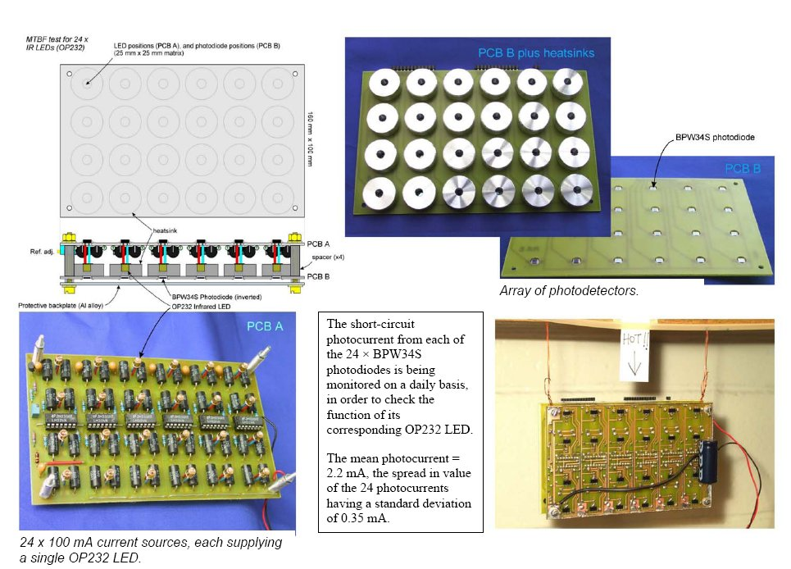
Figure 19: MTBF Test Results
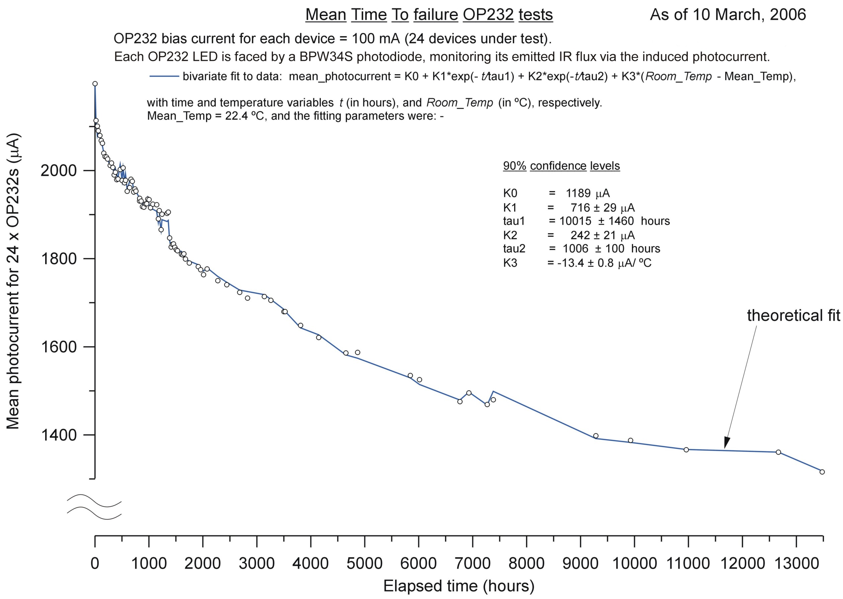

Figure 19 (figure provided by N. Lockerbie) shows the degradation of the induced mean photocurrent in the 24 x BPW34S’s over 13000 hours. At the present time, after over 13000 hours of running, the mean photocurrent induced in the photodiodes has now fallen to 62% of the 'day 1' value. None of the devices has failed to-date. We define the failure condition to be when a device output level falls to 50% of its initial value. It should be noted that these tests are being conducted at the maximum allowable forward current of 100mA, whereas the nominal current we intend to use is around 35mA.

The manufactures model of optical output degradation over time has been broadly validated by the testing that has so far been conducted. It would be possible to extrapolate an MTBF from this data, but it should be noted that the estimate would be extremely conservative and would not include scaling the MTBF when de-rating the device.

Prototype OSEM Fabrication
To enable a function and fit check of the Noise Prototype OSEM design, a prototype device has been fabricated and assembled. This prototype device will enable us to assess the ‘new’ features of the design (e.g. the revised adjustment assembly) and also allow us to verify the sensitivity performance (and operating range) of the sensor.

Figure 20, shows the pictures of the fully assembled coilformer and OSEM assemblies. The prototype units constructed utilized oversize taps for all taps in aluminum parts, as required for the Noise Prototype devices (reference [13]).

Figure 20: OSEM Prototype Assembly
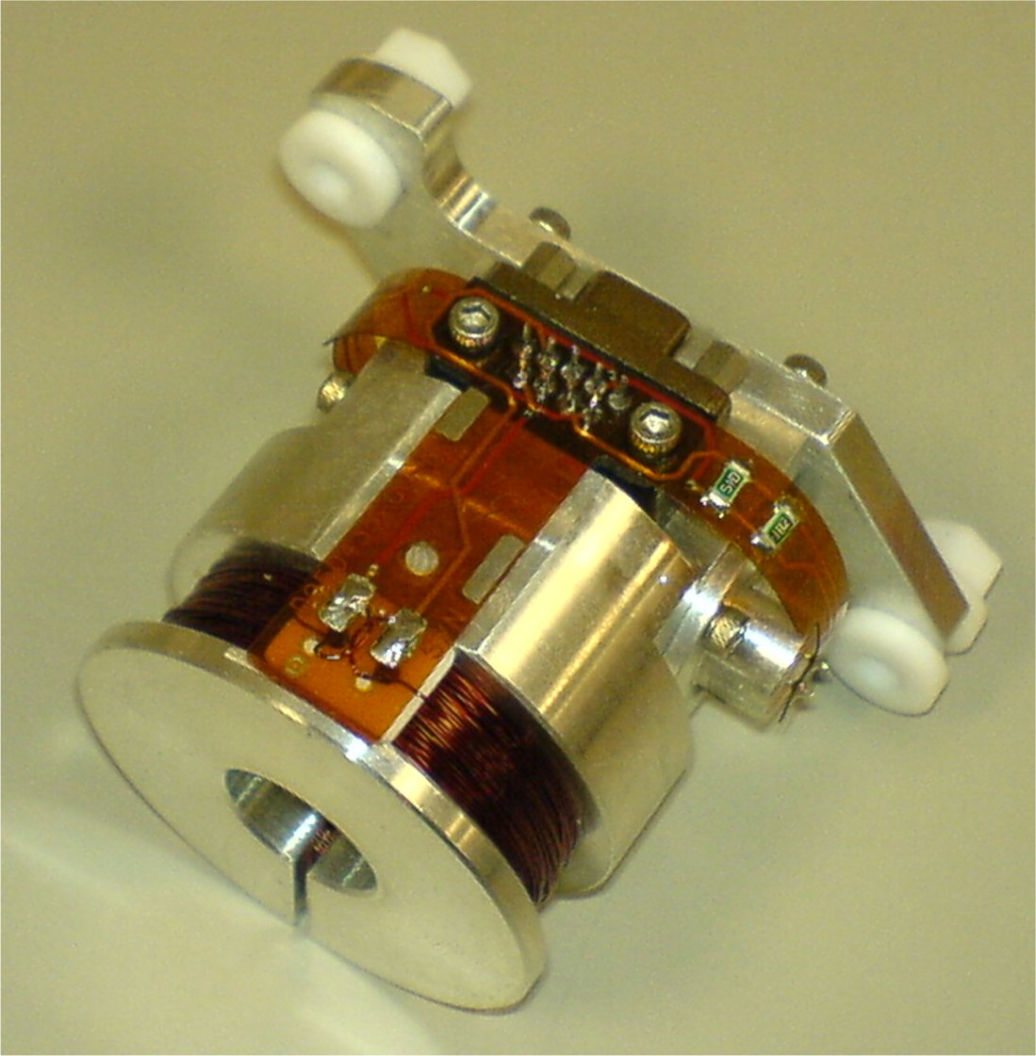 | 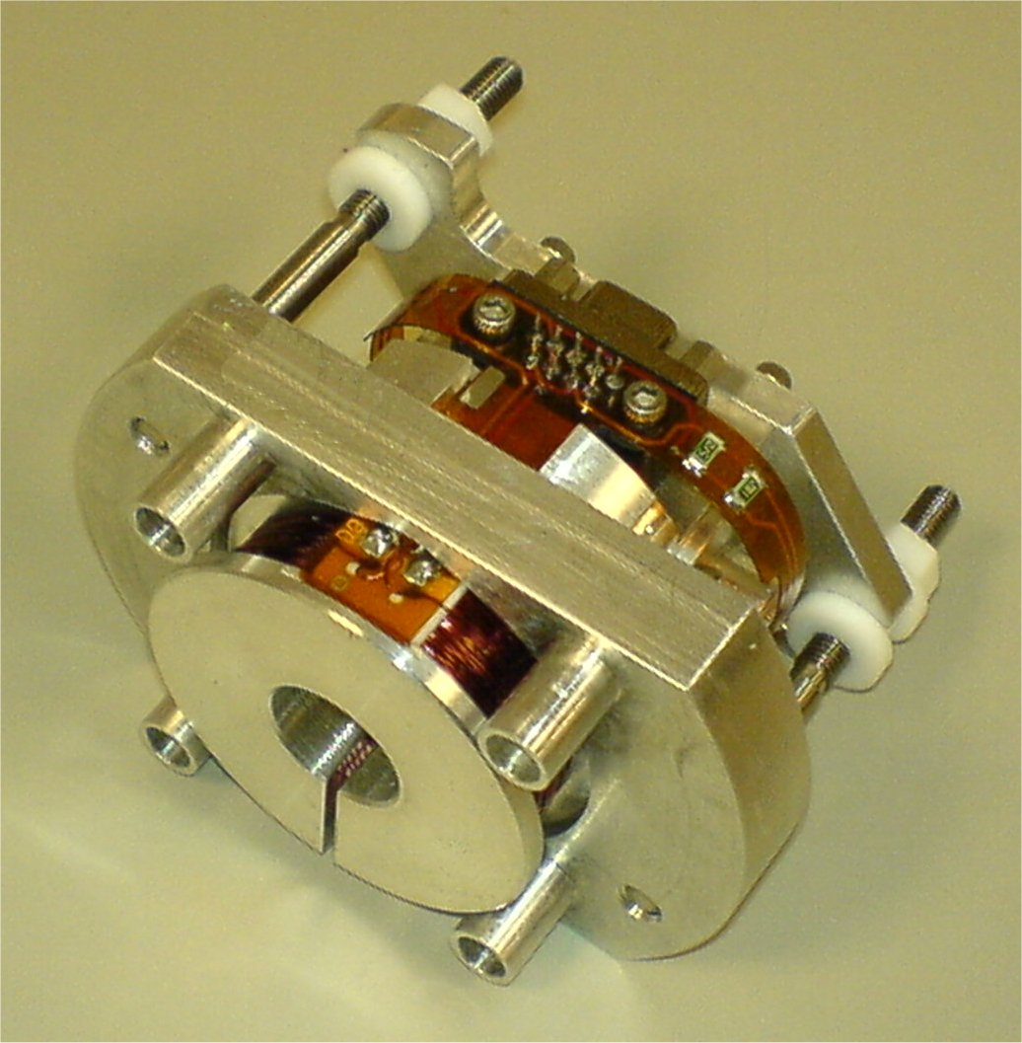
Fully Populated Coilformer

Fully Assembled OSEM

Noise Prototype OSEM Test Results
An initial batch comprising five complete units were fabricated and assembled (see section 7.3) to enable the further characterization of the Noise Prototype OSEM.

Operating Range
The operating range of a prototype unit was first measured at Birmingham and then sent to Strathclyde for independent verification. Figure 21, provided by N. Lockerbie, shows the Measured Detector Response obtained for a Noise Prototype OSEM.

Figure 21: Measured Detector Response
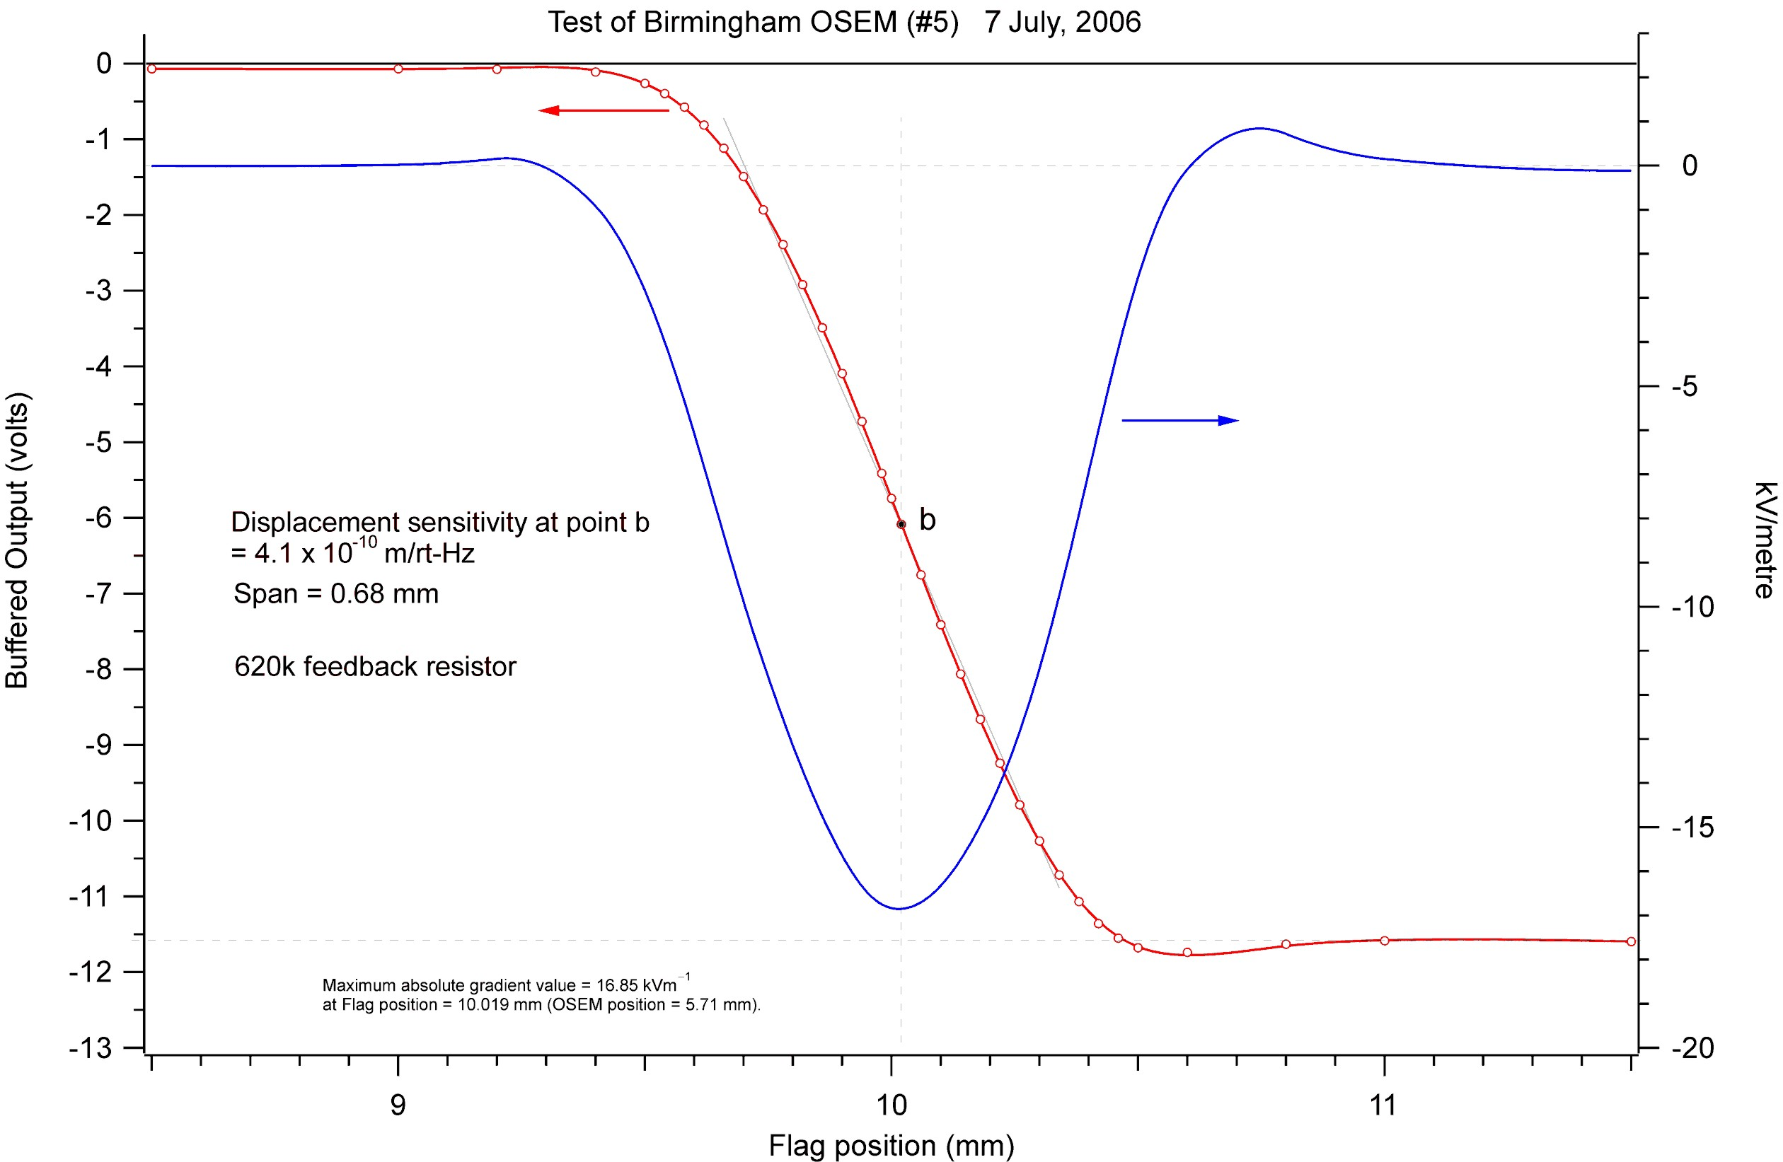

Figure 21 shows the gradient in the region of linear response is ≈ 16.85kV/m. The sensing range (or span) is found to be:-

- Measured Sensing Range = 0.68mm (peak-peak)

Sensitivity Performance
Again the sensitivity performance of a prototype unit was first measured at Birmingham and then sent to Strathclyde for independent verification. Figure 22, provided by N. Lockerbie, shows the Power Spectral Density obtained for the Noise Prototype OSEM.

Figure 22: Power Spectral Density Plot
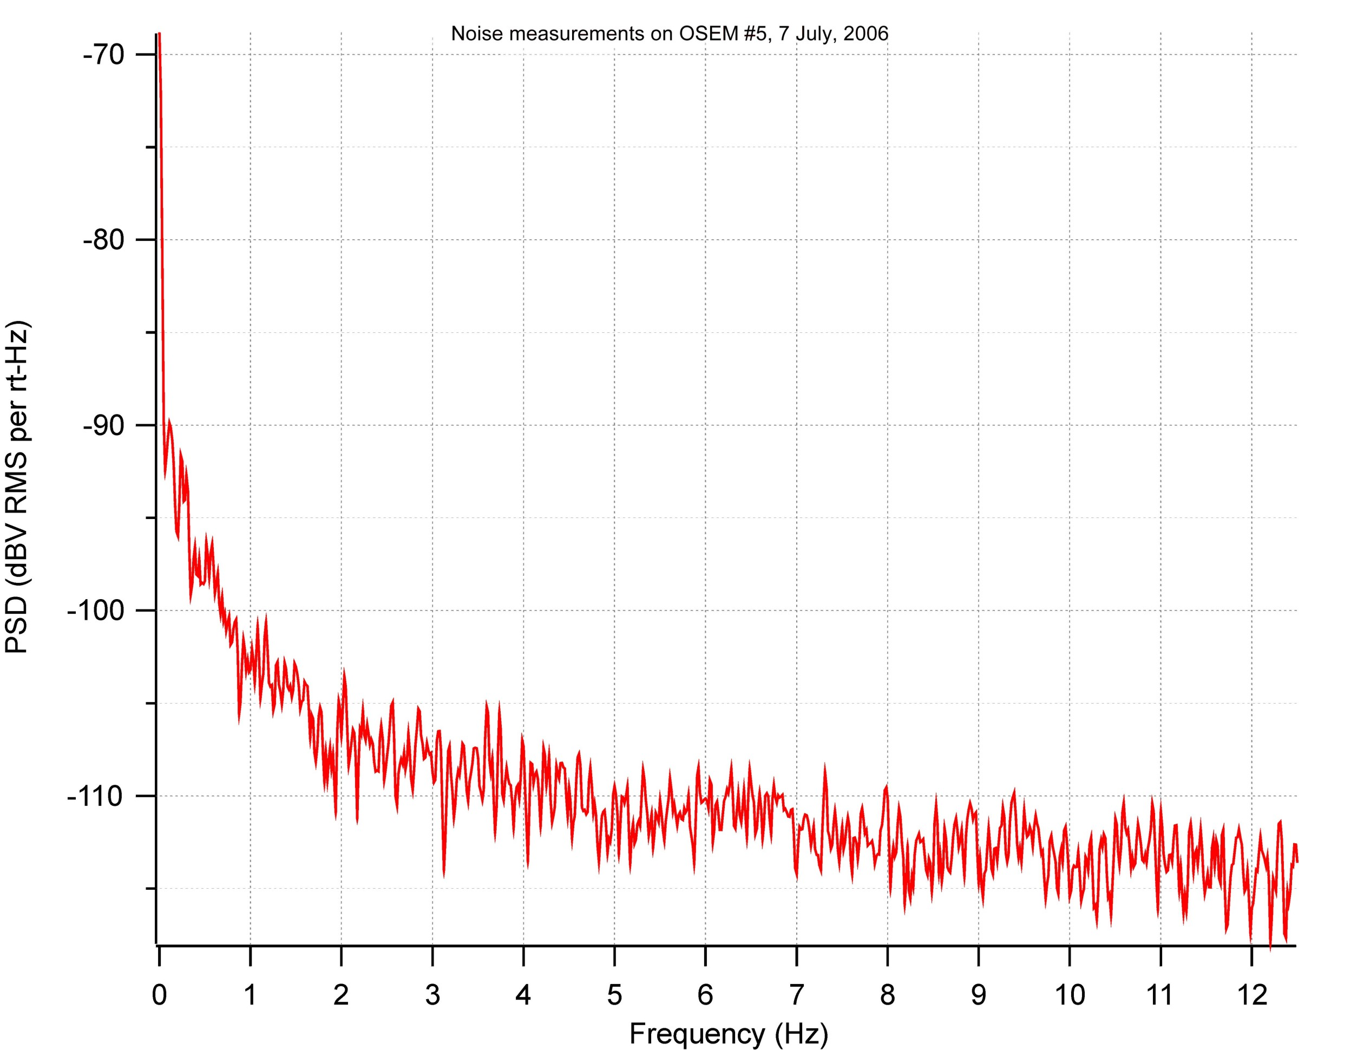

Using the measured detector response gradient obtained the previous section (7.4.1) in conjunction with the noise performance shown in Figure 22, enables the sensitivity in m/√Hz to be determined.

Both Birmingham and Strathclyde results were in agreement. The OSEM sensitivity was found to be:-
- Sensitivity at 1Hz = 3×10⁻¹⁰m/√Hz
- Sensitivity at 10Hz = 1×10⁻¹⁰m/√Hz

In-Vacuum Thermal Performance
In-vacuum testing to determine the thermal properties (i.e. maximum operational temperatures) of the Noise Prototype OSEM have been conducted. Testing of this nature has previously been carried out for Initial LIGO OSEMs, so a procedure very similar to that documented in reference [22] has been adopted for these tests. The Noise Prototype OSEM is sufficiently different from the Initial LIGO design that this further testing is necessary. For example, the coil geometry, the coil winding wire (plus insulation) and the material properties of the parts are significantly different.

Figure 23 shows the experimental set-up used for the duration of the tests. The Noise Prototype OSEM is situated within a vacuum chamber, which has been pumped down to a pressure of <0.05 torr. Electrical feed-troughs’ are incorporated to enable the drive current to be provided to the coil. Environmental monitors (i.e. two thermocouple channels) are also fed-through. Thermocouples are attached (using Kapton tape and thermal compound) to the surface of the coil winding and the surface of the inner diameter of the coil former body. The Noise Prototype OSEM was mounted using 4 fixings screws through its own clamp assembly into a custom L-shaped bracket. This is representative of a non-suspended OSEM mounted onto the ‘tablecloth’ or structure of a quad suspension. A programmable Power Supply Unit was used to generate the required level of drive current for the coil. Drive currents of 100mA, 150mA, 200mA and 250mA have been tested.

Figure 23: Thermal Test Set-Up
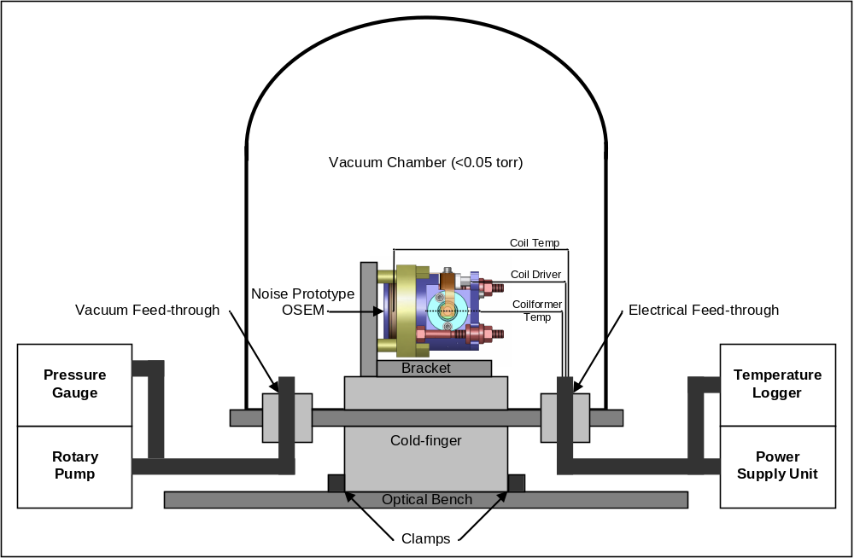

Results obtained from these tests can be seen in Figure 24. Table 7.4.3-1 provides an overview of this data. It can be seen that the time constant for the OSEM to reach thermal equilibrium was around 2 hours.

Figure 24: Thermal Test Results
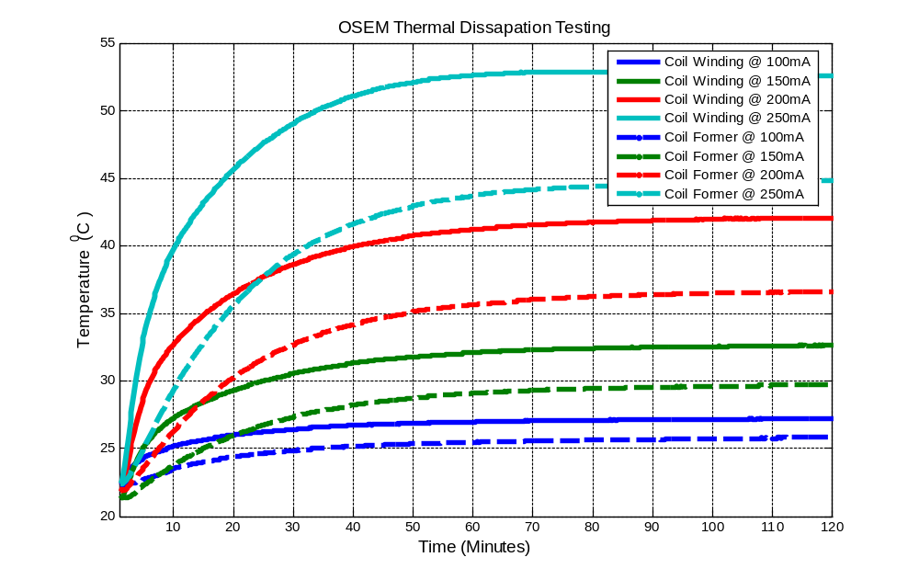

Coil Current (mA) | Coil Winding Measured Surface Temperature |  | Coil Winding Calculated Internal Temperature |  | Coilformer Measured Temperature
Coil Current (mA) | Max (⁰C) | Delta (⁰C) | Max (⁰C) | Delta (⁰C) | Max (⁰C) | Delta (⁰C)
100 | 27.3 | 4.9 | 28.3 | 7.4 | 25.8 | 3.5
150 | 32.7 | 11.4 | 38.4 | 17.1 | 29.7 | 8.4
200 | 42.1 | 20.2 | 52.2 | 30.3 | 36.7 | 14.8
250 | 52.9 | 30.5 | 68.2 | 45.8 | 44.8 | 22.5
Table 7.4.3-1

These results demonstrate that the coil can maintain a 250mA rms drive current without failure. However, it will be necessary to determine what level of out-gassing from the coil, at these elevated temperatures, is acceptable within the LIGO UHV system. This will most likely place more stringent limits upon the maximum rms coil current for the Noise Prototype OSEM.

