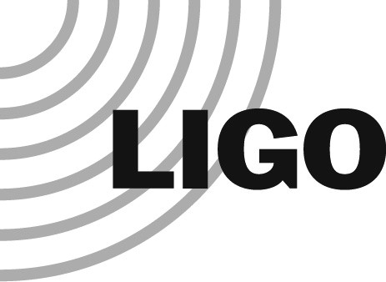LASER INTERFEROMETER GRAVITATIONAL WAVE OBSERVATORY

LIGO Laboratory / LIGO Scientific Collaboration

LIGO-M080401-v10 LIGO LABORATORY January 24, 2024

LIGO LABORATORY
Contractor / Vendor Safety Requirements

Danny Sellers

California Institute of Technology LIGO Project – MS 18-34 1200 E. California Blvd.  Pasadena, CA 91125  Phone (626) 395-2129  Fax (626) 304-9834  E-mail: info@ligo.caltech.edu | Massachusetts Institute of Technology  LIGO Project – NW22-295  185 Albany St  Cambridge, MA 02139  Phone (617) 253-4824  Fax (617) 253-7014  E-mail: info@ligo.mit.edu
LIGO Hanford Observatory  P.O. Box 1970  Mail Stop S9-02  Richland WA 99352  Phone 509-372-8106 | LIGO Livingston Observatory  P.O. Box 940  Livingston, LA 70754  Phone 225-686-3100 Fax 225-686-7189
Fax 509-372-8137

Signature Sheet
Each of the undersigned has reviewed the contents of the LIGO Contractors/Vendor Safety Requirements and believes it has adequately identified safety requirements form contractors and vendors. Signatures are digitally indicated in the Document Control Center (DCC) record for this document (https://dcc.ligo.org//LIGO-M080401-v10)

Danny Sellers, LIGO Laboratory Safety Officer
Hannah Hansen, LIGO Laboratory Chief Operations Officer

Introduction
LIGO requires all on-site work to be covered by a written safety plan consistent with LIGO safety requirements to ensure safe work practices are followed while performing construction, maintenance, or like activities at any of the LIGO facilities.

Safety Requirements
The following safety topics shall be considered as a minimum to be addressed in the safety plan:
- LIGO prefers to utilize the contractor's existing written safety plans to the fullest extent possible, consistent with the LIGO Laboratory Safety Program requirements. Caltech, MIT, and LIGO staff requests all bidders to submit either a copy of their existing safety plan/program or a written description/outline of their safety program with their proposal. The bidder must also submit their plan/program for managing their subcontractor’s safety related activities. In the event that a prospective contractor/vendor lacks an acceptable existing safety plan and/or program, the contractor/vendor shall develop and implement a system safety program in compliance with the LIGO Laboratory Contractor Safety Plan Requirements document LIGO-M2000283, in addition to requirements negotiated at contract/PO award.
- The existing contractor's written Safety Plan should include, but not be limited to, the critical safety topics that address the work activities that will be performed to fulfill the contract requirements.
- The contractor/vendor must ensure that all individuals for which it is responsible, including its employees, vendors, and guests who access indoor areas, comply with current LIGO health and safety protocols.
- California Institute of Technology is committed to providing a drug and alcohol-free environment for all its’ facilities. The unlawful use, possession, or distribution of drugs and alcohol is strictly prohibited while performing work under this contract.
- Prior to awarding a bid, the LIGO Contractor Safety Evaluation Form may be sent out to the contractor/vendor for completion. This form asks for basic safety information that will allow LIGO Safety to determine the level of safe work practices that the contracting company performs.

Procurement Criteria for Contractor Safety Evaluation
The safety evaluation process ensures that contractors meet the required safety criteria to be approved for work. This process also enables a rating system to be developed based on a contractor's health and safety history.
Contractor safety evaluations will ultimately depend on the type of contract being awarded, SOW (scope of work), and the level of risks associated with the activity or process. New construction, equipment replacement or repair, facility maintenance, or routine cleaning all represent contracts that possess different levels of risks and occupational hazards.
During the beginning stages of the contractor procurement process, the procurement team should review the SOW (scope of work) to determine if the following safety evaluation criteria are met.
LIGO Procurements requiring contractor safety evaluation:
- When a bid package includes cost that exceeds the $100,000 threshold, or if multiple projects by the same contractor exceed the threshold.
OR, regardless of dollar value, contractor safety evaluations will be required for the following situations:
- Electrical maintenance contracts requiring compliance with NFPA 70 National Electrical Code and Standards, along with work performed on electrical circuits 50 volts and above.
- Contracts that may require heavy machinery such as cranes, forklifts, excavators, etc., will be used within close proximity (50 feet) to detector infrastructure and equipment.
- (Scope of work) activities will be directly related to LIGO detector vacuum systems.
- Situations where sub-contractors shall be employed by a principal contractor as part of an overall contract.

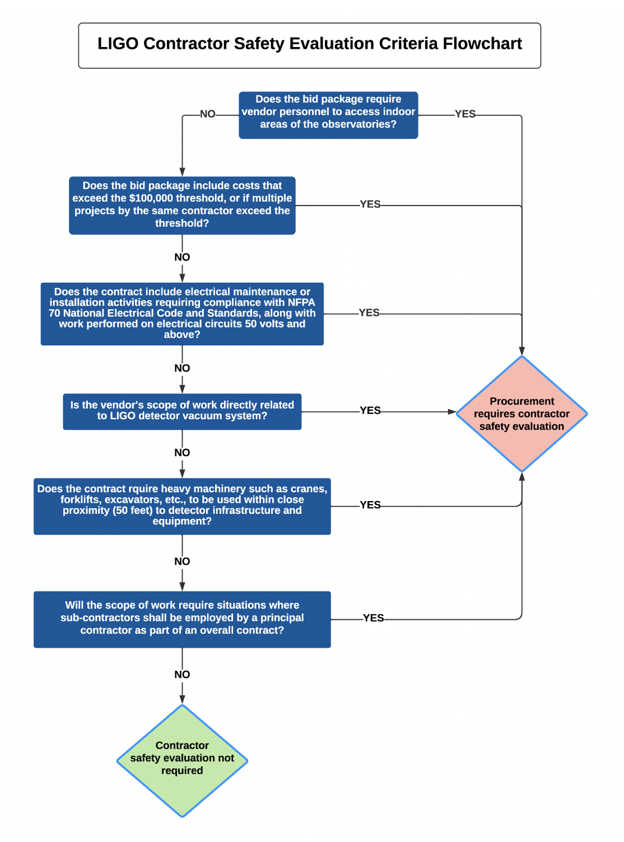
Bid packages that meet the specified criteria, the Contractor Safety Evaluation Form must be completed and returned with the bid.
- LIGO Contractor Safety Evaluation - F080010, current version.
The designated LIGO Safety Representative will review and approve all contractually required Safety Plans for all contractors/vendors when their contents are considered acceptable.
The LIGO contracting official will provide to the contractor/vendor, by means of a letter, the approval notification.
Any safety related questions can be directly handled by contacting the LIGO Safety Officer at Office (225) 686-3135 or Cell (225) 276-6673.

