Laser Interferometer Gravitational Wave Observatory (LIGO)

CALIFORNIA INSTITUTE OF TECHNOLOGY
MASSACHUSETTS INSTITUTE OF TECHNOLOGY

Specification LIGO-E960022-v23 13 April 2012

LIGO Vacuum Compatibility,
Cleaning Methods and Qualification Procedures

LIGO Systems Engineering
Dennis Coyne (ed.)

This is an internal working note
of the LIGO Project.

California Institute of Technology Massachusetts Institute of Technology
LIGO Project – MS 51-33 LIGO Project – MS 20B-145
Pasadena CA 91125 Cambridge, MA 01239
Phone 626.395.2129 Phone 617.253.4824
Fax 626.304.9834 Fax 617.253.7014
E-mail: info@ligo.caltech.edu E-mail: info@ligo.mit.edu

CHANGE RECORD
Revision | Date | Authority | Description
A | 28 Jan 2000 | Initial Release | Initial Release
B/v1 | 13 Mar 2003 | DCN E030125
C/v2 | 21 May 2004 | Limited distribution | - integrate cleaning/air bake/FTIR sampling and evaluation used on large parts  - add a qualified increase in the bake temperatures for 6061-T6 aluminum  - define safe procedure for use of methanol in ultrasonic cleaning  - define safe procedures for gross cleaning with acid, trichloroethane and acetone.  - switch from a callout of “Ameristat poly sheet”, an obsolete term, to a generic description of an acceptable bag material
D/v2 | Oct 2007 | Limited distribution | - added cleaning procedures based on discussions and advice received while cleaning parts for the AdLIGO BSC prototype at LASTI  - added bake time and temp for Indium & picomotors
v3 | 21 Jul 2009 | see DCC record | - added responsibilities section which defines the roles of the VRB, VRT, cognizant engineer, etc.  - dropped reference to provisionally approved materials  - defined two separate FTIR sampling methods (alcohol rinsate and Freon swiping)  - explicitly added a “gross” cleaning step (only obliquely mentioned in previous versions), derived from LIGO-E048225-v1  - added spray and parts cabinet washer procedures  - separated wet cleaning from baking instructions
V4 |  | see DCC record | - reorganized Section 10 as site technicians were having trouble navigating
v5 | Feb 2010 | see DCC record | - Section 10 Added ICS wherever PT was called out  - Removed Equipment operations Section 10.6.1.3 as this info is in SOPs, listed in Reference Document Table  - Elaborated on large washing equipment instructions, ref. SOPs  - Removed 2 person requirement from Precision Cleaning steps  - Removed Parts Cleaning Request Contam Control Doc specifies how to request cleaning/baking  - Removed Vacuum Baking Procedure Form – LHO vacuum team reported that form was out dated and never used.
V6 | 26 Feb 2010 | see DCC record | - Clarification to the cleaning solution dilution ratios in Table 2
V7 | 29 Mar 2010 | See DCC record | - Clarified that section B.4, “Sensor/Actuator “Pigtail” Cables, applies to OSEM, A-OSEM and B-OSEM cables only
V8 | 5 May 2010 | See DCC record | - Many component additions. More clarifications.
V9 | Nov 2010 | See DCC record | - Clarification in Sect 10.  - Added Masterbond EP30 Section  - Corrected numbering scheme at end of Section 12
V10 | Dec 2010 | See DCC record | - Added section for Glass processing  - Updated AOSEM bake duration from 48 hours to 96 hours.  - Added statement in large 0-ring step to vacuum bake after processing per E960159.
V11 | 29 Mar 2011 | See DCC record | - Added Electro-polish section  - Added Sapphire Prisms section
V12 | 29 Mar 2011 | See DCC record | - Clarified bake procedures for fluoroelastomers (Viton™ and Fluorel™) in section 12.15  - Clarified free fluorine extraction process” for fluoroelastomers (Viton™ and Fluorel™) in section 12.15
V13 | 30 Mar 2011 | See DCC record | Section 12.15:  - Noted that the free fluorine extraction process (aka “Walker” process) is not needed for large vacuum equipment o-rings  - Noted that small loads of fluoroelastomer can go directly from the free fluorine extraction process into a VBO  - Defined the temperature of the Liquinox cleaning step for the free fluorine extraction process  - Clarified the vacuum baking options
V14 | 22 May 2011 | See DCC record | - Added section on granite processing as per email instructions Coyne May 22, 2011.  - Added notes on magnet handling.  - Added section on EP30-2 gluing on Glass Masses.
V15 | 28 Jun 2011 | See DCC record | - Added a section 7.1 defining Class A and B (consistent with E0900047), and noting that section 11 has instructions for cleaning class B parts  - Moved the section on granite to be under the Class B cleaning instructions in section 11 (not within the class A instructions)  - Added instructions for Class B cleaning of Nylon and Delrin
v16 | 11 Jul 2011 | See DCC record | - Added cleaning instructions for Filter Glass in section 13.18.3
v17 | 25 Aug 2011 | See DCC record | - Added section on NOT cleaning or baking hygroscopic crystalline optics such as DKDP or RTP (language similar to v2)  - Made clarifications in the section on Vac-Seal
v18 | 26 Aug 2011 | See DCC record | - Added general stipulations in section 12.2 such as for design applications where dimensional control is extremely important or tolerances are exceedingly tight, it is the responsibility of the design engineer to (a) establish a basis for baking parts at temperatures lower than the default temperatures recommended herein, and (b) get a waiver for a lower temperature bake from the LIGO Vacuum Review Board.  - Corrected indium entry  - Combined copper and copper alloys (such as aluminum bronze, phosphor bronze and beryllium copper) into a single section
v19 | 24 Sep 2011 | See DCC record | - Added section regarding Class B cleaning and baking of Viton
v20 | 19 Oct 2011 | See DCC record | - Changed section 12.27.8 to show updated cleaning procedure for viewports
V21 |  | See DCC record | - Changed Section 12.27.8 (again) to show updated viewport cleaning procedures  - Clarified and updated section regarding electrical feedthroughs
V22 | 26 March 2012 | See DCC record | - Clarified responsibilities of cognizant engineer and VRB  - Added section about DI water and inspection of DI water systems that supply Clean and Bake facilities  - Augmented fluoroelastomers section with reminder to maximize surface exposure and minimize surface contact during baking and made it explicit that CIT is the default site for baking ALIGO Viton, etc.  - Clarified OSEM cables and sensor probe sections  - Removed note about not using water on electro-polished parts  - Clarified labeling section to mention ICS generated labels  - Added explicit note about oven ramp up and cool down times for feed-throughs  - Updated optics cleaning and baking section to indicate VRB acceptance of “no bake” proposal  - Added section about Clean and Bake requests including link to CNB Ticketing System  - Clarified cleaning process for Macor  - Added process for cleaning Optics Lens Caps  - Added link to CNB of Siskiyou Mirror Mounts  - Added Zerodur and Invar clean and bake instructions  - Stuff that still needs to be done: clean and bake of anodized Al, clarification of CNB of taps, CNB of PEEK cable clamps, etc.
V23 | 13 April 2012 | See DCC record | - Viewports section updated to reflect the following:  -Commercial viewports being solvent cleaned (isopropanol followed by methanol if required) rather than Liquinox-ed and  -Custom viewport glass being cleaned  according to Freon Wipe Procedure  (E1200266), which states that no FTIR is  required.  - Link to M1200015 (LIGO Lab Disposal of Solvent Contaminated Materials) added to Solvent Cleaning section

TABLE OF CONTENTS

1 Purpose 1
2 Scope 1
3 Responsibilities 1
3.1. Vacuum Review Board (VRB) 1
3.2. Vacuum Review Team (VRT) 2
3.3. Cognizant/Responsible Engineer 2
3.4. Chief Engineer 3
3.5. Vacuum Preparation Team 3
4 Nomenclature and Acronyms 3
5 Applicable Documents 5
6 Vacuum Compatible Material Usage in LIGO 6
6.1. Material Approval Process 6
6.2. Component Qualification 6
7 Cleaning and Preparation of Materials Procedures 7
7.1. Class A versus Class B 7
7.2. Components Prepared for UHV Service Commercially 8
7.3. Components Prepared for UHV Service by the LIGO Laboratory 8
8 Handling and Storage Procedures 8
9 Qualification and Screening Tests for Materials and Components 10
9.1. Initial Qualification & Screening 10
9.1.1. High Power Exposure Tests of Cavity Mirrors 10
9.1.2. Out-gassing Screening Tests 11
9.1.2.1. Vacuum Bake/RGA Test 12
9.1.2.2. FTIR/Air Bake 13
9.2. QA Screening 13
10 Clean and Bake Requests 14
11 Class A Cleaning Procedures 14
11.1. Precedence 14
11.2. Background 14
11.3. Safety 14
11.4. Gross and Precision Cleaning 15
11.4.1. Equipment 16
11.5. Solvents and Soaps 16
11.5.1. Cleaning Solutions 16
11.6. Gross Cleaning 17
11.6.1. Cleaning Facility 17
11.6.2. Approved Cleaning Materials 17
11.6.2.1. Special Fixtures 17
11.6.3. Part Preparation 18
11.6.4. Approved Processes 18
11.6.4.1. Aggressive Mechanical Cleaning 18
11.6.4.2. Solvent Cleaning 19
11.6.4.3. Acidic Cleaning 19
11.6.4.4. Steam Cleaning 19
11.6.4.5. Detergent Pre-Cleaning 19
11.6.4.6. Tap Water Rinsing 19
11.6.4.7. Drying 20
11.7. Precision Cleaning 23
11.7.1. Cleaning Facility 23
11.7.2. DI Water system 23
11.7.3. Parts Preparation 23
11.7.3.1. Sorting by Material Type 23
11.7.4. Choosing a Process 23
11.7.5. Approved Processes 23
11.7.5.1. Manual Cleaning 23
11.7.5.2. Ultrasonic Cleaning 24
11.7.5.3. Large Parts Cabinet Washer Cleaning 24
11.7.6. De-ionized Water (DI) Rinsing 25
11.7.7. Drying 25
11.7.8. Inspection 25
11.7.9. Wrap/Bag/Tag 26
11.7.10. Required Documentation 26
11.7.11. Other Processes Not Commonly Used 26
11.7.11.1. Pressure Washer 26
11.7.11.2. CO2 Cleaning 27
12 Class B Cleaning Procedures 27
12.1. Brass 27
12.2. Nylon 28
12.3. Delrin® 28
12.4. Granite 28
12.5. Viton 28
12.6. Process Documents for Specific Components 29
13 Specific Cleaning and Baking Procedures 29
13.1. General Requirements 29
13.2. Air Bake or Vacuum Bake 29
13.3. Air Bake 29
13.3.1. Procedure 29
13.3.2. Acceptance Criteria 30
13.4. Vacuum Bake 30
13.4.1. Procedure 30
13.4.2. Acceptance Criteria 30
13.5. Aluminum 30
13.6. Polished Aluminum Target Faces 30
13.7. Brass 31
13.8. Bronze 31
13.9. Stainless Steel (including Invar) 31
13.10. Maraging Steel 31
13.10.1. Nickel Plated Maraging Steel Blades 31
13.11. Music Wire 31
13.12. Copper and Copper Alloys 31
13.13. Indium 32
13.14. Gold (connector contacts) 32
13.15. Ceramics (including Macor and Zerodur) 32
13.16. Fluoroelastomers – Flourel and Viton 32
13.16.1. Free Flourine Extraction 32
13.16.2. Vacuum Baking Fluoroelastomers 33
13.16.2.1. Molded castings (manufactured as per E970130): 33
13.16.2.2. O-rings (ie. in EQ stop applications) 34
13.16.2.3. VE Seals and O-rings: (less than 8” diameter with cross section ≤ .275” nominal) 34
13.16.2.4. VE Larger diameter O-rings (ie. for VE chamber doors) 34
13.16.3. Storage of Fluoroelastomers 34
13.17. Masterbond EP30-2 (Vacseal replacement) 34
13.17.1. HAM SUS Metal Masses with D070334 magnet/standoffs 35
13.17.2. Flag Assemblies 35
13.18. Glass Components 35
13.18.1. Fused silica 1” and 2” mirrors and substrates 35
13.18.2. Black/Welder’s Glass, Silver Coated Optics, Calcite Prisms 35
13.18.3. Filter Glass 35
13.18.4. Other Optic Specifications used in iLIGO 35
13.18.5. QUAD ERM/CP glued EQ Stops 36
13.18.6. QUAD Pen Flag Mounts 36
13.18.7. Optics (BS/FM secondary prisms) 36
13.18.8. Sapphire Prisms 36
13.19. PFA 440 HP grade Teflon 36
13.20. Magnets 36
13.20.1. NEO 35 (NdFeB) magnets: 37
13.20.2. Nickel Plated NdFeB magnets: 37
13.20.3. Sm-Co permanent magnets: 37
13.21. Solder: Lead-tin (Kester 6337) 37
13.22. Vac-Seal 37
13.23. Hygroscopic Crystalline Optics 38
13.24. PZT piezoelectric ceramics: 38
13.25. PEEK 38
13.25.1. Connectors/Kapton cabling/wire harnesses: 38
13.25.2. PEEK Cable Clamps (D0900004) 38
13.26. Assemblies 38
13.26.1. SEI Constrained Layer Damped Springs 38
13.26.2. SEI Large In-Vacuum Components 38
13.26.3. LOS Cleaning Procedure 39
13.27. Composite Assemblies 39
13.27.1. Commercial Stages 39
13.27.2. Electronic Components 40
13.27.3. Sensor/Actuator Head Assemblies (OSEMs) 40
13.27.4. Cables - PEEK shielded Kapton cables with various SST or PEEK connectors 40
13.27.5. SEI position sensor probes (ADE-made probes) with kapton coated wire (for actuator assemblies 40
13.27.6. ISI Electromagnetic Actuators 41
13.27.7. Picomotors (for OMC group) 41
13.27.8. Viewports 41
13.28. Electro-polish 41
14 FTIR Screening for Air Baked Components 41
14.1. Isopropyl Alcohol Rinse 42
14.1.1. Preparation 42
14.1.2. Sample Collection 44
14.1.3. FTIR Testing 45
14.1.4. Evaluation of Results 45
14.2. Freon Surface Sampling 46
15 Calculation of Vacuum Load 46
15.1. Database 47
15.2. Estimation of Material Buildup 47
15.3. Extrapolation of Optical Losses in LIGO from High-power Cavity Tests 52
15.4. Determination of Out-gassing for Highly Condensable Organic Molecules 53

LIST OF FIGURES

Figure 1: Exposure Test Setup 11
Figure 2: Typical Vacuum Bake Test Set 13
Figure 3: Geometrical arrangement of source, mirror, and pumping system 46
Figure 4: Schematic for the calculation. A substance that outgasses a condensable material has a surface area A_{s}, in the figure located in a sidearm of the system, though this is not essential to the model. The surface of the system initially has no surface loading of this material. The question is how to estimate the surface loading of the system as a function of time. 50
Figure 5: Relation between the surface coverage and the equilibrium pressure for the Dubinin - Radushkevich theory 54

LIST OF TABLES
Table 1: Applicable Documents 5
Table 2: Cleaning Solution Parameters 16
Table 3: Suggested Gross Cleaning Steps – (Try Processes A, B, C, or D as needed followed by tap water rinse and drying.) 20
Table 4: Pressure Wash and Rinse Guidelines 25
Table 5 45
Table 6: Physical Constants 45

Purpose
The goal of this document is to provide reasonable assurance against the inadvertent introduction into the LIGO vacuum envelope of material which could contaminate optics and/or produce excess phase noise by forward scattering.
This document sets forth certain procedures and standards by which material to be used in LIGO interferometers may be qualified and assayed for compatibility in operation with high-power resonant cavities inside an ultra-high vacuum (UHV) system.
All items to be installed inside LIGO vacuum equipment or onto beam tube pump ports shall conform to this policy for selection of components and exposed materials, for preparation, handling, testing and storage prior to assembly and during assembly. These items are considered Class A hardware. For definition of Class A hardware, refer to LIGO-M990034 (Section 5).
It is intended that the total optical contamination produced by detector components placed into the LIGO vacuum envelope shall be limited to < 0.5 ppm/yr/optic absorption and < 10 ppm/yr/ optic scatter.

Scope
All materials/parts (commercial and custom designed) must undergo vacuum out-gassing and contamination evaluation to ensure compatibility with operation in high-power laser cavities within UHV systems.
Certain materials needed to fabricate LIGO interferometers, although used in other UHV applications, need to be evaluated for possible deleterious effects which their out-gassing products may produce on high reflectivity mirrors while these mirrors are under laser irradiation at power levels of tens of kW. A determination of the rate of increase of optical losses by exposure of test cavity mirrors to substances in question shall be the basis for vacuum qualification whenever possible for such substances.
It is also necessary to ensure proper cleaning of components fabricated from acceptable materials. Cleaning of LIGO components shall be performed in accordance with recognized and accepted cleaning practices. Some of these cleaning procedures are generic and baking will be carried out generally at the maximum temperature permissible for a given material: other procedures have been developed to handle specialized or oversized components that could otherwise not be cleaned.

Responsibilities

Vacuum Review Board (VRB)
The VRB makes recommendations on policy affecting the LIGO UHV system. When new materials or processes are contemplated, out-gassing (and ideally, optical loss data) shall be submitted to the VRB for review and acceptance. The VRB must approve tested materials/parts before they may be included in the LIGO Vacuum Compatible List (E960050). VRB members are selected by the Systems Engineering and the Detector Systems group management.
The Vacuum Review Board will recommend the disposition of issues where policy and schedule are in conflict. This document will be updated as irradiance exposure data become available. (What does this sentence mean? Do I need to leave it in here?)
The VRB members are listed on the (secure) VRB wiki page.

Vacuum Review Team (VRT)
The test data (either RGA scans or FTIR results) which is used to verify that a Class A part is acceptable for LIGO UHV use must be reviewed and approved by a Vacuum Review Team member. This applies to test data produced or provided by contractors as well as test data produced within the LIGO Laboratory. The VRT is comprised of at least one member from each of the LIGO Laboratory sites at which UHV preparation work is performed. The intent is that the local VRT member serves principally to review and approve the Class A parts prepared at their local site. The other VRT members may be called upon to review and approve another site’s Class A parts is the local representative is absent. If the verification test data is difficult to interpret or in some way questionable, or if a waiver on process or acceptance criteria is wanted (for example for expedience of schedule), then the VRT must refer the matter to the VRB.
The RGA scan or FTIR results should be attached to the appropriate bake load in ICS.
The VRT members are listed on the (secure) VRB wiki page.

Cognizant/Responsible Engineer
It is the responsibility of the Cognizant Engineer for a subsystem or assembly intended for UHV service, to make certain that:
- only approved materials are used. Approved materials are listed in “LIGO Vacuum Compatible Materials List”, LIGO-E960050. If a new material needs to be qualified for use, the Cognizant Engineer should discuss the need and any alternatives with the Chief Engineer as soon as possible in the design process.
- only approved cleaning processes are used by contractors performing UHV cleaning services. If the contractor cannot use one of the LIGO Laboratory approved procedures/processes, then the Cognizant Engineer should discuss the need and any alternatives with the Chief Engineer.
- A procedure to clean and bake any new materials or unique combinations of approved materials has been approved by the Chief Engineer prior to submitting a Clean and Bake Request.

Chief Engineer
It is the responsibility of the Chief Engineer to arrange for and review/approve testing for new UHV materials in accordance with the qualification procedures defined in this document. The VRB makes recommendations to the Chief Engineer who makes final decisions on policy related to the LIGO UHV. It is also the responsibility of the Chief Engineer to approve cleaning and baking procedures for new materials.

Vacuum Preparation Team
Only individuals who have been trained on the procedures defined in this document and have been approved to use the equipment and chemicals associated with the procedures may carry out the preparation of LIGO parts for UHV service. In general, this work is performed by a small team of individuals at each LIGO site. Untrained or unqualified staff should not presume to clean parts.

Nomenclature and Acronyms
ADP Ammonium Di-hydrogen Phosphate [(NH₄)H₂PO₄]
AMU Atomic Mass Unit
Class A Categories of hardware (components, parts, assemblies, tooling, etc.)
Class B and associated cleanliness levels for LIGO. Defined in the “Advanced LIGO Contamination Control” document LIGO-E0900047. Class A hardware is intended for UHV service, Class B is “tooling” which comes into contact with Class A parts or assemblies.
CO₂ Carbon Dioxide
DI De-ionized Water
FDR Final Design Review
FTIR Fourier Transform Infra-red : Spectroscopic method for determining HC contamination levels
HC Hydrocarbons
HF Hydrofluoric acid
ICS Inventory Control System
JPL Jet Propulsion Laboratory: Analyzes FTIR samples
KDP Potassium Di-hydrogen Phosphate [KH₂PO₄]
LIGO Laser Interferometer Gravitational Wave Observatory
LOS Large Optics Suspension
MEC Mechanical Cleaning
OFHC Oxygen Free High-Conductivity Copper
NEO Neodymium Iron Boron (A type of magnet)
PFA Perfluoroalkoxy fluoropolymer (Du Pont)
PT Process Traveler? Does this still need to be in here?
PTFE Polytetrafluorethylene (Du Pont)
PZT Lead-Zircomate-Titanate
RGA Residual Gas Analyzer: Small mass spectrometer designed contamination monitoring in vacuum systems; attached to LIGO VBOs
RTV Room Temperature Vulcanizing Silicone Elastomer
SEI Seismic Isolation System
TBD To Be Determined
UHV Ultra High Vacuum
VBO Vacuum Bake Oven
VRB Vacuum Review Board
VRT Vacuum Review Team

Applicable Documents
The documents cited in Table 1 have been used to develop some of these guidelines and serve as reference material.
Table 1: Applicable Documents
Document Title | ID Number
Project System Safety Plan | LIGO-M950046
Project QA Plan | LIGO-M970076
Vacuum Compatible Materials List | LIGO-E960050
Stanford Synchrotron Radiation Project User Specifications for Vacuum Systems and Components which Interface with the SPEAR Vacuum System | LIGO-E870001
Detail Specification for General Cleaning Requirements for Spacecraft Propulsion Systems and Support Equipment | LIGO-E740001
Seismic Isolation System: Fabrication Process Specification | LIGO-E970063
Material, Process, Handling and Shipping Specification for Fluorel Parts | LIGO-E970130
Material, Process, Handling and Shipping Specification for Welded Diaphragm Bellows | LIGO-E970129
Material, Process, Handling and Shipping Specification for Damped Coil Springs | LIGO-E970131
Specification for the LIGO Bake-out Ovens | LIGO-T980008
General Optics Cleaning Procedure | LIGO-E1100439
Cleaning Procedures for LIGO Commercial Optics (Other Than Core or IO Optics) | LIGO-E000007
Process Specification: CO₂ Cleaning Procedures | LIGO-E990316
Cleaning and Baking Viewports | LIGO-E990190
Advanced LIGO Contamination Control Plan  (supersedes LIGO Hanford Observatory Contamination Control Plan, LIGO-M990034) | LIGO-E0900047
Viton Spring Seat Vacuum Bake Qualification | LIGO-T970168
Outgassing Documents from 1988-1992 | LIGO-T920009
Process Specification for AdLIGO Seismic Isolation System In-Vacuum Mechanical Elements Fabrication (N.B.: never used for fabrication) | LIGO-E048225
Specification for Cleaning Procedure for LIGO Vacuum Equipment, Hanford & Livingston (PSI V049-2-015, Rev 2) | LIGO-E970004
RGA Test Qualification for the BSC Suspension Structures | LIGO-E080177
Astro Pak’s Precision Cleaning Procedure | LIGO-C1102328
Standard Operating Procedure for Large Parts Washer | LIGO-M1000027
Standard Operating Procedure for Large Air Bake Oven | LIGO-M1000028
Standard Operating Procedure for Large Ultrasonic Parts Cleaner | LIGO-M1000029

Vacuum Compatible Material Usage in LIGO

Material Approval Process
LIGO maintains an updated list of materials considered safe to use in LIGO vacuum systems. This approved list is LIGO-E960050. New material must go through the prescribed screening process before it may be added to this list. The screening process is described in Section 6 of this document. The vacuum data of the tested materials/parts will be compared to the LIGO vacuum out-gassing and contamination requirements before being included in the LIGO vacuum compatible materials approved list. Qualifications on the approved use of a material (or component) shall also be defined, for example the total permissible amount, restrictions to particular sources, special processing steps, etc.
In cases where any of the cleaning procedures cannot be followed due to considerations such as material durability or sensitivity to elevated temperatures, a waiver shall be completed and submitted to the Vacuum Review Board for consideration and approval. The waiver shall be accompanied by an alternative preparation procedure which has been demonstrated to achieve the desired cleaning effects.

Component Qualification
- A component or subassembly is itself considered approved if all its exposed materials are approved and if its pre-installation treatment is consistent with the preparation procedures for those materials.
- All blind holes and trapped volumes shall be explicitly vented to avoid virtual leaks; provision for cleaning such volumes adequately (e.g., by solvent flushing) shall also be considered in the design process.
- A material is considered "exposed" unless it is encapsulated fully and hermetically within another material. All designs using hermetic containment must be approved specifically by the Vacuum Review Board.
- Components composed of materials from a single class are to be prepared, handled and stored according to the corresponding procedure for that class.
- Irreducible subassemblies comprising more than one material class are to be prepared and handled according to the most stringent subset of procedures consistent with all materials involved.
- A Qualification and Screening Test Report must be written for the candidate material/ component after completion of tests. This report must include the amounts of materials, out-gassing rates (approved or not), residual gas analyses and RGA scan data, molecular species that is out-gassed, amount of hydrocarbons out-gassing, and surface contamination information if available. A material usage list must be compiled for every subassembly or component that is placed in the vacuum and be included in the report. This information shall be available by the FDR of the subject system or subsystem. The material usage list for each assembly shall be updated to maintain it current.
- The Qualification and Screening Test Report and associated raw data (e.g., RGA scans) shall be processed as follows:
  - File original with the LIGO QA Officer.
  - Submit a copy to the requester of the qualification tests.
  - Submit a copy to the LIGO Document Control Center.

Cleaning and Preparation of Materials Procedures
All materials/parts (both commercial and LIGO-produced) must be scrutinized for vacuum cleanliness compatibility before being accepted for utilization with the LIGO vacuum system.

Class A versus Class B
CLASS A hardware is defined as any item that will be temporarily or permanently mounted inside of, or on, the inner surfaces of the interferometer vacuum equipment and will be exposed to vacuum. Materials for Class A components are strictly limited to those listed in E960050, and for the specific approved applications noted.
CLASS B hardware is defined as any item that will come into contact with CLASS A hardware, or the surfaces of the interferometer vacuum equipment, that will be exposed to vacuum. Materials which comprise Class B components are less restricted, but should generally be from the materials listed in E960050, or herein in section 12, in order to minimize cross-contamination of the UHV system.

Components Prepared for UHV Service Commercially
If a vendor is required to provide clean components, then the vendor shall use recognized UHV practices. The vendor shall submit to LIGO a description of the practices for prior approval by LIGO as part of the quote or proposal for the work in accordance with the procurement process, if we have the time for LIGO Lab to qualify the contractor’s proposed process. Otherwise the contractor shall use one of the processes already approved by the LIGO Laboratory.
For commercially produced components with potentially many materials used in the construction, a detailed accounting of all materials and the amounts used shall be submitted for review. It may be necessary for some components to require certifications (per article or serial number) for the materials employed in their manufacture, so that material substitutions by the manufacturer are visible to LIGO. The vendor shall notify LIGO of any material substitutions which occur after the agreed-upon list of materials has been determined. LIGO QA shall have oversight to ensure such notification is obtained. Where practicable, a first article screening using an RGA scan and out-gassing measurement shall be performed by LIGO prior to receiving shipment of all other components.

Components Prepared for UHV Service by the LIGO Laboratory
LIGO shall clean all components intended for UHV service in accordance with the procedures referenced or defined within this document. Cleaning procedures shall be defined for all materials on the LIGO approved materials list. These procedures are listed in Appendix A and will be updated as new materials or cleaning procedures are approved.

Handling and Storage Procedures
Approved gloves are to be worn for handling, assembly and installation of cleaned or partially cleaned parts. Unless otherwise indicated, gloves are to be changed when proceeding to handle components at different stages of processing.
Tools and fixtures which may contact cleaned parts in assembly or transport are to be cleaned and baked as Class B material. (See Class B processing procedure, Appendix A, Section 3.)
Processed parts will be prepared for transport and storage using the following wrap-bag-tag procedure.
(a) Wrap large or awkward part(s) with 2 layers of UHV quality aluminum foil. Class B stainless steel or glass containers are preferred for small parts.
(b) Place part(s) into a zipper bag made of Class 100 clean, anti-static, poly sheeting. If the part(s) are too large or awkward for zipper bags, then wrap them in Class 100 clean, anti-static, poly sheeting.
(c) Compress the bag tightly around the part(s) to purge excess air and then zip the bag closed. If a zipper bag is not available, then fold down the top of the bag at least twice and then tape the folded top to the bag to provide a complete seal.
(d) Place the part(s) into a second anti-static polyethylene bag or second layer of sheeting, as specified above, remove excess air, and then zip or tape shut.
(e) A label must be used on the outer layer of all bagged components. The label must contain the following: (i) a warning stating: "UHV CLEAN PART -- HANDLE ONLY WITH PROPERLY GLOVED HANDS" and (ii) a part description/identification. Ideally, the standard labels generated by ICS for Bake loads should be used as they contain all required information.
If the labels are not self-adhesive, then they shall be affixed with cleanroom tape. All empty fields on the ID label shall be filled in with the relevant information; use “N/A” rather than leaving a field blank. ????

(f) Place the double bagged part(s) in an appropriate shipping or storage container, using care to not puncture or cut the bags. Seal the shipping container closed. Attach a label with the LIGO part number (drawing number(s), including revision letter) and serial number(s) to the outside of the container.

The shipping containers must be such that they insure that the double bags do not get punctured and that the parts are properly supported during transit.
For a list of approved contamination supplies and vendors refer to LIGO-E0900047, Appendix 1.
Tables and work areas for cleaning, packing/unpacking, assembly, alignment and testing of cleaned parts are to be lined or covered with fresh contamination-free foil or Ameristat immediately before starting work. Ameristat shall not be used if a solvent incompatible with the film is involved in the assembly or cleaning process. Final assembly of any small subassembly or component intended for installation in LIGO shall be assembled under a Class 100 laminar flow bench. Assemblies too large for handling on laminar flow benches shall be unwrapped and assembled in portable clean rooms assembled around open chambers.

Qualification and Screening Tests for Materials and Components
Tracking and control of material usage in LIGO has two aspects:
- Initial determination that a particular material (or component assembly if it cannot be disassembled) is benign with regard to its effect on optical surfaces and interferometer excess phase noise caused by forward scattering. This shall be done by exposing mirror surfaces in test resonant cavities with resonant optical power representative of the worst-case LIGO irradiances. A corroborating RGA scan of the material, whenever possible, shall be recorded in order to develop a database containing both optical effects and related out-gassing measurements.

- QA screening of components fabricated from approved materials. The basis of such screening shall be the measurement of hydrocarbon outgassing of the subject components using RGA scans after appropriate vacuum preparation. The RGA levels for a pre-determined and specified group of species masses which represent hydrocarbon fragments shall be compared to those obtained in the material qualification step. Excess RGA levels shall indicate inadequate cleaning and preparation of the component under test. Reliance on RGA scans for screening is required to provide a faster process to accommodate fabrication schedules. An alternative method of screening is to perform Fourier Transform Infra Red (FTIR) tests of rinsate from the components, followed by an air bake. This method is only to be used for parts too large for practical vacuum baking.

Initial Qualification & Screening
All candidate materials must satisfy the criterion of screening and qualification testing before being considered for addition to the vacuum compatible “approved” or “provisionally approved” list. The distinction between approved and provisionally approved materials lies at present with lack of definitive data for provisional materials about their behavior in mirror cavities at LIGO irradiance levels.
The high power exposure (qualification) test of cavity mirrors and screening test are described in detail in the following paragraphs. Materials which are intrinsically free of organic compounds (after suitable cleaning) may be excluded from laser cavity testing.

High Power Exposure Tests of Cavity Mirrors
The purpose of the exposure test is to evaluate the candidate material for optical contamination potential under high laser power in the presence of high reflectance mirrors. Out-gassing can lead to contamination of the optics with the result of increased optical losses and ultimately failure due to heating. The amount of out-gassing is less important than the molecular species that is out-gassed. There are two test procedures in the exposure test, which are briefly described below; a complete procedure shall be developed. Efforts to date have been directed at developing comparison tests between empty cavities and cavities exposed to candidate materials. A typical cavity setup is shown in Figure 1.

Figure 1: Exposure Test Setup
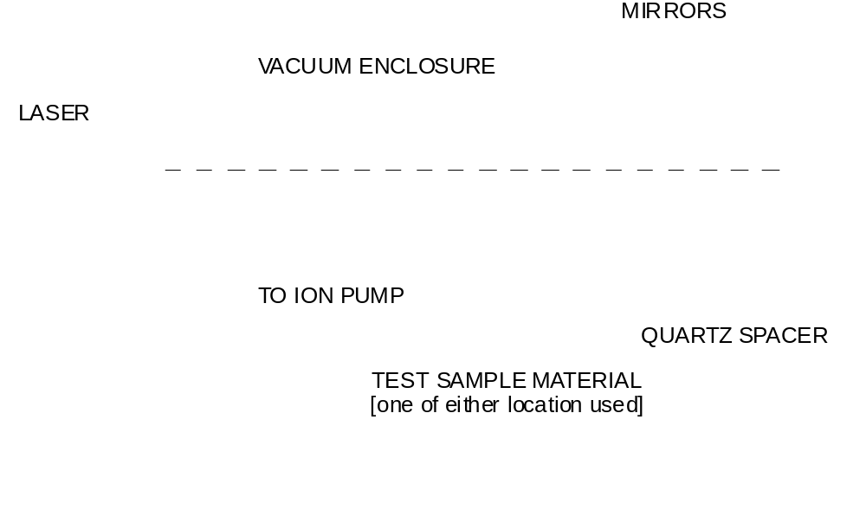
The qualification procedure includes the following steps:
- Vacuum bake candidate materials according to the procedure for that material, then cool and take an RGA scan to quantify the out-gassing. The scan must be calibrated against one or more standard leaks.
- Run an optical exposure test at > 150 kW/cm² in a resonant cavity to qualify material at the level of optical losses discussed in Section 1.1. The run shall be the shorter of 2 months or when a measurable effect is observed.
- If the candidate material is deemed safe for incorporation into LIGO designs, then subsequent components made of this material shall be screened in the manner described below.

Out-gassing Screening Tests
There are two steps of the screening test:
- a vacuum bake-out for driving volatile substances (HCs) off the component; followed by a residual gas analysis (RGA)
- a Fourier Transform InfraRed (FTIR) analysis of the rinsate from the component followed by an air bake for driving volatile substances (HCs) off the component.
The preferred method is the vacuum bake/RGA test, as it measures hydrocarbon out-gassing more directly. The FTIR/air bake method is to be used for those components that are too large for practical vacuum baking.

Vacuum Bake/RGA Test
The default bake-out procedure shall be conducted under vacuum. With large components, which it may not be feasible to bake under vacuum, an air bake will be considered acceptable providing cautions are taken to preclude contamination from the ambient air.
All bakes shall be performed in LIGO-approved ovens; these may be located at vendors.
Vacuum baking of the candidate component/material is performed to obtain hydrocarbon and other out-gassing data information. The typical vacuum bake test setup is shown in Figure 2.
Typical testing procedures are:
- Prepare a sample of candidate component/material to be tested.
- Coordinate with the site personnel to place parts appropriately in the queue for material qualification.
- The oven operator will perform a system calibration according to the defined procedure.
- The oven operator will perform a vacuum bake of candidate component/material.
At the end of the vacuum bake period, obtain a record of the partial pressures of suspect HC masses by a residual gas analysis. This analysis shall be performed and documented according to LIGO defined procedures.
Figure 2: Typical Vacuum Bake Test Set
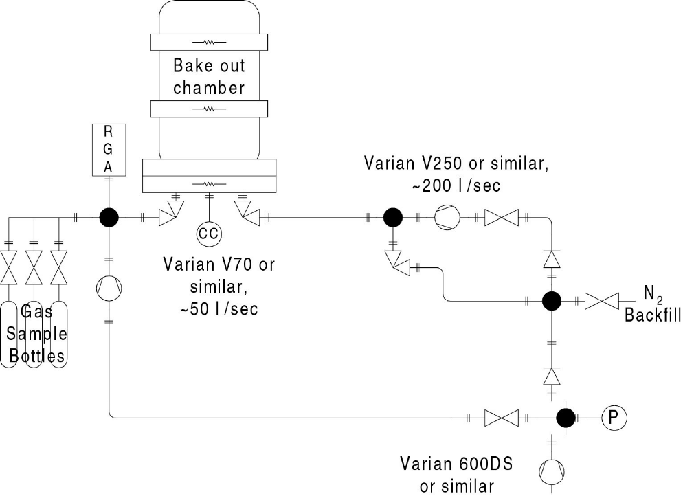

FTIR/Air Bake
With large components, which it may not be feasible to bake under vacuum, an air bake will be considered acceptable providing cautions are taken to preclude contamination from the ambient air. The temperature and duration of the air bake shall be identical to the vacuum bake parameters shown in Appendix A.
Without a vacuum, the RGA scan cannot be made; it is replaced with an FTIR analysis of rinsate from the component, which must be performed prior to the air bake due to sensitivity limitations of the FTIR process. The procedure for collecting the rinsate and conducting and evaluating the FTIR analysis of large in-vacuum components is set forth in Appendix E.

QA Screening
All components fabricated from approved materials and which are intended for installation into the LIGO vacuum envelop shall be screened to ensure that proper preparation of the subject components has been achieved. This screening follows the procedure outlined in Section 6.1.2, Out-gassing Screening Tests.
In cases where a large number of components are to be screened, it may be permissible to perform a statistical sampling of components instead of 100% testing. However, in this case, it must be assured that the results of the screening test for the sampled article are determined to be acceptable before any intervening untested articles are integrated into LIGO. In this way, a screening failure can be tracked to all potentially affected articles. The sampling frequency shall be submitted for approval by the Detector Cognizant Engineer to the Vacuum Review Board.
In the event that a component fails the screening test, it must either be re-processed or if there are sufficient reasons, a request must be made of the Vacuum Review Board for a waiver. In the case of a screening test failure with statistical sample, it must be assumed that all intervening untested articles are also suspect and must thus be reprocessed unless it can be shown that the reason for failure is specific to the failed article.

Clean and Bake Requests
During ILIGO, clean and bake requests were dealt with using a “traveler system” and during ELIGO, most clean and bake requests were sent via email to a site clean and bake coordinator. ALIGO demanded a more structured and transparent system due to the complexities of coordinating Clean and Bake (CNB) activities at three sites: CIT, LHO, and LLO. A web-based CNB Ticketing System was developed and is the primary method for submitting any CNB Request. If you have any questions or need help filling out the on-line form, please contact your local site CNB person, Jodi Fauver, Calum Torrie, or Jonathan Hanks.

Class A Cleaning Procedures

Precedence
The cleaning procedures defined below are general and should cover most situations. Special cleaning or material compatibility issues may dictate deviations in the procedure and should be defined in the original Clean and Bake Request and the Special Instructions fields of the Inventory Control System (ICS). A deviation from these procedures requires an approved waiver from the Vacuum Review Team. (The VRT may refer waiver requests to the VRB.) If a waiver is approved, then it takes precedence over these general procedures.

Background
The cleaning procedures identified herein were developed to accomplish the cleaning of hardware as defined in the Appendix of MIL-STD-1246 with an emphasis on using low-hazard (biodegradable) critical cleaning detergents.
This process is not intended to provide guidance for passivation or phosphate-based acid cleaning of austenitic stainless steels.

Safety
Although much effort has been taken to make cleaning processes less hazardous, the techniques and materials described herein may have health, safety and environmental impacts. Consult the appropriate Material Safety Data Sheets (MSDS’s) of the products to be used before performing any process specified herein. MSDS sheets are on file in each building at the sites where detergents and solvents will be used.
Good industrial hygiene and safety practices shall be employed at all times. The use of the following personal safety equipment is recommended: gloves, splash goggles and an apron.

Cleaning Precautions
The operator doing the washing shall wear a bouffant cap, mask, lab coat/frock, shoe covers and cleanroom gloves. (This also applies to anyone handling the cleaned pieces.)
The operators should be familiar with the washing system and its components before operating the equipment.
Do not let any surface dry between start of washing and end of final rinse.
Handle each piece or component with appropriate care and clean gloves.
Certain safety equipment shall be worn by personnel during the processes specified herein to minimize exposure risk to chemicals, which maybe hazardous. This equipment shall include, but is not limited to: Safety glasses/goggles, aprons, and additional layers of gloves.

Gross and Precision Cleaning
Ideally, all parts received by LIGO from its contractors/fabricators are quite clean, i.e. free of scales, welding slag, particulates, greases, oils, minerals. etc. The parts must be inspected by the vacuum preparation team to determine what level of cleaning is required. In most cases, LIGO’s contracts have some level of cleanliness or cleaning defined, though usually not to the level of UHV readiness. Even if a shipment of parts is supposed to be quite clean, all of the parts must be examined as a QA check and to insure that contamination has not occurred during shipment.
In some cases preliminary cleaning is required in order to remove “gross” contamination. Gross contamination includes weld slag, scale or oxidation (perhaps due to heat treatment or on an as-received, non-machined surface), soil or grease/oils, inks, etc. The surface cleanliness condition of the received parts should be cited in ICS and brought to the attention of the cognizant engineer for the parts. If it is determined that the parts will not be sent back to the manufacturer, then LIGO Laboratory must perform appropriate gross cleaning processes to remove the contamination before beginning the “precision” cleaning processes. See Table 2 in Section 10.5.4 below, for a list of gross cleaning processes applicable to various materials.
Precision Cleaning shall always be performed after Gross Cleaning for Class A and Class B parts.

Equipment
Become familiar with the SOPs for the Large Parts Washer (LPW), and the ultrasonic cleaners used to process Class A and Class B parts. The SOPs contain instructions for necessary cycling of the wash and rinse baths which happen regularly, as well as maintenance and parameter settings of the equipment.

Solvents and Soaps
Cleaning materials used in the processes identified herein, shall be as specified in Table 4. Note that not all detergents are compatible with all cleaning equipment, so follow the table carefully.

Cleaning Solutions
Cleaning solutions should be prepared fresh per the recommended solution dilution stated on the bottle. Table 2 is a summary of the recommended cleaning parameters from the Alconox vendor, who supplies many of the LIGO approved cleaning chemicals. Cleaning solutions prepared for manual and ultrasonic processes should be discarded after a few loads, or when the solution appears dirty. In some cases, the solution may need to be switched after every load, but it is a judgment call by the operator. Solution life extension maybe accomplished as directed by the manufacturer, as required.

Table 2: Cleaning Solution Parameters
Product | Equipment | Dilution | Amount | Wash  Temperature | Manual Precautions
Product | Compatibility | % | Oz/Gal | Degrees F | Hand | Eye | Clothing
Citranox® | Ultrasonic/manual | 1 to 2 | 1 – 3 Oz : 1 Gal | 140 | Yes | Yes | Yes
Citrajet® | LPW | 1 to 2 | 1 – 3 Oz : 1 Gal | 140 | Yes | Yes | Yes
Alconox | Ultrasonic/manual | 1 | 1 – 2 Oz : 1 Gal | Warm | Yes | Yes | No
Alcojet | LPW | 1 | 1 – 2 Oz : 1 Gal | Hot | Yes | Yes | No
Liquinox® | Ultrasonic/manual | 1 | 1 – 2 Oz : 1 Gal | Hot | Yes | Yes | No

N.B.:
1) Citranox, Citrajet, and Alcojet are provisionally approved by the VRB. Formal approval is in process.
2) Liquinox is approved and suitable for manual and ultrasonic washing.
3) Protex and Gosh are approved and suitable for manual gross cleaning.

Gross Cleaning

Cleaning Facility
Unless otherwise specified, Gross Cleaning shall be performed in a facility (building or room) that is isolated from general shop practices (e.g. machine operations, welding or aerosol applications). Some gross spot cleaning is permitted in the clean areas of the clean and bake facilities. Consult with the clean and bake leader. Isolation should also include separate air handlers to minimize re-contamination. When an isolated facility is not available, suitable isolation may be accomplished using a temporary soft wall partition or clean bench.
Parts that have been gross cleaned and dried shall be identified and stored appropriately

Approved Cleaning Materials
The following supplies are required to support the procedures specified herein. All equipment used to perform the cleaning procedures identified herein shall be pre-cleaned using the cleaning materials and procedures identified below. A list of vendor information regarding these supplies, and additional handling supplies can be found in the Contamination Control Plan E0900047.
- Stainless Steel Tanks, Containers and/or Pails
- Stainless Steel Brushes with ABS handles
  - Scouring Brushes
  - Finishing Brushes (for soft metals)
  - Tube Cleaning Brushes (for holes)
- Stainless Steel Metal Wool or Gauze
- Polyester Clean Room Wipers
- Chemical Bottles
- Solvents and detergents specified in Section 10

Special Fixtures
If any special tools or fixtures are required for the cleaning processes, they shall be designated and approved by a cognizant engineer.

Part Preparation
All parts subjected to Gross Cleaning shall be free from all visible tape, inks, and other residues not identified in the engineering drawing. All residues shall be removed using a solvent and a low-lint task wiper such as ConTec PNHS-99. LIGO approved solvents are isopropanol, methanol, and acetone.
Separate parts in groups according to the extent of the contamination. For example, greasy parts might get one gross cleaning treatment, while rusty parts get another.

Approved Processes
The recommended gross cleaning processes for selected materials and surface conditions are identified in Table 2. Cleaning processes will normally be accomplished in order from left to right depending on the level of cleaning required for the parts, starting from an appropriate step as determined by the vacuum preparation team. For example, if the part does not have heavy scale (usually true for LIGO parts) or welding slag, then the Mechanical Cleaning process can be skipped. However if the part appears to have an oil film, then the Solvent Cleaning step should be undertaken.

Chemical cleaning agents must be compatible to prevent excessive material attack or latent degradation. Check material compatibility before proceeding with cleaning procedures. Consult with the cognizant engineer.

Aggressive Mechanical Cleaning
This process is used to remove scale and heavy oxide by abrasive action and should only be used when physical damage to the items being cleaned would not be a concern.
Remove all weld splatters, slag, scale, discoloration, and carbonization using mechanical cleaning methods (such as scrubbing with metal brushes, stainless steel wool, etc.)
In most cases, detergent can be used for mechanical cleaning. If necessary, solvents can also be used.
During the mechanical cleaning process, ensure that the resulting surfaces are smooth and meet workmanship requirements. Tools used for mechanical cleaning shall be clean and previously used only on the same material being cleaned.

Solvent Cleaning
This process is used to remove forms of organic contamination such as oils, grease, hydrocarbon fuels and inks.
Solvent cleaning shall be performed using controlled application methods (e.g., saturated technical wipers or swabs), and prioritizing on threads and holes, while finishing with the main surfaces. Technical wipers and swabs will be discarded when there is visible evidence of contamination.
The approved solvents are acetone, methanol, and isopropanol. Proper precautions should be taken when using and disposing of solvents or solvent contaminated materials. Please see LIGO-M1200015 for details.

Acidic Cleaning
This process is used for the removal of inorganic contamination, trace metals and oxides such as scale, (calcium and magnesium) salts and where general metal brightening is required. Ideally this is accomplished with a phosphate-free acid. However a mild phosphoric acid may be used on aluminum parts.
Acidic cleaning is effective when the part is submerged in the appropriate solution; therefore, manual scrubbing, wiping, soaking or ultrasonic cleaning would work.
Use the appropriate acidic cleaner listed in Table 3, given the material being cleaned and the application used. 10 min. soaks or cycles should be sufficient.
Acidic cleaning agents will cause eye and skin burns if operators do not take appropriate precautions. Eye and Hand protection are mandatory.

Steam Cleaning
A high pressure, high temperature steam clean process is used to remove loose debris and contaminants from the surface. Follow the recommended vendor instructions.

Detergent Pre-Cleaning
This process is used for the removal of organic contamination such as oils, fats, shop soil and grease. Using a Liquinox solution, run the parts in a designated dirty ultrasonic cleaner (3 min. for Aluminum, 10 min. for stainless steel).

Tap Water Rinsing
This step is used to remove the residue material left by any gross cleaning processes.(*Note-While tap water is appropriate for rinsing during gross cleaning processes it IS NOT acceptable for rinsing during or after precision cleaning.)
Subject parts to an initial running water rinse with ambient or warm (120F) tap water. The rinse water should contact all surfaces and hole details for a minimum of 20 seconds on each surface. Where a running water rinse is not practical, a series of three (3) or more agitated soak/rinse tanks or at least two (2) counter-flow cascade rinse tanks is required. Immediately dry parts per 10.5.4.7 or proceed to subsequent operations.

Drying
The gross cleaning drying process is used to minimize the impurities from rinse water that can be deposited on the part during evaporation. Physically remove rinse water from all surfaces using clean room wipers and/or clean nitrogen gas.

Table 3: Suggested Gross Cleaning Steps – (Try Processes A, B, C, or D as needed followed by tap water rinse and drying.)
Material | Surface Condition | A.  Aggressive Mechanical Clean  (detergents + steel wool, brushes) | B.  **Solvent degrease  Meth/Acet  PPE Required* |  | C.  Acidic Cleaning  (acidic solution + ultrasonic cleaning)  PPE Required* | D.  Steam Cleaning | E. Detergent  Pre-Cleaning  (Liquinox + ultra sonic cleaning) | Tap Water  Rinse | Drying
Aluminum | Machined |  | X | X | Citrojet (Alconox), Citronox  Protex (Thermodyne Arcair p/n 57014000) |  | X | X | X
Aluminum | Rolled |  | X | X | Citrojet, Citronox  Protex |  | X | X | X
Aluminum | Weld Scale, Corrosion, or Oxidation | X | X | X | Citrojet, Citronox  Protex |  | X | X | X
Brass  Copper  Phosphor- Bronze | Machined |  | X | X |  |  | X | X | X
Brass  Copper  Phosphor- Bronze | Corrosion or Oxidation |  | X | X | Citrojet, Citronox |  | X | X | X
Stainless Steel | Machined |  | X | X |  |  | X | X | X
Stainless Steel | Weld Scale, Corrosion, or Oxidation | X | X | X | Citrojet, Citronox  Gosh |  | X | X | X
Stainless Steel | Electro-Polished |  | X | X |  |  | X | X | X
Maraging Steel | Machined, Rolled |  | X | X
Maraging Steel | Corrosion or Heat Oxidation |  | X | X | Citrojet, Citronox
Polymers |  |  | X | X
*Note: Personal Protective Equipment (PPE): Hand=H, Eye=E, Clothing=C
** Solvent degrease does not require tap water rinse or drying steps.

Precision Cleaning

Cleaning Facility
Precision cleaning is to take place in a cleanroom facility, with workers donning the appropriate garb. See E0900047 for cleanroom areas and protocol set up at the sites. This document also discussed contamination control supplies that may be used in the following processes.
All Class A parts shall go through the steps specified in this section. Additional instructions and deviations for specific hardware can be found in Section 12.

DI Water system
The quality of the DI water used for precision cleaning and rinsing is very important in meeting the LIGO cleanliness requirement. A resistivity gauge should be part of the system and should be checked on a regular basis. (Ideally, DI water resistivity should be independently verified using a resistivity meter once a month.) All filters, hoses, and storage tanks that are part of the system supplying DI water for precision cleaning and rinsing should be inspected on a regular basis (every three to six months depending on the number of loads processed). Be aware of water spots on parts: they are the leading indicator that the system needs a clean-out.

Parts Preparation

Sorting by Material Type
Parts should be processed in manageable lots of identical materials (i.e., aluminum with aluminum).

Choosing a Process
The choice of approved cleaning processes (manual, ultrasonic, pressure washer or large parts cabinet washer) depends on the part size and on judgment from engineering and technical staff.
In some cases, a manual washing or ultrasonic wanding of suspect areas (e.g. blind holes, tapped holes, blackened/oxidized regions, etc.) will be required before automated washing.

Approved Processes

Manual Cleaning
Manual cleaning is sometimes needed for objects which do not fit into the washing machines, etc. Manual cleaning shall be performed in accordance with the following procedure:
- Transfer prepared cleaning solution in a stainless tank or container (bucket).
- Submerge the part or incremental sections until all surfaces have been exposed to cleaning solution.
- Clean the entire part using soaked clean wipers/brushes, prioritizing on blind and through holes, while finishing with the main surfaces. Cleaning solution should not be allowed to dry on part during cleaning operations.
- Rinse and dry entire part thoroughly as identified in the following sections.

Ultrasonic Cleaning
Ultrasonic cleaning shall be performed in accordance with the following procedure and SOP (M1000029):
- Immerse parts: clean racks or baskets may be used to ease handling.
- Set the ultrasonic cleaner for cycles according to the material you are cleaning. (Note that Aluminum discolors in the ultrasonic when left in too long, hence the shorter duration.)

Metals-Stainless | Aluminum
10 min | 3 min

- Rinse and dry entire part as identified in the following sections.
Utilize the ultrasonic wand on small areas such as blind and tapped holes when needed. Observe all safety recommendations from the wand vendor.

Large Parts Cabinet Washer Cleaning
When the Large Ultrasonic cleaner cannot be used, use the Large Parts Washer (LPW) wash cycles.
- Setup the LPW with wash solution as per its SOP (M1000027).
- When loading parts into the washer, make sure that they do not overlap, or rub against each other causing damage. Utilize SST parts baskets such that parts can be accessed easily. Basket lids and SST tie-down wire may be required to hold light weight parts in place during the cycle.
- A typical wash cycle is 10 min. Actual durations will depend on the size and complexity of the parts. The parts may need to be rotated after the cycle and the cycle re-run such that all surfaces are exposed to the wash fluid. Consult with engineering staff.
- Rinse and dry entire part as identified in the following sections.

De-ionized Water (DI) Rinsing
Parts can be rinsed by hand with DI water equipment, or in the LPW. Appropriate rinse cycles are the following:
- When lifting items out of the ultrasonic cleaner, use a DI water spray to rinse the parts (draining back into the ultrasonic) for a thorough rinse of 20 sec over the entire surface.
- Parts could be transferred to the sink for DI hand rinsing the surface for 20 seconds.
- After loading washed parts in the LPW, parts can be hand rinsed there utilizing the LPW rinse wand for 20 second surface treatment
- After loading the LPW, set the machine for a 10 min. rinse cycle (and 0 min. wash cycle).
The goal should be to have 3 of the above rinses, whether all the same type, or mixing types.

Drying
This drying process is used to minimize water induced corrosion. Drying can be accomplished by blowing clean air over the component before allowing it to cool or exhausting/venting the parts cabinet washer so that all surfaces dry before the part is cool. It is also acceptable to lay parts out on clean racks to let the water evaporate. Heat lamps can also be used. Parts should be dried as quickly as possible such that they can be stored. However, parts should be thoroughly dry before wrapping, or staining occurs. Parts may take several hours to dry.

Inspection
Inspect the components (or close up the vessel) as soon after drying as possible.
Inspection shall be done (before removing the piece from the washing cabinet) using a black light (such as Bayco UVR-9012B) on all interior surfaces or flange faces. No visible contaminant of any form shall be detected when viewed with the naked eye under both natural and ultraviolet light.???
A visual inspection shall be made of exterior surfaces. The presence of any hydrocarbon or fingerprints or other contamination, shall be cause for rejection. Parts will need to be re-cleaned.

Wrap/Bag/Tag
Immediately after drying and inspection, place the items in CLASS B storage containers (SST, Aluminum or glass) and then double wrap in CP Stat bags. In cases where the CLASS A item to be stored is too large for such containers, wrap the parts with UHV foil and then double bag the component using clean, oil-free CP Stat bags or wrap and seal using the CP Stat material.
Move the component(s) to a clean storage/staging area.

Required Documentation
A record of the cleaning steps performed shall be in the ICS. At a minimum, the following points shall be recorded.
- Cleaning log describing parts cleaned and procedure used (gross/precision and specification followed)
- Comments and observations
- Record of RGA data package
- Record RGA approval, waivers, and any inspection notes

Other Processes Not Commonly Used

Pressure Washer
Pressure washing is not a typical step performed at the sites; however, steps are defined for those occasions, as well as for outside vendors treating LIGO parts. Pressure washer cleaning shall be performed in accordance with the following procedure:
- Prepare cleaning solution in a stainless tank or container.
- Transfer prepared solution into pressure washer.
- Clean entire part prioritizing on blind and through holes, while finishing with the main surfaces (changing nozzles as necessary to facilitate). Cleaning solution should not be allowed to dry on part during cleaning operations. Alternate between spray wash and spray rinse cycles as indicated in Table 4.
- Perform a final DI rinse of the entire part as identified in section 10.7.5.
Table 4: Pressure Wash and Rinse Guidelines
Component Area | Minimum Duration per Cycle  (minutes) |  | Number of  Wash/Rinse  Cycles | Final DI  Rinse  Minimum  Duration  (minutes)
Component Area | Spray Wash | Spray Rinse | Number of  Wash/Rinse  Cycles | Final DI  Rinse  Minimum  Duration  (minutes)
Exterior Surfaces | 3 | 3 | 3 | 5
Interior Cavity Surfaces | 3 | 3 | 5 | 10
Through Holes | 3 | 3 | 5 | 10
Blind Holes | 3 | 3 | 10 | 20

CO2 Cleaning
TBW

Class B Cleaning Procedures
 WARNING! Only tools, tooling, jigs, rigging and handling components are generally cleaned to Class B procedures. Components that are to be exposed to the vacuum MUST be Class A and MUST be comprised of materials that are listed in E960050 for the approved application.
The same cleaning procedures outlined for Class A materials should be used for Class B materials. The difference between Class A and Class B designation is in the bake-out process. For Class B, only an air bake is required (not a vacuum bake as in Class A), at the specified/appropriate temperature, for a minimum of 24 hours. No RGA or FTIR testing is required for Class B equipment.
The following sub-sections give Class B cleaning instructions for materials that are not permitted for Class A components, but may be used for Class B components, as long as shedding or abrasion of the Class B component is prevented.

Brass
Use acetone with clean room cloth and a stainless steel or brass bottle brush (for internal threads) or stainless steel wool over the threaded areas.
Ultrasonic clean in methanol or isopropanol for 10 minutes at room temperature in a fume hood.
Blow the parts with dry N2
Wrap in UHV aluminum foil or appropriate Class B container
Do not use water or water-based cleaners since this will cause an oxide layer on the brass part.
Do not bake brass since it may contaminate the oven (vacuum or air oven) with lead.

Nylon
Nylon has excellent chemical resistance to isopropanol, methanol, acetone and soap solutions. Nylon does swell due to exposure to water but the diffusion time is much longer than the duration of the cleaning step and it is reversible by baking so both aqueous and/or solvent cleaning is acceptable.
Nylon has a maximum, continuous operation/service temperature ranging from 80 to 140 C, depending on grade or type. Consequently, air bake at 80C for 24 hr.

Delrin®
Delrin® (acetal homopolymer) is a registered trademark/material by DuPont. Delrin has excellent chemical resistance to isopropanol, methanol, acetone and soap solutions so both solvent and/or aqueous cleaning is acceptable.
The deflection temperature (1.80 MPa per the ISO 75-1/-2 test) for Delrin® is slightly, or somewhat, higher than 90C. One source cites a maximum, continuous service temperature of 85C. Consequently, air bake at 80C for 24 hr.

Granite
"Gross" (or initial) cleaning with either (1) manual or ultrasonic cleaning with Liqui-Nox(R) or (2) manual cleaning with a granite or stone cleaner such as DuPont(TM) StoneTech(R) professional stone & tile cleaner, which is a dilute mixture of isopropyl alcohol & alcohol ethoxylate (<5%) and water (>90%). The alcohol ethoxylate is a surfactant. Only a cleaner should be used -- without any sealers or "protecting" agents (such as silicone). If one is unsure of the composition of the stone cleaner, then do not use it. After cleaning, the stone should be thoroughly rinsed with water and allowed to dry.
"Precision" clean by wiping thoroughly with isopropyl alcohol. If the stone is small enough to be air baked (and not bonded to other materials), then bake at 200C for 12 hr. If this is impractical, then repeat the isopropyl alcohol wiping twice more.

Viton
The Class B process may be used as long as the Viton will not be staying in the vacuum envelope AND will not come in direct contact with optics. In this case, optics are defined as glass that has been coated to reflect or absorb light.
1. Walkerizing is NOT required.
2. Clean Viton using standard Liquinox solution for 10 minutes in an ultrasonic cleaner.
3. Bake for 24-hours in 180 degree C air bake oven.

Process Documents for Specific Components
T1000057 Class B Solid Stack Process
T1200149 Cleaning Procedure for Optics Lens Caps

Specific Cleaning and Baking Procedures

General Requirements
First, perform any required “gross” and “precision” cleaning (see section 10). Any special cleaning notes related to a specific material are found below.
These procedures are consistent with:
1) a material’s bake-out at the maximum temperature possible; and,
2) achievement of the summed mass pressure limit.
Any deviation from these procedures must be cleared with the Vacuum Review Team with an approved waiver and the waiver attached to the ICS Bake Load.
Note that there are restrictions on material grades/formulations for many of the materials listed below. These restrictions are listed in the LIGO Vacuum Compatible Materials List, E960050.
For design applications where dimensional control is extremely important or tolerances are exceedingly tight, it is the responsibility of the design engineer to (a) establish a basis for baking parts at temperatures lower than the default temperatures recommended herein, and (b) get a waiver for a lower temperature bake from the LIGO Vacuum Review Board. Cleaning and Baking
Material certifications must be obtained for all materials. All materials must comply with the limits set on high vapor pressure elements defined in L080072.

Air Bake or Vacuum Bake
It is preferred that all parts be vacuum baked so that an RGA scan can be taken for the bake load. The RGA scan provides a direct measure of the outgassing from the parts.
If the parts are too large to fit into a LIGO UHV oven, then the parts must be air baked.

Air Bake

Procedure
TBW

Acceptance Criteria
TBW

Vacuum Bake

Procedure
TBW

Acceptance Criteria
TBW – see E080177

Aluminum
Tempered aluminum is very sensitive to reheat; and can lose significant yield strength with excessive bake temperature or time. The following time and temperature cycles will keep strength losses to less than 5%:
- Type 6061-T6: Bake at 150 C° for 48 hours.
- All others: Bake at 120 C° for 48 hours.

Polished Aluminum Target Faces
Do not touch the polished surface at all, even with a cleanroom wipe. Any contamination on the surface must be removed only by flowing liquids over the surface, and only the liquids described below. Take care in handling during all of the following steps to not touch the polished surface and to not let the polished surface come into contact with any other surface.
Do not place this part into an ultrasonic cleaner; This will cause surface pitting.
- Immerse the part into a 1% Liquinox solution and stir the solution to keep it flowing over the part. Do not let the polished surface contact any other surface. Remove the part after 3 minutes (maximum) in the Liquinox bath.
- Immediately rinse the part in DI water for 5 minutes, with the DI water flowing/moving over the part surfaces.
- Place the part into spectrometer grade (not reagent grade) Methanol and stir for about 1 minute.
- Air dry the part in a cleanroom or fume hood.
- Vacuum bake the part at 120 C°.
Warning: During all of the above steps, do not touch the polished surface and do not let the polished surface come into contact with any other surface.

Brass
Do not bake brass since it may contaminate the oven (vacuum or air oven) with lead. See notes in the cleaning section above, when processing Brass.

Bronze
See section 13.12.

Stainless Steel (including Invar)
Bake at 200 C° for 48 hours.

Maraging Steel
Bake at 200 C° for 48 hours.

Nickel Plated Maraging Steel Blades
Ni Plated Maraging Steel Blades fabricated as per E090023 should only be handled with gloves. Soak blades for 3 minutes in isopropanol, wiping surface to treat problematic areas. For larger blades, soaking may not be applicable, so thoroughly wipe all surfaces and flush holes.

Music Wire
SUS utilizes steel music wire in many assemblies. The wire does not get baked, prior to use. Spools should be kept in dry area, preferably with desiccant wrapping it came with.
Cleaning: After removing segment from spool, wipe entire length with acetone until no more reside comes off of the wire onto the wipe. Change gloves and wipe entire length three (3) times with methanol.

Copper and Copper Alloys
Acceptable copper alloys are listed in E960050 and T0900368. All materials must comply with the limits set on high vapor pressure elements defined in L080072 and must be wrought (not cast). Acceptable alloys can be found from the following material types:
- Copper (including OFHC)
- Beryllium copper
- Aluminum bronze
- Phosphor bronze
The clean and bake procedure is as follows:
- Clean using a compatible procedure from section 11.7.
- For all copper alloys except phosphor bronze, bake in vacuum at 200 C° for 48 hrs. For phosphor bronze, bake in air at 200 C° for 24 hrs. If circumstances call for any copper alloy (other than phosphor bronze) to be baked in air rather than vacuum, then limit to 175 C° for 48 hrs.

Indium
The cleaning process to remove oils and hydrocarbons from the surface of indium is as follows:
- ultrasonically clean the indium with acetone
- vacuum bake at 120 C° for 48 hrs.
If the indium is to be used for cold welding or soldering/fusing, then an acid etch process to remove the oxide film is required. See document XXXXX for the procedure.)
N.B.: This bake temperature is only for pure indium (melt temperature of 156 C°) and not low temperature indium solders.

Gold (connector contacts)
Bake at 200°C for 48 hours. However, if the contacts are part of a cable assembly, then other materials may limit the maximum temperature. The cognizant engineer should specify in the original clean and bake request.

Ceramics (including Macor and Zerodur)
Many ceramics can be baked at high temperature. The cognizant engineer should specify the bake temperature on the original clean and bake request. Lacking better information clean with Liquinox in ultrasonic cleaner (preferably a small one) and bake at 200 C°for 48 hours. Treat small parts very gently as they may be brittle or fragile.

Fluoroelastomers – Fluorel and Viton
Note: The only fluoroelastomers approved for use in the LIGO UHV system are specific grades of Fluorel™ (3M product) and Viton™ (DuPont product), except for small o-rings - See E960050 for details.

Free Fluorine Extraction
Free fluorine extraction processing must be performed on all fluorel and viton parts which will be used inside LIGO vacuum (as part of a subassembly, for example) with the exception of the large o-rings used for sealing the vacuum vessels. This includes off-the-shelf commercial parts as well as custom procured molded parts. (Note: E960050 stipulates which fluorel and viton formulations are approved.)
To perform fluorine extraction, follow the steps below (similar to the steps specified in the technical summary of processing detailed by Walker & Sons in L990205):
- Ultrasonic or agitated clean in warm (about 120F) Liquinox solution for 10 min.
- Rinse with DI water.
- Pressure cook in DI water at 15 psi for 2 hours. (Be sure to place the parts on a shelf or rack within the pressure cooker and not on the bottom of the pressure cooker where the temperature can get much higher due to contact with the heated bottom.)
- Repeat steps 2 and 3 four (4) times.
- Rinse in DI water 3 times
- Dry in oven for 4 to 5 hours. Note that if the load is small it can go directly into a VBO. However if the load is large it should be dried prior to going into the VBO or it may choke the turbo pump.
If the above steps cannot be performed in-house, Walker & Sons Enterprises can perform the work. Contamination control and handling specifications will need to be sent at the time of request for this work.
After fluorine extraction, perform vacuum bake as follows:

Vacuum Baking Fluoroelastomers
Fluoroelastomer parts (Viton™ and Fluorel™) have the potential to emit lots of hydrocarbon material when baked. Care should be taken to maximize surface exposure and minimize surface contact during bake-out. There are three choices for baking fluoroelastomers:
- At LHO: Bake the fluoroelastomer parts in a ~1 torr “dirty”, dedicated oven to remove most of the hydrocarbon material before placing the parts into a low pressure vacuum oven for final baking and RGA measurement. This is the preferred method for Class B cleaning fluoroelastomer parts.
- At Caltech: Bake the fluoroelastomer parts in a dedicated ~1 microtorr oven fitted with a cryogenic trap and an RGA (which is of course valved off from the main volume when baking).
- Small cross-section (< .275 inch diameter) commercial o-rings (from materials and sources consistent with E960050), or small parts (< .275 inch diameter and <.5 inch length) manufactured per specification E970130 can go directly into a low pressure, vacuum bake oven equipped with an RGA.
*Note: For aLIGO, in general, fluoroelastomer parts will be baked at CIT.

Molded castings (manufactured as per E970130):
1. Ramp up from room temperature to 182 C° (360ºF) at a rate not to exceed 2.5 C°/min (4.5ºF/min).
2. Maintain 182 C° (360ºF) +/- 1 C° (2ºF) and a vacuum pressure not to exceed 10-6 torr for 48 hours.
3. Cool down in vacuum at rate not to exceed 3 C°/min (5ºF/min). Handling of parts out of the vacuum oven is particularly critical. It should be performed with clean tools and/or gloved hands (Latex gloves only). Gloves must be changed for new ones, should operators touch anything other than the parts or the packaging material.
4. After cool down, perform an RGA measurement (per LIGO-E960022). RGA test results shall indicate an out-gassing rate (for AMU components 41, 43, 53, 55 and 57) of 2 x 10-12 torr-liters/cm2/s requirement. If necessary based on RGA test results, re-bake for an additional 24 hours and repeat the RGA analysis. Repeat the last step until satisfactory RGA results are achieved

O-rings (ie. in EQ stop applications)
Bake in vacuum for 48 hours at 120 C°.
(To Class B – ultrasonic clean in DI water for 10 minutes, air bake at 120 C°for 48 hours.)

VE Seals and O-rings: (less than 8” diameter with cross section ≤ .275” nominal)
Bake in vacuum for 48 hours at 120 degrees C.
Wipe with isopropanol thoroughly immediately before each use.

VE Larger diameter O-rings (ie. for VE chamber doors)
Process per LIGO document: E960159-01-V
Vacuum bake at 150 C° for 48 hours.

Storage of Fluoroelastomers
After the above fluorine extraction and baking steps have been performed, either:
- seal the items in Class B paint cans backfilled with dry N2, or
- seal the items double bagged with a desiccant between bags.

Masterbond EP30-2 (Vacseal replacement)
Assemblies glued with EP30 should be cured and vacuum baked as per E1000386. Note some assemblies can be found in the Assemblies section below – instructions there take precedence over these basic instructions for EP30.
- Clean assembly parts prior to applying EP30 according to appropriate instructions in Section 10.
- Apply as minimal of a volume of EP30 as possible.
- Cure according to E1000386 – see specific components below.
- Vacuum Bake assemblies at 145 C° if appropriate for all assembly materials. If not, bake at the temperature of the material with the lowest bake temp. For example, some Aluminum alloys require a bake temp of 120 deg C°. If EP30 is used on an Aluminum assembly, then the bake temp should be at 120 not 145 deg C.
Specific Components:

HAM SUS Metal Masses with D070334 magnet/standoffs
- Cure via airbake instructions in E1000386 at 100 C° for 2-4 hours. Check that magnets can tolerate this temp/duration (although it has been determined that SmCo can).

Flag Assemblies
- Cure via heat lamp instructions in E1000386 for 16-24 hours.
- Vacuum bake at 120 C°.

Glass Components

Fused silica 1” and 2” mirrors and substrates
The VRB approved a proposal (L1100046) to allow optics to be installed in vacuum without being baked as long as they are cleaned in accordance with the appropriate COC cleaning procedure and NO FTIR is required.
For completely polished mirrors from REO (edges also polished!), no baking required. Clean as per E1200266.
For mirrors with ground edges clean as per E1200266, no baking required.
*Note: Optics that have items bonded to them with a polymer adhesive (e.g. magnets, wire stand-off prisms) must be baked to cure the adhesive.

Black Glass, Silver Coated Optics, Calcite Prisms
- Clean as per E000007
- Vacuum bake at 120 C° for 48 hours.

Filter Glass
For ionically colored, filter glass such as Schott KG5:
- Clean as per E000007
- Vacuum bake at either 120 C°or 200 C° for 48 hrs

Other Optic Specifications used in iLIGO
Posted here for posterity since these documents are in the Old DCC:
- Small Optics Cleaning Procedure E990034
- Large Optics Cleaning Procedure E990035.
- CO2 Gun Cleaning Procedures E990316.

QUAD ERM/CP glued EQ Stops
- See E1000752. Cure EP30 glue bonds via heat lamp for 16-24 hours.

QUAD Pen Flag Mounts
- Cure via airbake (dedicated optics/gluing airbake oven) as per instructions in E1000386 at 100 C° for 2-4 hours.

Optics (BS/FM secondary prisms)
- Cure prisms via heat lamp instructions in E1000386 for 16-24 hours.

Sapphire Prisms
- Ultrasonic clean in DI water for 20 min.
- Ultrasonic clean in Liquinox and DI water for 20 min.
- Ultrasonic rinse in DI water for 20 min.
- Ultrasonic clean in isopropyl alcohol for 20 min.
- Vacuum bake at 200 C° for 48 hours.

PFA 440 HP grade Teflon
Note: Only PFA 440 HP grade Teflon is approved. Parts requiring high dimensional tolerances are not to be made of PFA 440 HP grade Teflon (see E960050).
- Ultrasonic clean in acetone for 10 minutes.
- Ultrasonic clean in methanol for 10 minutes.
- Bake in vacuum at 120 C° for 48 hours.

Magnets
Warning: Some LIGO magnets are very strong, so care should be taken during all handling. Some magnets will chip very easily when they contact other surfaces. For example, they will chip when they snap to another object a few inches away. To aid in cleaning, baking, and handling, use metal mesh to hold magnets in pairs away from one another. Place one magnet on one side of the mesh attracted to another, barrel to barrel to maximize surface area exposed for cleaning and baking.

NEO 35 (NdFeB) magnets:
- Mount magnets on a fixture to minimize flat surfaces being trapped during cleaning.
- Ultrasonic clean in methanol for 10 minutes.
- Bake in vacuum at 80 C° for 48 hrs.
When the magnets became part of a magnet/standoff assembly, after sanding, and prior to bonding, clean using a CO₂ cleaning system (LIGO-E990316).

Nickel Plated NdFeB magnets:
- Mount magnets on a fixture to minimize flat surfaces being trapped during cleaning. Mount magnets on a fixture to minimize flat surfaces being trapped during cleaning.
- Ultrasonic clean in Liquinox solution for 3 minutes and thoroughly DI rinse.
- Bake in vacuum at 80 C° for 48 hrs.

Sm-Co permanent magnets:
- Ultrasonic clean in methanol for 10 minutes.
- Bake in vacuum at 177 C° for 96 hours

Solder: Lead-tin (Kester 6337)
- Same as metals, but flux is to be removed first by spraying Deflux solution.

Vac-Seal
As of March 2008, the LIGO qualified adhesive product known as “Vac-Seal” and manufactured by Tra-Con, (now part of Emerson & Cuming, a division of Henkel) is no longer available. Note that there is another product called Vacseal from SPI, which we have not qualified for use. For a replacement (for LIGO purposes of staking parts only and not “sealing”), see EP30-2 Masterbond.
For the historical record, our cleaning and baking protocol for the Vac-Seal adhesive was:
- Ultrasonic clean in methanol for 10 minutes.
- Bake in vacuum at 80 C° for 48 hrs.

Hygroscopic Crystalline Optics
Hygroscopic crystalline optics such as:
- KDP (potassium dihydrogen phosphate)
- DKDP (deuterated potassium dihydrogen phosphate or KD2PO4),
- KTP (potassium titanyl phosphate)
- RTP (rubidium titanyl phosphate)
shall NOT be cleaned and shall NOT be baked. Do not let water, detergent or solvent contact the crystals at all. Do not expose the crystals to solvent fumes: keep open containers of solvent at least 2 meters from crystals and keep containers closed whenever possible.
If there is some dust particles on the surface, use a clean, dry gas source (e.g. liquid nitrogen boil-off) to blow the particulates away.

PZT piezoelectric ceramics:
- Ultrasonic clean in methanol for 10 minutes.
- Bake in vacuum at 80 C° for 24 hrs.

PEEK

Connectors/Kapton cabling/wire harnesses:
- Ultrasonic clean in methanol for 10 minutes.
- Bake in vacuum at 200 C° for 48 hrs.

PEEK Cable Clamps (D0900004)

Assemblies

SEI Constrained Layer Damped Springs
SEI damped springs shall be cleaned per the procedure outlined in E970131.

SEI Large In-Vacuum Components
Initial LIGO SEI large in-vacuum components were cleaned per the procedure outlined in E970063.
Advanced LIGO SEI large in-vacuum components will be cleaned by subcontract per the procedure outlined in TBD

Electrical Vacuum Feedthroughs
A Picture Guide to ALIGO Electrical Feethroughs may be found in document LIGO-1200250.
- Leak check ALL feedthroughs prior to Clean and Bake.
- Ultrasonically clean all feedthroughs in isopropanol for 10 minutes.
- Bake feedthroughs in an oven that has a programmed ramp up and ramp down of 120 C° in 6 hours (20 degrees per hour)
- Carefully load feedthroughs into oven so as to avoid damage, especialy to connectors and knife edges, while at the same time maximizing loads.
- Bake at 150 C° for 48 hour.
- DO NOT force cooling of oven when feedthroughs are in the load.
- Leak check all feedthroughs after Clean and Bake.

LOS Cleaning Procedure
- Use flashlight and inspect every cavity; if contaminated send out for another pickle and passivate (using local vendor who has experience in handling and wrapping per our procedures).
Note: A few areas of reddish surface contamination (rust) in the interior is acceptable.
- Check all threaded holes with UHV cleaned and baked silver-plated, stainless screws to confirm that the threads are clear; if necessary chase the threads with a clean tap using no lubricant except DI water or approved solvents.
- Wipe all exposed surfaces with a clean room cloth (not a clean room paper/tissue) and isopropanol.
- Flush thoroughly with DI water using stainless steel brushes; turn the structure end-over-end and on all sides to clear as much of the particulate from the interior cavities as possible.
- Blow dry (as much as possible) with N₂ (do not allow the water to sit and dry).
- Wipe the exposed surfaces again with a clean room cloth (not a clean room paper/tissue) and isopropanol to see if any particulates have been flushed out of the cavities and onto the exterior; flip the structure end-over-end.
- Vacuum bake at 200 C° for 48 hours.
- Spot check after the vacuum bake for particulates as the structure is turned end-over-end; wipe any particulates off with a clean room cloth (not a clean room paper/tissue) and isopropanol.

Composite Assemblies

Commercial Stages
- Disassemble and clean parts in ultrasonic cleaner with Liquinox for 10 minutes.
- Rinse in DI water.
- Clean in ultrasonic cleaner with methanol for 10 minutes.
- Replace all plastic parts with appropriate metal or Teflon replacement part (Teflon PFA 440 HP pieces).
- Remove Teflon parts and clean thoroughly.
- Reassemble stages.
- Bake in vacuum at 120 C° for 24 hours.

Electronic Components
- Clean with Liquinox solution and rinse with DI water.
- Bake in vacuum at highest temperature compatible with manufacturer's maximum rating.

Sensor/Actuator Head Assemblies (OSEMs)
- iLIGO OSEM Complete Assembly:
  - Ultrasonic clean in methanol for 10 minutes.
  - Soak in isopropyl alcohol for 10 minutes agitating regularly.
  - Bake in vacuum at 80 C° for 48 hours.
- AOSEM Complete Assembly with loosened or removed assembly screws:
  - Soak in isopropyl alcohol for 10 minutes agitating regularly.
  - Bake in vacuum at 145 C° for 96 hours.
- BOSEM Complete Assembly:
  - Soak in isopropyl alcohol for 10 minutes agitating regularly.
  - Bake in vacuum at 120 C° for 48 hours.

Cables - PEEK shielded Kapton cables with various SST or PEEK connectors
This procedure applies to the sensor cables for the various Optical Sensor and Electro-Magnetic Actuator (OSEMs) assemblies and SEI assemblies.
- Ultrasonic clean in methanol for 10 minutes.
- Bake in vacuum at 120 C° for 48 hours.

SEI position sensor probes (ADE-made probes) with kapton coated wire (for actuator assemblies
- Ultrasonic clean in methanol for 10 minutes.
- Soak in isopropyl alcohol for 10 minutes agitating regularly.
- Dry under heat lamp for at least 48 hours.
- Air bake at 100 C° for 48 hours (max temp of 100 C° per ADC, supplier of probes)
- Bake in vacuum at 100 C° for 48 hours. (max temp of 100 C° per ADE, supplier of probes)

ISI Electromagnetic Actuators
- See E0900257

Picomotors (for OMC group)
- max survival temperature of 100 C° so bake at 80 C°for 24 or 48 hours?

Mirror Mounts (by Siskiyou)
A technical write-up of the procedure used to provide LIGO with almost completely assembled mirror mounts suitable for vacuum baking is outlined in LIGO-E12002245.

Viewports
- Metal-to-glass directly sealed view port assemblies (off-the-shelf)
Ultrasonic clean for 10 minutes in isopropanol
Rinse in methanol if required to clean optic
Air bake at 200 C° for 48 hours
- O-ring sealed view port assemblies
Clean and bake stainless steel parts according to standard procedure
Clean and bake O-rings according to standard procedure
Clean fused-silica according to E1200266 and then air bake at120 C° for 48 hours
Assemble the clean parts in a clean space

Electro-polish
- If parts are simple, ultrasonic clean in standard Liquinox solution. Items with difficult holes or complex geometries should be ultrasonic cleaned in DI water alone after the HULK or other ultrasonic machine has been cleaned out to remove Liquinox residue. As a last resort, parts may be ultrasonically cleaned in isopropanol under a fume hood.
- Vacuum bake parts for 48 hours. Temperature is determined according to the material. (i.e. Stainless steel is baked at 200 C)

FTIR Screening for Air Baked Components
When an air bake is performed for components too large for vacuum bake-out, screening must be performed by means of an FTIR test: this is in lieu of a residual gas analysis following a vacuum bake.
There are two FTIR test methods which LIGO has employed: an isopropyl alcohol rinsate method and a Freon surface sampling method. At this point in time neither method is preferred over the other. Freon is likely a better solvent for the likely contaminants that are a concern for LIGO. However, the Freon method only samples some of the surface area, whereas the isopropyl alcohol method is designed to sample all of the surface area.
This procedure is designed to limit potential hydrocarbon outgassing by limiting the FTIR absorbance magnitude at wave number 2950 cm⁻¹, a common dominant component from cracked hydrocarbons. Due to limitations on the sensitivity of the FTIR results, the FTIR sample is taken prior to air bake; acceptable FTIR results mean that the tested item is acceptable after the prescribed air bake is performed.

Isopropyl Alcohol Rinse
Include references for sample procedure & example report

Preparation
Equipment Required
- Ultra high purity isopropyl alcohol (< 1 PPM residue after evaporation)
- 1,000 ml beaker, glass (for dispensing alcohol)
- 1,500 ml beaker , glass (for collecting alcohol)
- 250 ml glass syringe without needle
- White, low-linting cleanroom class 100 towels
- Rinsate collecting trough and support base (note: this can be made of steel, wood, plastic or even cardboard—it will be lined with foil for cleanliness)
- UHV aluminum foil
- Ultra clean sample collection bottles and exterior packaging acceptable for shipment of flammable liquid via air carrier
- Clean stainless steel lifting chains
- Clean in stain less steel lifting fixture
- 5 gal plastic bucket for discarded alcohol

Cleaning and Rinsing of Equipment

Beakers: Clean beakers with detergent solution and rinse well before first time use. Prior to each use, perform the following: fill beakers with 300 ml high purity isopropyl alcohol. Swirl alcohol all around inside surfaces. With clean, gloved hand, wipe inside surfaces using a white, low-linting cleanroom class 100 wiping towel. Be careful not to touch the inside surfaces except with the towel. Swirl alcohol all around the inside surfaces then pour into a collecting bucket. Clean the outside of each beaker with a Class 100 wipe soaked in high purity alcohol. fill the beaker again with 300 ml of alcohol. Swirl alcohol around the inside surfaces for about a minute an discard. Repeat filling and swirling with 300 ml of alcohol for a third and final time. Cover the beaker with new, UHV aluminum foil until needed. Keep covered between every use.

Syringe: Avoid disassembling glass plunger from syringe body. Obtain a suitable clean pan or clean foil-lined box in which to hold the syringe in a clean stage between uses. Handle the syringe during all cleaning operations and used with clean, gloved hands. Clean the exterior of the syringe using high purity alcohol and white, low-linting cleanroom class 100 towels. Fill a cleaned beaker with 300 ml of high purity alcohol. Draw about 20-50 ml of air in the syringe, then place the needle end of the syringe into the alcohol. Fill the remaining volume in the syringe with high purity alcohol by withdrawing the plunger to the 250 ml mark. Shake and swirl the alcohol inside the syringe for one minute. Depress plunger to express alcohol from syringe back into the beaker. Draw the same alcohol back in and out of the syringe 4 additional cycles, or 1 minute duration, whichever comes first. Discard the alcohol. Fill the beaker to the 300 ml mark with more alcohol. Draw alcohol into the syringe to the 250 ml mark, then expel back into the same beaker. Repeat this process for a minimum of 5 cycles or 1 minute, whichever is greater. Rotate the plunger as it is being drawn back and forth. Discard this alcohol. Fill the beaker with 300 ml of high purity alcohol and repeat the 56 cycles or 1 minute cleaning detailed above. Discard alcohol. Rinse the beaker with 300 ml of high purity alcohol.

Lifting Chains and Lift Fixture: Clean the stainless steel lifting chains and the lift fixture by soaking them in a bucket of Mirachem 500 detergent and hot water. Rinse with hot de-ionized water. Sluice with alcohol and let air dry. Protect chains and the lift fixture from contamination between uses by wrapping them in foil or holding them in a clean bucket filled with clean alcohol.

Rinsate Collection Trough: When collecting FTIR sample rinsate from some parts, it is necessary to use a V-trough constructed especially for the purpose. The trough is not cleanable. It must be lined with ultra high cleanliness aluminum foil for every FTIR sampling operation where it is used. Roll out enough 32” wide foil to cover the trough plus 6” on each end. Double back the foil on the inside collection surfaces, except when using another piece of sterile foil as a protective barrier. Place the V-trough on its support base, sloped downhill at one end to drain toward the collection beaker. When collecting the sample rinsate, ensure that alcohol does not dribble backwards and become contaminated by the galvanized steel trough. Prevent any alcohol which may have contacted the galvanized steel trough from dripping into the collection beaker.

Facility Hoist: Prior to usage, cover the crane hook and about 2 feet of cable above it with ultra-clean aluminum foil. Fashion an “upside-down” umbrella from ultra-clean foil just above the hook to prevent crane particles from falling the part being cleaned or sampled. Connect a clean lifting chain to the protected hook.

Sample Collection
Surface Area Wetted
For proper sensitivity, group items to be tested in batches that have total surface areas of 10K-30K cm². Do not mix aluminum and stainless steel parts in the same batch, as they are baked at different temperatures. Calculate the surface area to be wetted in cm²; this should be the entire surface area unless practical constraints prevent a full wetting. IN any event, the portion wetted should be representative of the entire surface, included fillets, edges, tapped holes, etc. Record the batch number, parts contained in the batch, date and wetted surface area of the parts.

Control Samples
Note: only one control sample needs to be taken for group of batches of parts sampled in one day with eh same collection trough. If the collection trough needs to be relined with foil during the day, another control sample must be taken. Pour a 1000 ml control sample of ultra-pure alcohol into the 1000 ml beaker. DO NOT use the syringe to apply the control sample. Pour alcohol over the entire length and width of the ultra-clean foil lining the sample collection V-trough. Collect rinsate at the “downhill” end in the 1500 ml beaker. Pour 500 ml of the collected rinsate into an empty sample bottle. Do not fill above the shoulder of the bottle to allow for expansion. Cap and label the bottle “Control”; record the date and list the batch numbers to which it applies. Seal cap with tamper-resistant sealing material. Discard the surplus rinsate into the bucket. Cover the beakers with clean aluminum foil until needed again.

Part Sampling
Collecting: Position the crane in the approximate position for sampling. Hang the part to be sampled and position the rinsate collection trough below the part, so that the rinse runoff will drip into the trough. Position the 1500 ml beaker at the low point of the trough for collection.

Dispensing: alcohol may be dispensed over the sampled parts by either pouring from a beaker or by applying with the syringe. It helps to have the parts sloping instead of hanging vertically, as pouring is preferred. Pour or syringe the alcohol from the top of the parts, allowing it to rinse over the rest of the surfaces. If necessary, apply the alcohol to the lower sections to achieve good wetting. Use at least 1000 ml to wet the batch of parts; if this is insufficient for the planned wetting, ass alcohol in 500 ml increments until the planned areas have been wetted. Pour 500 ml of the colleted rinsate into tan empty sample bottle. Do not fill above the shoulder of the bottle to allow for expansion. Cap and label the bottle with the assigned batch number, part numbers, serial numbers, wetted areas, volume of rinsate applied, and date. Seal cap with tamper-resistant sealing material. Discard the surplus rinsate into the bucket. Record the total rinse volume used for each batch.

Shipment Details
Ship the control and sample bottles to the appropriate lab for FTIR analysis. Make sure that all of the appropriate regulations for shipping hazardous substances are complied with.

FTIR Testing
Evaporation

Evaporate 200 ml of a sample bottle’s contents into a 9mm diameter KBr disk.

Absorbance Testing
Plot FTIR absorbance on a scale from 0-1 as a function of wave number, from wave numbers of 500-4000 cm⁻¹. Label absorbance magnitude values at peaks that occur near 2950 cm⁻¹ and 1100 cm⁻¹. Include all information from the bottle label as test on the plot, plus the volume of rinsate evaporated and the size of the KBr disk. If problems are experienced, re-test from the bottle’s remaining contents.

Reporting of Results

Fax or e-mail plots to the LIGO project for evaluation. Do not dispose of the tested sample bottles and their remaining contents until at least a week after the results are reported.

Evaluation of Results
Examination of the Data
If the magnitude of absorbance for the batch sample analysis at wave number 1100 cm⁻¹ approaches with 75% of that at wave number 2950 cm⁻¹, a unique contaminant exists and the batch must be re-cleaned and re-sampled for screening.

If the magnitude of absorbance for the control sample is greater than 0.20, the sampling process is suspect and the batch must be re-sampled for screening after evaluation and correction of the process.

Calculation of Z₂₉₅₀
Calculate the value for Z₂₉₅₀ from the following:

Parameter

Y_{b} = absorbance of batch sample
Y_{c} = absorbance of control sample
V_{e} = rinsate volume evaporated, ml
V_{r} = rinsate volume applied, ml
A_{b} = area of KBr window, cm²
A_{w}= total wetted area of parts in batch, cm²

Using the equation:

Z₂₉₅₀ = (Y_{b} – Y_{c}) * A_{b} * V_{r} / (V_{e}*A_{w})

Acceptance Limit
The batch cleaned is considered to be acceptable if Z₂₉₅₀ ≤ 1.8 x 10⁻⁵, with the condition that the FTIR sampling is followed by the appropriate air bake cycle.

If the calculation shows the batch to be unacceptable, the batch must be re-cleaned and re-sampled.

Freon Surface Sampling
See E0900479 for instructions on swiping for FTIR via this method.

Calculation of Vacuum Load
In order to account for the anticipated load on the LIGO vacuum system arising from the introduction of LIGO Detector components into the chambers, it is necessary to develop an accounting system to track the contribution made to the partial pressure gas load by individual detector subsystem components.

Database
This could be done by assembling a suitably designed database in which the results of all screenings and high-power exposure tests will be logged. The database shall be searchable/listable according to any of its entries. As a minimum, the database shall contain the following data:
Inventory data:
- Material, exposed surface area, material volume.
- Subsystem and system comprising material.
- Location, by chamber, of component material.

Physical data:
- Approximate distance to nearest mirror and indication whether there is a direct viewing path.
- Approximate orientation of surface to mirror surface -- needed to estimate viewing factor.
- Pumping speed for HCs in specific location.

Measured data:
- Out-gassing rates, by mass number for important complex HC masses.
- Ringdown and frequency shift data: (absorption + loss) and loss rates: ppm/yr.
- Source of information -- LIGO document number or other traceable reference.

Derived quantities:
- Partial pressure by mass.
- Predicted accumulation on target mirror, monolayers/yr and estimated (absorption + loss) and loss rates: ppm/yr, where possible or relevant.

Estimation of Material Buildup
Optical performance degradation of the LIGO interferometers from material contamination within the vacuum vessels involves three elements: an out-gassing source (“culprit”), a target mirror (“victim”), and a path. The out-gassing source is most simply characterized by the set of parameters: {A, J_{i}, m_{i}, _{i}, a_{i}}. A(m²) is the source surface area exposed to the vacuum, J_{i}(W/m²) is the out-gassing rate for the i^{th} species of contaminant, having mass m_{i}(AMU), _{i} is the affinity for the species to adhere to a (clean) vacuum surface (0 <_{i} < 1), and a_{i} is the characteristic linear dimension of a molecule of species i (molecular area ~ a_{i}²). The vessel is maintained at ultrahigh vacuum by a pumping system characterized by a pumping speed for the i^{th} species, S_{i} (m³/s). The target mirror is characterized by the parameters: {d_{m},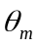, A_{m}}. d_{m}(m) is the distance between mirror surface and out-gassing source,is the orientation of the surface normal to the mirror relative to the line-of-sight to the contamination source and A_{m}(m²) is the mirror surface area. These parameters are summarized in Table 5.
Table 5
Parameters for estimating contaminant buildup on LIGO optics
Parameter | Symbol | Value or Units (SI) | Value or Units (CGS) | Conversion Factor, :  CGS = SI
Out-gassing rate for species i | J_{i} | (N-m)/m²/s or W/m² | torr-liter/cm²/s | 133.32
Source area | A_{i} | m² | cm² | 10⁻⁴
Species molecular weight | m_{i} | AMU |  | -
Sticking affinity | _{i} | 0< _{i} <1 |  | -
Molecular linear dimension | a_{i} | m | cm | 10⁻²
Distance to mirror | d_{m} | m | cm | 10⁻²
Mirror area | A_{m} | m² | cm² | 10⁻⁴
Mirror orientation | 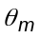 | -
Pumping speed for species i | S_{i} | m³/s | liter/s | 10⁻³
Partial pressure for species i | P_{i} | N/m² or Pa | torr | 133.32
Rate of increase of optical losses with time |  | ppm/yr

Table 6: Physical Constants
Physical Constants
Boltzmann constant | k | 1.38 10⁻²³ J/K | 1.38 10⁻¹⁶ erg/K | 10⁻⁷
Atomic Mass Unit ¹²C standard: 12 AMU = 12 gm / N_{A}) | AMU | 1.66 10⁻²⁷ kg | 1.66 10⁻²⁴ gm | 10⁻³
Avogadro's Number | N_{A} | 6.023 10²³ |  | -
Ambient Temperature, 27ºC | T₀ | 300 K |  | -

Figure 3 depicts schematically the geometrical arrangement of a source, mirror, and pump system.
Figure 3: Geometrical arrangement of source, mirror, and pumping system
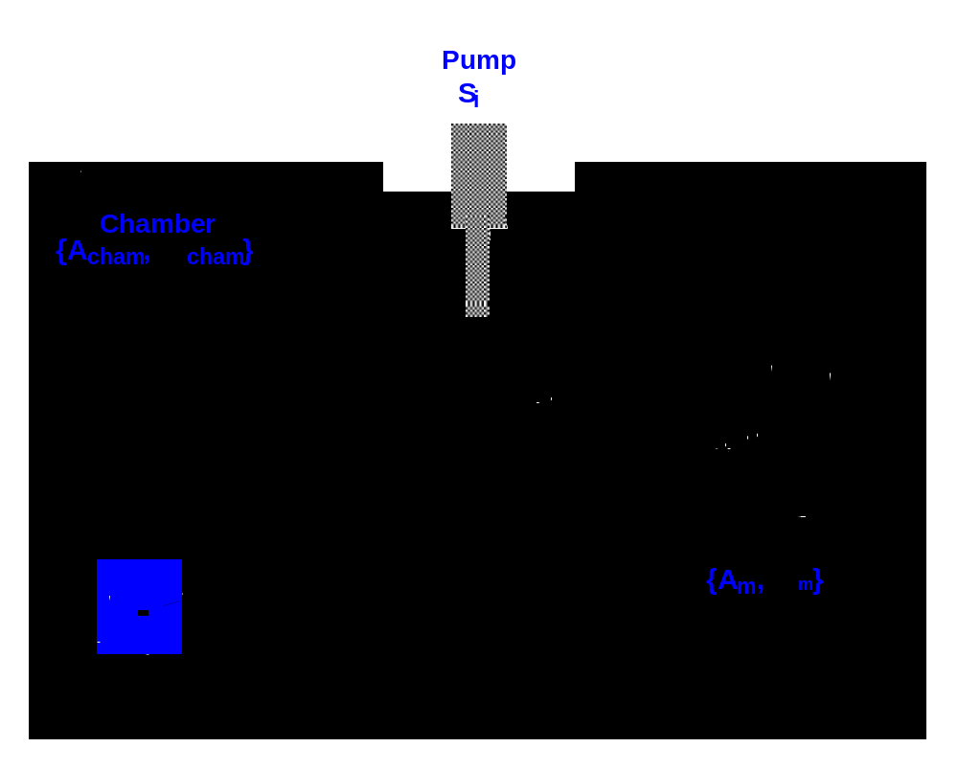
η
η
η

As shown in the figure, there are (at least) two mechanisms by which contaminants can migrate to a mirror surface: a direct path and an indirect or diffuse path, involving the equilibrium partial pressure of contaminant species in the vacuum vessel. The following discussion uses statistical mechanical description derived from discussions found in O’Hanlon’s A User’s Guide to Vacuum Technology, 2nd Ed., Wiley Interscience. It may also be reconstructed from material found in Reif’s Statistical and Thermal Physics, McGraw-Hill. This derivation assumes that equilibrium has been achieved and does not take into account partial pressure gradients which may be present.
Viewed from the mirror surface, the contaminant flux has a direct component and indirect component determined by the material partial pressure.
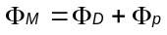 [1]

The direct component is given by:
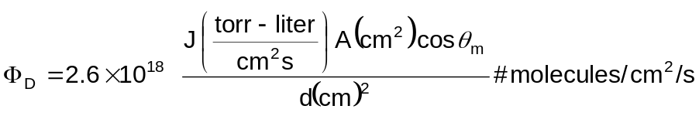 [2]
The indirect component is given by:
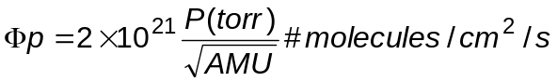 [3]
The partial pressure is proportional to the out-gassing rate-area product and inversely proportional to the system pumping speed:
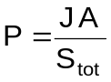 [4]

S_{tot} is the total pumping speed, which may include the pumping provided by the (otherwise clean) vacuum chamber walls:

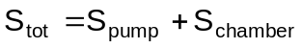 [5]

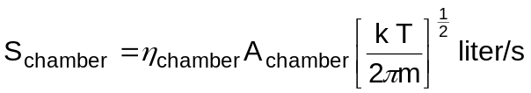 [6]

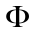_{D} is given in eq. [2] above. The worst case is given by _{chamber} 0, in which case the contaminants do not adhere to the chamber walls and the only pumping action is provided by the pumping system itself. In this limit, the molecular flux incident on the mirror surface at room temperature is given by:
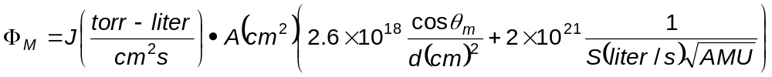 [7]
Note that d scales weakly as AMU^{1/4}: using S 1000 liter/s, the distance scale where the two contributions become comparable for AMU=36 is d 3 cm, and for AMU = 500 d 5 cm.
The rate accumulation of material on a surface depends on the physical dimensions of a molecule, a_{i}. A simple model-independent estimate of this dimension may be obtained by considering a substance’s molecular weight and density. Many hydrocarbon have densities which are comparable to that of H₂O, 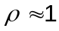 gm/cm³ (at least they will not differ from this value too greatly). The molecular volume is estimated by:
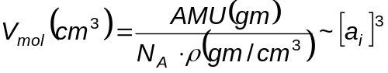 [8]
This yields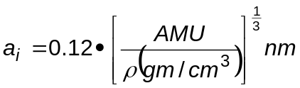. For AMU = 36, this yields a_{i} = 3.9  and
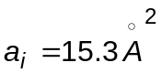or 1.5 10⁻¹⁵cm². Using this dependence of molecular size on molecular weight (assuming a constant density of ~1 gm/cm³), the following expression obtains for the rate of monolayer buildup:
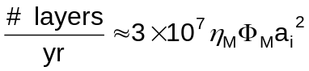 [9]
For 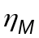 1 and S₀ = 1000 liter/s, this yields:
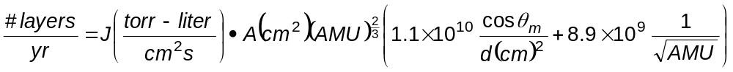
[10]
This represents a worst-case estimate because it assumes that all molecules adhere to the mirror surface and remain there indefinitely. T980008, “Bake Oven Requirements and Conceptual Design,” Appendix 1, discusses the effect of considering surface dwell time for contaminating molecules.
Eq. 10 will be implemented in the database which predicts the buildup of material on mirrors from out-gassing products.

Extrapolation of Optical Losses in LIGO from High-power Cavity Tests
The least model-dependent estimate of the potential for mirror contamination in LIGO comes from in-situ exposure of resonant cavities to samples of materials. Extrapolation of laboratory test results to LIGO will be performed as follows.
Assume that the ratio of loss buildup to material buildup, 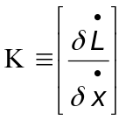, is an intrinsic property of the material under evaluation. Here is the rate of increase of optical loss (absorption or absorption-plus-scatter) in ppm/yr per optical surface and is the material buildup rate in monolayer/yr. Then, using equation 10 (and reintroducing the pumping speed dependence into numerator and denominator), the extrapolation from a laboratory-scale measurement to LIGO follows:
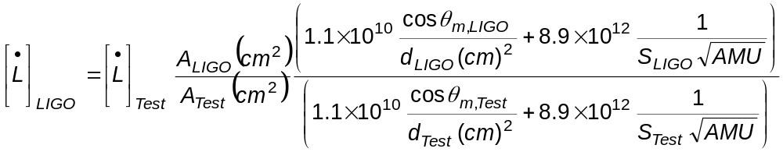
[11]
Note that if either the setup or the LIGO installation for the material does not have a direct view of the mirror, then the corresponding term in Eq. 11 will be equal to zero.

Determination of Out-gassing for Highly Condensable Organic Molecules
The calculations required to determine the surface coverage of a condensable gas are not as straightforward as estimating the surface coverage for an almost non-condensable gas. The surface coverage is not determined by merely calculating the flux onto the surface and multiplying by the product of the accommodation coefficient times the exposure time. The surface adsorbs and re-emits molecules and when out of equilibrium has an enormous pumping or emission capacity that dwarfs the pumping speed of the system. Hence, the simple technique of estimating the out-gassing rate of a substance by measuring the partial pressure of the gas, multiplying by the pumping speed of the system and dividing by the exposed area of the substance can result in substantial errors if the system is out of equilibrium. The estimated out-gassing rate is smaller than the actual rate.

A better approach is to use the Dubinin-Radushkevich adsorption theory (Refer to LIGO- T920009). In this theory at equilibrium, the surface coverage is given by

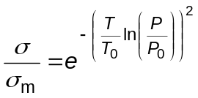

is the surface coverage in monolayers or torr liters/cm² while 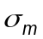 is the maximum surface coverage. At this coverage the equilibrium vapor pressure is P₀. T₀ is the average molecular binding energy to the surface expressed as a temperature and T is the temperature, both in K. The figure indicates the parameters used to apply the theory to our measurements. A substance with out-gassing rate J (torr liters/sec cm²) is placed in the vacuum system. The emitting area of the substance is A_{s}. The surface area of the vacuum system (including the stuff placed inside of it) is A_{sys}. The pumping speed out of the vacuum system is F (liters/sec) and the pressure throughout the volume of the system, V (liters), is P (torr).
Figure 4: Schematic for the calculation.
A substance that out-gases a condensable material has a surface area A_{s}, in the figure located in a sidearm of the system, though this is not essential to the model. The surface of the system initially has no surface loading of this material. The question is how to estimate the surface loading of the system as a function of time.

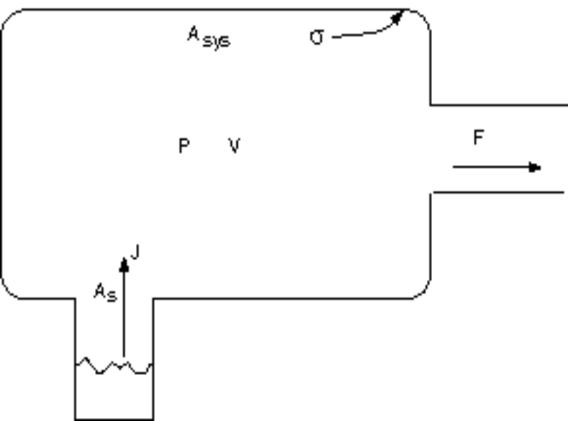

If one can assume that the pressure in the system is appropriate to the surface coverage given by the Dubinin-Radushkevich adsorption theory, the system is in a “dynamic” equilibrium on the collecting surface. There is still a net flow from the sample to the surface so there is no global equilibrium. Under these assumptions, the particle conservation equation is

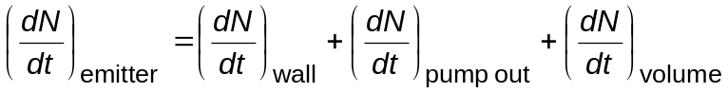

which can be rewritten in terms of the system parameters as

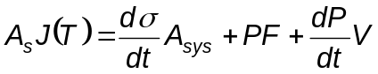

The first order differential equation for the evolution of the pressure in the system becomes

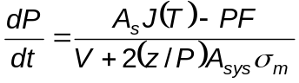

where

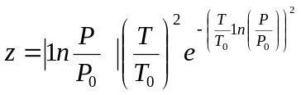

When the system is initially exposed to the source, the surface coverage is small and the dynamical equilibrium pressure is small. The denominator of the pressure derivative equation is dominated by the surface term and the numerator by its surface term. The time it takes for the system to come to pumping speed equilibrium where 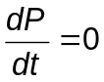and 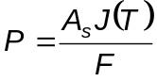is approximately given by: 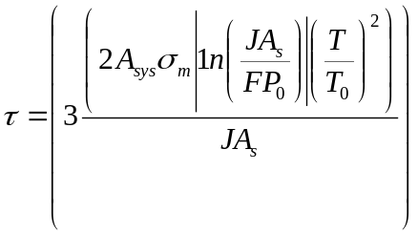

In order to determine the surface adsorption parameters, , P₀ and T_{0,} it is useful to measure the pressure changes vs. time by accumulation methods and to determine the equilibrium pressure under different pumping speeds and temperatures. Typical values for water determined from the beam tube project are given in 7.

Table 7: Typical values for water on hot rolled 304L stainless steel
T₀ | 1.0x10⁴ K
 | 100 monolayers = 2.8x10⁻³ torr liters/cm²
P₀ | 1.0x10⁻³ torr
J(300K) | 1.0x10⁻⁸ /t (hours) torr liters/sec cm²

An example calculation for a source in one of the LIGO instrumentation tanks might give an equilibration time of 200 days using typical parameters given in Table 8.

Table 8: Sample parameters leading to 200 day equilibration time
T₀ | 10⁴ K
T | 300 K
J | 10⁻⁹ torr liters/sec cm²
P₀ | 10⁻³ torr
 | 100 monolayers = 2.8x10⁻³ torr liters/cm²
F | 10³ liters/sec
A_{sys} | 10⁶ cm²
A_{s} | 10⁴ cm²

Figure 5 shows the relation between the surface coverage and the equilibrium pressure for the Dubinin - Radushkevich theory. The enormous range in pressure for a small change in surface coverage is the fundamental reason for the vacuum “stiffness” of the process.

Figure 5: Relation between the surface coverage and the equilibrium pressure for the Dubinin - Radushkevich theory
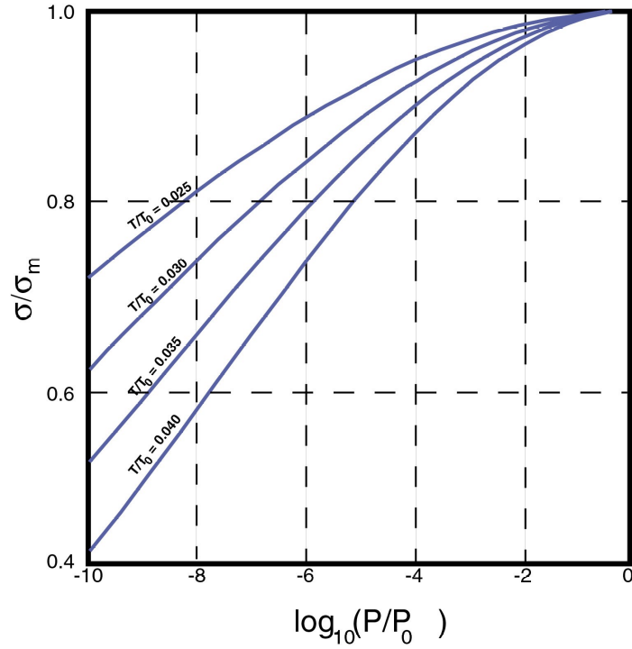

ABS: Any class of plastics based upon acrylonitrile-butadiene-styrene copolymers
An example of a suitable ultrasonic unit is the following: Branson Ultrasonics Corp. (Tel: +1.203.796.0400) Model 8210(latest model as of March, 1998: #8510) has a 5.5 gal. tank (19.5"x18"x6"). Transducer output is 320 watts @ 40khz. The tank can also be heated.
Walker & Sons Enterprises, Inc. 105 SE 16th Street, Newcastle, OK 73065 (405) 392-4721
Paint cans should be unlined, tin-coated steel or equivalent for class B compatibility, such as MPC128UL-BP from www.bascousa.com.
In previous versions of this document it was erroneously reported that VacSeal was manufactured by Perkin Elmer.

