1 Safety 2
2 Objective and Scope 2
3 Documents 2
4 Documenting the Assembly Process 3
5 Vacuum Compatibility 3
6 Fasteners 4
7 Overview of Assembly Process 5
8 Safety – Handling Suspension Wire 6
9 Assembling Upper Wires 7
10 Assembling Intermediate Wires 10
11 Assembling Lower Wires 13
12 Assembling Upper Blade Guards 17
13 Assembling Upper Blade Rotational Adjusters 18
14 Assembling Barrel Earthquake Stops 22
15 Assembling Face EQ Stops 24
16 Assembling AOSEM Alignment Assemblies 26
17 Overall Assembly 29
18 Preparing The Weldment 30
19 Installing the Rotational Adjusters 31
20 Installing Barrel EQ Stops 34
21 Assembling the Intermediate Mass (M2) 35
22 Assembling the Lower Mass (M3) 36
23 Installing Intermediate and Lower Masses and Face EQ Stops 38
24 Assembling Magnets – Upper Mass 41
25 Assembling the Upper Mass (M1) 43
26 Installing the Upper Mass and Coil Holder 53
27 Suspending the Masses 58
28 Creep Bake 60
29 Bonding Magnet Assemblies to Intermediate Mass 69
30 Bonding Magnet Assemblies to Lower Masses 72
31 Installing AOSEM Brackets 77
32 Installing AOSEMs and BOSEMs 78
33 Aligning the HSTS for the 6 Degrees of Freedom 80
34 Replacing Lower Mass with the Optic 83

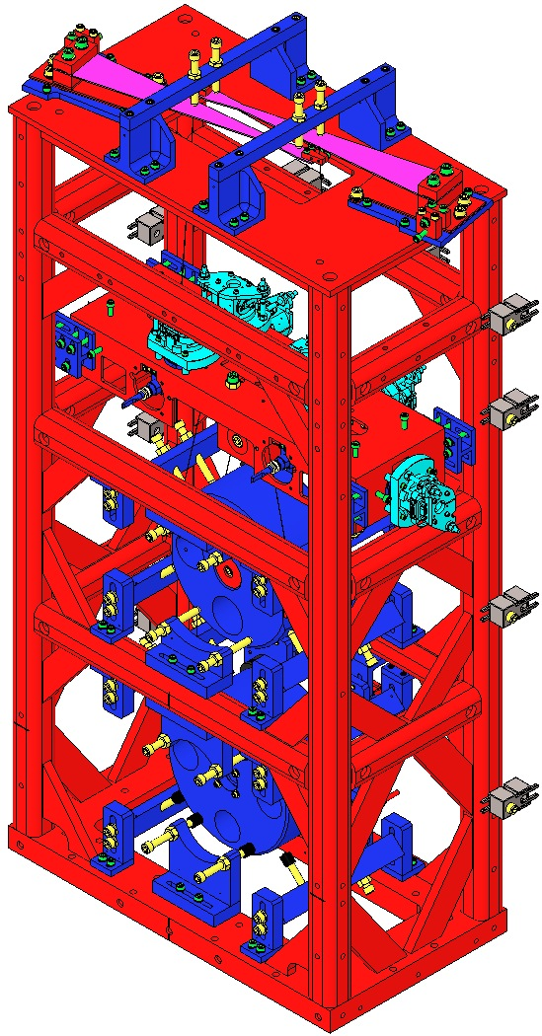  Fig 1: HSTS | 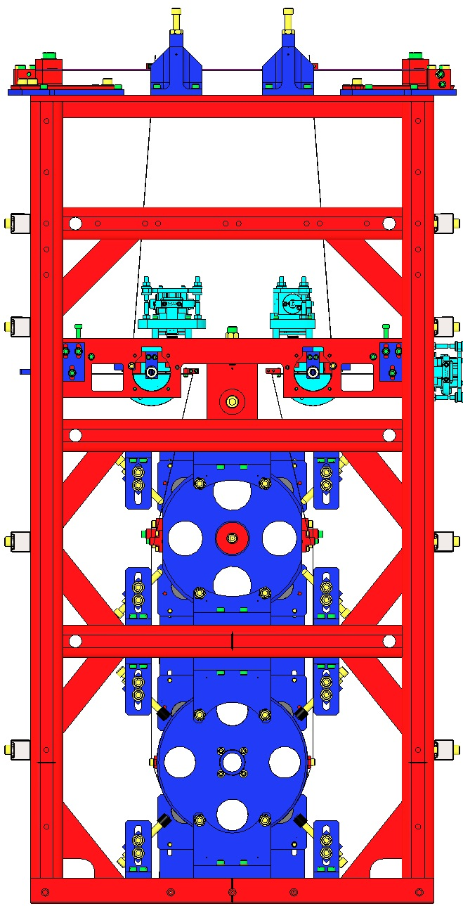  Fig 2: Front | 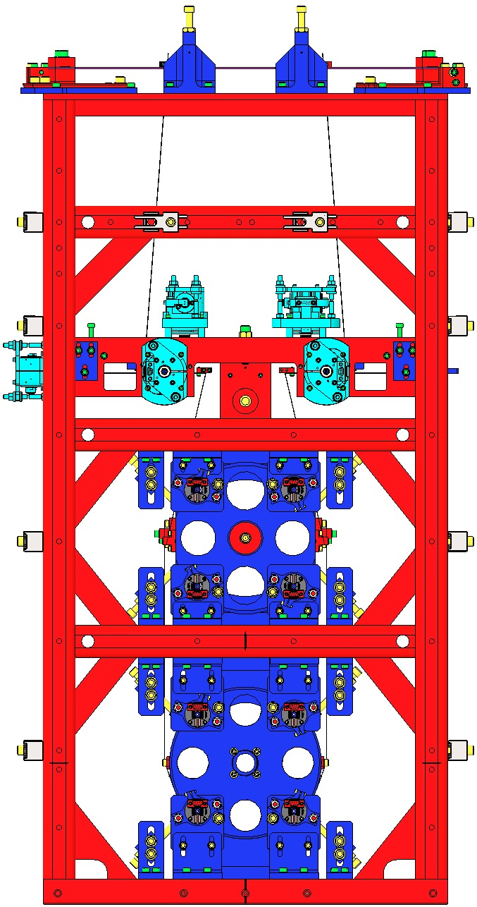  Fig 3: Rear

Safety
Review E0900332 HSTS Assembly and Installation Hazard Analysis.

Objective and Scope
Subassembly and Final Assembly of the aLIGO HAM Small Triple Suspension, including:
- General considerations for assembly;
- Use of the Assembly Fixtures.

Documents
E0900332 HSTS Assembly and Installation Hazard Analysis
E1100471 HSTS Assembly and Installation Documentation
G1100107 HSTS Introduction
T0900435 HSTS Final Design Document
E030518 HSTS Assembly Instructions (this document)
D020700 HSTS Assembly
D040391 HSTS Assembly Fixtures
E0900334 HSTS Installation Procedure
T0900467 HSTS Test Plan
T0900559 HSTS Choice of Blades
E0900047 LIGO Contamination Control Plan
E1000169 Blade Characterization Spreadsheet
E960022 LIGO Vacuum Compatibility, Cleaning Methods and Qualifications Procedures
E990196 Magnet/Standoff Assembly Preparation Specification (needs to be updated.)
T000053 aLIGO, Universal Suspension Subsystem Design Requirements
T010007 Cavity Optics Suspension Subsystem Design Requirements
T010103 aLIGO Suspension System Conceptual Design
T0900559 Blade Pairings Spreadsheet

Documenting the Assembly Process

Documents
T1100003 Building Suspensions Subassemblies in ICS.

Procedure

See the above document.

Data for each Final Assembly will be stored in ICS; using a Process Traveler is optional:
Item | Assembly 1  Part Name | Assembly 1  Part Number | Serial Number | Position | Variant | Weight
Each Mass | X | X | X | X |  | X
Each Blade | X | X | X | X
Each Blade Clamp | X | X | X | X | X
Each OSEM | X | X | X | X
Each Optic | X | X | X |  |  | X
Note regarding Subassembly weights: Each Subassembly must have 3 distinct weights recorded:
- Estimated Weight Calculated by SolidWorks;
- Actual Weight Measured by a lab scale after built to the nominal mass;
- Balanced Weight Totaled after Suspension is balanced (i.e. Actual Weight + Add-On Weights).
When Addable weights are used, note their location on the Mass.

Vacuum Compatibility

General Handling
All procedures must be performed in a clean room environment while suited up in:
- Coverall with Hood
- Boot style shoe covers
- LIGO-approved latex gloves
- Glove Liners and Safety Glasses when working with Wire
All Tables surfaces used for Class A components should be wiped down daily with Isopropanol.

Review E0900047 Contamination Control Plan for details. All HSTS parts are Class A hardware and once cleaned and baked should not come into contact with anything but Class A or B hardware.

Cleaning Components
Clean items per E960022 Vacuum Compatibility, Cleaning Methods and Qualification Procedures.

Inspection
After baking, sample check the cleanliness of blind-tapped and through-tapped holes with a clean swab dampened with alcohol for a minimum of 10% of the holes in case any material has leached out during baking. If any discoloration of the swab is evident, then the part must go through at least one more wash cycle before repeating the bake. After inspection, wrap items per E960022.

Fasteners

Silver Plated Stainless Steel
All Silver Plated fasteners are also SSTL, and so are labeled simply “AgPlated”, not “AgPlated SSTL”.

Screw Applications
Screw Type | Screw Description | Receiver Application
AgPlated SSTL | Silver-Plated Stainless Steel | - Stainless Steel threads
SSTL | Stainless Steel | - Aluminum Threads  - Helicoil Threads
Vented | SSTL Screw with holes | - Rare Vacuum Compatibility situations

Helicoils
Helicoils are specified for:
- Certain SSTL applications to avoid using AgPlated fasteners;
- Certain applications where assembly / disassembly recurs.
- Helicoils are cleaned, baked and installed with clean tools in a Class 100 clean room.

Torque Values
- Except where noted, Socket Head Cap Screws are to be tightened per the following table, which is based on T1100066 – Torque Values.
- “Generic” applies to Screws that are non-plated, non-vented, and not marked as Holokrome.
- Holokrome Screws are marked as such on the Screw.
- UC (UC Components, Supplier) Screws are AgPlated.
- All Screws are UNC (coarse threaded), except Pitch Adjustment Set Screw.
 | Torque (in-lb)
Supplier | Generic  (unmarked) | Holokrome | UC | UC | UC
Type | Unplated | Unplated | Ag-Plated | Ag-Plated, Vented | Vented
Size
#2-56 | 2.5 | 4 | 4 | 2.9 | 2.9
#4-40 | 5.2 | 6 | 6 | 6.7 | 6.7
#8-32 | 19.8 | 30 | 30 | 25.2 | 25.2
¼-20 | 75.2 | 100 | 100 | 85.8 | 85.8

Tightening Screw Pairs
To ensure proper alignment of components and to ensure even clamping pressure, it is important to perform the final few turns of the bolts evenly, almost in tandem. That is, after pairs of Screws have first been assembled and snugged up finger tight, when drawing up the Screws to their final Torque value, each Screw should be turned no more than ¼ turn before switching to the opposite screw.

Overview of Assembly Process

General sequence:
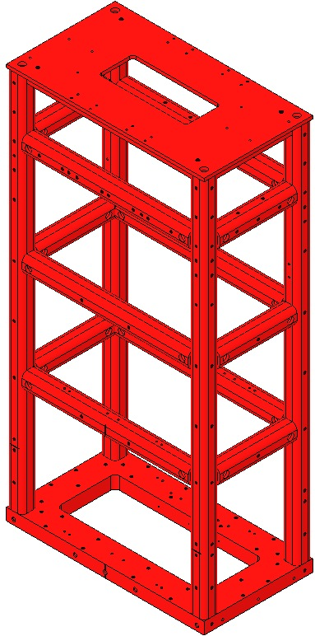
- Subassemblies are built first, in any convenient order.
- Main Assembly is built, mostly from Subassemblies.
Main Assembly sequence:
- Rotational Adjusters
- Intermediate Mass
- Lower Wire
- Lower Mass
- Upper Mass + Upper and Intermediate Wires
- Balancing
- OSEMS

Frame of Reference
Using the Right-Hand-Rule when viewed from behind the Weldment, with the origin at the center bottom of the Weldment, the positive X, Y and Z directions are shown at right. | +Z  +X  +Y  Front  Fig 4: Frame of Reference

Safety – Handling Suspension Wire
The Wire used for all Suspensions is a hard temper carbon steel, delivered on large spools. When unwound for cleaning, cutting and preparation for clamp-wire-clamp assembly, care must be taken such that the wire’s strong potential energy (making it act like a coiled spring) does not cause injury.

Safety Glasses, provided in all Clean Room garbing areas, must be worn during all wire work.

Glove Liners should be worn under the latex clean-room gloves as a protective layer and extra barrier. The E0900047 Contamination Control Plan, p. 13, provides further information on Glove Liners.

For easier holding, bend a small section (~3”) of the end of the Wire. The bent section can be hooked around your thumb and held by your index finger. Un-spool the proper length of Wire – including extra for handling – and control the area of the Wire that will be cut. Add a 2nd bend at the newly cut end for easier handling.

Change your gloves and wipe each Wire at least 3 times each, until nothing further appears on each Wipe, using:
  - A Cleaning Wipe with Methanol;
  - A Cleaning Wipe with Acetone;
  - A Cleaning Wipe with Isopropanol;
changing Wipes until the wire is completely clean. Clean the Wire while it is coiled; do not stretch the wire until it is taut for cleaning. It can be laid down on a clean surface during this process. Clean one section at a time.

Transfer the Wire to the Assembly Jig. Use the Jig clamps to hold the Wire in place, and then cut off and discard the bent Wire ends.

Assembling Upper Wires

Documents
E0900332 HSTS Assembly and Installation Hazard Analysis
D0901854 HSTS Upper Wire Assembly
E960022 Vacuum Compatibility, Cleaning Methods and Qualification Procedures

Materials
Qty | U | ID | Description
1 | Ea | D0902108 | HSTS Upper Wire Assembly Jig
4 | Ea | D980184 | Clamp, LOS Long
1 | Ea | D020481 | HSTS Upper Mass C-Clamp
1 | Ea | D0901999 | HSTS Upper Mass Clamp, Inside
1 | Ea | D0901998 | HSTS Upper Mass Wire Clamp, Outside
1 | Ea | D020198 | HSTS Upper Blade Wire Clamp
1 | Ea | D0901994 | HSTS Upper Blade Wire Clamp, Outside
4 | Ea | NA | Socket Head Cap Screw 2-56 x .375” AgPlated SSL
4 | Ea | NA | Washers, Flat, #2
2 | Ea | NA | Socket Head Cap Screw 8-32 x .500”
2 | Ea | NA | Socket Head Cap Screw 4-40 x .500”
1 | Spl | NA | Music Wire, 0.014” / 0.36mm dia.
1 | Ea | NA | Hang Weight, 4482.7g
2 | Ea | PNHS-99 | Wipes / Polynit Heatseal
1 | Btl | NA | Methanol
1 | Btl | NA | Acetone
1 | Btl | NA | Isopropanol

Procedure
2 Assemblies are required per HSTS.  Use safety glasses per E0900332.  Ensure D0902108 Assembly Jig has been cleaned Class B per E960022.  Ensure Jig is fully assembled per the drawing.  Attach the Jig to an Optical Table with 4 D980184 LOS Clamps, ensuring the Clevis extends beyond the edge of the Table to allow clearance for the Hang Weight. |  | 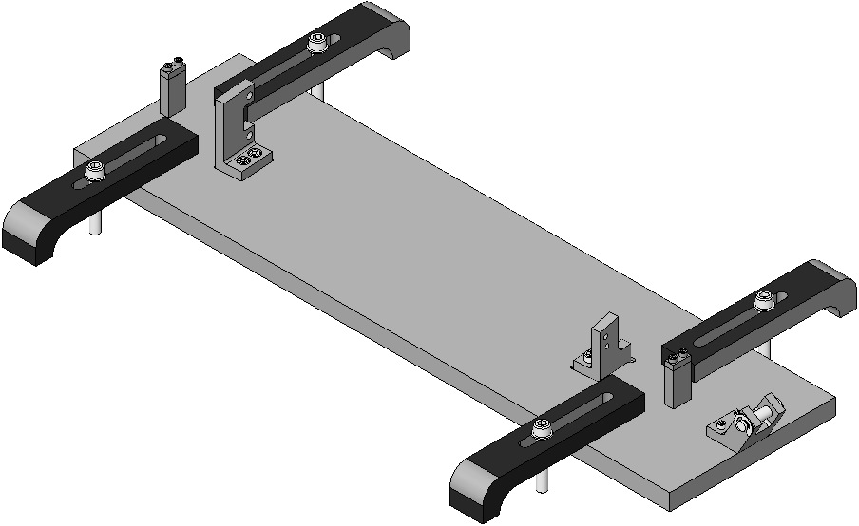  Class B  Table Edge  Clevis  LOS Clamp  Class A  Fig 5: Upper Wire Jig
Assemble all the Clamps you’ll need, and do not tighten the clamps.  Each C-Clamp includes:  - 1 D020481 Upper Mass C-Clamp  - 1 D0901999 Upper Mass Wire Clamp, Inside  - 1 D0901998 Upper Mass Wire Clamp, Outside  - 2 SHCS 2-56 x .375” AgPlated SSTL  - 2 Washers, Flat, #2  Each L-Clamp includes:  - 1 D020198 Upper Blade Wire Clamp  - 1 D0901994 Upper Blade Wire Clamp Outside  - 2 SHCS 2-56 x .375” AgPlated SSTL  - 2 Washers, Flat, #2 |  |  |  | 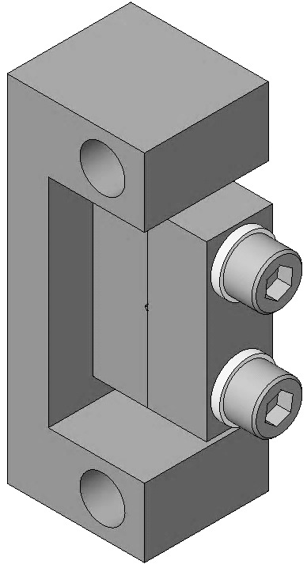  D020481  (2)  D0901999  (2)  D0901998  (2)  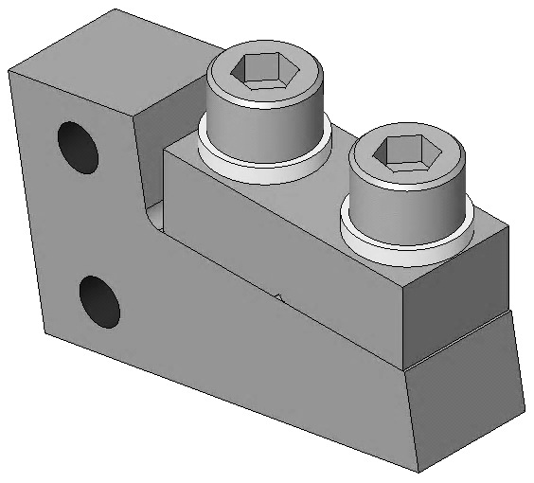  D0901994  (2)  D020198  (2)  Fig 6: Clamps
On the Jig, assemble 1 C-Clamp to the outboard side of the D0902110 Upper Wire Clamp Mount with:  2 SHC Screws 8-32 x .500” AgPlated SSTL  On the Jig, Assemble 1 L-Clamp to the outboard side of the D0902111 Blade Clamp Mount with:  2 SHC Screws 4-40 x .500” AgPlated SSTL  2 #4 Flat Washers |  |  |  | 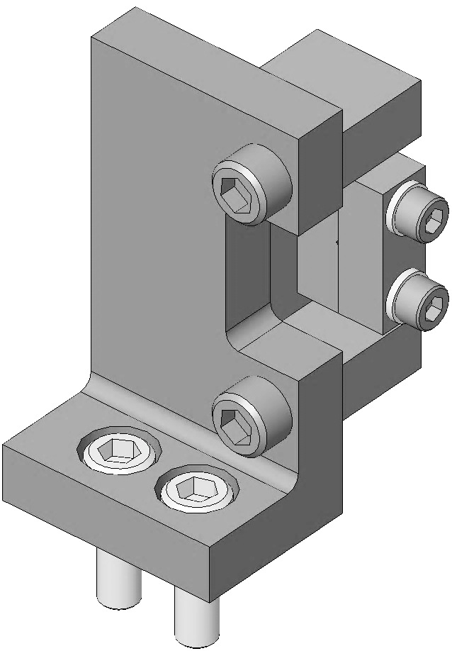  D0902110  Screws (2)  (2)  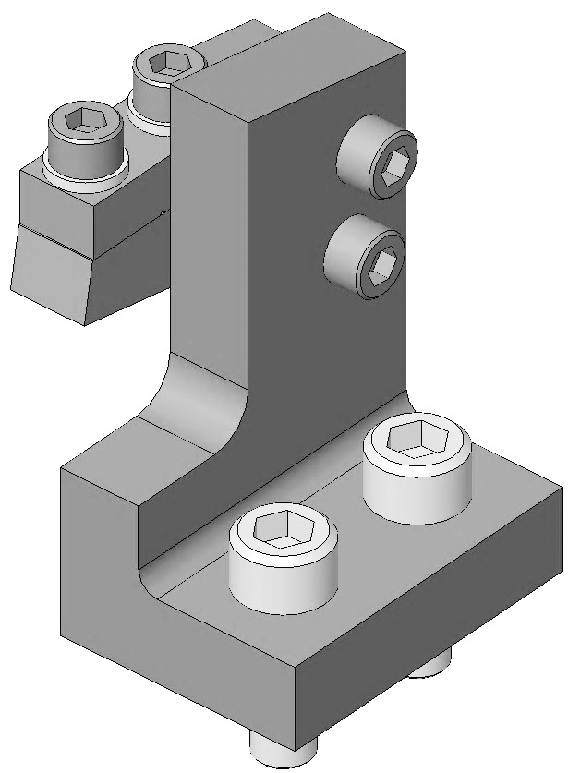  D0902111  (2)  Screws (2)  (2)  Fig 7: Clamp Mounts
Cut 36” of Wire from the spool.  - Clean the Wire per Section 12.4  Feed the Wire through the Clevis and Clamps, as shown:  1) Over Clevis Pin  2) 1st Start Post;  3) L-Clamp;  4) C-Clamp;  5) 2nd Start Post  Tighten the 2nd Start Post Clamp, after feeding through about ½” of wire. |  |  | 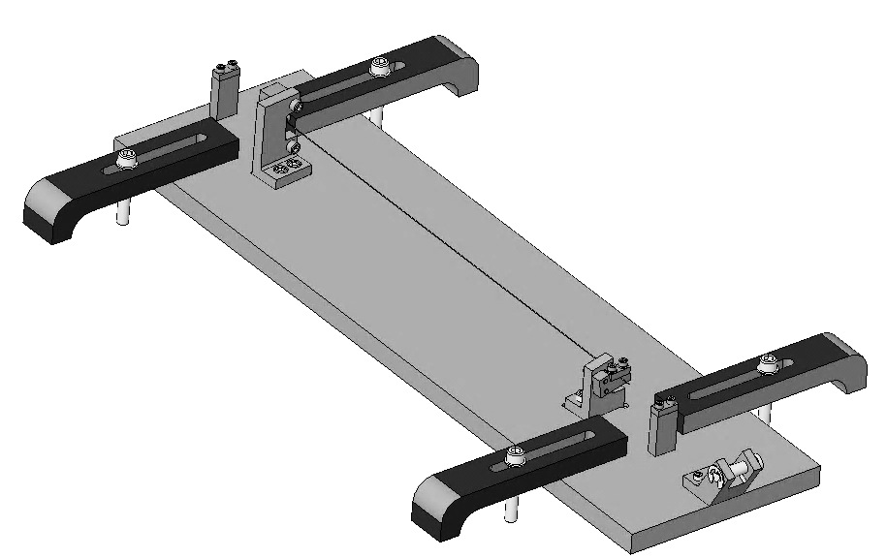  5  4  2  1  3  Fig 8: Wire Path
Tie a simple overhand knot, about ½” dia. in the un-clamped end of the Wire. Slide the 4482.7 g Hang Weight hook through the loop and tighten the knot. The Wire should now be taught, due to the hanging weight.  Allow the wire to hang as is, for at least 5 minutes. |  |  |  |  | Fig 9: Hang Wt.
Tighten Clamps in the order shown, tightening clamps 2 and 3 to 16 in-lb.  Remove the Hang Weight from the wire.  Measure the Wire length between the two clamps and note in the ICS Assembly Load.  Cut the Wire as shown, 2 locations.  To avoid puncture injury, fold over the 2 cut ends of Wire on the final Assembly. |  |  | 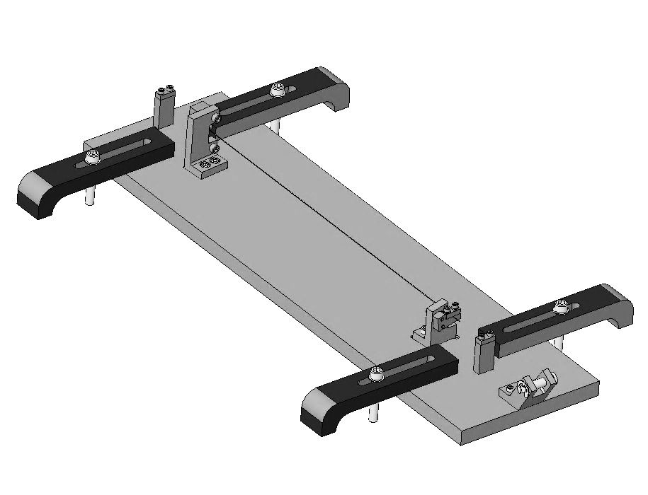  3  1  2  Cut Wire  Cut Wire  Fig 10: Clamping and Cutting the Wire
Remove the 2 Clamps from the Jig.  The completed assembly is shown here. | Fig 11: Upper Wire Assembly

Assembling Intermediate Wires

Documents
E0900332 HSTS Assembly and Installation Hazard Analysis
D0901905 HSTS Intermediate Wire Assembly

Materials
Qty | U | ID | Description
1 | Ea | D0902526 | HSTS Intermediate Wire Jig
4 | Ea | D980184 | Clamp, LOS Long
1 | Ea | D020132 | HSTA Lower Blade Wire Clamp
1 | Ea | D030044 | HSTS Lower Blade Wire Clamp Plate Angled
1 | Ea | D0901904 | HSTS Intermediate Wire Clamp Mount, Lower
1 | Ea | D0901903 | HSTS Intermediate Wire Clamp, Outside
5 | Ea | NA | SH Cap Screw, 4-40 x .375”, AgPlated SSTL
4 | Ea | NA | SH Cap Screw, 2-56 x .375”, AgPlated SSTL
2 | Ea | NA | Washer #2
2 | Ea | NA | Washer #4
3 | Ft | NA | Wire, Steel Music, 0.008” / 0.20 mm dia.
2 | Ea | PNHS-99 | Wipes / Polynit Heatseal
1 | Btl | NA | Methanol
1 | Btl | NA | Acetone
1 | Btl | NA | Isopropanol
1 | Ea | NA | Hang Weight, 1460g

Procedure
Table Edge

Jig

Clevis
4 Assemblies are required per HSTS.  Use safety glasses per E0900332.  Ensure Assembly Jig D0902108 has been cleaned Class B per E960022.  Ensure Assembly Jig D0902526 is fully assembled per the drawing.  Attach the Jig to an Optical Table with 4 LOS Clamps, ensuring the Clevis extends beyond the edge of the Table to allow clearance for the Hang Weight. |  | 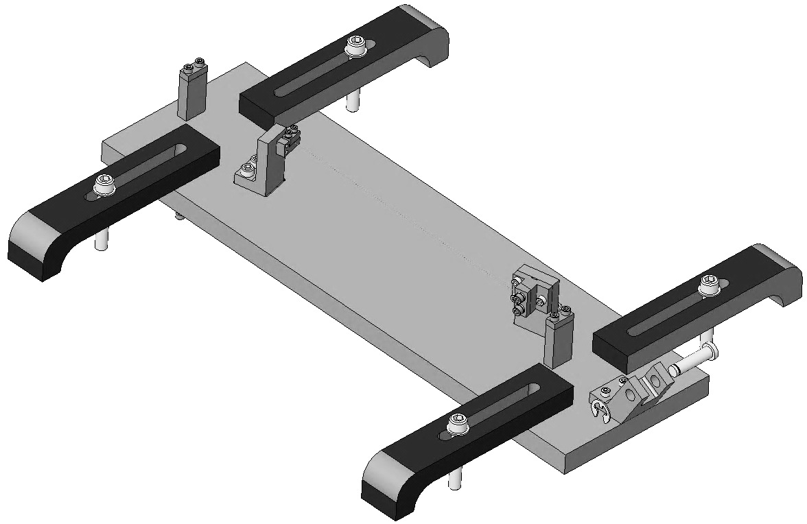  Table Edge  Clevis  Jig  Clamp  Fig 12: Intermediate Wire Jig
Assemble – but do not tighten – all the Clamps you’ll need.  Each Lower Blade Wire Clamp includes:  1 D020132 Lower Blade Wire Clamp  1 D030044 Lower Blade Wire Clamp Plate, Angled  2 SHCS 2-56 x .375” AgPlated  2 Washers, Flat, #2  Each Intermediate Wire Clamp includes:  - 1 D0901904 Int Wire Clamp Mount, Lower  - 1 D0901903 Int Wire Clamp, Outside  - 2 SH Cap Screws 4-40 x .375” AgPlated  - 2 Washers, Flat, #4 |  |  |  | 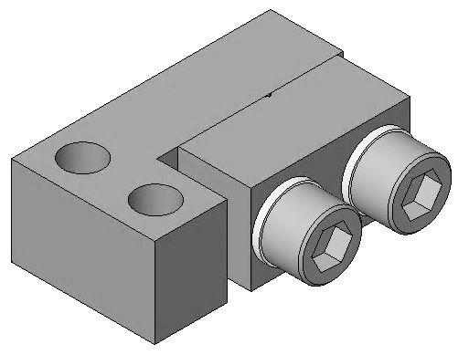  D020132  D030044  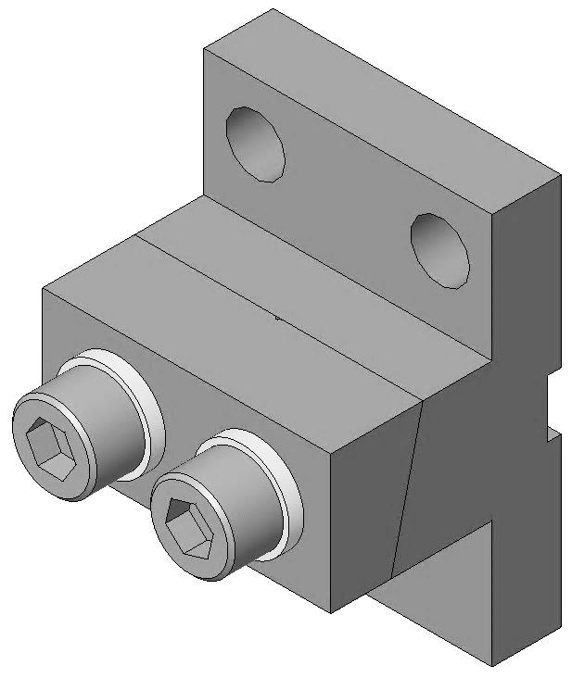  D0901904  D0901903  Fig 13: Clamps
Assemble one L-Clamp to the Jig, using:  - 2 SHC Screws 2-56 x .375” AgPlated  Assemble one Intermediate Clamp to the Jig, using:  - 3 SHC Screws 4-40 x .375” AgPlated |  |  | L-Clamp  Intermediate Clamp  Fig 14: Clamps mounted on Jig
Cut 24” of Wire from the spool.  Clean the Wire per Section 12.4  Feed the Wire through the Clevis and Clamps, as shown:  1) Over Clevis Pin  2) 1st Start Post;  3) L-Clamp;  4) C-Clamp;  5) 2nd Start Post  Tighten the 2nd Start Post Clamp after feeding through ½” of wire. |  |  | 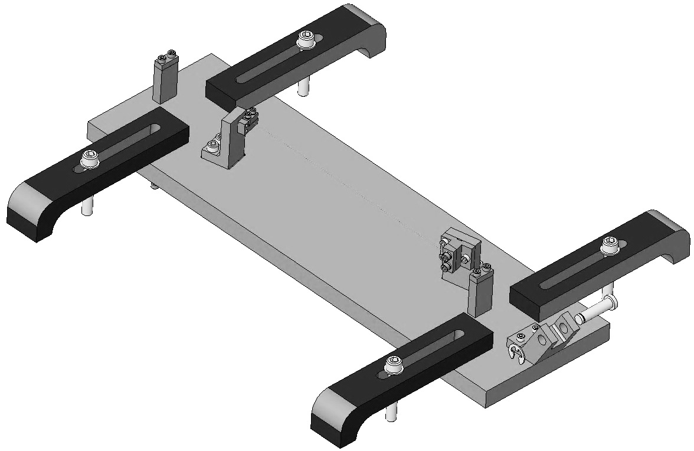  2  5  4  1  3  Fig 15: Wire Path
Tie a simple overhand knot, about ½” dia. in the un-clamped end of the Wire. Slide the 1460g Hang Weight hook through the loop and tighten the knot. The Wire should now be taught, due to the hanging weight.  Allow the wire to hang as is, for at least 5 minutes. |  |  |  |  | Fig 16: Hang Weight
Tighten Clamps in the order shown, tightening clamps 2 and 3 to 7 in-lb.  Remove the Hang Weight from the wire.  Measure the Wire length between the two clamps and note in the ICS Assembly Load.  Cut the Wire just outboard of the L-Clamp and Intermediate Clamp.  To avoid puncture injury, fold over the 2 cut ends of Wire on the final Assembly. | Cut Wire  2  3  Cut Wire  1  Fig 17: Clamp and Cut Wire
Remove the 2 Clamps from the Jig. The completed assembly is shown here. |  |  |  | Fig 18: Intermediate Wire Assembly

Assembling Lower Wires

Documents
E0900332 HSTS Assembly and Installation Hazard Analysis
D0901902 HSTS Lower Wire Assembly

Materials
Qty | U | ID | Description
1 | Ea | D0902524 | Lower Wire Jig Assembly
4 | Ea | D980184 | Clamp, Long
4 | Ea | NA | Socket Head Cap Screw, ¼-20 x 2” AgPlated
2 | Ea | D1200108 | HSTS Lower Wire Clamp Base
2 | Ea | D1200188 | HSTS Lower Wire Clamp Blank Top
4 | Ea | NA | SHCS 8/32 x .626”, AgPlated
6 | Ea | NA | SHCS 8/32 x .500” SSTL
4 | Ea | NA | Washer, Flat, #8, NAS 620 CB
10 | Ft | NA | Wire, Steel Music, .0047”
2 | Ea | NA | Hang Weight, 1440 g
2 | Ea | PNHS-99 | Wipes / Polynit Heatseal
1 | Btl | NA | Methanol
1 | Btl | NA | Acetone
1 | Btl | NA | Isopropanol
1 | Ea | NA | Vise Grip, 6”, Needle Nose
1 | Ea | NA | Electronic Microscope

Procedure
1 assembly is required per HSTS.  Use safety glasses per E0900332.  Ensure Assembly Jig D0902524 has been cleaned Class B per E960022.  Ensure the Jig is assembled properly.  - The Start Posts are no longer used.  - 1 End Post is no longer used.  Attach the Jig to an Optical Table corner such that both ends extend beyond the Table edges  - 4 D980184 Clamps  - 4 Socket Head Cap Screws  ¼-20 x 2” AgPlated |  | 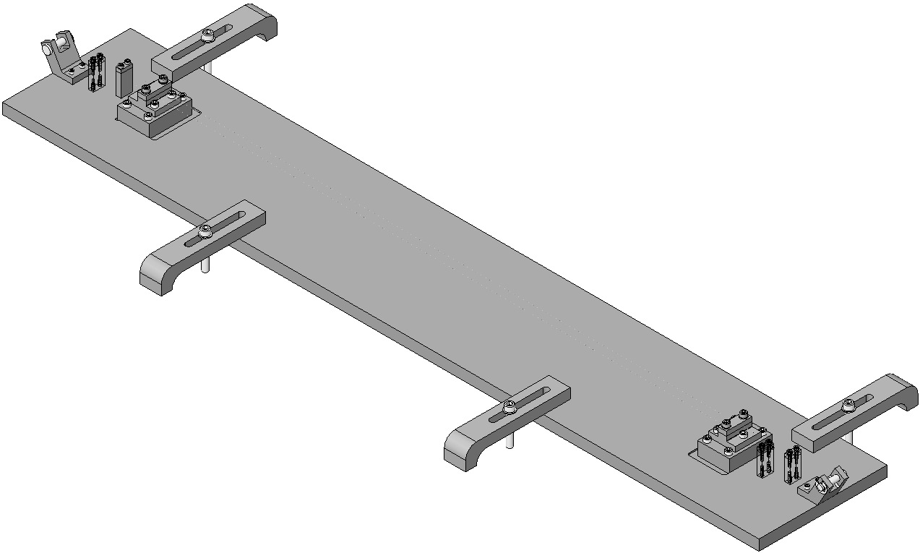  Start & End Posts removed  Start Post removed  Table  Edge  Fig 19: Lower Wire Assembly Jig
Assemble to the Jig:  2 D1200108 Clamp Base  - 4 (not 6) Socket Head Cap Screws  8/32 x 0.50” SSTL  2 Screws are omitted to provide clearance for the Machinist’s Square.  Align the Clamp Mounts with the Jig Blocks using the Machinist’s Square, and Torque to 20 in-lb. |  |  | 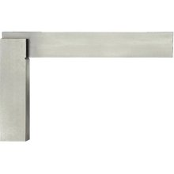  Base with 2 Screws  Machinist’s  Square  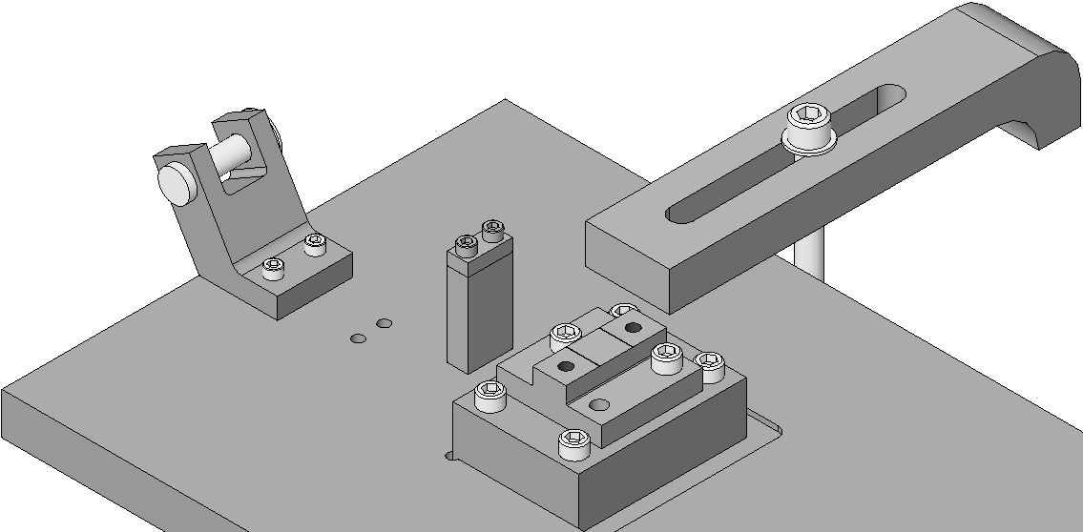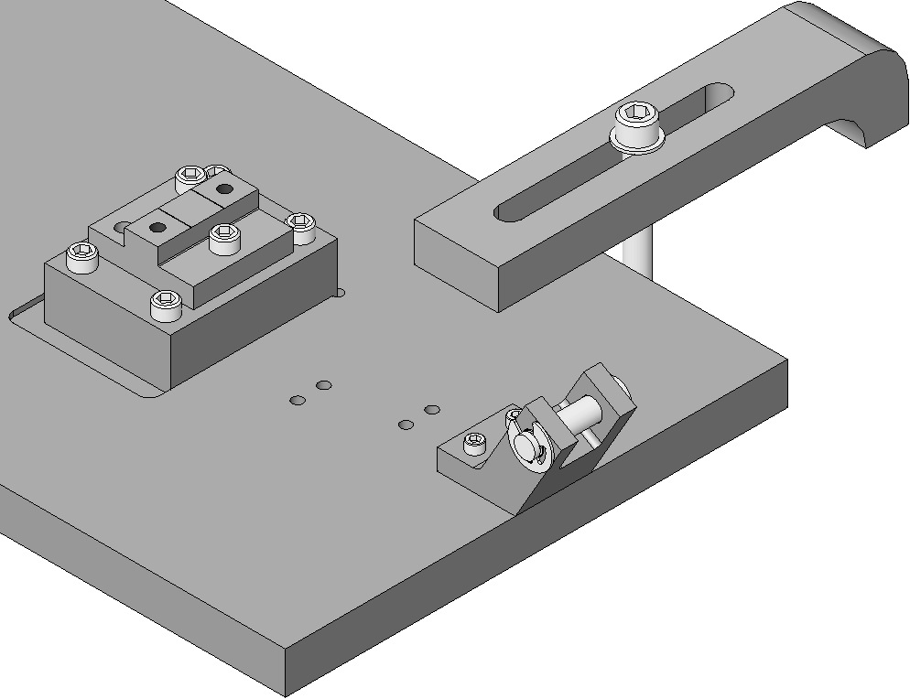  Block  Fig 20: Clamps with 2 Screws each
Assemble the 1st Wire  Cut 2 48” pieces of .0047” Wire from the spool.  Clean the Wire per Section 12.4  Lay the 1st Wire down on the far-side Wire Grooves of the 2 Clamp Bases.  Feed the LH end of the Wire through the LH Start Clamp, leaving about ½” of Wire beyond the Clamp.  Drape the RH end of the Wire over the RH Clevis.  Lay out the wire in a straight line from the Start Clamp, across the Clamp Bases and over the Clevis.  Tighten the 2 Start Clamp Screws to 30 in-lb. | 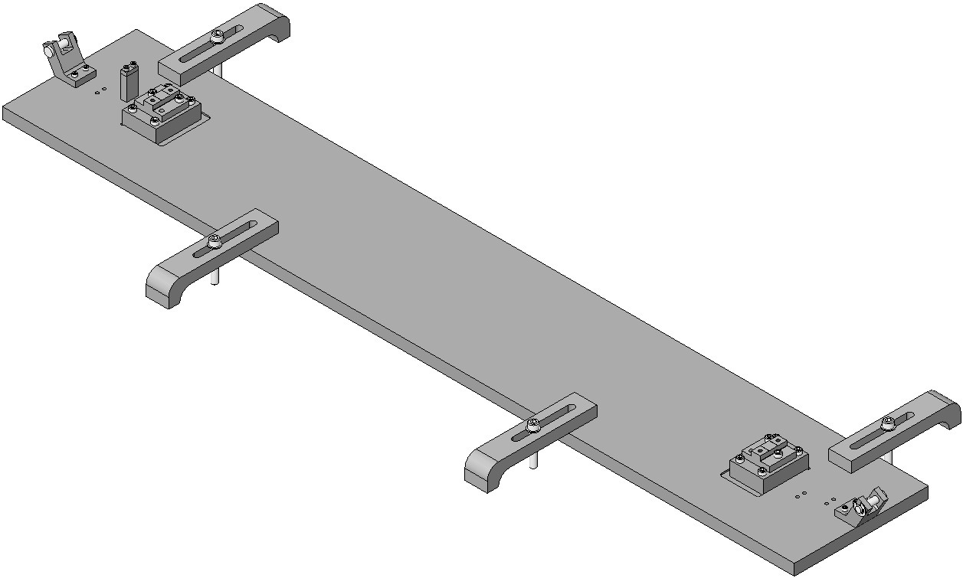  LH Start Clamp  Fig 21: Installing 1st Wire
Create a small loop in the free end of the Wire and tie a Square Knot to secure the Loop.  Slide the Hang Weight hook through the Wire Loop and allow the Weight to pull the Wire taught.  Ensure the Wire lies smooth and straight from the Start Clamp, across the 2 Wire Grooves in the Clamp Bases, and across the Clevis.  Leave the Weight on the Wire for at least 5 minutes. |  |  | 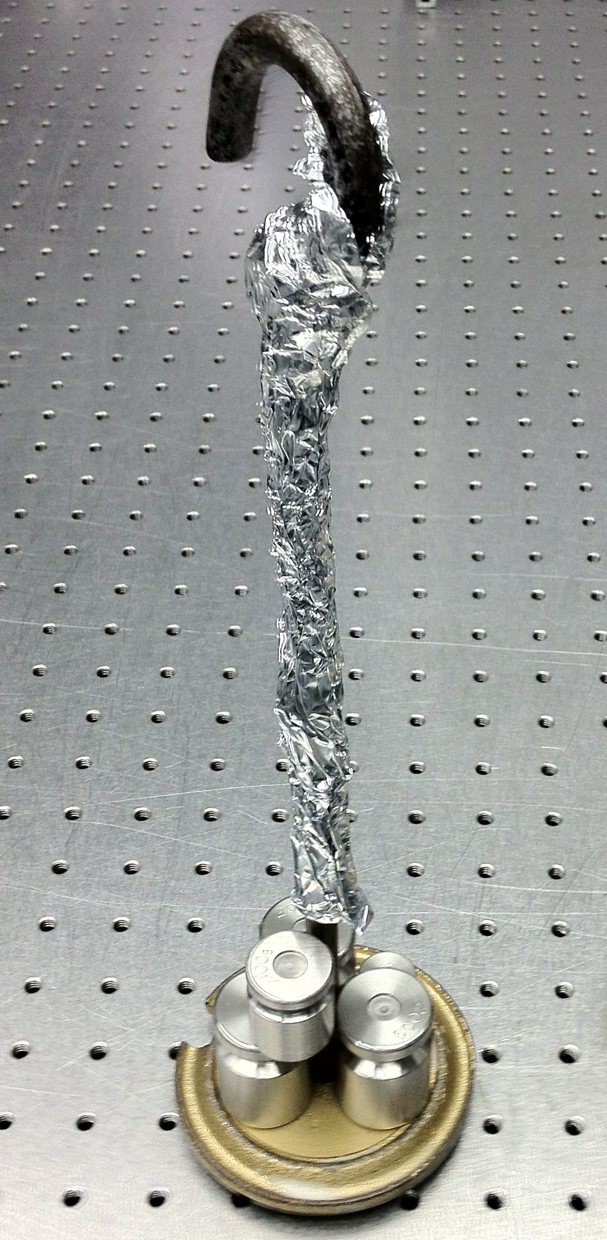  Fig 22: Hang Weight
Assemble the 2nd Wire  Lay the 2nd Wire down on the near-side Wire Grooves of the 2 Clamp Bases.  Drape the LH end of the Wire over the LH Clevis.  Ensure the Wire is lying in a straight line across the Clamp Bases and over the Clevis.  Lay the 2 D1200188 Clamp Tops on top of the Wires and Clamp Bases.  Assemble through the RH Clamp Base and Clamp Top:  - 2 Socket Head Cap Screws  8/32 x .625” AgPlated  - 2 Flat Washers  Inspect the Clamps from the side, to verify the Wires are fully seated in the Grooves of each bottom Clamp.  Align the Clamp Top with the Clamp Base using the Machinist’s Square.  Torque to 30 in-lb. | 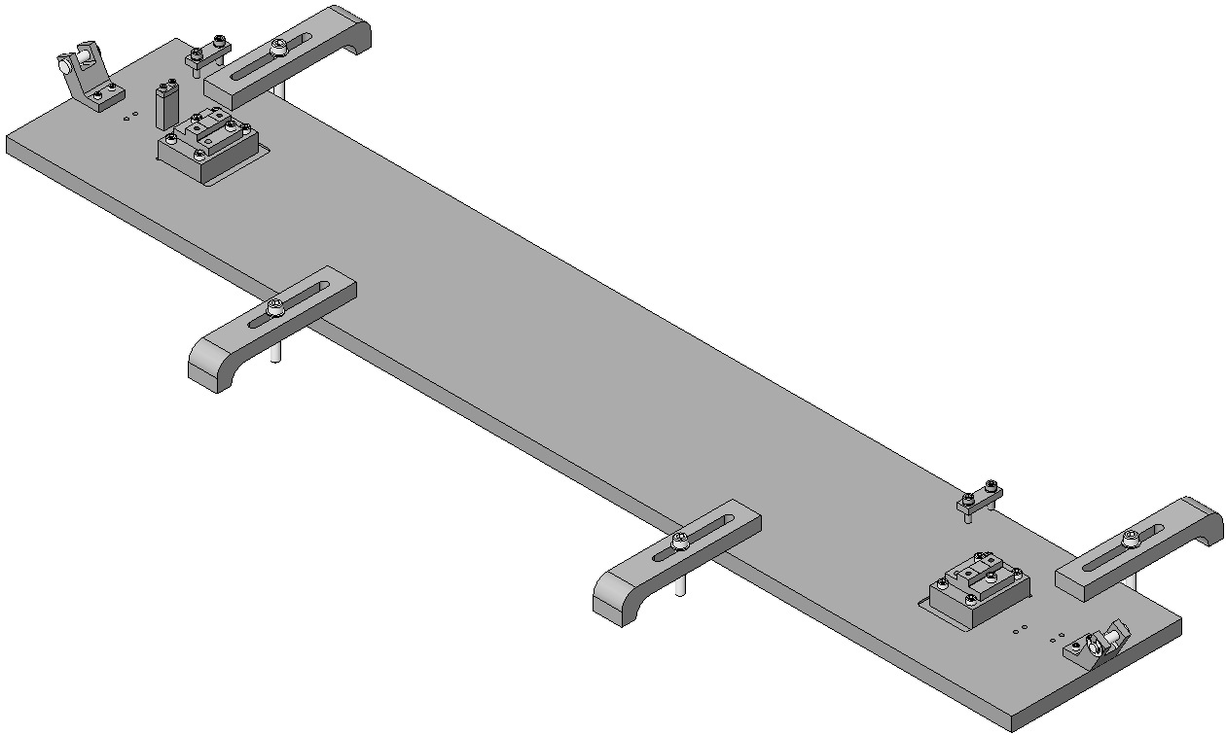  Fig 23: Installing the 2nd Wire

Ensure the Wire is lying in a smooth, straight line across the other Clamp Base and across the LH Clevis.

Leave the Weight on the Wire for at least 5 minutes.

Assemble through the LH Clamp Base and Clamp Top:
- 2 Socket Head Cap Screws
8-32 x .625” AgPlated
- 2 Flat Washers
Inspect the Clamps from the side, to verify the Wires are fully seated in the Grooves of each bottom Clamp.
Align the Clamp Top with the Clamp Base using the Machinist’s Square.
Torque to 30 in-lb.
Remove the Hang Weights from the Wires.  Cut the Wires just outboard of the 2 Lower Wire Clamps, making three cuts total.  To avoid puncture injury, fold over the 4 cut ends of Wire on the final Assembly.  Remove the Assembly from the Fixture:  - Loosen the 2 inboard Screws  - Loosen the 4 outboard Screws | 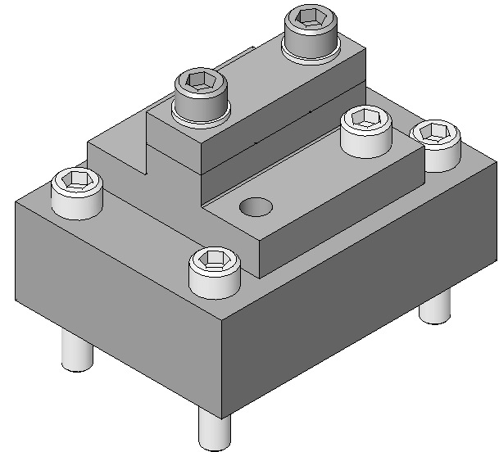  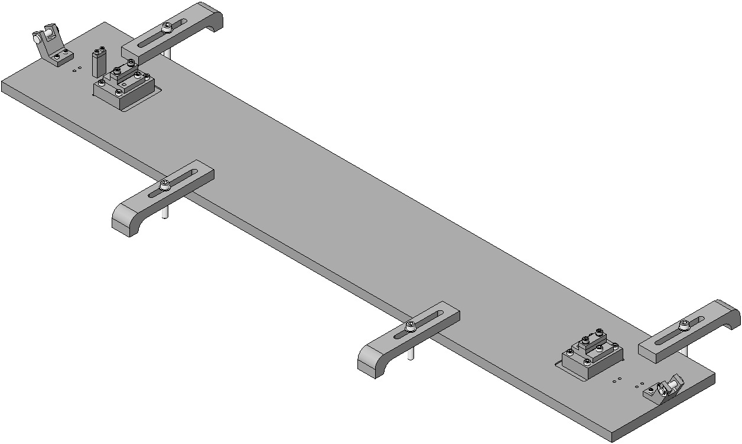  Loosen inboard Screw first  Cut  Cut  Fig 24: Measuring and cutting, first Wire
Finished lower wire, Clamp-Wire-Clamp assembly: 2 Wires, 2 Clamps. |  |  |  | 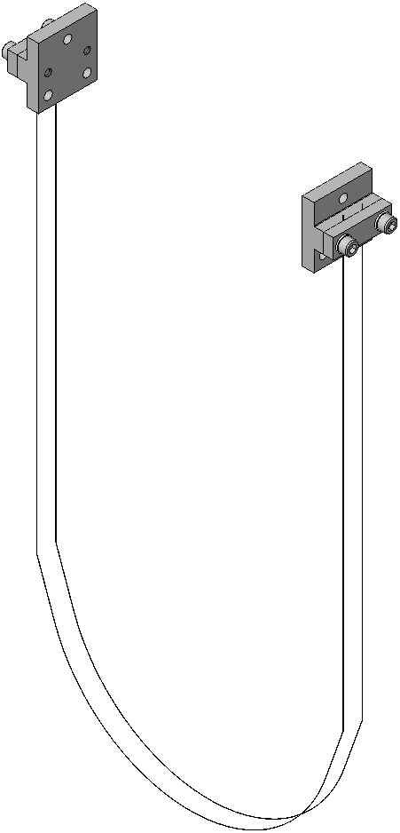  Fig 25: Lower Wire Assembly complete

Assembling Upper Blade Guards

Documents
D0901934 HSTS Upper Blade Guard Assembly

Materials
Qty | U | ID | Description
2 | Ea | D0901936 | HSTS Blade Guard Riser
1 | Ea | D0901935 | Blade Guard Crossbeam
4 | Ea | NA | Socket Head Cap Screw 8-32 x 0.625” SSTL
2 | Ea | NA | Socket Head Cap Screw ¼-20 x 2.00” Round-Tip SSTL
2 | Ea | NA | Hex Nut ¼-20 SSTL AgPlated

Procedure
Assemble 2 D0901934 Upper Blade Guard Assemblies using:  2 D0901936 Blade Guard Risers  1 D0901935 Blade Guard Crossbeam  4 Socket Head Cap Screws  8-32 x 0.625” SSTL  Torque to 20 in-lb  2 Socket Head Cap Screws  ¼-20 2.00” rounded-head SSTL  2 Hex Nuts, ¼-20 AgPlated | 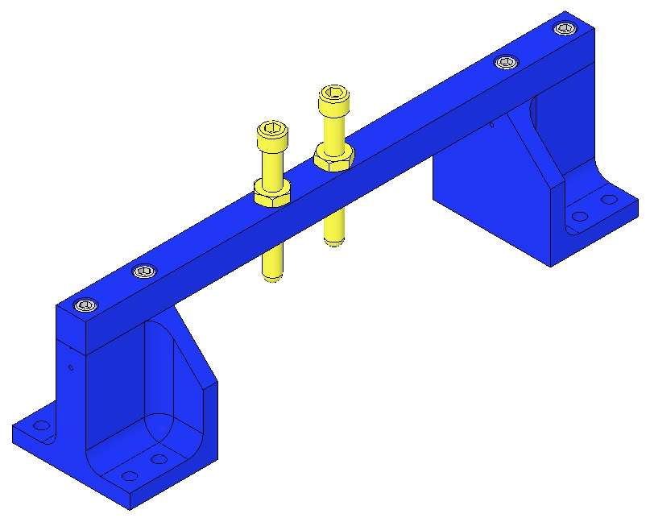  Crossbeam  ¼-20 x 2.00  Riser  8-32 x .625 SSTL  Fig 26: Assembly

Assembling Upper Blade Rotational Adjusters

Documents
D1000045 HSTS Rotational Adjuster Assembly
E1000169 Blade Characterization Spreadsheet
T0900559 Blade Pairings Spreadsheet

Materials
Qty | U | ID | Description
2 | Ea | D020660 | Blade Pulldown Device
2 | Ea | D0901815 | Upper Clamp Inside
2 | Ea | D0901813 | Upper Clamp Outside
4 | Ea | NA | 2 Socket Head Cap Screw 4-40 x 0.375” AgPlated
2 | Ea | NA | Flat Washer #4 Vented, SSTL
2 | Ea | NA | Socket Head Cap Screw 4-40 x 0.25” AgPlated
1 | Ea | NA | 4.483 kg in weight
2 | Ft | NA | Music Wire .024” dia. min.
1 | Ea | D020677 | Library of Clamps
2 | Ea | D1000045 | HSTS Rotational Adjuster Assembly
1 | Ea | D030448 | Base Plate
1 | Ea | D030447 | Rotating Plate
2 | Ea | D1001812 | HSTS Upper Blades
1 | Ea | DXXXXXX | Upper Blade Clamp, Upper Side, 0-3.5°
1 | Ea | DXXXXXX | Upper Blade Clamp, Lower Side, 0-3.5°
1 | Ea | DXXXXXX | Upper Blade Clamp, Lower Shim
1 | Ea | D030449 | Push Plate
1 | Ea | D030450 | Pull Plate
2 | Ea | NA | Flat Washer, ¼” SSTL
3 | Ea | NA | Socket Head Cap Screw, ¼-20 x .375”, SSTL
2 | Ea | NA | Socket Head Cap Screw, 8-32 x 1.00”, SSTL
2 | Ea | NA | Socket Head Cap Screw, 8-32 x 0.75”, AgPlated
1 | Ea | NA | Socket Head Cap Screw, 8-32 x 1.00”, AgPlated
1 | Ea | NA | Socket Head Cap Screw, 8-32 x 1.00” Round Tip AgPlated
3 | Ea | D1100785-472 | Flat Washer, ¼” x .472 OD, N-60
1 | Ea | D1100785-359 | Flat Washer, .20 x .359 OD, N-60
2 | Ea | NA | Socket Head Cap Screw, ¼-20 x 1.375”, AgPlated
1 | Ea | D1002440 | HSTS Upper Blade Bake Fixture

Procedure
Use Safety Glasses and Glove Liners per E0900332.
Prepare 2 D020660 Blade Pulldown Devices per Materials List above. |  | 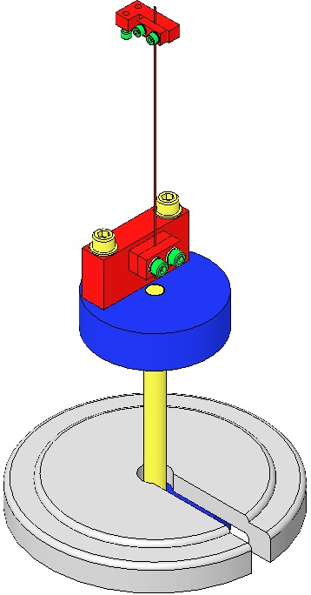  Fig 27: Blade Pulldown Device

Select pairs of D1001812 Blades and Blade Clamps per the T0900559 Blade Pairings Spreadsheet.

Correlate each Blade to a location within the Suspension:
- The Blade with the higher tip goes to the +X, -Y corner (meaning that the blade with the higher tip is installed in the Rotational Adjuster that is mounted on the +X, -Y corner).
- The Blade with the lower tip goes to the -X, +Y corner (meaning that the blade with the lower tip is installed in the Rotational Adjuster that is mounted on the –X, +Y corner).
- Blade launch angle is set by Blade Clamps. These range from 0-3.5 deg. in .5 deg. increments.
- Select Clamps from the D020677 HSTS Library of Clamps
- Select Clamps according to Blade Characterization data for stiffness and expected load.
- Select Blades in pairs according to Blade Characterization data.
- Record the Blade serial numbers and Blade clamp angles and orientations within ICS.
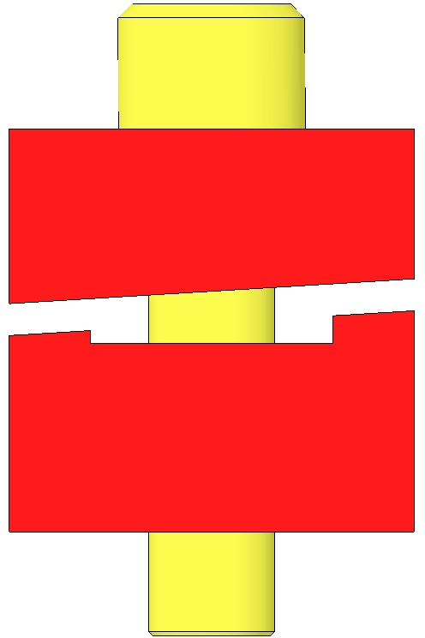  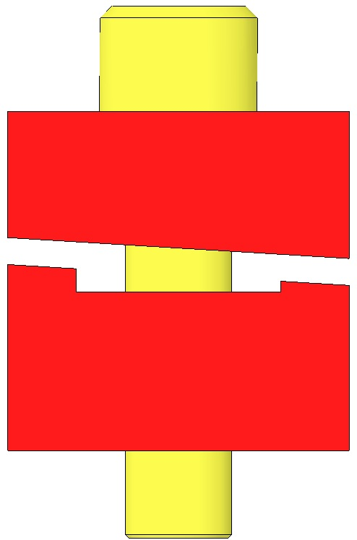  Fig 28: Clamps Control Launch Angle | 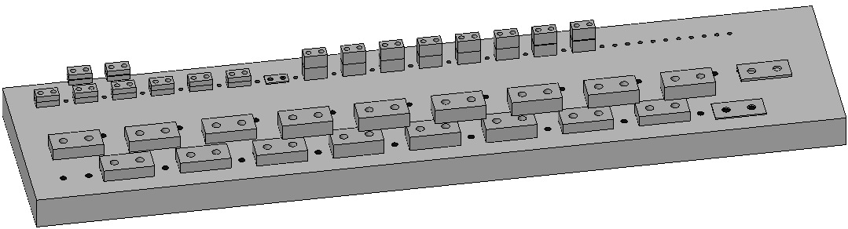  Fig 29: HSTS Library of Clamps
Mount the D1002440 Baking Fixture to an Optics Table, aligning the Crossbar side with the Table edge to allow clearance for the Blade Pulldown Device.  Remove a D1002443 Crossbar from the Baking Fixture.  Assemble to the Baking Fixture:  - 2 D030447 Rotating Plates  Beveled-side-down  - 4 Socket Head Cap Screws  ¼-20 x 0.375” SSTL  - 4 D1100785-472 Flat Washers  Tighten the Screws firmly | 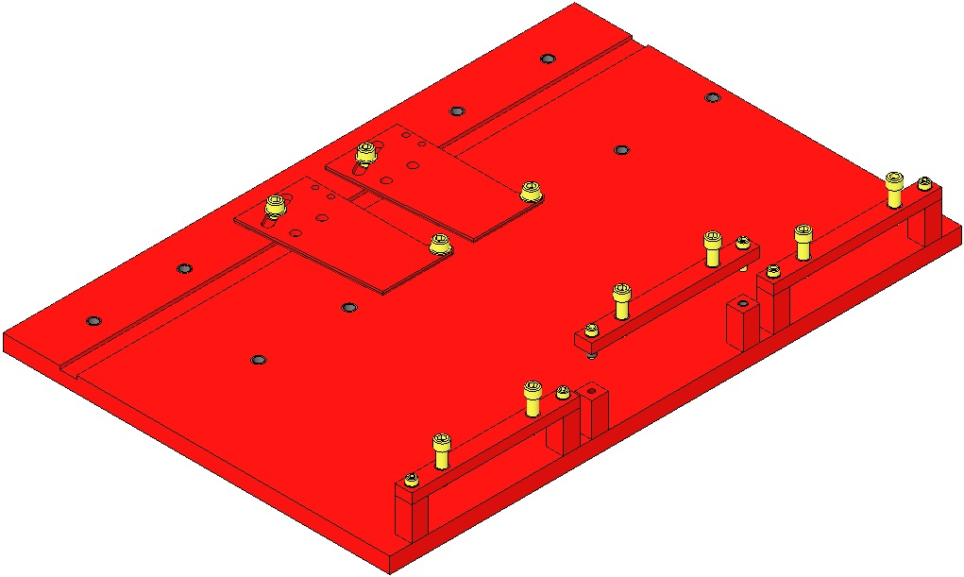  Table Edge  Fig 30: Base Plates in Baking Fixture
Assemble to each Rotating Plate:  - 1 DXXXXXX Shim, Upper Blade Clamp  Each Weldment is packaged with 2 Rotational Adjuster Shim’s, each marked with the Weldment Serial Number  - 1 DXXXXXX Lower Clamp  - 1 D1001812 Upper Blade  - 1 DXXXXXX Upper Clamp  - 2 Socket Head Cap Screws  ¼-20 x 1.375” SSTL  - Flat Washer ¼” SSTL  Hand-tighten the 2 Screws | 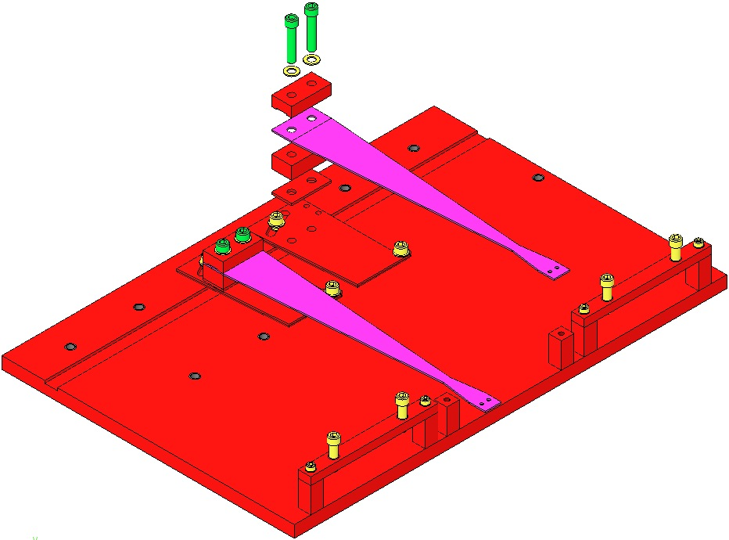  Machinist’s  Square  Fig 31: Shim, Clamps, Blade, Screws, Washers

Attach a Pulldown Device from each Upper Blade Tip to flatten the Blades.

Assemble to the Bake Fixture:
- 1 D1002443 Bake Fixture Crossbar
- 2 Socket Head Cap Screws 8-32 x 0.625” SSTL
- 2 Flat Washers #8 SSTL
Tighten the Screws firmly
- 2 Socket Head Cap Screws ¼-20 x 1.0 Full-Thread, Round-Tip SSTL

Turn down the Round-Tip Screws until the weighted Blade tip is level with the Blade root.
Be careful not to damage the nickel plating on the blade

Leaving the Wire Clamp attached to the Blade, remove the rest of the Blade Pulldown Device.

Using the Machinist’s Square, square the Blade, Clamps, and Shim to each other and to the Rotating Plate.

Tighten the ¼-20 Screws that clamp the Blade, to 100 in-lb.

Re-attach the Blade Pulldown Device to the Wire Clamp.

Turn back the Rounded-End Screws and remove the D1002443 Crossbar again.

Slowly lift and then disconnect the Blade Pulldown Device, allowing each Blade to curve fully upward.

Disassemble the Rotational Adjuster(s) from the Upper Blade Baking Fixture.
Assemble to a D030448 Base Plate:  A just-assembled Rotational Adjuster  3 Socket Head Cap Screw  ¼-20 x 0.375” SSTL  3 D1100785-472 N-60 Flat Washers  Hand-tighten only  D030450 Pull Plate  2 Socket Head Cap Screw  8-32 x 0.75” AgPlated  Torque to 30 in-lb | 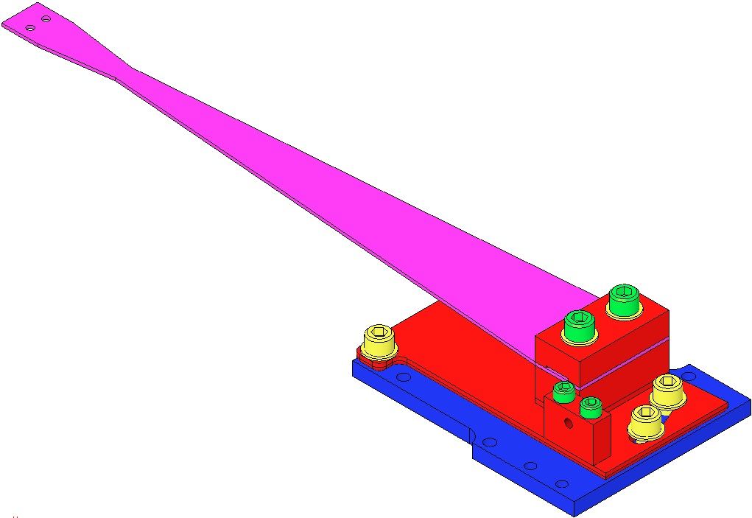  Rotating Plate  Pull Plate  8-32 x 0.75  ¼-20 x 0.375” (3)  Flat Washer ¼” (3)  Base Plate  Fig 32: Base Plate and Pull Plate added
Assemble to the Base Plate:  - D030449 Push Plate  - 2 Socket Head Cap Screws  8-32 x 1.00” SSTL  Torque to 20 in-lb  Assemble through the Push Plate, into the Pull Plate:  - 1 Socket Head Cap Screw  8-32 x 1.00” AgPlated  - 1 D1100785-359 N-60 Flat Washer  - 1 Socket Head Cap Screw  8-32 x 1.00” Round Tip AgPlated | 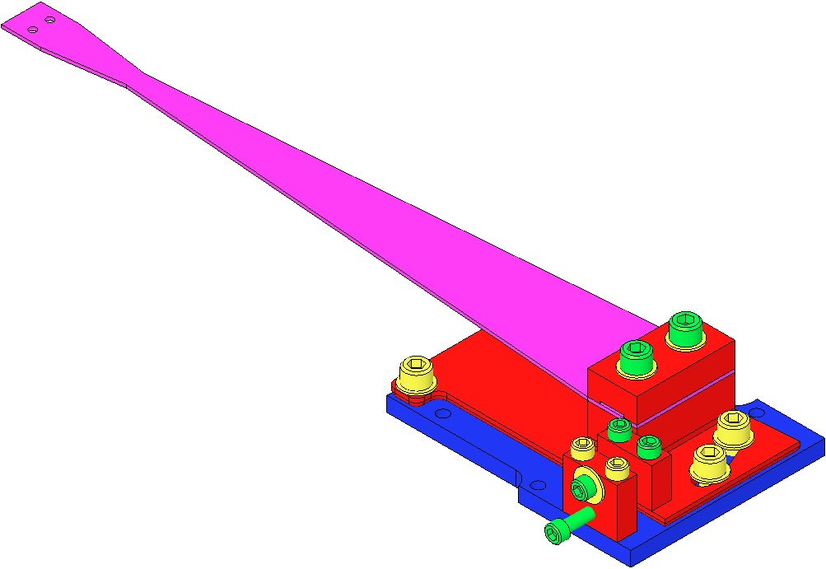  8-32 x 1” SSTL  8-32 x 1” AgPlated  8-32 x 1” AgPlated Round Tip  Fig 33: Adding Push Plate

Assembling Barrel Earthquake Stops
2 Assemblies for Intermediate Mass / Upper Side

Documents
D0902203 Barrel Earthquake Stop Assembly / Intermediate Wire

Materials
Qty | U | ID | Description
4 | Ea | D0902009 | Barrel EQ Stop Base
4 | Ea | D0902008 | Barrel EQ Stop Top
8 | Ea | NA | Socket Head Cap Screw 4-40 x 0.375” SSTL
2 | Ea | D0901925 | Barrel EQ Stop Crossbar, Intermediate Wire
8 | Ea | NA | Socket Head Cap Screw ¼-20 x 0.875” SSTL
8 | Ea | NA | Flat Washer, ¼” SSTL
4 | Ea | NA | Socket Head Cap Screw ¼-20 x 2.25” SSTL Round Tip
4 | Ea | NA | Hex Nut ¼-20 AgPlated

Procedure
Repeat these steps to build 2 Assemblies.  Used above the Intermediate Mass.  Assemble:  - 2 D0902009 Barrel EQ Stop Base  - 2 D0902008 Barrel EQ Stop Top  - 2 Socket Head Cap Screws  4-40 x 0.375” SSTL  Torque to 5 in-lb  Ensure the Vent Holes of each D0902008 are facing outboard.  Ensure the Bases and Tops are aligned with a Precision Square.  Assemble 1 D0901925 Barrel EQ Stop Crossbar to the previous assemblies, using:  - Socket Head Cap Screw  ¼-20 0.875” SSTL  - Flat Washer ¼” SSTL  Assemble Bolts loosely.  Assemble to the Crossbar:  - 2 Socket Head Cap Screw  ¼-20 2.25” SSTL Rounded Tip  - 2 Hex Nuts ¼-20 AgPlated  Note the orientation of the bolts relative to the Crossbar. | 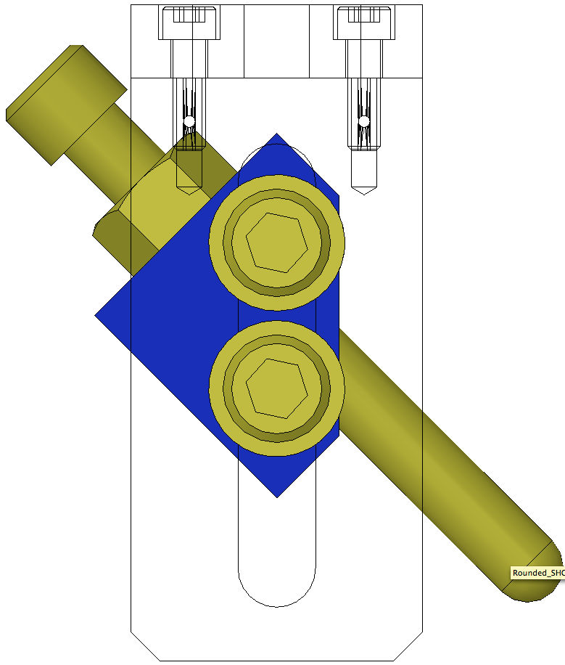  Bolt  Orientation  Precision  Square  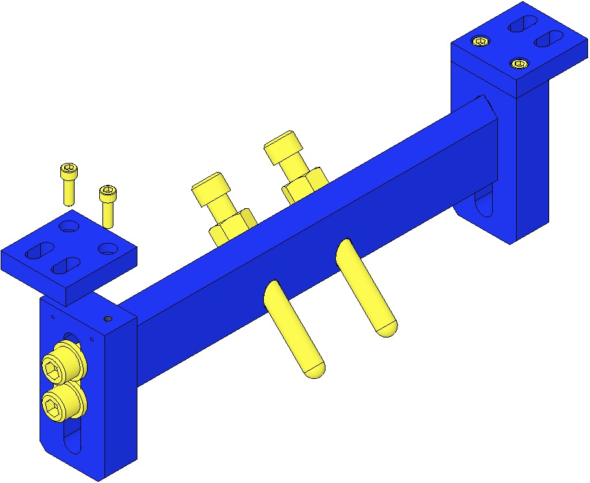  D0902009  ¼-20 x 2.25”  ¼-20 x .875” Loose  4-40 x 0.375”  D0902008  Hex Nut  D0901925  Vent Holes facing outboard.  D0902008  Fig 34: Build 2 Assemblies
2 Assemblies for Intermediate Mass / Lower Side
4 Assemblies for Lower Mass

Documents
D0902201 HSTS Barrel EQ Stop Assembly, Lower Wire

Materials
Qty | U | ID | Description
12 | Ea | D0902009 | Barrel EQ Stop Base
12 | Ea | D0902008 | Barrel EQ Stop Top
24 | Ea | NA | Socket Head Cap Screw 4-40 x 0.375” SSTL
6 | Ea | D0902202 | Barrel EQ Stop Crossbar
24 | Ea | NA | Socket Head Cap Screw ¼-20 x 0.875” SSTL
24 | Ea | NA | Flat Washer, ¼” SSTL
12 | Ea | NA | Socket Head Cap Screw ¼-20 x 2.25” Round-Tip SSTL
8 | Ea | D0900932 | EQ Stop for Glass
12 | Ea | NA | Hex Nut ¼-20 AgPlated
1 | Ea | NA | Machinist’s Square

Procedure
6 Assemblies; 2 beneath Intermediate Mass; 4 for Bottom Mass or Optic. For Optic, use EQ Stops for Glass; for Intermediate and Bottom Mass, use ¼-20 x 2.25” SHCS Round Tip.
Assemble:  - 2 D0902009 Barrel EQ Stop Bases  - 2 D0902008 Barrel EQ Stop Tops  - 2 Socket Head Cap Screws  4-40 x 0.375” SSTL  Torque to 5 in-lb  Ensure the vent holes of the D0902008 are facing outboard relative to the D0902009.  Ensure the Bases and Tops are aligned with a Machinist’s Square.  Assemble 1 D0902202 Barrel EQ Stop Crossbar, Lower Wire, to the previous assemblies, using:  - Socket Head Cap Screw  ¼-20 x 0.875” SSTL  - Flat Washer ¼” SSTL  Assemble Bolts loosely.  Assemble to the Crossbar:  - 2 Socket Head Cap Screw  ¼-20 x 2.25” SSTL Round Tip  - Hex Nuts ¼-20 AgPlated  Note the orientation of the bolts relative to the Crossbar. | Machinist’s  Square  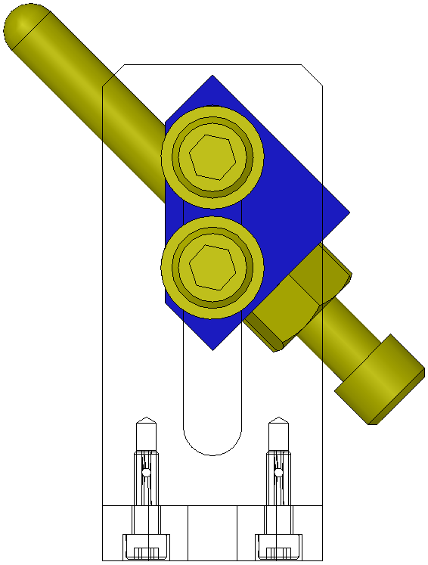  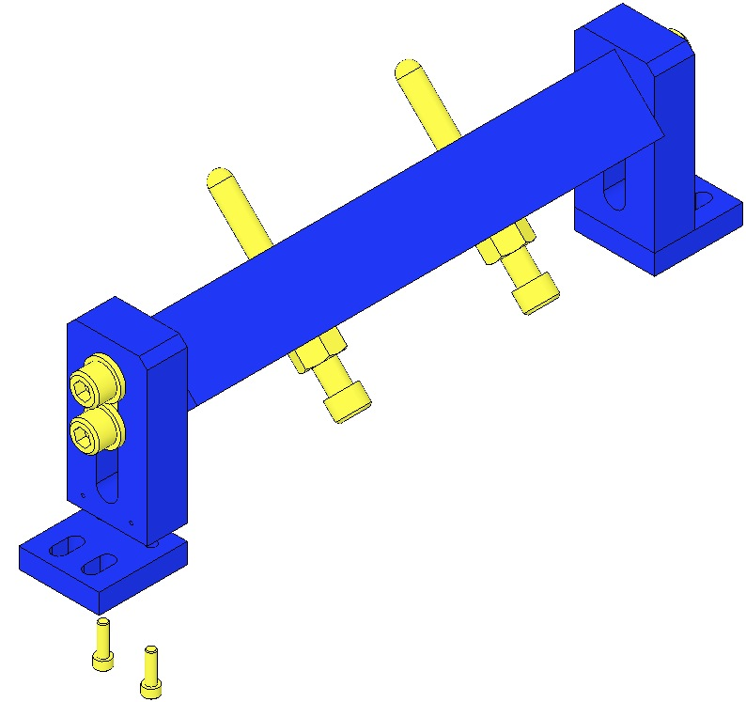  Hex Nut  Bolt  Orientation  ¼-20 x .875” Loose  D0902008  Vent Holes facing outboard.  D0902009  4-40 x 0.375”  ¼-20 x 2.25”  D0902202  Fig 35: Build 6 Assemblies

Assembling Face EQ Stops
2 Assemblies for Intermediate Mass

Documents
D0902413 Face EQ Stop Assembly, Intermediate Mass

Materials
Qty | U | ID | Description
2 | Ea | D0902204 | HSTS Face EQ Stop Bracket, Intermediate Mass
2 | Ea | D0901923 | HSTS Face EQ Stop Base
4 | Ea | NA | Socket Head Cap Screw 8-32 x 0.625” SSTL
4 | Ea | NA | Socket Head Cap Screw ¼-20 x 2.25” SSTL Round Tip
4 | Ea | NA | Hex Nut ¼-20 AgPlated
4 | Ea | 1185-4EN375 | Helicoil ¼-20 x 0.375”

Procedure
Repeat steps to build 2 Assemblies:  Assemble:  - 1 D0901923 Base  - 1 D0902204 Bracket  - 2 Socket Head Cap Screws  8-32 x 0.625” SSTL  Torque to 20 in-lb  - 2 Socket Head Cap Screws  ¼-20 x 2.25” SSTL Round-Tip  - 2 Hex Nuts ¼-20 AgPlated | 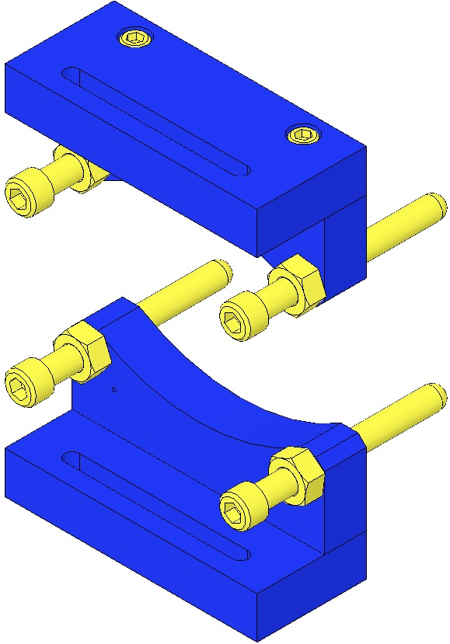  Hex Nut  ¼-20 x 2.25”  D0901923  D0902204  8-32 x 0.625”  Fig 36: 2 Assemblies

2 Assemblies for Lower Mass

Documents
D0902205 Face EQ Stop Assembly, Bottom Mass

Materials
Qty | U | ID | Description
2 | Ea | D0901922 | HSTS Face EQ Stop Bracket, Lower Mass
2 | Ea | D0901923 | HSTS Face EQ Stop Base
4 | Ea | NA | Socket Head Cap Screw 8-32 x 0.625” SSTL
4 | Ea | NA | Socket Head Cap Screw ¼-20 x 2.25” Round-Tip SSTL (for Mass)
4 | Ea | D0900932 | EQ Stop for Glass, 2” (for Optic)
4 | Ea | NA | Hex Nut ¼-20 AgPlated
4 | Ea | 1185-4EN375 | Helicoil ¼-20 x 0.375”

Procedure
Create 2 Assemblies, each with:  - 1 D0901923 Base  - 1 D0901922 Bracket  - 2 Socket Head Cap Screws  8-32 x 0.625” SSTL  Torque to 20 in-lb  For Mass:  - 2 Socket Head Cap Screws  ¼-20 x 2.25” Round-Tip SSTL  - 2 Hex Nuts ¼-20 AgPlated  For Optic:  - 2 D0900932 EQ Stop for Glass  - 2 Hex Nuts ¼-20 AgPlated | 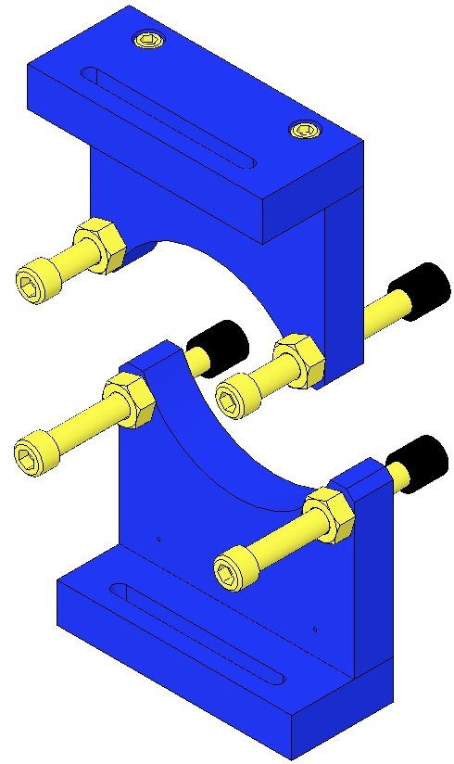  D0901923  8-32 x 0.625”  Jam Nut  D0900932  D0901922  Fig 37: 2 Assemblies

Assembling AOSEM Alignment Assemblies
These assemblies are identical, with 3 exceptions:
- Intermediate Mass assemblies have a shorter Alignment Bracket;
- LH / RH versions (Alignment Bracket is reversed);
- 3 heights of Alignment Bracket Mounts, depending on PN.
Brackets are shown with A OSEMs in place, but A OSEMs are actually installed later on.
D0901924 (4)  A OSEM Alignment Assy  Intermediate Mass  Used in all 4 locations at the Intermediate Mass. | 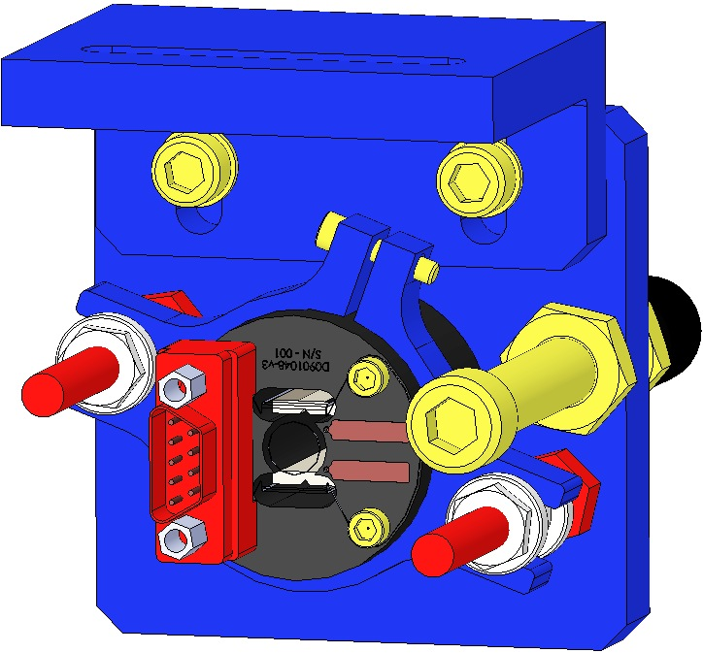 | Small Mount  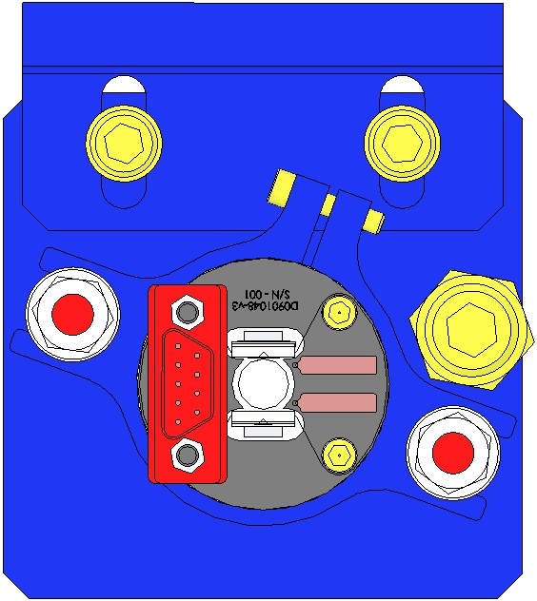  LH  Configuration  Shorter Bracket | RH  Configuration
D0902207 (2)  Upper A OSEM Alignment Assy  Lower Mass  Used in the top 2 positions at the Lower Mass. | 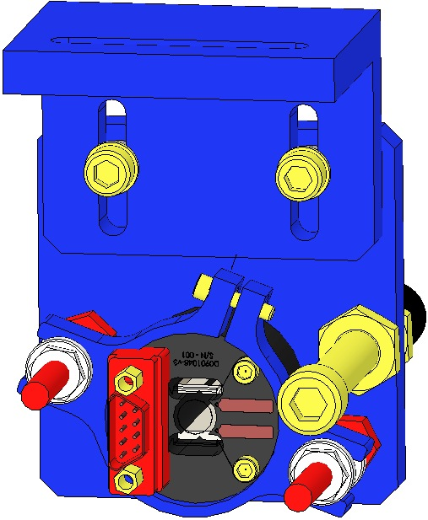 | Medium Mount  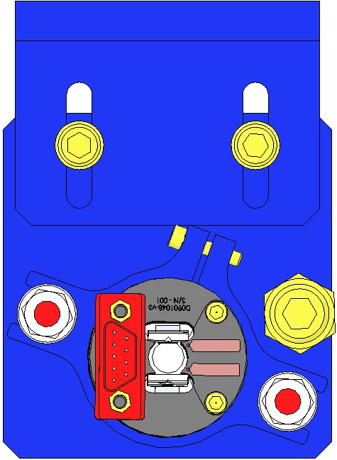  LH  Configuration | RH Configuration
D0902208 (2)  Lower A OSEM Alignment Assy  Lower Mass  Used in the lower 2 positions at the Lower Mass. | 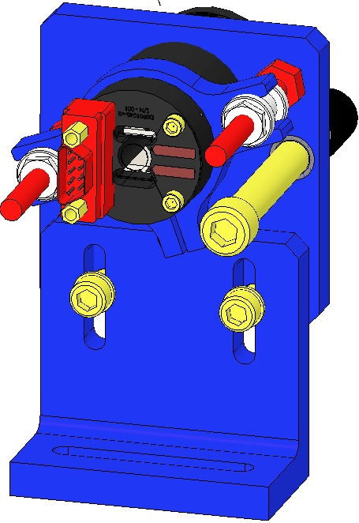 | Large Mount  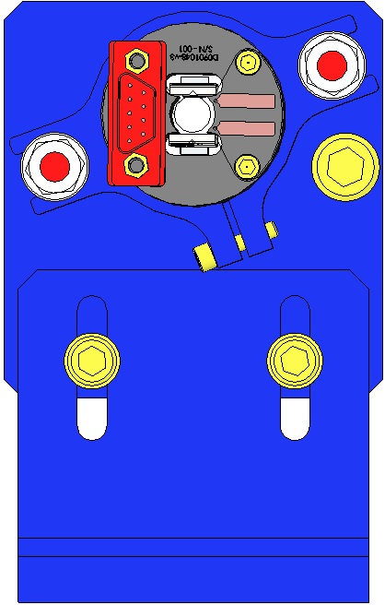  LH  Configuration | RH  Configuration

Materials
D0901924
Qty | U | ID | Description
1 | Ea | D0902206 | A OSEM Alignment Bracket Mount, Intermediate Mass
1 | Ea | D0902414 | A OSEM Alignment Bracket, Intermediate Mass
1 | Ea | D0901065 | A OSEM Assembly
1 | Ea | D0901548 | A OSEM Adjustment Collar
2 | Ea | D1000660 | Adjustment Nut
2 | Ea | D1000659 | Adjustment Shaft
1 | Ea | NA | Socket Head Cap Screw ¼-20 x 2.25” Round-Tip SSTL
1 | Ea | 1185-4EN250 | Helicoil ¼-20 x 0.25”
2 | Ea | 1185-2EN246 | Helicoil 8-32 x 0.246”
2 | Ea | NA | Socket Head Cap Screw 8-32 x 0.625”
2 | Ea | NA | Flat Washer #8 SSTL
1 | Ea | NA | Socket Head Cap Screw 2-56 x 0.375”
1 | Ea | NA | Hex Nut ¼-20 AgPlated
D0902207
Qty | U | ID | Description
1 | Ea | D0902417 | A OSEM Alignment Bracket
1 | Ea | D0902416 | A OSEM Alignment Bracket Mount, Intermediate Mass
1 | Ea | D0901065 | A OSEM Assembly
1 | Ea | D0901548 | A OSEM Adjustment Collar
2 | Ea | D1000660 | Adjustment Nut
2 | Ea | D1000659 | Adjustment Shaft
1 | Ea | NA | Socket Head Cap Screw ¼-20 x 2.25” Round-Tip SSTL (for Mass)
1 | Ea | D0900932 | EQ Stop for Glass 2” (for Optic)
1 | Ea | 1185-4EN250 | Helicoil ¼-20 x 0.25”
2 | Ea | 1185-2EN246 | Helicoil 8-32 x 0.246”
2 | Ea | NA | Socket Head Cap Screw 8-32 x 0.625”
2 | Ea | NA | Flat Washer #8 SSTL
1 | Ea | NA | Socket Head Cap Screw 2-56 x 0.375”
1 | Ea | NA | Hex Nut ¼-20 AgPlated
D0902208
Qty | U | ID | Description
1 | Ea | D0902417 | A OSEM Alignment Bracket
1 | Ea | D0902415 | A OSEM Alignment Bracket Mount, Intermediate Mass
1 | Ea | D0901065 | A OSEM Assembly
1 | Ea | D0901548 | A OSEM Adjustment Collar
2 | Ea | D1000660 | Adjustment Nut
2 | Ea | D1000659 | Adjustment Shaft
1 | Ea | NA | Socket Head Cap Screw ¼-20 x 2.25” Round-Tip SSTL (for Mass)
1 | Ea | D0900932 | EQ Stop for Glass 2” (for Optic)
1 | Ea | 1185-4EN250 | Helicoil ¼-20 x 0.25”
2 | Ea | 1185-2EN246 | Helicoil 8-32 x 0.246”
2 | Ea | NA | Socket Head Cap Screw 8-32 x 0.500”
2 | Ea | NA | Flat Washer #8 SSTL
1 | Ea | NA | Socket Head Cap Screw 2-56 x 0.375” SSTL
1 | Ea | NA | Hex Nut ¼-20 AgPlated

Procedure
Assembly procedure is nearly identical for all 3 units, but varies by the part number and orientation of the Alignment Bracket, and Mount.
Assemble D1000659 Adjustment Shafts to an Alignment Bracket, ensuring you have the correct Alignment Bracket and ensuring the correct orientation of the Shafts to the Bracket to enable the LH/RH configuration.  Assemble to the D0901548 Adjustment Collar:  - 1 Socket Head Cap Screw  2-56 x 0.375” SSTL  Do not tighten Screw  Assemble the Adjustment Collar to the D1000659 Adjustment Shafts using D1000660 Adjustment Nuts  The Adjustment Nut threads MUST be tapped; as is, the Nuts are tight and will seize  Be extremely careful to not strip the Heads of the Nuts  Assemble the correct Bracket Mount to the Alignment Bracket using:  - Correct Socket Head Cap Screw 8-32  - Flat Washer #8  Assemble EQ Stop to Alignment Bracket with Hex Nuts | 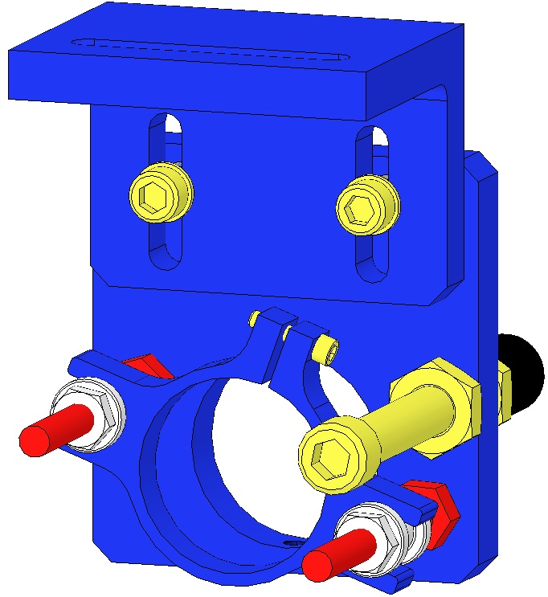  EQ Stop  8-32 Screw  Adjustment Collar  Adjustment Shaft  Bracket Mount  Adjustment Nut  2-56 Screw  Alignment Bracket  Fig 38: Assembly without A OSEM

Overall Assembly
The following document sections encompass installation into the main D020023 Weldment of:
- All aforementioned Subassemblies;
- Other individual components.
Each Subassembly must be weighed and documented in ICS, correlated to a specific overall assembly.

Subassemblies
Qty | U | ID | Description
2 | Ea | D1000045 | Rotational Adjuster
2 | Ea | D0901934 | Upper Blade Guard
1 | Ea | D020534 | Upper Mass
2 | Ea | D0901854 | Upper Wire
2 | Ea | D0901905 | Intermediate Wire
2 | Ea | D0901902 | Lower Wire
1 | Ea | D0901873 | Intermediate Mass
1 | Ea | D0901791 | Metal Lower Mass MC
1 | Ea | D0902333 | Metal Lower Mass PR/RS
2 | Ea | D0902201 | Earthquake Barrel Stop, Lower Wire
1 | Ea | D0902413 | Face EQ Stop, Intermediate Mass
1 | Ea | D0902205 | Face EQ Stop, Test Mass
6 | Ea | D060218 | BOSEM
4 | Ea | D0901924 | Upper AOSEM Alignment, Intermediate Mass
2 | Ea | D0902207 | Upper AOSEM Alignment, Test Mass
2 | Ea | D0902208 | Lower AOSEM Alignment, Test Mass

Individual Components
Qty | U | ID | Description
8 | Ea | D980184 | LOS Clamps
8 | Ea | NA | Socket Head Cap Screw ¼-20 x 1.5” AgPlated
4 | Ea | D020346 | Tablecloth Bracket
1 | Ea | D020239 | Tablecloth

Preparing The Weldment

Procedure
Verify usability of ALL tapped holes.  Install at the base of the Weldment:  - 6 1185-2EN492 Helicoils  8-32 x 3.0D  Install these BEFORE securing the Weldment to the Optical Table!  Install in the top plate of the Weldment:  - 4 1185-4EN250  Helicoils  ¼-20 x 1.0D  Identify the Front vs Rear of the Weldment by examining the hole patterns on the top surfaces of the bottom crossmembers. | 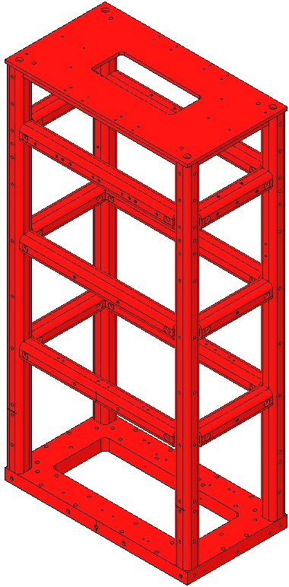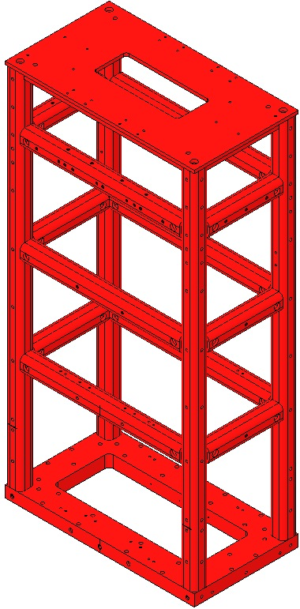  Helicoils  Helicoils  Fig 39: Front of Weldment Fig 40: Rear of Weldment
Secure the Weldment to an Optics Table with  - 8 D980184 LOS Clamps, 2 per corner  - 8 ¼-20 x 1.5” Screws AgPlated |  | 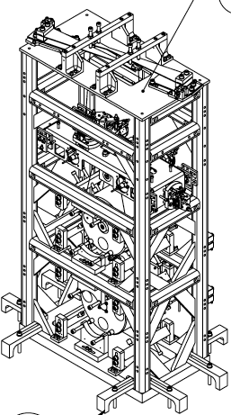  Fig 41: Clamping Weldment to Optics Table

Installing the Rotational Adjusters

Documents
D020023 HSTS Weldment Assembly

Materials
Qty | U | ID | Description
2 | Ea | D020660 | Blade Pulldown Device
2 | Ea | D0901815 | Upper Clamp Inside
2 | Ea | D0901813 | Upper Clamp Outside
4 | Ea | NA | 2 Socket Head Cap Screw 4-40 x 0.375” AgPlated
4 | Ea | NA | Flat Washer #4 Vented, SSTL
4 | Ea | NA | Socket Head Cap Screw 4-40 x 0.25” AgPlated
1 | Kg | NA | 4.483 kg in weight
2 | Ft | NA | Music Wire .024” dia. min.
2 | Ea | D1102119 | Blade Pulldown Support Class B cleaned
2 | Ea | D1000045 | Upper Blade Rotational Adjustment Assemblies
2 | Ea | D0901934 | Blade Guard Assembly
24 | Ea | NA | Socket Head Cap Screw 8-32 x .625” AgPlated SSTL
24 | Ea | NA | Washer, Flat #8 SSTL
1 | Roll | NA | UHV Foil

Process
Wear Safety Glasses and Glove Liners per E1000043.  Prepare 2 D020660 Blade Pulldown Devices per Materials List. | Fig 42: Blade Pulldown Device
Attach 2 D0901934 Upper Blade Guard Assemblies to the Weldment using:  16 Socket Head Cap Screws  8-32 x 0.625” AgPlated SSTL  16 Washers, Flat #8 SSTL  Torque to 30 in-lb | 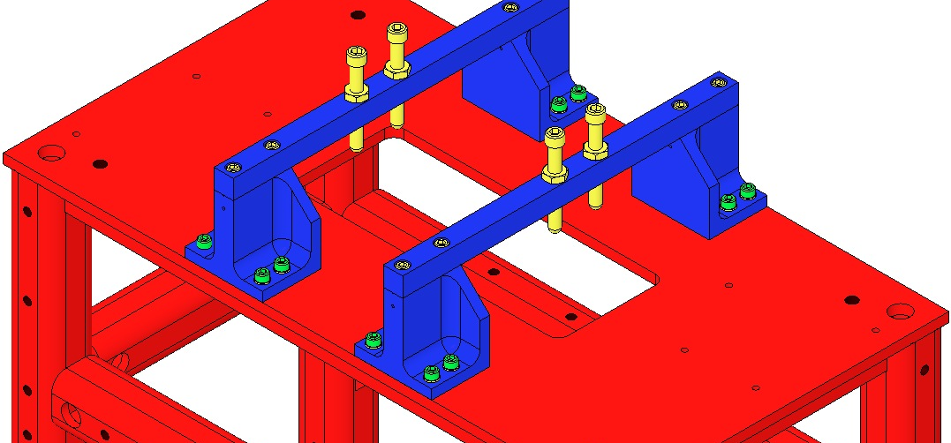  Fig 43: Base Plates and Blade Guards
Remove the 2 D0901935 Blade Guard Bars  Attach the Rotational Adjusters to the Weldment with:  8 Socket Head Cap Screws  8-32 x 0.625” AgPlated SSTL  8 Washers, Flat #8 SSTL  Torque to 20 in-lb.  Blades are shown flat but are actually curved upward at this point.  Record the serial number and location of both Upper Blades in ICS in the RA assembly load. | 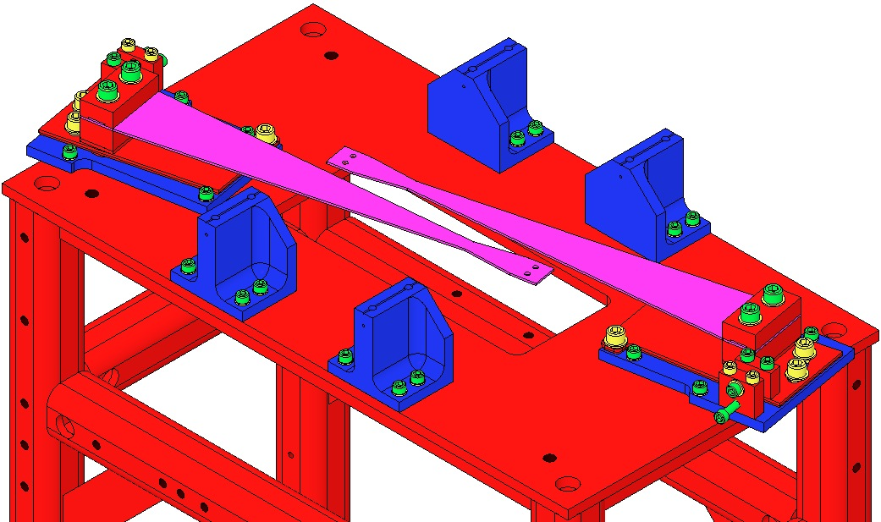  Fig 44: Crossbars removed
Ensure the 2 D1102119 Blade Pulldown Supports are Class B clean.  Attach the Blade Pulldown Supports to the center of the Weldment cross member shown, Clevis extending outboard.  Cover each end of the Weldment Structure and surrounding Optical Table areas with UHV Aluminum Foil, to protect them from the dirty Pulldown Device.  2 workers required:  1st person holds the Pulldown Weight.  2nd person passes Wire Clamp of the Pulldown Device through the Weldment side opening, up toward the Upper Blade Tip, then attaches the Clamp to the Blade tip with:  - 2 Socket Head Cap Screws  4-40 x .375” AgPlated SSTL  1st person gently drapes the wire over the Clevis, and slowly releases the Weight.  Repeat Steps 11-13 for the second Pulldown Device. | 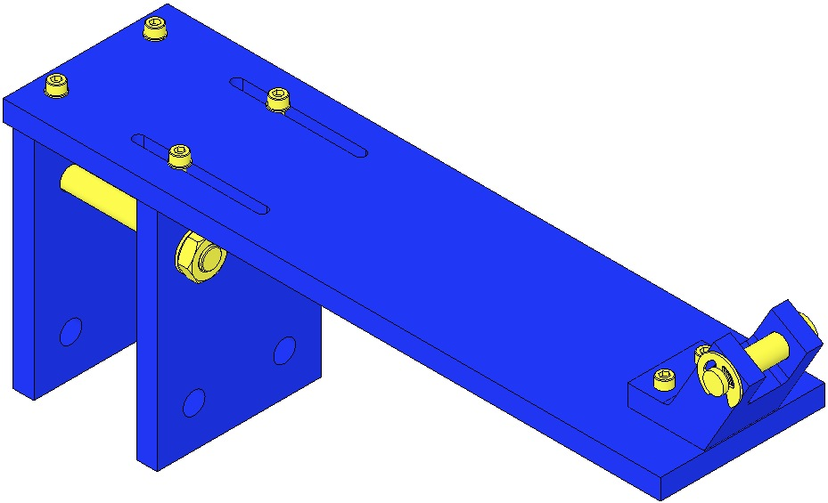  Fig 45: Blade Pulldown Support  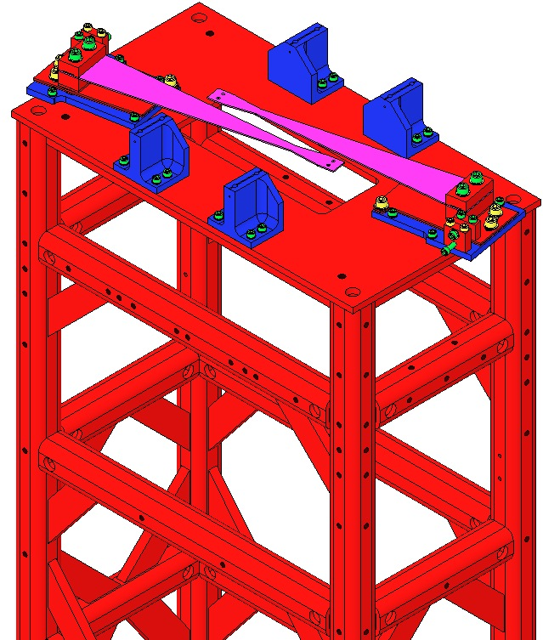  Blade Pulldown Supports  Fig 46: Location of Blade Pulldown Support
Re-Assemble the 2 D0901935 Blade Guard Bars to the Risers, using the original:  - 4 Socket Head Cap Screws  8-32 x .625” SSTL  Torque to 20 in-lb  Ensure the Bars are oriented with the EQ Stop Screws directly over the Blades.  The EQ Stop Screws should be adjusted so the Blades are flat. Once adjusted, the Screws should be secured with the Hex Nuts.  Carefully remove the 2 Blade Pulldown Devices.  Remove the 2 Blade Pulldown Supports. | 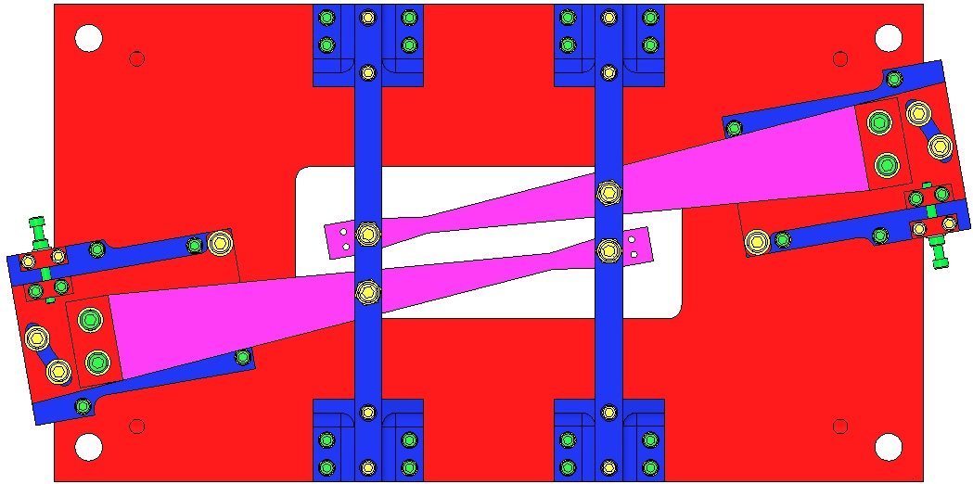  Fig 47: Bar orientation  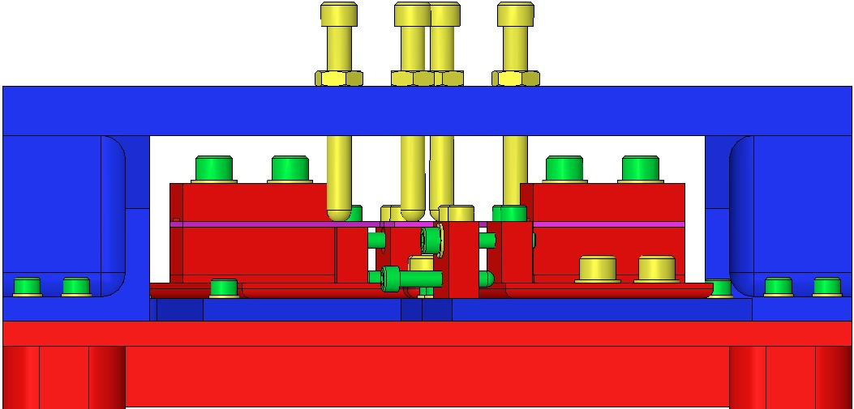  Fig 48: EQ Stops turned to flatten Blades

Installing Barrel EQ Stops

Materials
Qty | U | ID | Description
2 | Ea | D0902203 | Barrel EQ Stop, Intermediate Wire
6 | Ea | D0902201 | Barrel EQ Stop, Lower Wire
32 | Ea | NA | Socket Head Cap Screw 8-32 x 0.5” AgPlated
32 | Ea | NA | Flat Washer #8
1 | Ea | NA | Machinist’s Square

Procedure
Assemble to the Weldment:  - 2 D0902203 Assemblies above the Intermediate Mass  Raise Crossbars  Retract Stop Screws  - 2 D0902201 Assemblies beneath the Intermediate Mass  Lower Crossbars  Extend Stop Screws to support the Mass  - 2 D0902201 Assemblies above Bottom Mass / Optic  Crossbars at midpoint  Stop Screws at midpoint  - 2 D0902201 Assemblies beneath Bottom Mass / Optic  Raise Crossbars  Extend Stop Screws  - 32 Socket Head Cap Screw  8-32 x 0.675” AgPlated  - 32 Flat Washer #8  Torque to 30 in-lb | 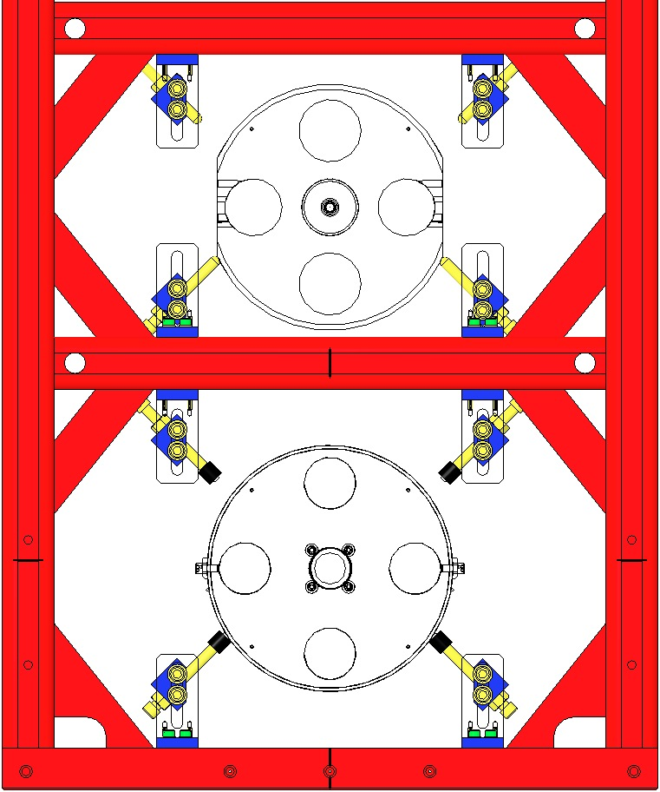  D0902201 Lower Crossbars, Screws support Mass  D0902201 Screws Halfway, Crossbars Halfway  D0902201 Raise Crossbars, Extend Screws  D0902203 Raise Crossbars, Retract Screws  Fig 49: Weldment / Front View

Assembling the Intermediate Mass (M2)

Documents
D0901873 HSTS Intermediate Mass Assembly

Materials
Qty | U | ID | Description
1 | Ea | D0901792 | HSTS Intermediate Mass
2 | Ea | NA | Socket Head Cap Screw ¼-20 x .875” Vented
2 | Ea | Several | Add-On Masses
2 | Ea | D020202 | Lower Wire Clamp, Inside
4 | Ea | D020203 | Lower Wire Clamp, Outside
6 | Ea | NA | Socket Head Cap Screw, 8-32 x .5” SSTL
4 | Ea | NA | Socket Head Cap Screw, 8-32 x .625” AgPlated
10 | Ea | NA | Flat Washer #8 SSTL
4 | Ea | D0901904 | Intermediate Wire Clamp Mount
4 | Ea | D0901903 | Intermediate Wire Clamp, Lower
8 | Ea | NA | Socket Head Cap Screw 4-40 x .375” AgPlated
12 | Ea | NA | Socket Head Cap Screw 4-40 x .375” SSTL
20 | Ea | NA | Flat Washer #4 SSTL

Procedure
Weigh the following items, selecting Add-On Weights to arrive at 2963.30 total:  - Intermediate Mass  - Lower Wire Clamps per list above  - Intermediate Wire Clamps per list above  - Add-On Masses for the Intermediate Mass  D1100894 2g  D1100863 5g  D1100855 10g  D030078 20g  D020351 50g  D020350 100g | 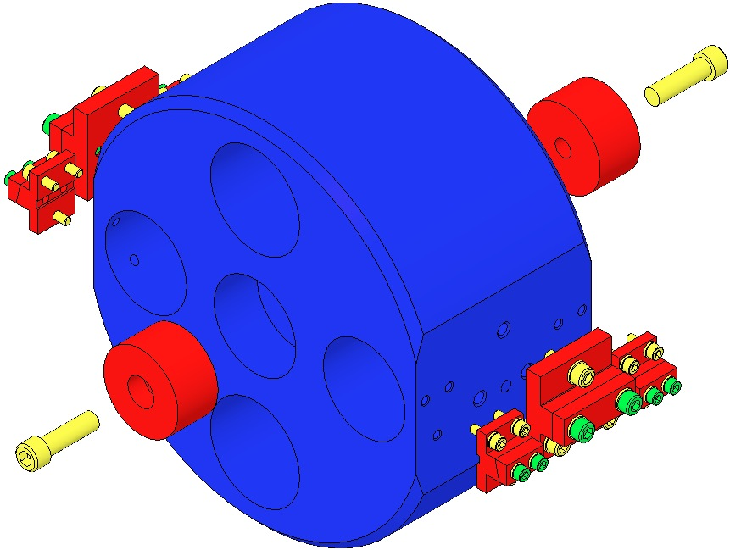  Fig 50: Add-On Weights and Wire Clamps
Assemble the Add-On Masses to the Intermediate Mass.  The grooves on the Add-On Masses must face inboard | 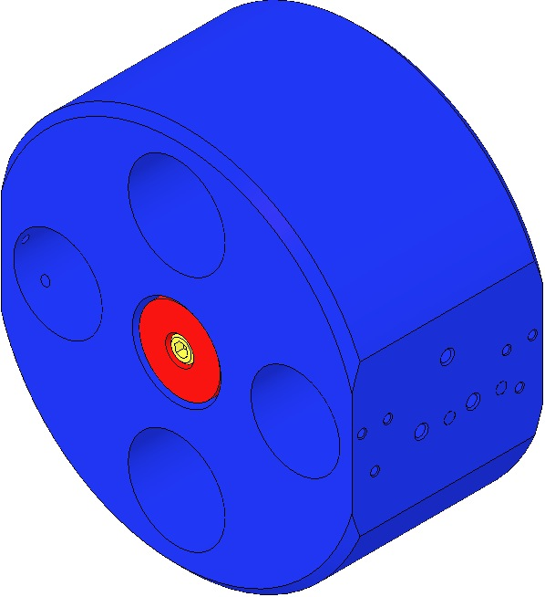  Fig 51: Intermediate Mass with Add-On Masses

Assembling the Lower Mass (M3)

Documents
D0901791 HSTS Metal Lower Mass Assembly (MC)

Materials
Qty | U | ID | Description
1 | Ea | D0902658 | Optic Holder
4 | Ea | D980184 | LOS Clamps
4 | Ea | NA | Socket Head Cap Screw ¼-20 x 1.5” AgPlated
1 | Ea | D020234 | HSTS Metal Lower Mass
2 | Ea | Y1-1037-0 | Laser Mirror
8 | Ea | NA | Socket Head Cap Screw 4-40 x .375” SSTL
8 | Ea | NA | Flat Washer #4 SSTL
8 | Ea | NA | Flat Washer #8 SSTL
2 | Ea | D0901790 | Primary Metal Breakoff Prism
4 | Ea | NA | Socket Head Cap Screw 8-32 x .375” SSTL
4 | Ea | NA | Flat Washer #8 SSTL
2 | Ea | D0901278 | Secondary Metal Breakoff Prism

Procedure
Mount the D0902658 Optic Holder to an Optic Table using 4 D980184 Clamps and 4 Socket Head Cap Screws, ¼-20 x 1.5” AgPlated.  Place the D0901792 Intermediate Mass into the D0902658 Optic Holder. | 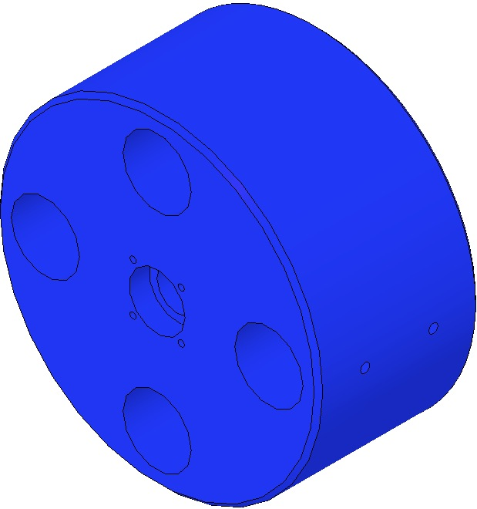  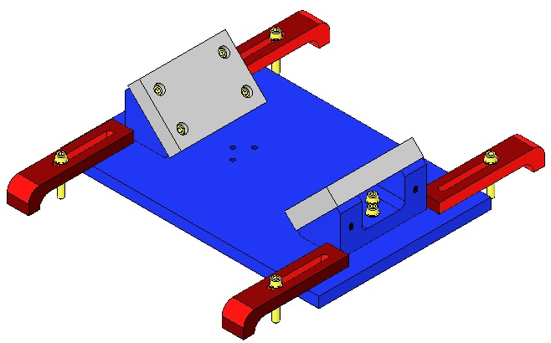  Fig 52: Optic Holder and Bottom Mass
Assemble to the Lower Mass:  - 2 Y1-1037-0 Laser Mirrors  - 8 Socket Head Cap Screws  4-40 x 0. 375” SSTL  - 4 Flat Washers #4 SSTL  - 4 Flat Washers #8 SSTL  Torque to 5 in-lb  Mirror Arrow must face outwards.  - 2 D0901790 Prism Breakoffs  - 4 Socket Head Cap Screws  8-32 x 0.375 SSTL  - 4 Flat Washers #8 SSTL  Torque to 20 in-lb | 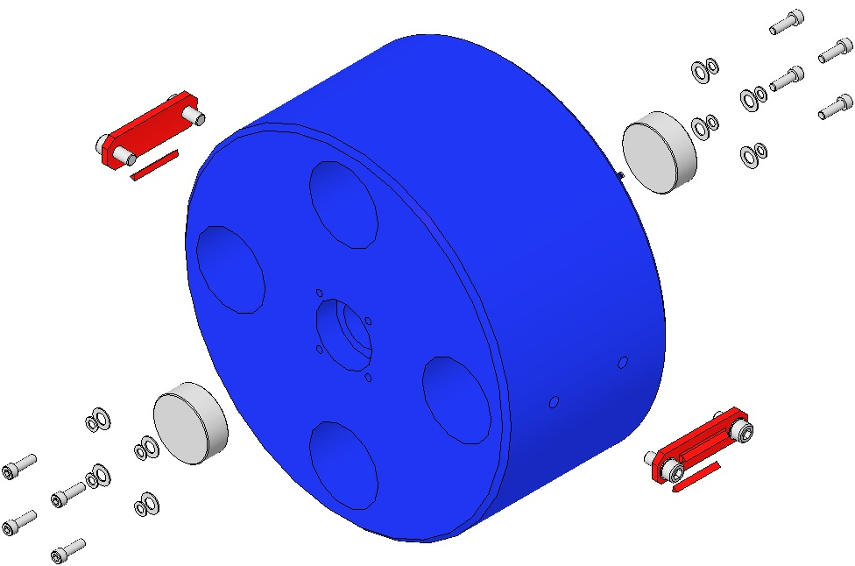

With the assembly process complete, weigh the Bottom Mass Assembly, including the D0901278 Secondary Metal Prism Breakoffs; the combined weight should be 2888.695g. Record this value in ICS. The Lower Mass is not designed to be weight-adjusted; weight is added to or subtracted from the Intermediate Mass. So adjusting Lower Mass weight is actually adjusting the combined weight of the Intermediate and Lower Masses, a total of 2963.30g + 2888.69g = 5851.99g.

Installing Intermediate and Lower Masses and Face EQ Stops

Materials
Qty | U | ID | Description
1 | Ea | D0901873 | Intermediate Mass Assembly
1 | Ea | D0901791 | Lower Mass Assembly

Procedure

Place a 0901873 Intermediate Mass Assembly on top of the 4 Barrel EQ Stop Screws at the Intermediate Mass level.
- Magnets on the Mass face the rear of the Weldment.
- Top/Bottom of the Mass is identified per the Screw hole pattern in the side of the Mass.

Level the Mass (flat sides vertical) by adjusting the 4 EQ Stop Screws such that the lower four corners of the Mass are equidistant from the Optic Table surface.
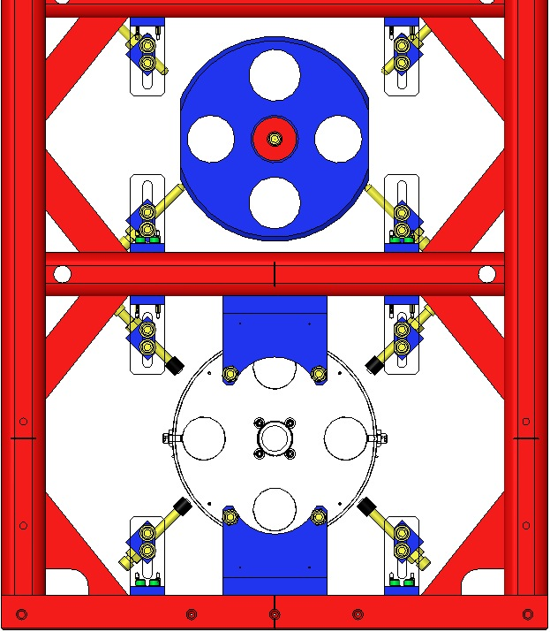  Fig 53: Intermediate Mass on Stops | 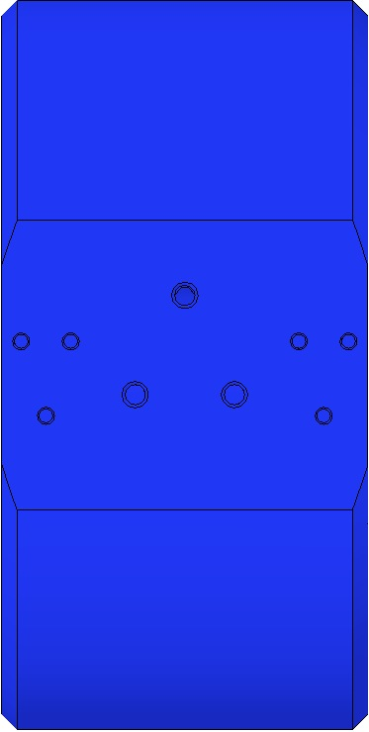  Mass  Right-Side Up | 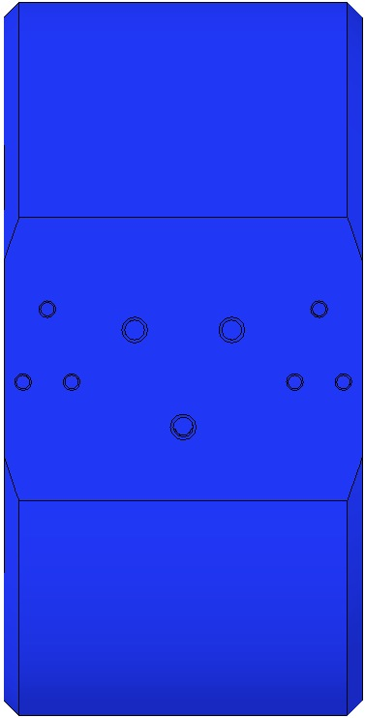  Mass  Upside Down
 | Fig 54: Right-Hand View of Mass

Assemble 2 D0902413 Face EQ Stops to the Weldment in front of the Mass, using:  - 4 Socket Head Cap Screws  8-32 UHC x .75” AgPlated  - 4 Flat Washers #8 SSTL  Torque to 30 in-lb | 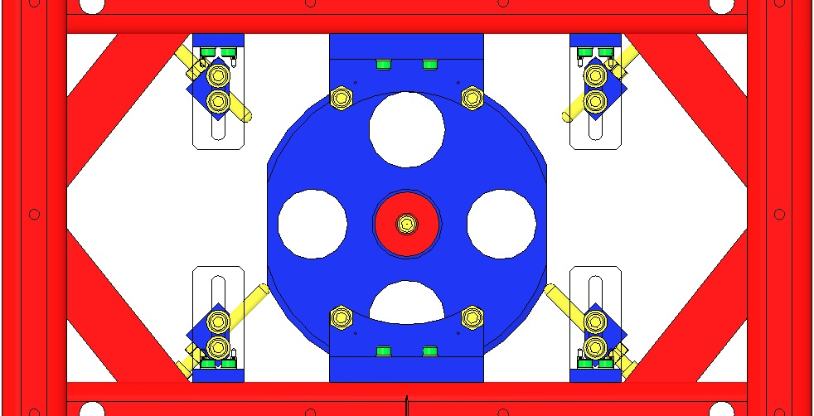  Fig 55: Face EQ Stops
Assemble both ends of the D0901902 Lower Wire Assembly to the Intermediate Mass with:  - 6 Socket Head Cap Screws  8-32 x 0.5” SSTL  - 6 Flat Washers #8 SSTL  Torque to 20 in-lbs  Use the Machinist’s Square to square the Wire Clamps with the front side of the Mass.  Machinist’s  Square |  | 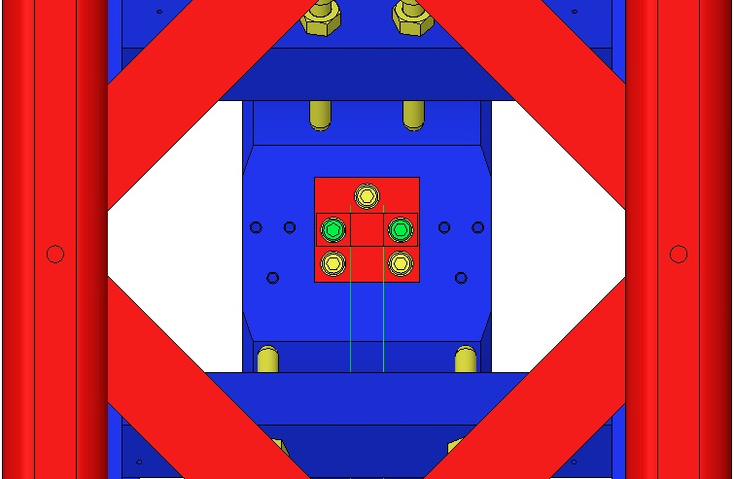  Fig 56: Lower Wire Assembly / Side View
Place a D0901791 Lower Mass within the twin wires of the D0901902 Lower Wire Assembly, but resting on the lower Stop Screws. Ensure:  - The 2 Crossbeams are raised fully;  - The 4 Stop Screws are extended fully.  - Each wire is seated in a Prism notch.  Retract the 4 Stop Screws until the Lower Wires are almost taught. Retract the Screws equally, turning each no more than 1 revolution at a time.  Level the Mass by adjusting the 4 Stop Screws such that both ends of each Prism are equidistant from the Optic Table surface. |  | 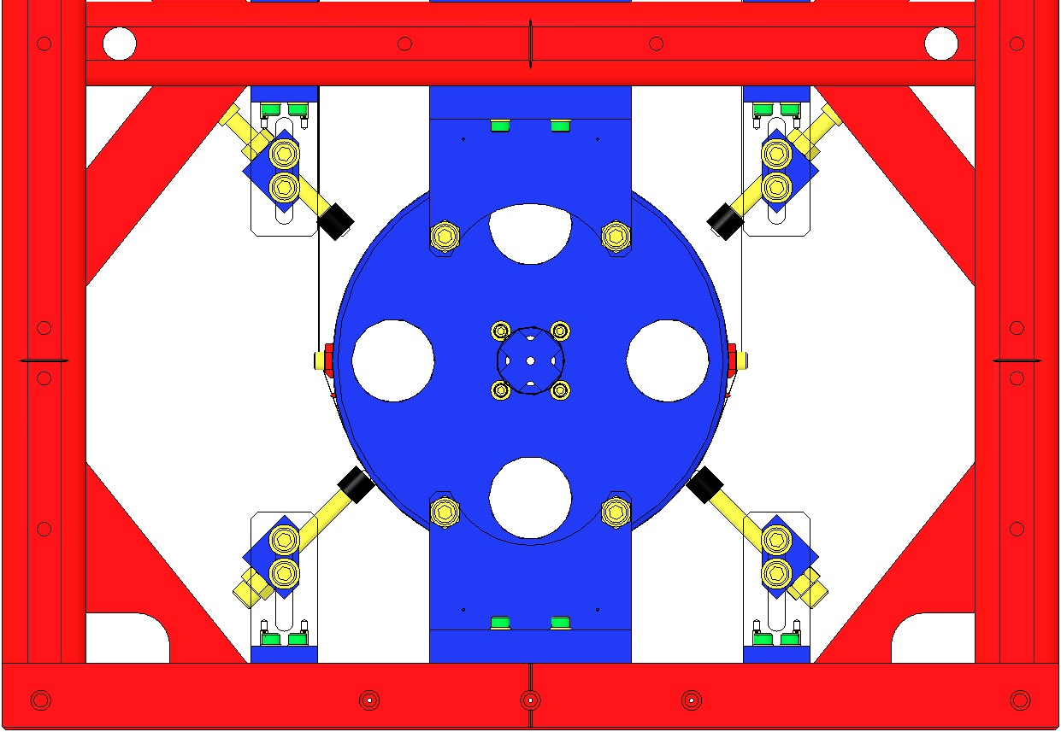  Crossbars Raised  Prism  Screws Extended  Fig 57: Lower Mass installed

Seat the 2 Lower Wires within the tiny grooves in the 2 Prisms. Adjust the 2 Wire loops such that they are equally spaced beneath the Mass.

Retract the 4 Stop Screws to lower the Mass until it is fully supported by the Lower Wires.
Adjust the Screws equally, turning each Screw no more than 1 revolution at a time.

Level the Lower Mass: Raise the Mass evenly on the 4 Stop Screws until the wire is slack but does not leave the Prism Grooves.

Reposition the 2 Wires to achieve leveling. If leveling is not possible, then the Lower Wire Assembly is defective and must be replaced (the 2 wires likely are of different lengths).
Install 2 D0902205 Face EQ Stops in front of the Lower Mass, using:  - 4 Socket Head Cap Screws  ¼-20 UHC x 0.375” SSTL  - 4 Flat Washers ¼” SSTL  Torque to 75 in-lb  Back off the lower Stop Screws (4) so that the Mass hangs free and the Lower Wires (2) are therefore taught. |  | 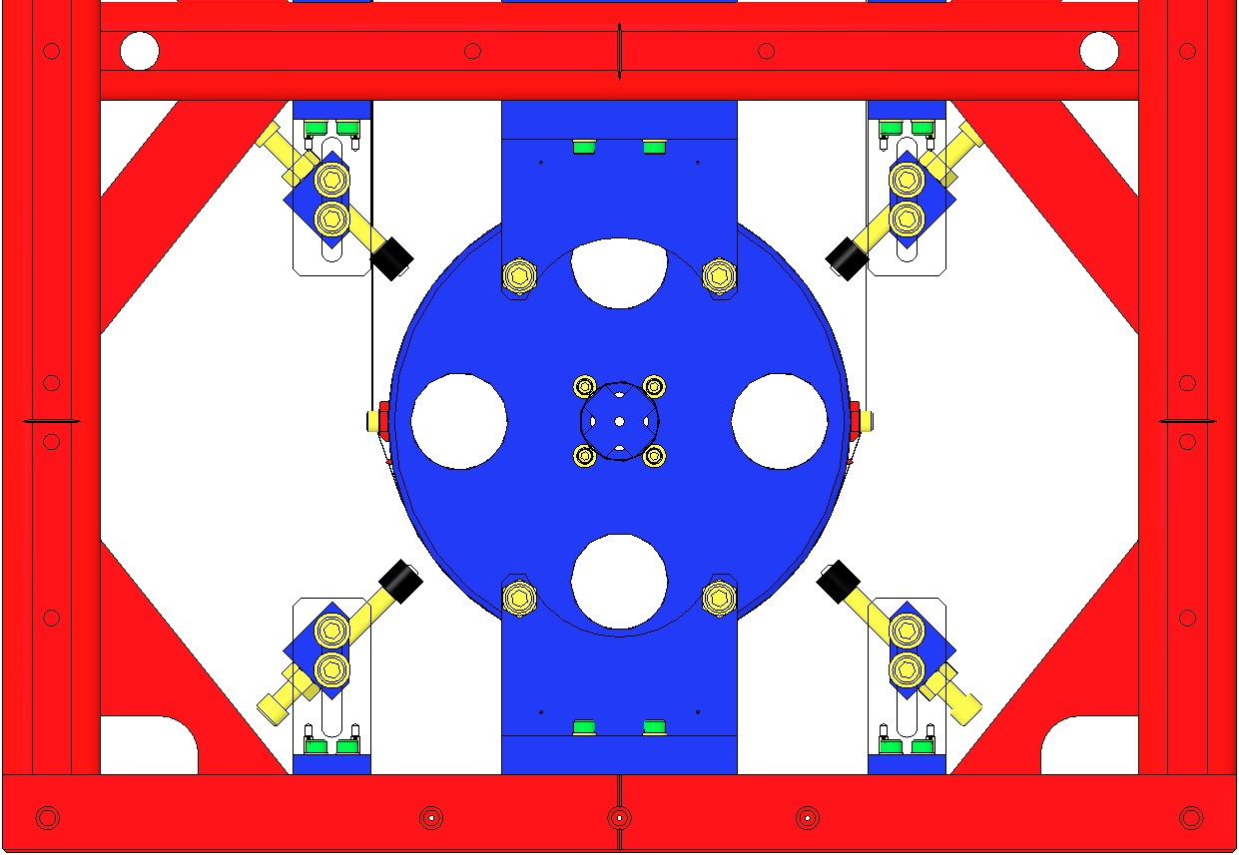  Wires Taught  Fig 58: Lower Mass and Face EQ Stops

Assembling Magnets – Upper Mass

Materials – Upper Mass Magnets
Qty | U | ID | Description
9 | Ea | D1100573 | BOSEM Flat Magnet Flag
9 | Ea | D1100574 | BOSEM Flat Magnet Flag Disk
9 | Ea | 94518A108 | Screw, Countersunk
9 | Ea | D394197N35UHP | Sintered NdFeB Magnet, Ni Plated, 10mm x 5mm
18 | Ea | D1001534 | BOSEM Magnetic Plug
3 | Ea | D0902494 | BOSEM Magnet Holder, Short
6 | Ea | D0902423 | BOSEM Magnet Holder, Long

Assembly Procedure – Upper Mass Magnets
Assemble 3 D0902492 BOSEM Magnet / Flag Assemblies, Short, each with (shown left-to-right, at right):  D1100573 BOSEM Flat Magnet Flag  D1100574 BOSEM Flat Magnet Flag Disk  94518A108 Screw, Countersunk  Magnet DCNI 00626/N Sintered NdFeB Ni-Plated  10 mm x 5 mm  D1001534 BOSEM Magnetic Plug  See Plug Insertion procedure, below  D0902494 BOSEM Magnet Holder, Short  Handle with care; thin sidewalls are easily damaged. | 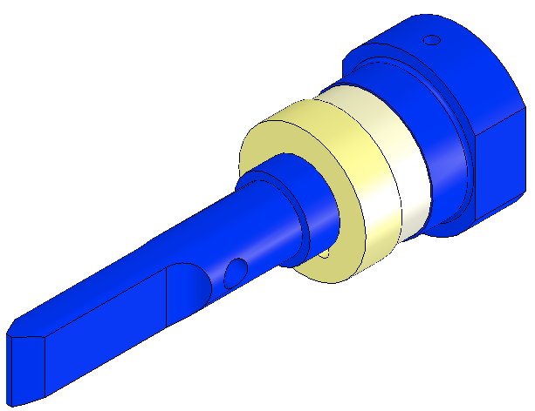  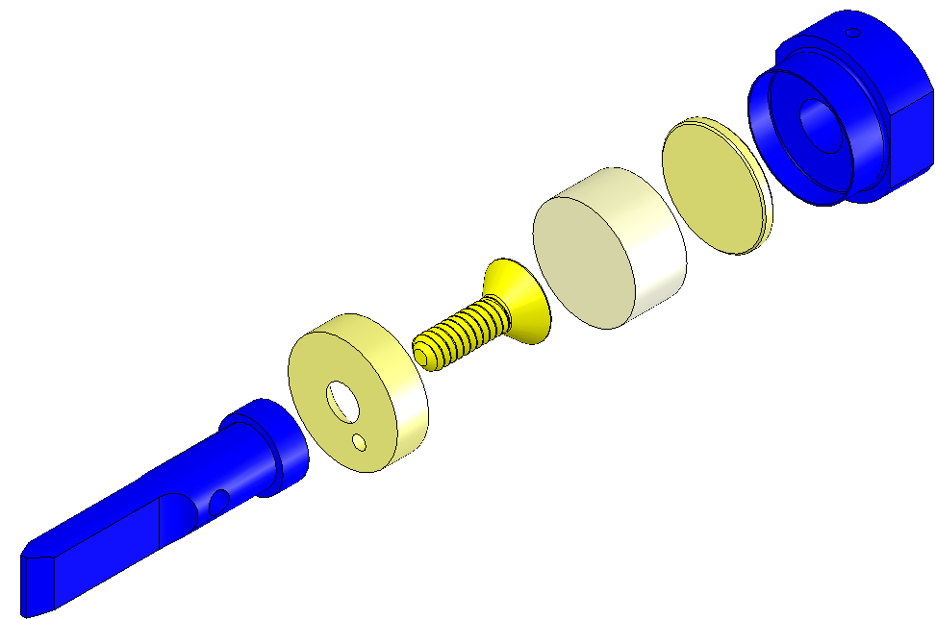  Plug  Magnet  Screw  Disk  Flag  Short Magnet Holder  Fig 59: Short Magnet Assembly
Assemble 6 D0902418 BOSEM Magnet / Flag Assemblies, Long, each with (shown left-to-right, at right):  D1100573 BOSEM Flat Magnet Flag  D1100574 BOSEM Flat Magnet Flag Disk  94518A108 Screw, Countersunk  Magnet DCNI 00626/N Sintered NdFeB Ni-Plated  10 mm x 5 mm  D1001534 BOSEM Magnetic Plug  See Plug Insertion procedure, below  D0902423 Magnet Holder, Long  Handle with care; thin sidewalls are easily damaged. | 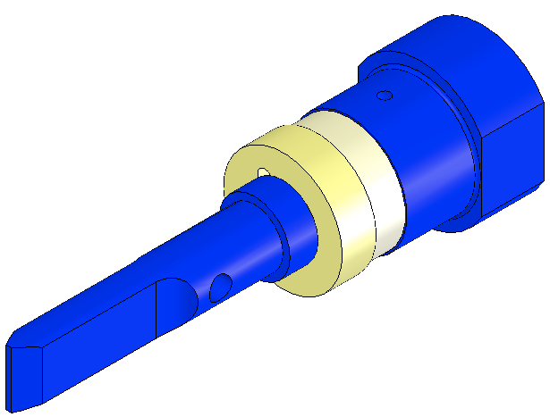  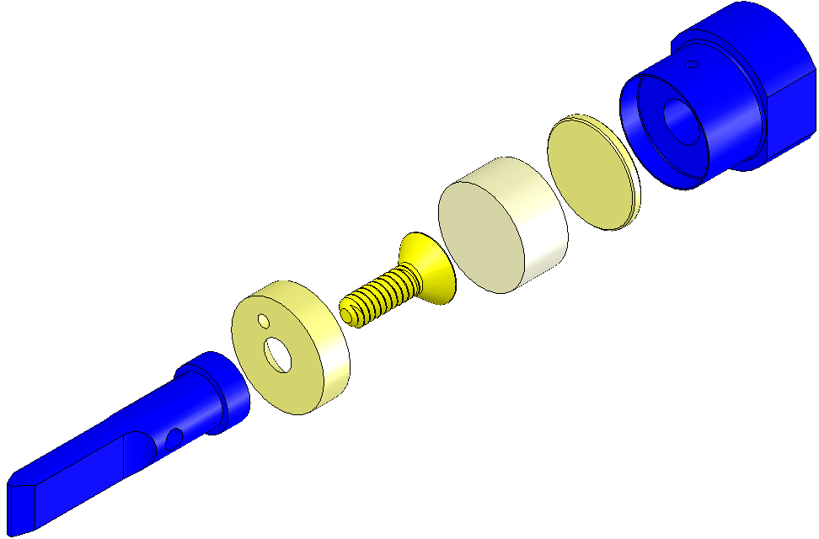  Screw  Magnet  Plug  Long Magnet Holder  Disk  Flag  Fig 60: Long Magnet Assembly

Procedure – Plug Insertion
Procedure for assembling D1001534 Plug to Magnet Holder:  Heat Air Bake Oven to 70°C;  Attach Magnet Holders to Heating Fixture with:  - Socket Head Cap Screw  8-32 x 0.3125” SSTL  Screws must be Class A or B clean  Place Heating Fixture in Oven for 10 min. minimum;  Remove Heating Fixture from Oven and inspect Magnet Holders for out-of-round condition, using tapered end of the Disk Insertion Tool to address any out-of-round conditions.  Place Disk on a Magnet Holder, Place non-tapered end of Disk Insertion Tool on Disk, and tap Insertion Tool until Disk is fully seated within Holder.  Return Heating Fixture to Oven for another 5 minutes, minimum.  Remove Heating Fixture from Oven, and repeat Step 5, above.  Remove Magnet Holders from Heating Fixture. | 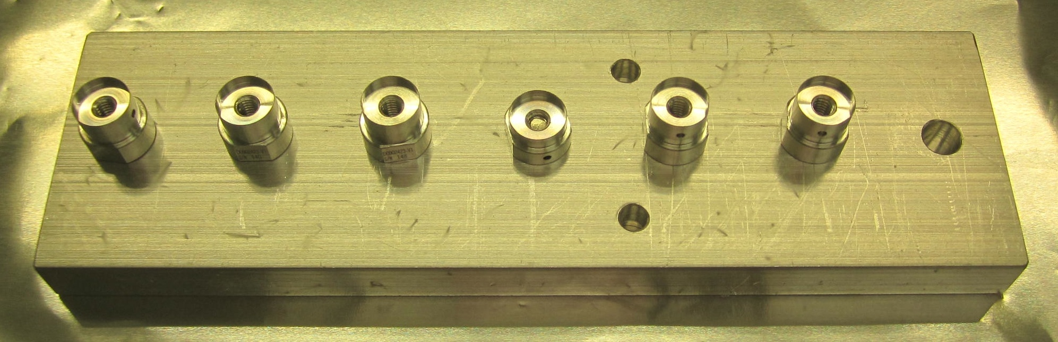  Fig 61: Heating Fixture with Holders  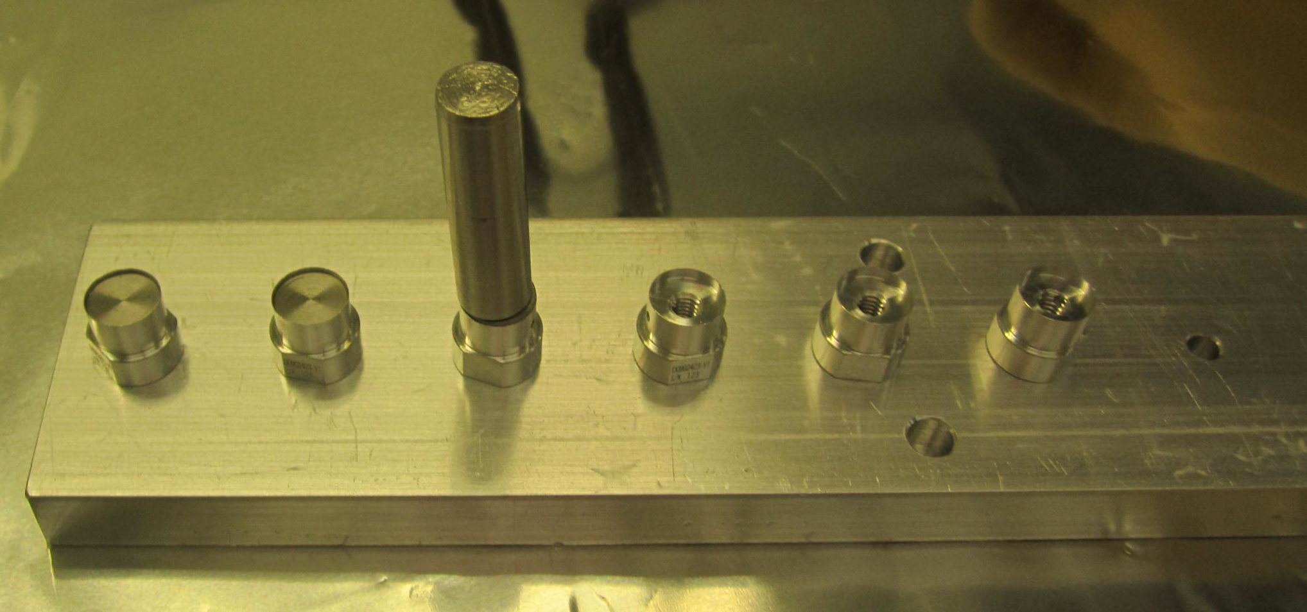  Fig 62: Insertion Tool in position  Note: Tapered end of Tool is up  Note: Seated Disks on left 2 Holders

Assembling the Upper Mass (M1)

Documents
D020534 HSTS Upper Mass Assembly
E0900023 Maraging Steel Blade Specification
E1000169 Blade Characterization Spreadsheet
T0900559 Blade Pairings Spreadsheet

Materials
Qty | U | ID | Description
1 | Ea | D040259 | HSTS Jig, Upper Mass and Coil Holder
1 | Ea | D020534 | HSTS Upper Mass Assembly
1 | Ea | D020134 | HSTS Upper Mass Main Section
4 | Ea | D080761 | HSTS Lower Blades
2 | Ea | 0902030 | HSTS Blade Guards, Upper Mass
4 | Ea | NA | Socket Head Cap Screws 4-40 x .5” SSTL
4 | Ea | NA | Socket Set Screw 4-40 x .625 SSTL
4 | Ea | D020482 | Screw Drive Body
8 | Ea | NA | Socket Head Cap Screw 8-32 x .625 SSTL
4 | Ea | NA | Socket Head Cap Screw 8-32 x .75” Fully-Threaded SSTL
7 | Ea | D0902493 | Base Plate, Long
2 | Ea | D020199 | Base Plate, Short
4 | Ea | NA | Socket Head Cap Screw 4-40 x .625” Vented AgPlated
2 | Ea | NA | Socket Head Cap Screw 4-40 x .625” AgPlated
4 | Ea | NA | Socket Head Cap Screw 4-40 x .625” SSTL
7 | Ea | NA | Socket Head Cap Screw 8-32 x .3125” SSTL 2
2 | Ea | NA | Socket Head Cap Screw 8-32 x .5” SSTL
4 | Ea | D0902492 | BOSEM Magnet Holder, Short
6 | Ea | D0902418 | BOSEM Magnet Holder, Long 4
4 | Ea | D020211 | Magnet Holder Brace
8 | Ea | NA | Socket Head Cap Screw 4-40 x 1.25” AgPlated
18 | Ea | NA | Flat Washer #4
8 | Ea | NA | Socket Head Cap Screw 2-56 x 0.25” AgPlated
8 | Ea | NA | Flat Washer #2 SSTL
1 | Ea | D020136 | HSTS Upper Mass T-Section
1 | Ea | D020137 | HSTS Pitch Insert for T-Section
1 | Ea | NA | Socket Set Screw ½”-20 x 2.00” AgPlated
1 | Ea | D020676 | HSTS Roll Insert for T-Section
4 | Ea | NA | Socket Set Screw 8-32 x .25” AgPlated SSTL
2 | Ea | NA | Socket Head Cap Screw ¼-20 x .375 AgPlated SSTL
10 | Ea | NA | Flat Washers #8
1 | Ea | D020677 | HSTS/OMC Library of Clamps
4 | Ea | D0XXXXX | HSTS Lower Blade Clamp, Upper Side
4 | Ea | D0XXXXX | HSTS Lower Blade Clamp, Lower Side
1 | Ea | D020239 | HSTS Coil Holder
2 | Ea | NA | Socket Head Cap Screw ¼-20 x 1.125” AgPlated
2 | Ea | NA | Hex Nut ¼-20 SSTL
12 | Ea | NA | Socket Head Cap Screw 8-32 x 1.00” Round Tip, AgPlated
12 | Ea | NA | Hex Nut 8-32 SSTL
2 | Ea | D020660 | Blade Pulldown Device
2 | Ea | D020132 | Lower Blade Wire Clamp
2 | Ea | D0901855 | Intermediate Wire Upper Clamp, Outside
8 | Ea | NA | Socket Head Cap Screw 2-56 x 0.25” AgPlated
4 | Ea | NA | Flat Washer #2 Vented SSTL
1 | Kg | NA | 1.4595 kg in weight
2 | Ft | NA | Music Wire .024” dia.
1 | Ea | NA | Machinist’s Square

Procedure – Main Section & T Section
Assemble to the T-Section D020136:  - Roll Insert D020676  - Pitch Insert D020137  - 4 Socket Set Screws  8-32 x .25” AgPlated  Torque to 30 in-lb | 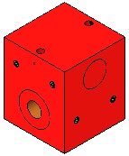  Screws (2)  Roll Insert  Pitch Insert  Screws (2)  Fig 63: Upper Mass T-Section
Attach the D040259 Upper Mass Jig to an Optics Table with a ¼-20 Ag-Plated Bolt.  Thread the T-Section onto the ¼-20 stud at the top of the Jig.  The Jig will not be shown for the remainder of the assembly steps, but is necessary to secure the Upper Mass during the assembly process. | Fig 64: Upper Mass Jig and T-Section
Assemble the D020134 Upper Mass Main Section to the T-Section using:  2 Socket Head Cap Screws  ¼-20 x .375” AgPlated  Torque to 100 in-lb | 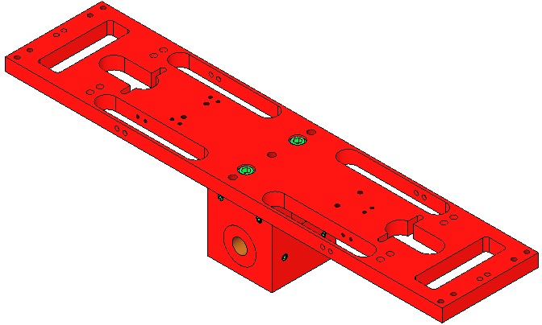  Upper Mass  Main Section  T-Section  Screws (2)  Fig 65: Main Section assembled to T-Section

Procedure – Lower Blades & Screw Drives
Wear Safety Glasses and Glove Liners per E1000043.  Blades are shown flattened but are curved upward until weighted.  Prepare 2 D020660 Blade Pulldown Devices per Materials List.  Per the data in T0900559 Blade Pairings, retrieve:  A matched set of 4 D080761 Lower Blades.  4 sets of Blade Clamps from the D020677 Library of Clamps, each with an Angle corresponding to a specific Blade.  Identify the Blades for installation in the Upper Mass as follows:  - Blade with highest tip in +X, +Y corner  - Blade with next to highest tip in –X, +Y corner  - Blade with next to lowest tip in +X, -Y corner  - Blade with lowest tip in –X, -Y corner | Fig 66: Blade Pulldown Device
 | Assemble Blade Assemblies with:  - 2 Socket Head Cap Screws  8-32 x 1” AgPlated  - 2 #8 Flat Washers SSTL  - 1 D0XXXXX Blade Clamp, Lower  - 1 D080761 Lower Blade  - 1 D0XXXXX Blade Clamp, Upper | 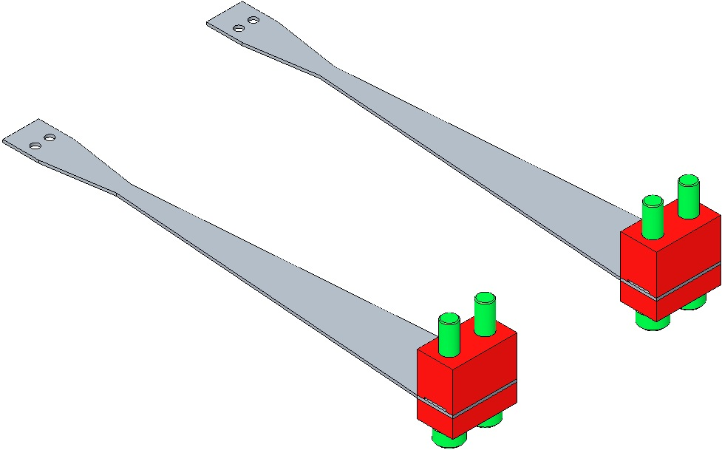  8/32 x 1” AgPlated  Blade Clamp Lower Side  Blade Clamp Upper Side  Fig 67: Lower Blade Assemblies
The Upper Mass remains on the Upper Mass Jig, as shown in Step 2.  Attach each Blade assembly to the Main Section in the location specified in the T0900559 Blade Pairings file; snug the Screws tight.  Square Blades and Clamps with the Main Section using the Machinist’s Square. Ensure the Blade tips won’t touch the oval cutout walls.  Attach the Blade Pulldown Device to the tip of each Blade. The Blade tips will pass through the cutouts until the Blades are essentially flat.  Torque the Blade Clamp Screws to 30 in-lb AFTER the Blades are flattened. |  | 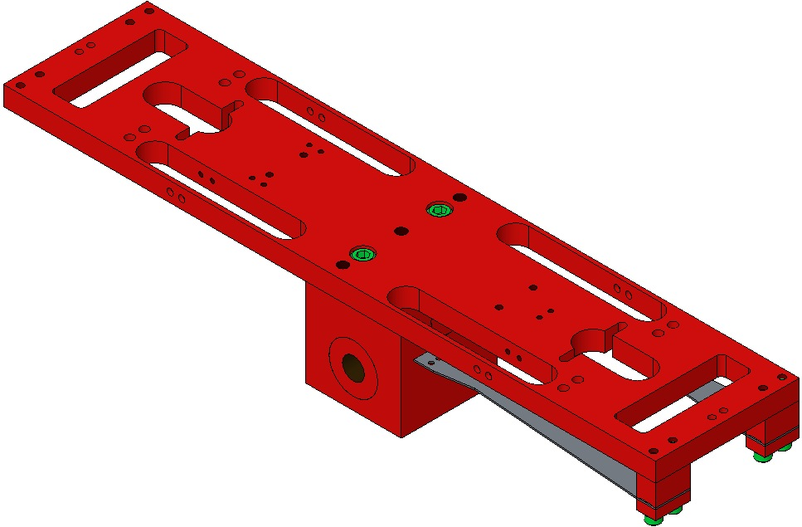  Blade tips must not touch cutouts as they pass through  Machinist’s  Square  Fig 68: Attaching the Blades to the Main Section
When using Blade Clamp pairs other than 0° ensure the orientation of Upper Clamp to Lower Clamp is such that the bolt holes are concentric (visibly, the Clamp sidewalls must be parallel). |  | Measure  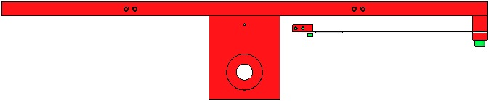  Non-Concentric  Concentric  Fig 69: Profile Matching & Blade Clamp Alignment
Assemble a 0902030 Blade Guard to the Main Section with:  2 Socket Head Cap Screw  4-40 x .5” SSTL  Torque to 5 in-lb  Assemble to the Blade Guard:  2 Socket Set Screws  4-40 x .625” SSTL  Diagram shows SHC Screws; ½” Set Screws are being used as a temporary deviation as of 2/12.  Turn the Screws down as far as possible.  Disconnect the Pulldown Devices from the Blade tips. |  | 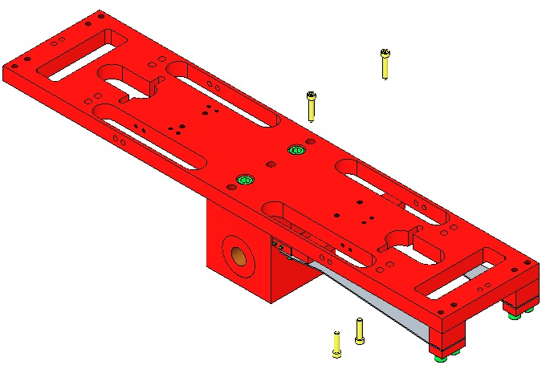  4-40 x .625”  4-40 x .5”  Blade Guard  Fig 70: Adding Blade Guards

Repeat steps 7–14 to assemble the 2nd pair of Lower Blades and Blade Guards.
Assemble to Pitch Insert:  1 Socket Set Screw  ½”-20 x 2.00” AgPlated  Assemble 4 D020482 Screw Drive bodies to Main Section with:  8 Socket Head Cap Screws  8-32 x .625” SSTL  8 Flat Washers #8  Torque to 20 in-lb  Use a Machinist’s Square to ensure Screw Drive bodies are square with the Upper Mass Main Section.  Assemble to Screw Drive System bodies:  4 SHCS 8-32 x .75”  Fully-Threaded SSTL |  |  | 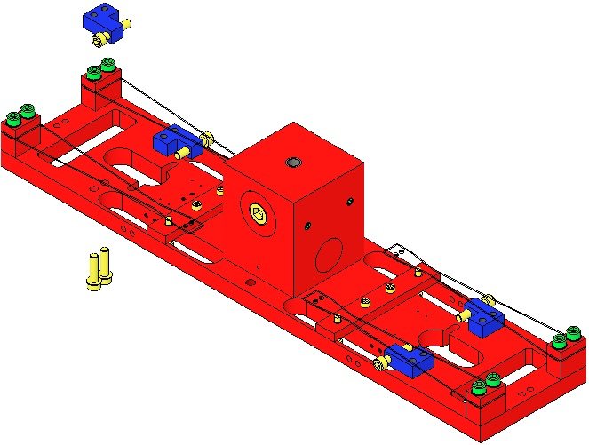  Socket Set Screw  8-32 x .625”  8-32 x .75”  Screw Drive (4)  Fig 71: Adding Screw Drives  Machinist’s  Square

Procedure – Magnets
The Magnet Holders and Wires that follow, are vulnerable to damage and therefore must ONLY be added JUST PRIOR to the Upper Mass being assembled (with the Coil Holder) to the Weldment. The Magnet/Flag Assemblies are left off until all Masses and Wires are installed and suspended.
The Upper Mass continues to be mounted on the Upper Mass Jig, as shown in Section 24.3 Step 2.  Assemble:  2 D0902492 Magnet Holder, Short  2 D0902493 Base Plates, Long  2 SHCS 8-32 x .3125” SSTL  s to 20 in-lb  Assemble these to the top of the Main Section with:  4 SHCS 4-40 x .625” Vented AgPlated  4 Flat Washers #4  Torque to 7 in-lb |  | 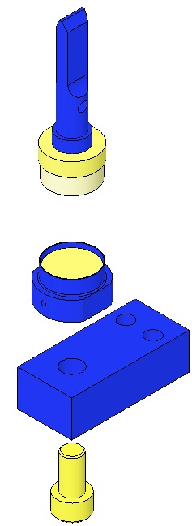  Base Long  Magnet Holder  Short  8-32 x .3125  Remove Flag for ease of assembly  Fig 72: 2 Short Assemblies attached to Main Section
Assemble:  1 D0902492 Magnet Holder Short  1 D0902493 Base Long  1 SHCS 8-32 x .3125” SSTL  Torque to 20 in-lb  Remove Magnet Flag for ease of assembly.  Assemble the Base to the top of the Main Section with:  2 SHCS 4-40 x .625” AgPlated  2 Flat Washer #4  Torque to 6 in-lb |  | 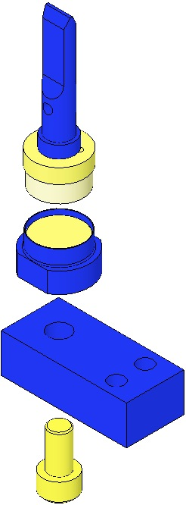  Base Long  Remove Flag for ease of assembly  Magnet  Holder  Short  8-32 x .3125  Fig 73: 1 Short Assembly attached to Main Section
Assemble:  4 D0902418 Magnet Holder, Long  4 D0902493 Base Plate, Long  4 SHCS 8-32 x .3125” SSTL  Torque to 20 in-lb  Remove Magnet Flag for ease of assembly. | 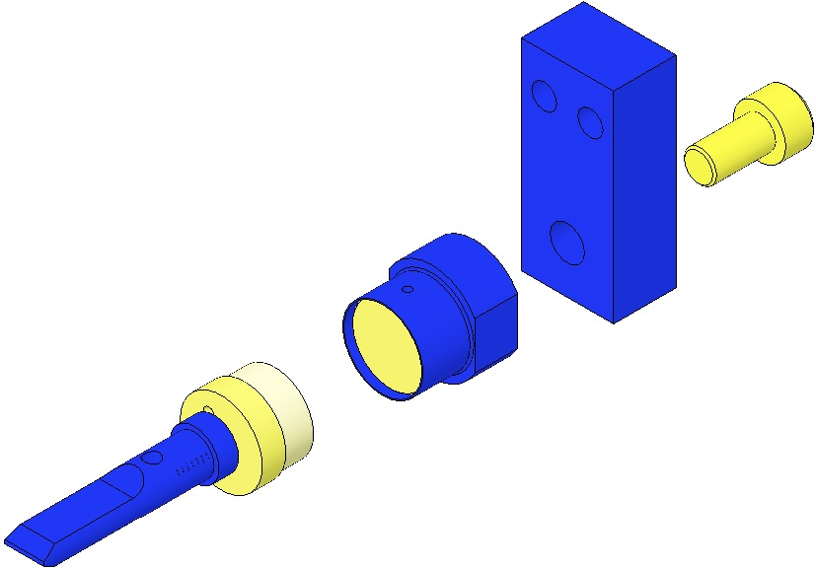  Base Long  Magnet Holder Long  Remove Flag for ease of assembly  Fig 74: 5 Long Assemblies

Assemble these 4 Assemblies to the sides of the Main Section with:  - 4 D020211 Magnet Holder Brace  - 8 SHCS 4-40 x 1.25” AgPlated  - 8 Flat Washer #4  Torque to 30 in-lb | 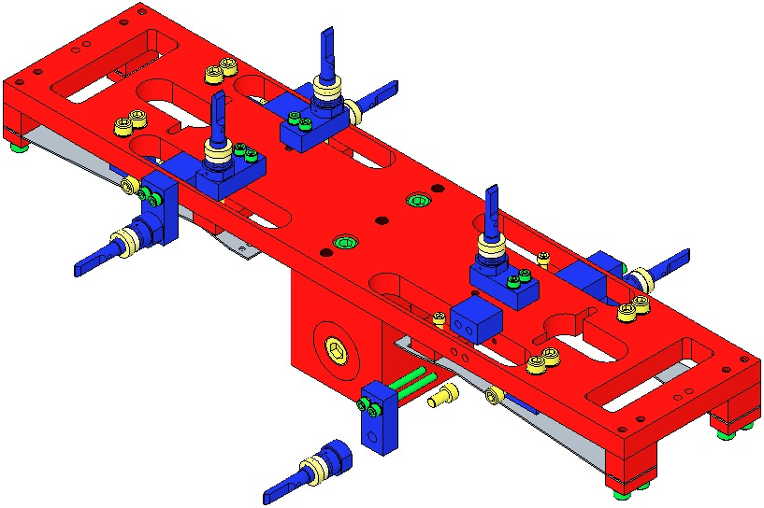  Magnet Holder Brace  Fig 75: 4-7 of 9 Magnet Assemblies
Assemble:  - 2 D020199 Base Plate Short  - 2 D0902418 Magnet Holder Long  - 2 SHCS 8-32 x .5” SSTL  Torque to 20 in-lb  Remove the Flag portion of the M/F Assembly when attaching the | 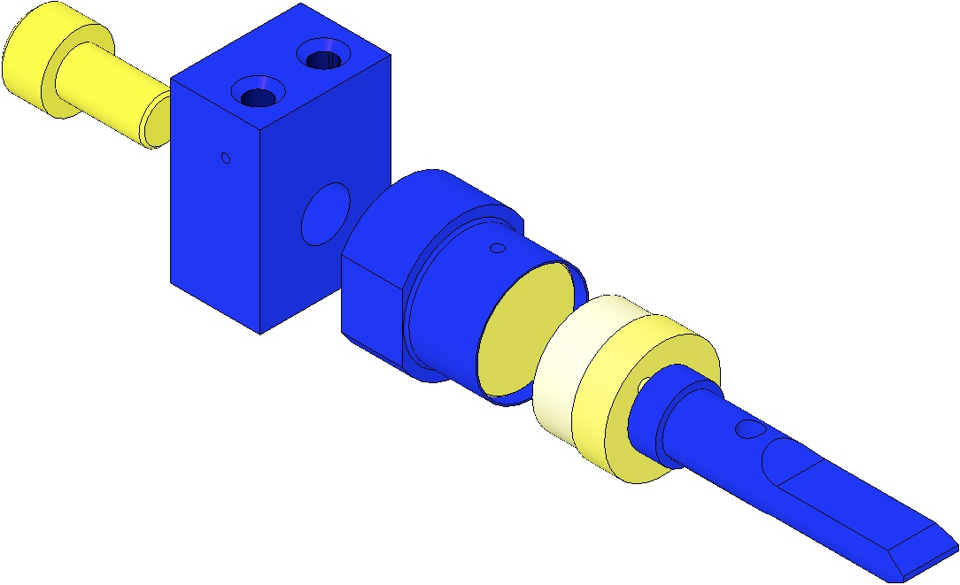  Remove Flag for ease of assembly  Magnet Holder Long  Base Short  8-32 x .5”  Fig 76: 2 Short Assemblies
Assemble one of these Assemblies to each end of the Main Section using:  - 4 SHCS 4-40 x .625” SSTL  - 4 Flat Washer #4  Torque the -Y assembly to 5 in-lb  Hand-tighten +Y Assembly; it will be dis-assembled and re-assembled during assembly to the Weldment. | Fig 77: LH end of Main Section; 8 of 9 Magnet Assys  Fig 78: RH end of Main Section; 9 of 9 Magnet Assys

Weigh the following items to arrive at the Upper Mass total weight of 3115 gm., and record with the Upper Mass Serial Number in ICS:  1 Upper Mass assembly just completed, including the 9 Magnet Flags  2 Lower Clamps (with bolts) from the Upper Wire Assembly:  - 2 D020481 Upper Mass C-Clamp  - 2 D0901999 Upper Mass Wire Clamp, Inside  - 2 D0901998 Upper Mass Wire Clamp, Outside  - 4 Socket Head Cap Screws  2-56 x .375” AgPlated SSTL  - 4 Flat Washers, #2 SSTL  - 4 Socket Head Cap Screws  8-32 x 1.00” AgPlated SSTL  - 4 Flat Washer, #8, D1100785-281  4 Upper Clamps (with bolts) from the Lower Wire Assembly:  - 4 D020132 Lower Blade Wire Clamp  - 4 D030044 Lower Blade Wire Clamp Plate, angled  - 8 Socket Head Cap Screws  2-56 x .375” AgPlated SSTL  - 8 Washers, Flat, #2  - 8 Socket Head Cap Screws  2-56 x 0.25” AgPlated SSTL  - 8 Washers, Flat #2, SSTL  Hand-tighten the Screws. | Fig 79: Upper Mass subassembly  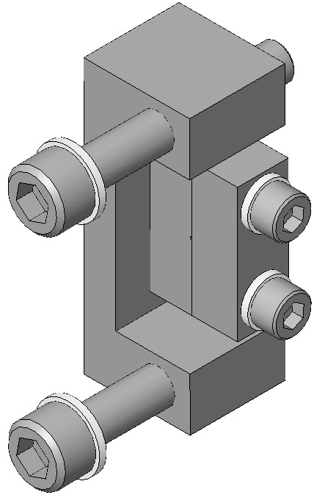  2-56 x .375”  (2)  D0901999  (2)  8-32 x 1.00”  (2)  D020481  (2)  D0901998  (2)  Fig 80: Lower Clamp from Upper Wire Assy  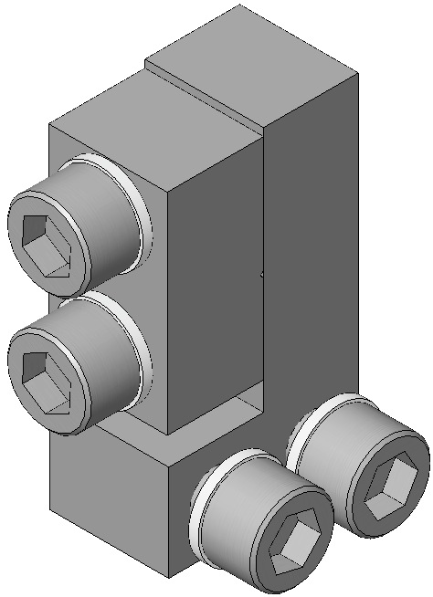  2-56 x .25”  2-56 x .375”  D030044  D020132  Fig 81: Upper Clamp from Lower Wire Assy

Procedure – Lower Wires
The Upper Mass continues to be mounted on the Upper Mass Jig, as shown in Section 24.3 Step 2.  Assemble the L-Clamps of the 4 D0901905 Lower Wire Assemblies to the tips of the 4 Lower Blades, using:  - 8 Socket Head Cap Screws  2-56 x 0.25” AgPlated  - 8 Flat Washers #2, SSTL  Hand-tighten the Screws.  Note that the Clamp mounts above the Blade and the Screw assembles from beneath the Blade.  Note the orientation of each Clamp is the same relative to each Blade tip.  If any Wire becomes kinked during assembly, replace with another Wire Assembly. | 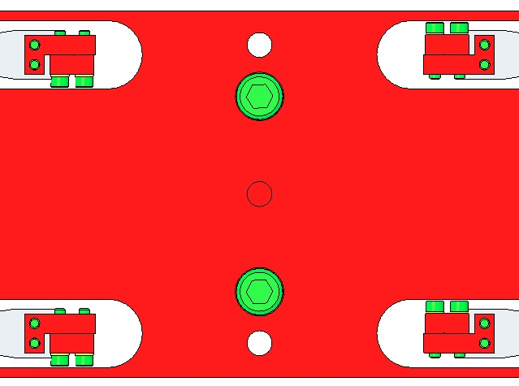  Fig 82: Top View of Clamps  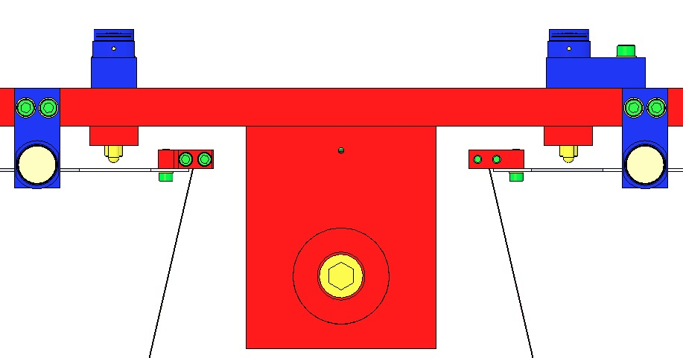  Fig 83: Lower Wire Assemblies added
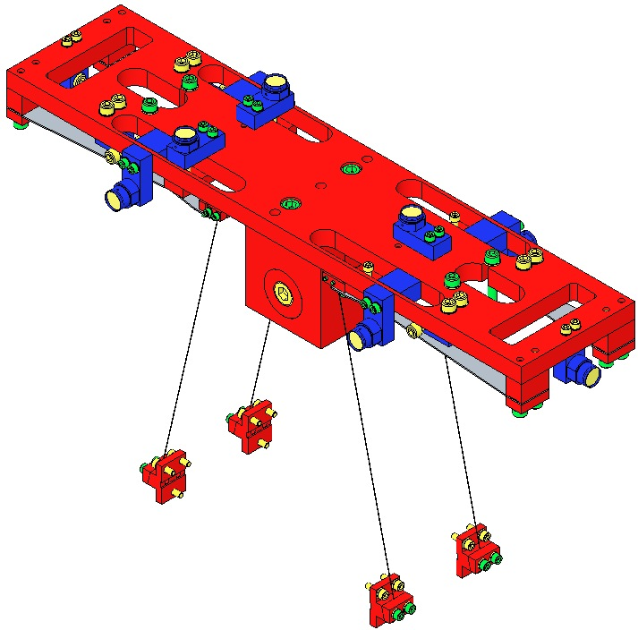
Fig 84: Upper Mass (Magnet Flags removed) with Lower Wires

Procedure – Coil Holder
The Upper Mass continues to be mounted on the Upper Mass Jig, as shown in Section 24.3 Step 2.  Remove the previously hand-tightened Magnet Holder at the +Y side of the Upper Mass, to allow assembly clearance for the Coil Holder.  Place the D020239 Coil Holder over the Upper Mass and secure with:  - 2 Socket Head Cap Screws  ¼-20 x 1.125” AgPlated  - 2 Hex Nuts ¼-20 SSTL | 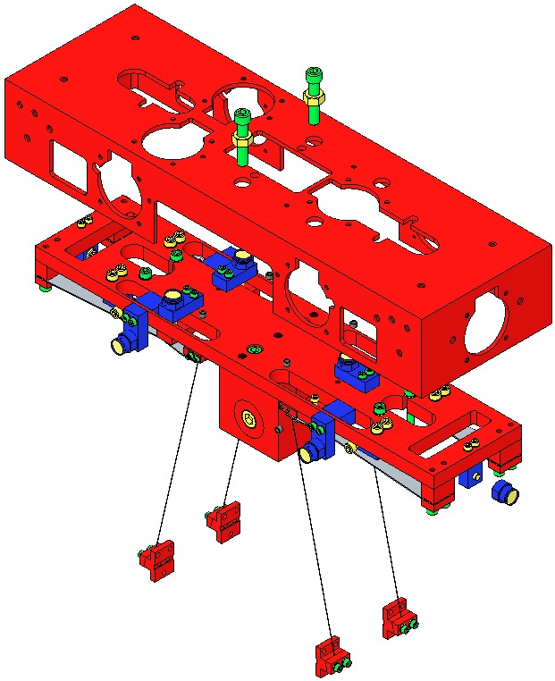  Hex Nut  ¼-20  Magnet  Holder  removed  Fig 85: Assembling Upper Mass to Coil Holder
Using the 2 ¼-20 Screws, draw the Upper Mass fully upwards into the Coil Holder, to optimize later assembly steps.  Re-attach the end Magnet Holder.  Torque to 30 in-lb  Assemble into the Coil Holder:  - 12 Socket Head Cap Screws  8-32 x 1.00” Round Tip, AgPlated  - 12 Hex Nuts 8-32 SSTL  Diagram will be updated to show Hex Nuts.  Adjust the Screws to protrude 10 mm inside the Coil Holder. | 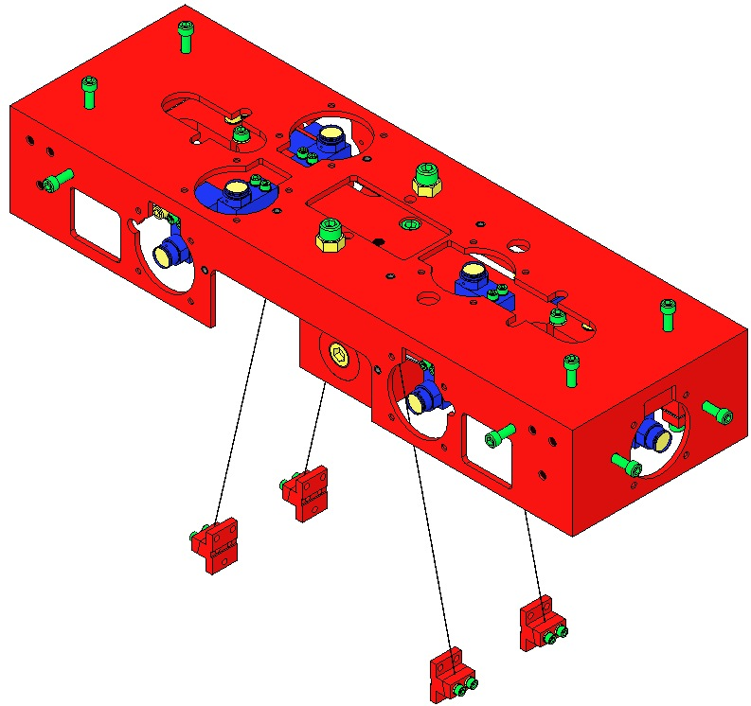  Ensure Upper Mass is fully raised into the Coil Holder  Magnet  Holder  re-attached  Fig 86: 12 Screws added

Installing the Upper Mass and Coil Holder

Materials
Qty | U | ID | Description
1 | Ea | D040259 | Upper Mass Jig
1 | Ea | D020239 | HSTS Coil Holder
4 | Ea | D020346 | HSTS Coil Holder Bracket
16 | Ea | NA | Socket Head Cap Screw 8-32 x .375” AgPlated
16 | Ea | NA | Flat Washer #8 SSTL
12 | Ea | D030025 | Socket Head Cap Screw, 8-32 x 1.00”, Round Tip, AgPlated
1 | Ea | D020534 | HSTS Upper Mass Assembly
4 | Ea | D020482 | HSTS Screw Drive System
9 | Ea | D0902418 | Magnet/Flag Assembly Long
7 | Ea | D0902493 | Magnet/Flag Assembly Base
2 | Ea | D020199 | Magnet/Flag Assembly Base Short
4 | Ea | D020211 | HSTS Magnet Holder Brace
8 | Ea | NA | Socket Head Cap Screw 4-40 x 1.25” AgPlated
4 | Ea | NA | Socket Head Cap Screw 4-40 x .625” Vented AgPlated
6 | Ea | NA | Socket Head Cap Screw 4-40 x .625” AgPlated
18 | Ea | NA | Flat Washer #4
4 | Ea | NA | Socket Head Cap Screw 4-40 x 0.375” AgPlated SSTL
1 | Ea | NA | Allen Head Wrench #4 T-Handle

It is important that the Upper Wires NOT be assembled to the Upper Mass / Coil Holder until it is ready to be installed in the Weldment.

Procedure – Assembling Upper Mass & Coil Holder to Weldment
Coil Holder brackets are made to match each Weldment.  Assemble loosely to one end of the Weldment (LH end of Weldment shown):  - 2 D020346 Coil Holder Brackets  - 4 Socket Head Cap Screws  8-32 x .375” AgPlated SSTL  - 4 Flat Washers #8 SSTL  Attach Bracket to the Weldment through the horizontal Screw Slots. | 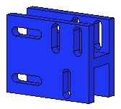  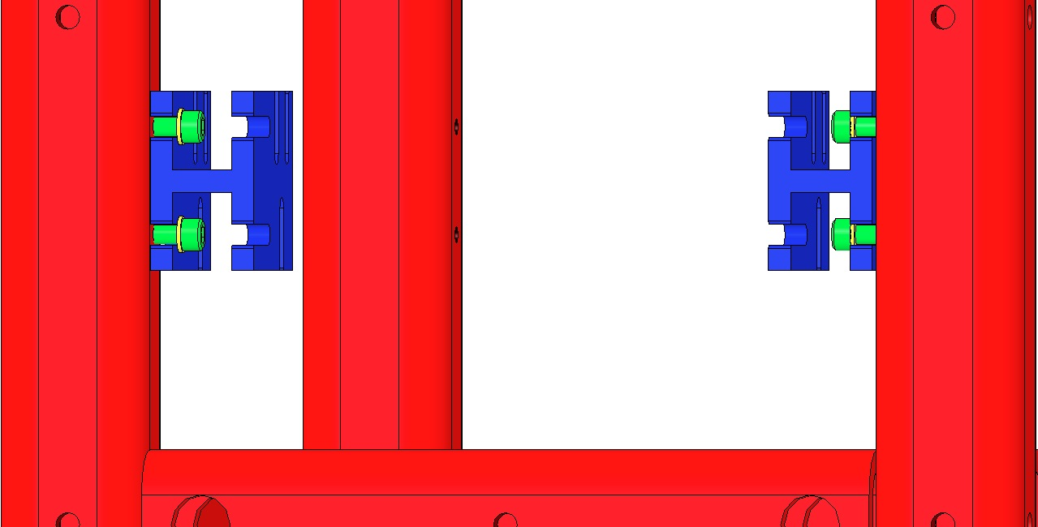  Coil Holder Slots  Weldment Slots  Fig 87: 1st pair of Coil Holder Brackets
Assemble loosely to the 2 Brackets:  - The D020239 Coil Holder  - 4 Socket Head Cap Screws  8-32 x .375” AgPlated SSTL  (2 shown)  - 4 Flat Washers #8 SSTL  Although each Coil Holder Bracket has 3 Screw slots for the Coil Holder, only 2 Screw slots are usable due to clearance issues with the Weldment.  Assemble loosely to the other end of the Weldment:  - 2 D020346 Coil Holder Brackets  - 4 Socket Head Cap Screws  8-32 x .375” AgPlated SSTL  - 4 Flat Washers #8 SSTL  Assemble loosely to the 2 Brackets:  - The D020239 Coil Holder  - 4 Socket Head Cap Screws  8-32 x .375” AgPlated SSTL  - 4 Flat Washers #8 SSTL  Align Coil Holder to Weldment and with the 4 Coil Holder Brackets:  - Horizontally: Visually centered  - Vertically: Low in the Bracket Slots  Torque all 8 Screws that connect the Brackets to the Weldment to 30 in-lb. Leave the 8 Screws that connect the Brackets to the Coil Holder loose. | 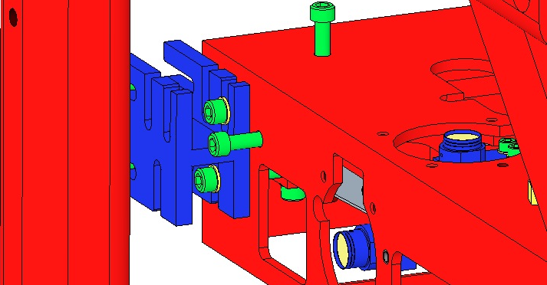  Fig 88: Assemble Coil Holder to 2 Brackets  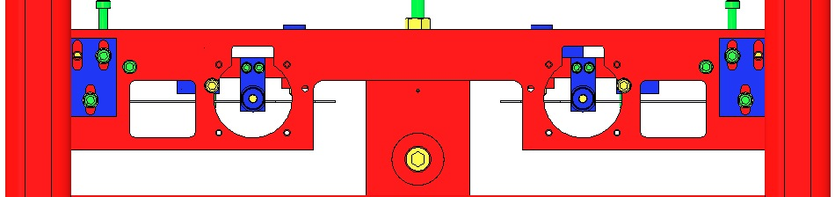  Fig 89: Unusable Screw locations  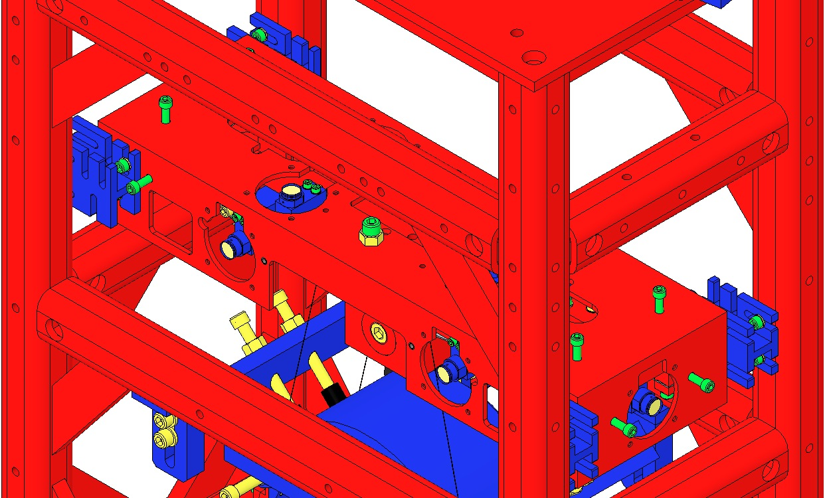  Fig 90: 2nd pair of Coil Holder Brackets

Procedure – Assembling Intermediate Wires to Intermediate Mass
Extend the Intermediate Mass lower Barrel EQ Stop screws (4) as far as possible. These will raise both the Intermediate and Lower Masses.  While extending these screws, observe the 8 screws within the 4 upper Barrel EQ Stops, and retract those screws if it appears either Mass will come in contact with any of them. | 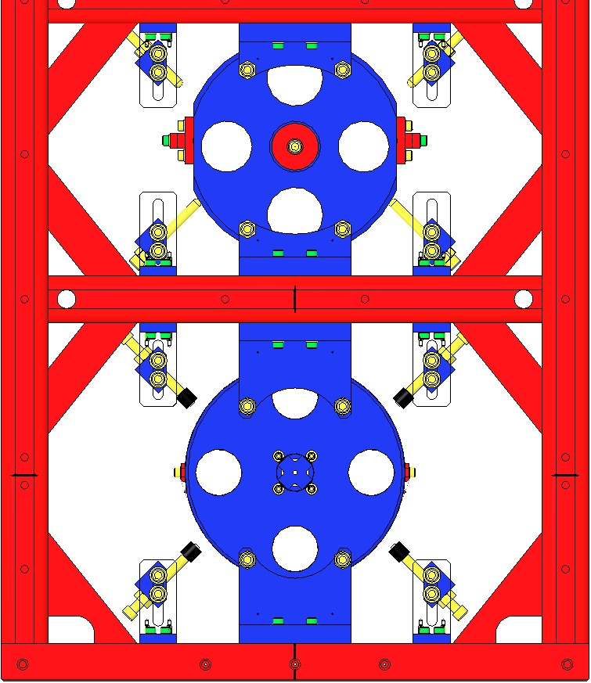  Lower  Mass  Intermediate Mass  Fig 91: Raising the Masses
Ensure the Coil Holder is fully raised within the Coil Holder Brackets. The Screws may be left loose at this point.  Using the 2 center ¼-20 Screws, lower the Upper Mass fully, within the Coil Holder (shown transparent here). | 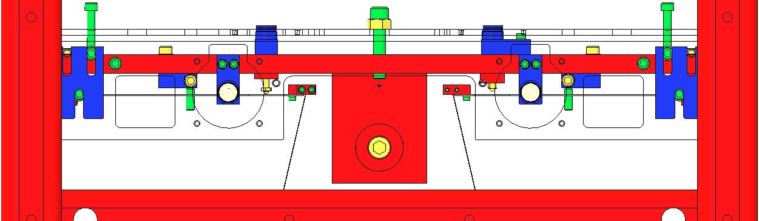  Fig 92: Coil Holder lowered
Assemble the 4 Intermediate Clamps of the D0901905 Intermediate Wire Assemblies to the Intermediate Mass with:  - 12 Socket Head Cap Screws  4-40 x 0.375” SSTL  - Flat Washer #4 SSTL  Torque to 5 in-lb | 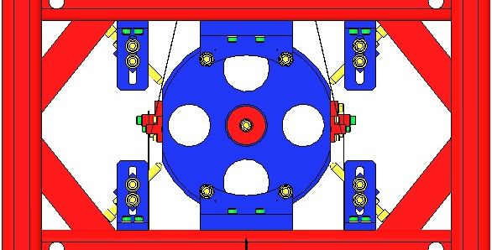  Fig 93: Intermediate Mass and Face EQ Stops
Raise the Coil Holder fully within the Coil Holder Brackets and then tighten the Screws.  Using the 2 center ¼-20 Screws, raise the Upper Mass fully, within the Coil Holder (shown transparent here). | 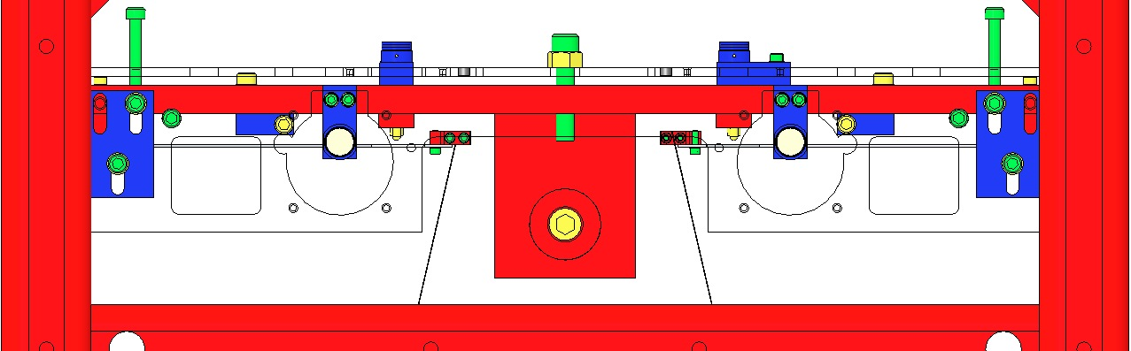  Fig 94: Coil Holder raised

Procedure – Assembling Upper Wires to Upper Mass
To improve clarity, the diagrams for this procedure do not show the Weldment.  Grasp the L-Clamp end of each D0901854 Upper Wire Assembly and feed the Assemblies upwards through the oval openings in the Upper Mass and Coil Holder.  If any Wire becomes kinked during assembly, replace with another Wire Assembly. | 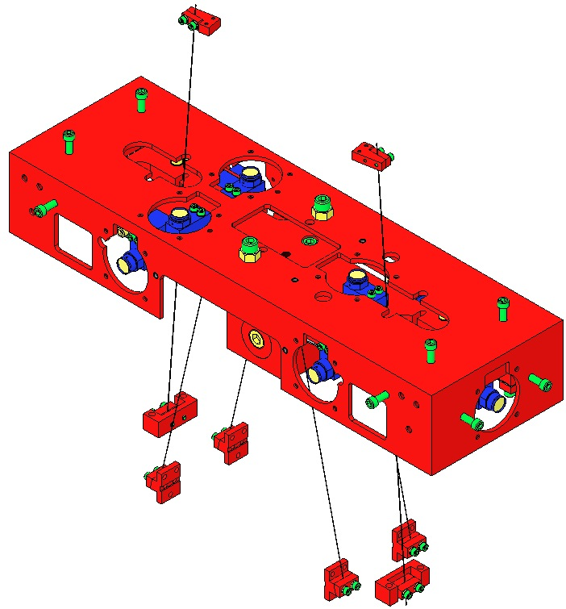  Fig 95: Upper Wires fed through Upper Mass
Assemble the C-Clamps of the Upper Wire Assemblies to the Upper Mass, using:  - 4 Socket Head Cap Screws 8-32 x 1.00” AgPlated SSTL  Use Screws that have only ½” of shaft threaded; fully-threaded Screws will not fit in the slots.  - 4 Washers Flat, #8, SSTL  Torque to 30 in-lb | 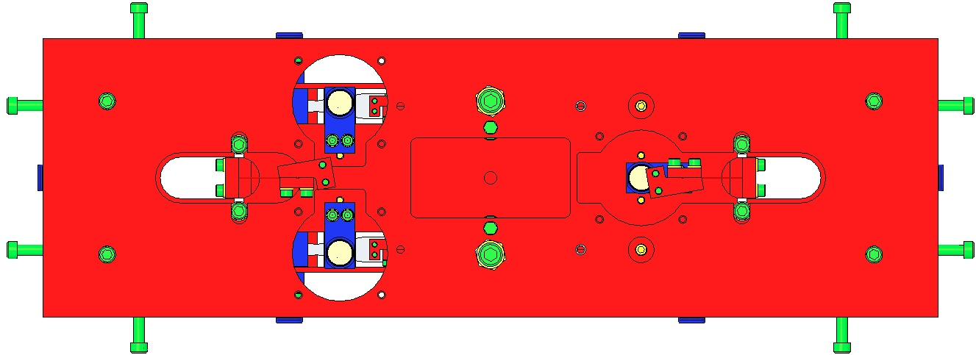  C-Clamp Screws  Fig 96: Attaching Upper Wires to Upper Mass
Use the 4 Screws from the Screw Drive Systems to center the C-Clamps on the oval openings. | 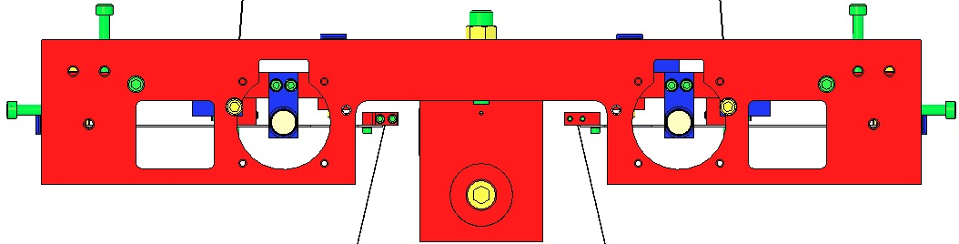  Screw Drive Screws  Fig 97: Centering the C-Clamps with the Screw Drives

Procedure – Assembling Upper Wires to Upper Blades
Fasten the 2 L-Clamps of the Upper Wire Assemblies to the Upper Blades using:  - 4 Socket Head Cap Screws  4-40 x .375” AgPlated SSTL  When assembling the Screws, use a T-Handle Allen Wrench, approaching the Screws from below. Hand-tighten only; do not use a Torque Wrench.  The L-Clamps are mounted ON TOP OF each Upper Blade.  Note the orientation of the L-Clamps, relative to each Blade.  If any Wire becomes kinked during assembly, replace with another Wire Assembly. | 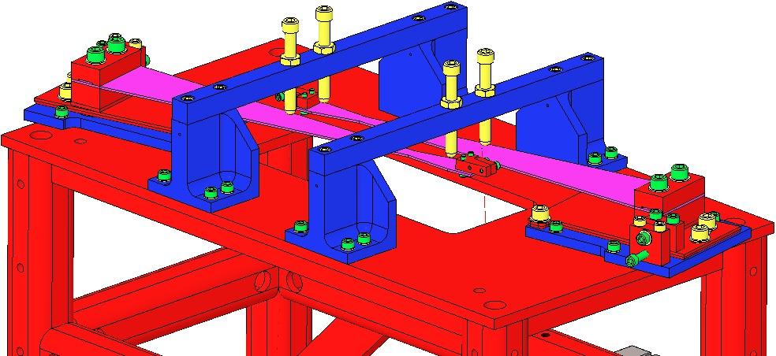  Use T-Wrench from below Blade  Clamps ON TOP of Blades  Fig 98: Upper Wire L-Clamps  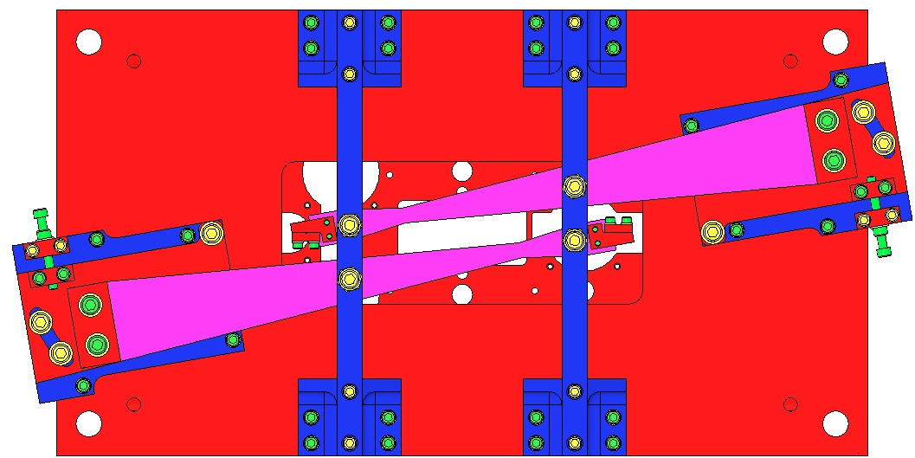  Fig 99: Orientation of Clamps

Suspending the Masses

Procedure
Lower the Coil Holder halfway within the Coil Holder Brackets and then tighten the 8 Screws.  Using the 2 center ¼-20 Screws, lower the Upper Mass halfway within the Coil Holder (shown transparent here). |  | 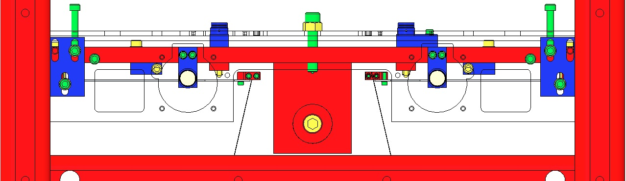  Fig 100: Coil Holder & Upper Mass lowered
Retract the 4 screws of the Intermediate Mass lower Barrel EQ Stops until the Intermediate Wires are taught (until the Intermediate and Lower Masses are supported by the Upper Mass, and not the EQ Stops). The EQ screws should barely contact the Mass. |  | Fig 101: Lower Screws retracted
Adjust all 24 EQ Stop Screws so they contact the 2 Masses, but with no pressure.  Turn these Screws ¾ turn counterclockwise to leave a 1 mm gap at the 2 Masses:  Adjust Lower Mass Screws first:  - 8 Barrel EQ Stop Screws  - 4 Face EQ Stop Screws  Adjust Intermediate Mass last:  - 8 Barrel EQ Stop Screws  - 4 Face EQ Stop Screws  Tighten each Hex Nut at all 24 of the above Screws, to ensure each Screw is locked in the 1 mm gap position. |  | 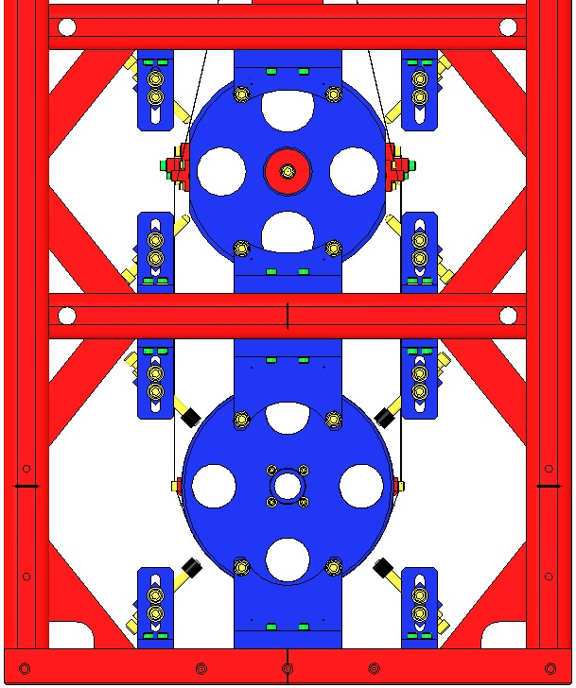  Adjust  Lower Mass Screws first  Adjust  Int. Mass Screws second  Fig 102: Adjusting Screws to 1 mm gaps
Separate the Upper Mass from the Coil Holder by completely removing the 2 ¼-20 Screws and Hex Nuts (the Upper Mass is then supported by the Upper Blades).  Adjust the 12 8-32 round-tipped Coil Holder Screws so that they contact the Upper Mass, but with no pressure.  Turn the 8-32 Screws counterclockwise 1 ¼ turns, to leave a 1 mm gap with the Upper Mass. | 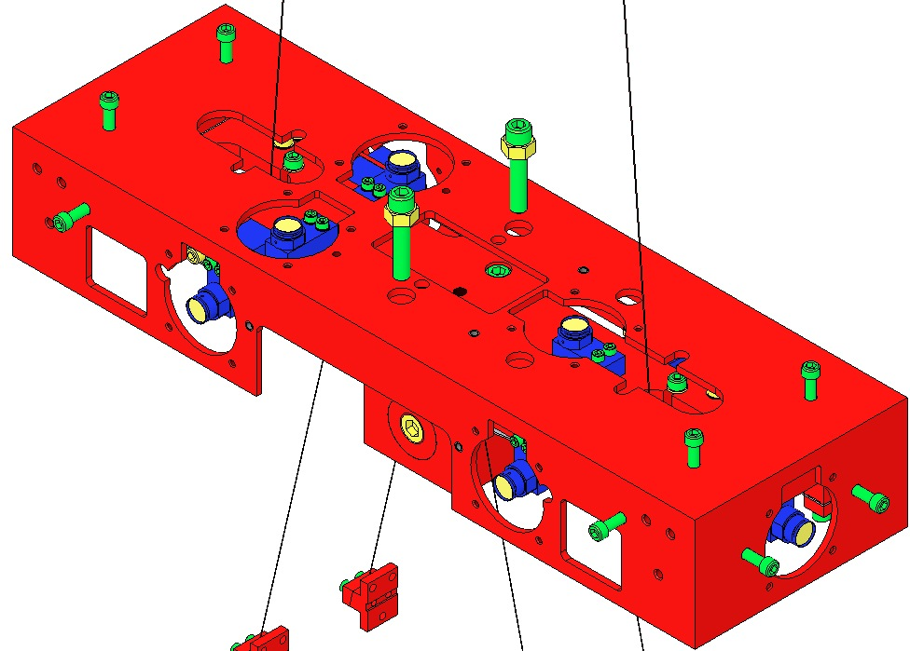  Fig 103: Suspending the Upper Mass
Adjust the 4 Lower Blade Guard Screws so they contact the Blades, but with no pressure.  2 Magnet Holder Assemblies will need to be removed to access 2 of the Screws.  Turn the 4 Screws counterclockwise 1 ½ turns each, to leave a 1 mm gap at the Lower Blades.  Replace the 2 Magnet Holders when finished. | 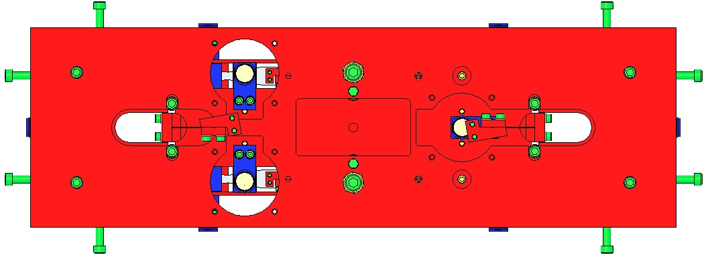  Fig 104: Top View / Adjusting Blade Guard Screws  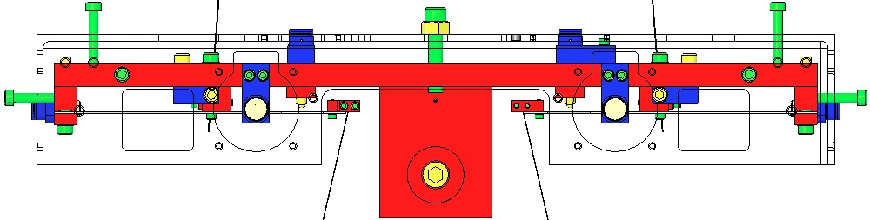  Fig 105: Side View / Adjusting Blade Guard Screws
Turn the 4 Upper Blade Guard Screws down until they contact the Upper Blades, but apply no pressure.  Turn Screws counterclockwise ¾ turn, to leave a 1 mm gap with the Blades.  Tighten each Hex Nut to ensure each Screw is locked in the new position. | 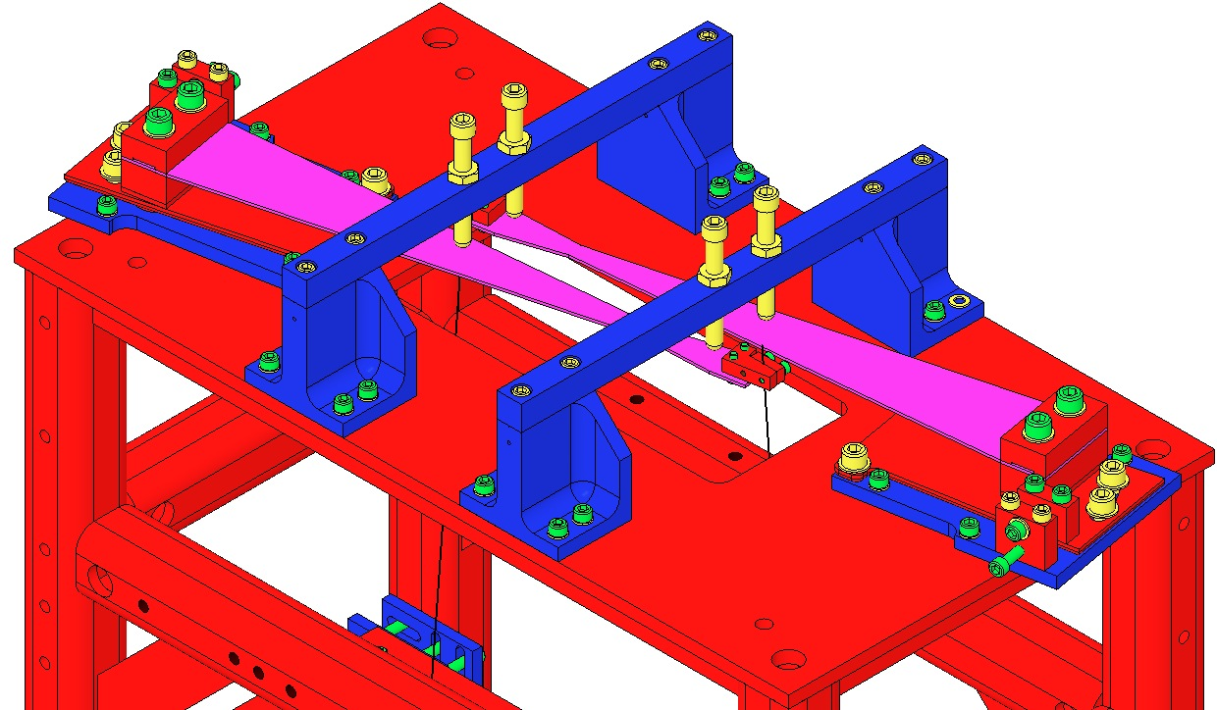  Fig 106: Suspending the Upper Blades

Creep Bake
All Blades (2 Upper, 4 Lower) are exposed to 120°C @ 168 hr., accelerating the microscopic yielding of the Blade material, to reduce mechanical noise of the Suspension when in operation.

Documents
T1100289 Notes on Creep/Creak Bakes for Blades
E0900023 Process for Manufacturing Cantilever Spring Blades

Materials
Qty | U | ID | Description
1 | Ea | D1002440 | Upper Blade Baking Fixture
2 | Ea | D020660 | Blade Pulldown Device
2 | Ea | D0901815 | Upper Clamp Inside
2 | Ea | D0901813 | Upper Clamp Outside
4 | Ea | NA | 2 Socket Head Cap Screw 4-40 x 0.375” AgPlated
4 | Ea | NA | Flat Washer #4 Vented SSTL
4 | Ea | NA | Socket Head Cap Screw 4-40 x 0.25” AgPlated
1 | Kg | NA | 4.483 kg in weight
2 | Ft | NA | Music Wire .024” dia. min.

Procedure
 | Wear Safety Glasses and Glove Liners per E1000043.  Prepare 2 D020660 Blade Pulldown Devices per Materials List. | Fig 107: Blade Pulldown Device
Lock down the 2 Upper Blades by extending the 4 EQ Stop Screws until they just contact the Blades.  Disconnect the 2 Upper Clamps from the Upper Blade tips. Handle the Wire Assemblies carefully to ensure they are not kinked. |  | 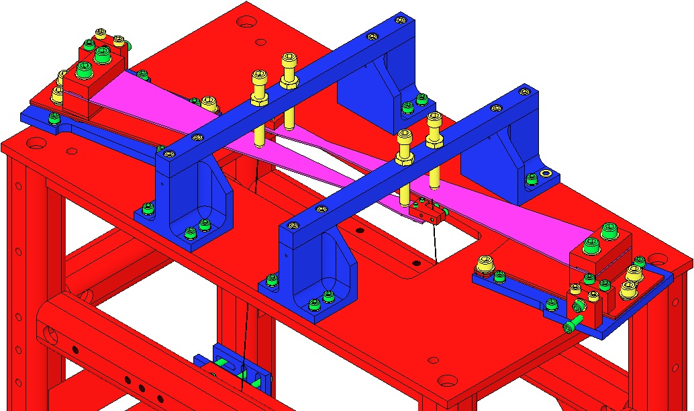  Wire Clamps  Fig 108: EQ Stop Screws contact Blades
Ensure the 2 D1102119 Blade Pulldown Supports are Class B clean.  Attach the Blade Pulldown Supports to the center of the Weldment cross member shown, Clevis extending outboard.  Cover each end of the Weldment Structure and surrounding Optical Table areas with UHV Aluminum Foil, to protect them from the dirty Pulldown Device.  2 workers required:  1st person holds the Pulldown Weight.  2nd person passes Wire Clamp of the Pulldown Device through the Weldment side opening, up toward the Upper Blade Tip, then attaches the Clamp to the Blade tip with:  - 2 Socket Head Cap Screws  4-40 x .375” AgPlated SSTL  1st person gently drapes the wire over the Clevis, and slowly releases the Weight.  Repeat Steps 7-9 for the second Pulldown Device. |  | Fig 109: Blade Pulldown Support  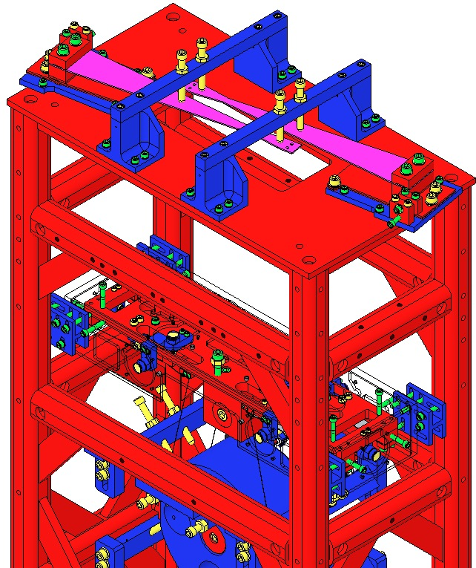  Blade Pulldown Supports  Fig 110: Location of Blade Pulldown Support
Remove the 2 D0901935 Blade Guard Bars.  Slowly lift the Pulldown Devices and then disconnect the Wire Clamps from the Blade tips. The Blades will be left curving upward.  Remove the Rotational Adjusters from the Weldment, down to the Rotating Plate (leaving the Base Plate attached to the Weldment).  Record the serial number and location of both Upper Blades in ICS in the RA assembly load. |  | 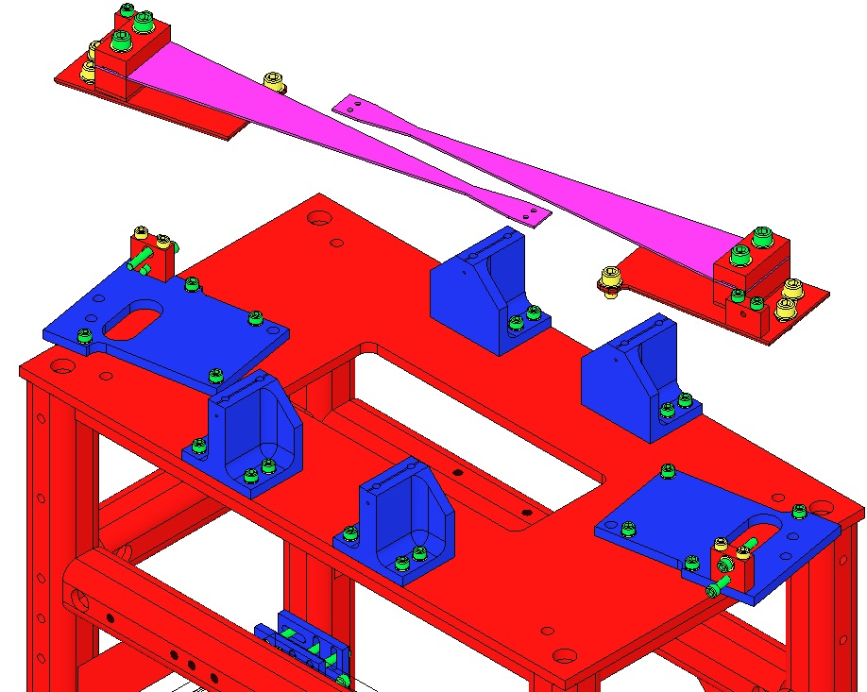  Fig 111: Rotational Adjusters removed
Ensure the D1002440 Baking Fixture is Class B clean.  Mount the Baking Fixture to an Optics Table, aligning the Crossbar side with the Table edge to allow clearance for the Blade Pulldown Device.  Remove a D1002443 Crossbar from the Baking Fixture. | 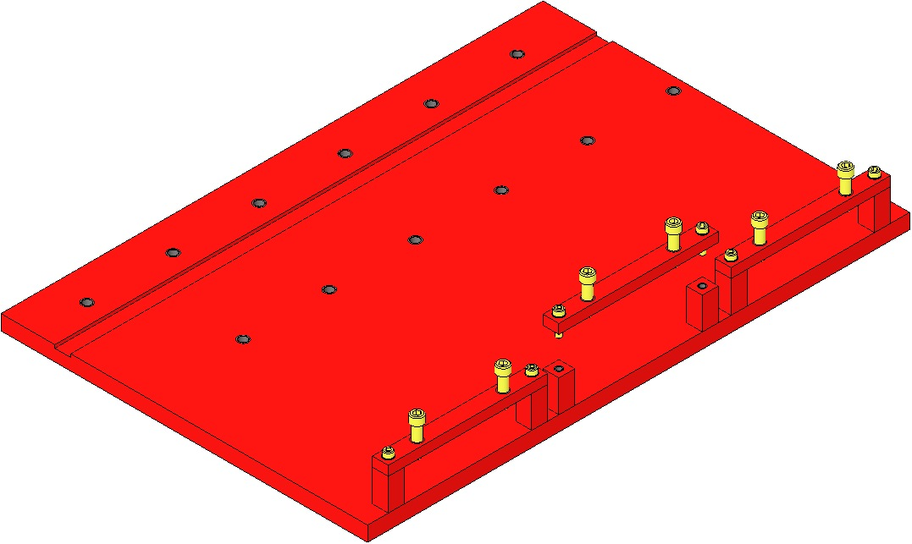  Table Edge  Fig 112: Base Plates in Baking Fixture
Assemble to the Baking Fixture the 2 Rotational Adjuster assemblies using the same Screws from the Suspension:  - 4 Socket Head Cap Screws  ¼-20 x 0.375” SSTL  - 4 D1100785-472 Flat Washers  Tighten the Screws firmly  The Blades are shown here as flat, but are actually curved upward at this point. | 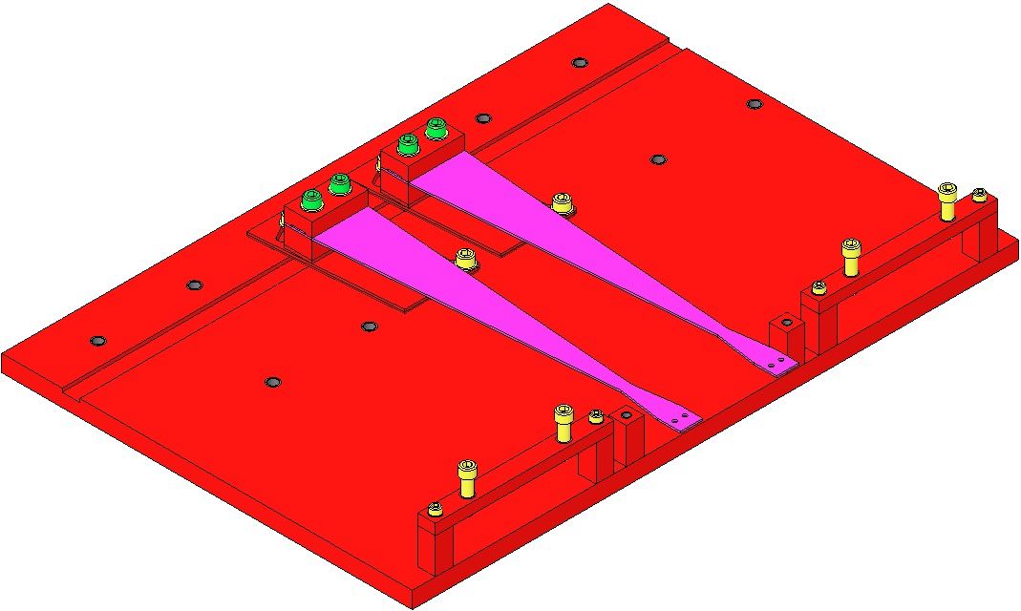  Machinist’s  Square  Fig 113: Shim, Clamps, Blade, Screws, Washers

Attach a Pulldown Device to each Upper Blade Tip to flatten the Blades.

Re-assemble the Crossbar to the Bake Fixture:
- 1 D1002443 Bake Fixture Crossbar
- 2 Socket Head Cap Screws 8-32 x 0.625” SSTL
- 2 Flat Washers #8 SSTL
Tighten the Screws firmly
- 2 Socket Head Cap Screws ¼-20 x 1.0 Full-Thread, Round-Tip SSTL

Turn down the Round-Tip Screws until the weighted Blade tip is level with the Blade root.
Be careful not to damage the nickel plating on the blade

Remove the Blade Pulldown Devices.
The Rotational Adjusters and Baking Fixture are now ready for the Creep Bake.
Fully retract the 8 Screws in the 4 Upper Barrel EQ Stops. |  | 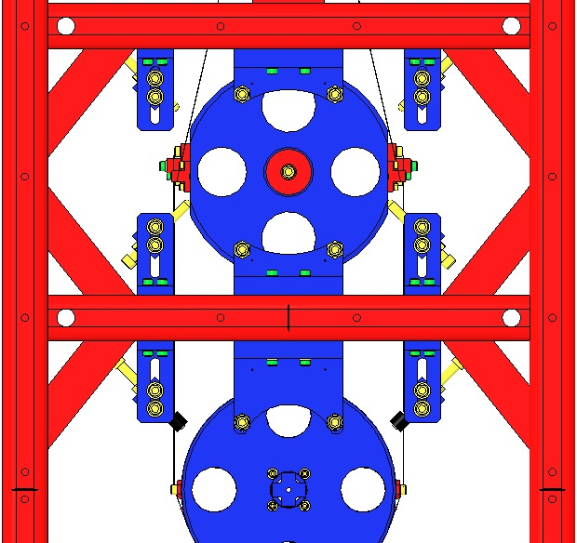  Fig 114: 8 Screws in Upper Barrel EQ Stops
Fully raise the Coil Holder within it’s 4 corner Brackets (The Screws will be at the top of their Bracket slots). |  | 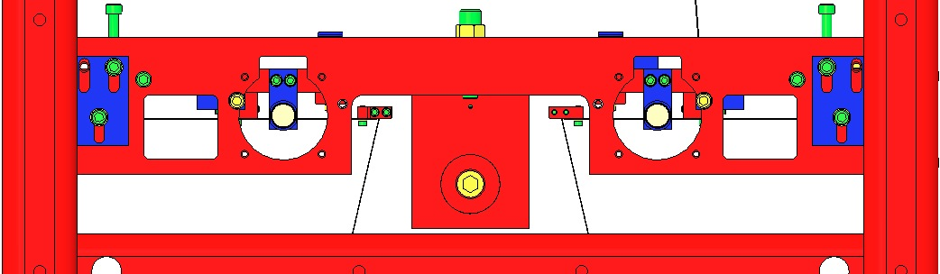  Fig 115: Coil Holder Raised in Brackets
Using the two ¼-20 Screws, fully raise the Upper Mass within the Coil Holder.  The Upper Wires will go slack at this point. |  | 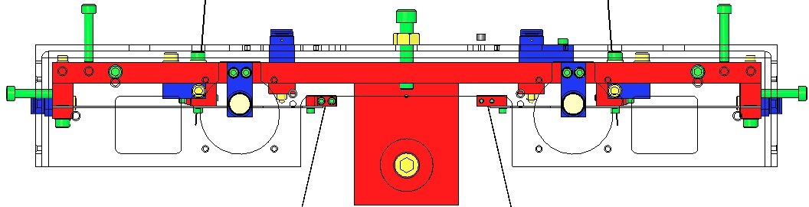  Fig 116: Upper Mass raised within Coil Holder
Fully retract the 4 Adjustment Screws within the 4 Screw Drives. |  | 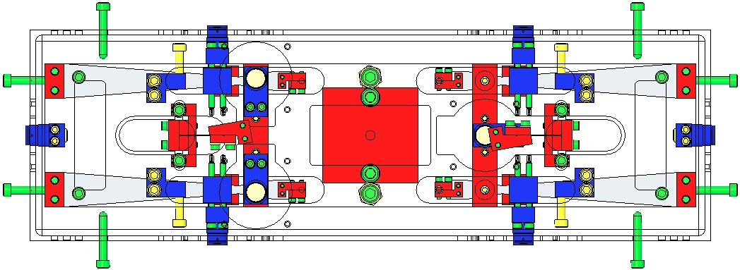  Fig 117: Top View – 4 Screws Retracted  Fig 118: Side View – 4 Screws retracted
Disconnect the Upper Wire Assemblies:  - Remove the 4 C-Clamp Screws at the Upper Mass |  | 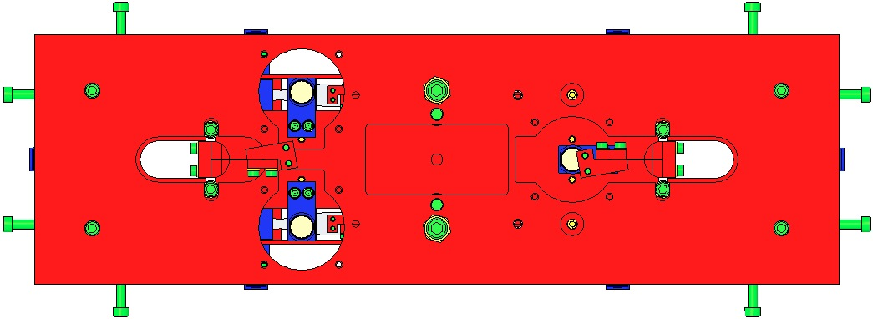  Fig 119: Top View – 4 C-Clamp Screws
Remove the Upper Wire Assemblies completely by grasping the L-Clamps and lowering the Assemblies down through the openings in the Coil Holder and Upper Mass.  Record in ICS, which Wire Assembly correlates to which Upper Blade.  Handle the Wire Assemblies with great care and store them in a protected container until the Creep Bake process is complete. |  | 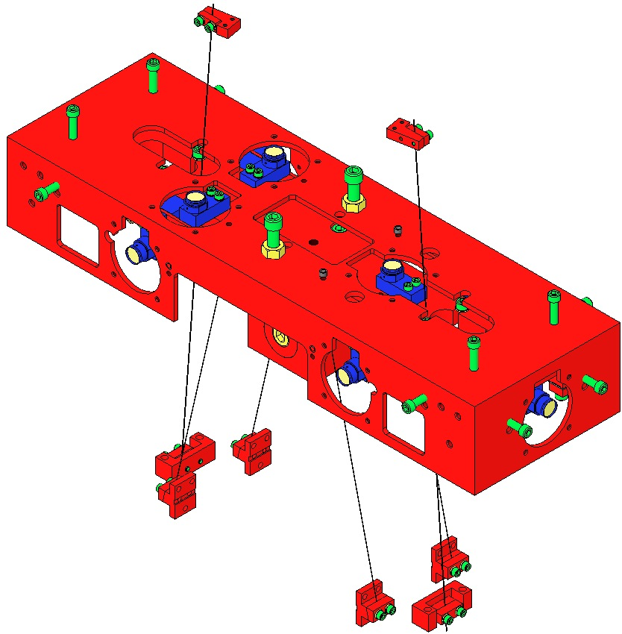  Fig 120: Upper Wires fed downward  Fig 121: 2 Upper Wire Assemblies removed

Fully extend the 8 Screws within the lower 4 Barrel EQ Stops. | 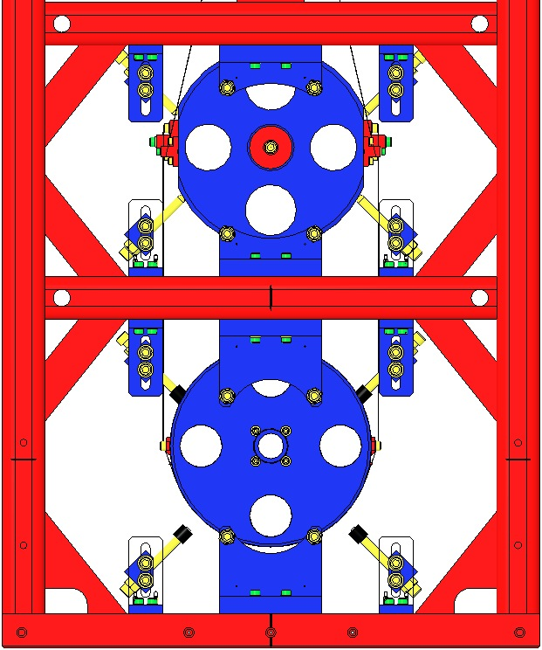  Fig 122: 8 Screws extended
Remove the 4 Screws that attach the pair of Magnet Holders on top of the Upper Mass.  Remove the 2 Magnet Holders. | 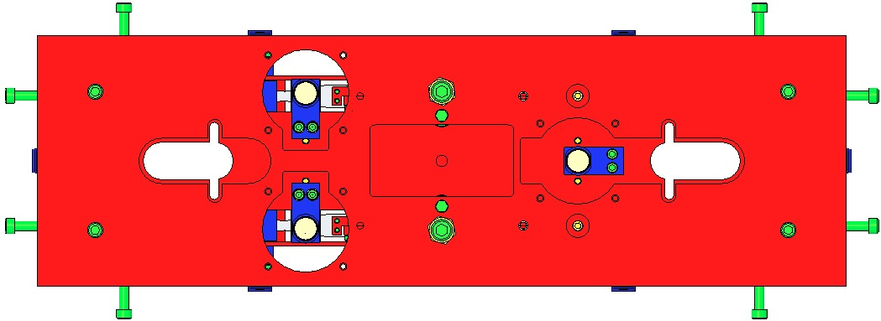  Fig 123: 4 Screws to remove
Extend the 4 Blade Guard Screws until they just touch the Lower Blades. | 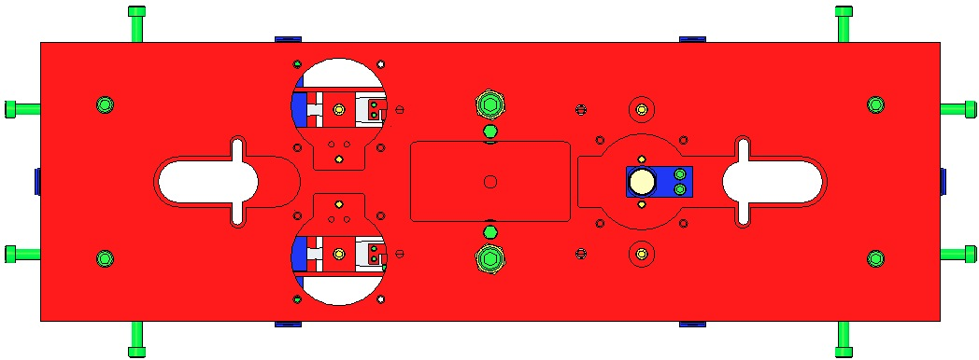  Fig 124: Top View - 4 Blade Guard Screws  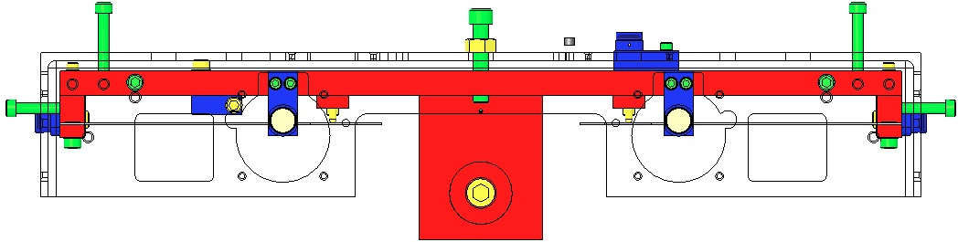  Fig 125: Side View – 4 Screws extended
Using the 2 ¼-20 Screws, lower the Upper Mass within the Coil Holder.  The Intermediate Wires will go slack at this point. | 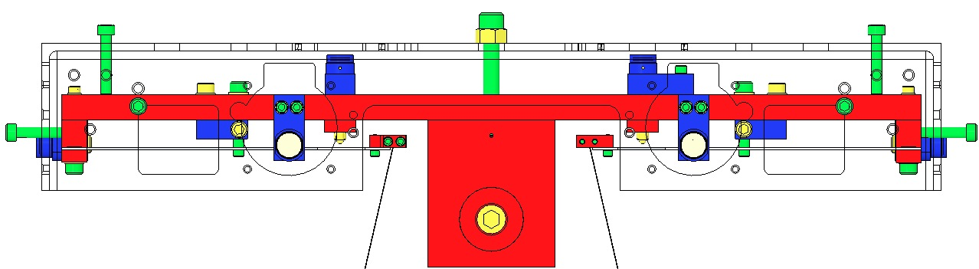  Fig 126: Upper Mass lowered within Coil Holder
Disconnect the Intermediate Wires from the Intermediate Mass by removing the 12 Screws from the 4 Lower Clamps of the Intermediate Wire Assemblies. | Fig 127: Lower Clamps of Intermediate Wires
Remove the Upper Face EQ Stop from in front of the Intermediate Mass. | Fig 128: Upper Face EQ Stop
Remove the 8 Screws attaching the L-Clamps of the Intermediate Wire Assemblies to the 4 Lower Blades.  Remove the 4 Intermediate Wire Assemblies.  Record in ICS, which Wire Assembly correlates to which Lower Blade.  Handle the Wire Assemblies with great care and store them in a protected container until the Creep Bake process is complete. | 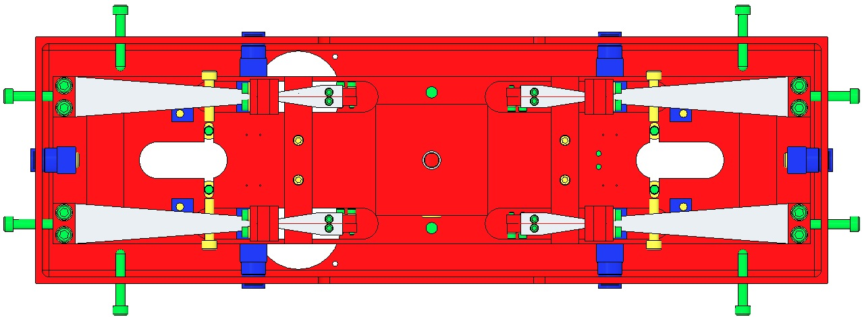  Fig 129: Bottom View – L-Clamp Screws  Fig 130: Intermediate Wire Assemblies
Remove the 8 Screws from the 4 Coil Holder Brackets.  Remove the Coil Holder / Upper Mass Assembly from either short side opening in the Weldment. | 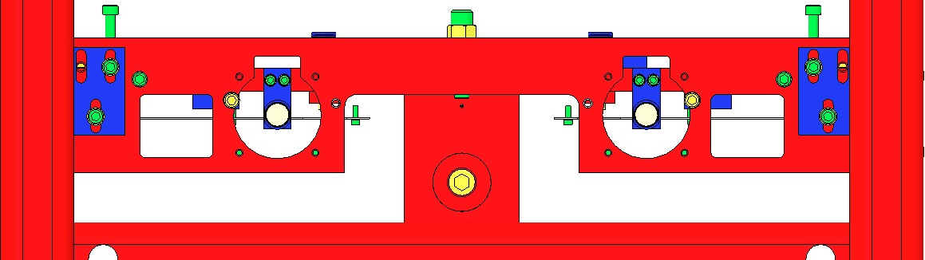  Fig 131: Coil Holder Screws
From one of the two Magnet Holders assembled to the ends of the Upper Mass, remove 1 Magnet Holder from it’s Base. This will provide clearance for separation of the Upper Mass from the Coil Holder.  Remove the 2 ¼-20 Screws from the Coil Holder.  Separate the Upper Mass Assembly from the Coil Holder.  Re-attach the Magnet Holder to its Base. | 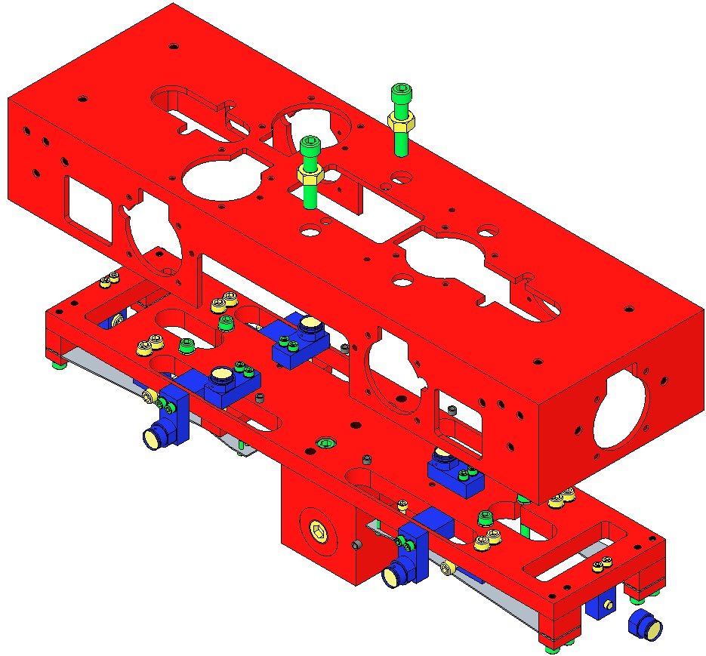  Fig 132: Upper Mass and Coil Holder seperated
Remove all 9 Magnet Holder / Base Assemblies from the Upper Mass. This includes the 4 Braces for the Magnet Assemblies attached to the sides of the Upper Mass.  Remove all 4 Screw Drives from the Upper Mass.  Remove the T-Section from the Upper Mass Main Section. | 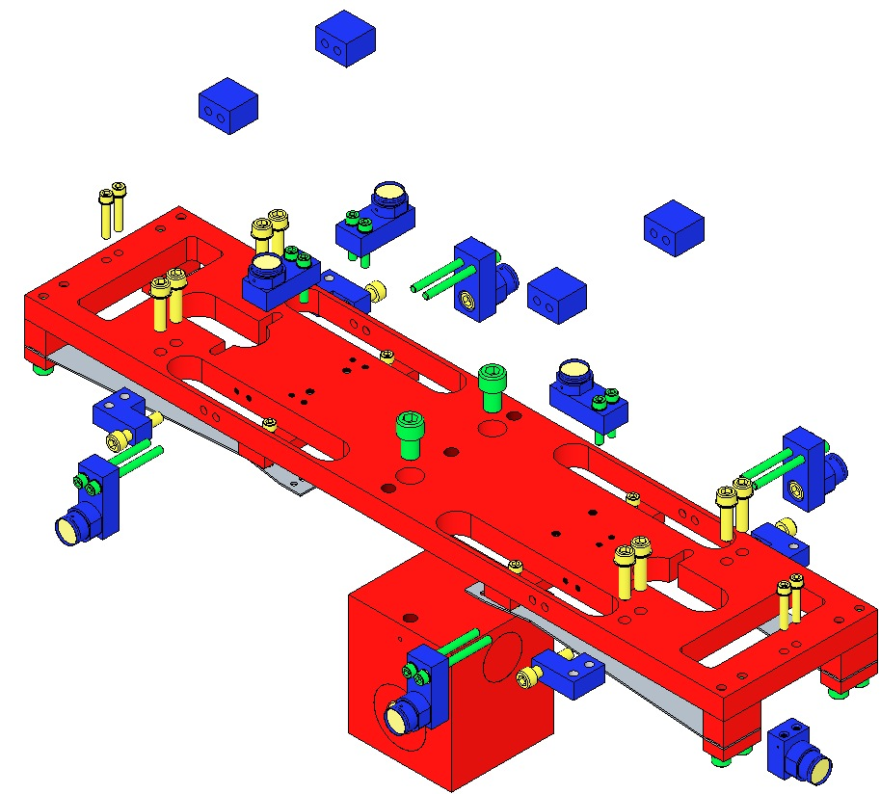  Fig 133: Disassembled Upper Mass
The remaining Assembly, ready for Creep Bake, consists only of:  1 Main Section;  4 clamped Lower Blades;  2 Blade Guards with 4 Screws each. | 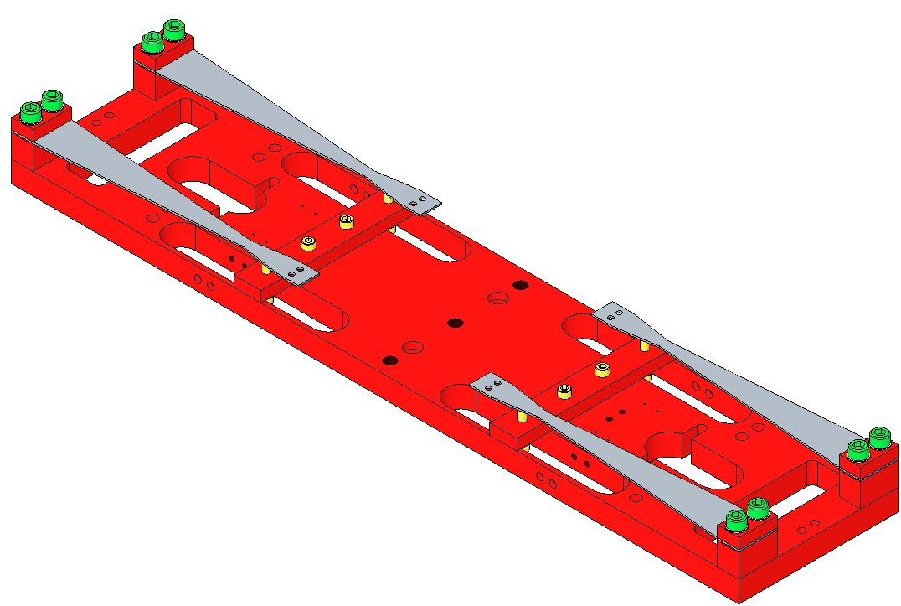  Fig 134: Assembly Ready for Creep Bake

Follow the process outlined in E0900023 for baking all 6 Blades for 120°C @ 168 hr.
- 2 Upper Blades (2 Rotational Adjusters);
- 4 Lower Blades (clamped in 1 Main Section);

Re-assemble and install in the Weldment:
- The Upper Blades in their Rotational Adjusters, per the section, “Installing the Rotational Adjusters”;
- The Upper Mass per the sections, “Assembling the Upper Mass” and “Installing the Upper Mass and Coil Holder”.

Bonding Magnet Assemblies to Intermediate Mass

Documents
M0900034 Use of Magnets in Suspensions
E990196 HSTS HLTS Magnet/Standoff Assembly Preparation
E960022 Vacuum Compatibility, Cleaning Methods and Qualification Procedures

Materials
Qty | U | ID | Description
1 | Ea | D1100356 | Triple Optic Base Assembly
4 | Ea | D980184 | LOS Clamps
4 | Ea | NA | Socket Head Cap Screw ¼-20 x 1.5” AgPlated
1 | Ea | D0901873 | HSTS Intermediate Mass Assembly
2 | Ea | D020661 | North magnet/dumbbell assembly, Intermediate Mass
2 | Ea | D020661 | South magnet/dumbbell assembly, Intermediate Mass
1 | Ea | D1002606 | Intermediate Mass Ring Fixture Assembly
1 | Ea | TBD | Gun Applicator, MasterBond
1 | Ea | EP30-2 | Epoxy, Double Barrel Cartridge with Mix Tube, MasterBond
1 | Ea | NA | Machinist Square, approx. 6” in length
1 | Ea | NA | Depth Gage; either Vernier Calipers or Spring-Type Needle Gage
1 | Ea | NA | Tweezers
1 | Btl | NA | Isopropanol
X | Ea | NA | Lint Free Wipes
X | Ea | TBD | Sewing Needle
X | Ea | TBD | Razor Blade
X | Roll | NA | UHV Aluminum Foil
1 | Ea | NA | Heat Lamp, 120w Bulb

Procedure
Mount the D1100356 Base Assembly to an Optics Table with the 4 D980184 LOS Clamps and ¼-20 x 1.5” AgPlated Screws.  Place the D0901873 Intermediate Mass Assembly on the Base Plate.  Place the D1002606 Intermediate Mass Ring Fixture Assembly on top of the Intermediate Mass.  For clarity, the Base Plate is not shown after this point. | 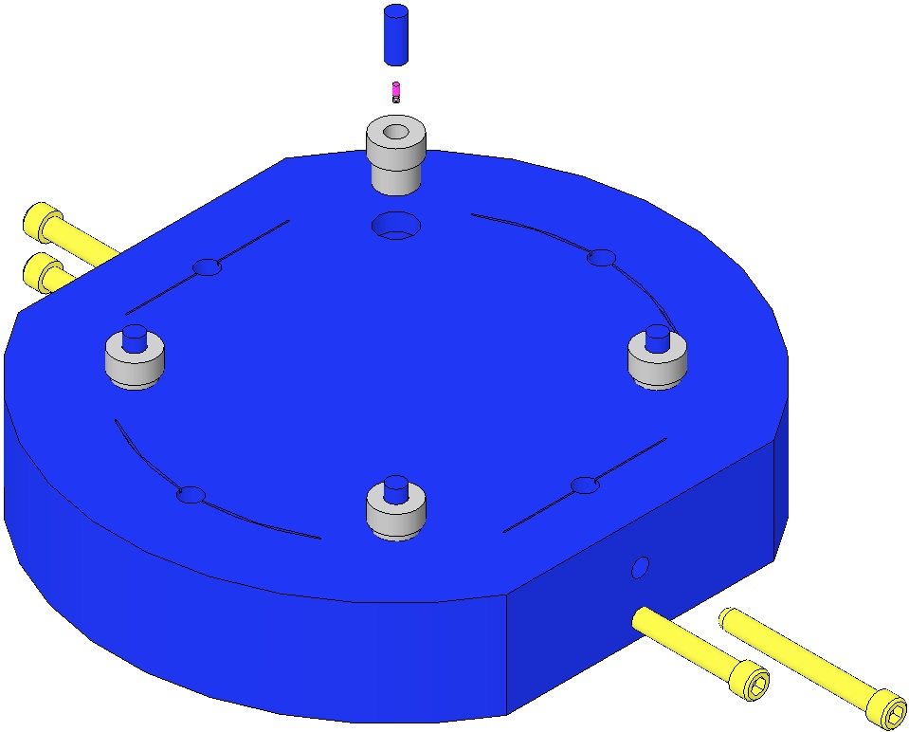  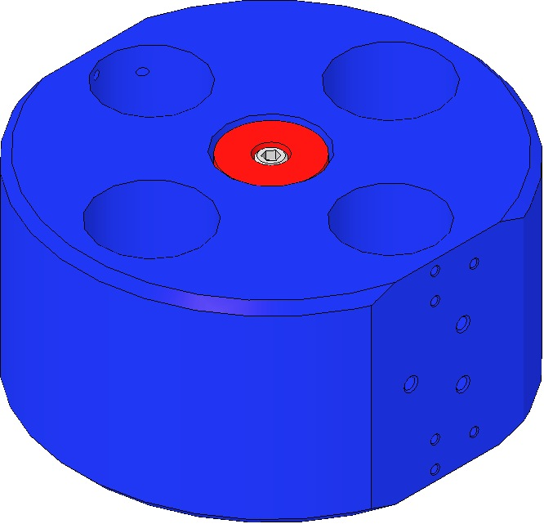  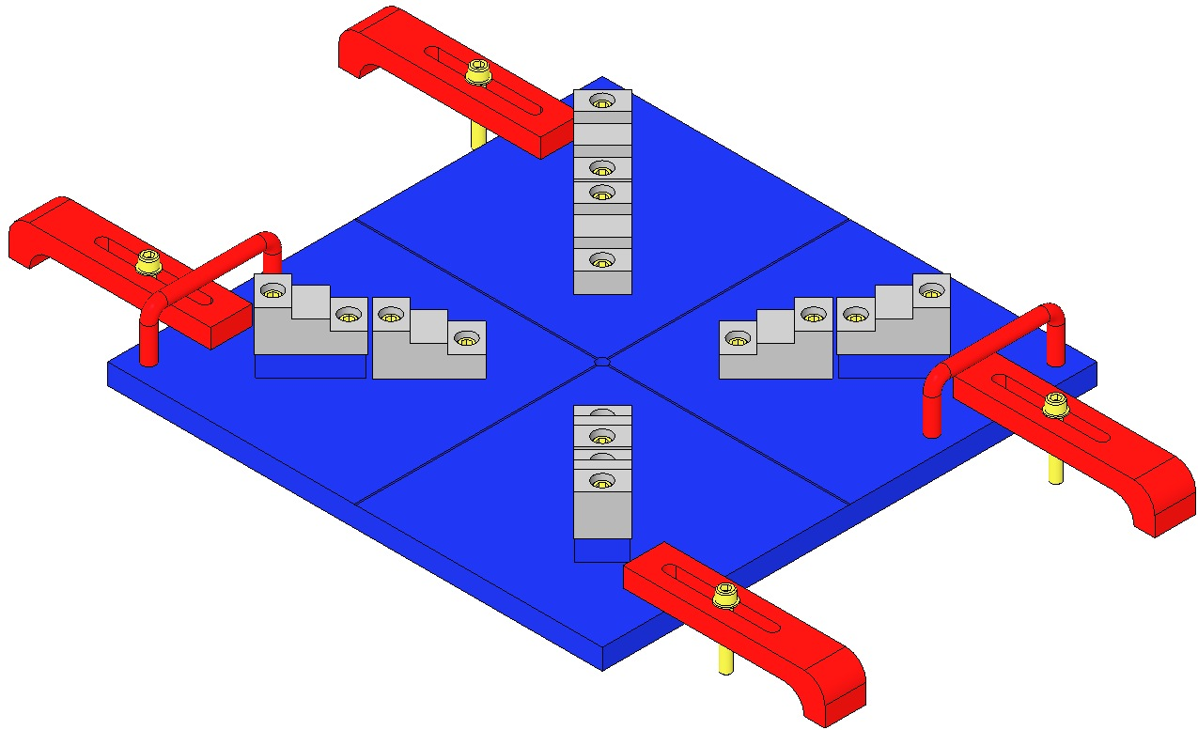  Fig 135: Ring Fixture, Mass, Base Plate
Align the Ring Fixture and Mass  Center the Ring Fixture on the Mass by obtaining equidistant readings between opposing parallel sides of the Fixture and Mass, using a Depth Gage. The Ring Fixture Screw tips must barely contact and not “clamp” the Mass.  Note the locations of the 4 Magnet Plungers. | Magnet Plunger  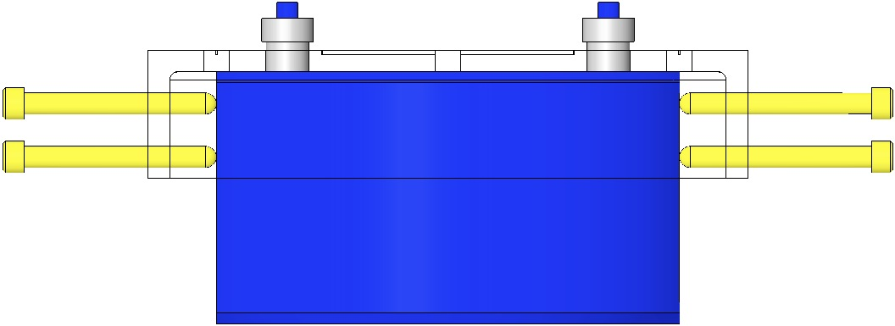  Fig 136: Ring Fixture Aligned with Mass
Prepare 2 “N” and 2 “S” D020661 Magnet/Standoff assemblies per the E990196 Preparation procedure. | 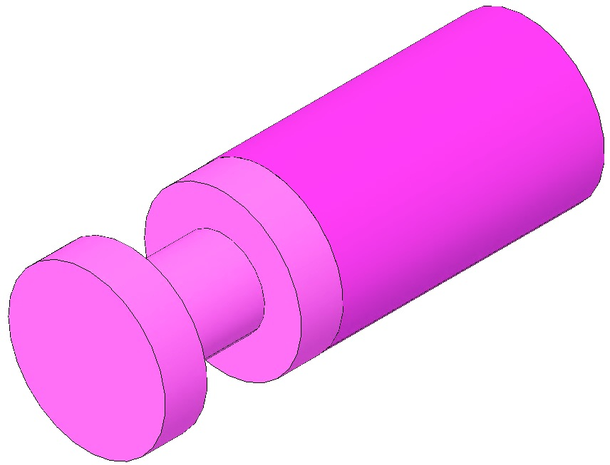  Fig 137: D020661 Magnet/Standoff Assembly
Load Plungers  Remove the 4 Magnet Plungers from the Fixture and wipe the counterbore end of each plunger with Isopropanol and a Wipe.  Using the Tweezers, load 4 Magnet/Standoff assemblies into the 4 Plungers, 2 North Magnets and 2 South Magnets. The Magnet end of each assembly rests within the Plunger counterbore.  The Magnet/Standoffs are held to the Plungers magnetically. | 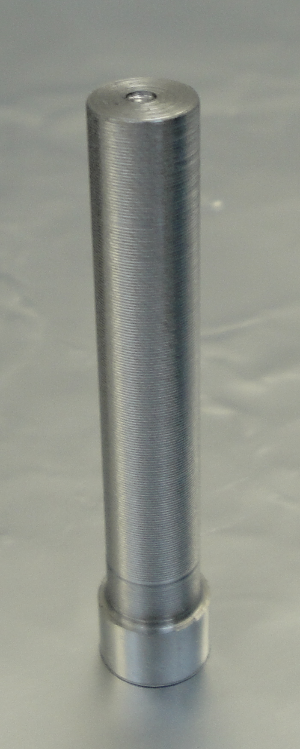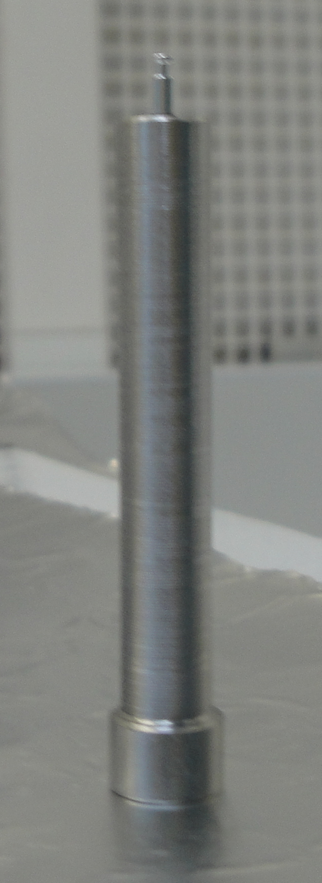  Counterbore  Assembly held to Plunger Magnetically  Fig 138: Plungers Empty and Loaded

Determine the correct Magnet Polarity Layout by identifying the in-use top of the Mass. The Wire Assembly Clamp Hole patterns on the sides of the Mass identify the top of the Mass.
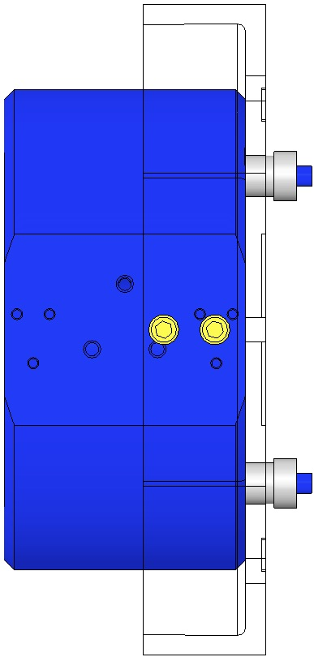  Top of Mass | 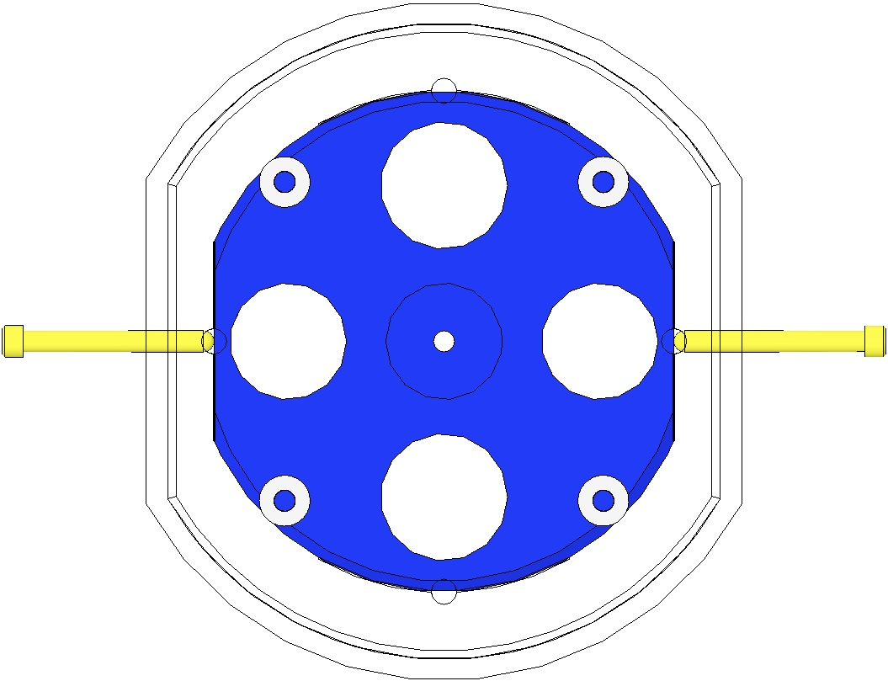  N  S  N  S  Top of Mass
Fig 139: Top of Mass identified by Hole Pattern | Fig 140: Magnet Polarity Layout

Bond Magnets to Mass/Optic

Load the EP30-2 Cartridge with Mix Tube attached, into the Gun Applicator.

Pull the trigger on the Gun Applicator 1 full stroke, to purge the Mix Tube of under-mixed adhesive.

Dispense a “quarter-sized” pool of Adhesive onto a small piece of clean UHV aluminum foil.

Pick up a Plunger loaded with a Magnet/Standoff assembly and hold it vertically, with the Magnet/Standoff end facing up. Clean the Standoff with Isopropanol and a Wipe.

Dip the end of a Sewing Needle in the pool of Epoxy and withdraw it, leaving a tiny drop on the Needle tip. Apply approximately ½ mm of Epoxy to the center of the Standoff end.

Load the Plunger, Magnet/Standoff down, into the appropriate Bushing in the Ring Fixture. Slide the Plunger down within the Bushing until the Standoff contacts the Mass/Optic. Press down on the Plunger lightly with one finger for about 2 seconds, then release.

Repeat steps 13-15 to load all 4 Plungers into the Placement Fixture.

Allow the Epoxy to cure within the Fixture at room temperature for 24 hours.

Carefully remove the 4 Plungers from their Bushings, and remove the Fixture from the Mass/Optic.

Center the Heat Lamp over the Fixture and adjust the height such that the Fixture surface is receiving 60°C, then allow the adhesive to cure for 4hr. The assembly process is complete.

Bonding Magnet Assemblies to Lower Masses

Documents
M0900034 Use of Magnets in Suspensions
E990196 HSTS HLTS Magnet/Standoff Assembly Preparation
D020234 HSTS Metal Lower Mass, 0.5 Degree Wedge
D0902332 HSTS Metal Lower Mass, 1.0 Degree Wedge
E0900342 HSTS Optic Orientations
E960022 Vacuum Compatibility, Cleaning Methods and Qualification Procedures

Materials
Qty | U | ID | Description
1 | Ea | D1100356 | Triple Optic Base Assembly
4 | Ea | D980184 | LOS Clamps
4 | Ea | NA | Socket Head Cap Screw ¼-20 x 1.5” AgPlated
1 | Ea | D020427 | HSTS Magnet Gluing Ring Fixture, Lower Mass
1 | Ea | D0901791 | HSTS Lower Mass Assembly
1 | Ea | Various | Optic, HSTS
4 | Ea | D0902432 | Magnet/Standoff Assemblies, 2 N and 2 S configurations
1 | Ea | NA | Machinist Square, approx. 6” in length
1 | Ea | NA | Depth Gage; either Vernier Calipers or Spring-Type Needle Gage
1 | Ea | EP30-2 | Epoxy, Double Barrel Cartridge with Mix Tube, MasterBond
1 | Ea | TBD | Gun Applicator, MasterBond
1 | Ea | NA | Generic Compass mounted on non-magnetic isolation post
1 | Ea | NA | Tweezers
1 | Btl | NA | Isopropanol
X | Ea | NA | Lint Free Wipes
X | Ea | TBD | Sewing Needle
X | Ea | TBD | Razor Blade
X | Ea | NA | UHV Aluminum Foil
1 | Ea | NA | Heat Lamp, 120w Bulb

Procedure
Notes:
The D020427 Fixture is being modified as of 3/12. Major modifications include:
  - The Fixture as shown will be inverted, and a Base for the Mass/Optic has been added.
  - The Stop Screw design will change.
  - The Magnet placement bushings will change.
- Glass Optics and Metal Masses will not be Air Baked.
- Glue Magnets before gluing Prisms (primary and secondary).

Ensure the Main Section of the Mass has been cleaned and baked before attaching the Magnet/Dumbbell assemblies.
- Thoroughly Class B clean all parts of the Magnet Gluing Ring Fixture.
- Magnet/Standoff Assemblies are produced per E990196 HSTS HLTS Magnet/Standoff Assembly Preparation.
Prepare 2 “N” and 2 “S” D0902432 Magnet/Standoff assemblies per E990196 Preparation procedure. |  | 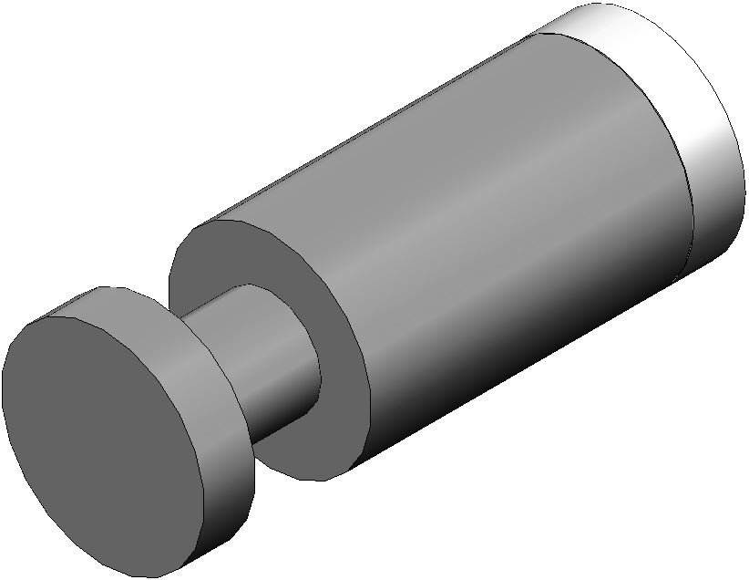  Fig 141: D0902432 Assembly
Mount the D1100356 Base Assembly to an Optics Table with the 4 D980184 LOS Clamps and ¼-20 x 1.5” AgPlated Screws.  Place the Mass/Optic Assembly on the Base Plate with arrows pointing down.  Place theD020427 Magnet Gluing Fixture Assembly on top of the Mass/Optic.  Note the Scribe Lines on both the Fixture and the Mass / Optic.  For clarity, the Base Plate is not shown after this point. | 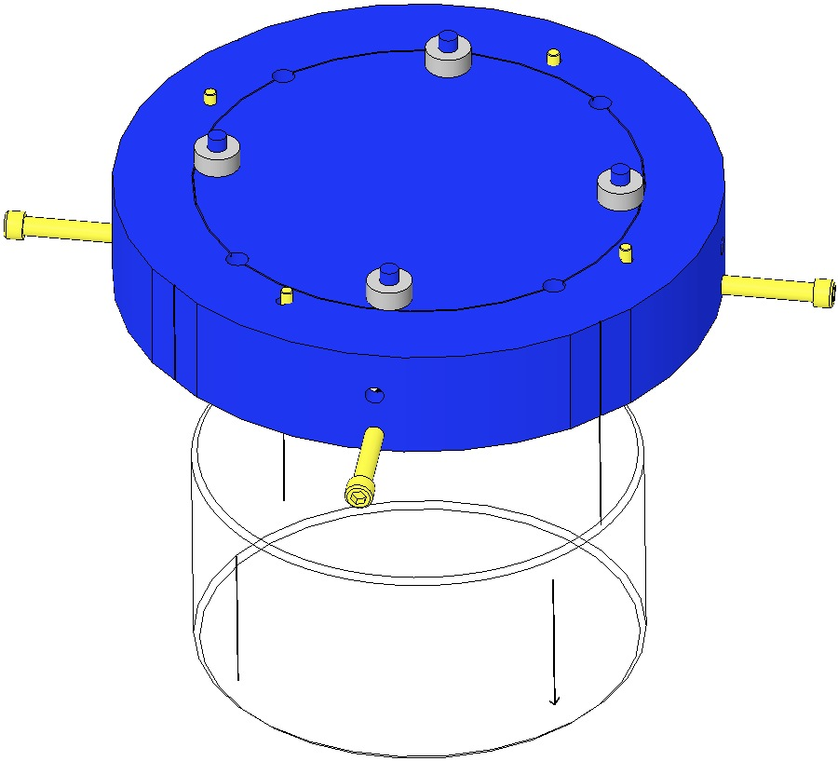  Scribe Lines  Arrow  Fig 142: Magnet Gluing Ring Fixture
Center the Mass / Optic within the Fixture by using the 4 Stop Screws. Use a Depth Gage to obtain equidistant readings at opposing pairs of Mass / Optic Scribe Lines, between the Fixture and Mass / Optic perimeters. The Screw tips must barely contact and not “clamp” the Mass/Optic. | 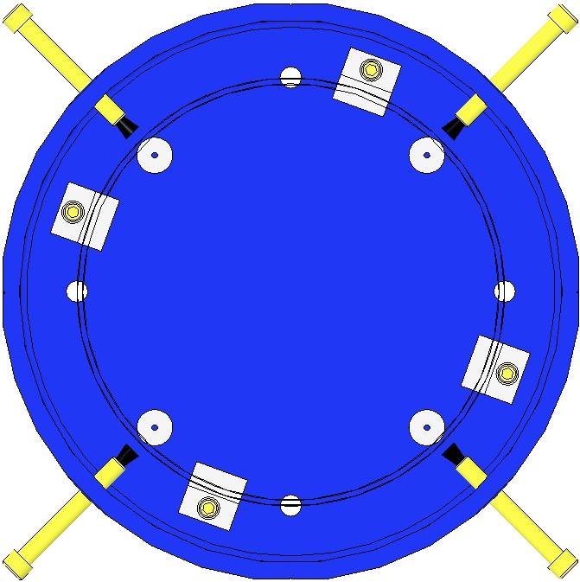  Stop Screw  Equal measurements  Fig 143: Top View of Centering
For a Metal Mass, rotate the Gluing Fixture while aligning the Mass and Fixture Scribe Lines with a Machinist’s Square. Align at 2 Line positions 90° apart.  For an Optic, sight across (through) the glass through 2 opposing Scribe Lines, then rotate the Gluing Fixture to align the Optic and Fixture scribe lines with a Machinist’s Square. | 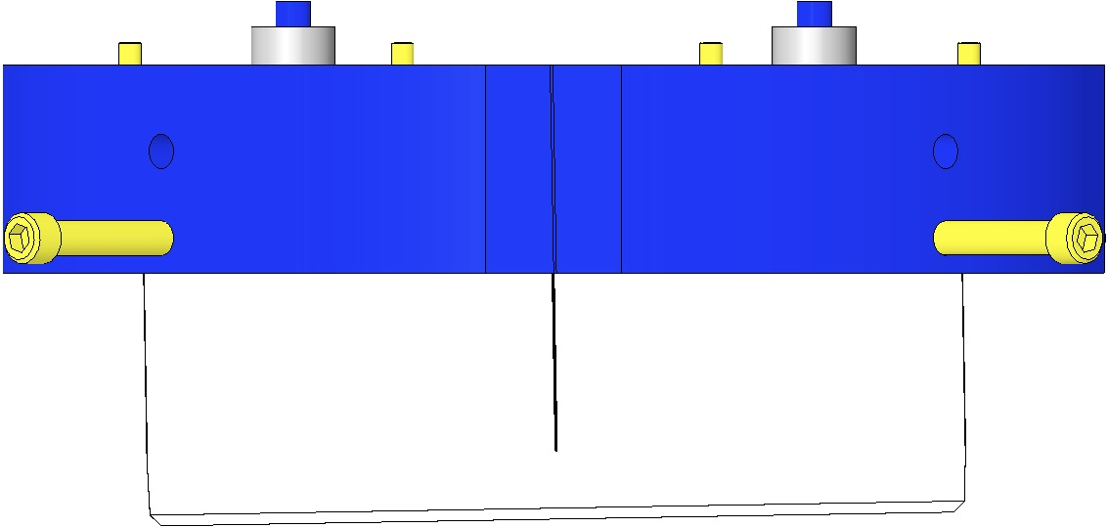  Machinist’s  Square  Scribe Lines Aligned  Fig 144: Centering the Mass / Optic in the Fixture
Load Plungers  Remove the 4 Magnet Plungers from the Fixture and wipe the counterbore end of each plunger with Isopropanol and a Wipe.  Using the Tweezers, load 4 Magnet/Standoff assemblies into the 4 Plungers, 2 North Magnets and 2 South Magnets. The Magnet end of each assembly rests within the Plunger counterbore.  The Magnet/Standoffs are held to the Plungers magnetically. |  | Counterbore  Assembly held to Plunger Magnetically  Fig 145: Plungers Empty and Loaded

Determine the correct Magnet Polarity Layout by identifying the in-use top of the Mass/Optic. The prisms on the sides of the Mass and the arrow on the Optic and the identify the top of the Mass.
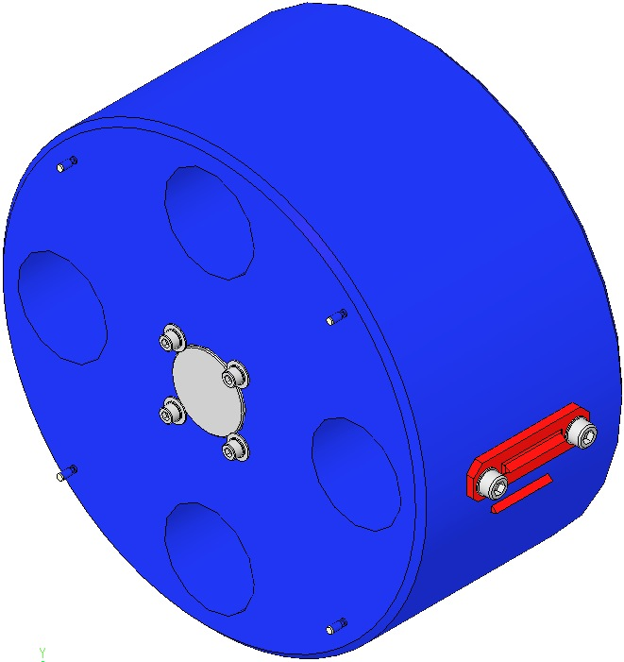  Magnet  Fig 146: HSTS Lower Mass Assembly | 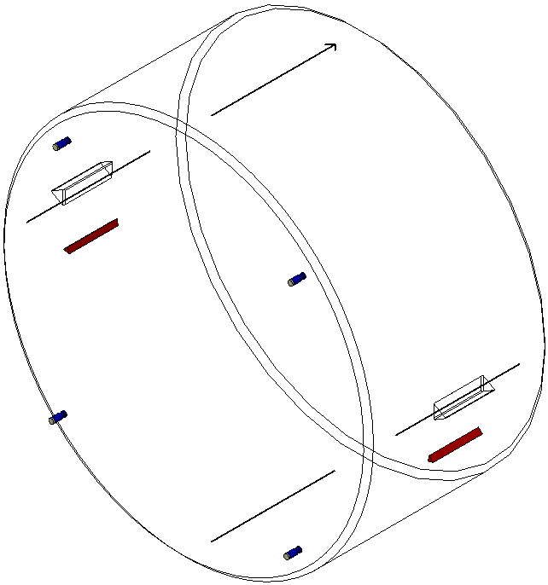  Magnet  Fig 147: HSTS Optic Assembly

Bond Magnets to Mass/Optic  Load the EP30-2 Cartridge with Mix Tube attached, into the Gun Applicator.  Pull the trigger on the Gun Applicator 1 full stroke, to purge the Mix Tube of under-mixed adhesive.  Dispense a “quarter-sized” pool of Adhesive onto a small piece of clean UHV aluminum foil.  Pick up a Plunger loaded with a Magnet/Standoff assembly and hold it vertically, with the Magnet/Standoff end facing up. Clean the Standoff with Isopropanol and a Wipe.  Dip the end of a Sewing Needle in the pool of Epoxy and withdraw it, leaving a tiny drop on the Needle tip. Apply approximately ½ mm of Epoxy to the center of the Standoff end.  Load the Plunger, Magnet/Standoff down, into the appropriate Bushing in the Ring Fixture. Slide the Plunger down within the Bushing until the Standoff contacts the Mass/Optic. Press down on the Plunger lightly with one finger for about 2 seconds, then release.  Repeat steps 11-13 to load all 4 Plungers into the Placement Fixture.  Allow the Epoxy to cure within the Fixture at room temperature for 24 hours.  Carefully remove the 4 Plungers from their Bushings, and remove the Fixture from the Mass/Optic.  Center the Heat Lamp over the Fixture and adjust the height such that the Fixture surface is receiving 60°C, then allow the adhesive to cure for 4hr. The assembly process is complete. | Top of Mass  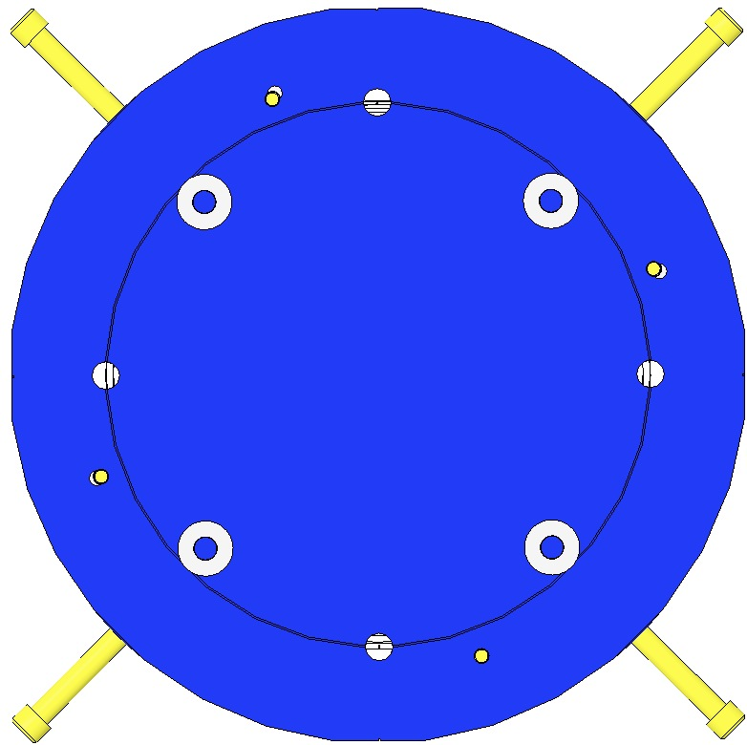  N  S  N  S  Fig 148: Magnet Polarity Layout

Installing AOSEM Brackets

Materials
Qty | U | ID | Description
4 | Ea | D0901924 | A OSEM Alignment Assemblies
2 | Ea | D0902207 | A OSEM Alignment Assemblies
2 | Ea | D0902208 | A OSEM Alignment Assemblies
16 | Ea | NA | Socket Head Cap Screws 8-32 x 0.5 AgPlated
16 | Ea | NA | Flat Washer #8 SSTL

Procedure
A OSEMS are assembled in LH and RH configurations per section 16. Note the configuration at each location within the Weldment.  The A OSEM Assemblies are attached using:  - 16 Socket Head Cap Screws  8-32 x 0.5” AgPlated  - 16 Flat Washers #8 SSTL  Torque to 30 in-lb  Assemble 4 D0901924 A OSEM Alignment Assemblies into the Intermediate Mass section of the Weldment.  Assemble 2 D0902207 A OSEM Alignment Assemblies into the upper half of the Lower Mass section of the Weldment.  Assemble 2 D0902208 A OSEM Alignment Assemblies into the lower half of the Lower Mass section of the Weldment. | 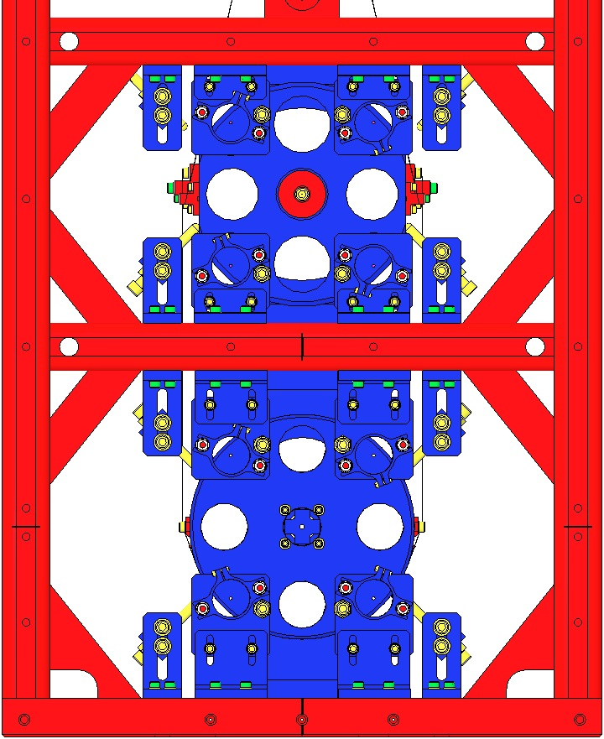  D0901924 RH  D0902208 RH  D0902207 RH  D0901924 LH  D0901924 RH  D0902207 LH  D0902208 LH  D0901924 LH  Fig 149: Rear view of Weldment

Installing AOSEMs and BOSEMs

Documents
D060218 BOSEM Assembly
D0901065 AOSEM Assembly

Materials
Qty | U | ID | Description
8 | Ea | D0901065 | AOSEM Assembly
6 | Ea | D060218 | BOSEM Assembly
24 | Ea | NA | Socket Head Cap Screw 4-40 x 1.0 AgPlated
24 | Ea | NA | Flat Washer #4 SSTL

Procedure

Review the test data that comes with the BOSEMs & the AOSEMs.
Position each BOSEM such that it is centered around its magnet. Assemble each to the Coil Holder with:  - 4 Socket Head Cap Screw  4-40 x 1.0” AgPlated  - 4 Flat Washers #4 SSTL  Torque to 6 in-lb  Each HSTS assembly must contain 1 fully-characterized  BOSEM, mounted at the T2 position (the –Y location). | 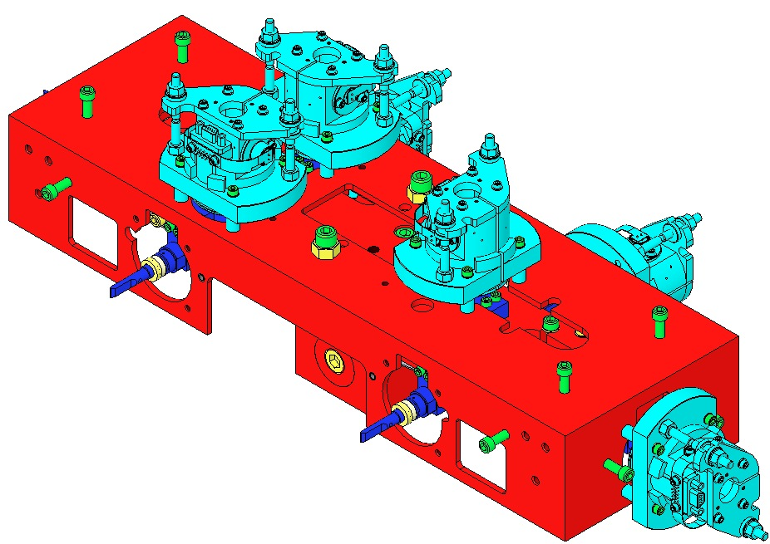  4-40 x 1”  Characterized  BOSEM  Fig 150: B OSEMS mounted on Coil Holder

Using the electronics test stand, read the open light voltage for each B OSEM, and position the BOSEM longitudinally to 50% open light voltage.
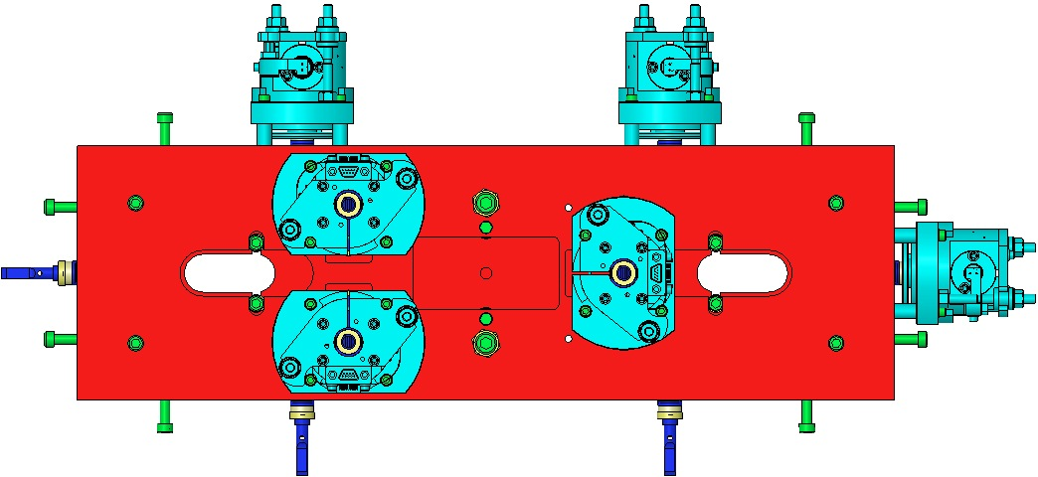
S
S
N
S
N
S
+X
+Y
+ / - indicates
magnet polarity
Fig 151: Top View of Upper Mass and BOSEMS

Place 4 AOSEMs in the Brackets behind the Intermediate Mass. Place another 4 A OSEMs in the Brackets behind the Lower Mass or Optic. Position each A OSEM such that it is centered around its magnet. | 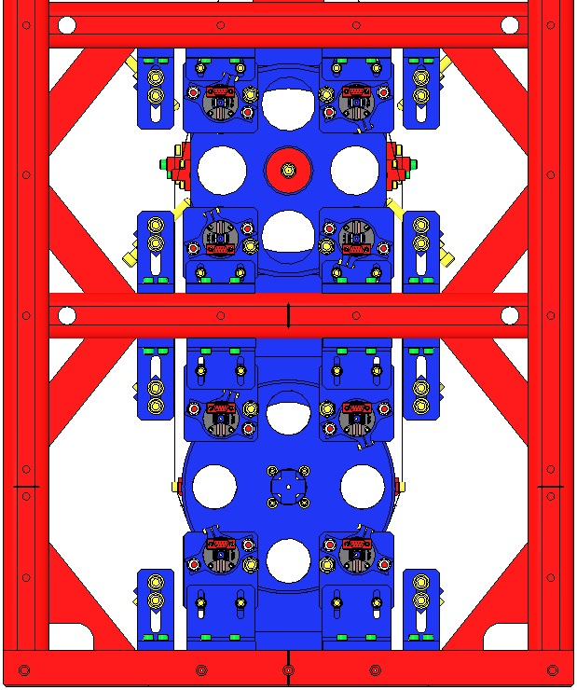  Fig 152: A OSEMs installed in Brackets

Aligning the HSTS for the 6 Degrees of Freedom

Materials
Qty | U | ID | Description
2 | Ea | NA | Laser Beam Height Targets, 3xß
1 | Ea | NA | He Ne Laser
1 | Ea | NA | Height Gauge

Procedure
The alignment tolerance for the Metal Build is much greater than that for the Optic Build. This procedure references the Optic requirements.
VERTICAL  Use the Laser to determine the Lower Mass height; that is, the beam height from the Optical Table, 140mm.  - Set up Laser, Target, Lower Mass, Target, with 1 meter minimum between each.  - Align the Laser height and angle with the 2 Targets holes.  - If the beam passes through the center the metal Test Mass mirror; proceed to “PITCH” procedure, below.  A digital or dial Height Gauge may be used to determine the (center) height of the Lower Mass. | 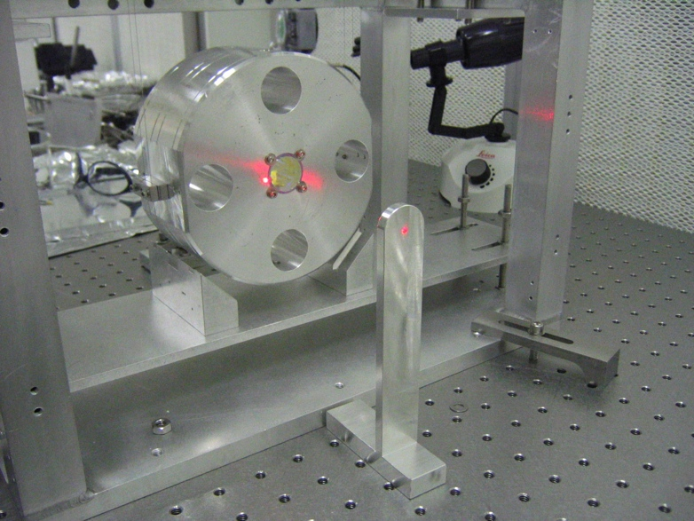  Fig 153: Laser, 2 Targets, Lower Mass
If the Laser does not pass through the Lower Mass centerline, add or remove Addable Masses to/from the Upper and/or Intermediate Masses.  - The Upper Mass has a vertical ¼-20 hole on each of the top and bottom center of the Mass.  - The Intermediate Mass has a horizontal ¼-20 hole through the center, designed so Addable Masses of 10, 20, 40, 50 or 100 grams can be added to either side. | (Intermediate Mass with addable weights  drawing in progress 1/2012)  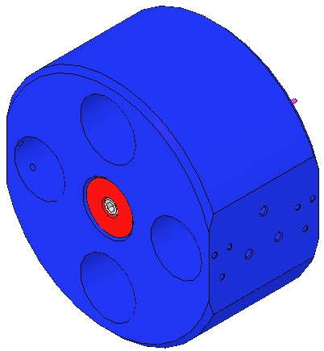  Fig 154: Intermediate Mass with Add-on Masses
If needed, angled Blade Clamps for the Upper Blades may be changed (see D020677 HSTS Library of Clamps). | 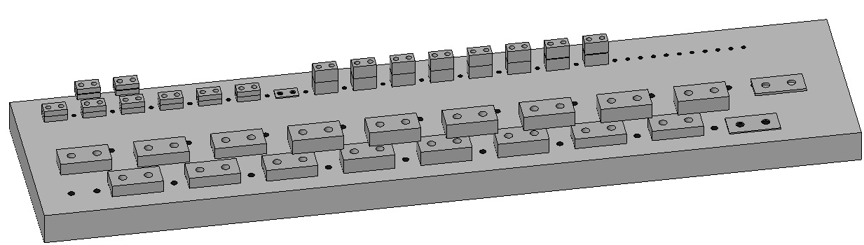  Fig 155: HSTS Library of Clamps
PITCH  Align the Lower Mass first.  Adjust the Upper Wire C-Clamps by using the Screw Drives. | 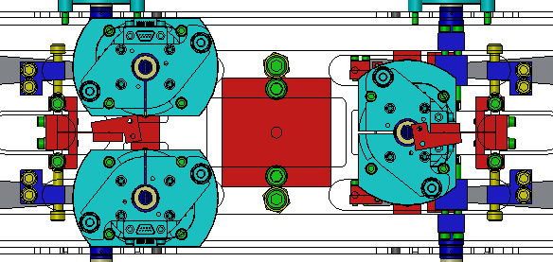  Screw Drive  C-Clamp  Fig 156: Adjusting Upper Wire Clamps to address Pitch
To make a finer adjustment, use the mirror to reflect the laser beam and place the target near the laser to catch the return beam… | 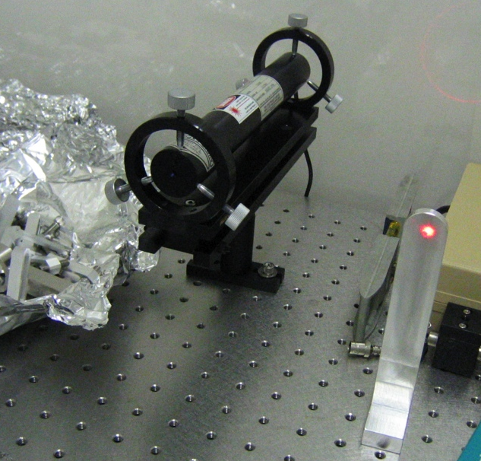  Fig 157: Using Laser & Target to adjust Pitch
…then adjust the Pitch Mass in the T-section. | 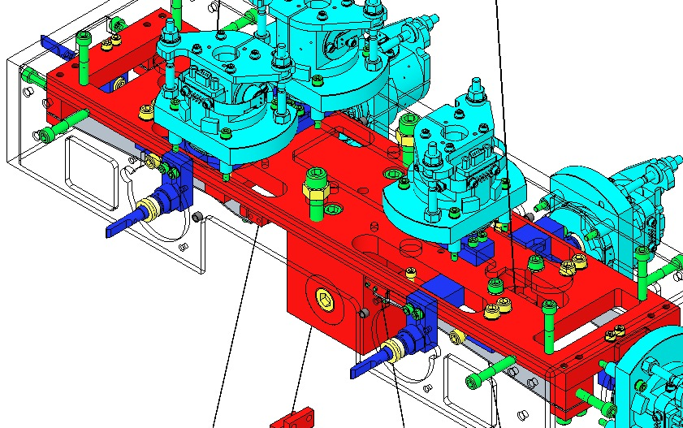  Pitch Mass  Fig 158: Adjusting the Pitch Mass

LONGITUDINAL: move the entire suspension on the optical table

TRANSVERSE: move the entire structure on optical table
YAW  Yaw is visible by comparing the position of the 2 Upper Wires as they pass through the Coil Holder (which serves as the reference for Yaw). Yaw can be adjusted with the Push and Pull Screws within the Rotational Adjusters. | 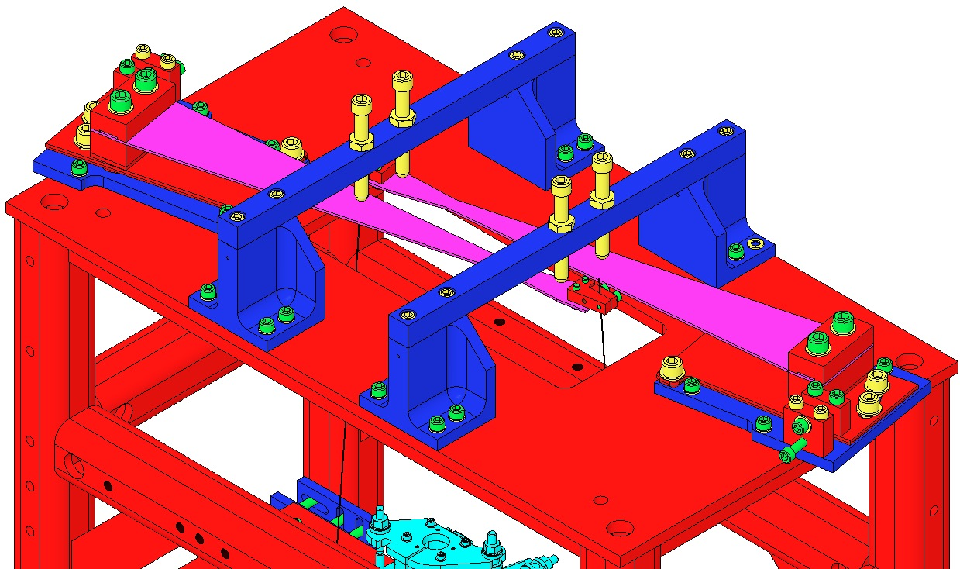  Fig 159: Yaw Adjustment with Push/Pull Screws

ROLL: The roll should be acceptable, as the wires are all the same length. As already mentioned it is important to bench test the upper blades with their chosen angled clamps to ensure they are well matched. If, after installation, this is not the case, it is possible to fix the misalignment from some combination of the following. A. Ensure each blade is torqued to the same amount at the interface between its clamp and the rotational adjuster. B. Adjust one of the wires making it shorter using the winch fixture, D970180. C. Could add a small amount of mass to the tip of the blade. D. and E. Could replace the blade or angled clamp using the library of blades and library of clamps supplied.

Replacing Lower Mass with the Optic

Procedure

The D0901791 Metal Test Mass assembly has bolted-on D0901790 Primary Prisms similar to the bonded-on D0810033 Primary Prisms for the Optic.  The D0901278 Secondary Prisms are the same for each. | 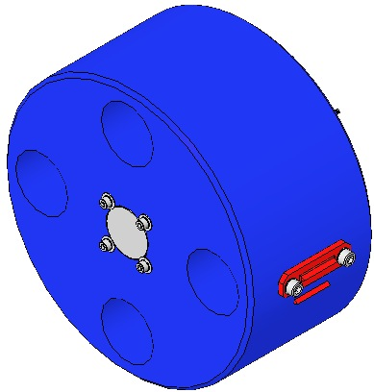  Primary Prism  Secondary Prism  Fig 160: Metal Test Mass
Weigh the Test Mass and Optic, including:  - 4 Magnet Assemblies  - 2 Primary Prisms  - 2 Secondary Prisms  - 2 Mirrors  - 8 Screws  - 8 Washers  The weights must be within a few hundred grams of each other. Compensation can be made at the Upper or Intermediate Masses.  Document the data in ICS. | 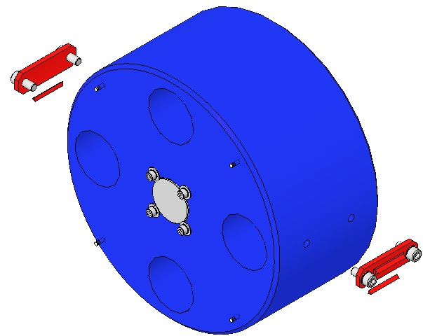  Fig 161: Test Mass Assembly

Bond the sapphire prisms to the optic using epoxy TBD and the bonding fixture, D0902543.

Bond magnet/standoff assemblies to the optic, per the procedure detailed in Section 6.3.

Move the bottom EQ stops up onto the metal test mass. Remove the front stops and brackets. Move the stops up even further to provide slack in the wire. Remove and set aside the secondary prisms. Carefully remove the metal test mass, while leaving intact the wires.

Replace all of the test mass EQ stops with silica tipped ones: Earthquake Stop For Glass (Glass Tip), Simplified, 2 Inch, D0900932.

Carefully, move the optic in place of the metal test mass, onto the bottom EQ stops. Make sure the wires are securely positioned in the v-grooves of the sapphire prisms. Replace the front stops and brackets. Back down on the bottom EQ stops, until the optic is just suspended. Re-insert the secondary prisms, until there is no slack in the wire between the primary prism and the place where the wire meets the optic.

Realign the BOSEMs & AOSEMs. Check for damping with the electronics test stand.

Torque all bracket screws to 20 in-lb. Check torque on all blade clamp screws at 30 in-lb.
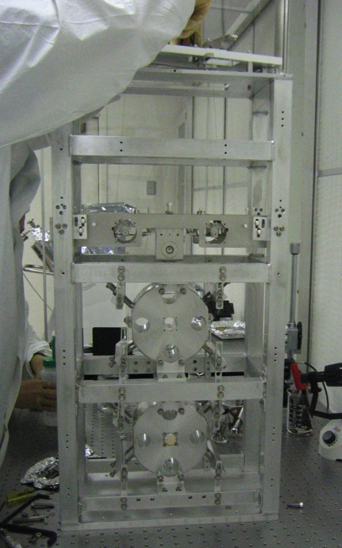  Fig 162: Prototype Small Triple Suspension | 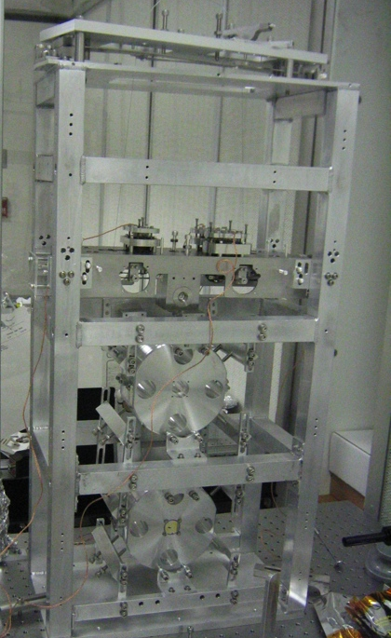  Fig 163: Prototype Small Triple Suspension with Control System

