LIGO Laboratory / LIGO Scientific Collaboration

LIGO-T0900478-x0 ADVANCED LIGO 10/12/09

ALIGO IO IMC OPTIC CONTAINER ASSEMBLY AND HANDLING

Luke Williams

Distribution of this document:
LIGO Science Collaboration

This is an internal working note
of the LIGO Project.

California Institute of Technology  LIGO Project – MS 18-34  1200 E. California Blvd.  Pasadena, CA 91125  Phone (626) 395-2129  Fax (626) 304-9834  E-mail: info@ligo.caltech.edu | Massachusetts Institute of Technology  MIT NW22-295  185 Albany Street  Cambridge, MA 02139 USA  Phone (617) 253-4824  Fax (617) 253-7014  E-mail: info@ligo.mit.edu
LIGO Hanford Observatory  P.O. Box 1970  Mail Stop S9-02  Richland WA 99352  Phone 509-372-8106  Fax 509-372-8137 | LIGO Livingston Observatory  P.O. Box 940  Livingston, LA 70754  Phone 225-686-3100  Fax 225-686-7189
http://www.ligo.caltech.edu/
Table of Contents
1 Components and Tools 3
2 Cleaning and Handling 4
3 Pre-assembly 5
4 Optic Installation 10
5 Optic Removal 15

Components and Tools

Table 1 lists the components for one complete assembly. The only required tools are a 7/64” hex key and a 9/64” hex key.

Part Name | Part Number | Qty | Manufacturer | Material
Base | D0901265 | 1 | UF | Aluminum
Tube | D0901261 | 1 | UF | Aluminum
Cap | D0901260 | 1 | UF | Aluminum
Static Bumper | D0901262 | 2 | UF | PEEK
Sliding Bumper | D0901263 | 1 | UF | PEEK
Sliding Bumper Plug | D0901264 | 2 | UF | PEEK
Spring | LC 022C 00 S | 2 | Lee Springs | Stainless Steel
Pull Handle Plate | 15675A51 (a) | 2 | McMaster | Stainless Steel
Pull Handle Ring | 15675A51 (b) | 2 | McMaster | Stainless Steel
Large O-Ring | 266 RPS | 2 | Row Inc. | PFA coated silicon
Small O-Ring | 254 RPS | 2 | Row Inc. | PFA coated silicon
Washer | N/A | 1 | Phoenix Specialty MFG. CO. | Copper
SHCS #8-32 X 0.375 | 92196A192 | 1 | McMaster | Stainless Steel
SHCS #8-32 X 0.75 | 92196A197 | 24 | McMaster | Stainless Steel
SHCS #8-32 X 2.5 | 92196A207 | 4 | McMaster | Stainless Steel
SHCS #6-32 X 0.1875 | 92196A143 | 8 | McMaster | Stainless Steel
Optic | D070091, D070092, or D080740 | 1 | Coastline Optics | Fused Silica

Table 1. Components List.

Cleaning and Handling
Pre-assembly, optic installation, and optic removal should all be carried out on a laminar flow bench to prevent contamination. Gloves should be worn at all times and general clean room procedures should be followed. Even when wearing gloves, avoid touching the optic faces.
When the optic is class A clean, all tools and parts, with the exception of the optic, will be cleaned at the University of Florida (UF) using the class B cleaning techniques outlined in E960022-B. Clean all tapped holes with a wire brush during the Liquinox3 wash.
If the optic is not class A clean (such as shipping between the polisher and the coater) the air bake can be omitted.
Table 2 summarizes the class B cleaning procedures for relevant materials.

Material | Procedures
Aluminum | -Ultrasonic clean in Liquinox3 for 10 minutes.  -Rinse in distilled water at least 3 times, changing the rinse water every time.  -Ultrasonic clean in methanol for 10 minutes.  -Air bake at 120 C° for 24 hours.
Stainless Steel | -Ultrasonic clean in Liquinox3 for 10 minutes.  -Rinse in distilled water at least 3 times, changing the rinse water every time.  -Ultrasonic clean in methanol for 10 minutes.  -Air bake at 200 C° for 24 hours.
Copper | -Ultrasonic clean in Liquinox3 for 10 minutes.  -Rinse in distilled water at least 3 times, changing the rinse water every time.  -Ultrasonic clean in methanol for 10 minutes.  -Air bake at 120 C° for 24 hours.
PEEK | -Ultrasonic clean in methanol for 10 minutes.  -Air bake at 120 C° for 24 hours.
PFA Coated Silicon | -Ultrasonic clean in acetone for 10 minutes.  -Ultrasonic clean in methanol for 10 minutes.  -Bake in vacuum at 120 C for 24 hours.

Table 2. Class B cleaning procedures for relevant materials

Pre-assembly
The containers will be pre-assembled at UF.
Step 1. Place a large o-ring in the large groove of the base. Make sure not to confuse the base with the cap. The base does not have a serial number engraved into it.
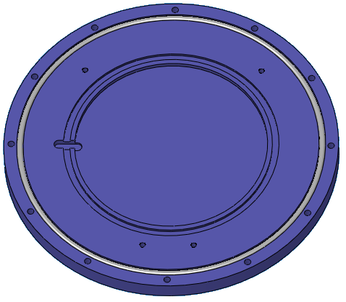
Figure 1. A large o-ring in large groove of base.

Step 2. Attach the tube to the base with twelve screws (#8-32 x .75). The tube has an orientation mark scribed into the side. Make sure it is oriented as shown in the figure below, with the horizontal mark close to the base and the small o-ring notch clocked 180° away from the mark. Tighten the screws gradually until the o-ring is fully compressed and the base is flush with the tube.
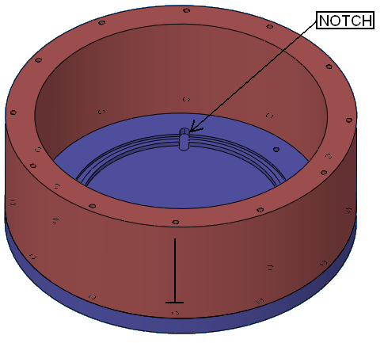
Figure 2. Proper alignment of orientation mark on tube.
Step 3. Attach the static bumpers with two screws (#8-32 x 2.5).
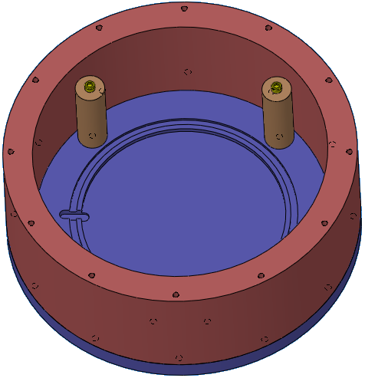
Figure 3. Static bumpers installed.

Step 4. Place two springs into the bores of the sliding bumper, and then place the sliding bumper plugs on top of the springs.
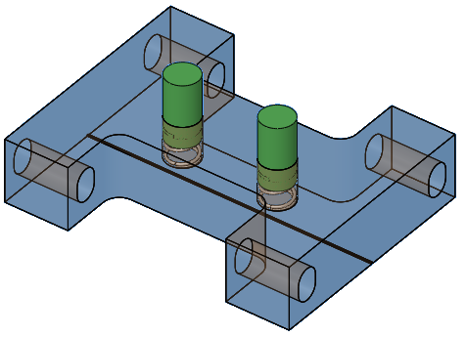
Figure 4. Sliding bumper, springs, and plugs.
Step 5. Attach the sliding bumper (along with springs and plugs) to the base using two screws (#8-32 x 2.5). Let the sliding bumper push towards the center of the container, so that the springs are kept at minimum load.
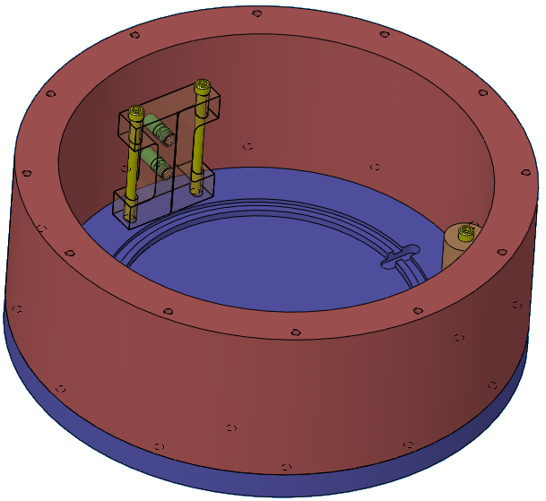
Figure 5. Sliding bumper attached to base.

Step 6. Place one small o-ring in the small groove of the base, and place an additional small o-ring inside the container.
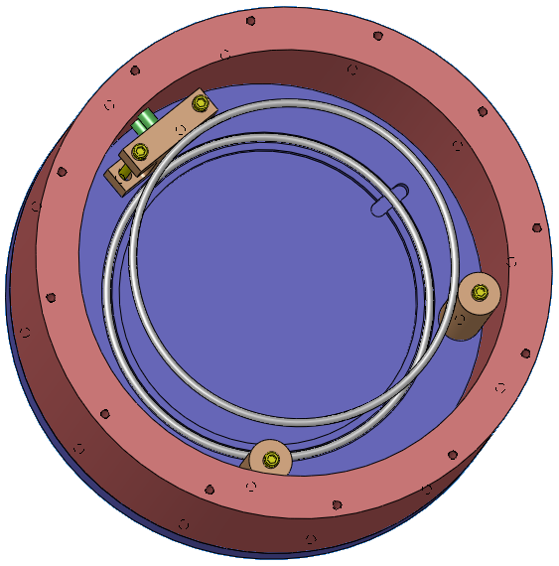
Figure 6. Two small o-rings inside the container.

Step 7. Place one large o-ring on top of the tube.
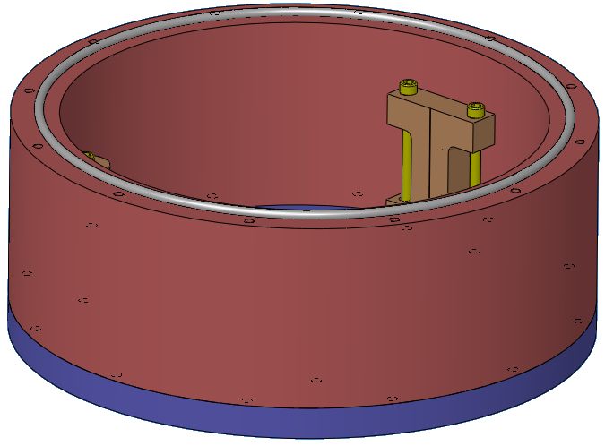
Figure 7. Place one large o-ring on top of the tube.

Step 8. Place the cap on top of the tube so that the large o-ring fits into its groove. Align the cap so that the vent hole is clocked properly with respect to the orientation mark on the tube. Attach the cap with twelve screws (#8-32 x .75). Tighten the screws gradually until the o-ring is fully compressed and the cap is flush with the tube.
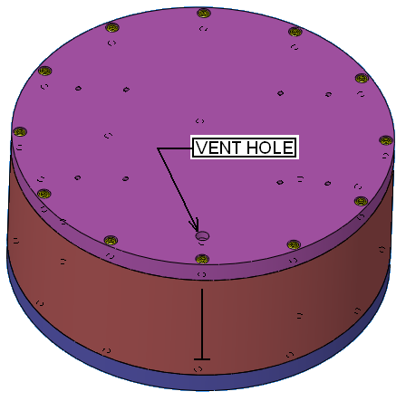
Figure 8. Cap in proper orientation with respect to the tube.
Step 9. Place one copper washer in the vent hole of the cap and seal the hole with a short screw (#8-32 x .375).
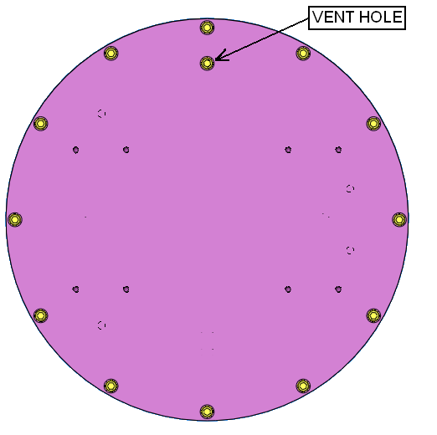
Figure 9. Copper washer and short screw to seal vent hole.

Step 10. Attach two handles to the cap with eight screws each (#6-32 x .1875). The handles should be oriented so that the rings rest over the center of the case.
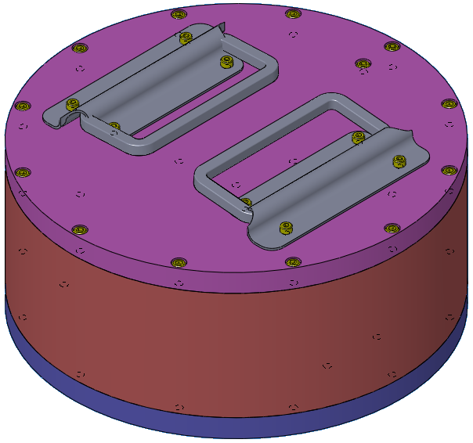
Figure 10. Attach pull handles to the cap.

Step 11. Double bag the assembly in Ameristat ziplock bags and then store it in a Pelican case.

Optic Installation
Step 1. Loosen the vent screw to equalize the pressure inside the case.
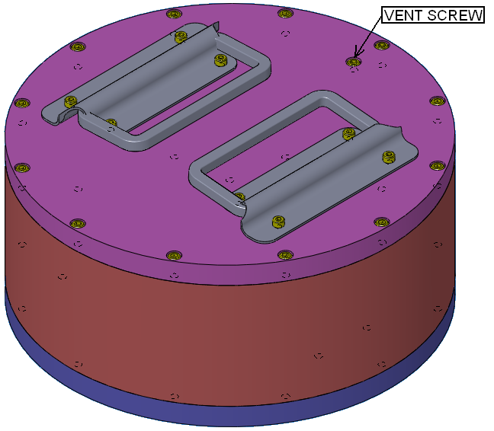
Figure 11. Loosen the vent screw.

Step 2. Remove the twelve screws that attach the cap to the tube and then remove the cap and its large o-ring. Also remove one of the small o-rings inside the case.
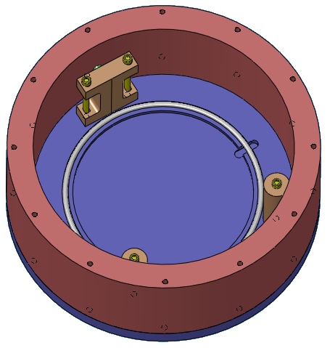
Figure 12. Remove the cap, large o-ring, and one small o-ring.

Step 3. Loosen the two screws that hold the sliding bumper. Push the sliding bumper towards the tube, hold it in place, and retighten the screws. Make sure that the small o-ring in the bottom of the container is sitting in the groove.
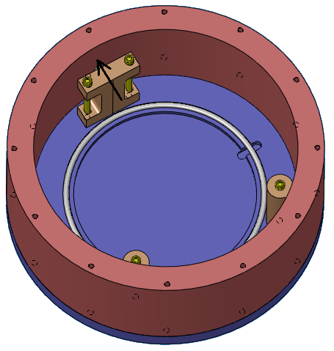
Figure 13. Move the sliding bumper and lock it down.

Step 4. Place the optic into the container. The arrow on the optic should point towards the bottom of the container, and the arrow should be placed tangent to the sliding bumper. Slide the optic so that it contacts both of the static bumpers.
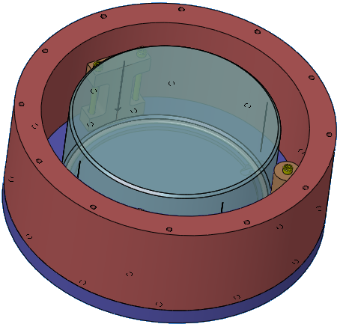
Figure 14. Place the optic in the container.

Step 5. On this step be careful to not scratch or contact the optic with the wrench. Loosen the two screws that hold the sliding bumper so that it slides into contact with the optic. Wiggle it to make sure that it is flush with the barrel of the optic. Retighten the screws and check that the optic cannot move in the radial direction.
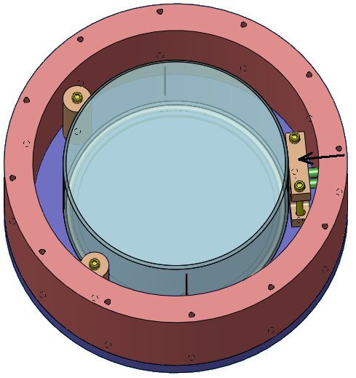
Figure 15. Slide the bumper up to the optic and lock it down.

Step 6. Set the remaining small o-ring on top of the optic and center it on the optic face. Set the large o-ring on top of the tube and center it.
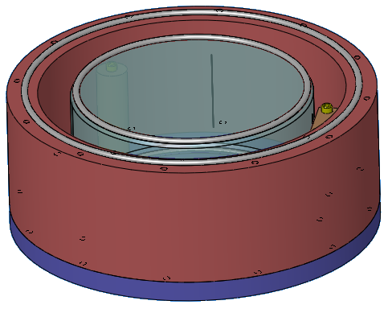
Figure 16. Place the large and small o-rings.

Step 7. Look at the vent screw in the cap and make sure that the threaded part of the screw does not stick out of the hole. If it does stick out of the hole, turn it until it does not.
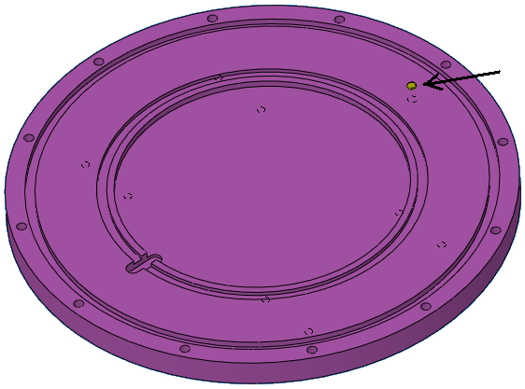
Figure 17. Make sure the vent screw does not stick out past the surface of the cap.

Step 8. Place the cap on top of the container so that the vent screw is aligned with the orientation line on the outside of the tube. Carefully move the cap until both o-rings are seated into their grooves.
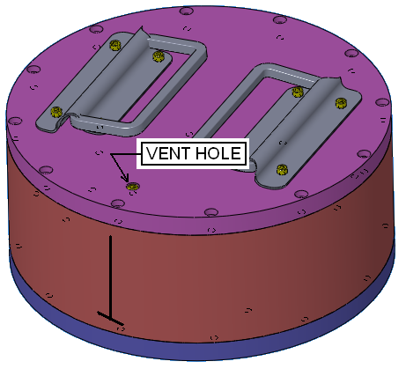
Figure 18. Put the cap on top in this orientation.

Step 9. Insert twelve screws into the empty holes in the cap and turn them until finger tight. With the wrench, gradually tighten the screws with in a star pattern until the cap is flush with the tube.
Figure 19. Screw down the cap.

Step 10. Tighten the vent screw.
Figure 20. Tighten the vent screw.

Step 11. Double bag the container in Ameristat ziplock bags and place it in the Pelican case.

Optic Removal
Step 1. Remove the vent screw and copper washer.
Figure 21. Remove the vent screw.

Step 2. Remove the twelve screws that attach the cap to the tube.
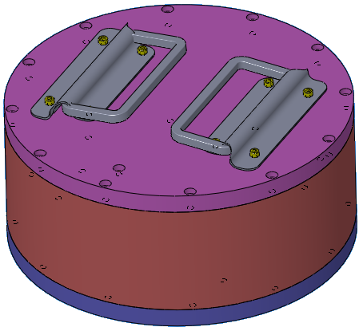
Figure 22. Remove the screws that attach the cap to the tube.

Step 3. Remove the cap, the large o-ring, and the small o-ring.
Figure 23. Remove the cap and o-rings.

Step 4. Carefully remove the optic, holding it by the barrel and the bevel. Avoid touching the optical faces.
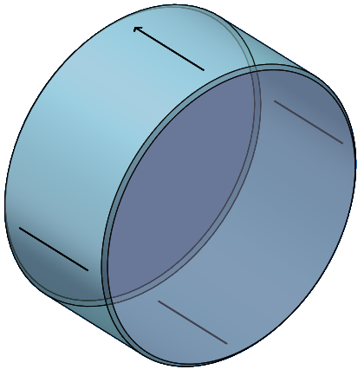
Figure 24. The optic removed from the container

