LIGO Laboratory / LIGO Scientific Collaboration

LIGO-T0900495-v4 ADVANCED LIGO 01-Nov-10

HAM Auxiliary Suspensions Electronics Requirements

Giacomo Ciani, Guido Mueller, David Reitze

Distribution of this document:
LIGO Science Collaboration

This is an internal working note
of the LIGO Project.

California Institute of Technology  LIGO Project – MS 18-34  1200 E. California Blvd.  Pasadena, CA 91125  Phone (626) 395-2129  Fax (626) 304-9834  E-mail: info@ligo.caltech.edu | Massachusetts Institute of Technology  LIGO Project – NW17-161  175 Albany St  Cambridge, MA 02139  Phone (617) 253-4824  Fax (617) 253-7014  E-mail: info@ligo.mit.edu
LIGO Hanford Observatory  P.O. Box 1970  Mail Stop S9-02  Richland WA 99352  Phone 509-372-8106  Fax 509-372-8137 | LIGO Livingston Observatory  P.O. Box 940  Livingston, LA 70754  Phone 225-686-3100  Fax 225-686-7189
http://www.ligo.caltech.edu/

Contents
Introduction 3
1.1 Purpose 3
1.2 Scope 3
1.3 Acronyms 3
1.4 Applicable Documents 3
1.4.1 LIGO Documents 3
Assumptions 4
1.5 HAM Aux Mechanical Design 4
1.6 HAM Aux Naming Convention 5
1.7 HAM Aux control electronics block architecture 5
Requirements 7
1.8 Noise Model 7
1.9 AOSEM Sensing Noise 8
1.10 AOSEM coil electronics 9
1.11 Summary of requirements 9
Monitors and Controls 11

Introduction

Purpose
The purpose of this document is to outline the design requirements for the aLIGO HAM Auxiliary suspension electronics. This includes all electronics, both analog and digital, necessary to:
- Provide a maximum current of 35 mA to the A-OSEM coils
  - To produce a pitch and yaw dynamic range of +/- 10 mrad
  - with the appropriate roll off for f > 10 Hz
- Provide a continuous current of 35 mA to the AOSEM LEDs (Honeywell model # SME-2470-001)
- Monitor the photodiode current from the AOSEM PDs (Honeywell model # SMD-2420-001)

The requirements in this document derive from performance considerations of the induced HAM Auxiliary suspension beam jitter noise.

Scope
This document covers only the A-OSEMS used in the HAM Aux suspensions.

Acronyms
AOSEMS Another Optical Sensor Electromagnetic Motor
HAM Horizontal Access Module
HAM Aux HAM Auxiliary Suspensions
IO Input Optic
SOS Small Optic Suspension

Applicable Documents

LIGO Documents
LIGO-T1000526, “HAM Auxiliary Suspensions Design Requirements”
LIGO-T1000338, “HAM Auxiliary Suspension Final design”
LIGO-T1000339, “HAM Auxiliary Suspension modeling and test results”
LIGO-D1000120, “ALIGO IO HAM AUX SUS ASSEMBLY”
LIGO-T0900142-v2, “Pointing requirements for Advance LIGO”
LIGO-T0900285-v2, “L1 HAM6 ISI eLIGO Final Performance Measurements (March 24 2010)”
LIGO T1000100-v2, “Parametric Study of AOSEM Sensor Noise”

Assumptions
The HAM auxiliary (HAM Aux) suspensions are used for suspended mirrors located in the IO on HAM 2 (straight) and HAM 8 (folded). Mirrors suspended in HAM Aux suspensions are steering and focusing mirrors.
HAM Aux suspensions are not planned for used in any aLIGO cavities.

HAM Aux Mechanical Design
The HAM Aux mechanical design is given in LIGO-D1000120. It is based on the iLIGO SOS design, with some modifications:
- The inclusion of blade springs to provide vertical isolation, and eddy current damping for the vertical bounce mode.
- The elimination of the side AOSEMS.
A design of the HAM Aux suspensions is shown in Figure 1 below.

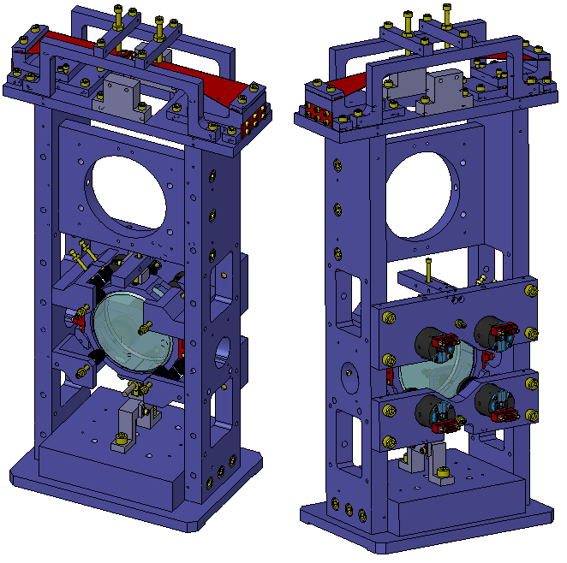
Figure 1. SolidWorks model of the HAM Aux Suspensions.

The 4 OSEMs/magnet pairs are all equal, and identical to those employed in the iLIGO SOS. The force coefficients are shown in Table 1.
Table 1. Magnet and OSEM properties
OSEM Type | MAGNET SIZE/DIPOLE MOMENT | FORCE COEFF
A-OSEM | 3.175 mm long, 0.9525 mm radius, 0.075 A/m² | 0.016 N/A

HAM Aux Naming Convention
The naming convention is such that the OSEMs are identified by viewing the HAM Auxiliary suspension from the rear. See Figure 2 below.

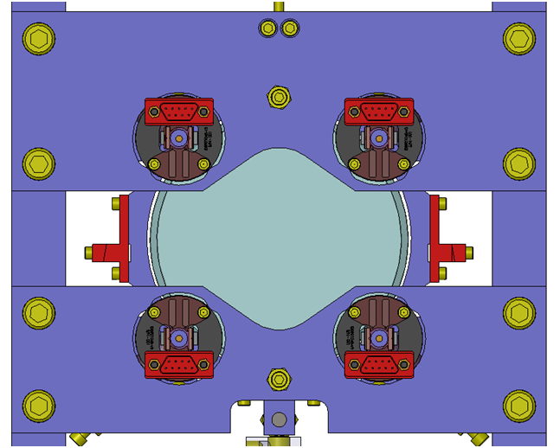
LOWER RIGHT
LOWER LEFT
UPPER LEFT
UPPER RIGHT
Figure 2. Naming conventions for A-OSEMS for the HAM Aux suspensions.

HAM Aux control electronics block architecture
We anticipate that the HAM Aux control electronics will be very similar in overall architecture to the iLIGO small optics suspensions. Figure 3 shows the concept for the HAM Aux electronics.
Figure 3. Overview of the HAM Aux control electronics

Requirements
Requirements for the jitter noise are expressed in LIGO-T1000526.
At low frequency (about 0.1 Hz and below) ISC is planning to take care of the suppression of the IO beam jitter with a servo loop. Above 0.1 Hz, requirements on HAM Aux performances are as follows:
- in-band jitter noise: the overall jitter in the IO beam above 10 Hz, expressed in term of the TEM10 mode amplitude, has to satisfy the requirement (see LIGO-T0900142-v2):
$S_{ϵ10}^{1/2}≤{10}^{-8}\sqrt{1+{\left(\frac{100 Hz}{f}\right)}^{4}}\frac{1}{\sqrt{Hz}}$.
Assuming incoherent sum of the noise contributions from the 4 mirrors mounted on HAM Aux suspensions (SM1, PMMT1, PMMT2 and SM2), this translates in a pointing noise per suspension of
$S_{α}^{1/2}≤{6 ∙10}^{-13}\sqrt{1+{\left(\frac{100 Hz}{f}\right)}^{4}}\frac{rad}{\sqrt{Hz}}$ .
- in the 0.1-10 Hz band, the suspension resonances should be damped so to limit the amplitude of the jitter. Based on a preliminary study by the ISC group, this requirement has been expressed in terms of the RMS noise in that band to be less than 1 µrad.
To meet the RMS noise requirements, IO will use a local damping feedback loop based on A-OSEMs as sensors and actuators. Their performances are thus critical to obtain the desired level of RMS noise without spoiling the in-band requirement.

Noise Model
To assess the requirements on the A-OSEM performance, a noise model of the HAM Aux suspensions has been developed based on Mark Barton’s Mathematica suspensions toolbox. On top of that, a sample 1-zero, 2-poles control loop has been implemented to show the role of the different noise sources (see LIGO-T1000339 for details).
The pitch degree of freedom appears to be the most critical, and thus sets the requirements. Figure 4 shows its noise spectrum for specific values of the control loop parameters. For the ISI platform input noise, measured spectra available in LIGO-T0900285-v2 have been used. Values used for the AOSEM sensing and force noise are discussed in the next sections.
We note that the calculation of the RMS noise shown in Figure 4 in is not completely accurate due to the resolution of the input data being too small to resolve the sharp resonances. However, to estimate the error due to the limited resolution, one can compare the numerical integral of the RMS of the transfer function alone (available with arbitrary precision) calculated with very high resolution and with the resolution imposed by the input noise data. Because the resonances are only introduced by the transfer function multiplying a relatively smooth noise input (in this case the dominant contribution is the ISI platform displacement noise), this comparison will be representative of the ratio between the two RMS noises. Performing this calculation shows that the RMS in Figure 4 is underestimated no more than a factor 2 and thus easily meets the requirements.
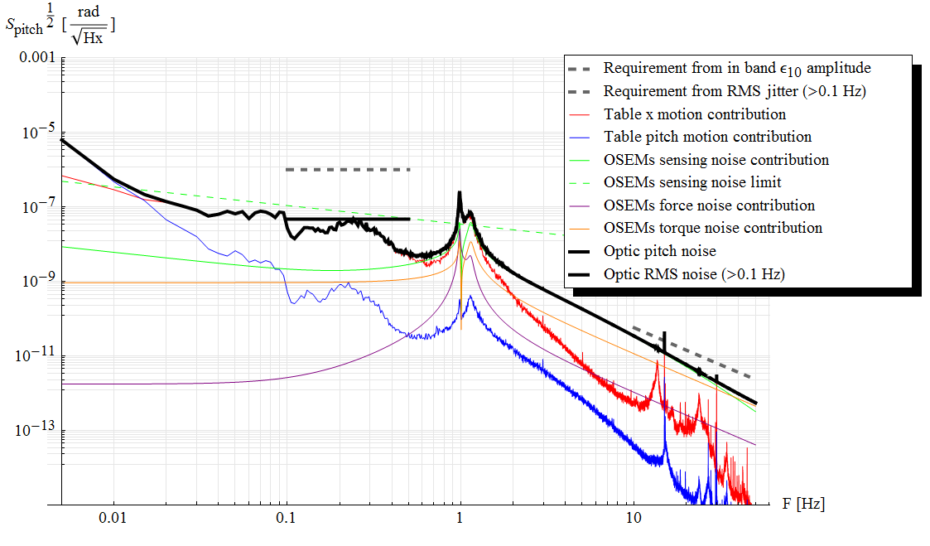
Figure 4. Overall closed loop HAM Aux pitch noise calculated using the Mathematica model. Single contributions are also shown.

AOSEM Sensing Noise
The A-OSEM sensing performance has been documented in LIGO T1000100-v2, “Parametric Study of AOSEM Sensor Noise”. Some variability is found in the photodetectors’ noise, with current noise floor in the range $0.4-2.0∙{10}^{-10}A/\sqrt{Hz}$ at 1 Hz falling roughly as f^{-1/2}.
In the same document, calibrated displacement noise has been measured for 10 different units; despite the variability, the performances of most of them are well represented by the displacement noise spectrum
$S_{sens}^{1/2}=2∙{10}^{-10}\sqrt{\frac{100 Hz}{f}}\frac{m}{\sqrt{Hz}}$ .
This level of noise has been assumed in the noise model described in Section 1.8. The model demonstrates that this level of noise is acceptable. However a factor 10 improvement would be desirable to be able to increase the control loop gain and to damp the resonances more effectively, without injecting in-band noise, as shown in Figure 5.
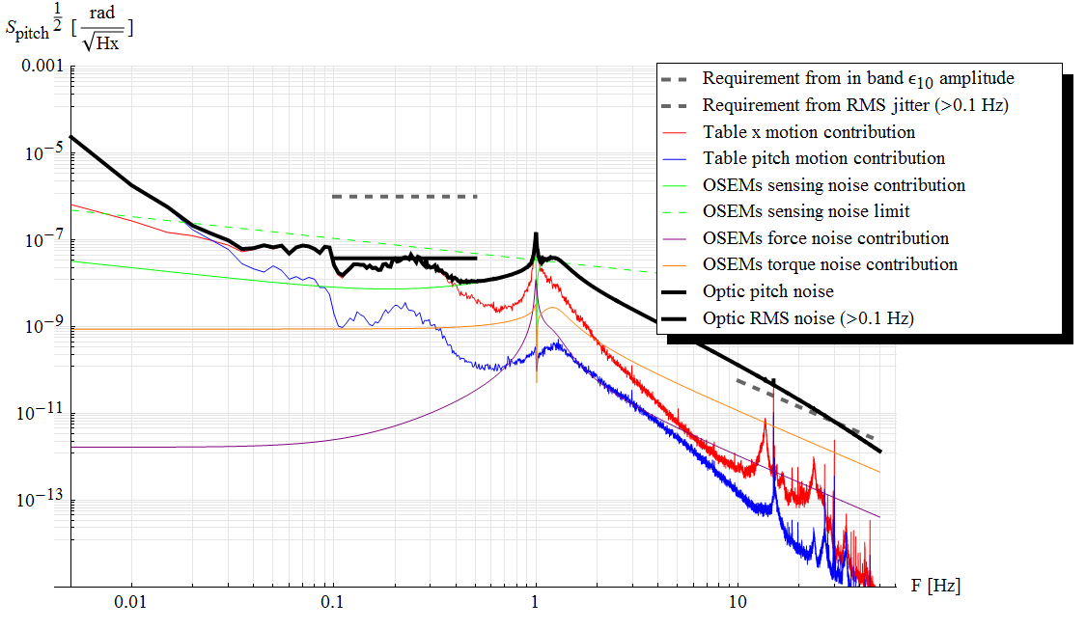
Figure 5. Same as in Figure 4, but with the gain of the control loop increased by a factor 4. While this allows for a more effective damping of the resonances, assumed A-OSEMs’ sensing performances cause the overall noise to exceed the in-band requirements. An improvement of the A-OSEMSs’ sensing noise would be desirable.

AOSEM coil electronics
The coil driver noise should not introduce in-band displacement noise at a level where it will compromise the beam jitter noise induced in the HAM Aux beam line. In the noise model, a coil drive current noise with a white spectrum of amplitude $1.6∙{10}^{-10}N/\sqrt{Hz}$ has been used. This number has been obtained assuming a coil driver noise of ${10}^{-8}A/\sqrt{Hz}$, multiplied by the force coefficient in Table 1.
The noise model shows this level of force noise to be below other source of noise for any practical configuration of the control loop parameters.

Summary of requirements
The conclusions drawn about the A-OSEMs requirements are summarized as follows:
- Sensing noise: the assumed displacement noise of
$$S_{sens}^{1/2}=2∙{10}^{-10}\sqrt{\frac{100 Hz}{f}}\frac{m}{\sqrt{Hz}}$$
is compatible with HAM Aux requirements. However an improvement of a factor 10 would be highly desirable to be able to increase the gain of the local control loop and more effectively damping the resonances.
- Actuation noise: assuming a current/force conversion factor of 0.016 N/A, a current noise of 10⁻⁸ A/rHz will meet the requirements.
- Actuation range: the pitch and yaw degrees of freedom have basically the same stiffness, found to be ≈ 6 10⁻³ N m/rad. For a maximum DC correction of 10 mrad, this requires a maximum current of about 35 mA.

Monitors and Controls
The following monitors and controls shall be provided as part of the design:
- Coil Driver output voltage monitor - the bandwidth of this monitor shall be at least 1 kHz and does not need to be capable of seeing the noise floor of the driver.
- Coil Driver Enable/Disable - The design of the coil driver shall provide for an Enable/Disable feature for each channel. When the coil driver is disabled, the input signal from the AdL Controls DACs shall be disconnected from the input of the coil driver circuitry. The nominal position of this switch shall be such that the coil driver is disabled. In the disabled mode of operation, the nominal output current from the driver shall be 0 mA.
- LED Driver Output Current - this is a very low bandwidth monitor of the LED drive current used to monitor and track possible drifts or changes in the LED current over time. The precision of this monitor should be better than 1% (relative).
- PD output voltage - a monitor of the PD output shall be provided. This monitor is separate from the signal used for the HAM Aux suspension damping loops.
- DC bias control - this shall be used to control a DC current up to 35mA per AOSEM, to be summed to the current requested by the damping loops (see Figure 3).

M. Evans, e-mail to G. Mueller and P. Fritschel, 7 June 2010

