Documenting Electronics using the DCC and the E-traveler
LIGO-T0900520-v1
R. Abbott, Caltech
26, October, 2009

- Overview
A paperless method for documenting and identifying electronics has been created. The principle document is referred to as an E-traveler, and consists of a PDF based form; copies of which can be obtained from the LIGO DCC (dcc.ligo.org, LIGO-F0900053, most recent version). An E-traveler acts as a birth certificate and life history for a chassis or circuit board.
The E-traveler is saved in the LIGO DCC under a unique type of document number known as an “S-number”. S-numbers can be obtained from the LIGO DCC in the same general manner as all other document numbers. As well as a file name for an E-traveler, S-numbers also serve as unique serial numbers used in identifying circuit boards and chassis. In the following note, definitions of parameters are provided, and a checklist will guide users so all E-travelers produce consistent results.
In addition to the E-traveler, this note provides guidelines to properly identify chassis and printed circuit boards in a manner consistent with the E-traveler. Guidelines will also be given as to the types of data that meet the minimum requirements for archiving an electronic design in the LIGO DCC.

- What to put where and why
  - Printed Circuit Boards
A printed circuit board is required to have the root of the document number printed on the board as shown in figure 1. The root number, or in this case “D” number, serves to identify the general information package (schematics etc.) for that version of the physical circuit board. The revision is no longer necessary. If a physical change is made to the artwork on the board, another “D” number must be obtained from the LIGO DCC.
An area should be designated to scribe, or adhere, a serial number (S-number), once one is generated. Do not use “Indelible” markers, as they wash off with circuit board solvents. The use of a title is very helpful, but the title should be terse.

Figure 1
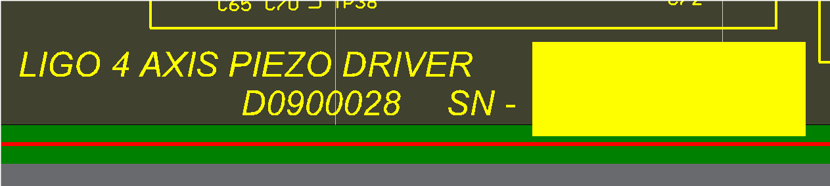

  - Chassis
The numbering scheme for a chassis is very similar to that of a printed circuit board. Figure 2 shows a view of a typical front panel. A D-number without version is present on the front panel to link the chassis to general documentation such as: Quick start guides, physical layout drawings, block diagrams etc. A unique S-number (not shown in figure 2) is attached to the front panel to identify the exact revision of all related documentation associated with the chassis.

Figure 2
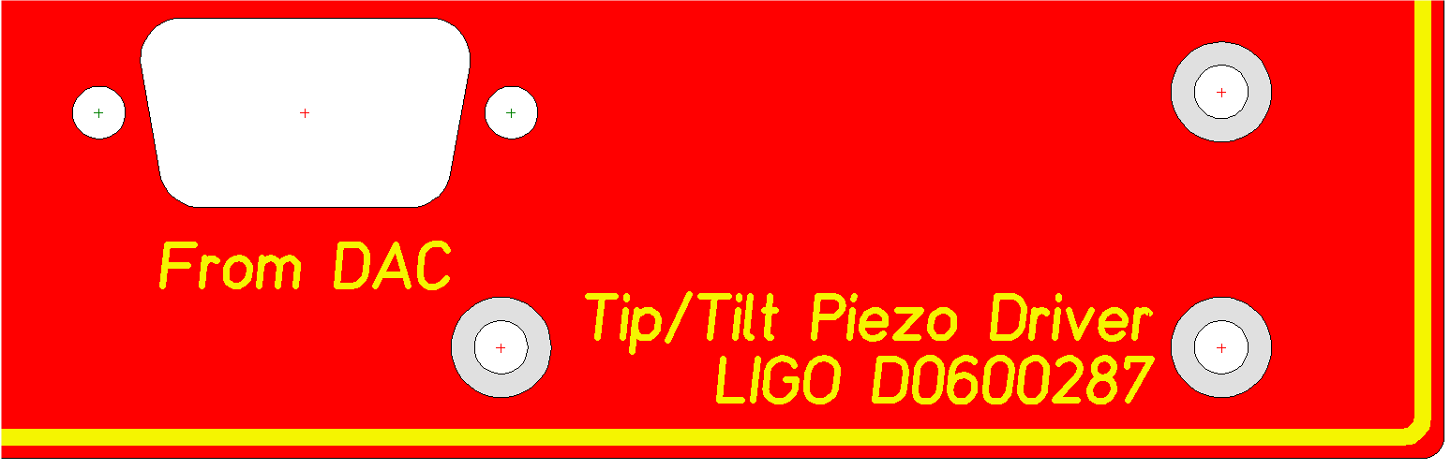

If a chassis is redesigned, such that its form or function changes to support a new line of production, a new D-number would be obtained to differentiate the new chassis from its predecessor. Revisions to an existing chassis, such as modifications to internal circuit boards, are captured by reference to the unique chassis S-number, and do not require the generation of a new D-number.

- How to adequately document a design. What things to put in the DCC.
  - Printed Circuit Boards
    - PDF Files
A PDF version of the schematics and board layout must be submitted to the DCC. Revisions to this basic documentation will detail the changes to component values at the schematic level. A complete redesign of the printed circuit board requires a new root D-number to be obtained.
    - Native Software Files
A zipped version of the native files generated by the software used to create the circuit board must be submitted to the DCC under the same D-number as the PDFs. In the case of the Altium software package, the entire project should be included in the zip file, along with the Gerber data used to order the circuit boards.
    - Miscellaneous Stuff
When it comes to documentation, we rarely have too much. JPEG files with clear images of the final design, test procedures and results, explanatory texts, etc. are all welcome additions, but are beyond the scope of this note.
  - Chassis
    - PDF Files
A PDF diagram should show the circuit board layout and associated interconnections for the interior of the chassis. A PDF quick start guide (see T080063-v1 for example), detailing the function of all inputs and outputs, including a functional block diagram and principles of operation should accompany all chassis.
- The E-traveler, how to fill out the form and what’s it all about?
With the latest copy of the E-traveler form, F0900053, in hand, the intent of each section can be detailed. Remember, an E-traveler can be associated with any item that has a serial number. A chassis is probably the most common target, but a circuit board can also have an E-traveler. An explanation of each field on the form follows below.
  - Page 1
    - S-Number – Once a serial number has been obtained from the LIGO DCC for the purpose of identifying a chassis or circuit board, the serial number is entered in the S-number field. This S-number also serves as the file name for the E-traveler, along with the current revision suffix.
    - Revision – Each change to the E-traveler form that occurs in the lifespan of the part for which it is associated results in a new revision to the E-traveler, and should be entered in this field. Typically, only the most current revision is of interest to the user, as all the older information is available on the latest revision.
    - Title – A short title of the device that the E-traveler is documenting.
    - Activity History Dropdown Fields – At the time of writing, seven different activities can be documented by these fields. The choices and associated fields are fairly self explanatory. Additional lines are added or removed by using the associated “Add” or “Delete” buttons.
  - Page 2
    - Modification History Dropdown Fields – These fields can contain unlimited text, and should include all changes made to a specific chassis or circuit board. Reference should be made to particular schematic revisions, and other amplifying documentation such as photos or document change notices (DCNs). This field is the essence of the “life history” nature of a module, and is the place where most common changes are captured.
  - Page 3
    - Acceptance Test Description and Results Fields – After a unit undergoes a modification, testing is required to verify proper operation. These fields allow a summary of the tests to be captured, along with references to the specific test procedures and results. Lines can be added or removed using the associated buttons.
  - Page 4
    - Original Manufacturing Notes – Following the concept of a birth certificate, these fields allow notes to be made at the time of manufacture. Slight manufacturing defects, marginal test results or other specific oddities can be noted in these fields. They are used once, at the time of initial manufacture.
- Documentation and E-traveler Checklist

Table 1
Item | Description | Check
1 | For a chassis or PCB, are both the PDF and native files in the LIGO DCC per section 3 of this document?
2 | Do the PCB and/or chassis have the root D-number, a title, and a place to adhere or scribe an S-number? No ink or markers.
3 | For the chassis or PCB, obtain an S-number from the LIGO DCC.
4 | Using the S-number as a file name, fill out the E-traveler form using the latest revision of LIGO F0900053. Save form to DCC.
5 | When a change has been made to an existing chassis or PCB, the associated E-traveler(s) must be updated, and then saved to the DCC as a new revision. If no E-traveler or S-number exists, obtain one from the LIGO DCC and update the module in question.
6 | Revised artwork for PCBs that result in a new production versions, or revisions to future production versions of a chassis, require the generation of a new D-number and a new series of S-numbers.

