LIGO Laboratory / LIGO Scientific Collaboration
LIGO- T0900629-v1 ADVANCED LIGO 15th December 2009

Response to questions from the review panel on the
Final Design Review of the ETM/ITM ears

M. van Veggel, A. Bell, A. Cumming, L. Cunningham, G. Hammond, K. Haughian, J. Hough, R. Jones, R. Kumar, K. Strain, S. Rowan
Institute for Gravitational Research, University of Glasgow

Distribution of this document:
LIGO Science Collaboration.
This is an internal working note
of the LIGO Project.

California Institute of Technology  LIGO Project – MS 18-34  1200 E. California Blvd.  Institute for Gravitational Research  University of Glasgow  Kelvin Building  Glasgow G12 8QQ  Phone: +44 (0)141 330 3340  Fax: +44 (0)141 330 6833  Web: www.physics.gla.ac.uk/igr/  Pasadena, CA 91125  Phone (626) 395-2129  Fax (626) 304-9834  E-mail: info@ligo.caltech.edu | Massachusetts Institute of Technology  LIGO Project – NW22-295  185 Albany St  Cambridge, MA 02139  Phone (617) 253-4824  Fax (617) 253-7014  E-mail: info@ligo.mit.edu
LIGO Hanford Observatory  P.O. Box 1970  Mail Stop S9-02  Richland WA 99352  Phone 509-372-8106  Fax 509-372-8137 | LIGO Livingston Observatory  P.O. Box 940  Livingston, LA 70754  Phone 225-686-3100  Fax 225-686-7189
http://www.ligo.caltech.edu
- Table of contents
1 Table of contents 2
1.1 Revision history 2
1.2 Reference documents 2
2 Questions and answers 3

Revision history
Rev v1 | 15th December 2009 | Marielle van Veggel
Rev v2

Reference documents
P0900053-v2 | Thermal noise arising from bonds in the Advanced LIGO test mass suspensions
T0900391 | Monolithic suspension procedure
E080090 | Component Specification – ETM Penultimate mass
E080112 | Component Specification – ITM Penultimate mass
E960022 | LIGO Vacuum Compatibility, Cleaning Methods and Qualification Procedures
T080091-00 | Proposal for baseline change from ribbons to fibres in AdvLIGO test mass suspension monolithic stage
Publications
Class. Quant. Grav. 19 (2002) 1655-1662 |  |  | Barr et al. Silica Research in Glasgow
Class. Quantum Grav. 21 (2004) S1091–S1098 |  |  | Smith et al. Mechanical quality factor measurements of monolithically suspended fused silica test masses of the GEO600 gravitational wave detector
Applied Optics, Vol. 45, Issue 28, 7269-7272 |  |  | Hild et al. Measurement of a low-absorption sample of OH-reduced fused silica
Optics Communications 280 (2007) 492–499 |  |  | W. Winkler et al. The GEO 600 core optics
Other
Datasheet Heraeus |  | Quartz Glass for Optics - Data and Properties
Datasheet Corning |  | HPFS® Fused Silica Standard Grade – Data and Properties
Datasheet Schott |  | Synthetic Fused Silica

Questions and answers
Section 2.2 Design requirements of the ears
Q Address the materials used, types of fused silica, your models are based on elastic modulus and density, how do these compare among the materials you are using. Can we scale directly from GEO given the materials?
Table 2.1
A Hereaus states the mechanical properties of the Suprasil family/Homosil/Herasil/ Infrasil /HOQ as one value for all parameters (datasheet Hereaus).
Schott Lithosil (datasheet Schott) and Corning 7980 (datasheet Corning) are mentioned as possible other materials for the PUM’s in the design documentation (E080090 and E080112) (second table). The mechanical properties of those are very close if not identical to Heraeus fused silica materials.
The GEO test masses, ears and fibres were made of Suprasil (Barr et al, Winkler et al, Smith et al, Hild et al), so we can indeed scale directly from GEO to advanced LIGO.

Table 2.1 Information on relevant mechanical properties of the fused silica used in GEO and advanced LIGO
Object in monolithic suspension | Material | Density [x10³ kg/m³] | Elastic modulus [GPa] | Linear coefficient of thermal expansion [x10⁻⁶ /K]
aLIGO ETM TM | Suprasil/Corning 7980/Lithosil ?? GariLynn
aLIGO ITM TM | Heraeus Suprasil 3001 | 2.20 | 70 | 0.51
aLIGO ETM PUM | Suprasil/Corning 7980/Lithosil ?? GariLynn
aLIGO ITM PUM | Suprasil/Corning 7980/Lithosil ?? GariLynn
aLIGO ears | Heraeus Suprasil 312 | 2.20 | 70 | 0.51
aLIGO suspension fibres | Heraeus Suprasil 2 | 2.20 | 70 | 0.51
GEO ears | Heraeus Suprasil | 2.20 | 70 | 0.51
GEO TM | Heraeus Suprasil 1 (Smith et al) | 2.20 | 70 | 0.51
GEO BS | Heraeus Suprasil 311 (Hild et al) | 2.20 | 70 | 0.51
GEO PUM | Heraeus Suprasil (check Winkler) | 2.20 | 70 | 0.51
GEO fibres | Heraeus old numbered Suprasil 2 (Barr et al.) | 2.20 | 70 | 0.51

Table 2.2 Information on relevant mechanical properties of the possible fused silica suggested for the ETM/ITM penultimate masses (E080090 and E080112)
Material | Density [x10³ kg/m³] | Elastic modulus [GPa] | Poisson’s ratio [-] | Bending strength [MPa] | Linear coefficient of thermal expansion [x10⁻⁶ /K]
Heraeus Suprasil (any grade, including commercial grades)/ /Homosil/Herasil/Infrasil /HOQ | 2.20 | 70 | 0.17 | 67 (tensile strength 50 MPa) | 0.51 (0-100°C)
Schott Lithosil QT | 2.2 | 72 | 0.17 | 80-100 | 0.5 (25-100°C)
Corning 7980 SG | 2.201 | 72.7 | 0.16 | - | 0.52 (5-35°C)

Section 3.1 Shape of ears
Q What does the reference to the GEO design tell us about the Advanced LIGO design? Clarify the reference.
A After the change of baseline from ribbons to fibres in 2008 (T080091-00) welding tests were performed with lapwelding cylindrical fibres. This proved difficult to achieve as it is more difficult to heat evenly and feed in material in lapwelds. Also lapwelds are more likely to cause undesirable stresses due to asymmetry. The decision was therefore made to use butt-welds instead.
In GEO also cylindrical fibres were used and these were butt-welded to the horns of the ears. Each GEO ear consists of one body for 2 fibres with two weld horns sticking out to allow for butt-welding the fibres on. As this has been very successful it was a logical decision to adopt a very similar design of ear for advanced LIGO. The bond area was scaled up to take the increased load of 40 kg (instead of 10 kg) and the cross section of the weld horns was scaled up from 2x2 mm to 3x3 mm to accommodate the larger diameter stock.

Section 3.2 Stresses
Q How does the GEO stress at weld compare to the final design?
A The diameter of the stock used for the fibres in GEO was 2 mm and was welded onto 2 x 2mm square weld horns. The GEO beamsplitter mass is 10 kg with for welds, so each weld takes 2.5 kg. The stress in the weld calculated from this is 6.1 MPa. The diameter of the stock used for advanced LIGO is 3 mm and is welded onto 3x3mm square weld horns. The advanced LIGO mass is 40 kg for 4 welds, so each weld takes 10 kg. The stress calculated from this is 10.9 MPa (1.8 x that in GEO).

Q The allowable fiber and bulk stresses appear different, please explain.
A The strength of silica is highly dependent on the number and size of flaws in the surface and bulk of the material. Fibres are pulled at a very high temperature and are never touched by human hands. They are therefore pristine and have very few flaws, which makes their average strength very high (in the order of 4 GPa). The ears are bulk fused silica and we therefore use the manufacturers quoted bulk average strength. In addition work is done to seal cracks in the surface with the flame polishing step and so to increase the strength of the ear. We take the conservative approach of using the average bulk strength stated by manufacturers for the ears.

Q Please address the feasibility of the 1 degree weld tolerance.
A We would expect a misalignment of 1 degree to be visible to the trained eye. By having a step where we heat the stock after welding with tension on the fibre we can align the weld with respect to the local tension direction. This reduces the misalignment below that level.

Q Is there, or has there ever been, a check on residual stress in the ears after bonding?
A Yes, residual stress after bonding and stresses in the ears after welding have been checked using crossed polarisers. No stresses have been observed in unloaded bonded ears.
Some stresses have been observed after welding, with no load. And some additional stresses have been observed when the fibres are under load. In those cases a white hue-type glow is seen. It is difficult to quantify the stresses, however the stresses seen have low intensity glows. Much higher intensity glows have been observed in samples that have been exposed to thermal loading (heating with hydrogen oxygen flame).
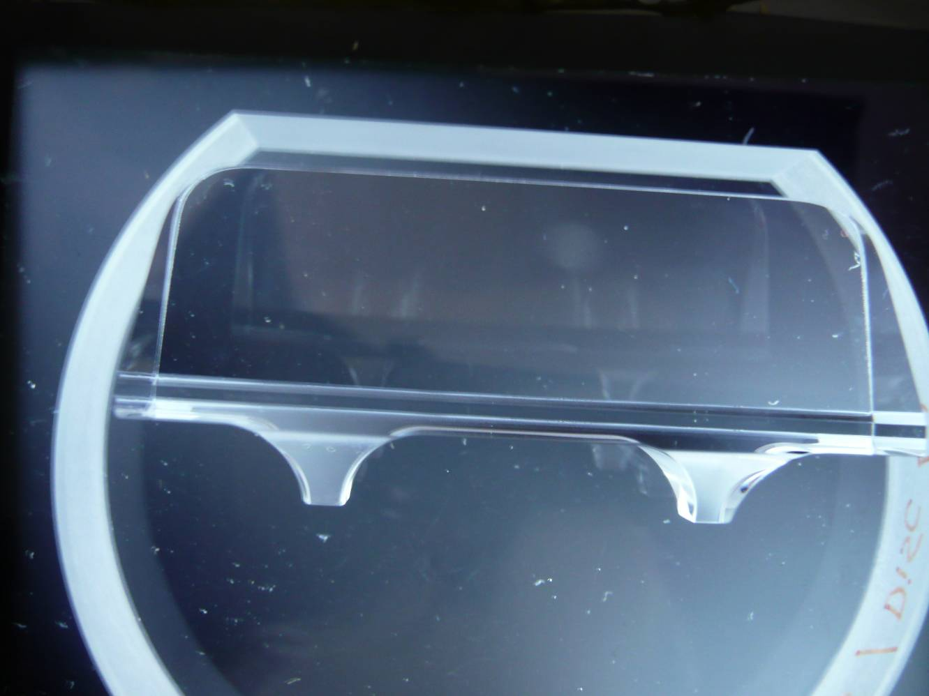
No stresses in bonded ear that has not been welded
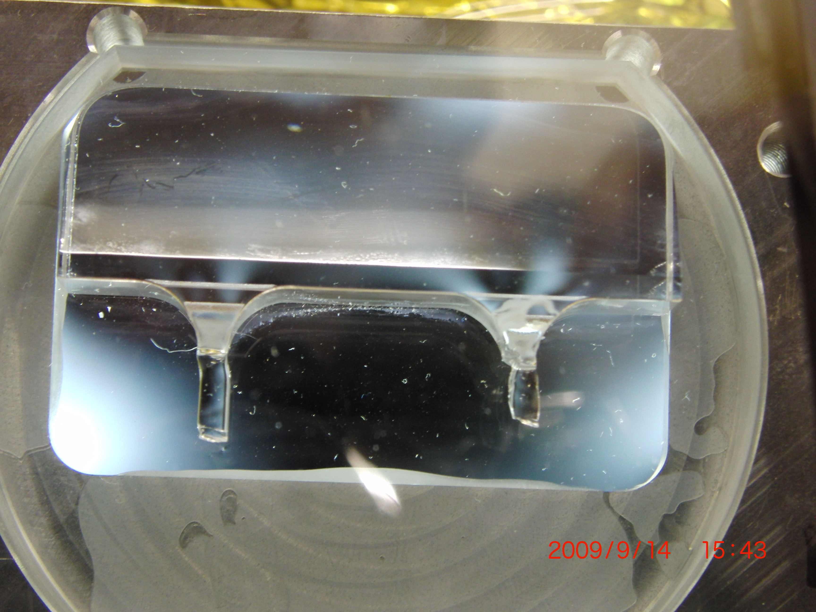
Typical thermal stress ranges after welding and welds not loaded
Stress in ear after laser welding, no load
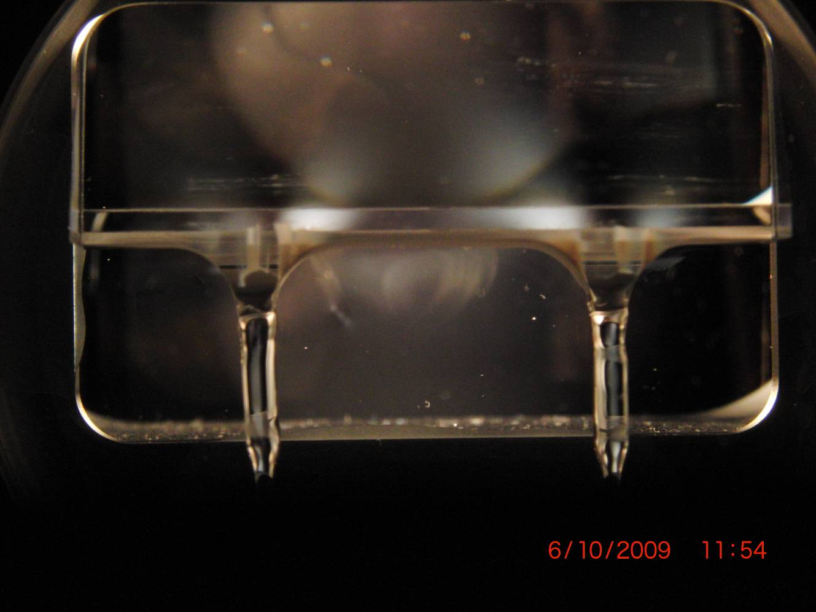
Typically stresses become slightly more pronounced when under tension
Stress in ear under full tension

Section 3.3 Weldability and Section 3.5 Hydroxide Catalysis Bonding
Q Are there any or welding procedures to examine? What is the development plan for these documents?
A The Ear Design Document refers in section 5.2.1 to the welding procedure document: T0900391. This document is still in development due to still ongoing developments with the monolithic procedure.
One test suspension is still scheduled in Glasgow at this date and two test suspensions are scheduled at LASTI to allow for the final further developments, before the LASTI monolithic suspension that is currently scheduled for March/April.
After the LASTI monolithic suspension the monolithic suspension procedure will be reviewed.

Section 3.3 Weldability
Q Address the following tradeoff in the document
From Rai Weiss. In order to make the welding of the 3mm rod at the ends of the fiber easier, it would be worth making a longer 3mm section on the horn to act as heat relief for the weld. I realize that the fused silica milling is done with cartesian rather than cylindrical coordinates and that currently the welding pyramid ends with a 3mm square. The idea is to extend the 3mm square about 3 to 5mm above the pyramid. (I would prefer a 3mm diameter extension to match the cylindrical rod but suspect that the fused silica machining company will charge an arm and a leg to go from square to round at that place.). The extra length is said to increase the thermal noise by a small amount (I think less than 20% in amplitude.) The heat relief section should make the weld easier and also provides for a few more extra attempts if there are weld failures. I brought this idea up with the Glasgow group at the time when I was there and they were going to look into it.
A The improvements suggested are interesting suggestions. We have looked into this.
Though indeed the suggestions might increase weldability slightly, we do not have any problems with the weldability of the current ears.
Furthermore, it would require a significant redesign of the ear as just lengthing the horns would mean that the bending point distances could not be met as per the original requirements. Longer horns would mean placing the ear further “up” the mass, outside the current polished flat area.

Section 3.4 Location of the ear and suspension dynamics
Q Last paragraph - You may mean to convey that you are looking at changing the "d" parameters to be able to fit everything in within existing constraints, but that it should not affect the ear design. Please clarify.
A In the current status of development of fibres it is not possible to maintain the d-distances of d₂ = 10 mm and d₃ = 1 mm, because it is not possible to fit the ears and fibres within existing assembly constraints. A change to d-distances to d₂ = 0.3 mm and d₃ = 7.2 mm is considered to be likely, because this will allow more flexibility in the assembly constraints. Fibre optimisation work is ongoing and therefore both options are still under consideration at this point. However, this will not lead to a change in ear design.

Section 3.6 Thermal noise of the bonds
Q The review committee, responsible for the preliminary design review on the ears, made frequent mention that thermal noise of the bonds should be measured. Please describe your efforts in this. What caused you to end up with an analysis-only approach?
A The qualification of the displacement noise associated with the suspensions for Advanced LIGO arising from all sources requires an instrument having displacement sensitivity equivalent to that of Advanced LIGO at low frequencies.
This challenging requirement was the original motivation for the dedicated LASTI test facility at MIT, and a LIGO decision was made not to use LASTI for this purpose.
However a high sensitivity interferometer experiment to measure directly the thermal noise associated with a bonded mirror (where the effect of the bond on the displacement noise sensed has been artificially enhanced due to the positioning of the bond) is currently in
preparation at Glasgow and may provide results by early next summer.
Q Is the thermal noise limit of 7e-22 m/rtHz given in Section 3.6 for a single ear, or for the whole test mass (ie two ears)? Please clarify.
A The thermal noise limit is for a whole test mass (ie two ears).

Section 4 Fabrication procedure
Q Call out the requirements on the mirror flat for comparison.
A Refer to D080117 for the PUM. The drawing states in notes 4 and 5:
4. SURFACE S4:
POLISH FLAT TO λ/10 PEAK TO VALLEY, OVER APERTURE "ZONE 1" AND APERTURE "ZONE 2" (WHERE APERTURE "ZONE 1" AND APERTURE "ZONE 2" ARE CENTERED ON FLAT IN THE POSITIONS SHOWN).
5. λ = 633nm FOR SURFACE MEASUREMENTS

Q Please spell out what MRF means.
A MRF is Magneto Rheological Finishing

Q Is there, or has there ever been, a check on residual stress in the ears after fabrication?
A Yes, see image below. No stresses have been observed
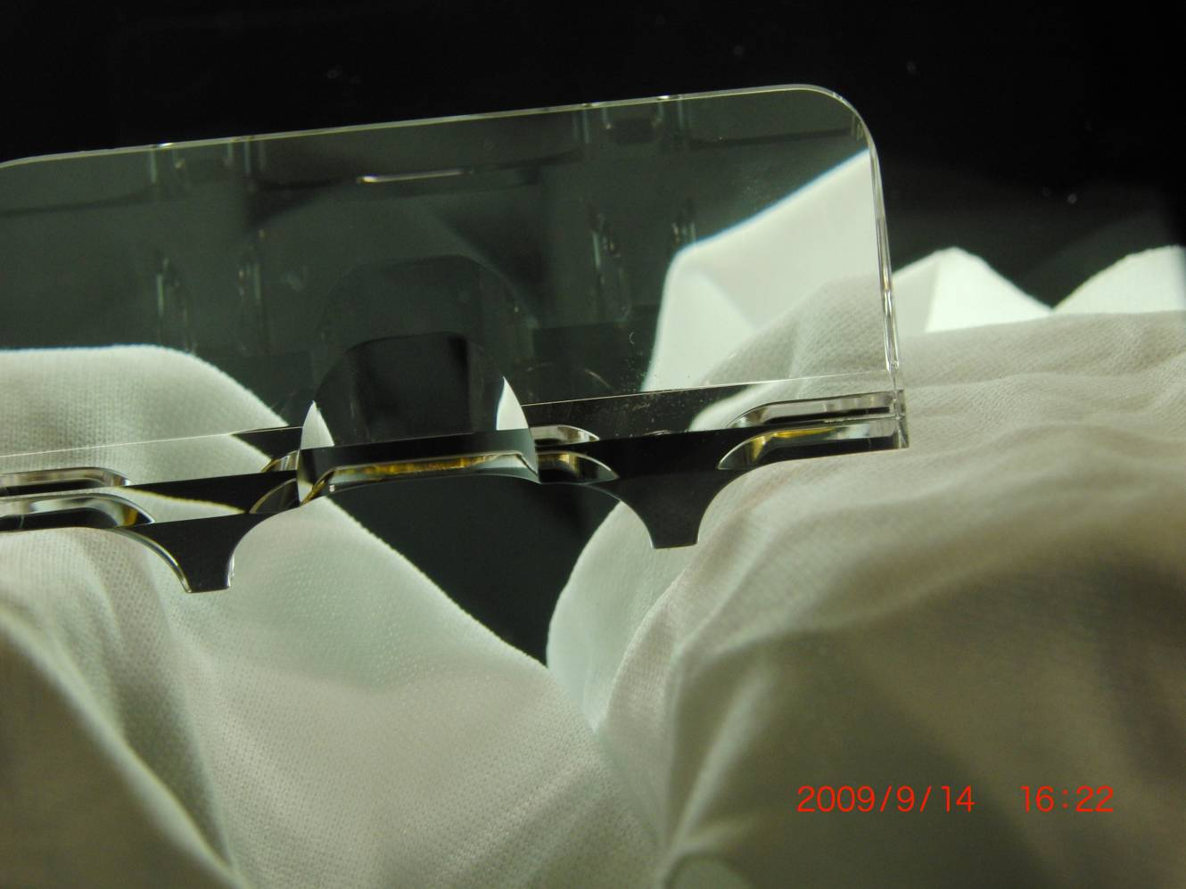
Unbonded, fully machined and polished ear between two crossed-polarizers

Section 5.1 Tests on hydroxide catalysis bonding
Q In the case where the silicate bond failed in section 5.1, was this poor flatness detected before the bonding? In other words, was this a known bad bond that was tested anyway, or is the poor flatness an after the fact explanation for why the bond failed?
A None of the ears failed mechanically. There were 3 bonds with poor quality. Of those 3 bonds only one ear had poor flatness as stated and this was indeed measured beforehand. Other ears with poor flatness were bonded in these tests and the bond quality of those was good. It cannot be concluded that the poor flatness was the cause for the bad bond. The mention of poor flatness of one of the bonds was a mere note as it might have contributed.

Q How long after bonding do you have to remove an ear if you suspect the bond integrity?
Address de-bonding scenarios.
A We have performed tests in which we ultrasonically debonded 1” diameter silica discs in DI water with 10% micro90. The discs had been bonded up to 48 hours. The discs would successfully debond within an hour. Research is ongoing on debonding ears that have been attached for more than a month.
Typically a low quality bond would become obvious within a few hours.
The procedure as developed by Helena Armandula for debonding ears is to hang the mass in a Teflon hammock with a hole for protruding ears in an ultrasonic bath. The ears would be completely submerged and (the flat of) the mass only just (by 1 mm or so, not to affect any coatings).

Q Please discuss what is the procedure or consequences if an ear or fiber breaks.
A We have done a large number of tests with fibres breaking. It is unlikely a horn of an ear will be lost completely. It is possible a horn will chip. The latter is considered fully reparable, by flame polishing the chip and possibly feeding in a little bit of material
One test has been performed to see if a completely broken off horn can be repaired in situ by feeding in material with a hydrogen oxygen flame. Initial tests have shown a strength can be achieved of 16 kg for one horn (which is 1.6 times over the nominal load). Further tests are ongoing.
There is a scale of breakages and repair scenarios:
- Only a fibre break: in this case the fibre is removed by scribing it off the horn using a diamond scribe. Then with minor intervention the horns are prepared for re-welding.
- A horn has a small chip: in this case we flame or laser polish the chip and horn and otherwise proceed as in 1.
- A horn breaks off and needs rebuilt: as mentioned above work continues on developing a repair solution in re-building the lost horn.
- The ear is not recoverable:
  - We are working on debonding ears that have been bonded on for more than a month. This appears to be not straight forward as the curing process continues and the minimal amount of remaining water is extracted from the bonds (either through diffusion into the bulk silica and/or through evaporation). We have had mixed success with debonding in an ultrasonic bath with DI water and Micro90 at 50 °C. Research with different chemicals is ongoing and also options with driving the bonded ears directly with a piezo transducer are ongoing.
  - Remove the ears on both sides of the mass by grinding them off and turning the mass upside down and bonding on a new set on the spare set of polished patches that each of the masses has been equipped with. This is possible for the ETM PUM, ITM PUM and ETM. However it is not possible for the ITM.
  - Use a spare mass.

Section 6 Conclusions
Q Including spares there are:
20 Test Masses
16 Penultimate Masses
This makes 72 spaces for ears, leaving 8 spares.
Re-assess the spares policy in light of this new information
A The number of masses has changed from the original proposal. We are willing to provide enough ears for the total number of masses as stated by GariLynn Billingsley plus 25% spare. This means we will supply 90 ears to advanced LIGO.

General
Q I know you have a test hang planned with steel wires, prism etc ... what are the thoughts of risk to ear design changing following this test? (in fact I think this test has been done, any reaction?) – CT
The suspensions team is encouraged to move successes into this document.
A Yes, test suspensions no 6 and 7 (not performed yet at the initial date of release of the final design document of the ears) have been performed with wire break-off prisms and steel wires in place during the welding procedure. All tooling had been designed to account for this and no difference has been observed in weldability. The risk for a required design change is therefore low.

Other comments and questions of interest, but not germane to this production readiness review
Q Not really a question for the FDR, but I am curious how well the frequency dependence of phi_substrate in Table 1 of P0900053-v1 agrees with what is expected from Ref [10]?-GH
A Loss vs frequency was tabulated (Table 1) in P0900053 for modes measured on the 50 and 70 mm long samples. These were lower than predicted by the Penn model. The data was then fitted with a semi empirical model like Penn’s model to get new coefficients to take into account the change in material from Suprasil 312 to 311. In general the frequency response is similar but the magnitude of the bulk loss is lower by approximately 17 % due to the changed material.

Q When pulling fibers at MIT I noticed a difference in the neck down profile of the fibers at each end that will affect the thermal noise (T080091-00). I think we need to see a QC step to control this. Perhaps the profiler machine inspection before welding.-DC
Q I have a bit of a concern on how well the neck down region of the fiber is controlled.
A The dataset used to pull fibres at MIT does give different neck sizes between top and bottom. Recent work in Glasgow on this has resulted in a dataset that give much more improved necks (closer to the reference design). Although work continues in this area, we believe this current dataset produces fibres that meet the noise requirements. This dataset will be transferred to MIT with appropriate adjustments as required.

Q Do we have the final fiber shape defined? -DC
A There is a theoretical fibre design defined. It is the dumbbell fibre as modeled in P0900084-v1.

R An assembly step should be included to make sure that the PUM wires are run straight and parallel so that no further adjustments will be made after the fibers are welded.-DC
A This already part of the procedure as exercised in January 2009

Q How is the uniformity maintained between the fiber and ear with respect to the squareness of the fiber end when the excess (3mm) is "snapped off". Are gaps and issue? Is the beam diameter critical here?-DC
A In the welding process about 1 mm of stock material is dialed into the horn, while both horn and stock are softened. This means squareness of the horn is not critical and there are no issues with gaps.
Ears have been reused by scribing of excess material, grinding and flame polishing to close (+/- 0.5 mm) the original dimensions of the ears weld horns and weldability has remained unchanged.
Beam diameter is not critical, because we’ve measured beam divergence from weld hub and it is very small.

Q How are the paired up fiber lengths controlled during the welding to maintain uniformity?
A The mass separation during welding, which is carefully set during the clocking procedure before welding. The fibres are cut about 2 mm oversize, so that the excess material can be fed into the horns during the welding process.

Q Comment: What about cleanliness controls throughout this process?
A In the real monolithic situation we will work in a cleanroom environment. Any tools used can and will be cleaned appropriately according to E960022.

Q Comment: Any concerns about silica "dust" from the welding raining down and sticking to the fiber causing issues?
A Silica soot landing on the fibres has not caused any problems for the strength of the suspensions. However, soot landing on the fibres may increase the surface loss contribution for the thermal noise. We are therefore in the process of developing a soot extraction process during welding that will minimize this.

