LIGO Laboratory / LIGO Scientific Collaboration

LIGO-E1000006-v9 ADVANCED LIGO 3 January 2011

Advanced LIGO Quad Suspension Metal-Build Assembly Procedure

Mark Barton, Betsy Bland, Jodi Fauver, Joe O’Dell, Brett Shapiro and Ian Wilmut.

Distribution of this document:
DCC

This is an internal working note
of the LIGO Project.

California Institute of Technology  LIGO Project – MS 18-34  1200 E. California Blvd.  Pasadena, CA 91125  Phone (626) 395-2129  Fax (626) 304-9834  E-mail: info@ligo.caltech.edu | Massachusetts Institute of Technology  LIGO Project – NW22-295  185 Albany St  Cambridge, MA 02139  Phone (617) 253-4824  Fax (617) 253-7014  E-mail: info@ligo.mit.edu
LIGO Hanford Observatory  P.O. Box 1970  Mail Stop S9-02  Richland WA 99352  Phone 509-372-8106  Fax 509-372-8137 | LIGO Livingston Observatory  P.O. Box 940  Livingston, LA 70754  Phone 225-686-3100  Fax 225-686-7189
http://www.ligo.caltech.edu/

Table of Contents
1 Introduction 4
1.1 Purpose and Scope 4
1.2 References 4
1.3 Version history 6
2 Template 7
3 Preparation 7
3.1 Receiving/inventory 7
3.1.1 Receiving/inventory of metal parts 7
3.1.2 Receiving/inventory of glass parts 8
3.2 Cleaning/Baking 8
3.3 HeliCoils 8
4 Subassemblies 8
4.1 Dummy test mass (D060355) 9
4.2 Dummy main chain penultimate mass (D0902075) 10
4.3 Dummy CP or ERM (D060356) 10
4.4 Penultimate Reaction Mass for CP or ERM (D060341) 11
4.5 Ring heater 11
4.6 Wire assemblies 11
4.7 Top wires (D0902643) 11
4.8 Middle wires (D0902644) 12
4.9 Bottom/Final wires (D0902645) 12
4.10 General clamp-wire-clamp assembly procedure 12
4.11 Magnets 14
4.12 Flags 14
4.13 Earthquake Stops 15
4.14 OSEMs 15
4.15 Top Stage Blade Cartridges 16
4.16 Top mass 17
4.17 UI Mass 18
4.18 Lower structure 19
4.19 Sleeve 20
5 Main assembly 20
5.1 Top stage and Upper Structure 20
5.2 Tablecloth and top mass 21
5.3 Lower structure 22
5.3.1 LSAT 22
5.3.2 Reaction chain 22
5.3.3 Main chain 23
6 Quad Structure Prep Prior to Glass Install 24
7 Glass Preparation 25
7.1 CP electrical connections 25
7.2 Using the triple-hang tooling 26
7.3 Lower structure wrap-up 28
7.4 3-in-1 assembly 29
7.5 Suspending 30
7.6 Final assembly 31
8 Storage 31
9 Tools 31
10 Useful procedures 33
10.1 Aligning the Brunson transit 33
10.2 Using the ergo-arm 34
11 Stuff from T080165-00 (Brett’s balancing procedure) for plagiarizing 36
11.1 Applying/removing First Contact 38
11.1.1 Applying 38
11.1.2 Removing 38
11.2 Drag-wiping 38

Introduction

Purpose and Scope
This document describes the assembly procedure for the production version of the quad suspension, from receiving of parts through to a balanced and aligned all-metal build in storage.
Mark Barton and Betsy Bland wrote most of the final version, flagrantly recycling from documents by Joe O’Dell, Brett Shapiro, and Ian Wilmut.

References
T080108: Notes on Lower Quad Installation at LASTI.
T080165: Metal Quad Noise Prototype Balancing and Alignment Procedure.
T060040: Noise prototype Assembly procedure.
G070359: LASTI Tooling (instructional DVD)
E070292: Optics Cleaning Specification - First Contact™
E960022: LIGO Vacuum Compatibility, Cleaning Methods and Qualification Procedures
T040108: Blade, wire and clamp process specification
E0900168: Advanced LIGO OSEM Assembly Specification
E1000494: aLIGO SUS Quad Suspension Metal Build Testing Procedure

Top level assembly:
D0901346: Advanced LIGO Quadruple Suspension
E0900316: ALIGO QUAD DRAWING TREE
E0900167: Bill of Materials for the ETM / ITM Quad Suspension Assembly (Production)
T0900590: Quad production status

Subassembly drawings:
D060310: QUAD N-PTYPE TABLECLOTH, Tablecloth (Noise Prototype)
D060324: Quad N-Ptype Top Stage, BLADE CARTRIDGE
D060341: QUAD N-PTYPE, PENULTIMATE REACTION MASS, ETM CONFIGURATION
D060355: Quad N-Ptype, Dummy Test Mass Assembly Tooling
D0902075: Quad N-Ptype, DUMMY PENULTIMATE MASS
D060356: Quad N-Ptype, Dummy Test Reaction Mass Assembly Tooling
D060375: Quad N-Ptype, UI MASS
D0902233: QUAD UI MASS REACTION CHAIN
D060403: Quad N-Ptype Top Mass, TOP MASS - MAIN CHAIN
D0902031: Quad N-Ptype Top Mass - REACTION CHAIN
D060454: QUAD Lower Inner Structure Suspension
D060492: Quad ETM/ITM, Upper Structure Weldment
D070056: Quad N-PType, Quad Dog Clamp
D070214: Quad N-PType Wiring Harness, Top Ring Wire Clamp
D070217: Quad N-PType Wiring Harness, Upper Structure Stay Wire Clamp
D070538: Quad ITM/ETM, Implementation Ring Test Chain
D070539: Quad ITM/ETM, Implementation Ring Reaction Chain
D070552: ITM/ETM Structure, ITM/ETM Sleeve
D080241: Earthquake Stop Assembly
D090433: THIS, TRANSPORT PADS, QUAD SUS
D090434: THIS, FRONT TRANSPORT PAD, QUAD SUS
D0901342: SLEEVE - LS - WEDGE 1
D0901343: SLEEVE - LS - WEDGE 2

D060516: Wire jig assembly drawing (with usage diagrams)
D0902643: Top Wire Clamp Wire Assembly
D0902644: Middle Clamp Wire Clamp Assembly
D0902645: Bottom/Final Clamp Wire Clamp Assembly
D060421: QUAD Mass and Support Member
D060334: QUAD Wire Clamp Jaw
D070238: QUAD Steel Disk
D070235: QUAD Magnet Holder
D080580: Penultimate Mass Magnet & Flag Holder Assembly
D060370: QUAD Top Stage Blade Tooling
D060326: QUAD Top Stage Blade Clamp Top Half
D060327: QUAD Top Stage Blade Clamp Bottom Half
D060329: QUAD Top Stage Stiff Back (Back Bone)
D0901439: QUAD Top Stage Modified Back Bone
D060430: QUAD Top Mass Base Plate
D060236: QUAD Top Mass Middle Blade Spring
D060237: QUAD UI Mass Bottom Blade Spring
D070548: UI Mass Stop, Both Chains
D060321: QUAD Position Adjuster for Front Pitch OSEM
D060399: QUAD Top Mass Stop Bridge
D1001222: QUAD Lower Structure Assembly Tooling, Top Plate Large
D1001223: QUAD Lower Structure Assembly Tooling, Top Plate Small

T080230: Quad Pendulum Structure Pushers
T1000279: - Inventory Control Manual
F0900052: – Inventory Control System Part Import Template
E0900047: aLIGO Contamination Control Plan
T1000674: Wire Safety Procedure for Suspensions
T1000377: Silica Insertion Tool and Instruction Manual
T1000068: QUAD Blade and Clamp Pairing and Characterization Data
M0900034: Magnets in Advanced LIGO Suspensions
M1000312: RODA for use of SS316 in AOSEMs and BOSEMs
F1000008: QUAD Suspension Assembly Process Traveler Template
8851A23: McMaster-Carr Chucking Reamer
HeliCoil Inspection/Insertion Wiki Page (https://awiki.ligo-wa.caltech.edu/aLIGO/HeliCoils)
Holo-Krome Bolt Torque Data Sheet (http://www.holo-krome.com/pdf/techbk34-40.pdf)

Version history
1/14/10: First pre-v1 draft, adapting T060040-v1
1/18/10: Second pre-v1 draft adding stuff from Brett’s T080165-00.
2/24/10: Third-pre-v1 draft with input from Betsy on ICS, receiving, cleaning/baking, making of clamp-wire-clamp assemblies, etc.
2/26/10: v1. Tidying up by Mark B. Still very much a work in progress but released for comment.
01/03/2011: v9. By R. Lane: Further completion of TBD/TBR, glass assembly outline created, document number reference list updated, further TBD/TBR/possible corrections are noted in red highlighter.

Template
Copy and paste this to get another instance of the nice tables. Be sure to select the blank line after the table or funny things may happen (tables merging, etc). After adding a table, check the numbering of the table you added and the one below it - the setting to restart the numbering at 1 may have been cleared for either or both. If this is not what you want, click in the first numbered cell, choose Format->Bullets and Numbering… and click the “Restart numbering” radio button.

Step | What | Where | Time | People | Tools

Preparation
Advanced LIGO has implemented a new Inventory Control System (ICS) which is designed to record all aLIGO hardware as it moves through receiving, inspection, clean, bake, storage, shipment, and assembly processes. The ICS is meant to replace the shipping type paper traveler used in iLIGO. While the ICS is still in final development as of this writing, the hope is that the engineering teams will be able to utilize ICS to record many aspects of the lifetime of a part from its initial receipt through the clean and bake processes previously documented in the iLIGO traveler. The sites have dedicated staff to help with managing the data related to the processing of parts in ICS. Engineering staff should become familiar with the ICS such that they can utilize it for their own record keeping and data management. If the ICS fails to facilitate data that you need to record, process travelers (PT) can be placed on the DCC. In either case, make sure to record all serial numbers and data in the ICS or the DCC during the following steps.

Receiving/inventory

Receiving/inventory of metal parts
Upon receipt of shipments of SUS parts, the following steps should be performed:
Basic inspection by the receiver prior to unpacking the shipment (crate damage, etc). Packing slips should be sent (hardcopy or emailed) to Jennie Murdock at LHO. Person performing this step should notify site subassembly lead of the shipment arrival.
Inventory Control and inspection performed by ICS person and site subsystem lead as parts are unpacked. Drawing numbers, serial numbers, and quantities will be imported into the ICS database via spreadsheet templates (F0900052). This is a good time for QA/QC and engineering inspections. The following processes can now be recorded in ICS by grouping the parts into Loads.
Parts get separated into cleaning loads based on their level of cleanliness, and moved to the appropriate cleaning station.
Parts get separated into clean and bake loads based on their material – see E960022. Sorting should be reflected in the Load records in ICS, where instructions to technicians can be added for any special handling or material considerations.
Parts will be processed as per E960022.
Parts will be stored in clean storage areas until assembly.

Receiving/inventory of glass parts
[?? Different from metal?]

Cleaning/Baking
Process all parts except for the Dummy Masses as Class A per E960022. Dummy Mass D0603XX is to be processed as Class B, as it will later be swapped out with Class A glass mass. All Parts should be processed as Class A or B prior to Helicoil installation.

HeliCoils
Install all the HeliCoils in all the parts and make sure they are free running and not cross threaded, remove the tangs. Perform HeliCoil inspections as per the instructions listed on the Advanced LIGO HeliCoil Wiki page for installation and inspection.

Subassemblies
Assign each subassembly with a unique serial number based on the parent number which can be used for referencing data taken on that subassembly. For example, if 3 Top Mass Assemblies are assembled from drawing number D060421, the units should be assigned serial numbers like:
D060421-001
D060421-002
D060421-003, and so on. As individual parts are added to the subassembly, record their serial numbers as part of that subassembly. The overall subassembly number (i.e. D060421-001) can now be used in the ICS to track further operations performed on that subassembly. These subassemblies will eventually become associated with their parent QUAD which will have its own serial number, such as D0901346-001 (aka QUAD 001). Label the bag with the newly designated subassembly and serial number after wrapping and bagging.
When weighing subassemblies, use the high precision scale dedicated for the SUS assemblies.

Dummy test mass (D060355)
Steps for assembly are as follows:

Step | What | Where | Time | People | Tools
 | Prior to assembly, the half masses (D060358) can be processed as CLASS B, as it will be swapped with a glass mass.
Assemble each mass with the addable masses such that each has the appropriate weight, as per the drawing.
Masses should weigh as per specified to +/- 5 grams. Weight can be over or under, but should be as close as possible. Use washers with the fasteners if needed, to minimize the weight error. If the Dummy Test Mass is underweight a bit, make the Penultimate Dummy Mass over weight by the same amount.
Symmetry of addable mass: Add masses to each face of the dummy mass such that the center-of-gravity is maintained, i.e. When you add a 100g mass to the 3 o’clock position of the front face, add a 100g mass to the 3 o’clock position of the back face. The vector between the 2 added masses goes through the center of the dummy mass.
If possible, leave the 1:30, 4:30, 7:30, and 10:30 o’clock holes available, as these will be needed when attaching the adaptor plate for the ergo arm.

 | Record the weight of the assembly, along with the serial numbers of the half masses in the ICS/PT.
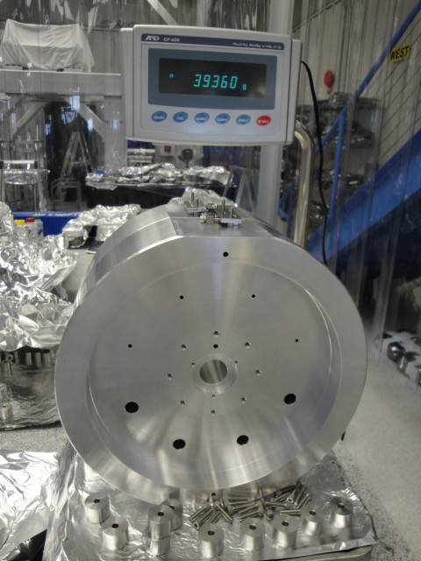
Figure 1 Main Chain Dummy Test Mass (D060355)

Dummy main chain penultimate mass (D0902075)

Step | What | Where | Time | People | Tools
 | Prior to assembly, this mass (D060358) can be processed as CLASS B, as it will be swapped with a glass mass.
 | Assemble all masses as per their assembly drawings. Assemble each mass with the addable masses such that each has the appropriate weight.

Dummy CP or ERM (D060356)
ERM stands for End Reaction Mass (chosen to avoid confusion with Recycling Mirror), which is also known as Re Test Mass. Note that due to abandonment of a plan to have an ERM of heavy glass, the production dummy ERMs are identical to the dummy CPs and lighter (approximately 22 kg) than the dummy ERM used in the all-metal build of the LASTI prototype (approximately 40 kg).
Prior to assembly, this mass (D060357) can be processed as CLASS B, as it will be swapped with a glass mass. Assemble all masses as per their assembly drawings. Assemble each mass with the addable masses such that each has the appropriate weight.

Penultimate Reaction Mass for CP or ERM (D060341)
This mass is also known as Pen Re. Just as all CPs and ERMs are now identical (see note in previous section), so are all the penultimate reaction masses. This mass needs to be cleaned to CLASS A because it is not a dummy and will be installed in vacuum.
Note: Isopropanol should be used to help insert the Cans into the mass.

Ring heater
ITM configuration only.

Wire assemblies
Follow the safety instructions below in Section 4.10 and detailed in T1000674
Follow the procedure in Section 4.10 for each assembly, taking account of the general notes immediately below, and the per-assembly-type notes in Sections 4.7 through 4.9.
Pay attention to the exploded views in the D060516 wire assembly drawings – these show when to use what grooves in the jaws.
Take care to not over stress or bend the wires when releasing the wire sets from the jig. Also take care when storing. Wire sets should be stored in dry storage along with the spools of wire.
When setting up the wire in the jig, note that it should never bend around any fixture pieces except for at the clamp and the tuners. If the wire bends around any of the fixture, then recheck the fixture setup.

Top wires (D0902643)
There are 2 grooves in the D060334 jaws, but only one groove will be used for the Top Wire assembly. Use ~1” segments of wire inserted into the empty wire groove in each clamp.
Use the groove that is more centrally located in the wire clamp assembly to mount the wire. Use the outer groove for the “dummy” wire.

Middle wires (D0902644)
Note in the drawings which grooves to use in the clamps of this assembly. Some are used, some are not.

Bottom/Final wires (D0902645)
This is a compound assembly which includes the UIM-PM wires and the loop supporting the TM/CP/ERM.

General clamp-wire-clamp assembly procedure

Step | What | Where | Time | People | Tools
 | Class B the wire jig assembly. Helicoil the assembly. | VPW | 2 days | 1
 | Using the Wire Jig assembly drawings as a guide, set up the jig fixture for the wire segment you will be assembling. There are 4 segments of wire assemblies to assemble for every QUAD. The jig can be reconfigured for each of these segment lengths. Note: Use gauge blocks of the thickness listed on the assembly drawings to set the jig fixture pieces the appropriate distance apart, and square relative to each other. | Lab | 20 min.
 | The wire used for all suspensions is a hard temper carbon steel. It is wound around spools, and when unwound for cleaning, cutting and preparation for clamp-wire-clamp assembly, care must be taken such that the wire’s strong potential energy (making it act like a coiled spring) does not cause injury to personnel.
 | - Safety glasses must be worn during all wire work. Safety glasses are provided in the garbing areas and in all clean rooms.  - Glove liners should be worn under latex clean-room gloves, as a protective layer and an extra barrier. For information on glove liners, see the Contamination Control Plan, E0900047, page 13.  - Take the end of the wire and bend a small section, say 3” or so, for easier holding. The bent wire section can be hooked around your thumb, and held by your index finger.  - Un-spool the proper length of wire, including extra for handling, and control the area of the wire that needs to be cut. Add a bend at the other end, if handling it that way is easier for you.  - Inspect length of wire for rust. If rust is found, discard wire and obtain a new length of wire.  - Clean the end with the first bend. Change your gloves and grab the cleaned, bent end around your thumb.  - Prepare the cleaning wipes with methanol. Wipe wire clean with methanol changing wipes until the wire is completely clean. Clean the wire while it is coiled; do not stretch the wire until it is taut for cleaning. It can be laid down on a clean surface during this process. Clean a section at a time.  - Transfer the wire to the wire jig. Use the wire jig clamps to hold down the wire. Cut the bent ends off and remove, after the wire is secured. |  | 5 min. | 1
 | Take care to secure the free ends tightly in the outer fixture jaws and the guitar tuner.
 | Snug up the “real” wire clamps such that the wire is free to slide through them, but does not chatter when the wire is strummed during the following tuning steps. |  | 10 min | 1
 | Setup an oscilloscope (such as Tektronix TDS 2012B) to trigger on the peak of the frequency specified in the assembly drawings for the segment you are working on. |  | 15 min | 1
 | Set cursors at +/-2Hz from the specified frequency.
 | Hook the guitar pickup BNC to the scope.
 | Place the guitar pickup on the jig just under the wire such that it will be able to pick up the sound of the wire when strummed.
 | Strum the wire like you would on a guitar, to see the frequency peak on the scope. Tension the wire by turning the guitar tuner until the peak is centered between the cursors on the scope.
 | Tighten the QUAD wire clamps and check that the frequency peak has not moved out of the cursor range. If it has, loosen the clamps slightly and retune by adjusting the tension. This might take a few iterations. |  | 10 min | 1
 | Remove wire from jig by first loosening the guitar tuners, and the fixture jaws. Take care not to induce any stretching in the wire segment when removing it from the fixture.
 | Repeat wire assembly steps above for each segment length necessary for the full QUAD assembly.
 | Assign each wire assembly a unique serial number and record final resonance frequencies for each in the ICS/PT.
 | Store as CLASS A in dry storage until ready for installation into a full QUAD Assembly. |  | 10 min. | 1

Magnets
Make Gauss measurements on all magnets and upload to the DCC as per M0900034. Use appropriate magnets in appropriate sub assemblies as per M0900034.

Flags

Step | What | Where | Time | People | Tools
 | Insert and glue the steel disks (D070238) into the magnet holder (D070235).
 | Cure the steel disk and magnet holder assembly as per E960022.
 | Scribe the faces of the steel disks and the magnet holder as shown below in figure 2.
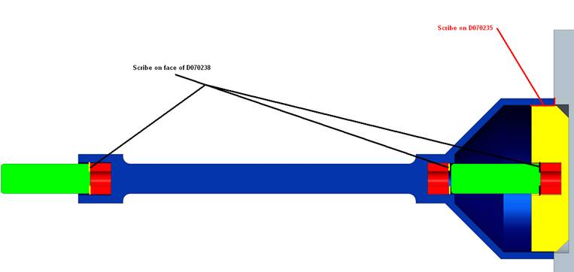
Figure 2 Penultimate Mass Magnet & Flag Holder Assembly (D080580)

Earthquake Stops
Assemble Flourel EQ Stops as per T1000377.
Note: Venting of the Flourel was a step added after the initial document was created.

OSEMs
Assemble AOSEMs as per E0900168. BOSEMs should be delivered by Birmingham, fully assembled and ready for Class A use.
Note: 316sst fasteners need to be used in some OSEM applications, see RODA M1000312.

Top Stage Blade Cartridges

Step | What | Where | Time | People | Tools
 | Assemble the Top Stage Blade Cartridge Tooling as per D060370. Clamp tooling to optical table.
 | Choose blades which are a matched sets with the appropriate Blade Clamps D060326 and D060327. See T1000068 for sets of blades and clamps with corresponding serial numbers.
Assemble 4 cartridges as per assembly picture book D060370. Note that 3 of the cartridges will have a D060329 Backbone and 1 will have a D0901439 Backbones.
It is important to align all holes in the clamps and blades the first time they are stacked together. Misalignments will mean that screws inserted later in the assy will not mate well.
 | Perform Creak bake on all Top Stage Blade cartridges at 120 deg C for 100 hours, as per T040108.
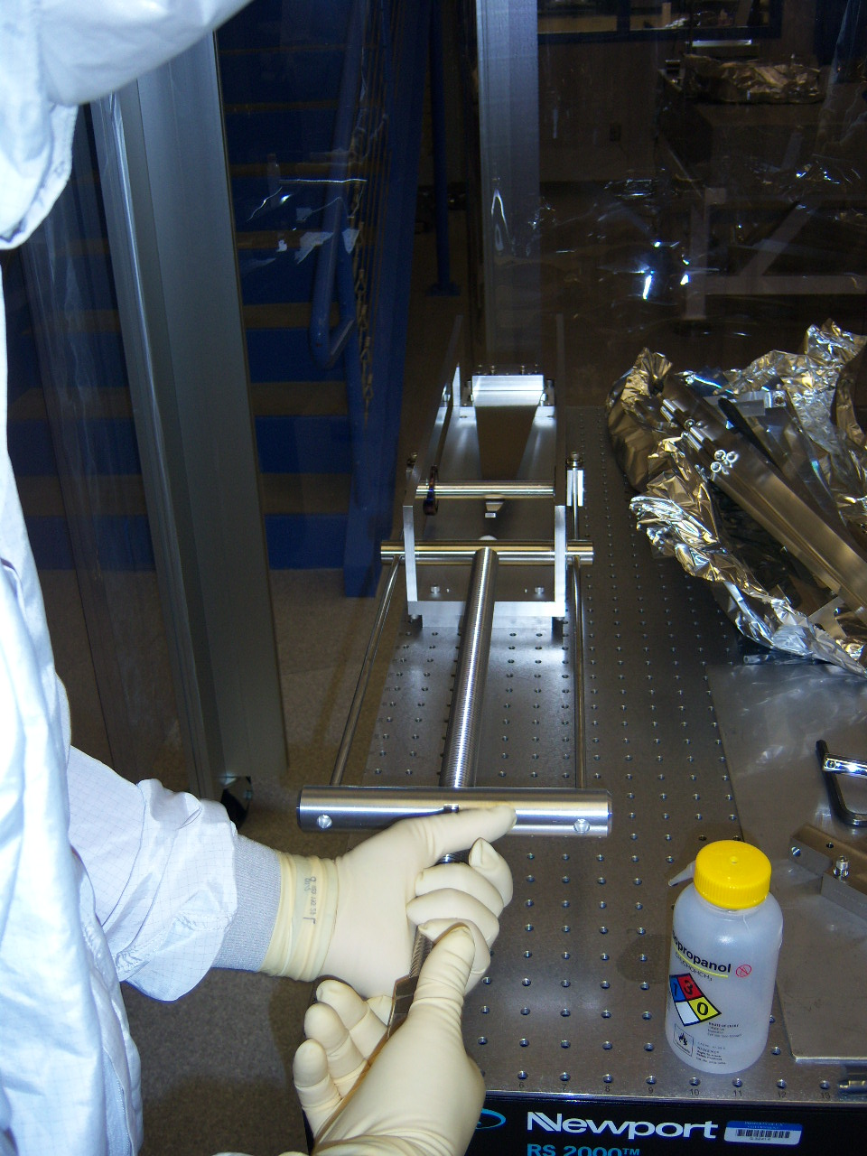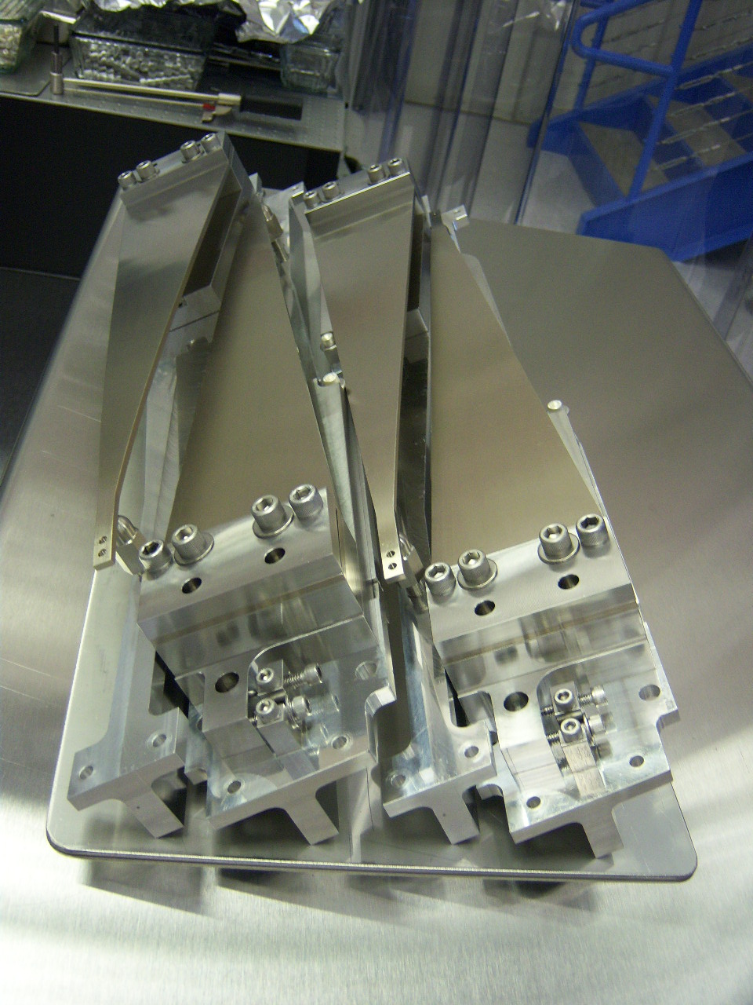
Figure 3 TS Blade Tooling D060370 Figure 4 TS Blade Cartridge Assembly D060324

Top mass
In general, the more carefully each assembly and alignment step is done, the easier later steps will become. For example, the more accurately the blade springs were installed during assembly, the easier it will be to balance pitch.

Step | What | Where | Time | People | Tools
 | Insert helicoil repair in all D060430 top plates. (Not in picture book.) |  |  |  | Standard Class B Tool Kit
 | Choose Middle Blades (D060236) which have been characterized as a set of 4 (2 for test chain and 2 for reaction chain) designated in T1000068.
 | Assemble one Top Mass as per the D060403 picture book, and one Reaction Top Mass as per the picture book D0902031 stopping at page 15. |  |  | 2 | Weight set for blade straightening
 | Perform Creak Bake on Top Masses in air at 120 deg C for 100 hours as per T040108.
 | Choose OSEMs which are matched to TBD.
 | Complete assembly of the Top Mass and Reaction Top Mass as per the picture books.  Notes:  Take care when pressing the steel disks into the aluminum ECD and flag holders, as the aluminum can be easily bent.  Handle magnets carefully as they are very strong and some are brittle. As well, be careful with tools in proximity to the magnets as many tools in the kits are magnetic.  Torque all fasteners as per the assembly picture book. |  |  | 2 | Clean Press  Standard Class B Tool Kit
 | Weigh the assembly. Add or remove Addable Mass symmetrically to the assembly until the unit weighs 22kg +/- 10g.
Store the sub assemblies until you are ready to install them into a QUAD.
Notes:
1) Magnets should be removed from assembly and stored with the unit separately.

UI Mass
In general, the more carefully each assembly and alignment step is done, the easier later steps will become. For example, the more accurately the blade springs were installed during assembly, the easier it will be to balance pitch.

Step | What | Where | Time | People | Tools
 | Choose Bottom Blades (D060237) which have been characterized as a set of 4 (2 for test chain and 2 for reaction chain) designated in T1000068.
 | Assemble one UIM and one Reaction UIM as per the picture book D060375 stopping at page 9. |  |  | 2 | Weight set for blade straightening
 | Perform Creak Bake on UIMs in air at 120 deg C for 100 hours as per T040108.
 | Select a set of OSEMs. Use one “characterized” BOSEM in each suspension.
 | Complete assembly of the UIM and Reaction UIM as per the picture book.  Notes:  Take care when pressing the steel disks into the aluminum ECD and flag holders, as the aluminum can be easily bent.  Handle magnets carefully as they are very strong and some are brittle. As well, be careful with tools in proximity to the magnets as many tools in the kits are magnetic.  The Blade ECD magnet is not tall enough to extend into the copper ECD shaft. Stack 2 magnets on the blade, such that the top magnet fits into shaft.  Torque all fasteners as per the assembly picture book. |  |  | 2 | Clean Press  Standard Class B Tool Kit
 | Weigh the assembly. Add or remove Addable Mass symmetrically to the assembly until the unit weighs 22kg +/- 10g.
Store the sub assemblies until you are ready to install them into a QUAD.
Notes:
1) Magnets should be removed from assembly and stored with the unit separately.
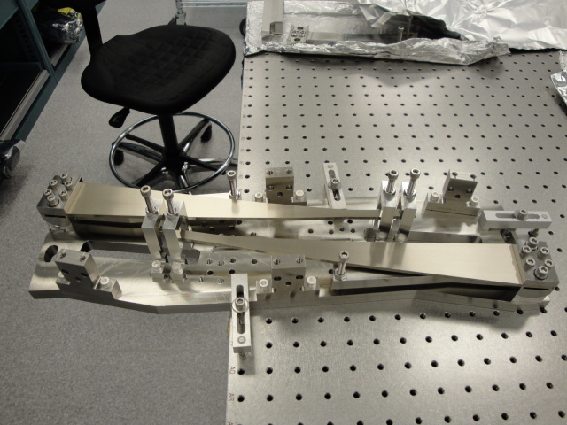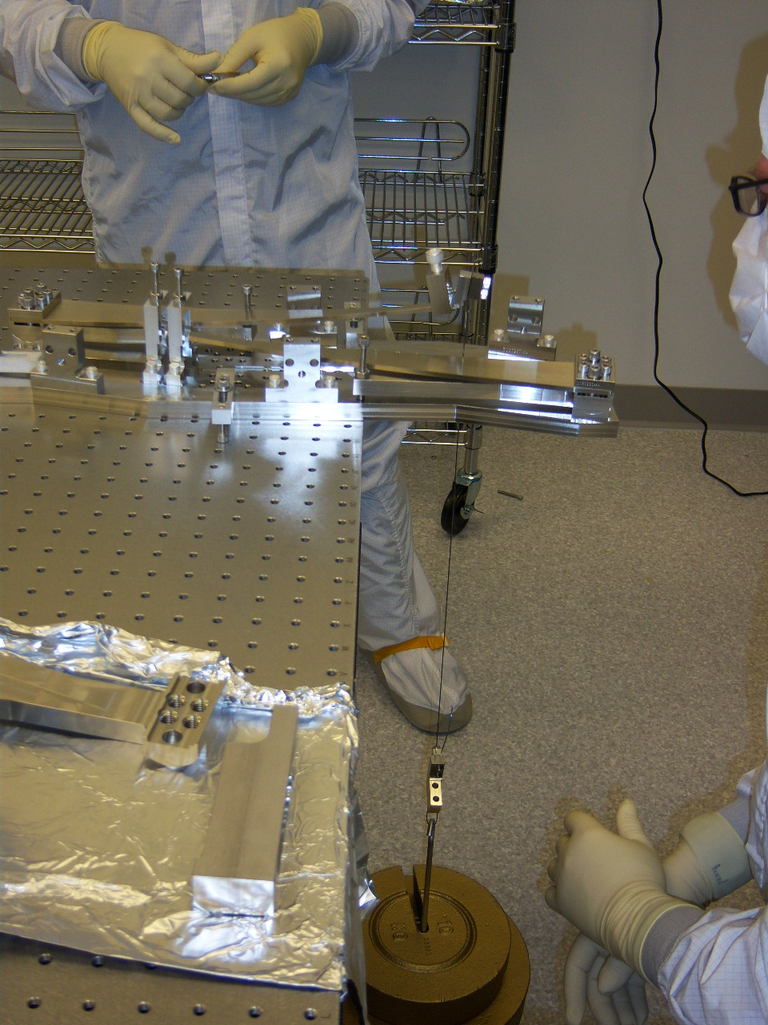
Figure 5 Caption Figure 6 Caption

Lower structure

Step | What | Where | Time | People | Tools
Assemble all EQ stop Brackets.
Note: The callout on some of the drawings which specify that the PFA440 bushings need to be reamed out after assembly into the Aluminum bracket. A Class B reamer (such as McM-Carr 8851A23) will be needed for this step. The reamer will be used clean, and can be done by hand. Work in an area where the particulate can be removed easily and completely from the cleanroom.

Sleeve
Ensure by trial fit that the upper and lower structure correctly interface to the sleeve. Matching of serial numbers between the sleeve and upper structure is unnecessary – the structures are interchangeable with each other.

Main assembly

Step | What | Where | Time | People | Tools
 | Download the quad traveler template, F1000008 (a Microsoft Excel spreadsheet), start a new copy under a new DCC number and title as described in the instructions sheet of the template.
 | Record the new traveler DCC number in the Related Documents field of E0900371 [and in the inventory control system in the record for the suspension being assembled].
 | In the steps below, record the called-for data in the traveler spreadsheet. After each work session, resubmit the updated traveler to the DCC as a new version.

Top stage and Upper Structure

Step | What | Where | Time | People | Tools
 | Install empty upper structure on the gazebo/Test Stand, attach with as many as possible: 16 dog clamps, 4 per side, with 2 per corner, are desirable. (Breadboard surface of Test Stand should be level to +/- XXX.)
 | Install all four top stage blade units in place. Check the tips are central, and the location holes align.
 | Ensure all blade tips are held well down with blade stops. Target is that the tips are 2mm below nominal (108mm from the optic table to the blade top).

Tablecloth and top mass

Step | What | Where | Time | People | Tools
 | Lie two ~36mm cross bars across the lower structure bottom ring and rest the two top masses approximately in place (the upper structure removable braces work well)
 | Optional step which replaces step 11: With plenty of slack, attach the wire clamps to the Top Stages and the Top Masses (note – the wire clamps can be attached to the Top Masses while still on the bench for ease).
 | Assemble the tablecloth side plates in place with no OSEMs/ECD assemblies. Install all the dowels to locate it nominally WRT to the structure. Adjust the plates until the dowel hole pins line up.
 | With the stops raise the top masses into place. Position nominally in x and y using dowels and approximately 10mm too high in z (do this by inserting the stops too far).
 | Connect the top two masses to the top stage, bolting the top wire clamps to the top blade tips and the top mass. The top plate of the top masses can be removed to make this easier.
 | Lower top two masses to nominal position - note the top stage blade tips may need to be pushed down for this.

Lower structure

LSAT

Step | What | Where | Time | People | Tools
 | Assemble both halves of the lower structure assembly tooling side by side on either the floor or a low table. Note when viewed from above they should look something like: ┌┐└┘ ideally with the rear of the penultimate mass easily accessible.
 | Install the respective halves of the lower structure into the tooling.

Reaction chain
Note the test and reaction chains are subtly different approaches, either is acceptable, the only reason they are different is that they are more-representative of the glass procedure.
Step | What | Where | Time | People | Tools
Add the reaction UI mass into place onto stops which are retracted such that the tips are ~10mm above the UIM bracket. This will allow slack to clamp the wires on later.
Note: OSEMS should be in place.
 | Add the Penultimate reaction mass in to a position in its nominal position WRT lower structure (on fixed PFA440HP pads); set roll (approximately) Note: OSEMS should be present and in the approximately correct position.
 | Add the reaction test mass; approximately set roll by eye.
 | Add the UIM-PenRe-TestRe wire assemblies to both sides. Roll test mass and Pen mass as required.
 | Lower test reaction mass to its nominal position.
 | Raise the UI mass to its nominal position on the vertical stops taking care to keep it horizontal.
 | Raise the UI mass further to lift the PenRe mass and remove the PFA440HP pads below the PenRe mass. Lower the UI mass to get the PenRe mass back into its original position.
 | Remove the stops from below the test mass to ensure everything hangs stable and with no gross pitch.
 | Lock all three masses in their nominal positions (leaving the wires all in tension).
 | Install magnets on Top Mass – see T080165.

Main chain

Step | What | Where | Time | People | Tools
 | Add the test UIM into place on partially retracted vertical stops 10mm below nominal.
 | Rough level the UIM with the vertical stops.
 | Add the Penultimate test mass in its nominal position WRT lower structure, with magnets omitted, onto the fixed PFA440HP pads. Set roll by eye.
 | Add the Test Mass into the LS. Set roll by eye.
Attach the Bottom-Final wire assemblies to all 3 masses, note the UIM blade tips and masses may need to be worked down to make room for the wire clamp.
The outer blade tip stop in the bridge will need to be retracted in order to bolt the wire clamp onto the tip. Replace the tip stop when clamp is attached.

 | Lower TM stops such that mass is hanging. Check that it is about nominally positioned in LS.
 | Raise the UI mass to its nominal position (line up the EQ stop holes on the D070548 plate with the UIM holes) on the vertical stops taking care to keep it horizontal.
 | Relevel UIM on the vertical stops.
 | Slightly raise the UIM mass allowing the Penultimate mass to raise and remove its PFA440HP pads (upper stops need to be retracted). Lower the UIM to its nominal along with penultimate mass suspending it.
 | Check that the PM is hanging – if not, check wire lengths and positions of TM and UIM again. Care should be taken that no unexpected pitches occur, although it is unlikely.
Check and adjust if needed the 5mm lateral and 12mm height positions of the UIM blade tips WRT the bridge.
If there is an error in the 12mm height, it is better to have the blade tips low than high.
 | Clamp all blades via blade stops such that blades are stored flat until installation.
 | All masses can now be locked in place. The simplest thing to do is to lock them in their nominal positions. A more representative thing to do is to raise the test mass 8mm as it will be when there is glass. For now nominal positions are recommended.

Quad Structure Prep Prior to Glass Install

Step | What | Where | Time | People | Tools
 | Assemble wire loops for main Penultimate and Reaction CP
 | Check for rust
 | Check for wire slippage
 | Clean suspension
 | Perform Testing Procedure E1000494
 | Switch in Silica Tipped Flourel EQ Stops
 | Install Ring Heater Assembly and route cables
 | Install ESD cables where appropriate and route cables

Glass Preparation
See Monolithic Documentation XXX for test mass bonding, etc.

CP electrical connections

Step | What | Where | Time | People | Tools
 | Check the electrical continuity of the ESD cables. (The cables are extremely prone to failure at the end where the gold connectors have been crimped on.) |  | 1 day for all steps |  | ohmmeter
 | Take the CP out of its case, remove the face-plate from the ESD side, and lay it with the ESD side up in a clean room. [It was very difficult to remove the face plates because they were quite tight and there were no vent grooves in them.]
 | Carefully wipe the face and sides of the optic with lint-free wipes moistened with methanol [acetone?] to remove dust and dirt. |  |  |  | methanol [??acetone], wipes
 | Cut gold tabs to appropriate size: width about the same as the traces in the ESD mask, length sufficient to protrude about 5 mm off the edge of the optic. (This will be different for different traces.) [Brett: 5 mm turned out to be too much given the narrow clearance between the CP and the structure – it should be more like 2-3 mm.) |  |  |  | tabs
 | Crimp a furrow across the end of the gold tab which will be used to support the coax cable at a later step. |  |  |  | pliers
 | Set up a bottle of clean, dry nitrogen with a regulator and nozzles to direct a flow of nitrogen across the work area. |  |  |  | N2 bottle, regulator, nozzles
 | Repeat the next few steps for each tab to be soldered:
 | Point the nozzles at the end of the ESD trace that the tab is to be attached to.
 | Place a small bead of indium on the end of the trace, lay the flat end of the tab on top and cover with an aluminum button. |  |  |  | indium solder, Al button
 | Press a soldering iron heated to 600 degrees F onto the button and keep it there until 10 seconds after the indium melts. The button will visibly sag when the solder melts. Remove the button and inspect the joint. Too much heat can damage the pattern, so do not keep the iron there longer than necessary. |  |  |  | soldering iron, button
 | Remove a length of shield approximately 1.5” long from the end of the coax, exposing the (very delicate) central conductor and inner insulation. |  |  |  | wire stripper
 | Carefully strip the inner insulation exposing 2 to 3 mm of the central conductor. |  |  |  | wire stripper
 | Lay the end of the intact section of shield into the groove in the tab and roll the end of the tab over so that the shield is gripped. |  |  |  | pliers
 | Carefully bend the inner conductor around towards the body of the tab and solder it there, using the same procedure as for the tab. Maintain slight pressure on the tab at all times so that it does not move if it the solder behind it should melt. |  |  |  | soldering iron, solder, button
 | Test the electrical continuity from the pattern to the end of the cable. |  |  |  | ohmmeter

Using the triple-hang tooling

Step | What | Where | Time | People | Tools
 | Assemble the Triple Hang Tooling (D060321) as Class B. This involves making up 2 single wire lengths with Top wire d=1.1mm using the wire clamps provided with the tooling. The wire lengths need to be 160mm between clamps. Use a ruler to set these lengths. Use Spare Middle Blades for this tooling.
 | Start with main or reaction chain lower structure with all masses and wires in place, with the UIM approximately 4 mm high of nominal on its stops, and with UIM blades overloaded by 5 mm.
 | Check UIM is level and if not, adjust earthquake stops till it is. |  | 5 min | 2 | bubble level
 | Retract upper earthquake stops on bottom mass. |  | 5 min | 2 | hex keys
 | Screw in lifting screws on lower earthquake stops a tiny amount to ease weight on pad spacers. |  | 2 min | 2 | hex keys
 | Remove pad spacers. |  | 1 min | 2
 | Retract lifting screws on lower earthquake stops until optic is suspended. |  | 5 min | 2 | hex keys
 | Check that optic is level relative to structure by eye – debug if not. |  | 1 min++ | 2
 | Retract upper earthquake stops on PM. |  | 5 min | 2 | hex keys
 | Retract overload screws on UIM blades, monitoring lower masses. If blade strength is matched to payload, PM should be about 4 mm off lower stops (same as UIM was high to begin with). |  | 5 min | 2 | hex keys
 | Place 12 mm slip gauge on top of each UIM blade in turn and adjust blade height until top of slip gauge is level with reference notch in upright of UIM blade stop bridge (D060399). |  | 5 min | 2 | slip gauge
 | Check that PM is level relative to structure by eye – debug if not. |  | 1 min++ | 2
 | On reaction chain, remove pitch adjuster, remove cable clamp, refit pitch adjuster. |  | 10 min | 2 | hex keys
 | Fit wire assemblies from triple-hang tooling to UIM. |  | 5 min | 2 | hex keys
 | Fit triple-hang tooling spacer blocks to top of lower structure. |  | 5 min | 2 | hex keys
 | Fit triple-hang tooling top plate to spacer blocks. |  | 5 min | 2 | hex keys
 | Connect wire assemblies to blades on triple hang tooling. |  | 5 min | 2 | hex keys
 | Release the overload screws on triple-hang tooling. |  | 2 min | 2 | hex keys
 | Check that all three masses are level relative to structure by eye – debug if not. |  | 1 min++ | 2
 | Reapply the overload screws on triple-hang tooling until tension is off wire assemblies. |  | 5 min | 2 | hex keys
 | Disconnect wire assemblies at blades triple-hang tooling. |  | 5 min | 2 | hex keys
 | Remove triple-hang tooling top plate and spacer blocks. |  | 5 min | 2 | hex keys
 | Disconnect wire assemblies at UIM. |  | 5 min | 2 | hex keys
 | On reaction chain, remove pitch adjuster, fit cable clamp, and replace pitch adjuster. |  | 10 min | 2 | hex keys
 | Repeat with other chain.
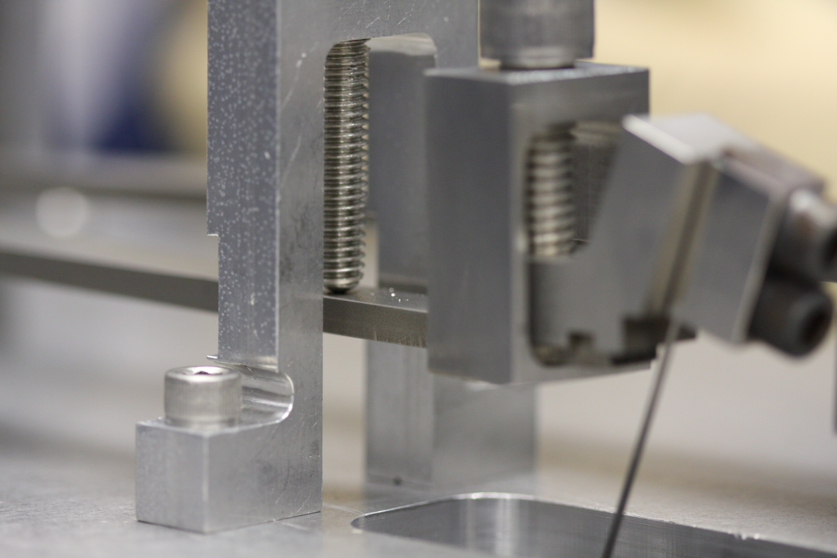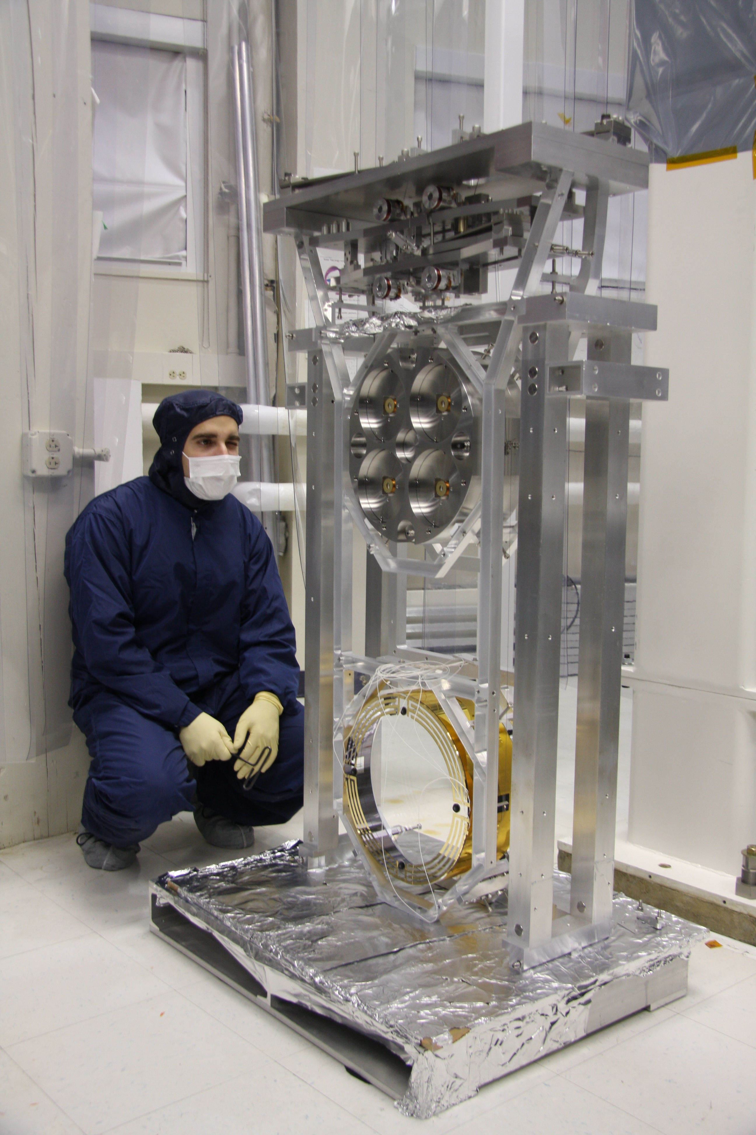
Figure 7 Caption Figure 8 Caption

Lower structure wrap-up

Step | What | Where | Time | People | Tools
 | Ensure all 6 masses are in their nominal positions and are secured with stops that are wrench (not finger) tightened.
 | Use the genie to manipulate the two structures so that they are face to face. This may involve moving one or both of them.
 | Bolt two halves of the lower structure together, also bolt the two halves of the lower structure assembly tooling together with the connection plates (4 off)
 | Unlock test and penultimate masses in both chains and verify that the penultimate masses are parallel, and that the test reaction mass is hanging at the correct angle. Also verify that there is no differential yaw in each chain. Correct if required (locking the round masses, releasing the UIM masses and manipulating them is the recommended method).

3-in-1 assembly

Step | What | Where | Time | People | Tools
 | Lift lower structure and tooling on to the 5 axis table, ensure that is correctly centered, and that the table will go low enough that the lower structure will fit under the upper, bolt down with dog clamps (8 min).
 | Wheel trolley and lower structure under upper structure on gazebo.
 | Raise lower structure as far as it will go (~28mm above nominal), so that the legs of the lower structure pushes up against the upper structure, note the lower structure must be correctly orientated, (test mass on test chain side).
 | Use the slack in the UI wires to connect them to the top masses. Note that the top masses are in their nominal positions WRT the upper structure and the UI masses are in their nominal position WRT the lower structure. If necessary lower the blades on top mass using the stops in order to allow the wires to be connected.
 | Let down the Lower structure into its nominal position, (28mm gap)
 | Insert implementation shim and connect lower and upper structures, 8 bolts.

Suspending
In general, the more carefully each assembly and alignment step is done, the easier later steps will become. For example, the more accurately the blade springs were installed during assembly, the easier it will be to balance pitch. The more precisely pitch is balanced on the first time through the alignment procedure, the fewer iterations will be needed to align all OSEMs, ECDs, and ESD.
While making adjustments on the quad make sure to watch out for touching stops and for interferences between the chains at every step. In particular the top masses have tight clearance around the blade spring clamp bolts. These bolts tend to get caught under the top plate of the opposing top mass if pitch and roll are not carefully aligned. There is nothing worse than spending an hour making adjustments only to discover that it was all for naught because a screw you did not see was touching one of the masses.
Remember that the blade springs magnify the tilts of the masses below them because their compliance allows for differential tilt between the masses.
Pitch is likely to cause a lot of trouble if the blade spring alignment within the rectangular masses is off. Pitch specifically is sensitive to errors in the blade assembly because any lateral misalignment of the blade tips away from the center of mass at each stage will generate a torque that will introduce a differential pitch between that stage and the one above it. If this problem is too extreme, it will be impossible to meet all the constraints of the OSEMs and test masses simultaneously, and the springs will need to be repositioned. Each blade tip should have exactly 5 mm of clearance on either side. Intolerable errors are on the order of a few tenths of a mm. More details on the spring positioning are in the procedure below.

Step | What | Where | Time | People | Tools
 | Ensure reaction top mass is horizontal and in its correct position.
 | Release test reaction mass and then pen re mass, check the blade tips are still at the correct height in the UI reaction mass and then release the UI reaction mass.
 | Release test mass and then pen test mass, check the blade tips are still at the correct height in the UI test mass and then release the UI test mass. There should now be two triples suspended side by side.
 | Retract the blade stops in the top reaction mass and check the tip heights are correct.
 | Retract the blade stops in the top test mass and check the tip heights are correct.
 | Retract top stage blade stops.
 | Carefully retract the stops on the top test mass, only retract them a little at a time and watch for pitch at all times. If the suspension appears stable and un-pitched then it is likely the blade tip stops are holding one of the blade tips down.
 | Refer to Section [?? insert cross-reference] [?? there was no Appendix A in T060040-v1!] on fixing problems.
 | As Step [?? insert cross-reference] but for the reaction mass.

Final assembly

Step | What | Where | Time | People | Tools
Balance and align the quad to the point where both chains are at the correct height and are correctly pitched, and yawed.
Note: alignment of the OSEMs will affect the pitch.
 | Add the front and back plates to the tablecloth omitting the ECD and OSEM mounts.
 | Add sleeve before cartridge installation. Use wedges (TBD).

Storage
Using the D1001222 and D1001223 Modified LSAT Top Plates hang the LS from the Installation Genie. Set the Top Plates (and LS) into the LS QUAD Storage Container. Use the end caps on the shelves in the storage box to clamp the LS down to the box. Remove the Genie. (The Top Plates stay with the LS until the cartridge install.)

Tools
Ian’s list
Test stand: | Mechanical Test Stand mounted with Solid Stack Assembly
Manual fork truck: | Similar to Caltech Genie
Bench: | May be an optics bench but this is not mandatory
Tools: | All the appropriate hand tools and measuring devices
Masses: | These will be necessary to load blades flat.
Lower structure assembly tooling:
Wire jig:

Brett’s list
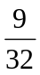 inch nut driver or wrench for axial OSEM positioning.
 inch nut driver or wrench for lateral OSEM positioning.
, , , and  inch allen wrenches.
A flat head screw driver for turning the top mass pitch adjusters.
Torque wrench for the blade clamp bolts capable of 400 in-lb (33 ft-lbs, 45 Nm).
Slip or block gauges for measuring 5 mm, 6.6 mm, and 12 mm gaps.
Dentist Mirror.
Flashlight or small lamp.
Structure pushers for rotating the structure on the optical table (see Figure 14).
5 axis table for safety while rotating the structure.
Lower structure tooling for use with the 5 axis table.
Safety goggles for working around the wires.
An optical alignment tool with 10 Rad accuracy, such as an autocollimator.
A small, light, reliable level to place on suspended masses (optional).

Useful procedures

Aligning the Brunson transit

Step | What | Where | Time | People | Tools
 | Set up the Brunson about 10’-15’ from the structure, with the telescope at very roughly the height of the mass to be clocked. If you get too close you won’t be able to see both ears/prisms/clamps and if you get too far away, the ears will be too small in the viewfinder to have their height read accurately. If there is a very large difference in height then you need to be careful that the structure is facing the telescope accurately (so that the ears/prisms/clamps are the same distance away), but this is not at all critical. Midway in height between the bottom mass and the penultimate mass is probably good enough, and gets you two clockings for the one setup. |  | 30 min | 2
 | Make sure the lock on the vertical height adjustment is tight and that upper mechanism is firm against moderate horizontal pressure. |  | 5 min | 1 | wrench: ¾” open-ended
 | Level the upper section as accurately as possible using the circular bubble level in the base of the rotating section. |  | 5 min | 1
 | Turn the telescope pitch adjustment screw until it is roughly in the middle of its range. |  | 1 min | 1
 | Unlock the telescope pitch clamp screw, roughly level the barrel of the telescope, and relock the clamp screw. |  | 1 min | 1
 | Using the pitch adjustment screw, level the telescope as accurately as possible looking by eye at the barrel. |  | 1 min | 1
 | Pick an opposing pair of the brass leveling discs in the leveling section and rotate the upper section until telescope is parallel with the line between the discs. |  | 1 min | 1
 | Rotate the prism in the knurled housing near the top bubble level so that the aperture is at right angles to the telescope. |  | 1 min | 1
 | Look into the prism aperture and adjust the long mirror to reflect the most ambient light into the side of the bubble level as indicated by the brightest view in the prism. |  | 1 min | 1
 | Adjust the pitch adjustment screw until both ends of the bubble can be seen in the prism and are aligned with each other. |  | 1 min | 1
 | Rotate the telescope by 180°, and then rotate the prism by a further 180° to bring the aperture back to the original direction. Readjust the long mirror if necessary. |  | 1 min | 1
 | Grip the telescope pitch adjustment screw knob and note its position. Keep careful track of the amount of adjustment required in the next step, either by keeping a grip on the knob (if the amount is not too great), or counting the number of quarter turns of adjustment. |  | 1 min | 1
 | Adjust the pitch adjustment screw until both ends of the bubble are aligned in the prism. |  | 1 min | 1
 | Back the pitch adjustment screw off to a point as near as possible to halfway between the initial and final positions. |  | 1 min | 1
 | Redo the second half of the leveling using the two brass discs identified earlier, rotating them in opposite directions, so as to tighten one as the other is loosened. |  | 1 min | 1
 | Rotate the telescope another 180° and readjust the prism and long mirror. Hopefully the ends of the bubble will be very nearly aligned. Repeat the previous six steps until convergence is achieved. |  | 5 min | 1
 | Rotate the telescope by 90° to align with the other pair of brass discs and repeat the previous seven steps. |  | 15 min | 1
 | Rotate the telescope back to the line of the first pair of brass disks and check that the alignment in that direction has not been disturbed. |  | 10 min | 1

Using the ergo-arm

Step | What | Where | Time | People | Tools
 | Connect ergo-arm reservoir to vacuum pump with hose. [According to Mike Gerfen, the hose should be permanently band-clamped to the reservoir, with the quick release fitting at other end connecting alternately to pump and suction plate. We were doing this backwards, and the following procedure has been revised to reflect what we should have done.] |  | 5 min | 1 | reservoir with hose, pump
 | Start pump, open valve at reservoir, evacuate reservoir to 30 psi, close valve, stop pump, disconnect hose. |  | 1 min | 1 | reservoir with hose pump
 | Connect hose to ergo-arm suction plate. |  | 1 min | 1
 | Close valve at suction plate, open valve at reservoir, monitor reservoir gauge for short time (e.g., 1 min) to check for stable pressure (i.e., no leaks in hose or connections). |  | 2 min | 1
 | Bring suction plate near to mass and use horizontal, vertical, pitch and yaw DOFs to match position and angle. |  | 5 min | 4
 | Hold suction plate firmly against mass and open valve at plate. |  | 1 min | 4
 | Check that good suction has been achieved (reservoir pressure should still be around 23 psi). If the alignment was poor there will likely be no vacuum at all, in which case, repeat from the beginning, being more careful in Step 5. |  | 1 min | 1
 | Close the valve at the suction plate, and then the valve at the reservoir. (The suction plate has a very slight leak and a small volume, so closing it requires constant attention to the pressure at the suction plate. If it drops it can be topped up by opening both valves momentarily. But if both valves are open and someone trips over the reservoir and pulls the hose off one of the connectors it’s an instant catastrophe.) |  | 1 min | 1
 | Raise mass, checking pressures at suction plate and reservoir regularly, and keeping a hand on the crank handle at all times. |  | 1 min | 4

END OF MAIN PROCEDURE

Stuff from T080165-00 (Brett’s balancing procedure) for plagiarizing
1 Related Documents

Numbers cited throughout this document refer to these documents.
1. Noise prototype Assembly procedure - T060040-05
URL:
http://www.eng-external.rl.ac.uk/advligo/Reviews/FRR/Documents/t060040-06.doc
Description:
This is the assembly procedure from RAL which should at this point be completed before balancing and alignment is to begin.
2. Quad Suspension Balancing and Alignment Procedure (UK Document)
URL:
http://www.eng-external.rl.ac.uk/advligo/Reviews/FRR/Documents/Quad suspension Balancing and Alignment procedure.doc
Description:
This document is the precursor to this updated procedure. It is a valuable reference since it contains additional details on how all the adjustments work and ideas on how to trouble shoot. This update should be considered a continuation, not a replacement.
3. Useful Data for Noise Prototype Quad Assembly (UK Document)
URL:
http://www.eng-external.rl.ac.uk/advligo/documents/Useful data for Noise Prototype Quad assembly.pdf
Description:
This document contains useful information about basic aspects of the quad such as weights, wire lengths and diameters, a description of how the blade tip positions are determined, and suspension stability.
4. Alignment Requirements for Quad - T080128-00-K
Description:
All the final alignment requirements for the quad are listed here.
5. AdvLIGO Quad Suspension Controls Prototype Suspension and Adjustment Method - T060039-00
Description:
This is the assembly and alignment procedure written for the quad controls prototype. Although the controls prototype clearly has some differences, many of the principles of aligning a quad are the same. As a result, this document is still a valuable reference of experience gained during the prototyping phases of the quad.
6. Holo-Krome Bolt Torque Data Sheet
URL:
http://www.holo-krome.com/pdf/techbk34-40.pdf
Description: This data sheet provides recommended bolt torque values from Holo-Krome.
7. Quad Pendulum Structure Pushers - T080230-00-0
Description:
This document provides additional detail on the use of the quad pendulum structure pushers used to align the quad structure on the seismic table.

Applying/removing First Contact

Applying

Step | What | Where | Time | People | Tools
 | See E070292-00. |  | 3 hours | 1 | See E070292-00.

Removing

Step | What | Where | Time | People | Tools
 | Carefully shave the entire bevel with a sharp single-sided razor blade to remove traces of First Contact that may have spilled there off the face. |  | 5 min | 1 | razor blade
 | With the edge of the razor blade leading, scrape from the bevel toward the face to prise up a corner of the First Contact on the face. The corner between the straight and curved sections is a particularly good place to start. |  | 1 min | 1 | razor blade
 | Grab the prised-up corner with gloved fingers and carefully pull the whole sheet off the face, avoiding tears as much as possible. |  | 1 min | 1
 | If any small patches of First Contact remain, very carefully scrape them off with a razor blade and clean up the area with spectroscopic grade methanol and a lens tissue. (This should not happen if the First Contact was applied thickly enough originally.) |  | 5 min | 1 | razor blade, methanol, lens tussue

Drag-wiping

Step | What | Where | Time | People | Tools
 | Pour a little spectroscopic grade methanol into a small foil boat or dish. |  | 5 min |  | foil, methanol
 | Repeatedly, bend a sheet of lens tissue (3”x5” is good) in half without creasing it, dip the bend in the methanol and drag slowly across the optic. (Doug: This bend technique is particularly good for vertical surfaces.) |  | 1 min |  | lens tissue
 | Work by strips, using a fresh sheet each time. If the lens tissue does not stick to the optic with surface tension, it is too dry. If it leaves streaks of liquid methanol behind (especially from the corners), it is too wet. |  | 10 min |  | lens tissue

