LIGO Laboratory / LIGO Scientific Collaboration

LIGO-E1000054-v1 LIGO 22 Feb 2010

Cabling Provisions for aLIGO HAM ISI

Andy Stein

Distribution of this document:
LIGO Scientific Collaboration

This is an internal working note
of the LIGO Laboratory.

California Institute of Technology  LIGO Project – MS 18-34  1200 E. California Blvd.  Pasadena, CA 91125  Phone (626) 395-2129  Fax (626) 304-9834  E-mail: info@ligo.caltech.edu | Massachusetts Institute of Technology  LIGO Project – NW22-295  185 Albany St  Cambridge, MA 02139  Phone (617) 253-4824  Fax (617) 253-7014  E-mail: info@ligo.mit.edu
LIGO Hanford Observatory  P.O. Box 1970  Mail Stop S9-02  Richland WA 99352  Phone 509-372-8106  Fax 509-372-8137 | LIGO Livingston Observatory  P.O. Box 940  Livingston, LA 70754  Phone 225-686-3100  Fax 225-686-7189
http://www.ligo.caltech.edu/

This document shows multiple places on the Advanced LIGO HAM ISI (D0900124) where cable clamps can be installed. This information is intended to aid in planning cable routing for opto-mechanical systems on the ISI. All of the cabling provisions on this system are tapped 1/4"-20 holes.
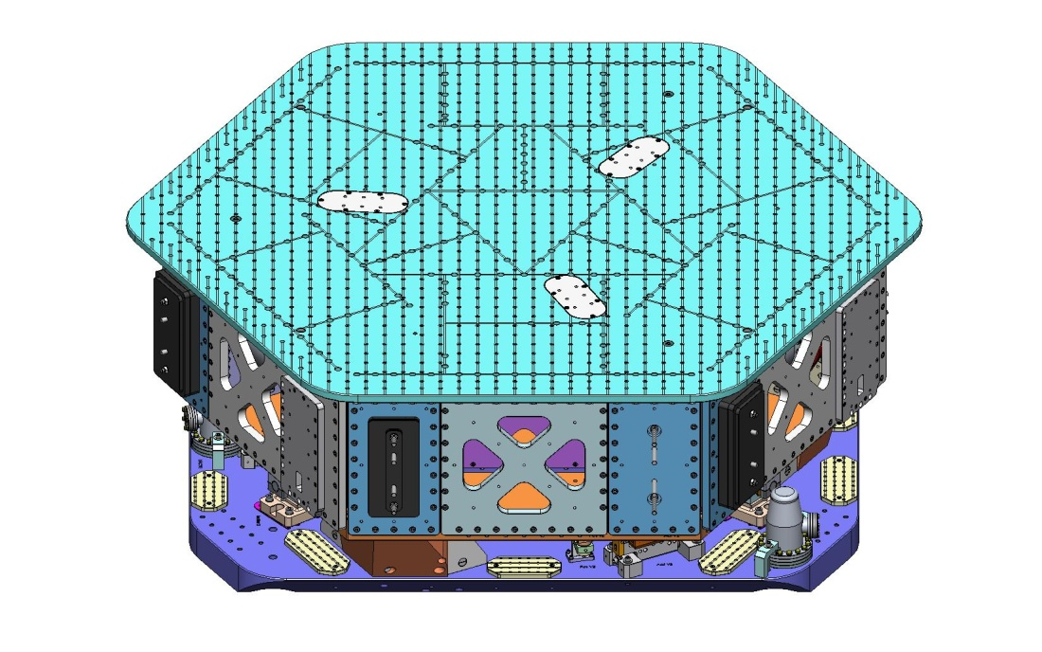
Large Wiring Breadboard
(D071255)
Small Wiring Breadboard
(D0900312)
Figure 1. There are (4) Small Wiring Breadboards and (6) Large Wiring Breadboards mounted on Stage 0.
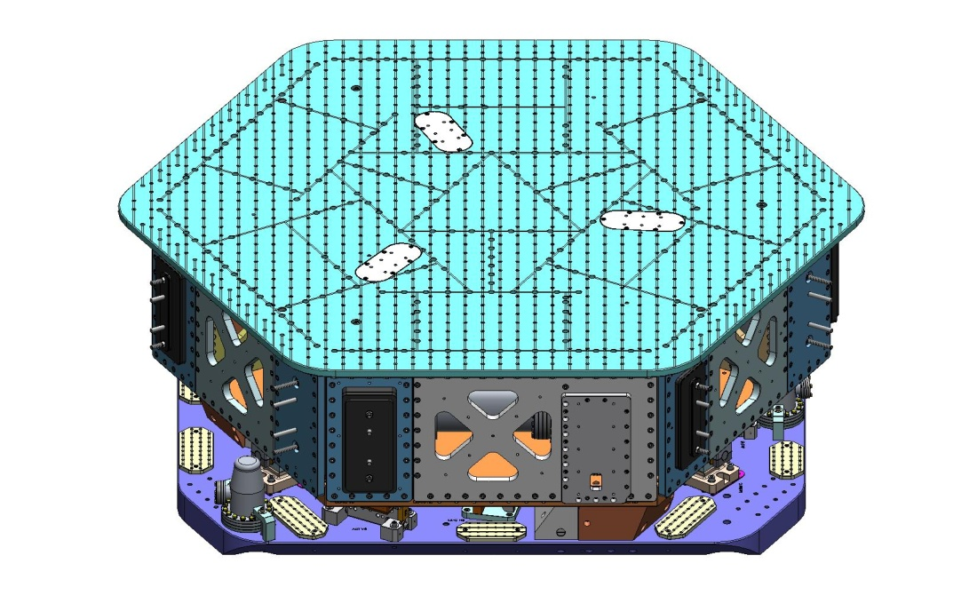
Spring Hatch Cover
(D071067)
Optical Table
(D071050)
Stage 0
(D0900153)
Stage 1
(D0900154)
Figure 2. Opposite view of HAM ISI, showing additional Wiring Breadboards. This view also indicates what is meant by "Stage 0" and "Stage 1." The Optical Table has a 2"x2" square grid of 1/4"-20 tapped holes (Nitronic-60 helical inserts). Also, there are (3) Spring Hatch covers bolted to the top of the Optical Table. Each of these has a set of (6) 1/4"-20 tapped holes.
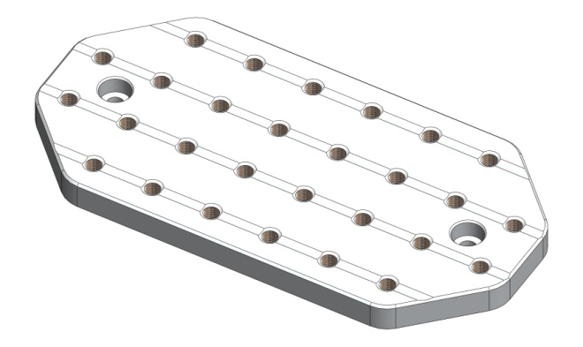
Figure 3. Close-up of a Small Wiring Breadboard, which has a 1"x1" grid of 1/4"-20 tapped holes. The Large Wiring Breadboard is similar.
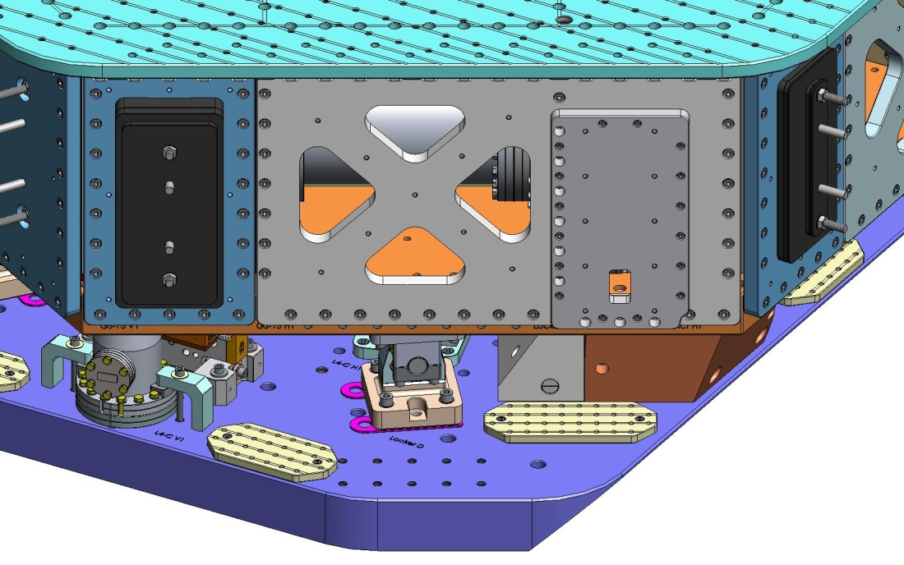
Cover
(D0900277)
GS-13 Outer Wall
(D071057)
Figure 4. All of the Outer Walls on Stage 1 include 1/4"-20 tapped holes, which can be used for attaching cable clamps. Some of these holes are highlighted above, with dashed red circles.
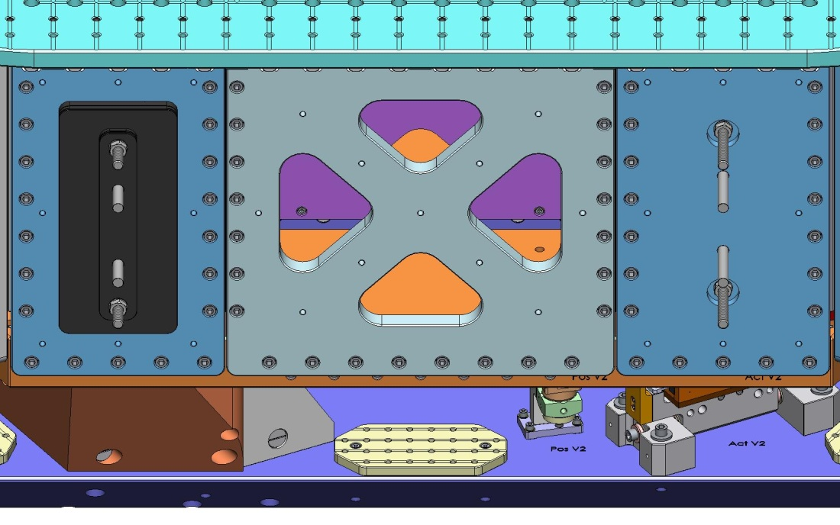
Small Panel Outer Wall
(D071059)
Flexure Access Outer Wall
(D071058)
Figure 5. Additional holes on the Flexure Access and Small Panel Outer Walls, which may be used for attaching cable clamps. Note: Small Panel Outer Walls are used for mounting Adjustment Masses for balancing Stage 1. The configuration of Adjustment Masses may need to change as the opto-mechanical layout evolves.

For each HAM ISI, some portion of the Wiring Breadboards will be used to clamp cables for the ISI's own active components, including: Actuators, Position Sensors, GS-13 Seismometers, and L4-C Seismometers. At this time, there are no detailed plans for how these cables will be routed.

Also, note that any cables on Stage 1 must include a compliant loop between the point(s) where they attach to Stage 1 and the point(s) where they attach to Stage 0. No cables may be routed directly from Stage 1 to any other mechanically "grounded" structure (e.g., a feedthru flange on the vacuum chamber).

