LIGO Laboratory / LIGO Scientific Collaboration

LIGO-T1000310-v2 LIGO May 24, 2012

Passive Isolation Stack for HAM1 (HAM7) in Advanced LIGO

P Fritschel

This is an internal working note
of the LIGO Laboratory.

California Institute of Technology  LIGO Project – MS 18-34  1200 E. California Blvd.  Pasadena, CA 91125  Phone (626) 395-2129  Fax (626) 304-9834  E-mail: info@ligo.caltech.edu | Massachusetts Institute of Technology  LIGO Project – NW22-295  185 Albany St  Cambridge, MA 02139  Phone (617) 253-4824  Fax (617) 253-7014  E-mail: info@ligo.mit.edu
LIGO Hanford Observatory  P.O. Box 1970  Mail Stop S9-02  Richland WA 99352  Phone 509-372-8106  Fax 509-372-8137 | LIGO Livingston Observatory  P.O. Box 940  Livingston, LA 70754  Phone 225-686-3100  Fax 225-686-7189
http://www.ligo.caltech.edu/

Introduction
In Advanced LIGO the HAM1 chamber (HAM7 for the folded interferometer) contains ISC sensors for length and alignment control. Two interferometer beams are delivered to this chamber: a sample of the REFL beam; and the POP beam transmitted by PR2. The HAM1 chamber is isolated from the main vacuum volume with a septum plate that contains ports for the two beams.
HAM1 will be equipped with HEPI, which provides some seismic isolation in the 0.5-10 Hz band. Inside the chamber, an initial LIGO HAM stack will be installed; this provides a large optical table for mounting the ISC hardware, and it gives passive seismic isolation above 5-10 Hz. We plan on modifying the iLIGO stacks in one respect: the coil springs and spring seats will be replaced with viton cork-shaped springs. The main motivation for this change is to have much lower stack mode Qs (reduced from 30 to about 3). Another motivation is to have a stiffer stack to make it easier to work on, yet still consistent with the isolation goals.

Isolation requirements
It is not clear how to derive a full set of seismic isolation requirements for HAM1. One of the main motivators for putting the ISC detectors on an isolated platform is to reduce upconversion from relative motion of the photodiodes and the beams. But we do not know how to quantify this, and instead we design in what we think is a prudent amount of low-frequency isolation (thus the decision to implement HEPI).
One noise mechanism that we have analyzed is (linear) back-scattering from the REFL beam; this is discussed in section 7.7 of the ISC Conceptual Design, LIGO-T070247-01. There we concluded that the HAM1 detection table needed about a factor of 10 isolation from the ground at 10 Hz.

Initial LIGO HAM Stack Design
A description of the initial LIGO HAM stack and its modeled performance can be found in LIGO-T970238-00-D, HAM Seismic Isolation Projected Performance Update, E. Ponslet (Jan. 1997). The stack consists of 4 legs of springs and stainless steel masses, and a 1.7m x 1.9m optics table mounted on top. Each leg consists of 3 layers of springs and two masses. The modeled performance of the stack built with coil springs (Fig. 9 of T970238), indicates that it provides a factor of 10 isolation at 20 Hz in the horizontal direction, and at 15-20 Hz in the vertical direction. Isolation at 100 Hz is about 10⁷ both horizontally and vertically. The lowest eigenfrequencies are 1.45 Hz in the horizontal direction, and 3 Hz in the vertical. The quality factors (Q’s) of the low-frequency eigenmodes are about 30 (from experience).

Stack design with viton cork springs
The original prototype isolation stack for LIGO was built with cork-shaped Fluorel (viton) springs. The springs were 5.2 cm tall, with upper and lower diameters of 3.1 cm and 4.1 cm. T970238 contains an analysis of a HAM stack built with such springs. In terms of isolation, the model shows a factor of 10 at 10 Hz for horizontal motion, and a factor of 10 at 35 Hz for vertical motion. The lowest eigenfrequencies are about 2.5 Hz horizontal, and 7 Hz vertical. Since the scattering mechanism mentioned above works nominally only along the beam axis (i.e., horizontally), the isolation of a viton cork stack appears to be adequate, and perhaps is preferable to the coil spring stack because it achieves a factor of 10 horizontal isolation at a lower frequency. We do note, though, that the isolation performance will be much poorer vertically than horizontally with these springs.

Advanced LIGO HAM1 stack design

Spring material and manufacturing
The cork-shaped spring design is found in LIGO-D1003012. The springs are 2.03” tall, 1.625" diameter at the base and 1.20" diameter at the top. They are molded from 3M Fluorel FKM FE5641Q polymer (by Manville Rubber Products, Inc.). The fluorine extraction process specified in E960022 was performed by Walker & Sons. The springs were then vacuum baked and screened at Caltech.

Spring loading
The rubber springs have a durometer value of 70 ± 1 (measured after processing). The original Hytec design (T970238) gave a maximum load per spring of 125 lbs (556 N), but this was for an assumed durometer of closer to 75. Therefore we have designed the stack for a nominal load of 100 lbs per spring.
A small test batch of springs was made before the production run was done. This test batch came out at a durometer of about 75. The loading of springs from this test batch was tested at MIT; see Figure 1. The final compression is seen to be about 3.6 mm (0.14"). Since the actual springs are a little softer than this test batch, we can expect a little more compression.
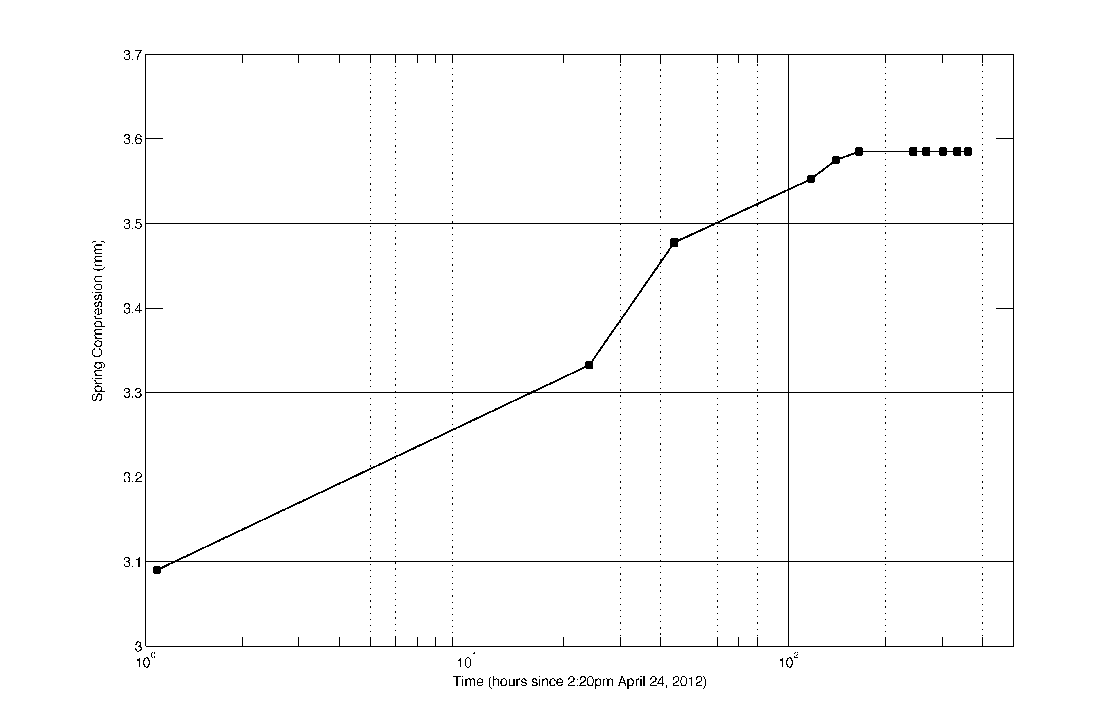
Figure 1. Spring loading and drift measurement for test batch of cork springs. Plotted is the average compression for 4 springs loaded with a single cylindrical mass. Load per spring: 103 lbs. Spring durometer: 75.

Stack layer design
The mass of the HAM optical table is 850 lbs. The cylindrical leg element masses are: upper masses, 234 lbs each; lower masses, 394 lbs each. We will add 350 lbs to the optical table, which is a combination of the components on the table and ballast mass (mostly ballast). The results mass and springs per layer is:

Stage | Mass (lbs) | # springs / leg | Load per spring
3 (top) | 850 + 350 = 1200 | 3 | 100 lbs
2 | 1200 + 234*4 = 2136 | 5 | 107 lbs
1 (base) | 2136 + 394*4 = 3712 | 9 | 103 lbs

The assembly drawing for the stack is LIGO-D1102387. This drawing also shows the arrangement of the springs on each layer.

J Giaime et al., A passive vibration isolation stack for LIGO: design, modeling, and testing, Rev. Sci. Instrum. 67 208-214 (1996).

