AUTHOR(S) | DATE | Document Change Notice, Release or Approval
Eric James | 28 June, 2012 | see LIGO DCC record Status
This document is intended to serve as a description of this assembly until a real assembly drawing can be made.

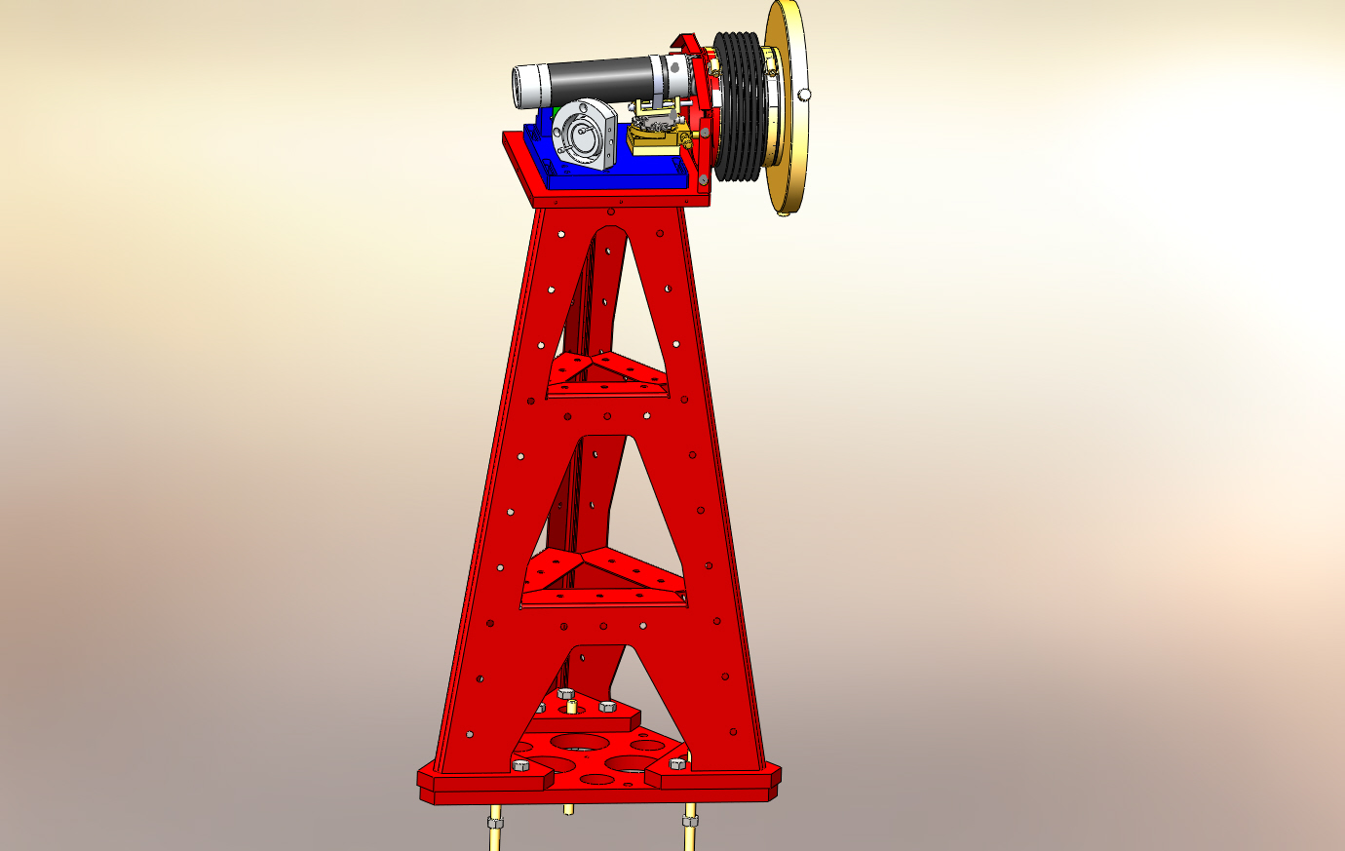

Figure 1: HAM Transceiver Pier Assembly. Shown with cover removed.

Bill of Material
Item | Part number | Description | Quant.
1 | D1001854 | TRX Pier Weldment | 1
2 | D1000434 | Pier Footing | 1
3 | D1001627 | TRX Mounting Base | 1
4 | D1001620 | QPD Bracket | 1
5 | D1100290 | QPD Board Assembly | 1
6 |  | 15-pin M-M Cable, Photodiode Board | 1
7 | KSP-60-C1A-S05 | OptoSigma Rotary Stage | 1
8 | GOHT40A10-MO2 0600-S10 | OptoSigma Goniometer | 1
9 | SL38 | Newport Gimbol Mirror Mount | 1
10 |  | Pico Motors w/Cables | 2
11 | D1102242 | Transmitter Telescope Mount | 1
12 | D0901362-1 | Projection Telescope Assembly, Short | 1
13 | D1200463 | Transceiver Enclosure Assembly | 1
14 | D1200622 | 6-inch Reducer | 1
15 | CT-6 | Gortiflex 6" Rubber Bellows | 1
16 |  | 1/2-20 x 1.5" Hex head cap screw | 9
17 |  | 1/4-20 x 3/4" SHCS | 10
18 |  | 1/4-20 x 3" SHCS | 1
19 |  | #8-32 x 1/2" SHCS | 11
20 |  | #8 Flat Washer | 11
21 |  | M3 x 10 SHCS | 4
22 |  | M3 x 6 SHCS | 4
23 |  | #4-40 x 5/8" SHCS | 4
24 |  | 3" Band Clamp | 1
25 | 45945K37 | McMaster -Carr 6" Band Clamp | 2
26 | 92421A540 | McMaster -Carr 1/4-20 Brass Thumb Screw | 3
27 | 9600K62 | McMaster-Carr Rubber Grommet | 1
28 | F12 635S | Fermion Laser w/ 10m fiber | 1
29 | D1200461 | Laser Power Board | 1
30 | D1100013 | Whitening Chassis | 1
31 | D1101248 | Anti-aliasing Chassis | 1
32 |  | 9-pin M-F Cable, Anti-aliasing Chassis | 1
33 |  | BNC M-M Cable, Laser | 1
34
35

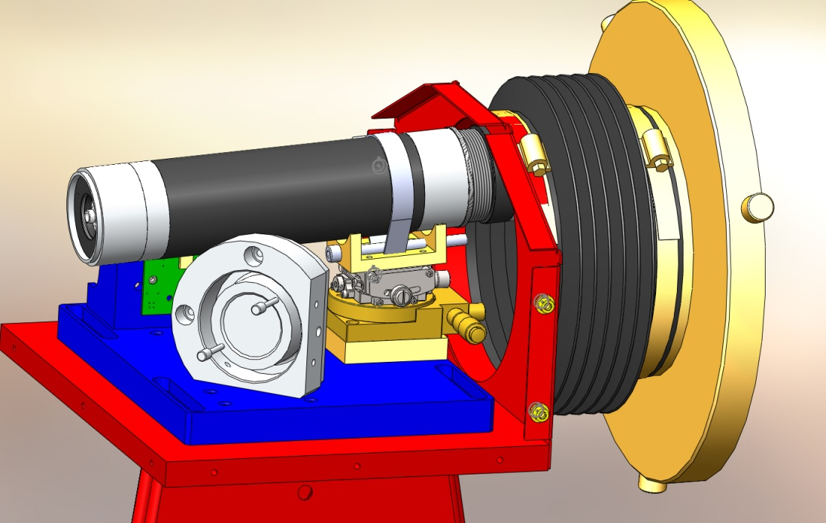
Figure 2: Telescope mounting hardware
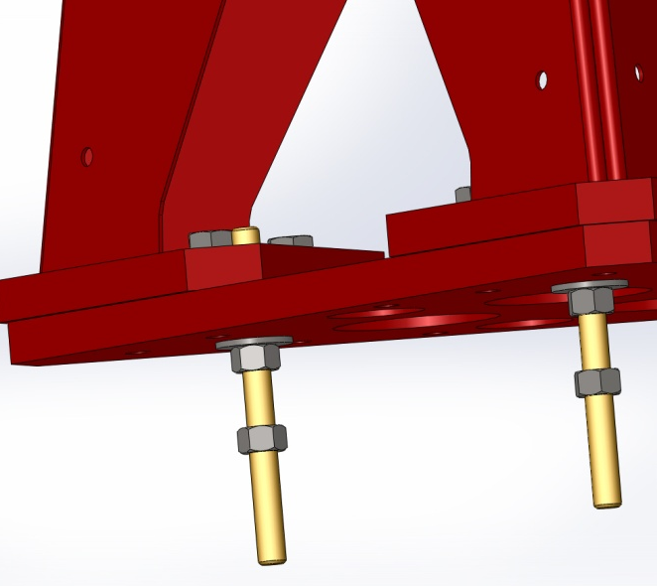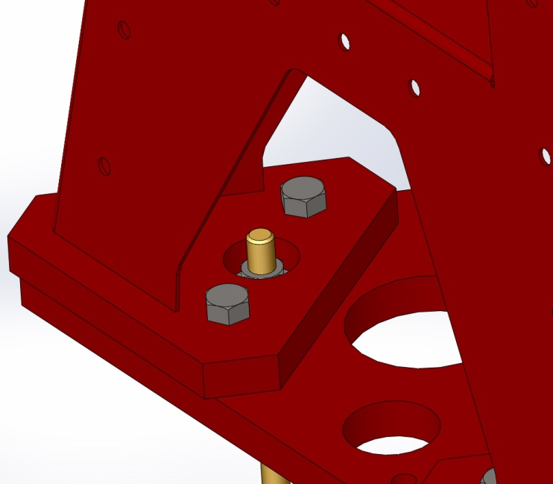
Figure 3:Base plate details

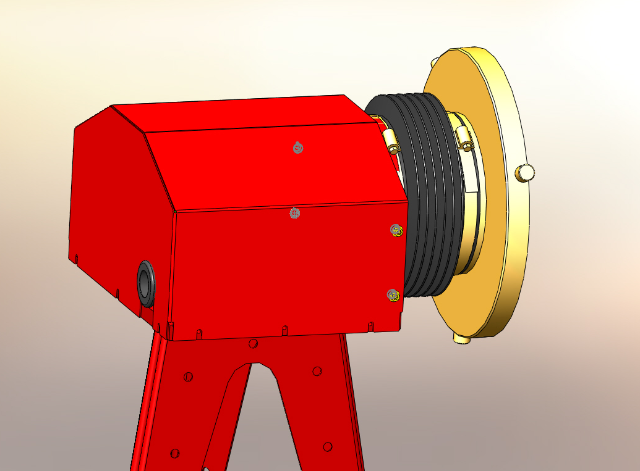
Figure 4: Cover installed

