LASER INTERFEROMETER GRAVITATIONAL WAVE OBSERVATORY

CALIFORNIA INSTITUTE OF TECHNOLOGY

MASSACHUSETTS INSTITUTE OF TECHNOLOGY

|  |
| --- |
| Laser SOP LIGO-M1000230-v1 14 October 2010 |
| **LLO 35 W TCS SOP** |
| Submitted By:  R.S. Amin and D. Kinzel |

LIGO Hanford Observatory LIGO Livingston Observatory

P.O. Box 159 19100 LIGO Lane

Richland, WA 99352 Livingston, LA 70754

Phone (509) 372-8106 Phone (225) 686-3100

Fax (509) 372-8137 Fax (225) 686-7189

E-mail: [info@ligo.caltech.edu](mailto:info@ligo.caltech.edu) E-mail: info@ligo.caltech.edu

California Institute of Technology Massachusetts Institute of Technology

LIGO Project – MS 18-34 LIGO Project – NW22-295

Pasadena, CA 91125 185 Albany St. Cambridge, MA 01239

Phone (626) 395-2129 Phone (617) 253-4824

Fax (626) 304-9834 Fax (617) 253-7014

E-mail: [info@ligo.caltech.edu](mailto:info@ligo.caltech.edu) E-mail: info@ligo.mit.edu

Contents

PREFACE 2

1. INTRODUCTION 2

2 HAZARDS 8

2.1 Nominal Hazard Zone 9

3. CONTROLS 10

3.1 Access and Administrative Controls 10

3.2 Physical Controls: Exposure Control 10

3.3 Physical Controls: Electrical Controls 11

3.4 Eye Protection 13

4. OPERATING PROCEDURES 15

4.1 Responsible Laser Operator 15

4.2 Start-up procedures 15

4.3 Shutdown procedures 16

5. TRAINING 18

6. RESPONSIBILITIES 18

7. References 19

# PREFACE

**Table of Documentation Hierarchy**

Tier 1 = M950046 (LIGO Laboratory System Safety Plan)

Tier 2 = M960001 (LIGO Laser Safety Program)

Tier 3 = M1000228 (LLO Laser Safety Plan) (Site-specific)

**Tier 4 = Site-specific, laser-specific SOPs, FMEAs, and special procedures**

Tier 5 = Operating, user, or other technical manuals from the manufacturer

Tier 6 = Wiki entries instructing operators "how-to".

This document is for individuals who require basic knowledge about this laser equipment. It is not a substitute for operating manuals or for one-on-one training. Standard operating procedures (SOPs) are site-specific and equipment-specific documents that fall under the jurisdiction of the site laser safety officer. Candidate laser operators must read and understand all site-specific laser safety plans as well as laser-specific SOPs. Candidate laser operators must understand that reading this documentation is necessary, but does not automatically qualify personnel to work on this laser equipment. Neither does it clear anyone to operate identical hardware at any other LIGO location.

# 1. INTRODUCTION

The Enhanced LIGO thermal compensation system (TCS) laser is model 48-2 carbon dioxide (CO2) laser[1] (see Figure 1). These lasers are produced by Synrad, Inc. and are capable of generating class 4 far-infrared laser radiation. Brochures from Synrad, Inc. indicate that the 48-2’s are capable of generating 25 W of laser light at a wavelength of 10600 nm. Calibrated tests at LIGO Livingston and LIGO Caltech indicate a maximum power of ≈ 35 W.

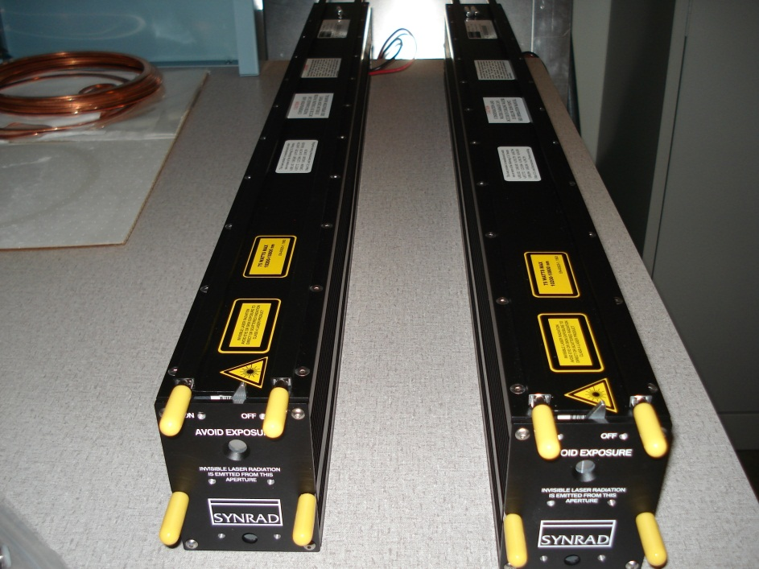

Mechanical Shutter

Water coolant inlets

Figure : A pair of 48-2 series CO2 lasers produced by Synrad, Inc. The mechanical shutters are closed in this photograph. The shutter’s lever arm is pointed out on top.

The TCS is required by LIGO’s interferometers to optimize thermal focusing behavior in the ITMs. In most cases, the ITM self-lensing is not sufficient to permit the interferometers to operate stably and at high sensitivity. The TCS projects an auxiliary heating pattern that optimizes the thermal focusing of the ITMs. The 48-2 series Synrad laser sitting on the TCS table provides the radiant heat source for the TCS.

The TCS and its lasers are located in two positions in the LVEA’s nominal hazard zone (NHZ). One TCS table is located at the flange of each arm adjacent the cryogenic pumps. Figure 2 depicts the location of the TCS tables with respect to the LVEA floor plan. Figure 3 is a photograph of a TCS table in the LIGO Livingston LVEA with its cover plate removed. Aluminum perimeter plates (beam dumps) encircle the table preventing light from escaping. The lexan panels are only sufficient to damp air motion (see Figure 5).

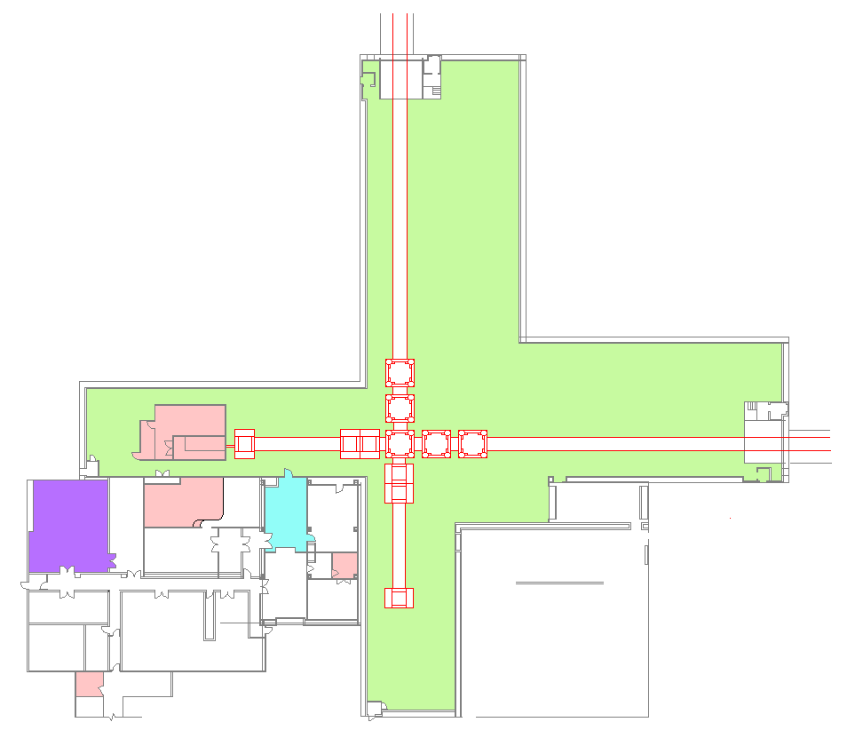

Pre-Stabilized Laser (PSL) Enclosure

LVEA Entrance

Control Room

Large Vacuum Equipment Area (LVEA) NHZ

To VEAY

To VEAX

**Laser Safety**

**Officer (LSO)**

TCSY

TCSX

Figure : Location of the TCS tables in the LVEA (not to scale). Notice the position of TCSY and TCSX near the end of the interferometer manifold. The green floor space is the LVEA nominal hazard zone.

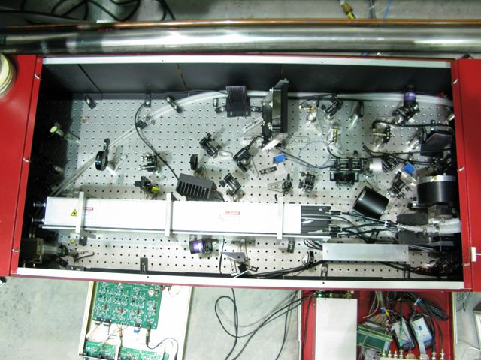

Perimeter Plates

48-2 Series Synrad Laser

35 W Beam Region

TCS Projection Optics

Figure : A photograph showing the TCS table layout. The laser head and 35 W beam paths are labeled.

The 48-2 series Synrad laser itself is comprised of a radio frequency (RF) excited gas/plasma chamber. One curved copper mirror serves as the fully reflective mirror. A flat zinc selenide mirror serves as the output coupler. This configuration places the waist of the laser at the inside face of the output coupler. A water coolant prevents the laser from overheating. However, a thermal sensor within the laser’s electronics will turn off the RF excitation if the laser head overheats.

NOTE: The electronics in a 48-2 series Synrad laser will fail before the any damage occurs to the laser cavity hardware.

The 48-2 series Synrad laser can be run in two modes, continuous wave (CW) and pulsed. The primary operating mode of this laser is CW. In this setting, the 48-2 series Synrad lasers will produce their maximum amount of laser light. Power reduction in CW mode is only possible by external optics.

When connected to the Synrad UC-2000 controller, the laser runs in a pulsed mode. Pulses have a fixed repetition rate of 5 kHz and can be varied in length from 0-200 micro-seconds. Altering the duty cycle fraction changes the output power.

The 48-2 series Synrad laser are powered by a single BK Precision power supply located beneath each TCS table. Figure 4 shows a picture of a power supply. Figure 5 indicates its location around a tidy and secured TCS table.



Figure : A BK Precision DC power supply. The power supplies are used to energize the TCS CO2 lasers.

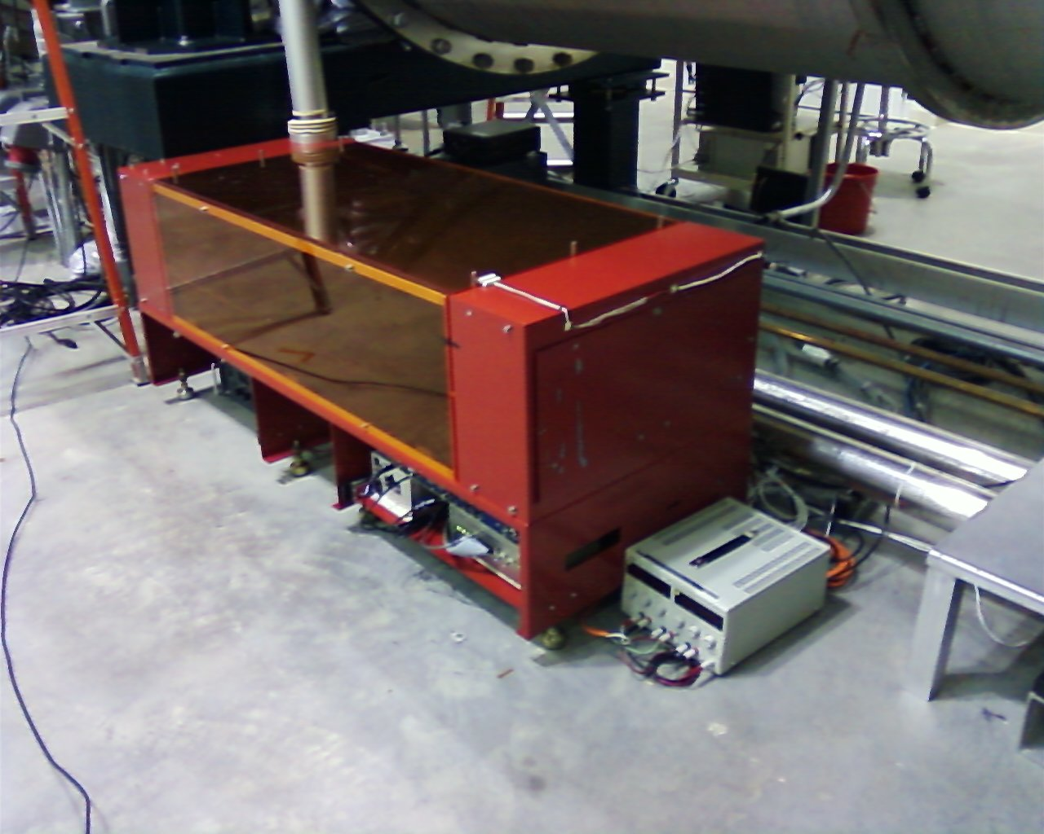

Lexan Panels

TCS Table (closed)

DC supply for TCS Electronics

BK Precision DC Power Supply

TCS Electronics

Figure : A closed TCS table with its various electronics and power supplies is shown. The DC laser power supply is somewhat hidden from view. Notice the table cover plate is bolted in place.

The parameters for the primary output of these lasers are listed in Table 1.

Table : Laser parameters

|  |  |
| --- | --- |
| Description | Value/Designation |
| Laser Type | RF excited gas/plasma |
| Class | 4 |
| Emission center wavelength | 10600 nm |
| Emission repetition rate | Continuous Wave unless in diag. mode |
| Emission waist (minimum radius) | < 1.25 mm |
| Waist location | At the aperture |
| Beam divergence | ≈2.7 mrad |
| Output polarization | Vertical with respect to the table |
| Maximum power output | ≈35 W |
| Interlocked | Continuously by Kantech Site Security Sys |
| Authorized locations | LVEA |

# 2 HAZARDS

* The 48-2 series Synrad lasers are class 4 devices. Exposure to the direct beam and scattered light is considered hazardous to eyes and skin. Diffuse reflections within the NHZ are considered hazardous to the eyes. Extra care needs to be taken when inserting or removing hardware from active beamlines.
* The direct beam is considered to be a fire hazard and should only be blocked using approved hardware. Focused beams impacting approved beam dumps or perimeter plates (see Figure 7) can also cause plasma bursts. These bursts generate UV radiation and high temperatures generating hazards to the eyes and skin. Long duration bursts can lead to sunburn.
* The lasing chamber of the 48-2 series Synrad laser contains carbon dioxide gas with trace amounts of carbon monoxide below atmospheric pressures. Breaking the seals of laser cavity will release this gas and may result in respiratory issues.
* Coolant water leaks around the electrical power supplies and 48-2 series Synrad laser equipment are also categorized as electrical shock hazards. The power supplies deliver ≈ 10 Amps at 30 Volts DC and pose the potential for injury.
* The potential for burn injuries is also present if beam dumps are left in the main beam for a short period of time. Several diagnostic beams pass through germanium based mirrors. These attenuated beams also pose the potential for burn injury.
* Hazards exist when working with the far infrared target cards. These cards are used in alignment and are charged by a UV lamp. Working in close proximity to this UV light source for long periods can cause eyestrain, possible eye damage, and sunburn.

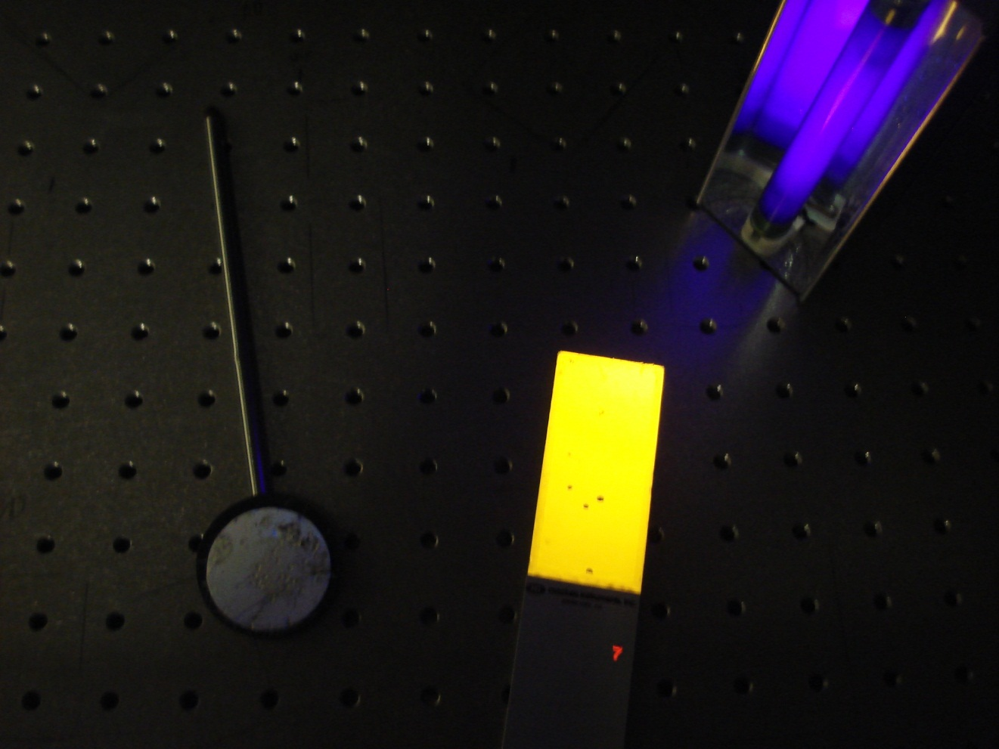

Figure : Far infrared target glowing card with UV lamp used in TCS alignment. Bolt holes are spaced by 1 inch for reference. A near infrared sensor sits to the left.

## 2.1 Nominal Hazard Zone

The LVEA is the nominal hazard zone (NHZ) for the 48-2 series Synrad laser. During special circumstances, these lasers may be setup in the High Power Laser Facility (HPLF) at LIGO Livingston for testing purposes. These special circumstances require approvals and work permits from the cognizant laser personnel, the LIGO Livingston laser safety officer, and HPLF scientists.

Periodically, the 48-2 series Synrad laser may need to be projected 30 m across the floor of the LVEA. The procedures for these events are found in LIGO-M1000328 (LLO TCS LVEA Alignment SOP).

# 3. CONTROLS

## 3.1 Access and Administrative Controls

Access to the TCS direct beams is controlled to ensure site personnel safety. Access to the LVEA and TCS tables are restricted to qualified laser operators only. These individuals gain access to these NHZs by individualized key cards and key card readers interlocked with door latches and tables covers. Unauthorized visitors must be escorted by qualified laser operators. Also, all operations in the LVEA must be follow LIGO work permit procedures.

Lighted warning signs are located at access points of each LVEA NHZ and indicate either a “Laser Hazard” or “Laser Safe” condition. Lighted warning signs for the LVEA are posted in the following locations:

1. Main LVEA personnel door (right side),
2. Large airlock door to LVEA,
3. The control room hazard panel.

Permanent warning signs are placed on the emergency doors and the chiller closet doors for the LVEA.

## 3.2 Physical Controls: Exposure Control

The 48-2 series Synrad laser is contained in a light-proof box. Sandblasted and anodized aluminum plates surround the table’s perimeter (perimeter plates). A similarly treated aluminum cover plate is bolted (hand tight) to the top of the TCS table. These plates have been specified to endure a focused (≈ 200 micron waist) beam for greater than 24 hours. Such tests were carried out at Caltech and LIGO Livingston.

The colored acrylic panels are laser resistant to lower power (8 Watts) FIR laser light. They serve as an external brace and reduce air currents in the TCS table during operation.

The 48-2 series Synrad laser has one mechanical shutter. This shutter is located at the aperture. In the closed position, this shutter stops the CO2’s direct beam delivered from the main aperture. The shutter also activates an electrical switch that prevents lasing.

Beam dumps are used to block un-used or stray light (see Figure 7). These dumps should be labeled when practical and in all circumstances secured to their working surface. Insertion and extraction of beam dumps for the primary beam requires care due to the scale of momentarily scattered light. Should beam dumps for the main beam be required for extended periods, a water cooled dump or a large plate dump is advised.

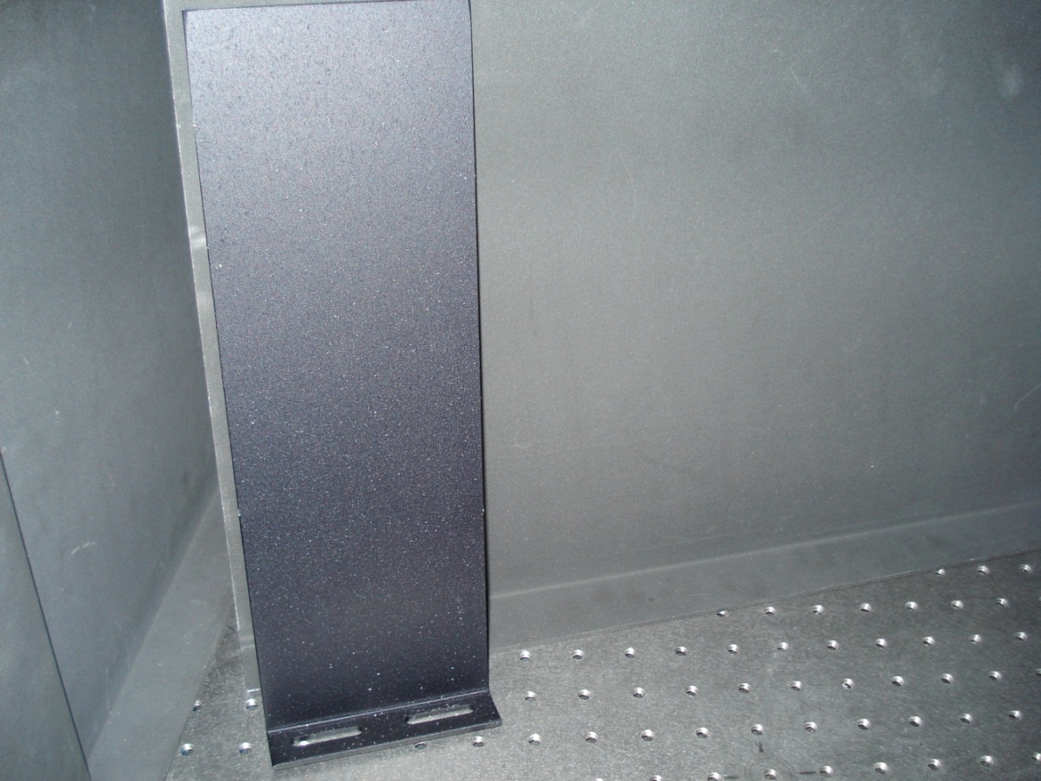

Figure : A plate style beam dump.

## 3.3 Physical Controls: Electrical Controls

The 48-2 series Synrad laser can only be energized if several hardware electronic stops are cleared. These are the water flow switch, the viewport temperature sensor (see Figure 8), and the laser key switch. Only then may the laser be activated and deactivated from a CDS workstation with EPICS access.

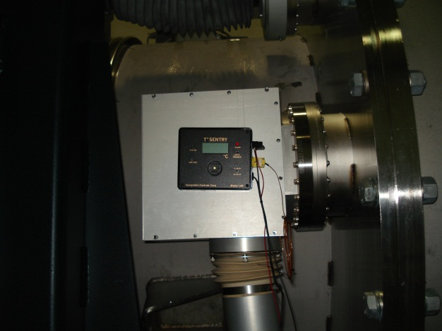

Figure : Photographs of the viewport temperature sensor and alarm, flow sensor, and laser keyswitch.

An illuminated indicator is located at the rear of the 48-2 series Synrad laser. When illuminated, it indicates the presence of laser light. In all cases, hardware switches override CDS control.

Both TCS lasers are interlocked and monitored by the site safety computer. Unauthorized access results in an immediate shutdown via a software command. The interlock sensor is shown in Figure 9.

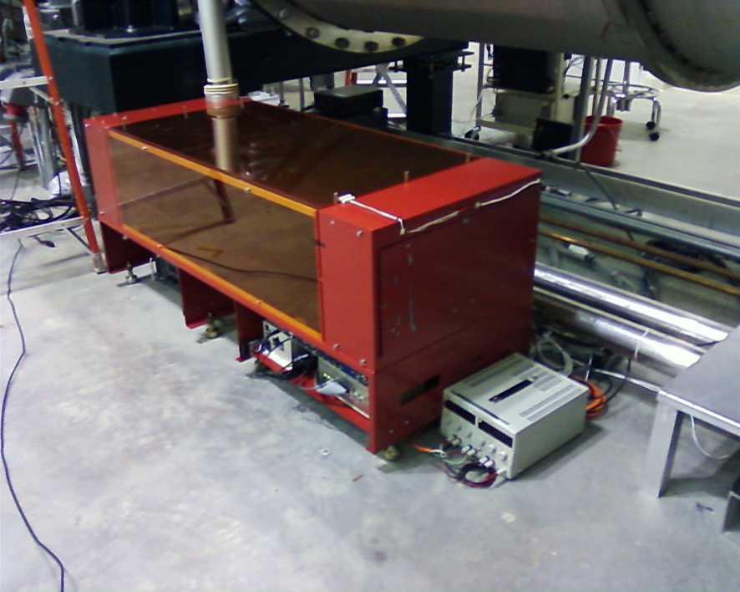

Interlock sensor

Figure : A TCS table interlock sensor situated on the cover plate.

In case of emergencies, ALL lasers in each NHZ can be shut down through the red colored “Emergency Shutdown” buttons. These buttons shut off technical power being supplied to laser light sources providing an immediate “Laser Safe” condition. The “Emergency Shutdown” button next to the LVEA entrance is shown in Figure 10.



“Emergency Shutdown” Button adjacent LVEA Main Door

Figure : The location of “Emergency Shutdown” button adjacent the LVEA main entrance.

## 3.4 Eye Protection

All personnel working in the LVEA while the laser is capable of being or is energized shall wear protective laser safety eyewear whose optical density is equal to 3.6 or above for 10,600 nm radiation in addition to other OD requirements. Example eyewear is show in Figure 11.

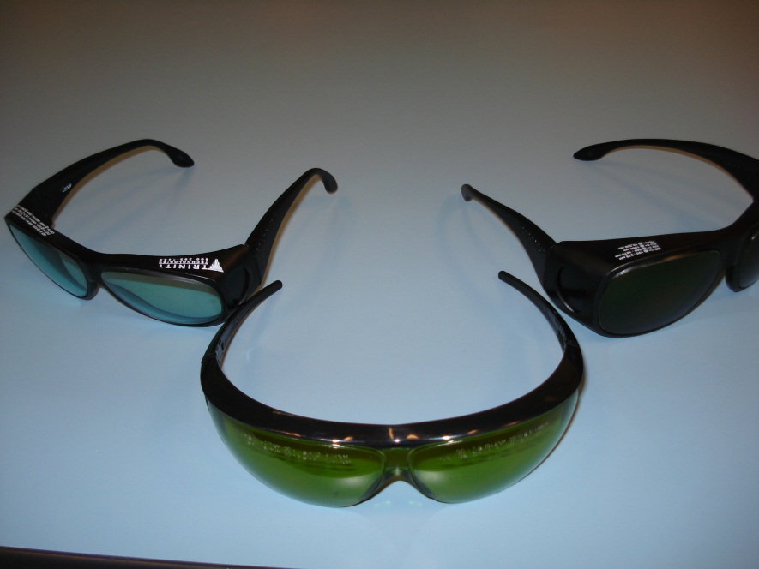

Figure : Sample laser goggles approved for TCS table work.

# 4. OPERATING PROCEDURES

## 4.1 Responsible Laser Operator

The Responsible Laser Operator (RLO) coordinates tasks in the LVEA with the on duty control room operator. When a work permit is required, it must be filed before any work begins.

Notice that the first individual who successfully accesses the TCS enclosure becomes the RLO for that particular table. The 48-2 series Synrad lasers are located two separate places and are independently operated. Only one RLO may be assigned to control *each* table. Access to the TCS table contents are handled by key card access (see section 3.1).

## 4.2 Start-up procedures

Only qualified laser operators are permitted to activate the LIGO Livingston TCS lasers.

The RLO is responsible for managing *the laser hazard state of a TCS table* laser’s status panel. The RLO will confirm that no one is physically in the direct path of the beam, that the beams do not leave the TCS table except during authorized projections, and that all personnel are wearing correct eyewear prior to powering up the laser. The RLO is required to obtain the TCSX and TCSY activation and padlock keys from the key safe, when necessary.

1. **Turn on the chiller:** Go to the TCSX’s and TCSY’s chiller closet and make certain the chillers are turned on and running.
2. **Key the laser status panel to “Laser On”:** Turn on the key lock on the Kantech card reader. The lock is located below the box and is pointing down.
3. **Unlock and connect power using the “TCS Laser Power Shut Off” boxes:** Unlock the lever and push the lever up on the box labeled “TCS LASERPOWER SHUT OFF”. This connects electrical power to the 48-2 series Synrad laser power source.
4. **Enable the Laser from the control room**: Contact the on-duty control room operator and have them go to the main TCS MEDM screen (L1TCS.adl) and click the “on” button in the laser power section (in the middle of the screen)
5. **Turn the laser activation key:** Toggle the key located on the TCS boxes (near the bottom of the box facing the Kantech card reader). Ensure that the laser is on by checking the power supply for the laser. The PD_IN DC and PD_OUT DC values for both arms should now be green as well on L1TCS.adl.
6. **Enable the chiller servos from the control room:** Open the L1TCS_CHILLER.adl screen for each arm. Click the orange “Chiller Servo” button which will open the L1_TCS_CHILLER_SERVO.adl screen for that arm. Click the big blue “On” button. The words “Servo input” will appear without a strikethrough.
7. **Search for Home**: Use the main TCS MEDM screen (L1TCS.adl) command the polarizer controllers to search for home.

**NOTE:** *If a laser beam with power in excess of 2 mW is found (reported by any observer), leaving the optics table, the laser will be shut down by the LSO and will remain “OFF” until start-up authorization is received.*

**NOTE:** *It is the responsibility of each person working within the Laser Nominal Hazard Zone (NHZ) to ensure that LIGO standards for safe laser operation are being followed at all times*

## 4.3 Shutdown procedures

Only qualified laser operators are permitted to deactivate the LIGO Livingston TCS lasers in a controlled manner.

The RLO is responsible for coordinating TCS laser shut downs with the on-duty control room operator. The RLO is responsible for filing a work permit, when necessary to perform this activity. For extended TCS subsystem shutdown periods, the RLO will also be responsible for managing the laser hazard status of the associated NHZs.

When safing the 48-2 series Synrad laser for extended periods of time, the activation key and the electrical disconnect padlock key must be placed in the control room key safe.

1. **Disable the Laser from the control room**: Go to the main TCS MEDM screen (L1TCS.adl) and click the “off” button in the laser power section (in the middle of the screen). The PD_IN DC and PD_OUT DC values for both TCSX and TCSY should turn red.
2. **Disable the chiller servos from the control room:** Click the purple chiller button at the bottom screen for TCSX and TCSY on the same MEDM screen. Click the orange “Chiller Servo” button on the new L1TCS_CHILLER.adl screen which will open the L1_TCS_CHILLER_SERVO.adl screen for that arm. Click the blue “off” button. The words “Servo input” will be struck through.
3. **Disconnect and lock “TCS Laser Power Shut Off” boxes off:** Pull the lever down on the box labeled “TCS Laser Power Shut Off” and lock it in place with the lock attached to the box.
4. **Key the laser status panel to “Laser Off”:** Turn the key switch on the Kantech card reader box to the “Laser Off” position. The key switch is located below the box and is pointing down.
5. **Remove all keys and place them in the control room key safe:** Remove all keys from TCSX and TCSY and place them in the control room key safe. This is required during extended safe periods (i.e. beyond an 8 hour shift).
6. **Turn off the chillers:** Go to the TCSX’s and TCSY’s chiller closet and make certain the chillers are turned off.

**NOTE:** *Turning off the 48-2 series Synrad lasers and removing the activation keys IS NOT sufficient to transition associated NHZs to laser safe status.*

**NOTE:** *In cases of emergency, any person may shut down the 48-2 series Synrad lasers via any of the Emergency Laser Shutdown buttons located in the LVEA, LDR, PSL enclosure, or control room.*

# 5. TRAINING

LIGO basic laser safety training must be completed before any individual can work around any class 3B and/or class 4 laser emission.

Access to the TCS tables and lasers is only on an “as needed” basis for qualified laser operators. To become a qualified laser operator, an individual must complete the following requirements.

1. Received LIGO basic laser safety training
2. Have a full understanding of this SOP and its associated FMEA
3. Understand emergency and safety procedures
4. Received authorization from the LIGO Livingston laser safety officer

**NOTE:** *Training on any specific laser system does not automatically qualify individuals for other lasers at the LIGO facilities and associated university labs.*

# 6. RESPONSIBILITIES

* Each person working with the LIGO TCS lasers is responsible for ensuring that safe laser practices are being followed at all times.
* The responsible laser operator is responsible for the conducting tasks on a specific laser system in accordance with the prescribed control measures and in compliance with this SOP.
* The responsible laser operator is responsible for informing any and all assisting personnel regarding the control measures and SOP for the specific laser system.
* The responsible laser operator shall be responsible for any communications with other site personnel regarding changes in the operational status of the specific laser system.
* In case of safety incidents, contact the immediate personnel and (if necessary) emergency medical services as soon as possible.
* Any identified flaws in procedures or potential improvements that could enhance safety should be brought to the attention of the LLO Laser Safety Officer or cognizant laser personnel.

# 7. References

* American National Standard for Safe Use of Lasers, ANSI Z136.1-2007

Laser Institute of America, ISBN 0-912035-65-X

* LIGO-M950046 (LIGO Laboratory System Safety Plan)
* LIGO-M960001 (LIGO Laser Safety Program)
* LIGO-M1000228 (LLO Laser Safety Plan)
* LIGO-M0900241 (Laser Safety Training for Certification and Recertification of LIGO Personnel)
* LIGO-M1000328 (LLO TCS LVEA Alignment SOP)
* LIGO-M080368 (LLO NHZ Transition Procedures)
* LIGO-G0901007 (LIGO Basic Laser Safety Training Presentation)
* LIGO-G1000017 (LLO Addendum to Basic Laser Safety Training)

1. “48-2 series Synrad laser” and TCS laser are used interchangeably in this context.