LIGO Laboratory / LIGO Scientific Collaboration

E1000387-v3 LIGO 12 Apr. 2011

Stage 1-2 Vertical Actuator Assembly

S.Biscans, M.Hillard

Distribution of this document:
Advanced LIGO Project

This is an internal working note
of the LIGO Laboratory.

California Institute of Technology  LIGO Project – MS 18-34  1200 E. California Blvd.  Pasadena, CA 91125  Phone (626) 395-2129  Fax (626) 304-9834  E-mail: info@ligo.caltech.edu | Massachusetts Institute of Technology  LIGO Project – NW22-295  185 Albany St  Cambridge, MA 02139  Phone (617) 253-4824  Fax (617) 253-7014  E-mail: info@ligo.mit.edu
LIGO Hanford Observatory  P.O. Box 1970  Mail Stop S9-02  Richland WA 99352  Phone 509-372-8106  Fax 509-372-8137 | LIGO Livingston Observatory  P.O. Box 940  Livingston, LA 70754  Phone 225-686-3100  Fax 225-686-7189

Reference D0902531
Note : ! Make sure there is no trash in the coil !
Remove the two shoulder screws and watch carefully inside the coil.

Clean room standards

For a clean assembly all LIGO standards should be followed, as presented in the latest version of the LIGO Contamination Control Plan (E0900047). Clean room garb including UHV gloves should be worn when working with parts.
All tools that come in contact with assembly should be cleaned to class B standards.
Assembly will be done under a portable clean room. Any time a part of the assembly is not covered by the portable clean room or not being actively worked on it should be covered with appropriate clean covers. (C3 polyester or equivalent).

Parts prep work: alignment pins and helicoils
To facilitate assembly, parts requiring helicoils and/or pins to be inserted before assembly will be listed to allow preliminary preparation of the parts, after cleaning and before starting general assembly. Preparation need to be complete on the following. See E1000402 part pre-preparation matrix
Helicoils

1. D0902155
Helicoil 1/2-23, 1XDIA lg.
#1185-8EN.500

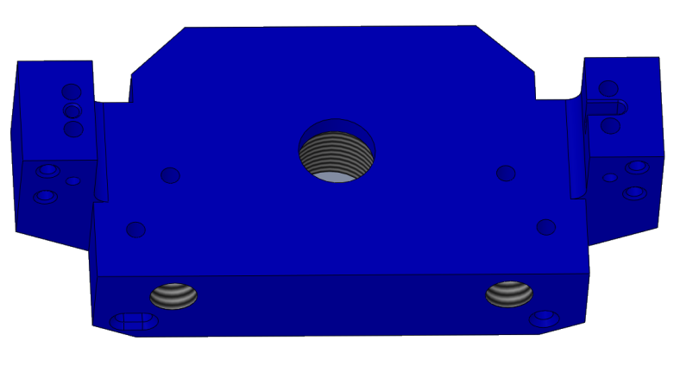
Helicoil 1/4-20, 1.5XDIA lg.
#1185-4EN.500

2. D0902161
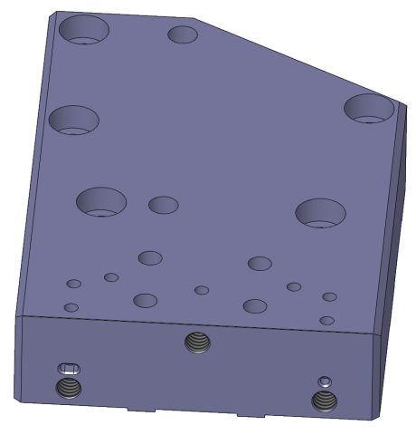
Helicoil 1/4-20, 1.5XDIA lg.
#1185-4EN.375

3. D0902137
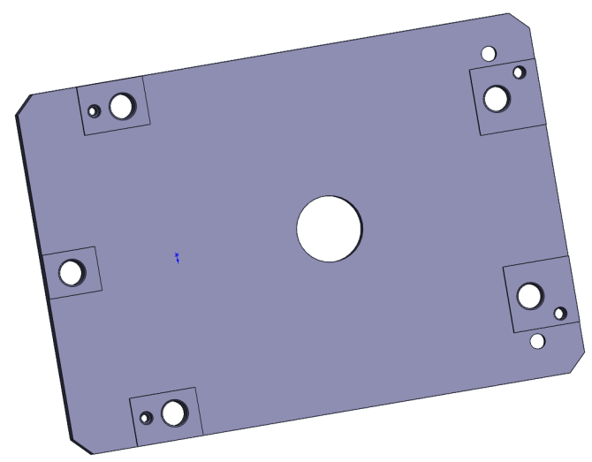
Helicoil 8-32, 2 X DIA lg.
#1185-2EN.328

Dowel pins

1. D0902137
Dowel Pin 1/8X7/16
MC MASTER 90145A481

2. D0902435

The pin has to stick out a little bit
Dowel Pin 1/8X1-1/8
MC MASTER 90145A882

Assembly procedure

1. Insert Item (23) (D1001737) Step Pin into Item (1) (D1000584) Small Actuator.

Note : Non pined face

1 | 23

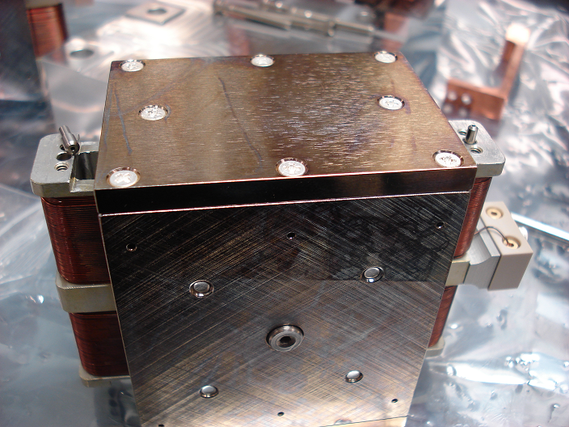

2.Attach Item (5) (D0902155) Actuator Coil Bracket, to Item (23) (D1001737) Step Pin and Item (1) (D1000584) Small Actuator using Item (13) washer and Item (14) screw.

5  1 | Note : Look this face, connector on the right  #4, 0.115 ID, 0.209 OD, 0.016 THK  UCC WFV-04  SHCS 4-40 X 0.75 lg.  MSC 05664073  Torque value : 5.2 in-lbs

3.Attach Items (3) (D0902154) Left Thermal Bar and Item (4) (D0902153) Right Thermal Bar, to Item (1) (D1000584) Small Actuator and Item (5) (D0902155) Actuator Coil Bracket using Item (13) washer and Items (14)/(15) screws.

4  3 | SHCS 4-40 X 0.25 lg.  MSC 82272881  Torque value : 5.2 in-lbs
SHCS 4-40 X 0.75 lg.  MSC 05664073  Torque value : 5.2 in-lbs | #4, 0.115 ID, 0.209 OD, 0.016 THK  UCC WFV-04

4. Insert Item Dowel Pin into Item (1) (D0902749) Large Actuator.

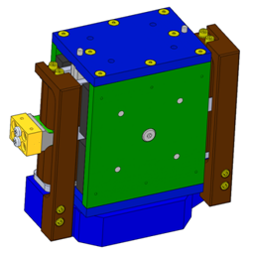
SHCS 1/8 X 3/8 lg.
MC MASTER 90145A470

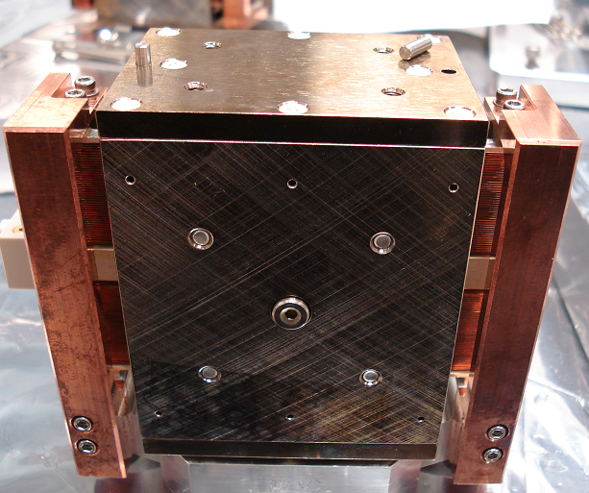

5. Attach Items (2) (D0902161) Small Actuator Mount, to Item (1) (D1000584) Small Actuator using Item (18) vent washer and Items (20) screw.

Note : connector on the right

SHCS 8-32, 1.50 lg. AG Plate
UCC C-824-NA
Torque value : 19.8 in-lbs
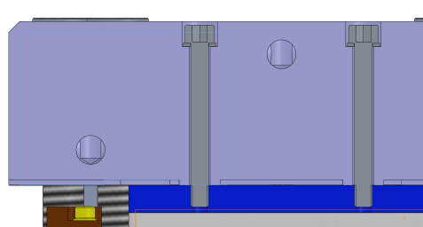
0.17 ID, 0.304 OD, 0.032 THK
UC COMPONENTS WFV 08

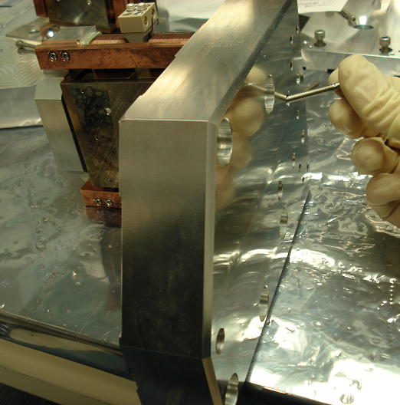

6. Tooling Bracket Assembly
Attach Part D0902137 Tooling Bracket (only the bottom), to Step Pin and Item (1) (D1000584) Small Actuator using vent washers and screws.

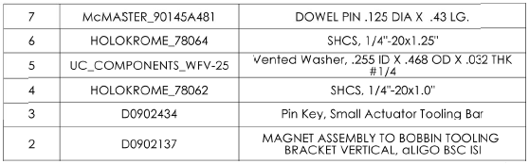

7. Loose the 2 shoulder screws of Item (1) (D1000584) Small Actuator.
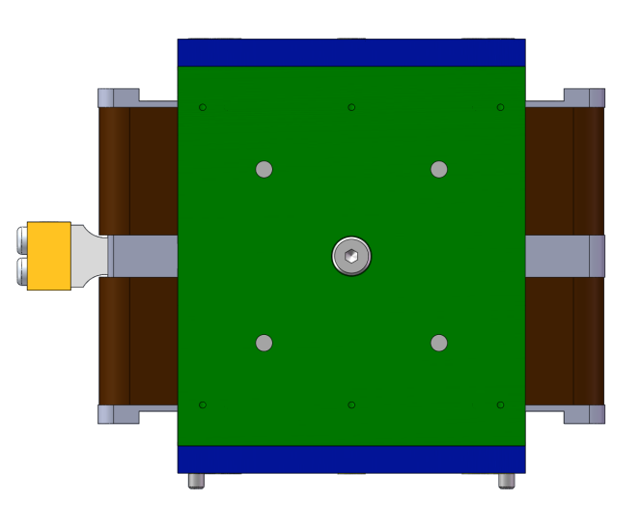
8. Slide Pin Carrier (D0902434) into the Tooling Bar and Item (5) (D0902155).
SHCS 8-32, 0.50 lg.
HOLOKROME 78028
Torque value : 19.8 in-lbs
9. Remove the 2 shoulder screws of Item (1) (D1000584) Small Actuator.

10. Add the two last screws and washers in the Tooling Bar
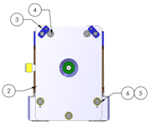

11. Remove the Pin Carrier (D0902434).

Gap Test : Go / No Go

- Check the gap between the coil and the magnet with shims on both sides.
Go : 0.085 inches
No Go : 0.115 inches

