**Vibration Absorbers location:**

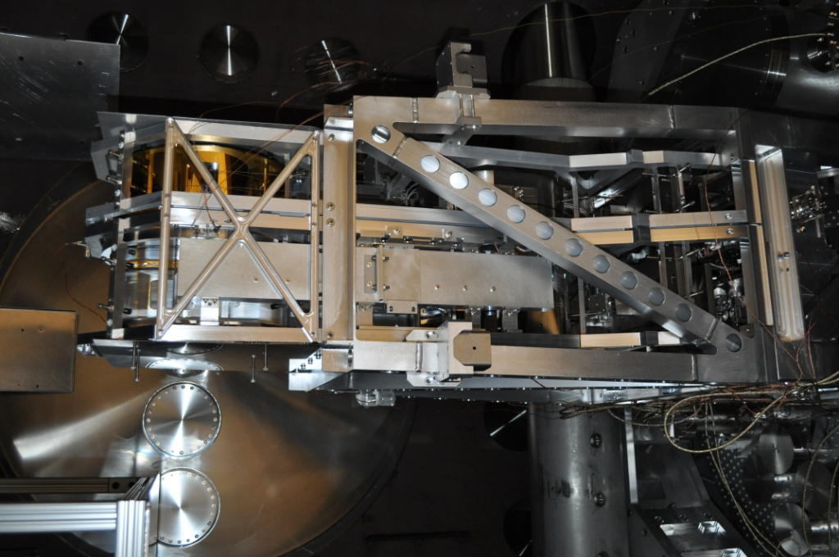

**Transfer function before keel mass damper experiment (Black)**

**Transfer function after keel mass damper experiment (Red)**

**Transfer function with keel mass damper and vibration absorbers (Blue)**











