-

LIGO Laboratory / LIGO Scientific Collaboration

LIGO- E1000486 LIGO January 19, 2010

aLIGO BSC-ISI, Pre-integration Testing procedure,
Phase I (post-assembly, before storage)
E1000486 – V5

Vincent Lhuillier, Fabrice Matichard

Distribution of this document:
Advanced LIGO Project

This is an internal working note
of the LIGO Laboratory

California Institute of Technology  LIGO Project – MS 18-34  1200 E. California Blvd.  Pasadena, CA 91125  Phone (626) 395-2129  Fax (626) 304-9834  E-mail: info@ligo.caltech.edu | Massachusetts Institute of Technology  LIGO Project – NW22-295  185 Albany St  Cambridge, MA 02139  Phone (617) 253-4824  Fax (617) 253-7014  E-mail: info@ligo.mit.edu
LIGO Hanford Observatory  P.O. Box 1970  Mail Stop S9-02  Richland WA 99352  Phone 509-372-8106  Fax 509-372-8137 | LIGO Livingston Observatory  P.O. Box 940  Livingston, LA 70754  Phone 225-686-3100  Fax 225-686-7189

Table of contents:

Introduction 4
I. Pre-Assembly Testing 5
▪ Step 1 - CPS Test and calibration – E1100231 5
▪ Step 2 - GS13 – Inspection/Assembly – E1000058 – E110740 5
▪ Step 3 - L4C – Inspection/Assembly – E1000136 – E1100740 5
▪ Step 4 - T240 – Inspection/Assembly - E1100326 – E1100740 5
▪ Step 5 - Actuators - T0900564-T1100234 6
▪ Step 6 – Geophones inspection after shipping 6
II. Tests to be performed during assembly 7
▪ Step 1 - Test stand level 7
▪ Step 2 - Actuators Inventory – E1100741 7
▪ Step 3 - Sensors Inventory – E1100369 – E1100740 7
▪ Step 4 - Electronics Inventory 9
▪ Step 5 - Check level of Stage 0 after top-bottom plate assembly (to be removed) 10
▪ Step 6 - Check gaps under the blade posts – (To ber removed) 11
▪ Step 7 - Blade post shim thickness 11
▪ Step 8 - Blade post launch angle (to be removed) 11
▪ Step 9 - Gap checks on actuators 13
▪ Step 10 - Mass budget 14
▪ Step 11 - Lockers adjustment 16
▪ Step 12 – Cables inventory – E1100822 17
▪ Step 13 - Cable routing – E1101028 17
III. Tests to perform after assembly 18
▪ Step 1- Geophones pressure readout 19
▪ Step 2- Set up sensor gaps and lockers – Locked vs unlocked position 20
▪ Step 3- Performance of the limiters 23
o Step 3.1 - Test Nº1 – Push “locally” 23
o Step 3.2 - Test Nº2 - Push “in the general coordinates Z/RZ” (to be removed) 24
▪ Step 4 - Sensors Spectra 26
▪ Step 5 - Coil Driver, cabling and resistance check 30
▪ Step 6- Actuators Sign and range of motion (Local drive) 32
o Step 6.1 - Actuators sign 32
o Step 6.2 - Range of motion - Local drive 33
▪ Step 7 - Vertical Spring Constant 34
▪ Step 8 - Static Testing (Tests in the local basis) 35
▪ Step 9- Static Testing - In the general coordinate basis (Static test - CPS) 37
o Step 9.1 – Base change matrices from local to Cartesian 37
▪ Step 10 - Linearity test 39
▪ Step 11 – Transfer functions – Local to Local 40
▪ Step 12 - Basis change – Cartesian to Local - Simulations 44
▪ Step 13- Transfer functions - Cartesian to Cartesian - Measurements 44
▪ Step 14 - Lower Zero Moment Plan (Is it doable?) 46
o Step 14.1 - Stage 1 - LZMP 46
o Step 14.2 - Stage 2 - LZMP 47
▪ Step 15- Damping Loops – Transfer function – Simulations 48
▪ Step 16- Damping Loops – Spectra 49
▪ Step 20- Isolation Loops – for one unit per site 50
IV. BSC-ISI testing Summary 51

Introduction

The BSC-ISI testing will be made in three phase:
1) BSC-ISI, Pre-integration Testing, Phase I (post-assembly, before storage)
2) BSC-ISI, Pre-integration Testing, Phase II : Final tests done after storage and before insertion
3) BSC-ISI, Integration Phase Testing: Procedure and results related to the commissioning in the cBSCber.

This document describes the test to be done on the BSC-ISI Pre-integration Testing, Phase I. All the units have to be tested with this procedure prior storage. Due to the several procedure releases, each test reports must mentioned the procedure version used during testing.

Companion documents:
T1000433 BSC-ISI LHO test stand, software and electronic check

Tests reports and results for each unit, including SVN data location (one test report per BSC-ISI):
LASTI:
- E1100281, aLIGO BSC-ISI, First Article (Dirty assembly) Testing at LASTI
LHO:
- E1100294, aLIGO BSC-ISI, Pre-integration Test Report, Phase I, LHO Unit #1
- E1100295, aLIGO BSC-ISI, Pre-integration Test Report, Phase I, LHO Unit #2
- E1100296, aLIGO BSC-ISI, Pre-integration Test Report, Phase I, LHO Unit #3
- E1100297, aLIGO BSC-ISI, Pre-integration Test Report, Phase I, LHO Unit #4
- E1100298, aLIGO BSC-ISI, Pre-integration Test Report, Phase I, LHO Unit #5
- E1100299, aLIGO BSC-ISI, Pre-integration Test Report, Phase I, LHO Unit #6
- E1100300, aLIGO BSC-ISI, Pre-integration Test Report, Phase I, LHO Unit #7
- E1100301, aLIGO BSC-ISI, Pre-integration Test Report, Phase I, LHO Unit #8
- E1100302, aLIGO BSC-ISI, Pre-integration Test Report, Phase I, LHO Unit #8
- E1100303, aLIGO BSC-ISI, Pre-integration Test Report, Phase I, LHO Unit #10
LLO:
- E1100304, aLIGO BSC-ISI, Pre-integration Test Report, Phase I, LLO Unit #1
- E1100305, aLIGO BSC-ISI, Pre-integration Test Report, Phase I, LLO Unit #2
- E1100306, aLIGO BSC-ISI, Pre-integration Test Report, Phase I, LLO Unit #3
- E1100307, aLIGO BSC-ISI, Pre-integration Test Report, Phase I, LLO Unit #4
- E1100308, aLIGO BSC-ISI, Pre-integration Test Report, Phase I, LLO Unit #5
SVN:
- Excell spreadsheet (.xls)
- Data location
- Figures location
- Masses distribution scheme (ppt)

Notes:
- Useful information such as sign conventions or calibration numbers are highlighted in green.
- This is a preliminary version of this document. Missing information and unsolved issues are highlighted in red.

Pre-Assembly Testing

Step 1 - CPS Test and calibration – E1100231
All data related to the CPS testing can be found in the SVN at
/svn/seismic/Common/Data/ /

The tests report must contain:
- Test result (Passed: Failed: ).””

Step 2 - GS13 – Inspection/Assembly – E1000058 – E110740
All the data related to GS-13 post podding testing can be found in the SVN at : /svn/seismic/Common/Data/aLIGO_GS13_TestData/GeoTech_TestResults_PDFs/

E1000058 spreadsheet provides the status of each individual GS-13 at LLO site for BSC-ISI and BSC-ISI.

Acceptance Criteria:
- GS13 should have been already tested. GS-13 Inspection/Pod Assembly (D047810). Checklist is defined in F090070-v6. Testing procedure is defined in T0900342

The tests report must contain:
- Test result (Passed: Failed: ).”
”

Step 3 - L4C – Inspection/Assembly – E1000136 – E1100740
All the data related to L4C post podding testing can be found in the SVN at : svn/seismic/Common/Data/aLIGO_L4C_TestData/TestResults_PDFs/

E1000136 spreadsheet provides the status of each individual L4C at LLO site for BSC-ISI and BSC-ISI.

Acceptance Criteria:
- L4C should have been already tested. L4C Inspection/Pod Assembly (D047820)

The tests report must contain:
- Test result (Passed: Failed: ).”
”

Step 4 - T240 – Inspection/Assembly - E1100326 – E1100740
All the data related to T240 post podding testing can be found in the SVN at :
seismic/Common/Data/aLIGO_T240_TestData/AsReceived_TestResults_PDFs.

E1100326 spreadsheet provides the status of each individual T240 at LLO site for BSC-ISI.

Acceptance Criteria:
- T240 should have been already tested.

The tests report must contain:
- Test result (Passed: Failed: ).””

Step 5 - Actuators - T0900564-T1100234
Large actuator data can be found at: T0900564. Actuator inventory is made at Section II – Step 2.
Smal actuator data can be found at: T1100234. Actuator inventory is made at Section II – Step 2.

Acceptance Criteria:
- Actuators were previously tested and results are reported in T0900564.

The tests report must contain:
- Test result (Passed: Failed: ).””

Step 6 – Geophones inspection after shipping
After reception of the geophones at LHO, they are checked by measuring a Spectra and recording the pressure that is read by the IOP model (raw).

In the L4C and the GS13 case, measurements have to be done using the horizontal geophones to be able to read the absolute pressure measured by the geophone.

A matlab script used for the measurements is located in the SVN at:
/seismic/Common/MatlabTools/Seismometer_Test/TEST_Seismometer_After_Reception.m

Reference Spectra are located in
seismic/BSC-ISI/Common/Testing_Reference_Results_BSC_ISI/Reference_Spectra/
aLIGO_Reference_Spectra_BSC_ISI.mat

Tests to be performed during assembly

Step 1 - Test stand level
The Test stand has to be leveled within +/-2 mils

Step 2 - Actuators Inventory – E1100741
Write down the actuators serial number in the table below.

Stage 1 |  | Stage 2
Actuator | Actuator S/N | Actuator | Actuator S/N
H1 |  | H1
H2 |  | H2
H3 |  | H3
V1 |  | V1
V2 |  | V2
V3 |  | V3
Table 1 - Actuators' inventory

Acceptance Criteria
- Inventory is complete
- Edit the DCC document E1100741

The tests report must contain:
- The table “Actuators’ inventory”
- Issues/difficulties/comments regarding this test
- Test result (Passed: Failed: )

Step 3 - Sensors Inventory – E1100369 – E1100740
Write down the capacitive position sensors (CPS) number, the boards’ number, and mount number. The mount number is necessary for tracking since the CPS serial number is not any more visible once mounted. Write down the geophones’serial number, the POD # and the adaptor in the following tables.

Sensors Stage 1 | CPS S/N | ADE board serial #
H1
H2
H3
V1
V2
V3
Table 2 - Capacitive position sensors' inventory – Stage 1

Sensors Stage 2 | CPS S/N | ADE board serial #
H1
H2
H3
V1
V2
V3
Table 3 - Capacitive position sensors' inventory – Stage 2

The DCC document E1100369 has to be updated.

Geophones GS13 | Serial Number | POD
H1
H2
H3
V1
V2
V3
Table 4 - GS13 inventory

Geophones L4C | Serial Number | POD
H1
H2
H3
V1
V2
V3
Table 5 - L4C inventory

Geophones T240 | Serial Number | POD
1
2
3
Table 6 - T240 inventory

The DCC document E1100740 has to be updated.
Note: Sensors calibration is summarized in D1001575

Acceptance Criteria
- Inventory is complete
- Documents E1100740 and E1100369 updated

The tests report must contain:
- The tables of Capacitive position sensors’ inventory
- The table of Geophones’ inventory (GS13, L4C, T240)
- Issues/difficulties/comments regarding this test
- Generic SVN path of figures of geophones testing after podding
- Generic SVN path of figures of CPS testing
- Test result (Passed: Failed: ).

Step 4 - Electronics Inventory
Write down in the table below all serial numbers all the electronic equipment:

Hardware | LIGO reference | S/N
Interface Chassis - Corner 1
Interface Chassis - Corner 2
Interface Chassis - Corner 3
Anti-Alliasing Chassis - Corner 1
Anti-Alliasing Chassis - Corner 2
Anti-Alliasing Chassis - Corner 3
Anti-image Chassis
Binary Input Chassis
Binary Input Chassis
Binary Output Chassis
T240 Interface - Corner 1
T240 Interface - Corner 2
T240 Interface - Corner 3
I/O Chassis
Coil driver Pod 1
Coil driver Pod 2
Coil driver Pod 3
Table 7 - Electronic equipment

Acceptance Criteria
- Inventory is complete
- Report fix on the electronic during testing

The tests report must contain:
- The table “Electronic equipment”
- Issues/difficulties/comments regarding this test
Test result (Passed: Failed: ).

Step 5 - Check level of Stage 0 after top-bottom plate assembly (to be removed)

Procedure to follow for this test:
- Set up the Optical Level so that it has a good view of Stage 0.
- Ensure that the instrument is set up level and stable.
- Looking through the optical level record the height on the target (LHO’s shown below) of ~15 different points as evenly spaced as possible around Stage 0. It will be necessary to move the optical level to cover the whole assembly.
- After each move, check the heights of at least 2 previously measured points to control for the change in height at the new position. More overlap of measured points is better.

Tips: A large number of points scattered on stage 0 is necessary for this check

Note: The desired precision of these measurements is finer than that offered by most rulers, so it will be necessary to estimate from the optical level’s reticule relative to a convenient mark on the ruler.

Figure – Checking level of stage 0

Acceptance Criteria
- The maximum angle of the table with the horizontal musn’t exceed ~100µrad

The tests report must contain:
- Issues/difficulties/comments regarding this test
- Test result (Passed: Failed: ).

Step 6 - Check gaps under the blade posts – (To ber removed)

Procedure to follow for this test:
Try to push a 0.001 inch shim between the blade post, gussets and Stage 0 along the edges shown below.
Acceptance Criteria:
- A 0.001 inch shim cannot be passed freely through any connection to Stage 0 or between post and gussets. If shim can pass through, loosen all constraining bolts, and then retighten iteratively from the center of the part to the edges. Retest.

The tests report must contain:
- Test result (Passed: Failed: ).””

Step 7 - Blade post shim thickness
Procedure to follow for this test:
- Report the shim thickness of each lockers
\

Stage 1 |  | Stage 2
Lockers | Shim thickness (mil) | Lockers | Shim thickness (mil)
A |  | A
B |  | B
C |  | C
Table 8 - Shims thickness

Step 8 - Blade post launch angle (to be removed)
The lauch angle of the blade post is measured using the rommer arm.

Procedure to follow for this test:
The launch angle of the blade post is measured using the rommer arm. Place the rommer arm tip at 20 points on the surface of the 4 following surfaces:
- Granite table surface (reference)
- Sprint mount (angled surface)
- Inner face
- Outer face

 | SN #1 |  | SN #2 |  | SN #3
 | Meas1 | Meas 2 | Meas1 | Meas 2 | Meas1 | Meas 2 | Units
Granite table flatness |  |  |  |  |  |  | "
Spring mount flatness |  |  |  |  |  |  | "
Inner face flatness |  |  |  |  |  |  | "
Outer face flatness |  |  |  |  |  |  | "
Launch Angle |  |  |  |  |  |  | °
Height of the post |  |  |  |  |  |  | "

Blade launch angle (Nominal) |  | 13.710 |  | °
Blade launch angle (Tolerance) |  | 0.030 |  | °
Height |  |  | 14.655 | "
Height (Tolerance) |  |  | 0.002 | "

Angle | 0.02 | °
Blade tip offset | 0.006 | "
Stiffness | 1241 | lb/in
Mass | 7.36 | lb

Acceptance Criteria:
- The blade launch angle must be 13.71+/-0.03 ͦ

The tests report must contain:
- Test result (Passed: Failed: ).””

Step 9 - Gap checks on actuators

Procedure to follow for this test:
After assembly use sized Teflon shims to measure gaps between stops and coils. Starting with 0.080”, adjust the stack height until the Teflon shims just barely pass freely between the coils and stops. Record the results
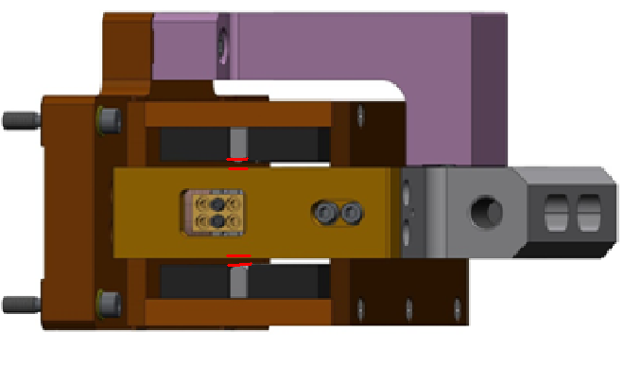
Figure - Showing gaps that need to be checked on actuators.

Issues/difficulties/comments regarding this test:

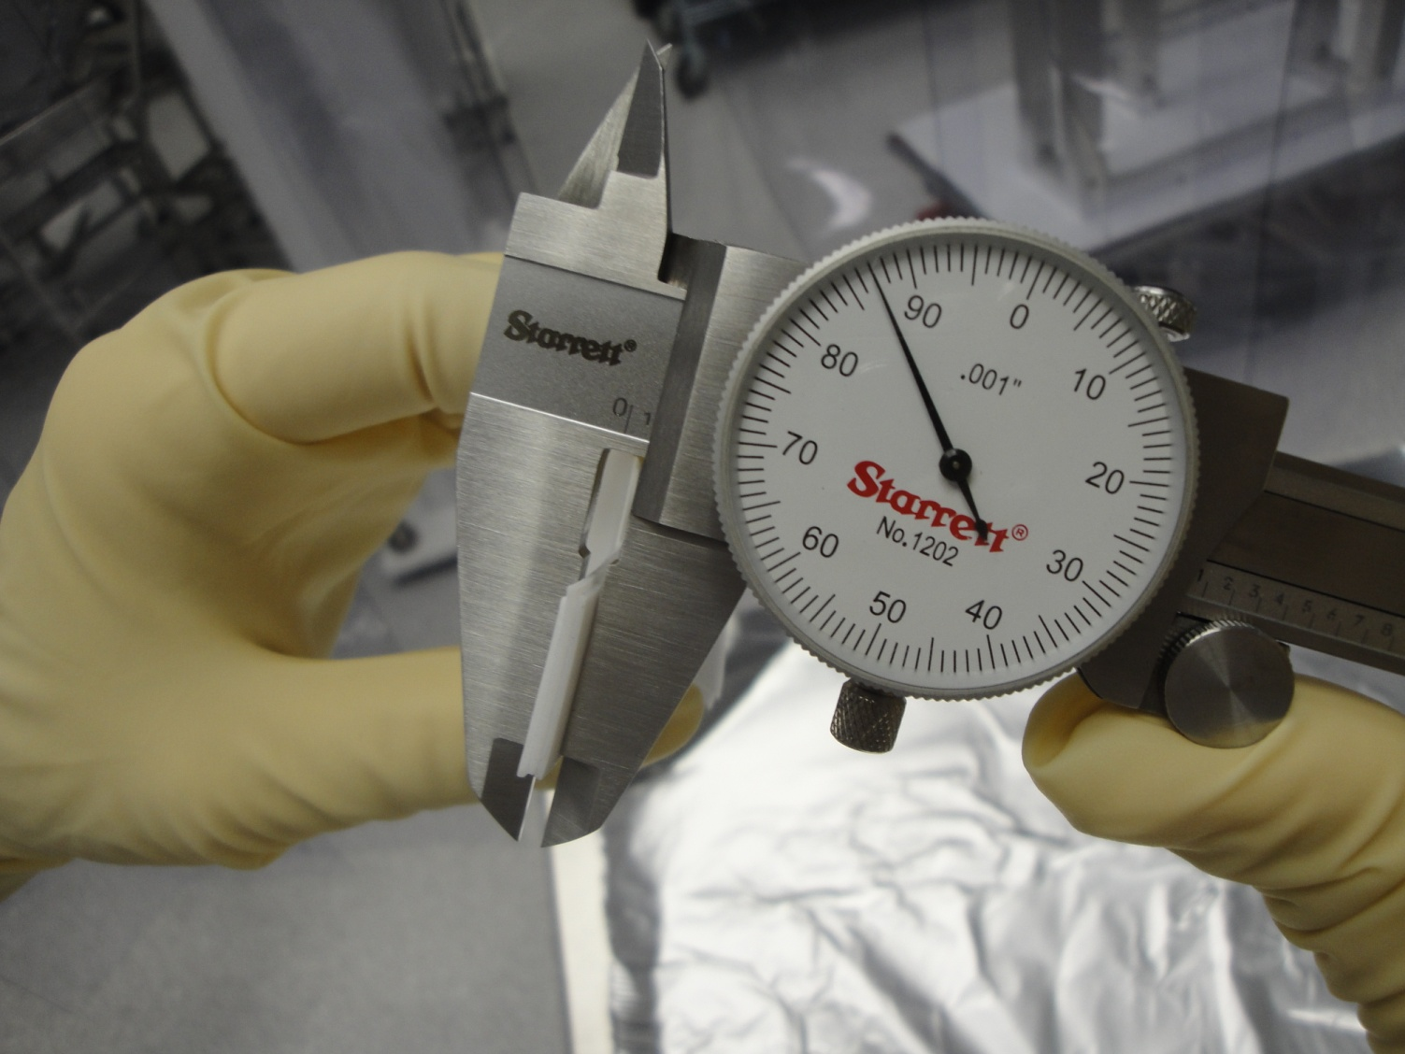
Figure - Stack of Teflon shims being measured for gap check of actuators.

Acceptance Criteria
- Gaps must be within 0.010” of design 0.08” (i.e. 0.090” and .070” pass, but 0.095” and 0.065” doesn’t).

The tests report must contain:
- Test result (Passed: Failed: ).””

Step 10 - Mass budget
During this step, the mass budget of the BSC-ISI is checked.

Procedure to follow for this test:
- Record the amount of mass used for each location and report in a table like the following ones

Stage 1
Location | Weight (lb) | Weight (Kg)
C1-1
C1-2
C2-1
C2-2
C3-1
C3-2
Total

Stage 2
Quantity | Weight (Kg) | Total Weight(Kg)
Total : |  |  | Kg

- Draw a map of masses distribution (a template can be found in on the DCC E1100294: Mass_distribution_BSC_ISI_8_Staging_Building.pptx
- Take a picture of the optic table
The nominal payload defined by the design is reported below:
Nominal payload on stage 1: 109Kg – 240lb
Nominal payload on stage 2: 1185Kg – 2612lb
After testing 2 units (BSC6 and BSC8) at LHO, it seems the payload is 5% lower than design due to an extra softness of the assembly.

Here is an example with the BSC-ISI-LHO – BSC8 in the staging building

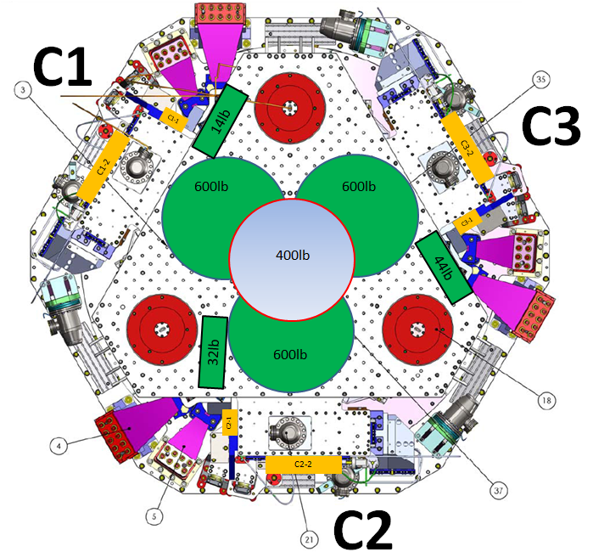
Figure - Masses distribution – BSC8 – Staging Building

Acceptance Criteria
The Mass budget must be :
- Nominal payload on stage 1: 109Kg – 240lb (-5% +/- 2% due to blade softness)
- Nominal payload on stage 2: 1185Kg – 2612lb (-5% +/- 2% due to blade softness)
The tests report must contain:
- The table “Masses distributions”
- Map of the mass location
- Issues/difficulties/comments regarding this test
- Test result (Passed: Failed: ).

Step 11 - Lockers adjustment
In this test, the motion of the ISI platform between the locked and the unlocked position are measured.

Once both stages are locked, dial indicators are set to zero and the table is released. In the table below reports the dial indicators evolution when unlocking the table. We consider the table centered when the difference doesn’t exceed 0.002”.

Note:
Vertical dial indicators read negative for increasing height of Optical Table.

Procedure to follow for this test:
- Lock both stages
- Set dial indicator to zero between stage 0 and stage 2
- Unlock stage 0-1
- Report dial indicators readouts in the table below
- Lock stage 0-1 and reset the dial indicators
- Unlock stage 1-2
- Report dial indicators readouts in the table below

 | Stage 1 |  | Stage 2
D.I at Lockers | Dial indicators V | Dial indicators H | Dial indicators V | Dial indicators H
A
B
C
Table 9 - Dial indicators read-out (stage locked-unlocked independently)

Acceptance Criteria
- Vertical and horizontal displacement near the lockers must be lower than 2 mils (0.002”)

The tests report must contain:
- The table “Dial indicators read-out (table locked-unlocked)”
- Issues/difficulties/comments regarding this test
Test result (Passed: Failed: ).

Step 12 – Cables inventory – E1100822
The location of all cables must be reported in the spreadsheet E1100822. This step MUST NOT BE SKIPPED. This cable inventory is reused when side-testing and in-chamber testing. Class-A cables tags have to be added to facilitate reconnections during side-testing and in chamber testing.

Step 13 - Cable routing – E1101028

Procedure to follow for this test:
- Pictures of the optimal cable routing are presented in E1101028
- Make sure the cables are not touching the stages between two clamping brackets.

Note: The hysteresis-linearity test as well as the transfer functions measurements might show the possible contact between cables and the ISI.

The tests report must contain:
- Issues/difficulties/comments regarding this test
- Test result (Passed: Failed: ).

Tests to perform after assembly
This section describes the tests that are performed to check and validate the subassemblies and the overall assembly. Data, Matlab scripts, figures and documentations must be posted on the SVN. X1 and X2 are respectively the Hanford and the Livingston test stand. In this procedure document, an example is given for tests realized on BSC-ISI-LHO-BSC8. SVN information that refers to sites, units # and dates are colored in red. Black is used for generic name. This procedure refers to scripts that may evolve with time. All the testing scripts are now generic to all BSC-ISI (multi-sites). The testing functions are launched from a unique script called Master_TEST_<UNIT_ID>.m
An example of the script that enables to launch all the testing function can be found in the SVN at:
seismic/BSC-ISI/H2/ITMY/Scripts/Data_Collection/Master_TEST_LHO_ISI_BSC8.m

This script calls testing functions located in the SVN at:
seismic/BSC-ISI/Common/Testing_Functions_BSC_ISI/

The functions that interact with the MEDM screens are located in the SVN at:
seismic/BSC-ISI/Common/MEDM_Functions_BSC_ISI/

The reference filters file that contains input and output filters is located in:
cds_user_apps/trunk/filterfiles/H2ISI_COMMON.txt

Even if the RCG is generating the .ini file, a list of the usefull channels with their respective sample rates can be found in the SVN at:
BSC-ISI/H2/ITMY/Channels_List/H2_BSC_ISI_Channellist_20110628.txt
The ini file can be recreated with write_ini_file

Transfer functions measurements scripts are detailed in step 11.
Note 1: Before starting testing, run the function Populate_MEDM_Screen_BSC_ISI.m. This script sets all the BIO switches and populates all the matrices. The input arguments are ‘IFO’, ‘Chamber’, ‘Direction’ and ‘Set_Gains’. Set_Gains must be set to one.
Note 2: This input and output filters must be loaded. The state of the BIO switches is changed when the filters are engaged or disengaged.
Note 3: Create shortcuts in the Matlab toolbar to create the seismic Matlab path.
Note 4: Balancing in the Cartesian basis (Z) allows having the right weight of payload even when the ISI is not balanced
MAKE SURE THE ACTUATOR COMPENSATION FILTERS ARE ENGAGED (They introduced a minus sign!)
NEVER SAVE THE MATLAB PATH
BEFORE STARTING TESTING THE ISI
MEASURE QUICK SPECTRA TO MAKE SURE GEOPHONES ARE WORKING

Step 1- Geophones pressure readout
Read and report the absolute and the relative pressures (in counts) read on ADC0, ADC1 and ADC2. A matlab scripts enables to quickly fill the table below.

Matlab Script:
A matlab script Pressure_Sensor_Check(IFO,Optics,Computer_name,Unit_ID) enables to read the pressure on the IOP input. Copy the generated table and paste it in the table below.

 | Pressure (count)
Sensors | Corner 1 | Corner 2 | Corner 3
ST1-L4C-D
ST1-L4C-P
ST1-GS13-D
ST1-GS13-D
ST1-T240-P
Table - Sensor pressure (Counts)

Acceptance criteria:

  - The absolute pressure on the L4Cs and the GS13s must be 24700 +/- 500 counts (100+/- 2 KPA)
  - The differential pressure on the L4Cs and the GS13s must be <2400 counts (2 KPa)
  - The absolute pressure on the T240 must be 14300 +/-300 counts (100 +/- 2 KPA)

The tests report must contain:
- The table “Sensors pressures”
- Issues/difficulties/comments regarding this test
- Test result (Passed: Failed: ).

Step 2- Set up sensor gaps and lockers – Locked vs unlocked position
During this step, sensors gap are adjusted. This step considers that the lockers have been finely setup during assembly.

Procedure to follow for this test:
- Lock the BSC-ISI
- Add 30 Kg masses at each corner of stage 1(A, B, C) and Stage 2 (D, E, F). Corners are presented in red

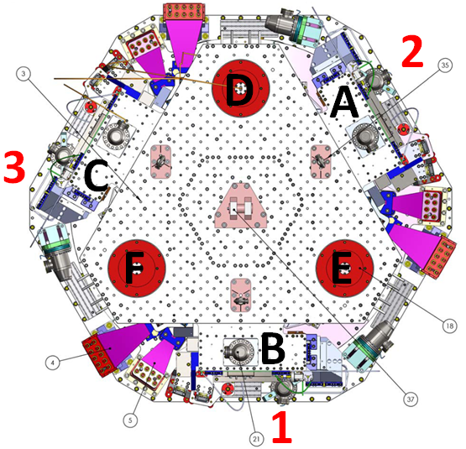
Figure – Corners location

- Pull up the capacitive position sensors (CPS) signals in a data viewer window
- Adjust the displacement sensor target position so that the collocated DISP channels readout is less than 400 counts for stage 1 CPS and 1600 counts for stage 2 CPS on Dataviewer (a bit less than .0005”).
- Lock the target
- Write down the mean values and standard deviation in the table below (call the Matlab functions Offset_STD_CPS_BSC_ISI(IFO,Optics) in the locked and the unlocked configuration

 | Table locked |  | Table unlocked |  | Difference locked - unlocked
Sensors | Offset (Mean) | Std deviation | Offset (Mean) | Std deviation | Offset (Mean) | mil
ST1 - H1
ST1 - H2
ST1 - H3
ST1 - V1
ST1 - V2
ST1 - V3
ST2 - H1
ST2 - H2
ST2 - H3
ST2 - V1
ST2 - V2
ST2 - V3
Table 10 - Capacitive position sensors readout after gap set-up

Matlab script:
Offset_STD_CPS_BSC_ISI.m computes the offset/STD at the execution time. The function waits for about 40 s before getting the results (30s are required before accessing the data from the frame builder). Column 1 of the table “Offset_STD_CPS” are the offsets, column 2 are the Standard deviations. Lines are the sensors (ST1-H1, ST1-H2, ST1-H3, ST1-V1, ST1-V2, ST1-V3; ST2-H1, ST2-H2, ST2-H3, ST2-V1, ST2-V2, ST2-V3). The result table “Offset_STD_CPS” can be copied and pasted in the test report as it is. This function doesn’t save any .mat file.
CPS_Read_Back_BSC_ISI(IFO,Optics,CPS_Readback) is a function that allows to read CPS offsets and STD back in time.

Notes:
- Before starting the gap set up, the targets are typically far from their target and consequently out of range. The signal should be +32000 counts. However, when the ADC saturates it can go to 0. The bottom line is that a 0 count signal doesn’t mean that the sensor is broken.
- When the target to sensor gaps gets larger, the MEDM count value increases (maximum gap is positive). When the target to sensor gaps gets smaller, the MEDM count value decreases (minimum gap is negative).

Acceptance criteria:

- In the locked position, all mean values must be lower than 400 counts for stage 1 CPS and 1600 counts for stage 2 CPS on Dataviewer (a bit less than .0005”).
- In the locked position, all standard deviations below 5 counts for stage 1, 20 counts for stage 2
- Absolute values of the difference between the unlocked and the locked table must be below:
Stage 1
  - 1600 cts for horizontal sensors (~0.002”)
  - 1600 cts for vertical sensors (~0.002”)
Stage 2
  - 6500 cts for horizontal sensors (~0.002”)
  - 6500 cts for vertical sensors (~0.002”)
- Considering the acceptance criteria of step 2, all mean values must be lower than
Stage 1
  - 2000 cts for horizontal sensors (~0.0025”)
  - 2000 cts for vertical sensors (~0.0025”)
Stage 2
  - 8000 cts for horizontal sensors (~0.0025”)
  - 8000 cts for vertical sensors (~0.0025”)

Note: The locker offset is set to +2 mils in step I.11.

The tests report must contain:
- The table “Capacitive position sensors readout after gap set-up”
- When the gap between the sensor head and the target gets larger MEDM counts increases
- Issues/difficulties/comments regarding this test
- Test result (Passed: Failed: ).

Step 3- Performance of the limiters
The two following tests enable to verify three points:
- Sensors signs
- Sensors range of measurement
- Check the stages range of motion

The range of motion of the BSC-ISI is tested while alternatively locking Stage 1 and Stage 2.

Step 3.1 - Test Nº1 – Push “locally”
The aim of this test is to check the potential contact between the different elements of the actuators or the sensors. The lockers should always limit the Actuators/Sensors from closing their gaps).

Procedure to follow for this test:
- Unlock stage 1 and stage 2
- Apply manually a force tangent to the stage (sensor axis you are testing (+ and - directions))
- For displacement sensors check
  - Move the table such that the stage is as close as you can get it to the Sensor Head. This motion is monitored visually in dataviewer and Sensor counts are recorded.
  - Move the table such that the target is as far as you can get it to the Sensor Head. This motion is monitored visually in dataviewer and Sensor counts are recorded.
- For the Actuators, check all possible contacts point. One person watches the Actuator while two people move the table in every direction possible. If there is no contact give the Actuator a positive “X”/PASS.

Displacement sensors and actuator gap check:

Sensors | Push in positive direction | Push in negative direction | Railing (ADC) | Actuator Gap Check
ST1 - H1
ST1 – H2
ST1 - H3
ST1 - V1
ST1 - V2
ST1 - V3
ST2 - H1
ST2 - H2
ST2 - H3
ST2 - V1
ST2 - V2
ST2 - V3
Table 11 - Stages range of motion – “Push locally”

Acceptance criteria:
- The vertical sensor readout must be positive when the optic table is pushed in the +Z direction
- The horizontal sensor readout must be negative when the optic table is pushed in the +RZ direction
- Step 3.1
  - Absolutes value of all estimated motions must be higher than 15000counts for stage 1 (~0.018”)
  - Absolutes value of all estimated motions must be higher than 32000counts for stage 2 (~0.010”)

The tests report must contain:
- The table Stages range of motion – “Push in the general coordinates”
- The table Stages range of motion – “Push locally”
- Issues/difficulties/comments regarding this test
- Test result (Passed: Failed: ).

Step 3.2 - Test Nº2 - Push “in the general coordinates Z/RZ” (to be removed)
This test requires two persons in the clean room and one person in front of the computer. This test is done in 2 phases:
- Stage 0-1 is unlocked and stage 1-2 is locked
- Stage 0-1 is locked and stage 1-2 is unlocked.

Procedure to follow for this test:
- Unlock stage 1 and lock stage 2
- The two operator in the clean room push simultenaously on stage 1 in the direction +Z or -Z or +RZ or -RZ until the stage touches the lockers
- The operator in front of dataviewer write down the sensors readout when the stage touches the lockers
- Lock stage 1 and unlock stage 2
- The two operator in the clean room push simultenaously on stage 2 in the direction +Z or -Z or +RZ or -RZ until the stage touches the lockers
- The operator in front of dataviewer write down the sensors readout when the stage touches the lockers
- Report the sensor readout in the table “Push in the general coordinates”

Vertical displacement sensors:
At each corner (A, B, C when stage 1 is unlocked or D, E, F when stage 2 is unlocked) , push down gently (uniformly) on the stage and watch the response in dataviewer. While pushing up/down, you have to make sure that the stage is not rotating. All sensors should respond with the same sign. When the stage is going down (-Z), the gap between the probe and the sensor decreases. Consequently vertical sensor readout is going in the negative direction. Push up/down until the stage is in contact with the locker. Report the MEDM count values in the table below.
Horizontal displacement sensors:
At each corner (A, B, C when stage 1 is unlocked or D, E, F when stage 2 is unlocked, push the stage tangentially at the plane of the sensors in one direction. While rotating, you have to make sure that the stage is not going up/down. All sensors should respond with the same sign. When the stage is turning -RZ or clockwise (viewed from top), the gap between the probe and the sensor decreases. Consequently, horizontal sensor readout is going in the positive direction. Rotate until the stage touches the locker. Report the MEDM count values in the table below.

 | CPS read out |  | Calculated after calibration
Sensors | "-Z" (Counts) | "+Z" (Counts) | "-Z" (mil) | "+Z" (mil)
ST1 - V1 - ST2 LCK
ST1 - V2 - ST2 LCK
ST1 - V3 - ST2 LCK
ST2 - V1 - ST1 LCK
ST2 - V2 - ST1 LCK
ST2 - V3 - ST1 LCK
 | CPS read out |  | Calculated after calibration
Sensors | "-RZ" (Counts) | "+RZ" (Counts) | "-RZ" (mil) | "+RZ" (mil)
ST1 - H1 - ST2 LCK
ST1 - H2 - ST2 LCK
ST1 - H3 - ST2 LCK
ST2 - H1 - ST1 LCK
ST2 - H2 - ST1 LCK
ST2 - H3 - ST1 LCK
Table 12 - Stages range of motion – “Push in the general coordinates”

Acceptance criteria

  - No contact point on sensors
  - Absolute value of sensor read out must be higher than 17000counts (~0.020”) for stage 1
  - Absolute value of sensor read out must be higher than 32000counts (~0.012”) for stage 2
  - No contact point on actuators

Step 4 - Sensors Spectra
The sensors Spectra are measured in different configurations:
- Stage 1 tilted
- Stages 2 tilted
- Stages locked (loaded with masses)
- Stages unlocked

The ASD are measured and calibrated using Matlab. During testing, you just need to record the GPS time.

Procedure to follow for this test:
- Unlock stages 1 and 2 of the BSC-ISI
- Load alternatively with a 30 Kg mass in the actuator pocket and blade pocket of corners 1,2 and 3. Note the GPS time and wait for 2 minutes between every mass swap.
- Note the GPS time and wait for 45 minutes in the Full unlocked configuration
- Report GPS Time in the table below and use the following programs to display ASD:
  - ASD_Measurements_Local_BSC_ISI
  - ASD_Measurements_Stages_Tilted_BSC_ISI.m

Matlab
A Matlab function is used to plot the spectra of the Geophones when the table is locked, unlocked and tilted.
Follow the steps below:
- Edit the GPS time for the different masses location
- Run the script and paste the figure in the report

Measurements # | Configuration | Mass location | GPS TIME
1 | ST1 Unlocked  ST2 Unlocked | Actuator pocket  Corner 1
2 | ST1 Unlocked  ST2 Unlocked | Blade Post  Corner 1
3 | ST1 Unlocked  ST2 Unlocked | Actuator pocket  Corner 2
4 | ST1 Unlocked  ST2 Locked | Blade Post  Corner 2
5 | ST1 Unlocked  ST2 Locked | Actuator pocket  Corner 3
6 | ST1 Unlocked  ST2 Locked | Blade Post  Corner 3
7 | ST1 Locked  ST2 locked | A, B, C, D, E, F
8 | ST1 Unlocked  ST2 Unlocked | No mass
Table 13 - GPS Time of the measurements

The parameters used to compute Spectra are reported in the table below:

 | Stages  locked/unlocked | Stages  tilted
F resolution | 0.02 Hz | 0.25 Hz
Average | 100 | 50
Overlap (%) | 50 | 50
Table – Spectra parameters

Sensor calibration filters are detailed in appendix X:

Data files in SVN at:
/svncommon/seisvn/seismic/BSC-ISI/H2/ITMY/Data/Spectra/Undamped
- LHO_ISI_BSC8_ASD_m_CPS_T240_L4C_GS13_DATE.mat
- LHO_ISI_BSC8_ASD_m_L4C_GS13_Stage_Tilted_DATE.mat

Figures in SVN at:
/svncommon/seisvn/seismic/BSC-ISI/H2/ITMY/Data/Figures/Spectra/Undamped/
- LHO_ISI_BSC8_ASD_CT_CPS_T240_L4C_GS13_DATE.fig
- LHO_ISI_BSC8_Tilted_ASD_m_ST1_L4C_DATE.fig
- LHO_ISI_BSC8_Tilted_ASD_m_ST2_GS13_DATE.fig

Issues/difficulties/comments regarding this test: Capacitive sensors use electric field for sensing. When multiple, independent capacitive sensors are used simultaneously, the electric field from one probe may be trying to add charge to the target, while another sensor is trying to remove charge. This conflicting interaction will create errors in the sensors’ outputs. This problem is solved by synchronizing the sensors. Synchronization sets the drive signal of all sensors to the same phase so that all probes are adding or removing charges simultaneously and interferences are eliminated. Interferences between ADE boxes can be roughly estimated by measuring standard deviation when one of the two satellite boxes is off.

The calibrated shouldn’t overshoot the reference Spectra (needs to be added in the functions) or the values reported in the following table:

 |  | Table locked |  | Stages unlocked
 |  | at 0.1 Hz | at 1 Hz | at 0.1 Hz | at 1 Hz
Stage 1 | Horizontal CPS
Stage 1 | Vertical CPS
Stage 2 | Horizontal CPS
Stage 2 | Vertical CPS
Table 14 – CPS Spectra levels

 | Stages locked |  |  | Stages unlocked
 | at 0.1 Hz | at 1 Hz | at 10Hz | at 0.1 Hz | at 1 Hz | at 10Hz
Horizontal L4C
Vertical L4C
T240 X
T240 Y
T240 Z
Horizontal GS13
Vertical GS13
Table 15 – Geophones Spectra levels - locked & unlocked

 | Stages tilted
 | at 0.1 Hz | at 1 Hz | at 10Hz
Horizontal L4C
Vertical L4C
T240 X
T240 Y
T240 Z
Horizontal GS13
Vertical GS13
Table 16 - Geophones Spectra levels - Stages tilted

Acceptance criteria:
- No cross talk on CPS (peaks at low frequencies + harmonics on measurements)
- All spectra must be similar per instrument type.
- Magnitudes of power spectra must be lower than the criteria defined in the table above

Warning:
Ground motion induced by ventilation, pumps, etc, can create relative motion between stages even in a locked configuration. The figure below is an ASD of a L4C in the LHO assembly area.

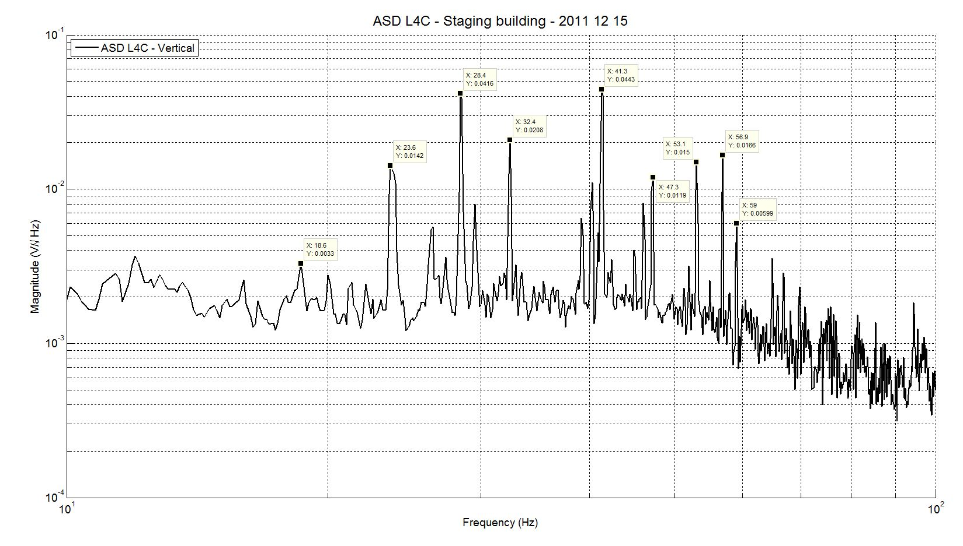
Figure - ASD Vertical - L4C LHO staging building

The tests report must contain:
- The calibrated Spectra of capacitive position sensors in the locked and unlockeed position
- The calibrated Spectra of geophones
  - When one of the stages is titled
  - When the stage 1 is unlocked and stage 2 is unlocked
stage 1 is locked and stage 2 is locked
- SVN paths of
  - Data files (with date label)
  - Figures
- Issues/difficulties/comments regarding this test
- Test result (Passed: Failed: ).

Step 5 - Coil Driver, cabling and resistance check
Before driving actuators, a few tests have to be carried out to check for shorts.

MEDM
- In MEDM open BSC_ISI_OVERVIEW.adl at the following location :
- Watchdog values, base change matrices can be uploaded with Populate_MEDM_Screen_BSC_ISI(‘IFO’,’Chamber’,’Direction’,1).m

Upload Watchdog limit values

For testing after assembly until the implementation of the damping filters, L4C, GS13 and T240 watchdogs don’t need to be set.
The matlab function Set_Watchdog_BSC_ISI(‘IFO’,’Chamber’,’Setup’) can be used to set watchdogs values. The sensor watchdogs are disengaged during testing. Only the actuators watchdogs remain (Setup value = 4).

Watchdog | Limits (counts) | Safe Limit (counts)
CPS | 100000 | 30000
L4C | 100000 | 30000
T240 | 100000 | 30000
GS13 | 100000 | 30000
Actuators | 30000 | 30000
Table 17 - Watchdogs set-up

On the actuator cable (vacuum side of the feedthrough)
The actuator cable is a three pin cables. All three pins are connected to a voltage drive, even though only two pins are used to drive actuators.
Pins are connected such the shield ground is not connected to the middle pin of the plug.

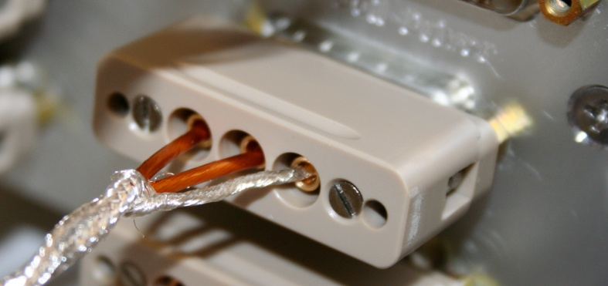
Figure – Actuator cable plugged on the feedthrough

Procedure to follow for this test:
- Lock the ISI
- Turn coil Driver (D0902744) OFF
- Disconnect the actuator cable at the back side of the coil driver
- Measure the resistance between the side pins and the middle pin of the actuator cable
- Measure the coil driver output for a 1000 counts offset drive (if no voltage, check the anti-image pin)
- Make sure there is no conductance between the two side pins
- Reconnect actuator cable to the coil driver
- Turn coil driver (D0902744) ON and make sure all LEDs on the front panel are green

Actuator | Coil driver name | Resistance (Ω)
ST1 H1 | Coil1 Coarse 1
ST2 H1 | Coil 1 Fine 1
ST2 V1 | Coil 1 Fine 2
ST1 V1 | Coil 1 Coarse 2
ST1 H2 | Coil 2 Coarse 2
ST2 H2 | Coil 2 Fine 1
ST2 V2 | Coil 2 Fine 2
ST1 V2 | Coil 2 Coarse 2
ST1 H3 | Coil 3 Coarse 1
ST2 H3 | Coil 3 Fine 1
ST2 V3 | Coil 3 Fine 2
ST1 V3 | Coil 3 Coarse 2

Acceptance criteria:

- For the actuators of stage 1, the measured resistance between the middle pin and one side pin must be 6.3 +/-0.5 ohms
- For the actuators of stage 2, the measured resistance between the middle pin and one side pin must be 10.3 +/-0.5 ohms
- Actuator neutral pins must be connected on pin #1 (left side pin of the plug)
- Actuator drive pins must be connected on pin #2 (middle pin of the plug)
- Actuator ground shield pins must be connected on pin #3 (right pin of the plug)
- All LEDs on the coil driver front panel must be green the binary input bit must be in the upper state.

Note: Cable lengths significantly change the overall resistance. If the resistance is too high, evaluate the resistance of the field cable.

The tests report must contain:
- The table “Actuators resistance check”
- Issues/difficulties/comments regarding this test
- Test result (Passed: Failed: ).

Step 6- Actuators Sign and range of motion (Local drive)
In this step, actuators signs are verified (7.1) and the range of motion (7.2) is measured when the table is moved by actuators.

Step 6.1 - Actuators sign
This test enables to check and set the actuators sign.

Procedure to follow for this test:
- Connect actuators to coil driver
- Open MEDM and data viewer (Visualize actuators and sensors signals in the local basis)
- In MEDM, drive an offset of 1000 counts on one actuator in the output filters bank
- In dataviewer, make sure that a positive offset drive gives a positive sensor offset
  - If not, turn the coil driver D0902744 OFF, swap pin #1 (not the shield ground) with the middle pin (pin #2) on the accuglass cable
  - Turn the coil driver D0902744 ON
  - Retest
- Repeat for every actuators

Acceptance criteria:

- A positive offset drive on one actuator must give positive sensor readout on the collocated sensor. Signs will also be tested when measuring local to local transfer functions.

The tests report must contain:
- Issues/difficulties/comments regarding this test
- Test result (Passed: Failed: ).

Step 6.2 - Range of motion - Local drive
In this step, range of motion of the two stages is checked when applying a local drive on actuators.

Matlab
A Matlab function is used to execute the “Range of motion – Local drive test”
Follow the steps below:
- Run Range_Motion_BSC_ISI(IFO,Optics,Unit_ID,Note_Range_Motion)
- Copy and paste the table in the test report as it is

Range_Motion_X1_BSC_ISI.m drives a +/-30000 counts offset in a single actuator and get the Local range of motion.

Alternative Matlab function: Range_Motion_BSC_ISI.m

Sensor readout (counts) | Negative drive | no drive | Positive drive | Amplitude count | mil
ST1 - H1
ST1 - H2
ST1 - H3
ST1 - V1
ST1 - V2
ST1 - V3
ST2 - H1
ST2 - H2
ST2 - H3
ST2 - V1
ST2 - V2
ST2 - V3
Table 18 - Range of motion - Local drive

Acceptance criteria:

- Amplitude must be at least 32000 counts (+/-0.02”) for Stage 1 CPS
- Amplitude must be at least 32000 counts (+/-0.003”) for Stage 2 CPS
- Signs of actuators drive and sensors read out have to be the same

The tests report must contain:
- The table “Actuators resistance check”
- Issues/difficulties/comments regarding this test
- Test result (Passed: Failed: ).

Step 7 - Vertical Spring Constant
This test verifies the vertical spring constant of the blade springs between stage 0 and stage 1, and between stage 1 and stage 2.

Procedure to follow for this test:
- Remove dial indicators
- Unlock stage 0-1and lock stage 1-2
- Write down initial position of the unlocked table given by the capacitive position sensors
- Place calibrated weights (3 x 7Kg) at various positions on Stage. The masses must be placed at equal radii from the center of Stage 1, at symmetric angles around the table. If possible, use the reference points of the close out plate next to the L4C (A, B, C)
- Measure displacements with position sensors after loading a total of 15 Kg. Make sure that stage 1is not touching the lockers
- Repeat the measurement after swapping masses (A,B,C=>B,C,A=>C,A,B)
- After averaging the difference of the CPS sensors readout between the unloaded and the loaded stage 1, fill the table below
- Remove the masses
- Lock stage 0-1 – Unlock stage 1-2
- Place calibrated weights (3 x 5Kg) at various positions on Stage. The masses must be placed at equal radii from the center of Stage 1, at symmetric angles around the table. If possible, use the reference points (D, E, F) for loading
- Repeat the measurement after swapping masses (D,E,F=>E,F,D=>F,D,E)
- After averaging the difference of the CPS sensors readout between the unloaded and the loaded stage 2, fill the table below

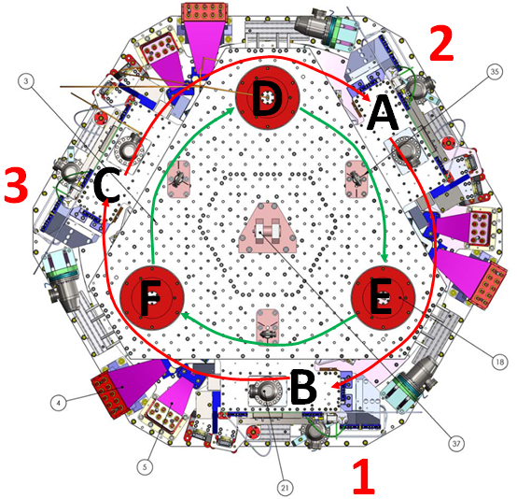
Table 19 - Vertical spring constant measurement - Reference points

Results presented below are obtained after the initial sensors calibration.

 | Sensors | Mean diff (counts) | Mean diff m | K (N/m)
Stage 1 | V1 | 0 | 0.00E+00 | #DIV/0!
Stage 1 | V2 | 0 | 0.00E+00 | #DIV/0!
Stage 1 | V3 | 0 | 0.00E+00 | #DIV/0!
 |  |  | Average (N/m) | #DIV/0!
Table 20 - Vertical spring constant – Stage 1

 | Sensors | Mean diff (counts) | Mean diff m | K (N/m)
Stage 2 | V1 | 0 | 0.00E+00 | #DIV/0!
Stage 2 | V2 | 0 | 0.00E+00 | #DIV/0!
Stage 2 | V3 | 0 | 0.00E+00 | #DIV/0!
 |  |  | Average (N/m) | #DIV/0!
Table 21 - Vertical spring constant – Stage 2

Acceptance criteria:

- Spring constant of stage 0-1 blades must be 229KN/m (T0900569) +/- 2%
- Spring constant of stage 1-2 blades must be 257KN/m (T0900569) +/- 2%

The tests report must contain:
- The table “Vertical spring constant – Stage 1”
- The table “Vertical spring constant – Stage 2”
- Issues/difficulties/comments regarding this test
- Test result (Passed: Failed: ).

Step 8 - Static Testing (Tests in the local basis)
This test verifies three points:
- Actuators-sensors readout chains
- Static main coupling
- Actuators power (driving signal and actuator response)
- Actuators plug sign

Procedure to follow for this test:
- Run the script Static_Test_Local_Basis_BSC_ISI(IFO,Optics,Unit_ID,Note_Test_Local_Basis)
- Copy the table automatically generated
- Make sure that the value in the table Comparison with reference don’t exceed 50 counts

Reference tables based on BSC8 (In the staging building with short cables < 50 feet):

 |  | Sensors
 |  | ST1 - H1 | ST1 - H2 | ST1 - H3 | ST1 - V1 | ST1 - V2 | ST1 - V3
Actuators | ST1 - H1 | 4380 | 1750 | 1750 | 0 | 0 | 0
Actuators | ST1 - H2 | 1750 | 4380 | 1750 | 0 | 0 | 0
Actuators | ST1 - H3 | 1750 | 1750 | 4380 | 0 | 0 | 0
Actuators | ST1 - V1 | 50 | -170 | 90 | 3500 | -650 | -650
Actuators | ST1 - V2 | 90 | 50 | -170 | -650 | 3500 | -650
Actuators | ST1 - V3 | -170 | 90 | 50 | -650 | -601 | 3500
Table - Main couplings – Static – Stage 1

 |  | Sensors
 |  | ST2 - H1 | ST2 - H2 | ST2 - H3 | ST2 - V1 | ST2 - V2 | ST2 - V3
Actuators | ST2 - H1 | 2400 | 360 | 360 | 0 | 0 | 0
Actuators | ST2 - H2 | 360 | 2400 | 360 | 0 | 0 | 0
Actuators | ST2 - H3 | 360 | 360 | 2400 | 0 | 0 | 0
Actuators | ST2 - V1 | 80 | 130 | -200 | 3000 | 330 | 0
Actuators | ST2 - V2 | -200 | 80 | 130 | 0 | 3000 | 330
Actuators | ST2 - V3 | 130 | -200 | 80 | 330 | 0 | 3000
Table - Main couplings – Static – Stage 2

Acceptance criteria:

- Main couplings readout must be positive
- Comparison with the reference table:
  - Main coupling differences mustn’t exceed 200 counts
  - Cross coupling differences mustn’t exceed 50 counts

The tests report must contain:
- The table “Main and cross coupling - Static”
- Issues/difficulties/comments regarding this test
- Test result (Passed: Failed: ).

Step 9- Static Testing - In the general coordinate basis (Static test - CPS)

Step 9.1 – Base change matrices from local to Cartesian
Procedure to follow for this test:
- Make sure the calibration gain of the CPS are disengaged
- Run the script Static_Test_Cartesian_Basis_BSC_ISI(IFO,Optics,Unit_ID,Note_Test_Cartesian_Basis)
- Copy the table automatically generated
- Make sure main coupling are identical
- Make sure that the values in the table Comparison with reference don’t exceed 50 counts

Reference table (static test in the Cartesian basis realized in the LHO staging building) with short in-air cables (<50feets)

 |  | Sensors
 |  | ST1 - X | ST1 - Y | ST1 - Z | ST1 - RY | ST1 - RY | ST1 - RZ
Actuators | ST1 - X | 1500 | 0 | 0 | 0 | 0 | 0
Actuators | ST1 - Y | 0 | 1500 | 0 | 0 | 0 | 0
Actuators | ST1 - Z | 0 | 0 | 650 | 0 | 0 | 0
Actuators | ST1 - RX | 0 | 320 | 0 | 2650 | 0 | 0
Actuators | ST1 - RY | -320 | 0 | 0 | 0 | 2650 | 0
Actuators | ST1 - RZ | 0 | 0 | 0 | 0 | 0 | 2900
 |  | Sensors
 |  | ST2 - X | ST2 - Y | ST2 - Z | ST2 - RY | ST2 - RY | ST2 - RZ
Actuators | ST2 - X | 1230 | 0 | 0 | 0 | 0 | 0
Actuators | ST2 - Y | 0 | 1230 | 0 | 0 | 0 | 0
Actuators | ST2 - Z | 0 | 0 | 980 | 0 | 0 | 0
Actuators | ST2 - RX | 0 | 0 | 0 | 3950 | 0 | 0
Actuators | ST2 - RY | 0 | 0 | 0 | 0 | 3950 | 0
Actuators | ST2 - RZ | 0 | 0 | 0 | 0 | 0 | 2350

 |  | Sensors
 |  | ST1 - H1 | ST1 - H2 | ST1 - H3 | ST1 - V1 | ST1 - V2 | ST1 - V3
Actuators | ST1 - X | 1500 | -750 | -750 | 0 | 0 | 0
Actuators | ST1 - Y | 0 | 1300 | -1300 | 0 | 0 | 0
Actuators | ST1 - Z | 0 | 0 | 0 | 650 | 650 | 650
Actuators | ST1 - RX | 0 | 120 | -150 | -2550 | 2150 | 400
Actuators | ST1 - RY | -180 | 75 | 75 | -1000 | -1700 | 2700
Actuators | ST1 - RZ | 2800 | 2800 | 2800 | 0 | 0 | 0

 |  | Sensors
 |  | ST2 - H1 | ST2 - H2 | ST2 - H3 | ST2 - V1 | ST2 - V2 | ST2 - V3
Actuators | ST2 - X | 650 | -1250 | 600 | 0 | 0 | 0
Actuators | ST2 - Y | 1050 | 0 | -1050 | 0 | 0 | 0
Actuators | ST2 - Z | 0 | 0 | 0 | 980 | 980 | 980
Actuators | ST2 - RX | -270 | 0 | 270 | -2300 | 2300 | 0
Actuators | ST2 - RY | 180 | -300 | 150 | -1350 | -1350 | 2750
Actuators | ST2 - RZ | 1650 | 1650 | 1650 | 0 | 0 | 0

Acceptance criteria:

- Comparison with the reference tables:
  - Differences mustn’t exceed 100 counts

The tests report must contain:
- Tables of the static tests
- Issues/difficulties/comments regarding this test
- Test result (Passed: Failed: ).

Step 10 - Linearity test
The linearity of the triplet Actuators - BSC-ISI - Sensors is evaluated during the following test. This test is carried out using Matlab and awgstream.

Matlab
A Matlab function is used to execute the “Linearity Test”
Follow the steps below:
- Open the Matlab script Linearity_Test_Awgstream_BSC_ISI
- Copy and paste the table Slopes_Offset in the test report as it is
- Paste the figure in the report
- Edit the script to replot the linearity curve

Linearity_Test_Awgstream_BSC_ISI.m performs the linearity Test. It plots the linearity test and computes the slopes)

Note: Perform this test when assembly area is quiet (BSC-ISIs bounce much more than HAM-ISI)

Report slopes in this table

 | Slope | Offset | Average slope | Variation from  average(%)
ST1 - H1
ST1 - H2
ST1 - H3
ST1 - V1
ST1 - V2
ST1 - V3
ST2 - H1
ST2 - H2
ST2 - H3
ST2 - V1
ST2 - V2
ST2 - V3
Table - Slopes and offset of the triplet Actuators - BSC-ISI - Sensors

Acceptance criteria:
- Horizontal and vertical slopes of the triplet actuators x BSC-ISI x sensors: Average slope +/- 1.5%

The tests report must contain:
- The table “Slopes and offsett of the triplet Actuators – BSC – ISI - Sensors”
- Figures that shows linearity on vertical and horizontal axis
- Issues/difficulties/comments regarding this test
- Test result (Passed: Failed: ).

Step 11 – Transfer functions – Local to Local
Measurement Scripts
Transfer functions are measured and processed via Matlab® in 3 steps:
- Measurement’s excitation is launched with Run_Exc_Batch_LHO_ISI_BSC8.m.
- Measurement’s time series are retrieved and transfer functions (frequency bands) are computed with Run_Get_Batch.m.
- Transfer functions are reformatted, plotted and saved with:
Step_1_Plot_TF_L2L_LHO_ISI_BSC8.m

Note 1:
Measurement excitation scripts are specific to each unit Run_Exc_Batch_LHO_ISI_BSC8.m. However, the measurements processing script is common to all subsystems (BSC-ISI, HAM-ISI, HEPI-BSC, HEPI-HAM) Run_Get_Batch.m.

Note 2:
Excitations can be launched from one Matlab while time series can be simultaneously processed with a second Matlab

- Run_Exc_Batch_LHO_ISI_BSC8.m
The excitation is divided into different frequency bands to optimize measurements quality.
Run_Exc_Batch_LHO_ISI_BSC8.m is the scripts that start to drive actuators using matlab functions. There is one function per frequency band.
In the local basis, excitation scripts are named Run_TF_L2L_Section’s_bandwitdh_subsystem.m.
In the Cartesian basis, excitation scripts are named Run_TF_C2C_Section’s_bandwitdh_subsystem.m.

Run_Exc_Batch_LHO_ISI_BSC8.m creates two files: the excitation file and the batch file.
- The excitation file contains specific data such as the excitation signals, GPS start time, frequency resolution, etc...
- The batch file is an “exchange file”. It carries general information such as data locations, data names, response channels, etc…

Note 3:
When Run_Exc_Batch_LHO_ISI_BSC8.m is run, the existing batch file is saved in seismic/BSC-ISI/H2/ITMY/Data/Transfer_Functions/Measurements/Batch_file_Archive/, and a new batch file is created.

- Run_Get_Batch (‘IFO’,’Subsystem’,’Chamber’,’Old_batch_file’)
Run_Get_Batch computes the transfer functions using the last batch file unless the fourth argument of the function is not empty. Old data can be processed by specifying an old batch file.

- Step_1_Plot_TF_L2L_10mHz_1000Hz_LHO_ISI_BSC8.m
This script concatenates the transfer functions into one data structure and gives the saturation time per channels.

Generic excitation and response channels are defined in the SVN at:
seismic/BSC-ISI/Common/Channels_List/

Scripts used to measure transfer functions are located in the SVN at:
seismic/BSC-ISI/Common/Transfer_Functions_Scripts/
- Run_TF_C2C_100Hz_1000Hz_BSC_ISI.m
- Run_TF_C2C_100mHz_700mHz_BSC_ISI.m
- Run_TF_C2C_10Hz_100Hz_BSC_ISI.m
- Run_TF_C2C_10mHz_100mHz_BSC_ISI.m
- Run_TF_C2C_10mHz_100mHz_LZMP_BSC_ISI.m
- Run_TF_C2C_700mHz_10Hz_BSC_ISI.m
- Run_TF_L2L_100Hz_1000Hz_BSC_ISI.m
- Run_TF_L2L_100Hz_500Hz_BSC_ISI.m
- Run_TF_L2L_100mHz_1Hz_BSC_ISI.m
- Run_TF_L2L_100mHz_700mHz_BSC_ISI.m
- Run_TF_L2L_10Hz_100Hz_BSC_ISI.m
- Run_TF_L2L_10mHz_100mHz_BSC_ISI.m
- Run_TF_L2L_1Hz_10Hz_BSC_ISI.m
- Run_TF_L2L_500Hz_1000Hz_BSC_ISI.m
- Run_TF_L2L_700mHz_10Hz_BSC_ISI.m

Schroeder Phase Scripts are located in the SVN at:
svncommon/seisvn/seismic/Common/MatlabTools/Schroeder_Phase_Scripts

Output Filters must be engaged
In order to get a good transfer functions measurements, the couple coil driver - actuator must be able to excite the structure over the identification frequency band. Actuators have been previously identified in T0900226.
Output filters are added to compensate the low response of the coil drivers and actuators at high frequency. A minus sign is also introduced in the output filters.
Links to the sensors interface chassis can be found in D1001575.
A sum up of the input and output filters is given in E1100524.

The reference filter file is located in:
cds_user_apps/trunk/filterfiles/H2ISI_COMMON.txt

Local to local transfer functions measurements

Parameters used for a quick identification (High Blend and testing) are reported below

Stage 1 | Section | Freq min | Freq max | Fres | Amplitude (H –V) | Nrep | Time Stage 1 (min)
Stage 1 | 1 | 0.01 | 0.1 | 0.01 | 2000 - 2000 | 5
Stage 1 | 2 | 0.1 | 0.7 | 0.02 | 140 - 200 | 30
Stage 1 | 3 | 0.7 | 10 | 0.05 | 160 - 220 | 75
Stage 1 | 4 | 10 | 100 | 0.1 | 120 - 120 | 75
Stage 1 | 5 | 100 | 500 | 0.2 | 130 -130 | 75
Stage 1 | 6 | 500 | 1000 | 0.25 | 100 -100 | 75
Stage 2 | Section | Freq min | Freq max | Fres | Amplitude (H-V) | Nrep | Time Stage 2 (min)
Stage 2 | 1 | 0.01 | 0.1 | 0.01 | 2000 - 2000 | 5
Stage 2 | 2 | 0.1 | 0.7 | 0.02 | 500 - 550 | 30
Stage 2 | 3 | 0.7 | 10 | 0.05 | 450 - 400 | 75
Stage 2 | 4 | 10 | 100 | 0.1 | 180 -180 | 75
Stage 2 | 5 | 100 | 500 | 0.2 | 200 - 200 | 75
Stage 2 | 6 | 500 | 1000 | 0.25 | 150 - 150 | 75
 |  |  |  |  |  | Overall ID | 838
Table 22 - System identification parameters – Local to Local measurements

Note: A full set of transfer functions takes ~15hours

Procedure to follow for this test:
- Engage the Actuators compensation Filters
- Run Run_Exc_batch_LHO_ISI_BSC8.m and Run_Get_batch.m
- Process the data using Plot_ LHO_ISI_BSC8_TF_L2L_DATE.m

Example of SVN path with BSC-ISI-LHO-BSC8
Data files measurement of local to local transfer functions in SVN at:
/svncommon/seisvn/seismic/BSC-ISI/X1/BSC8/Data/Transfer_Functions/Measurements/Undamped
- LHO_ISI_BSC8_Data_TF_L2L_10mHz_100mHz_DATE.mat
- LHO_ISI_BSC8_Data_TF_L2L_100mHz_700mHz_DATE.mat
- LHO_ISI_BSC8_Data_TF_L2L_700mHz_10Hz_DATE.mat
- LHO_ISI_BSC8_Data_TF_L2L_10Hz_100Hz_DATE.mat
- LHO_ISI_BSC8_Data_TF_L2L_100Hz_500Hz_DATE.mat
- LHO_ISI_BSC8_Data_TF_L2L_500Hz_1000Hz_DATE.mat

Script file for processing and plotting local to local transfer functions in SVN at:
/seisvn/seismic/BSC-ISI/X1/BSC8/Data/Transfer_Functions/Measurements/Undamped
- Plot_TF_L2L_LHO_ISI_BSC8.m
Or seismic/BSC-ISI/H2/ITMY/Scripts/Control_Scripts/
Step_1_TF_L2L_10mHz_1000Hz_LHO_ISI_BSC8.m

Figures of local to local transfer functions (Main couplings) in SVN at:
seisvn/seismic/BSCISI/X1/BSC8/Data/Figures/Transfer_Functions/Measurements/Undamped
- LHO_ISI_BSC8_TF_L2L_H_ST1_CPS_10mHz_1000Hz_DATE.fig
- LHO_ISI_BSC8_TF_L2L_V_ST1_CPS_10mHz_1000Hz_DATE.fig
- LHO_ISI_BSC8_TF_L2L_H_ST2_CPS_10mHz_1000Hz_DATE.fig
- LHO_ISI_BSC8_TF_L2L_V_ST2_CPS_10mHz_1000Hz_DATE.fig
- LHO_ISI_BSC8_TF_L2L_H_ST1_L4C_10mHz_1000Hz_DATE.fig
- LHO_ISI_BSC8_TF_L2L_V_ST1_L4C_10mHz_1000Hz_DATE.fig
- LHO_ISI_BSC8_TF_L2L_H_ST2_GS13_10mHz_1000Hz_DATE.fig
- LHO_ISI_BSC8_TF_L2L_V_ST2_GS13_10mHz_1000Hz_DATE.fig

Measured of local to local transfer functions in the SVN at:
/svncommon/seisvn/seismic/BSC-ISI/X1/BSC8/Data/Transfer_Functions/Measurements/Undamped
- LHO_ISI_BSC8_TF_L2L_10mHz_1000Hz_DATE.mat

Acceptance criteria:
- All sensors must be plugged
- First structural resonance of stage 1 must be above 200Hz
- First structural resonance of stage 2 must be above 200Hz
- Local to local measurements
  - On CPS, the phase must be 0º at DC
  - On Geophones, the phase must be -90º at DC
- Cartesian to Cartesian measurements
  - On CPS, the phase must be 0º at DC
  - On Geophones, the phase must be -90º at DC on the GS13 and +90º on the L4C. A minus sign will be introduced in the L4C compensation filters.

The tests report must contain:
- Figures of local to local measurements
  - Local to local vertical position sensors transfer functions
  - Local to local horizontal position sensors transfer functions
  - Local to local vertical geophones transfer functions
  - Local to local horizontal geophones transfer functions
- Path in SVN of local to local measurements
  - Data (5 sections)
  - Scripts used for processing
  - Figures
  - Data once the five sections have been concatenated
- Issues/difficulties/comments regarding this test
- Test result (Passed: Failed: ).

Step 12 - Basis change – Cartesian to Local - Simulations
During this step, transfer functions in the Cartesian basis are calculated. In details, this script:
- Loads symmetrized transfer functions and basis change matrices
- Computes the transfer functions in the Cartesian basis. The base change matrices don’t change the unit of the sensors readout. The Cartesian displacements are in nm/count and the Cartesian velocity is in (nm/s)/count.
- Saves the results in the svn at
  - Symmetrized transfer functions in the Cartesian basis at /svncommon/seisvn/seismic/BSC-ISI/X1/BSC8/Data/ Transfer_Functions/Simulations/Undamped
  - Figures at /svncommon/seisvn/seismic/BSC-ISI/X1/BSC8/
Data/ Figures/Transfer_Functions/Simulations/Undamped

Step 13- Transfer functions - Cartesian to Cartesian - Measurements
The table below summarizes the data acquisition parameters used for the Cartesian to Cartesian.

Stage 1 | Section | Freq min | Freq max | Fres | Nrep | Time Stage 1 (min)
Stage 1 | 1 | 0.01 | 0.1 | 0.01 | 5
Stage 1 | 2 | 0.1 | 1 | 0.02 | 30
Stage 1 | 3 | 1 | 10 | 0.05 | 75
Stage 1 | 4 | 10 | 100 | 0.1 | 75
Stage 1 | 5 | 100 | 500 | 0.2 | 75
Stage 1 | 6 | 500 | 1000 | 0.25 | 75
 |  |  |  |  |  | 0
Stage 2 | Section | Freq min | Freq max | Fres | Nrep | Time Stage 2 (min)
Stage 2 | 1 | 0.01 | 0.1 | 0.01 | 5
Stage 2 | 2 | 0.1 | 1 | 0.02 | 30
Stage 2 | 3 | 1 | 10 | 0.05 | 30
Stage 2 | 4 | 10 | 100 | 0.1 | 75
Stage 2 | 5 | 100 | 500 | 0.2 | 75
Stage 2 | 6 | 500 | 1000 | 0.25 | 75
 |  |  |  |  |  | 0
 |  |  |  |  | Overall ID | 0
Table - Measurement General Parameters – Cartesian to Cartesian

Procedure to follow for this test:
- Run Run_Exc_batch and Run_Get_batch
- Date label the script file use to process data and place into the data folder
- In the script file, edit title, input/output data.

Procedure to follow for this test:
- Engage the Actuators compensation Filters
- Run Run_Exc_batch_H2_ISI_BSC8 and Run_Get_batch
- Process the data using Plot_LHO_ISI_BSC8_TF_C2C_DATE.m

Example of SVN path with BSC-ISI-LHO-BSC8
Data files measurement of local to local transfer functions in SVN at:
/svncommon/seisvn/seismic/BSC-ISI/X1/BSC8/Data/Transfer_Functions/Measurements/Undamped
- LHO_BSC_ISI_BSC8_Data_TF_C2C_10mHz_100mHz_ DATE.mat
- LHO_BSC_ISI_BSC8_Data_TF_C2C_100mHz_700mHz_DATE.mat
- LHO_BSC_ISI_BSC8_Data_TF_C2C_700mHz_10Hz_DATE.mat
- LHO_BSC_ISI_BSC8_Data_TF_C2C_10Hz_100Hz_DATE.mat
- LHO_BSC_ISI_BSC8_Data_TF_C2C_100Hz_500Hz_DATE.mat
- LHO_BSC_ISI_BSC8_Data_TF_C2C_500Hz_1000Hz_DATE.mat

Script file for processing and plotting local to local transfer functions in SVN at:
/seisvn/seismic/BSC-ISI/X1/BSC8/Data/Transfer_Functions/Measurements/Undamped
- Plot_ LHO_ISI_BSC8_TF_C2C_DATE.m

Figures of local to local transfer functions (Main couplings) in SVN at:
seisvn/seismic/BSCISI/X1/BSC8/Data/Figures/Transfer_Functions/Measurements/Undamped
- LHO_BSC_ISI_BSC8_TF_C2C_H_ST1_CPS_10mHz_1000Hz_DATE.fig
- LHO_BSC_ISI_BSC8_TF_C2C_V_ST1_CPS_10mHz_1000Hz_DATE.fig
- LHO_BSC_ISI_BSC8_TF_C2C_H_ST2_CPS_10mHz_1000Hz_DATE.fig
- LHO_BSC_ISI_BSC8_TF_C2C_V_ST2_CPS_10mHz_1000Hz_DATE.fig
- LHO_BSC_ISI_BSC8_TF_C2C_H_ST1_L4C_10mHz_1000Hz_DATE.fig
- LHO_BSC_ISI_BSC8_TF_C2C_V_ST1_L4C_10mHz_1000Hz_DATE.fig
- LHO_BSC_ISI_BSC8_TF_C2C_H_ST2_GS13_10mHz_1000Hz_DATE.fig
- LHO_BSC_ISI_BSC8_TF_C2C_V_ST2_GS13_10mHz_1000Hz_DATE.fig

Measured of local to local transfer functions in the SVN at:
/svncommon/seisvn/seismic/BSC-ISI/X1/BSC8/Data/Transfer_Functions/Measurements/Undamped
LHO_ISI_BSC8_TF_C2C_10mHz_1000Hz_DATE.mat

The tests report must contain:
- Figures of Cartesian to cartesian measurements
  - Cartesian to Cartesian vertical position sensors transfer functions
  - Cartesian to Cartesian horizontal position sensors transfer functions
  - Cartesian to Cartesian vertical geophones transfer functions
  - Cartesian to Cartesian horizontal geophones transfer functions
- Path in SVN of Cartesian to Cartesian measurements
  - Data (6 sections)
  - Scripts used for processing
  - Figures
  - Data storage (concatenate)
- Issues/difficulties/comments regarding this test
- Test result (Passed: Failed: ).

Step 14 - Lower Zero Moment Plan (Is it doable?)
The lower zero moment plans are calculated from Cartesian to Cartesian transfer functions measured at low frequencies between 10mHz and 100mHz. The parameters used for these measurements are reported in the table below.

 | Stage 1 | Stage 2
Fmin
Fmax
F res
N rep
X Drive (count)
Y Drive (count)
Time
Table 23 - LZMP Measurements parameters

Step 14.1 - Stage 1 - LZMP
Procedure to follow for this test:
- Lock Stage 1-2 (don’t add mass on stage 2)
- Run_TF_C2C_10mHz_100mHz_LZMP_ST1_LZMP_BSC_ISI.m launched from Run_exc_batch_X1_BSC_ISI
- Date label the script file use to process data
- In the script file, edit title, input/output data.

Example of SVN path with BSC-ISI-LHO-Unit-1
Data files in SVN at:
seisvn/seismic/BSC-ISI/X1/BSC8/Data/Transfer_Functions/Undamped
- LHO_ISI_BSC8_Data_TF_C2C_10mHz_100mHz_ST1_LZMP_DATE.mat

Scripts files for processing and plotting in SVN at:
seisvn/seismic/BSC-ISI/X1/BSC8/Data/Transfer_Functions/Undamped
- Plot_LHO_ISI_BSC8_TF_C2C_10mHz_100mHz_ST1_LZMP_DATE.m

Figures in SVN at:
seisvn/seismic/BSC-ISI/X1/BSC8/Data/Figures/Transfer_Functions/Undamped
- LHO_ISI_BSC8_ST1_LZMP_DATE.fig

Report the LZMP offsets in the table
LZMP X offset – Stage 1 (mm)
LZMP Y offset – Stage 1 (mm)
Table 24 - Offset of the lower zero moment Plan of Stage 1

Step 14.2 - Stage 2 - LZMP
Procedure to follow for this test:
- Lock Stage 0-1 (add mass on stage 1)
- Run Run_TF_C2C_10mHz_100mHz_LZMP_X1_BSC_ISI.m launched from Run_exc_batch_X1_BSC_ISI
- Date label the script file use to process data
- In the script file, edit title, input/output data.

Example of SVN path with BSC-ISI-LHO-Unit-1
Data files in SVN at:
seisvn/seismic/BSC-ISI/X1/BSC8/Data/Transfer_Functions/Undamped
- LHO_ISI_BSC8_Data_TF_C2C_10mHz_100mHz_LZMP_DATE.mat

Scripts files for processing and plotting in SVN at:
seisvn/seismic/BSC-ISI/X1/BSC8/Data/Transfer_Functions/Undamped
- Plot_LHO_ISI_BSC8_TF_C2C_10mHz_100mHz_LZMP_DATE.m

Figures in SVN at:
seisvn/seismic/BSC-ISI/X1/BSC8/Data/Figures/Transfer_Functions/Undamped
- LHO_ISI_BSC8_ST1_LZMP_DATE.fig

Report the LZMP offsets in the table
LZMP X offset – Stage 2 (mm)
LZMP Y offset – Stage 2 (mm)
Table 25 - Offset of the lower zero moment Plan of Stage 2

Acceptance criteria:

- Step 17.1
  - X offset must be less than 1 mm
  - Y offset must be less than 1mm
- Step 17.2
  - X offset must be less than 1 mm
  - Y offset must be less than 1mm

The tests report must contain:
- Figures of Cartesian to Cartesian measurements (X to X, Y to Y, X to RY, Y to RX) for boath stages
- Path in SVN of Cartesian to Cartesian measurements
  - Data
  - Scripts used for processing
  - Figures
- The Tables “Offset of the lower zero moment plan” for both stages
- Issues/difficulties/comments regarding this test
- Test result (Passed: Failed: ).

Step 15- Damping Loops – Transfer function – Simulations
Generic damping filters are installed during this step. The actuators and the geophones are not symmetrized during this step.

Matlab Scripts:
- NOT DONE

The tests report must contain:
- Figures of Cartesian to Cartesian transfer function when the damping filters are engaged
- Path in SVN
  - Data of the simulated transfer functions
  - Figures of the simulated transfer functions
- Issues/difficulties/comments regarding this test
- Test result (Passed: Failed: ).

Step 16- Damping Loops – Spectra
Once the stability has been verified in simulation, the digital damping filters can be loaded in the MEDM filter bank.
Damping filters can be found in the CDS svn at:
userapps/trunk/isi/h2/filterfiles/H2ISIITMY_2011_08_17.txt

Matlab
A Matlab function is used to plot the ASD of the Geophones when the ISI is in the undamped and the damped configuration.

Follow the steps below:
- Write down the GPS Time once the table is undamped.
- Engaged the damping filters
- Wait for 25 minutes or reuse the GPS time of Step 8 if you can still access the data in the frame builder
- Run the script ASD_Measurements_Undamped_vs_Configuration_BSC_ISI.m and paste the figure in the report

Note: Calibration filters must be engaged

Example of SVN path with BSC-ISI-LHO-Unit-1

Filters used by Damping loops in SVN at:
seisvn/seismic/BSC-ISI/X1/Data/BSC8/

Data files in SVN at:
seismic/BSC-ISI/H2/ITMY/Data/Spectra/Damped/
- LHO_ISI_BSC8_ASD_m_L4C_GS13_Undamped_vs_Damping_DATE.mat

Figures in SVN at:
seismic/BSC-ISI/H2/ITMY/Data/Figures/Spectra/Damped/
- LHO_ISI_BSC8_ASD_CT_ST1_L4C_Undamped_vs_Damping_DATE.fig
- LHO_ISI_BSC8_ASD_m_ST1_L4C_Undamped_vs_Damping_DATE.fig

Acceptance criteria:
- Damping loop must be stable when all damping filters are engaged

The testing document must contain:
- Figures of Dampimg loops controller (vertical and horizontal)
- Path in SVN of Cartesian to Cartesian measurements
  - Data
  - Scripts used for processing
  - Figures
- Issues/difficulties/comments regarding this test
- Test result (Passed: Failed: ).

Step 20- Isolation Loops – for one unit per site
Cf E1100845, E1000487 and E100488

BSC-ISI testing Summary
This section must contain:
- Date of the tests
- Testing procedure document used to realize the tests
- Condition of the tests
- Major issues (point to eventual alog)
- A list of the tests that failed or waived. For each test must be placed in one of the following categories:
  - List of tests and won’t be redone
  - List of tests that failed and need to be redone during phase II
  - List of tests skipped that won’t be performed because not feasible during phase II
  - List of tests skipped that we won’t do because there are not essential (i.e. redundant with another test)
- Failed or waived tests must be explained or justified
- Date of the move

