**1) Set up and transfer functions**

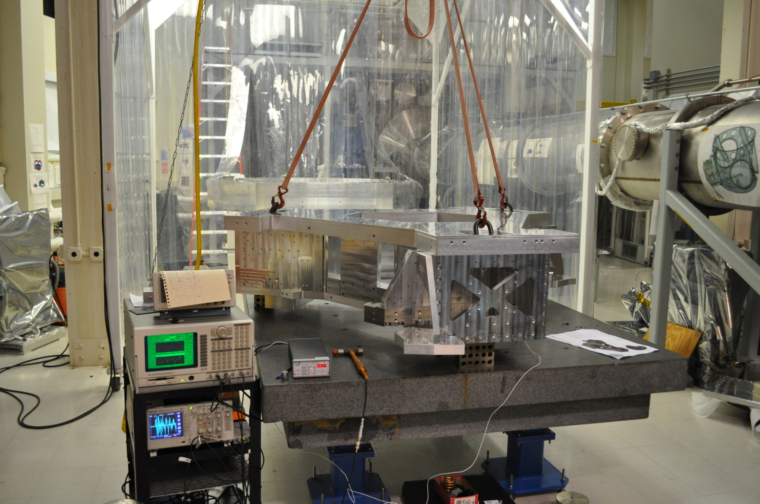

Input Point 3

Input Point 2

Input Point 1

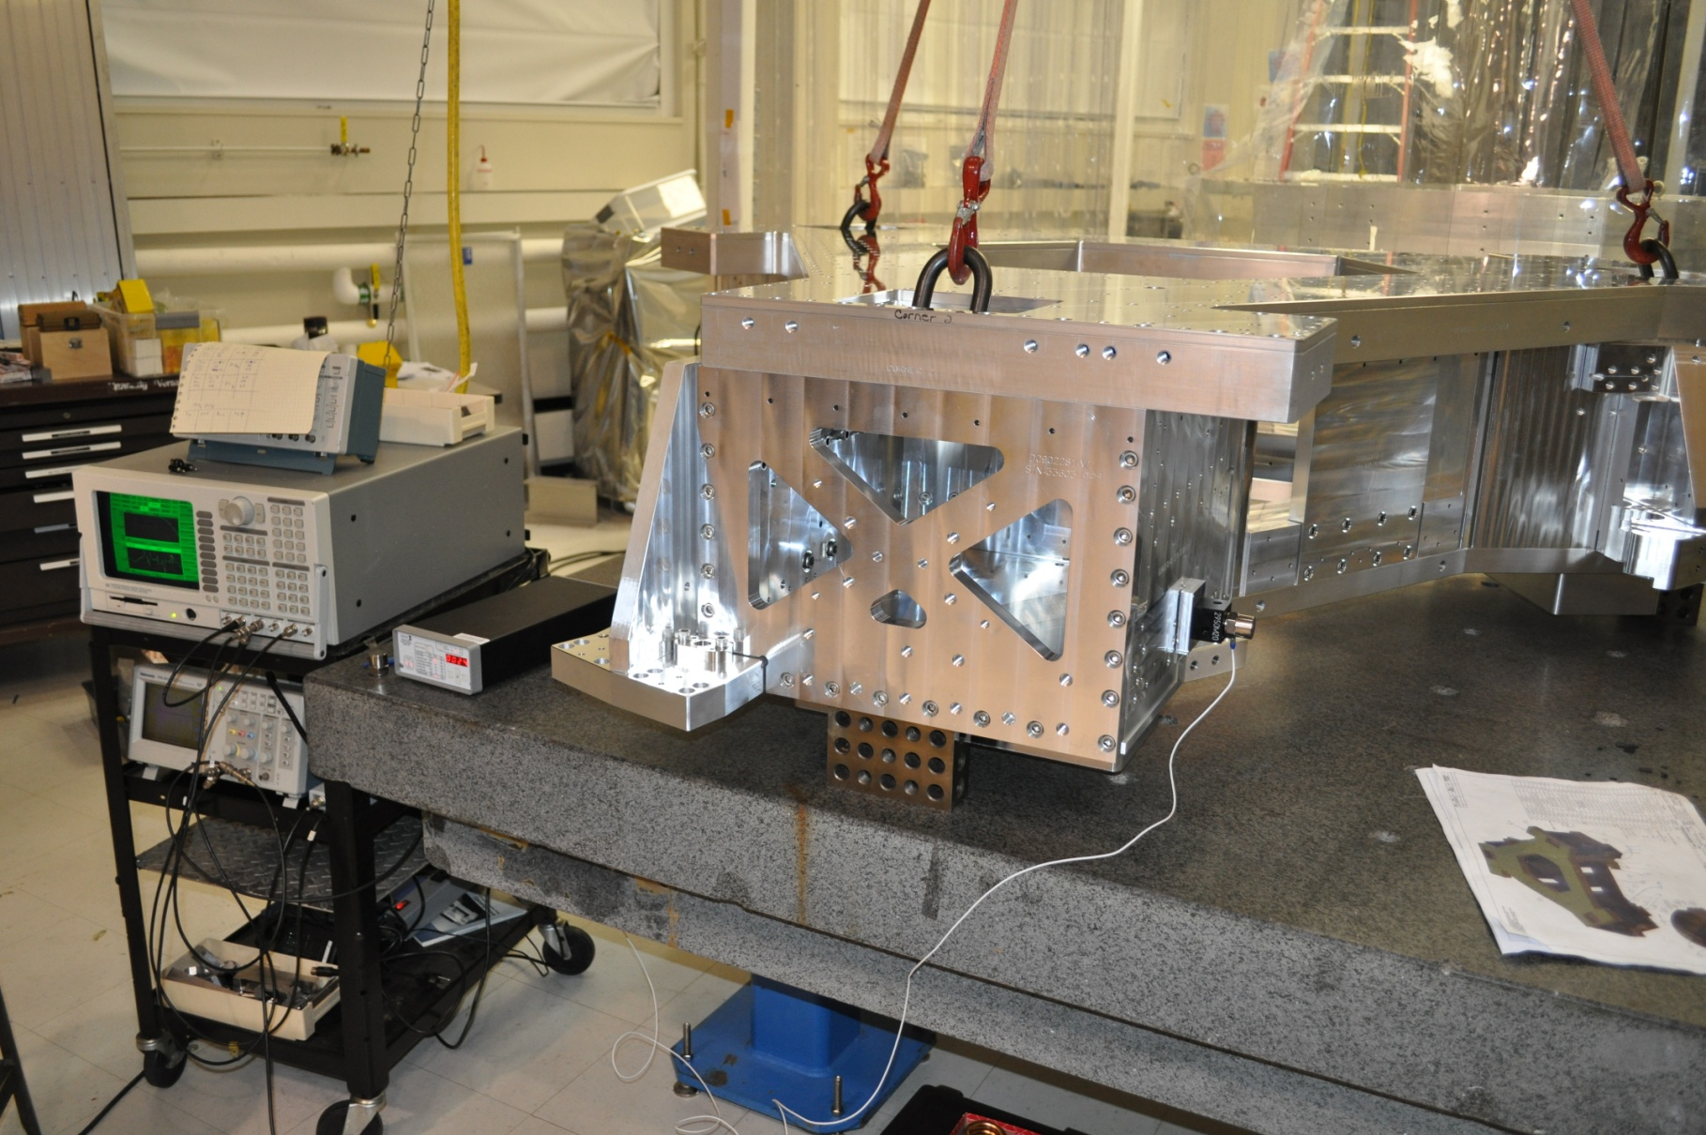

Output Point

"Point 1" is the transfer function from "Input point 1" to the "Output point"

"Point 2" is the transfer function from "Input point 2" to the "Output point"

"Point 3" is the transfer function from "Input point 3" to the "Output point"



The first three resonances are 278 Hz, 318 Hz and 367 Hz. We did many other measurements with other input points, vertical and horizontal excitations. We always found the same first three resonances. This confirms that these are pure global modes.

In the figure below, we compare the transfer functions in corner 1 and in corner 2. They are quasi identical, showing the good symmetry of the structure:



**2) Damping Experiments**

We add 10 lb of mass per corner, mounted on Viton pads:

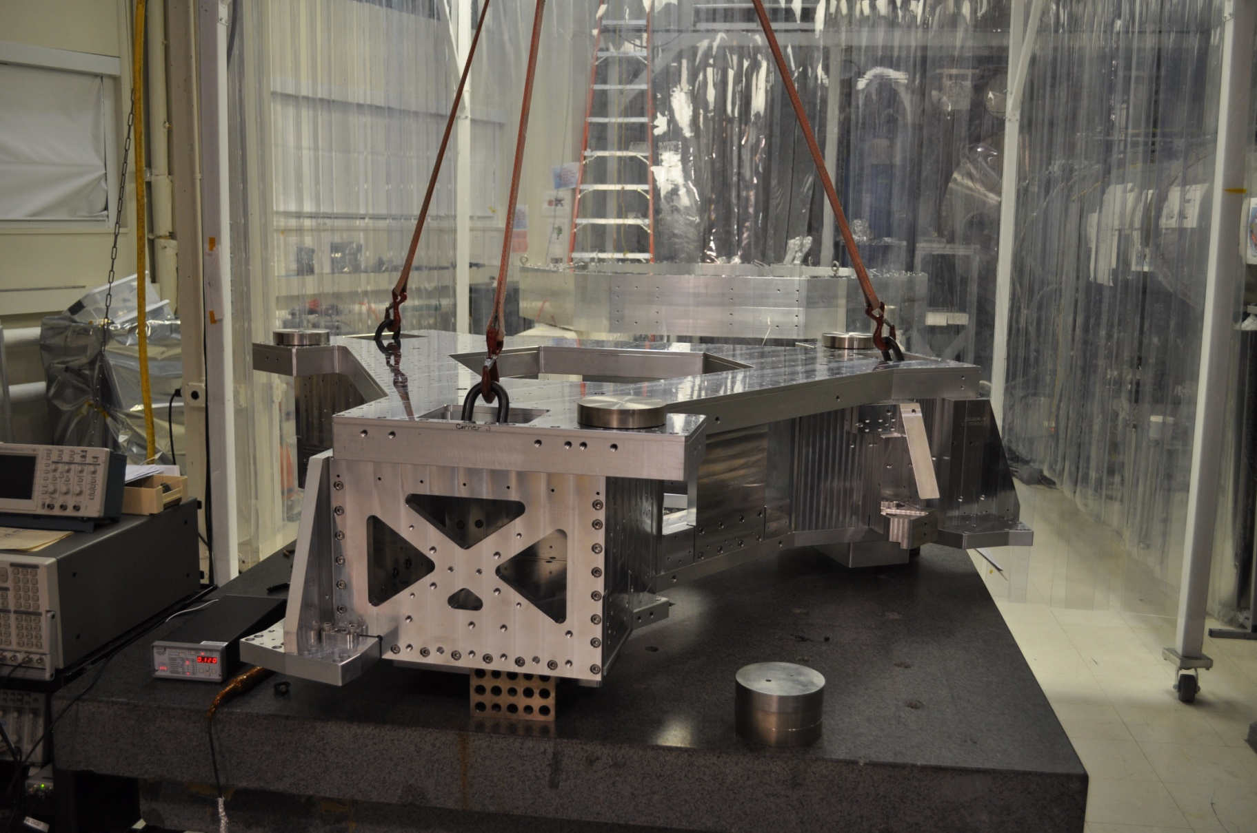

Transfer functions comparison with and without dampers: the Q of the first resonance is down by a factor of 20.

