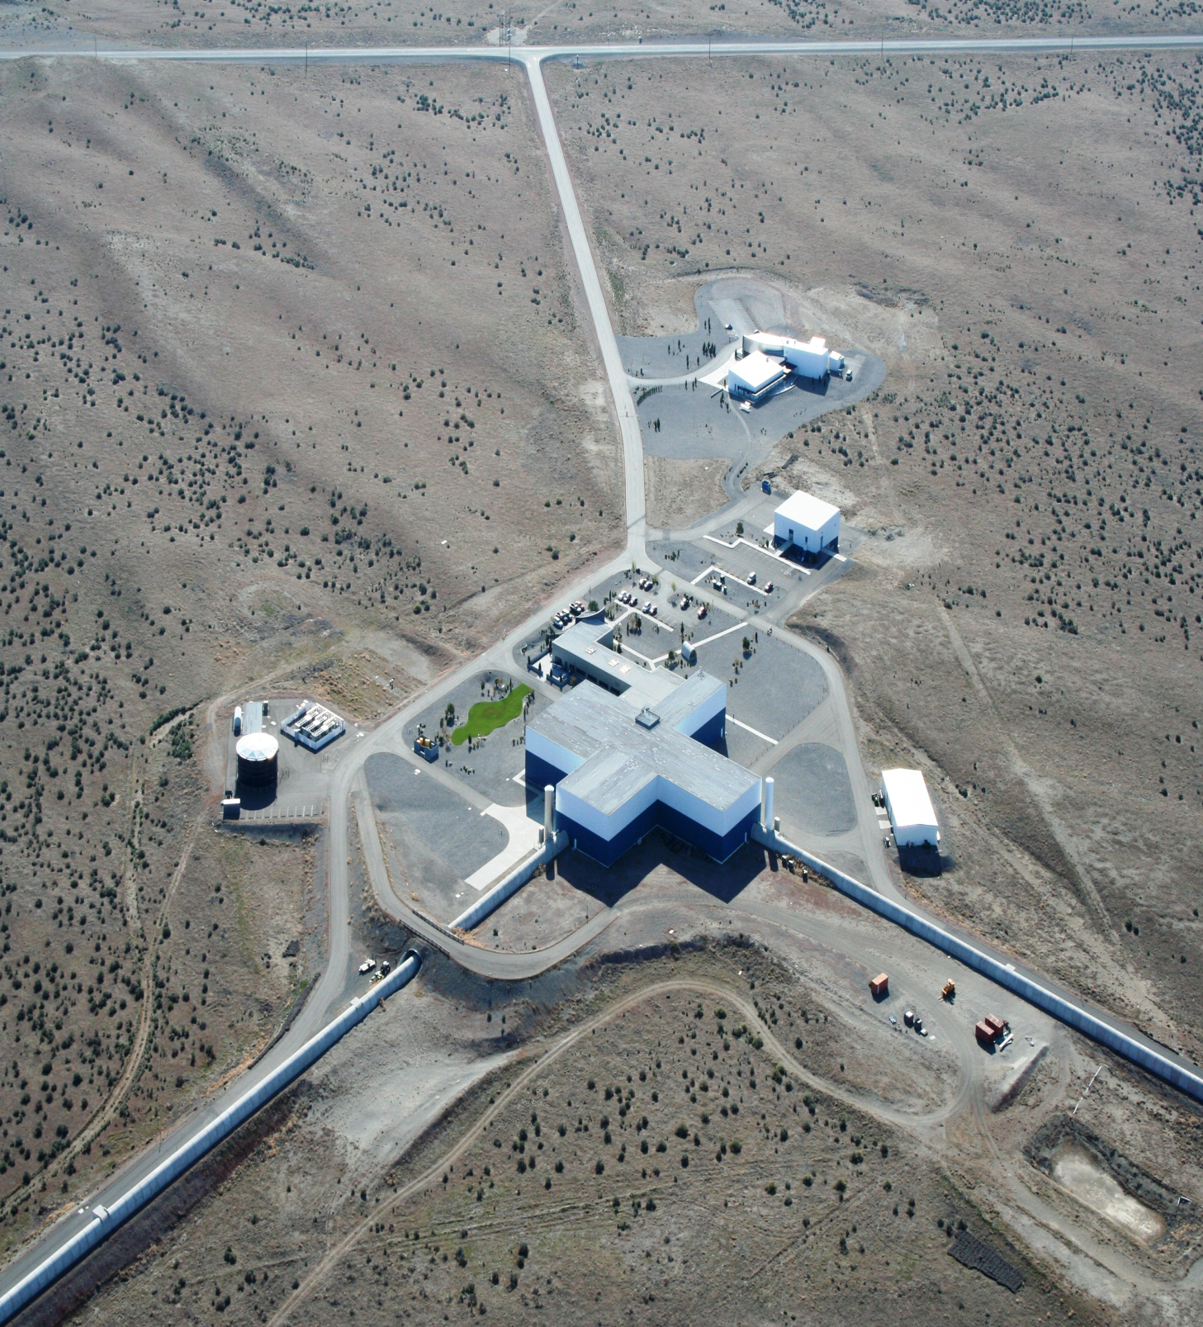

Operations Support Bldg. (OSB)

Auditorium (in LSB)



Front Desk/Visitor Check in

Laser Vacuum & Equipment Area

Large Conference Room

Multi Purpose Room

Rt. 10

Staging Building

Visitor Parking

Business Offices