SURF-LIGO 2005 PROGRAM

final report

Analyzing Double Nail Ended Wires

Student: Francesca Salsi, University of Florence (Italy)
Mentor: Riccardo De Salvo

I continued Maddalena Mantovani’s work (LIGO-P040025-00-D). I designed and built a digital control for her electromagnetic spring, changing the OP AMP feedback with a computerized feedback (with Lab View), attempting to drive the resonant frequency even lower. In order to apply the Real Time control PID to Maddalena´s thesis GAS filter system I tested a Labview program simulating the input voltage of a LVDT with a voltage generator, and reading the computer generated output voltage with an oscilloscope. I modified and ran this program in order to obtain the desiderate results. I found that Lab View is able to make a real time control under 1 KHz (provided the computer is not running other programs, if its only priority is to acquire and control the LVDT voltage). In order to amplify the scan/rate, I modified the lab view program (deleting everything that was wasting memory [as graphics]), in order to speed up the scan/rate maintaining the real time acquisition.
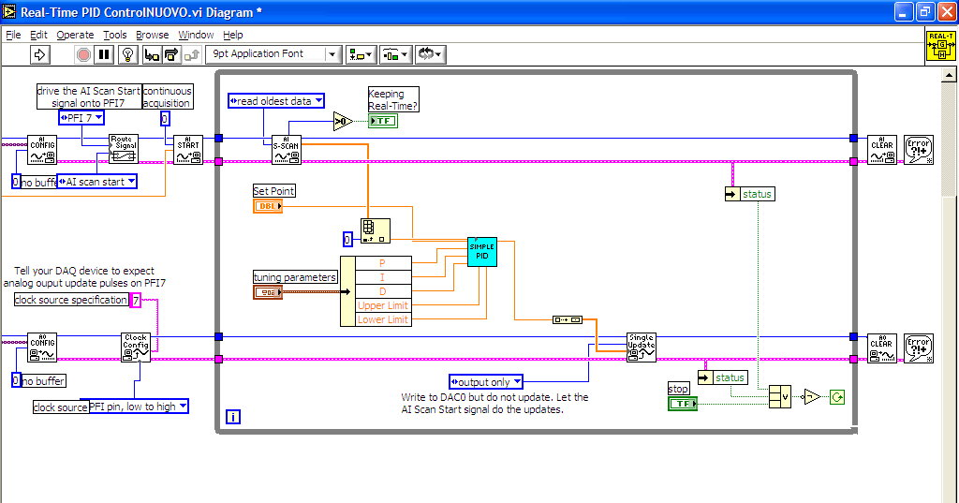
I added an RC filter between the output of lab view and the input of the amplifier. I controlled that the dephasing added to the waive by the RC filter was negligible (at 100 Hz the dephasing was about 48 degree, at 10 Hz the dephasing was about 3 degree and since I have to work at 1 Hz, I considered this dephasing acceptable).
Because the LVDT has a little linear region (circa 1 cm), I needed to find the point of work of my system (I needed that the zero of LVDT and the point of resonance of my system was coincident). I measured the response of LVDT when I put mass on the load of my system.
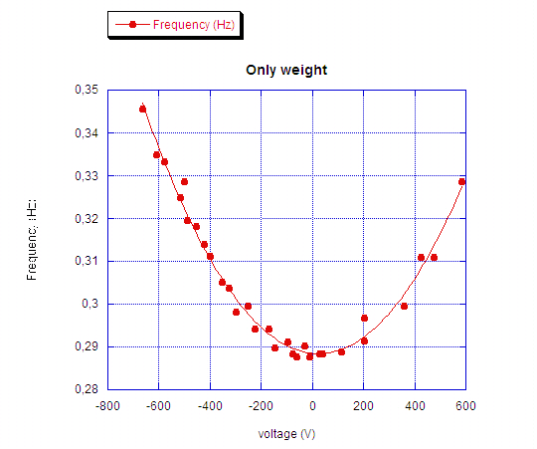
When I found the point of work of my system, I was able to start my measurements. Before I controlled that when the integrator (my lab view program) had P=0, I=0, D=0 (proportionality P, integration I, and differentiation D) the system didn’t change response (I controlled that the amplifier didn’t produce noise). Then I started my measurement, changing gain, and integration.
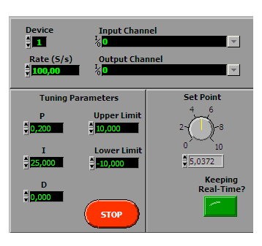
I found a lot of problems. Lab view was able to work in real time under 1 KHz, but only for not a long time. In order to work in real time, I had to put the Rate of my system on 300-400 S/s. We underestimated this problem. In order to make this measurement I needed a different program, and a different and more powerful computer.
I found another important problem. In order to excite my system, I used a different method than Maddalena. She measured the response of LVDT simulating (with a loudspeaker) the seismic noise. I measured the response of LVDT when I added mass on the load of my system. In this way I found strange effects that we (my mentor, Juri Agresti and me) thought connected to some hysteretic effects.
I started a different type of measurement, in order to analyse the hysteresis of my system and to find an explanation to the course 1/f (and not 1/f^2 as we would expect) found also from Maddalena at the low frequencies.
I connected to the coil an waves generator, and I read the LVDT output with a digital
oscilloscope.
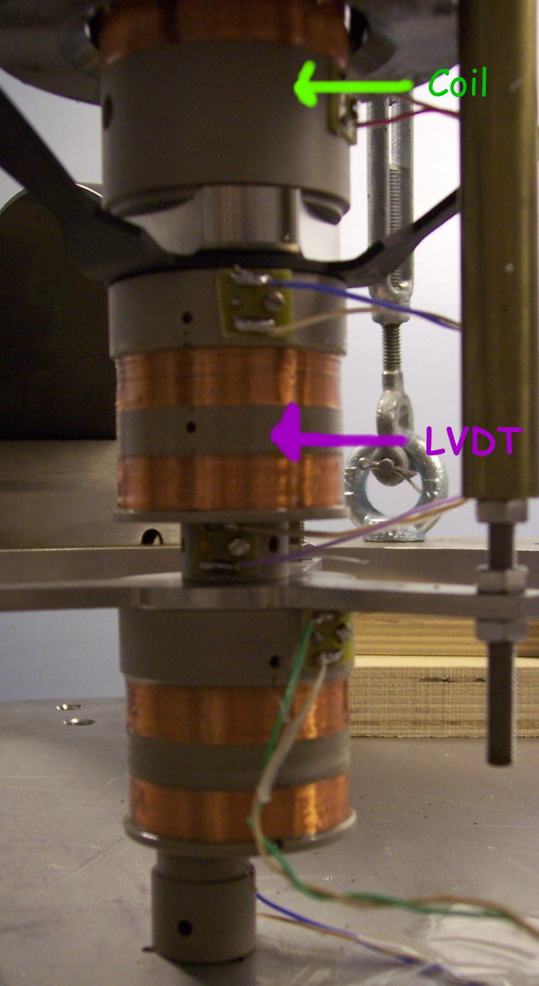
I took some measurement with constant frequency of the input signal and different input voltage, with constant voltage and different frequency, and varying the mass on the load.
I found a good response of my system.
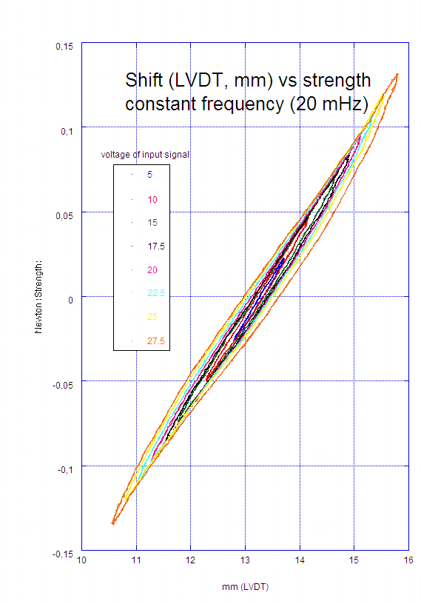

Now I’m making data analysis, and I’m studying those results.
This may go as far as generating a follow-up to Maddalena’s paper, explaining her observed 1/f behavior.

