*LIGO Laboratory / LIGO Scientific Collaboration*

LIGO-T1100080-v3 *LIGO* March 9, 2011



Commissioning Advanced LIGO’s First Arm Cavity



P Fritschel, D Sigg

Distribution of this document:

LIGO Scientific Collaboration

This is an internal working note

of the LIGO Laboratory.

|  |  |
| --- | --- |
| **California Institute of Technology**  **LIGO Project – MS 18-34**  **1200 E. California Blvd.**  **Pasadena, CA 91125**  Phone (626) 395-2129  Fax (626) 304-9834  E-mail: info@ligo.caltech.edu | **Massachusetts Institute of Technology**  **LIGO Project – NW22-295**  **185 Albany St**  **Cambridge, MA 02139**  Phone (617) 253-4824  Fax (617) 253-7014  E-mail: info@ligo.mit.edu |
| **LIGO Hanford Observatory**  **P.O. Box 159**  **Richland WA 99352**  Phone 509-372-8106  Fax 509-372-8137 | **LIGO Livingston Observatory**  **P.O. Box 940**  **Livingston, LA 70754**  Phone 225-686-3100  Fax 225-686-7189 |

http://www.ligo.caltech.edu/

# Introduction

The first major interferometer integration phase in Advanced LIGO is the Y-arm cavity of Hanford’s H2 interferometer. Integrated testing of this first arm cavity is expected to begin in late summer/early fall of 2011. This document describes the ingredients, testing plans, and goals of this testing phase.

# Motivation & Context

An interferometer must acquire lock reliably and robustly before serious strain sensitivity investigations can begin. The Advanced LIGO lock acquisition strategy is significantly different than in initial LIGO, and it was designed to improve upon the reliability and robustness of the earlier scheme. This acquisition strategy is described in [T1000294](https://dcc.ligo.org/cgi-bin/private/DocDB/ShowDocument?docid=12173), *Lock acquisition study for Advanced LIGO.* A new feature that is a significant part of this strategy is the Arm Length Stabilization (ALS) system, which is described in [T0900144](https://dcc.ligo.org/cgi-bin/DocDB/ShowDocument?docid=1625). The ALS is designed to provide independent control of each arm cavity length. Given that it is a new system in Advanced LIGO and that it is critical to achieving full lock, it is highly desirable to implement and test the ALS as early as possible. Since H2 is unique in that its ITMs can be isolated from the rest of the vertex vacuum volume, the H2 Y arm[1] was chosen as the first arm cavity installation. We call this integration phase the H2OAT (H2 One Arm Test).

The other main motivation behind this approach was to integrate as early as possible the BSC seismic isolation system and the test mass quadruple suspension. These are the most complex mechanical assemblies in Advanced LIGO, and since they are what support and isolate the test masses it is critical that they function as designed. Though the H2OAT phase will not be able to test their noise performance in the gravitational-wave band, it will exercise a tricky installation and alignment procedure and enable investigation of the lower frequency motion of the combined system.

There are two main objectives of the H2OAT integration phase:

1. Attaining and verifying the performance of the ALS arm cavity locking, at the level required to support full interferometer lock acquisition.
2. Investigation of the low-frequency (< 1 Hz) performance of the seismic isolation and suspension subsystems.

These, and other secondary objectives, are discussed later in Section .

# Components of the arm cavity integration phase

The first arm cavity integration phase is not planned as some sort of special test – it is rather the first step in building and commissioning the full interferometer. As such, the nominal plan is to install all the Advanced LIGO hardware associated with the arm cavity, even though some of it may not be used or required during the integrated testing phase. There are though a few differences between H2OAT and the final installation; these are described below for each subsystem.

A block diagram of the H2OAT is shown in . The arm cavity is comprised of the Input Test Mass (ITM) and the End Test Mass (ETM), both mounted in quadruple suspensions with their associated reaction chains and reaction masses (Compensation Plate for the ITM and End Reaction Mass for the ETM). In the test, the arm cavity is illuminated from the ETM, by a low-power 532nm laser located at the Y-end station. The laser beam is launched into the cavity through the suspended Transmission Monitor, which includes a telescope to expand the beam to the arm cavity mode size. The laser is reflection-locked to the cavity, and from there various aspects of the system are configured and characterized as discussed later. Note that the PSL is not involved in this phase (except as an option; see below), and there is no sensing of the beam in the vertex.

Figure 1. Block diagram of the H2OAT integration phase. ETM: End Test Mass; TM: Transmission Monitor; ITM: Input Test Mass; FM: Fold Mirror; ACB: Arm Cavity Baffle; ISI: Internal Seismic Isolation.

## Core Optics Components

From COC, the H2OAT setup requires: 1 End Test Mass; 1 End Reaction Mass; 1 Input Test Mass; 1 Compensation Plate. Ideally a Fold Mirror would also be included, but problems with the FM processing have delayed their production; instead, the FM triple suspension will be installed with a dummy metal mass that will later be replaced with the FM. Additionally, problems with the TM dielectric coatings means that the H2OAT will use temporary TMs that will later need to be replaced. The temporary TMs have radii-of-curvature that are outside the ETM/ITM specifications; this changes the mode size in the cavity, which will need to be accommodated for in the matching optics on the ALS table. (Higher order wavefront errors are also outside the specification, but the extra loss that this introduces is not significant for the H2OAT.) Since these TMs are temporary, we chose to have both of them coated with the ITM-type coating, rather than one ITM and one ETM; the ITM coating has a transmission of 1.4% for 1064 nm (vs. 5 ppm for the ETM), and 1.0% for 532 nm (vs. 5% for the ETM). This means that the cavity finesse for 532 nm will be higher than nominal (300 vs. 100). It also means we will be able to probe the cavity from the ETM with the 1064 nm beam, which we would not be able to do with the nominal ETM transmission.

## Suspensions

From SUS, the setup requires: 2 Quadruple suspensions; 1 BS/FM triple suspension; control electronics for all suspensions. There are no planned deviations for these from their baseline designs.

## Transmission Monitor and Suspension

The Transmission Monitor (TransMon) has three elements: beam reduction/expansion telescope (AOS); detection assembly for PSL and ALS beams (ISC); double suspension for the first two elements (AOS). The TransMon will be built and installed with no planned deviations from its baseline design. The ISC detection assembly will thus include the components that eventually are used to detect the ETM transmission of the PSL beam, but these components will not be used during the H2OAT.

## Seismic Isolation

This integration phase requires 2 full BSC seismic isolation systems: HEPI and ISI for each chamber, including control electronics. Since the full vertex field plumbing for HEPI will not be done until later, temporary plumbing between the LVEA wall penetration and BSC8 will be installed. Otherwise, there are no other planned deviations from the baseline SEI designs.

## ISC & Arm Length Stabilization

The ALS system ([T0900144](https://dcc.ligo.org/cgi-bin/DocDB/ShowDocument?docid=1625)) includes hardware at both the end stations and the corner station. The latter will not be installed for the H2OAT phase. Section 4 of T0900144-v4 describes the ALS setup (the ALS optics table and associated electronics) for the single arm test; [D1002803](https://dcc.ligo.org/cgi-bin/private/DocDB/ShowDocument?docid=22578) shows the block diagram for the ALS/ISC electronics. There are a few differences between the H2OAT and the long-term ALS setup:

* The ALS laser (1064 nm output) will be phase-locked to a reference cavity-stabilized NPRO located in the corner station optics lab; a sample of the optics lab NPRO is sent to the end station over fiber, and heterodyned with the ALS laser. This is the nominal ALS design, except that a sample of the PSL light will be sent to the ends via fiber.
* Two RF wavefront sensors will be installed on the ALS table as a diagnostic to measure cavity (or input beam) alignment fluctuations. It is not currently planned that WFS will be part of the final ALS system (though that could change depending on the outcome of this testing phase).
* Pointing of the 532 nm beam into the ETM chamber is controlled by two piezo-actuated mirror mounts. In the test phase, these actuators will be driven by commercial controllers made by the supplier of the piezo-mounts (Mad City Labs).

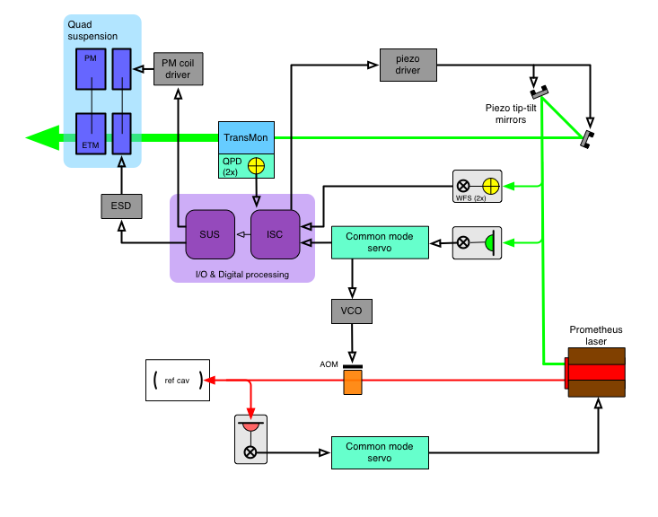

Figure . Servo block diagram for the H2OAT. ESD: electro-static drive; VCO: voltage-controlled oscillator; AOM: acousto-optic modulator

## Stray Light Control Baffles

From the AOS SLC subsystem, the arm cavity installation requires: 2 manifold/cryopump baffles; 2 arm cavity baffles. None of these of course are essential to locking the arm cavity and performing the integrated testing, but it is preferable to install these upfront. The ACBs are outfitted with photodiodes that will be used for initially locating and aligning the beam through the beamtube (video cameras could be used for this function if an ACB was not in place). For the H2OAT, the ACB photodiodes will be read out using commercial, off-the-shelf wide-range transimpedance amplifiers.

## Optical levers

Each test mass will be outfitted with an optical lever. The ETM will have a full Advanced LIGO optical lever. In the corner, however, the existing optical lever for the H1 ITMY needs to be maintained, and this precludes installation of the Advanced LIGO optical lever pier. The H2 ITMY will therefore use the initial LIGO optical lever pier, laser source and detector (electronics interfacing still TBD). This will give the opportunity to compare the performance of the new optical lever against the original.

## Thermal Compensation System

TCS will supply two ring heaters, one for each test mass, which will be installed into the quad suspensions. TCS will also install the Hartmann sensor for the ETM, which makes use of the ALS 532 nm beam as a probe beam.

In BSC8, the steering mirror assembly for the CO2 laser projector beam will be installed. None of the other TCS corner station hardware – CO2 laser projector or vertex Hartmann sensors – will be installed for the H2OAT.

## Photon calibrator

The photon calibrator (Pcal) design includes in-vacuum steering mirrors (end station chamber only) to direct the reflected Pcal beams out of the chamber for detection; these mirrors will be installed for this phase, pending their availability. No other Pcal hardware is intended to be installed for the H2OAT phase; in any case the system will not be nearly sensitive enough to measure an applied Pcal force.

## PSL & IO

There are no Input Optics components involved in the H2OAT phase. There are nominally also no PSL components involved, but there is an option to incorporate the PSL if it is installed within this testing timeframe. As mentioned above, the ALS laser will be phase-locked to an NPRO laser in the corner station optics lab that is stabilized to a reference cavity; a sample of this NPRO light is sent to the end station via one of the single-mode communications fibers that run between the stations. But if the PSL is available, we could test this phase-locking with the actual laser source.

## DAQ

The full H2 DAQ system is planned to be installed by the start of the H2OAT phase.

# H2OAT Objectives

As noted earlier, there are two main objectives of the H2OAT integration phase:

1. Attaining and verifying the performance of the ALS arm cavity locking, at the level required to support full interferometer lock acquisition.
2. Investigation of the low-frequency (< 1 Hz) performance of the seismic isolation and suspension subsystems.

These objectives, as well as various secondary objectives, are further discussed below. First we present noise estimates for the arm cavity.

## Noise Estimates

The H2OAT integration phase will not provide any kind of sensitive test-bed for the in-band noise performance of the suspensions and seismic isolation. Above ~1 Hz, the arm cavity sensing will be limited by frequency noise of the ALS laser (even when phase-locked to the corner station stabilized NPRO), at a level many orders of magnitude above the expected displacement noise of the test masses. shows an estimate of the noise performance of H2OAT setup.

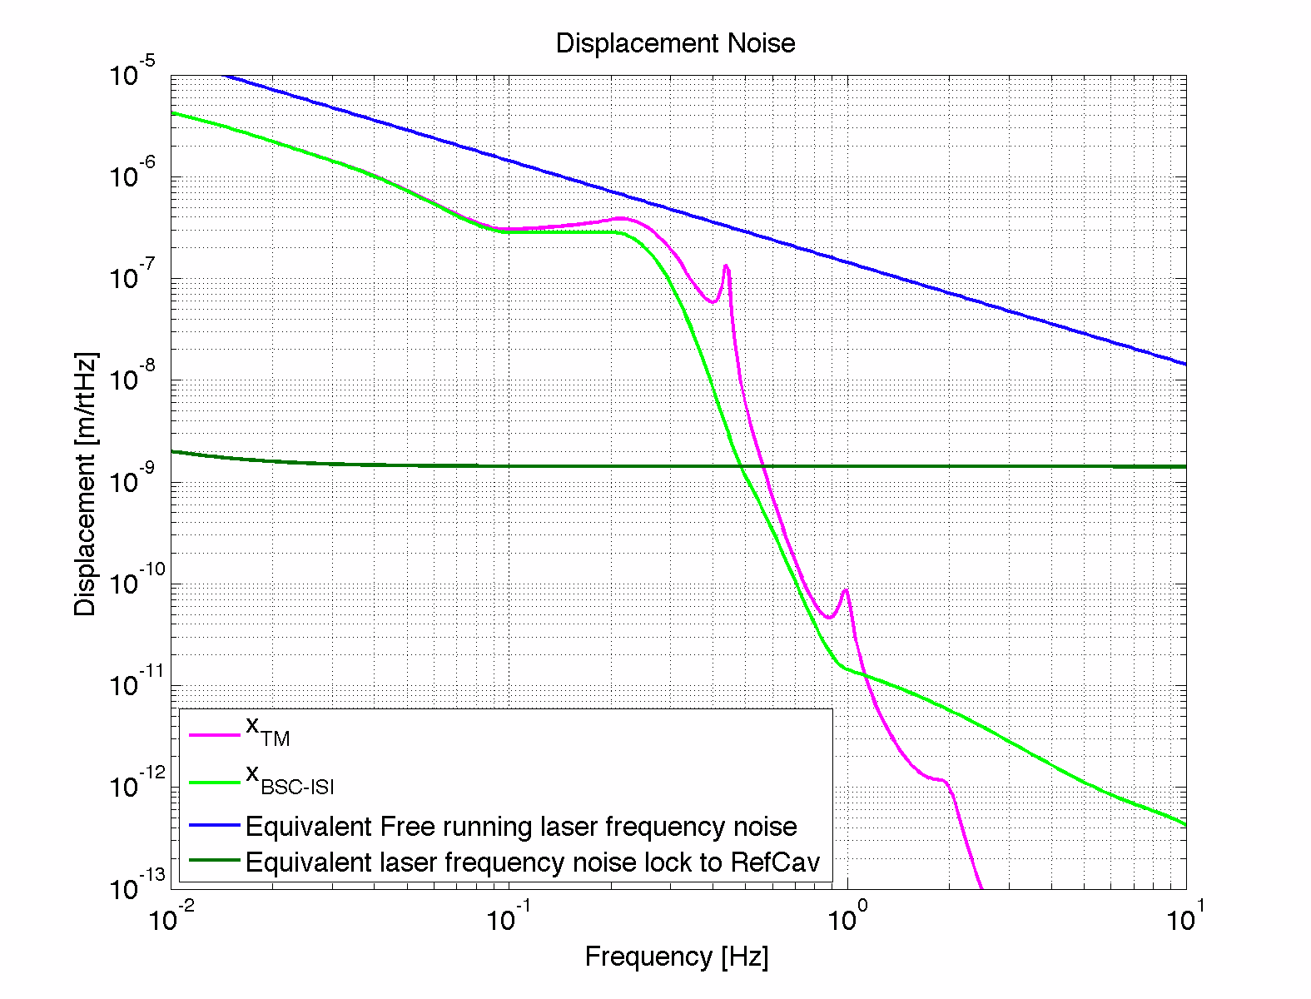

Figure 3. Estimate of equivalent arm cavity length noise for the H2OAT. With a free-running NPRO (Prometheus), laser frequency noise would dominate over the whole frequency band (blue curve). When the laser is stabilized to a reference cavity, we expect to measure test mass motion below about 0.5 Hz. This models the stabilized frequency noise as reaching 100 Hz/Hz1/2 over the band shown (1/*f* knee at 0.01 Hz). Experience suggests that the frequency noise could be up to 10x lower than this, in which case the H2OAT would be dominated by frequency noise above about 0.8 Hz.

## ALS test objectives

The full ALS system has four main control loops:

1. Lock of ALS laser 532 nm beam to Arm Cavity (at each end)
2. Phase/frequency lock of ALS laser to PSL light (at each end)
3. Arm differential mode suppression: feedback to the arm cavity length differential mode, based on vertex heterodyning of X- and Y-arm ALS beams
4. Common mode feedback: feedback to the PSL frequency via the common mode servo, based on vertex heterodyning of X-arm (or Y) and PSL beams

The H2OAT will fully test #1; #2 will be tested with a stand-in for the PSL, and potentially with the actual PSL; #3 will be tested in a fashion by off-loading the low frequency end of the arm cavity lock from the ALS laser to the arm cavity length (via the quad suspension actuators); #4 will not be tested in this phase.

Again the main objective with the ALS at this stage is to achieve reliable and robust locking of the arm cavity, and to implement the feedback to the arm length that serves to actually reduce the arm length fluctuations. Here are some specific design issues that the testing should inform:

* Is the commercial ALS laser (Innolight Prometheus) adequate? Is the amount of 532 nm power (50 mW) sufficient?
* Will we need active stabilization of the 532 nm beam pointing into the TransMon? If so, what servo bandwidth and actuation range?
* If active pointing stabilization is needed, which sensors are to be used – the quad detectors on the TransMon or the RF wavefront sensors on the ALS table?
* Will we want to outfit all ALS end station setups with RF wavefront sensors for the 532 nm beam (other than as driven by the preceding bullet) ?

Note that the ALS design assumes that stabilizing the arm length with the green light will also stabilize the arm length as seen by the PSL infrared light, at least to the sub-nanometer level. Since both test masses in the H2OAT will have the ITM-type coating, this could be tested by injecting the Prometheus 1064 nm beam into the cavity from the end. This green-infrared cavity comparison is currently being studied at the Caltech 40m lab. The priority testing this in the H2OAT will depend on the results of the 40m investigations.

## Seismic isolation performance

As shows, below about 1 Hz the arm cavity measurement will show length noise of the cavity due to test mass displacement noise. Thus the H2OAT will tell us about the actual relative displacement of the two BSC ISI platforms, which is especially of interest below ~0.1 Hz where the prototype testing done to date can be confused by tilts.

Along with the length noise, we will characterize the angular fluctuations of the test masses, and compare to model predictions. These measurements will be made with some combination of the optical levers and the RF wavefront sensors.

### ISI controls implementation

The ISI controls will first be implemented in a basic, relatively low-performance configuration (‘Level 1’ in the SEI controls hierarchy[2]). This is expected to be sufficient to get started with the arm cavity locking and testing. Then, periodically over the H2OAT phase, time will be allotted to the SEI team to do further ISI system identification and controls tuning (with the goal of achieving Levels 2 and 3 of performance).

### Adaptive feed-forward control

The H2OAT gives an opportunity to investigate the use of adaptive feed-forward control of the arm cavity length, using seismometer signals to predict and ultimately to reduce the low-frequency fluctuations of the arm cavity length. At this phase the investigation may be limited to computer simulations of the predictive algorithm, using data that is collected during the H2OAT.

## Suspension performance

The basic functionality of the quad suspensions will have been tested before the H2OAT: proper connection and operation of all local sensors; proper connection of all actuator channels; damping; static alignment control. Some aspects, however, require the arm cavity:

*Actuation:* Test and verification of the actuation coefficients for the electro-static drive on the test mass, the penultimate-mass (PM) stage drive, and the upper intermediate-mass (UIM) stage drive. Balancing of the drive channels at each stage to minimize (length-to-angle) cross-coupling. Note that the low-frequency feedback (below ~10 Hz) to the ETMY quad suspension in the arm cavity lock will be split between the TM and PM stages.

*Damping:* Investigation of the dependence of the rms motion of the test mass (longitudinal, pitch and yaw) on the damping filter design and damping gain. The goal is to minimize the rms motion of the test mass with respect to the damping filters.

## Test Mass Qs

Some time can potentially be devoted to measuring Qs of acoustic modes of the test masses. Such data would verify the proper mechanical fabrication and assembly of the test mass, and is useful for checking and refining predictions regarding parametric instabilities. Similarly, data on suspension fiber violin mode Qs would be interesting to obtain. However, it may be very difficult or even not possible to make these measurements given the frequency-noise limited sensitivity. For comparison, both TM and violin mode Qs were measured on the LASTI suspension, but the displacement sensitivity of that cavity was about 100 times better than expected for the H2OAT.

## Ring heater testing

Test mass ring heaters should be powered on to test for any problematic interaction with the suspension. On ETMY, the distortion produced by the ring heater can be measured with the ETMY Hartmann sensor.

## Scattered light measurements

Light scattered from the test masses can be measured using the photodiodes mounted in the Arm Cavity Baffles, and using the video cameras that monitor the test mass HR faces. Such data, if calibrated, can be compared against metrology data for estimates of optical loss and scattered light.

## Optical levers

Optical lever data can be analyzed to evaluate their stability. Given the hybrid installation, the performance of the new Advanced LIGO piers and light sources (on ETMY) can be compared to the initial LIGO versions (on ITMY).

# Prioritization of objectives

|  |  |  |
| --- | --- | --- |
|  | **Objective** | **Duration** |
| *Top priority* | |  |
|  | Arm cavity locking w/ ALS | Throughout test phase |
|  | Alignment stability / active stabilization | Throughout test phase |
|  | Low-frequency seismic isolation | Throughout test phase |
|  |  |  |
| *Secondary priority* | |  |
|  | Higher levels (2 & 3) of ISI performance | ~1 month total, at intervals |
|  | Quad suspension actuator testing | 1 week |
|  | Quad suspension damping optimization | 1-2 weeks |
|  | Adaptive feed-forward on cavity length | Data mining + 2-3 wks if applied |
|  | Test mass & fiber Q measurements | 1-2 weeks |
|  | Ring heater testing | 1-2 weeks |
|  | Optical lever characterization | Data mining |
|  | Scattered light measurements | 1 week |

# Intermediate and Quantitative Test Goals

The table below lists some intermediate and quantitative goals that will be used to gauge progress and guide how the objectives mentioned above are evaluated.

|  |  |
| --- | --- |
| **Category/Subsystems** | **Goal** |
| Initial alignment | Sustained flashes of optical resonances in the arm cavity |
| Cavity locking/ISC | Green laser locked to cavity for 10 minutes or more |
| TransMon/ALS | Active beam pointing error on the TransMon table below 1 urad rms in angle and below 100 um rms in transverse motion |
| SEI | Relative motion at the suspension point between the two SEI platforms below 250 nm rms (without global feedback) |
| Cavity length control / SEI/SUS/ALS | Relative longitudinal motion between ITM and ETM below 10 nm rms for frequencies below 0.5 Hz |
| Cavity alignment fluctuations / SEI/SUS | Relative alignment fluctuations between the TIM and ETM below 100 nrad rms for frequencies above 0.1 Hz (without global feedback) |
| Controls / SUS | Decoupling of length-to-angle at the level of 0.05 rad/m or less, for frequencies below 0.5 Hz |
| Controls / ISC | Fully automated cavity locking sequence; long term cavity locking |
| TCS | Ring heater wavefront distortion, as measured by the Hartmann sensor, in agreement with the model at the 10 nm rms level. |
| Optical levers | Optical lever long term drift below 1 urad |
| Calibration | ETM displacement calibration at the 20% level |
| ALS | Ability to control frequency offset between 1064 nm and 532 nm resonances at the 10 Hz level |
| ALS | Relative stability of the 1064 nm and 532 nm resonances at the 10 Hz level for frequencies below 0.5 Hz |

# Strawman timeline

|  |  |  |  |  |  |  |  |  |  |  |  |
| --- | --- | --- | --- | --- | --- | --- | --- | --- | --- | --- | --- |
| 1 month | | | 1 month | | | 1 month | | | 1 month | | |
| 10 days |  |  |  |  |  |  |  |  |  |  |  |
| Find beam, align cavity |  |  |  |  |  |  |  |  |  |  |  |
|  | Lock laser to cavity | |  |  |  |  |  |  |  |  |  |
|  |  | Develop robust & reliable locking, study alignment stability | | | | | | | | | |
|  |  |  | Low frequency seismic isolation investigations | | | | | | | | |
|  |  |  |  | Implement active beam pointing control | | |  |  |  |  |  |
|  |  | SUS actuator testing |  |  |  |  |  |  |  |  |  |
|  |  |  | ISI performance tuning | |  |  |  |  | ISI performance tuning | |  |
|  |  |  |  |  | SUS damping optimization | |  | |  |  |  |
|  |  |  |  |  |  | Ring heater tests | |  |  |  |  |
|  |  |  |  |  |  |  | Q measurements | |  |  |  |
|  |  |  |  |  |  |  |  |  | Scattered light |  |  |
|  |  |  |  |  |  |  |  |  |  | Adaptive feed-forward | |

**akjdsoiofjieo**

1. It has to be the Y-arm because the H2 X-arm will use the beam line that continues to be occupied by H1.
2. The ISI performance levels will be described in a document currently in preparation by the SEI team.