LIGO Laboratory / LIGO Scientific Collaboration
LIGO-T1100238-v2 ADVANCED LIGO 2nd August 2011

Report on hydroxide catalysis bonding at LHO in March and April 2011

M. Van Veggel¹, B. Bland², G. Moreno², M. Phelps³
¹ Institute for Gravitational Research, University of Glasgow
²LIGO Hanford Observatory
³ California Institute of Technology, LIGO Project

Distribution of this document:
LIGO Science Collaboration.
This is an internal working note
of the LIGO Project.

California Institute of Technology  LIGO Project – MS 18-34  1200 E. California Blvd.  Institute for Gravitational Research  University of Glasgow  Kelvin Building  Glasgow G12 8QQ  Phone: +44 (0)141 330 3340  Fax: +44 (0)141 330 6833  Web: www.physics.gla.ac.uk/igr/  Pasadena, CA 91125  Phone (626) 395-2129  Fax (626) 304-9834  E-mail: info@ligo.caltech.edu | Massachusetts Institute of Technology  LIGO Project – NW22-295  185 Albany St  Cambridge, MA 02139  Phone (617) 253-4824  Fax (617) 253-7014  E-mail: info@ligo.mit.edu
LIGO Hanford Observatory  P.O. Box 1970  Mail Stop S9-02  Richland WA 99352  Phone 509-372-8106  Fax 509-372-8137 | LIGO Livingston Observatory  P.O. Box 940  Livingston, LA 70754  Phone 225-686-3100  Fax 225-686-7189
http://www.ligo.caltech.edu

Executive summary 3
Introduction 5
1 Reference documents 5
2 Preparations 6
2.1 Goals 6
2.2 Resources 6
2.3 Time schedule 6
3 Bonding in March 2011 7
3.1 Weighing penultimate masses 7
3.2 Gluing prisms and magnet flag bases to PM ITM04 8
3.2.1 Gluing prisms 8
3.2.2 Gluing magnet flag mount discs 10
3.3 Bonding ears 11
3.3.1 PM ITM01 13
3.3.2 PM ETM04 14
3.3.3 PM ETM03 15
3.4 Measuring ear and prisms positions 16
3.5 To-do list after 18
3.6 Review of the week 19
4 Bonding in April 19
4.1 Inspection of TM ETM02 (with ITM coating) 19
4.2 Measuring the width of TM ETM02 (with ITM coating) 19
4.3 Bonding ears to TM ETM02 (with ITM coating) 22
4.4 Measuring ear positions 22
4.5 To-do list after 25
5 Conclusions and discussion 25

v1 | 27th July 2011 | First draft of report for comment (M. van Veggel)
v2 | 2nd August 2011 | Revision based on comments from Norna Robertson

Executive summary
Ears were bonded to four penultimate masses (PM ITM04, PM ITM01, PM ETM04, PM ETM03) and one test mass (TM ETM02) in September 2010 and March and April 2011. Prisms and magnet flag bases were glued to one penultimate mass (PM ITM04).
The penultimate masses were also weighed.
Bonding was largely successful except that one ear (S/N 94) on PM ETM04 does not appear to be within required position specification in horizontal direction. Also one prism (S/N 39) on PM ITM04 does not appear to be positioned horizontally within specification.
A number of observations were made during this work which flagged for improvement or further investigation:
- The initial prism holders (for gluing prisms to the penultimate masses would benefit from some small design changes to make handling easier and more reliable. This work has been completed. New drawings have been uploaded to the DCC and parts have been made, cleaned and sent to LHO.
- Dirt and discoloration was noticed of the magnet flag counter bore holes of the penultimate masses. The dirt was removed, the yellow discoloration does not appear to be removable.
- The ears have a tendency to drift if the bonding flat is not horizontal or slightly slanting towards the reference edge of the bonding jig. The solution is to make a note of this in the procedures (E1000277 and E1000278). This has not been done yet. (Action: Mariëlle)
- Working on four masses in one week is too intensive for two people and increases risk of error. Advise to limit scheduling bonding to two masses per week maximum.
- Scratches found on the barrel near the chamfers of ETM02. The presence of these scratches was noted by Margot Phelps and flagged to the COC team. Subsequently this has been flagged with the polishing vendor as well. It is unknown at this point where these scratches are created (polishing vendor or coating vendor). (Action: GariLynn)
- Width measurements of all (test) masses is required on site as the vendor does not provide this information with the required accuracy. This has been confirmed more recently with ITM04 as well. These measurements and a procedure will need to be included in the bonding procedures (E1000277 and E1000278). (Action: Mariëlle)
- The jig settings calculations are done using an Excel programme, but need to be checked manually and independently always by two other people to confirm no error is made. Currently the checking rests with Glasgow personnel only. This should also be done by LIGO staff. (Action: LIGO staff)
- Ear and prism positions were measured using slip gauges to confirm they are centred. A procedure of this check should be included in the bonding procedures (E1000277 and E1000278) (Action: Mariëlle)
- It was found that the position error of the ears was within the required accuracy for most ears and prisms. It was noted that the error has a predominant tendency to be in the direction of surface S2. It is not understood why.
- One ear (94 on PM ETM04) and one prism (39 on PM ITM04) seem to be bonded/glued on with a larger error than the required 0.1 mm. Coincidentally both have been bonded with jig 2 though with opposite sides. One of the dimensions on jig 2 appears to be incorrect after re-measurement. The required action is to re-measure ear positions on PM ETM04, prism positions on PM ITM04, and jig 2 to check if the position errors reported here are indeed of this magnitude and see if we can understand partly where they came from. (Action: Gerardo/Betsy)

Introduction
From Tuesday the 8th of March until Saturday the 12th of March 2011 ears were hydroxide catalysis bonded to 3 penultimate masses for the aLIGO quadruple input and end suspensions. Also wire break-off prisms and magnet flag base plates were glued to penultimate mass ITM04 (ears were bonded to it in September 2010).
From Tuesday the 19th of April until Thursday the 21st of April ears were bonded to test mass ETM02 (with ITM coating) that will serve as the input test mass for the one arm interferometer.
This report on the experiences during these installation steps.

Reference documents
Procedures
E1000277 | Preparation of an end or input penultimate mass (ETM-PM/ITM-PM) (Hydroxide-Catalysis Bonding of ears and gluing prisms and magnet flags)
E1000278 | Preparation of an end or input test mass (ETM/ITM)  (Hydroxide-Catalysis Bonding of ears)
E1000265 | Jig settings calculation spread sheet
Quality documentation optics, ears and prisms
Q1100032 | Final Inspection Record for Penultimate Mass (PM) D080128 S/N ITM04
Q1100030 | Final Inspection Record for Penultimate Mass (PM) D080128 S/N ITM01
Q1100028 | Final Inspection Record for Penultimate Mass (PM) D080117 S/N ETM04
Q1100027 | Final Inspection Record for Penultimate Mass (PM) D080117 S/N ETM03
C1000480 | ETM02 End Test Mass Final Polishing Data Package
Q1000027 | Quality documentation ETM/ITM ear (D090007) S/N 78
Q1000028 | Quality documentation ETM/ITM ear (D090007) S/N 84
Q1000023 | Quality documentation ETM/ITM ear (D090007) S/N 70
Q1000021 | Quality documentation ETM/ITM ear (D090007) S/N 71
Q1000029 | Quality documentation ETM/ITM ear (D090007) S/N 85
Q1000026 | Quality documentation ETM/ITM ear (D090007) S/N 77
Q1000030 | Quality documentation ETM/ITM ear (D090007) S/N 87
Q1000031 | Quality documentation ETM/ITM ear (D090007) S/N 86
Q1000033 | Quality documentation ETM/ITM ear (D090007) S/N 89
Q1100023 | Quality documentation ETM/ITM ear (D090007) S/N 94
Q1100033 | Groove Position measurements on D080479 PUM wire break-off prisms

Preparations

Goals
The goals of the visit in March were to:
- Bond ears to 3 penultimate masses
- Glue prisms and magnet flag bases to penultimate mass PM ITM04
The goal of the visit in April was to:
- Bond ears to test mass ETM02 (with ITM coating for the one-arm test)

Resources
Gerardo Moreno is the main person for the bonding at Hanford. He was receiving support from Betsy Bland and Margot Phelps.
Mariëlle van Veggel was there for support and advice.
As the visit in April involved a test mass, Margot Phelps was there during that visit to ensure that the manual handling of the test mass was done appropriately.

Time schedule
In Table 2.1 and Table 2.2 the scheduled (red) and actual (green) progress of both bonding exercises are shown. It was decided to weigh all penultimate masses sequentially before bonding, such that the weighing scale could be removed from the laboratory before bonding, thus creating more working area during bonding.

Table 2.1 Scheduled versus actual progress March (red = scheduled, green = actual)
 | Tuesday  08-03-2011 |  | Wednesday  09-03-2011 |  |  | Thursday  10-03-2011 |  |  | Friday  11-03-2011 |  | Saturday  12-03-2011
Weigh penultimate masses
Glue prism to side 3 PM ITM04
Glue prism to side 4 PM ITM04
Glue magnet flag mount discs PM ITM04
Bond ear to side 3 PM ITM01
Bond ear to side 4 PM ITM01
Bond ear to side 3 PM ETM04
Bond ear to side 4 PM ETM04
Bond ear to side 3 PM ETM03
Bond ear to side 4 PM ETM03

Table 2.2 Scheduled versus actual progress April
 | Tuesday  19-04-2011 |  | Wednesday  20-04-2011 |  | Thursday  21-04-2011
Measure width TM ETM02 (with ITM coating)
Bond ear on side s3 TM ETM02
Bond ear on side s4 TM ETM02
Measure bonding jigs

Bonding in March 2011

Weighing penultimate masses
For reasons of making the balancing of the quadruple suspensions easier after the exchange of the metal lower stage masses for the silica masses, ideally the metal suspension is built such that the weights of the metal masses correspond to the weights of the silica masses to within ± 100 grams. The metal masses have facilities for matching up to the weights of their silica counterparts.
As the penultimate masses were not weighed by the vendor this had to be done on site once the masses arrived.
For the weighing an AND GP-60K balance (available at LHO) was used. This scale can weigh objects ranging from 50 grams to 61 kg to a precision of 1 gram and with an accuracy of ± 10 grams.
The results for all weighed penultimate masses are shown in Table 3.3. Note that all penultimate masses measured have the same mass to within ± 15 grams.

Table 3.3 Measured masses of the penultimate masses
Penultimate Mass no. | Mass [kg]
PM ETM02 | 39.653
PM ETM03 | 39.621
PM ETM04 | 39.613
PM ETM05 | 39.641
PM ITM01 | 39.633
PM ITM04
PM ITM05 | 39.616
PM ITM08 | 39.650

Gluing prisms and magnet flag bases to PM ITM04
According to the preparation of penultimate masses procedure (E1000277) the penultimate masses are prepared by first bonding on ears for the monolithic fibre suspension. This is followed by a minimum of 4 weeks cure after which the wire break-off prisms for the 3rd stage in the suspension can be glued on using Masterbond EP30-2 and finally the magnet flag mount discs are glued.
The ears with S/N 78 and 84 for surface S3 and S4 respectively were bonded onto PM ITM04 in September 2010. Therefore in March 2011 plenty of time had passed to glue on the prisms and magnet flags.

Gluing prisms
Using jig 2 prisms with S/N 39 and 40 were glued onto surfaces S3 and S4 respectively. In order to set the horizontal and vertical alignment of the prisms with respect to surface S1 (front face) of the penultimate mass, the settings for D_{screw} and D_{slider} are calculated respectively based on the measured width of the mass the location of the grooves with respect to a marked side on the prism, the jig measurements and the prism holder measurements. The Excel sheet E1000265 does this automatically if the operator fills in the mass serial number and bonding flat, the prism serial number, the jig serial number and prism holder serial number. One can check the calculations manually by using the instructions in E1000265 as well to check if the calculation was done correctly.
The jig settings that were used for the prisms for PM ITM04 are shown in Table 3.4. D_{screw} and D_{slider} are set using slip gauges of the correct dimensions and checked using digital callipers.

Table 3.4 Jig settings used for gluing the wire break-off prisms onto PM ITM04
PM Mass no. | Flat no. | Prism no. | Jig no. | Prism holder no. | Side jig set-up | d₂ [mm] | l_{flex fibre} [mm] | h_{p apex} [mm] | D_{screw} [mm] | D_{slider} [mm]
PM ITM04 | s3 | 39 | 2 | 1 | right | 0.3 | 2.9 | 2.6 | 2.86 | 15.77
PM ITM04 | s4 | 40 | 2 | 1 | left | 0.3 | 2.9 | 2.6 | 3.14 | 15.77

Prism 39 on side S3 was glued on Tuesday afternoon the 8th of March 2011 by applying a cross figure of adhesive to the bonding surface using a copper wire while it was inserted into the prism holder and then glued on. The heat lamp was immediately switched on approximately 30 cm above the surface. This helps the adhesive run across the entire surface area initially and speeds up the curing. The heat lamp was switched on for approximately 12 hours (overnight). After removal of the prism holder and jig the next day a cross shaped figure was observed in the glue but very few bubbles. In the cross the adhesive looked somewhat hazier than in the rest of the joint. This same feature was observed with the prism joints made at LASTI using Vac-Seal as well and is not thought to negatively influence performance. Also the positions of both the ear and prism with respect to the front and back surface (S1 and S2) of the mass were measured. More details about this in section 3.4.
Some images of the gluing process of prism 39 are shown in Figure 3.1.
Prism 40 was glued on surface S4 on Wednesday morning the 9th of March 2011. The adhesive was applied as evenly as possible over the entire surface of the jointing surface of the prism. After curing under the heat lamp, haziness was observed in the entire joint and a few more small bubbles were observed. Applying the adhesive over the entire surface also increases the risk of applying more adhesive than needed. (I don’t have good pictures of this unfortunately) The positions of both the ear and prism with respect to the front and back surface (S1 and S2) of the mass were measured after removal of the jig on the next day. More details about this in section 3.4.

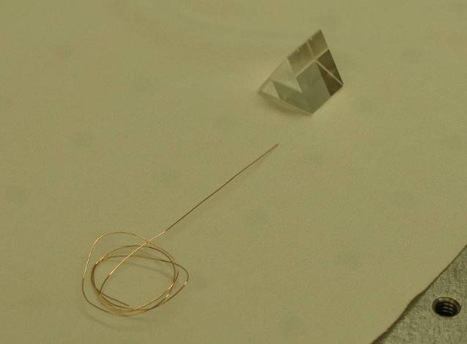  a) Prism and copper wire for applying the adhesive | 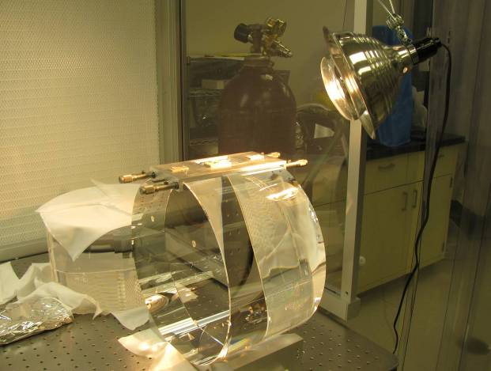  b) Heat lamp above the mass with prism glued on
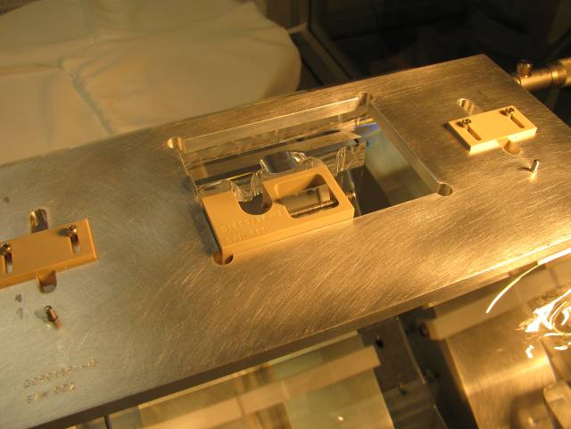  c) Close-up of prism 39 in prism holder and jig on surface S3 | 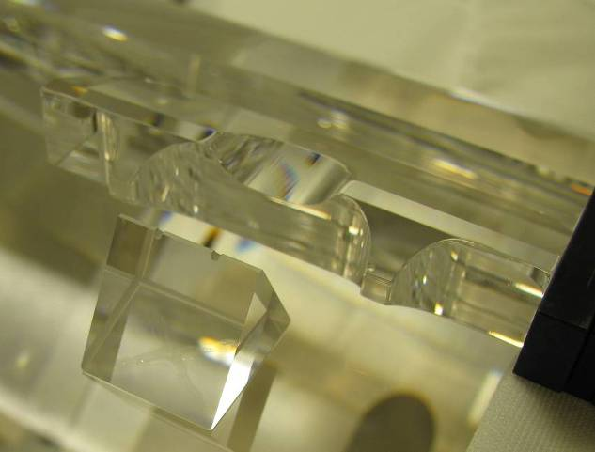  d) Imaging showing cross shaped feature in glue joint
Figure 3.1 Some images of the gluing of prism 39 to surface S3 of PM ITM04.
Gerardo Moreno applied the adhesive and did the gluing of the prisms. We observed three points that required a redesign of the prism holder. The first point is that the prism holder has the same width as the ear, which means the jig can interfere with the ear when placing the jig for gluing the prism. The required change in design involves making the prism holder 1 mm wider so that there is a gap of nominally 1 mm between the ear and the jig when gluing the prism. The other point was that Gerardo Moreno found it hard to hold and control the prism holder while placing it down onto the surface. The solution to this was to redesign the prism holder making it a bit higher, such that it sticks out more above the jig and is therefore easier to place down in a controlled way.
The third point involved the clamping screw. It didn’t have a ball shaped end, which meant the prism wanted to move during clamping into the prism holder. The redesign solution is to machine the screws to a ball shaped end. (FLAG)

Gluing magnet flag mount discs
For gluing the magnet flag mount discs PM ITM04 was placed onto S1 onto the storage container base plate on the table inside the clean room tent but outside the flow bench. This meant that surface S2 with the counter bore holes for the flag mount discs were facing up.
The counter bore holes were very dirty (something that has been observed in all penultimate mass). The holes have a lot of particulates in them and the edges have a yellow discoloration to them. Betsy Bland used clean dental tools and clean room wipes soaked with acetone to remove the particulates. It did not seem possible to remove the yellow discolorations. (FLAG)

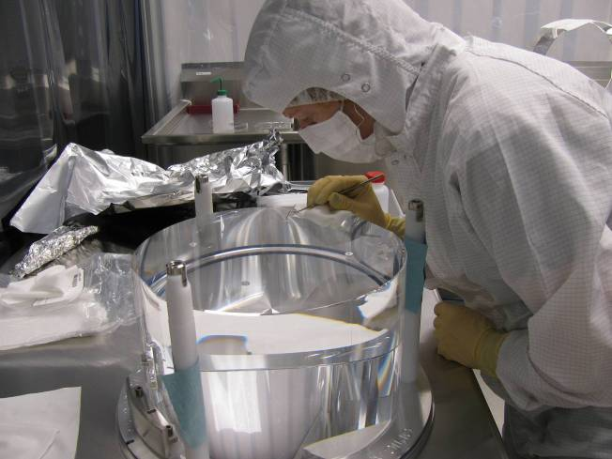  a) Betsy gluing a steel ring onto a mount disc on PM ITM04 | 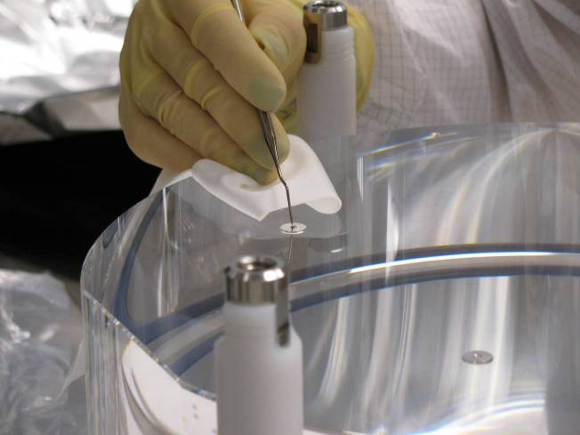  b) Close-up of gluing in a steel ring onto a mount disc using a pointy dental tool
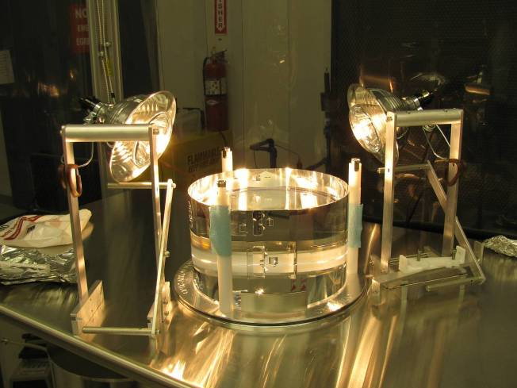
c) Two heat lamps on stands over PM ITM04 to help cure the adhesive
Figure 3.2 Some images of gluing magnet flag mount discs
Betsy also removed small nipples (remnants from turning the mount discs) using a razor blade before gluing.
Betsy then glued the magnet flag mount disc by applying a dot of adhesive to the back of the mount disc and carefully placing the mount discs into the holes. She then applied a tiny dot of adhesive to the magnetic steel ring and used pointy dental tools to place the ring inside the mount disc. She repeated this 4 times for all mount discs. Two heat lamps were put on stands over the mass to help cure the adhesive overnight. See Figure 3.2 for some images. The gluing of the magnet flag mount discs was done on Thursday morning the 10th of March 2011.
The heat lamps were switched off on Friday morning the 11th of March and PM ITM04 was stored back into its container. The mass was finally stored in its crate on the 19th of April, so it could be moved to the quad suspension laboratory.

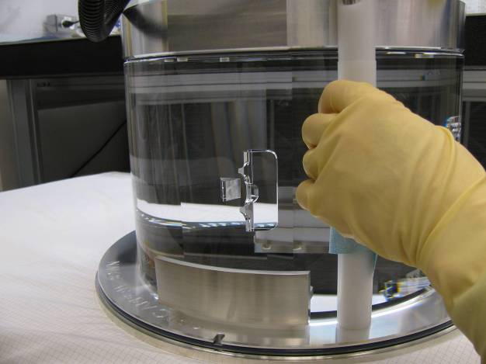
Figure 3.3 Storing PM ITM04

Bonding ears
With regards to bonding the ears to the penultimate mass the procedure described in E1000277 was followed. In rough steps the procedure involves:
- Setting the bonding jig to the calculated dimensions based on the measured dimensions of mass, jig and ear
- Preparing bonding solution in a ratio of 1:6 Sigma-Aldrich sodium silicate solution: DI water, by combining the components in a 15 ml centrifuge tube and shaking it manually. This is followed by a transfer into 1.5 ml centrifuge tubes and centrifuging them at ~10,000 rpm. Finally the solution is filtered into a sealed medical filter with a 0.2 µm membrane.
- Cleaning the bonding surface on the mass by rubbing with a cerium oxide: DI water paste twice followed by rubbing with a bicarbonate of soda: DI water paste. The cleaning procedure is finished by rinsing and a wipe with methanol. The mass is then transferred and turned onto the V-block in the flow bench (see Figure 3.4 a).
- Cleaning the entire ear but particularly the bonding surface is cleaned using the same technique as for the flat on the mass (see Figure 3.4 b).
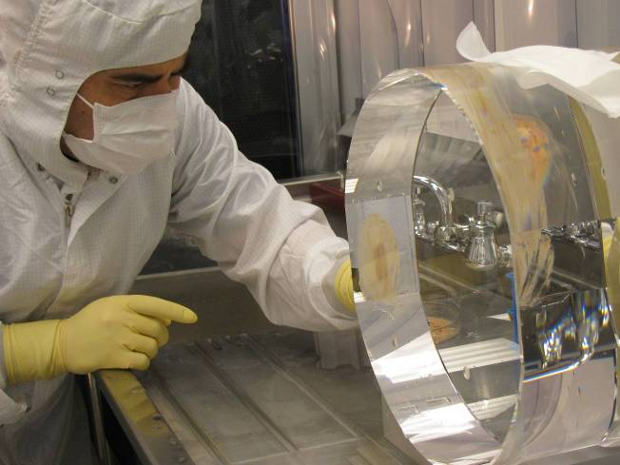  a) Cleaning the bonding surface with cerium oxide | 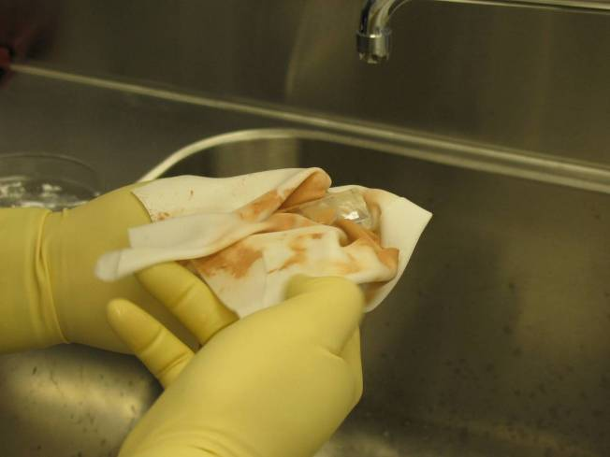  b) Cleaning the ear with cerium oxide
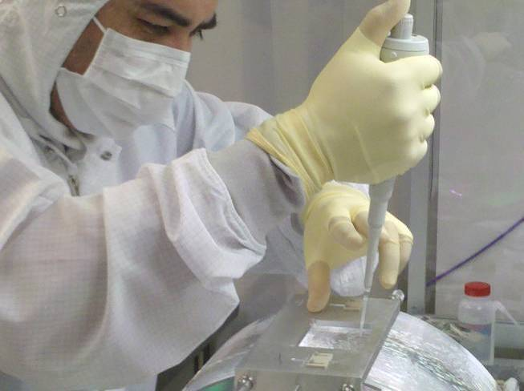  c) Pipetting bonding solution onto the bonding surface | 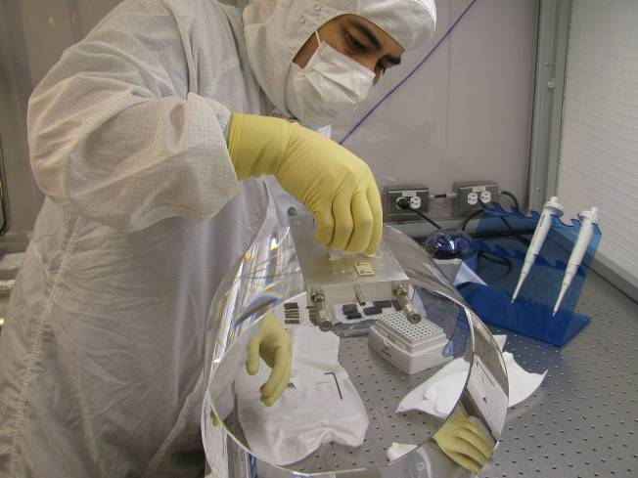  d) Placing the ear onto the bonding surface
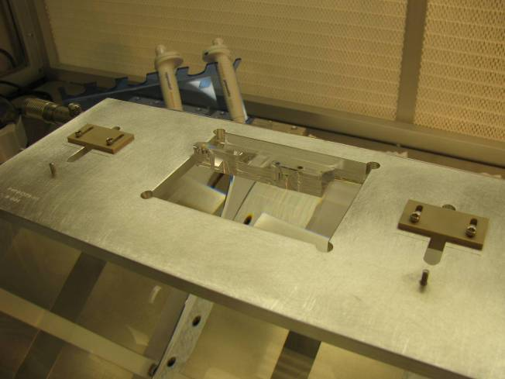  e) The ear curing against the top left surface of the jig | 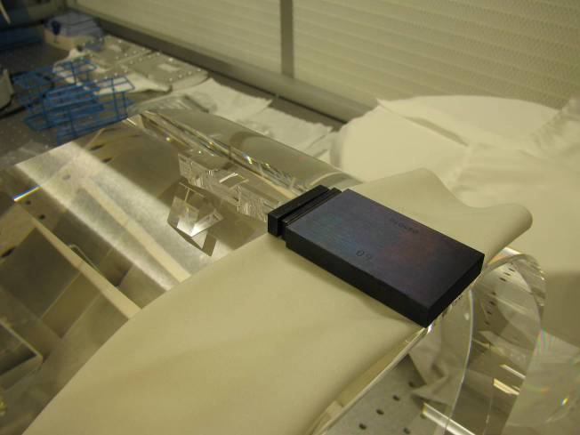  f) Measuring the position of the ear
Figure 3.4 Some images of the bonding procedure

- The bonding flat is wiped one more time with methanol and blown dry with ultra-pure nitrogen. The surface is then inspected closely using a high intensity light and eyes.
- The bonding jig is placed onto the surface.
- The ear is wiped on more time with methanol and blown dry with nitrogen. The bonding surface is then inspected.
- The bonding solution is pipetted from the medical filter and placed onto the bonding flat on the mass after which the ear is placed onto the flat against the top left corner of the bonding jig (see Figure 3.4 c and d).
- The bond is closely monitored while it settles in the first few minutes and the possibly existing bubbles are noted down with 30 minute intervals (see Figure 3.4 e).
- After 2 hours the bonding jig is removed and the position of the ears along the optical axis is measured with respect to surface S1 and S2 (see Figure 3.4 f).

PM ITM01
On Wednesday afternoon the 9th of March at 16.00 hrs (4 PM) ear S/N 70 was bonded to surface S3 by Gerardo Moreno. The bonding solution was prepared at 13.45 hrs (1.45 PM).
Bonding jig S/N 1 was used and the jig settings as shown in Table 3.5 were used. As with the prisms the jig settings were calculated based on the width of the mass (as provided through 6 measurements made at different locations on the mass by the vendor), on the measured dimensions of the jig (measurements made by the team in September 2010), and on the dimensions of the ear (measurements made by the vendor).
Observations made during the bonding of ear 70 were that the ear wanted to slide away from the top left corner. This was probably because the mass had not been tilted forward slightly to make the want to slide against the top left corner. (FLAG Solution: write a note into the procedures to flag this) This was solved by holding the ear down gently by hand against the top left corner of the jig until the bond initially settled (this take a few minutes typically). The bond initially had a larger number of tiny bubbles, but these disappeared over the course of the first few hours and by the next morning they were all gone. The scanned drawings of the bubble patterns of all bonded ears over time are included on the DCC page for this document. The jig was removed at 17.50 hrs (5.50 PM) and the position of the ear with respect to S1 and S2 was measured. Results of these measurements are discussed in section 3.4.

Table 3.5 Jig settings used for bonding the ears onto PM ITM01
PM Mass no. | Type of mass | Flat no. | Ear no. | Jig no. | d₃ [mm] | l_{flex-horn} [mm] | h_{horn} [mm] | Side jig set-up | D_{screw} [mm] | D_{slider} [mm]
PM ITM01 | PM | s3 | 70 | 1 | 10 | 17.9 | 7.9 | right | 2.82 | 22.77
PM ITM01 | PM | s4 | 71 | 1 | 10 | 17.9 | 7.9 | left | 2.93 | 22.77

On Thursday morning the 10th of March at 11.45 AM ear S/N 71 was bonded to surface S4 by Gerardo Moreno. The bonding solution was prepared at 11.00 AM. The mass was tipped slightly to allow the ear the slide against the bonding jig. The bond initially showed a large bubble but this bubble disappeared within the first 30 minutes after bonding leaving a clear bond. 1 hour and 45 minutes after bonding the jig was removed and the ear position was measured.

PM ETM04
On Thursday afternoon at 15.00 hrs (3 PM) ear S/N 85 was bonded to surface S3. Bonding jig S/N 2 was used with the jig settings shown in Table 3.6. The same bonding solution was used as for ear 71 on S4 of PM ITM01. It had been prepared at 11.00 AM.
The bond initially had a large number of fairly large bubbles. The number of bubbles reduced in the first 1.5 hours, but some bubbles did not seem to be able to escape and too large a surface area was still covered after which Gerardo and Mariëlle decided to debond this ear.
To achieve this, the mass was moved back to the sink with the bonded flat nearest the sink in vertical position. The bond was then subjected to approximately 10 minutes of rinsing DI water and increasing manual shearing force until the ear came off. It had a tendency to optically contact during this procedure which made it slightly more difficult than anticipated. A small scratch was left of both the bonding surface and the ear. This scratch coincided with the location of the large bubble left on the surface. The question rose: was there possibly a particle there? If there was, we still couldn’t see it after 1.5 hrs of curing. The ear was temporarily deposited in a petri-dish with DI water, while the bonding flat on the mass was once again thoroughly cleaned with cerium oxide paste, bicarbonate of soda and methanol to remove any possibly drying remnants of bonding solution. The mass was left on the sink overnight, for a new bonding effort the next day. The ear was then cleaned using the same procedure. As is prescribed in the procedure E1000277 a new ear was selected for the new bonding attempt.

Table 3.6 Initial jig settings used for bonding the ears onto PM ETM04 (with ears that were debonded)
PM Mass no. | Type of mass | Flat no. | Ear no. | Jig no. | d₃ [mm] | l_{flex-horn} [mm] | h_{horn} [mm] | Side jig set-up | D_{screw} [mm] | D_{slider} [mm]
PM ETM04 | PM | s3 | 85 | 2 | 10 | 17.9 | 7.9 | right | 3.05 | 22.80
PM ETM04 | PM | s4 | 86 | 2 | 10 | 17.9 | 7.9 | left | 3.23 | 22.80

Ear S/N 77 was chosen as the replacement for S3 PM ETM04. The bonding solution was prepared at 9.30 AM on the 11th of March. Bonding jig 2 was reset for ear 77 as shown in Table 3.7. The mass bonding flat was cleaned one more time with cerium oxide and bicarbonate of soda, before moving the mass back to the bonding table. The normal bonding procedure was then picked up again. Ear 77 was cleaned as normal and bonding went according to the set procedure. The bond was made at 10.30 and looked much more promising with only small bubbles initially. The bonding jig was removed at 12.50 PM and the ear position was measured. At this point only a few tiny bubbles were visible and a darkish coloured spot in the bond. The bubbles had all disappeared by the next morning. The dark spot remained.
Because of limited time ear S/N 86 was bonded onto S4 of PM ETM04 on Friday afternoon the 11th of March with the solution made at 9.30 AM and the jig with the settings shown in Table 3.6. The bond was made at 16.00 hrs (4 PM) and unfortunately also on this side of the mass the bond had a large number of large bubbles that had disappeared 45 minutes after the bond was made. Again a few of the bubbles did not seem to be able to escape from underneath the bond. Once again the decision was made to debond. The same procedure was used as above for ear S/N 85. It took between 5 and 10 minutes again to rinse the ear off. Again the ear tended to optically contact. This time a set of scratches was left in the bonding area on both the mass and the ear. One of the scratches had a length of ~10 mm. During the cleaning an assessment was made of the nature of the scratches and special attention was paid to cleaning around the scratches to make sure no material was sticking out of the surface that might hinder a good bond from forming the second time around.
Ear S/N 94 was chosen as the replacement ear for S4. The bonding solution was prepared at 9.00 AM on Saturday the 12th of March and bonded at 10.10 AM. Once again the second bond looked much better than the first and no bubbles lingered inside the scratches. After 2 hrs only a few small bubbles were left in the top right hand corner. The jig was removed at this point and the ear position was measured.

Table 3.7 Jig settings used for bonding the final ears onto PM ETM04
PM Mass no. | Type of mass | Flat no. | Ear no. | Jig no. | d₃ [mm] | l_{flex-horn} [mm] | h_{horn} [mm] | Side jig set-up | D_{screw} [mm] | D_{slider} [mm]
PM ETM04 | PM | s3 | 77 | 2 | 10 | 17.9 | 7.9 | right | 2.86 | 22.80
PM ETM04 | PM | s4 | 94 | 2 | 10 | 17.9 | 7.9 | left | 3.18 | 22.79

PM ETM03
The PM ETM03 mass has magnet flag holes on both sides. Only one set of holes are correct and have been marked (see Figure 3.5 b).

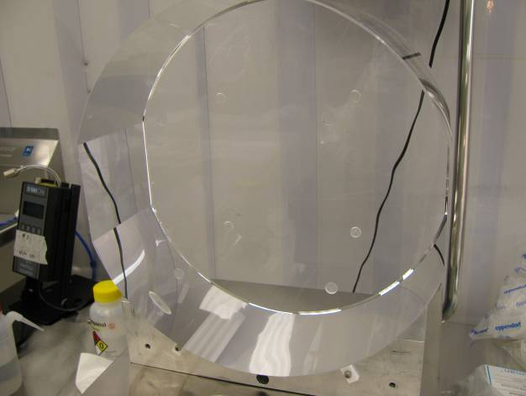  Good holes  Bad holes  a) PM ETM03 with two sets of holes | 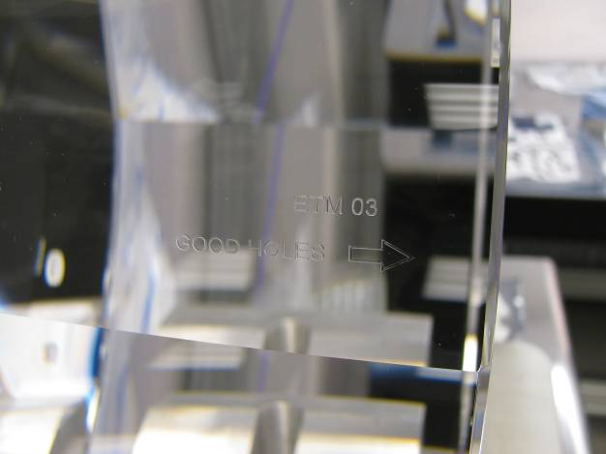  b) Indicating which side has the good holes
Figure 3.5 Some images of PM ETM03 with two sets of magnet flag holes.

Ear S/N 87 was selected for bonding to S3 of PM ETM03. Bonding jig S/N 1 was used for this penultimate mass. The jig settings are shown in Table 3.8. The same bonding solution was used for this bond as for ears 77 and 86 for PM ETM04. The bond was made at 12.05 on the 11th of March 2011. The bond had a large number of largish bubbles, most of which disappeared quickly. A few bubbles lingered in the top right hand corner. The total size of the bubbles was deemed acceptable. At 14.10 the bonding jig was removed and the ear position was measured. The ear position was measured (see section 3.4).

Table 3.8 Jig settings used for bonding the ears onto PM ETM03
PM Mass no. | Type of mass | Flat no. | Ear no. | Jig no. | d₃ [mm] | l_{flex-horn} [mm] | h_{horn} [mm] | Side jig set-up | D_{screw} [mm] | D_{slider} [mm]
PM ETM03 | PM | s3 | 87 | 1 | 10 | 17.9 | 7.9 | right | 2.93 | 22.78
PM ETM03 | PM | s4 | 89 | 1 | 10 | 17.9 | 7.9 | left | 2.90 | 22.82

Ear S/N 89 was selected for bonding to S4 of PM ETM03. The same bonding solution was used as for ear S/N 94 on S4 of PM ETM04. The bonding jig S/N 1 was set as shown in Table 3.8. The bond was made at 11.30 AM on Saturday the 12th of March. Once again the bond showed a large number of big bubbles initially that moved up towards the top edge of the bond. 2.5 hours after the bond was made the bubbles had largely disappeared except for some thin bond imperfections along the edge. The jig was removed at 14.10 hrs (2.10 PM) and the ear position was measured.

Measuring ear and prisms positions
Initially on the 9th of March an attempt was made to measure the position of the ear and prism on surface S3 of PM ITM04 using the Romer arm with a 3.000 mm sapphire ball tip. The measurement used was a surface to surface distance measurement in which each surface was located using 6 measurement points. Values A, B, C and D in Figure 3.6 a) were measured and also the width of the mass. The results are shown in Table 3.9. The width of the mass was measured with a repeatability of ± 0.009 mm, the average value being 200.140 mm. The vendor had returned a width using 6 measurements averaging 200.173 mm, which is 0.033 mm wider than the width we measured, but well within the required accuracy.

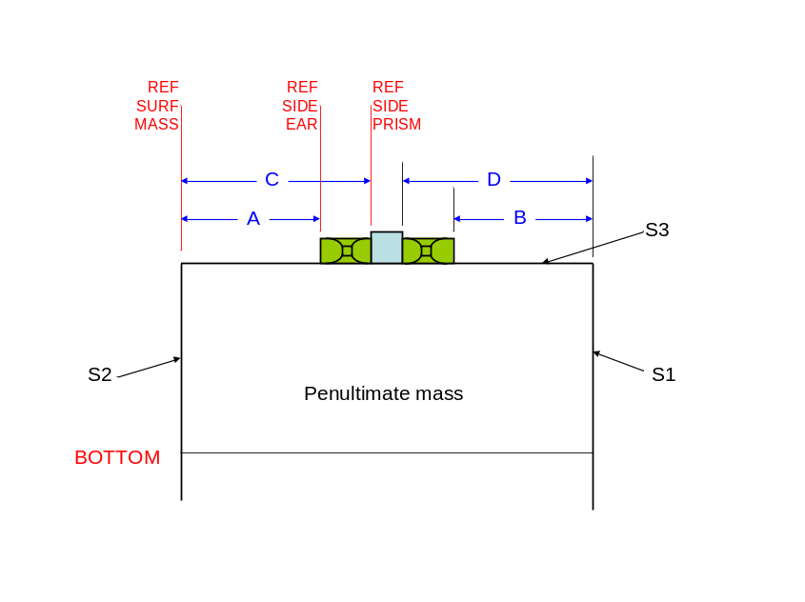  a) Ear and prism on S3 | 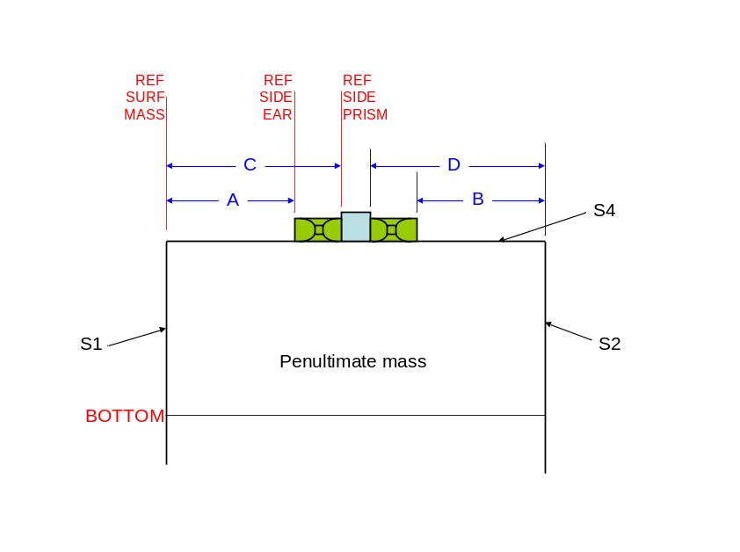  b) Ear and prisms on S4
Figure 3.6 Graphical representation of ear position measurements on the penultimate masses

The measurements of the ear and prism positions, however, were not repeatable at all. Results could vary by as much as a millimeter and though we tried several methods we weren’t able to improve this. The reason for this might be in the fact that the sides of the ear and prism are very small surfaces in comparison to the mass. The 6 measurement points on these surfaces are only approximately 5 mm apart from each other or even less, whereas the 6 measurement points on surfaces S1 and S2 are as much as 330 mm away from each other. Any small variation in the point location on the sides of the ear and prism can therefore blow up an error in surface location and parallelism with respect to surface S1 or S2 of the mass. An alternative way of measuring would be to measure a point on the ear or prism side and measure its distance to surface S1 or S2. This might improve accuracy, but in March 2011 we did not know how to do this.

Table 3.9 Measurement results with the Romer arm
Measured value [mm] | Measurement #1 | Measurement #2 | Measurement #3
Width mass | 200.146 | 200.142 | 200.131
A | 70.022 | 69.904 | 69.523
B | 70.221 | 70.430 | 70.224
C | 93.070 | 93.183 | 93.261
D | 92.335 | 92.142 | 92.196

Instead we came up with an alternative solution for the measurements. We decide to use slip gauges to measure the distance between the side of the ear and surface S1 or S2 as shown in Figure 3.7. The slip gauges were carefully sat on top of a clean room wipe against the side of the ear. Another slip gauge was touched against the face of the mass sticking out towards the slip gauges on the flat. One could then establish if there was still a gap between them and change the total width of the slip gauges on the flat until the gap is no longer visible and the stacked up array of slip gauges on the flat was used to establish if there was still a gap between them. This technique worked very well, though it was somewhat challenging to keep the slip gauges parallel to the flat because of the unevenness of the clean room wipe. It was therefore decided to design and make a PFA440 flat base to sit the slip gauges on for these measurements in the future.

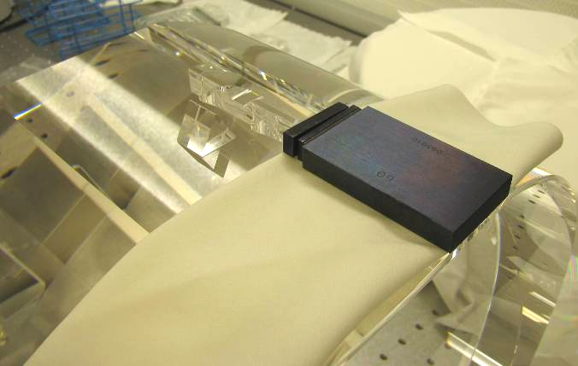
Figure 3.7 Slip gauges sitting on a clean room wipe on the flat against ear
side 2 for measuring the distance between it and face S3 of the mass.
The results of the measurements for all ears on the penultimate masses and for the prisms on PM ITM04 are shown in Table 3.10.

Table 3.10 Measurements of ear (and prism) positions made using slip gauges on the penultimate masses
Mass | Ear | Flat | A [mm] | B [mm] | C [mm] | D [mm]
PM ITM04 | 78 | S3 | 70.09 | 70.09 | 92.50 | 92.60
PM ITM04 | 84 | S4 | 70.02 | 70.06 | 92.5 | 92.7
PM ITM01 | 70 | S3 | 70.06 | 70.04
PM ITM01 | 71 | S4 | 70.00 | 70.00
PM ETM04 | 77 | S3 | 69.95 | 70.00
PM ETM04 | 94 | S4 | 69.80 | 70.12
PM ETM03 | 87 | S3 | 70.05 | 69.93
PM ETM03 | 89 | S4 | 70.02 | 70.00

All results are within a ± 0.1 mm symmetry, except for ear S/N 94 on S4 of PM ETM04 which was off by more. A calculation was done of the distance from surface S2 to the center of the ear using measurement A and the measured values x_{h1} and z from the ear as reported in E1000265 to see if this off-set had to do with an off-set in dimensions of the ear itself. As reported on the bond quality sheet this was done as follows:
mm.
The width of PM ETM04 measured by the vendor was 200.080 mm, which means the COM was 100.040 mm from surface S1 or S2. The conclusion was then drawn on Saturday afternoon the 12th of March that this was within tolerance and the ear had been bonded on in the correct location. In April 2011 we discovered however that this calculation was not the correct calculation and the ear is indeed not bonded on in the correct location. Further discussion of this in section 4.4. (FLAG)

To-do list after
- Increase shim size on the sink so that the dedicated cut-out can be used - Gerardo (not done in April, decision that change is not required in April)
- Teflon pads under the V-blocks – Gerardo (not done in April, change of plan in April, see section 4.5)
- Clean the 3rd V-block (the one that came from LASTI) – Gerardo (not done in April, remains on to-do list in section 4.5)
- Design and make a Teflon pad to make the ear and prism position measurements easier – Marielle (done in April)
- Redesign and make prism holder and screw – Marielle (design made in April, finished production early May).
- Get a fresh supply of Alpha wipes – Gerardo (done in April)
- Get extra bicarbonate of soda – Gerardo (done in April)
- Scan notes and put on the DCC – Gerardo (done in April)
- Store newly arrived discs in Pyrex dish or tray with lid – Betsy (done in April)

Review of the week
The consensus between Gerardo Moreno and Mariëlle van Veggel was that bonding ears to three masses and prisms to one mass in 5 days had been extremely intensive. The days were long, especially in the case of PM ETM04 on which we had to bond, debond and rebond. Retrospectively we should have been content with bonding ears to two masses and prisms to one mass, after the first ear on PM ETM04 had to be debonded. Our judgement was influenced in a negative way. (FLAG)

Bonding in April

Inspection of TM ETM02 (with ITM coating)
After lifting TM ETM02 out of its container the surfaces of the TM were inspected. The flaws on surface S1 and S2 corresponded largely to the flaws reported by the vendor. The polishing vendor had however not reported on the flaws on any of the other surfaces, particularly the barrel and the chamfers. We noticed quite a few large scratches and digs and even a crack on the barrel and the chamfers (see Figure 4.8). It is not clear if these flaws were there after polishing or after coating (by a different vendor). Some of these flaws are serious. (FLAG)

Measuring the width of TM ETM02 (with ITM coating)
The test mass TM ETM02 arrived at LHO and the report polishing measurement report from the vendor (C1000480) had been made available online (https://nebula.ligo.caltech.edu/optics/). Also a coating vendor report was placed online (C1103161), which is not relevant for bonding purposes. The vendor supplied information on the weight of the mass to ±10 gram accuracy using scales supplied by LIGO COC to the vendor. The weight was 39.562 kg. The vendor also supplied basic information on the width of the mass at its widest point (at the bottom) and the wedge angle. He reported these to be 200.15 mm at maximum width and 0.077º respectively. The vendor did not supply information on how the measurement was made.
Betsy Bland deemed the weight information from the vendor sufficient for balancing the suspension purposes as she required an accuracy of ±100 grams.
As no measurements had yet been done by the COC team (as to be reported in E1000776), the width information was not deemed sufficient by GariLynn Billingsley and it was therefore decided in an e-mail exchange between Mariëlle van Veggel and GariLynn Billingsley on the 15th of April 2011 that the width of the mass and its wedge should be measured on arrival at LHO. (FLAG)
The first attempts to do this were made on Tuesday the 19th of April 2011 using the Romer arm. The initial attempts made a surface measurement of surface S1 and then took 4 point measurements on the 12 o’clock (thinnest side), 3 o’clock, 6 o’clock (thickest side) and 9 o’clock positions on surface S2 to determine the distance between surface S1 and each of these points. The results consistently came back with 1.5 mm to large a width; 1.500 mm being the radius of the sapphire ball tip of the Romer arm. The results are shown in Table 4.11.
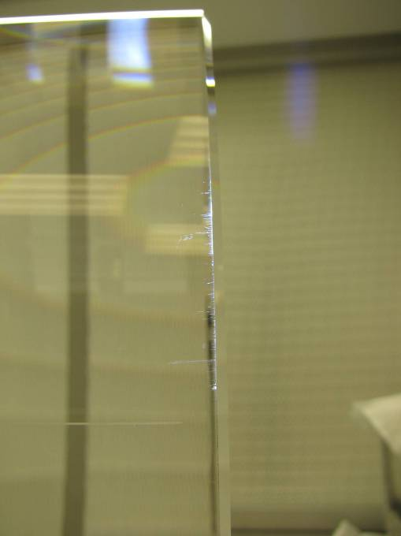  a) Scratches on the barrel at the chamfer | 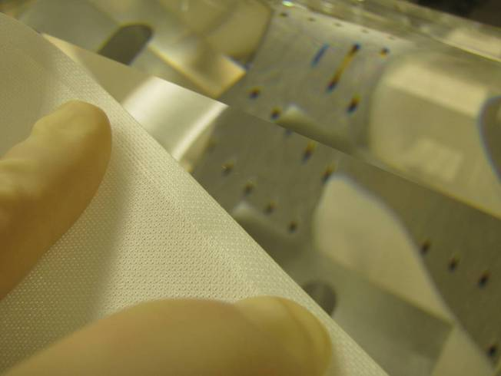  b) Scratch on barrel near one of the flats
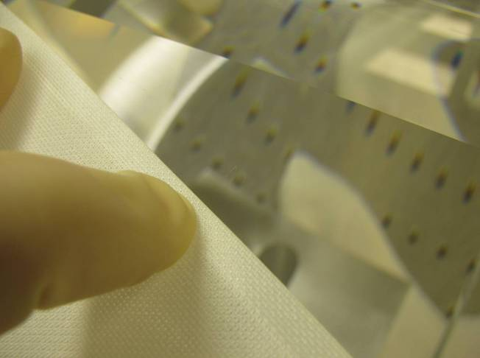  c) Scratch on the barrel near one of the flats | 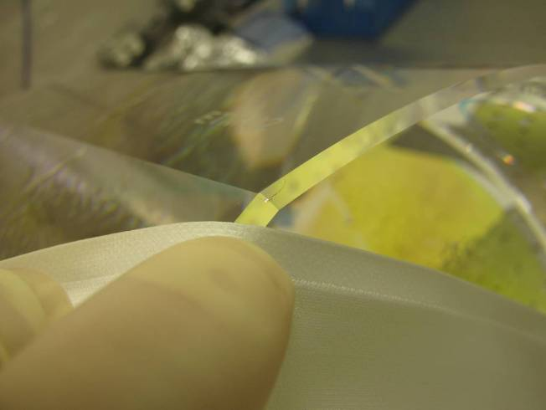  d) Crack in the chamfer area on the corner of a flat and the barrel
Figure 4.8 Flaws on the barrel and chamfers of TM ETM02 (with ITM coating)

Table 4.11 TM ETM02 width measurements made on the 19th of April (1.500 mm substracted from the results)
Location | Measurement #1 | Measurement #2 | Measurement #3 | Measurement #4
12 o’clock (thinnest) | 199.579 | 199.628 | 199.628 | 199.604
9 o’clock | 199.903 | 199.908 | 199.922 | 199.844
3 o’clock | 199.911 | 199.901 | 199.902 | 199.895
6 o’clock (thickest) | 200.137 | 200.141 | 200.169 | 200.127

The wedge was determined by using the angle calculation option between two planes in the Romer arm software. Surfaces S1 and S2 were measured in 6 locations each and the calculated angle from the software was 0.078º, corresponding to within 0.001º with the value measured by the vendor. The average width on the widest point was 200.144 mm, corresponding to within 0.006 mm with the value measured by the vendor.

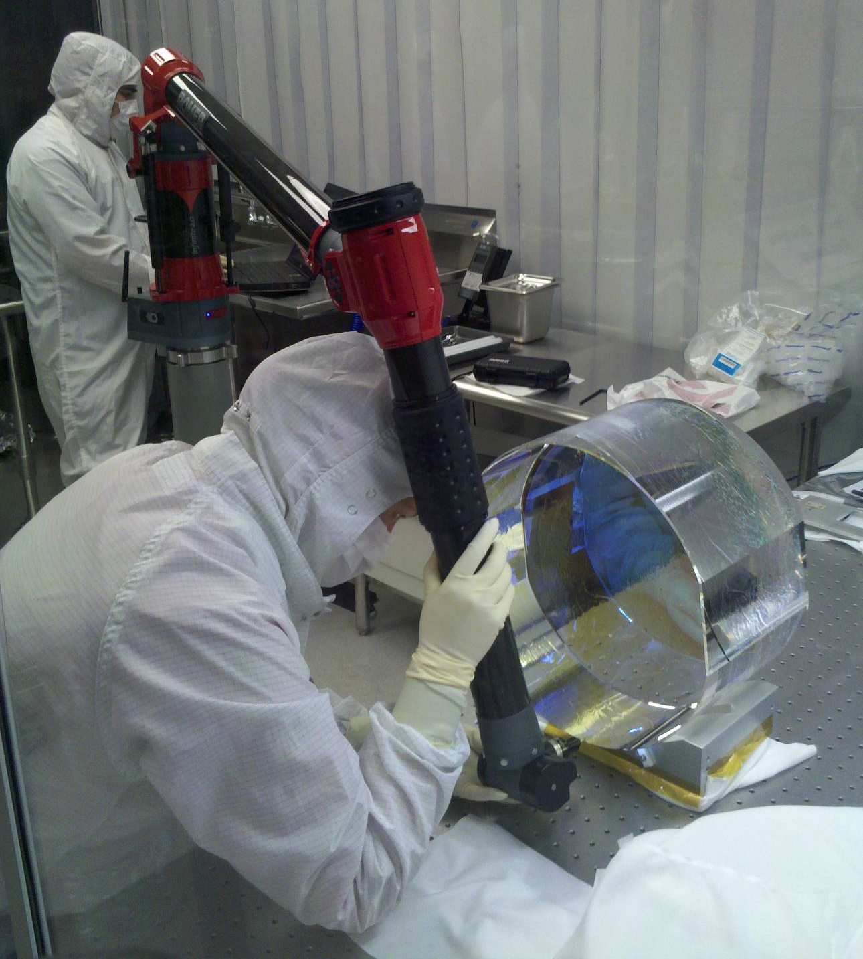
Figure 4.9 Using the Romer arm to measure the width of TM ETM02

On Wednesday morning the 20th of April, Gerardo had received advice on how to measure the distance between a point and a plane without getting the 1.5 mm error. This is done by first measuring the location of both planes S1 and S2. Then points on plane S2 were defined and projected on measured plane S2. The distance between the projected points and S1 could then be calculated and one had to specifically select to measure the distance between “point:centre” and place S1. Measurement results from the 20th of April are shown in Table 4.12.

Table 4.12 TM ETM02 width measurements [mm] made on the 20th of April
Location | Measurement #5 | Measurement #6 | Measurement #7 | Total average over 7 points
12 o’clock (thinnest) | 199.738 | 199.737 | 199.727 | 199.663 (±0.026)*
9 o’clock | 199.949 | 199.956 | 199.943 | 199.918 (±0.015)
3 o’clock | 199.951 | 199.946 | 199.945 | 199.922 (±0.009)
6 o’clock (thickest) | 200.160 | 200.162 | 200.159 | 200.151 (±0.006)
* standard error of the mean
The width measurement results consistently came back with a slightly larger value than on the 19th of April. The wedge was measured once again with the same technique as discussed above and was slightly smaller. It was 0.074º. The total average of the width at maximum was calculated to be 200.151 mm corresponding to within 0.001 mm to the vendor value. The width at the 9 and 3 o’clock position averaged at 199.920 mm, which also corresponded to the value calculated from the vendor information. We considered these measurements to be enough to be able to go ahead with bonding.

Bonding ears to TM ETM02 (with ITM coating)
As with the penultimate masses the ears were bonded onto the TM ETM02 test mass with the same procedure as discussed in 3.3. Margot Phelps was present to make sure the procedure would not interfere with the ITM coating. She and Gerardo had applied first contact to the centre of the coating getting to ~1 inch from the edge of the barrel on the 18th of April. The 1 inch distance from the barrel allows for picking up the optic using the ergo arm without interfering with the first contact. Also this will make alignment into the structure using optical tools easier at a later time.
For surface S3 on TM ETM02 ear S/N 38 was selected for bonding. The jig used was jig S/N 1 and the jig settings are shown in Table 4.13. The jig settings calculations done by E100265 were checked manually and independently by Mariëlle van Veggel and Angus Bell. (FLAG)
The bonding solution was prepared at 10.00 AM on the 20th of April by Mariëlle. The bond itself was made by Gerardo at 11.10. There were initially quite a few bubbles. Some of the bubbles moved out and some of the bubbles got thinner. The bonding jig was removed at 13.15 hrs (1.15 PM) and the position of the ear measured. These measurements are discussed in section 4.4. The next morning the bubbles except for one very small bubble had disappeared.

Table 4.13 Jig settings for TM ETM02 (with ITM coating)
TM Mass no. | Type of mass | Flat no. | Ear no. | Jig no. | d₄ [mm] | l_{flex-horn} [mm] | h_{horn} [mm] | Side jig set-up | D_{screw} [mm] | D_{slider} [mm]
ETM02 | TM | s3 | 38 | 1 | 10 | 17.4 | 7.4 | left | 2.93 | 23.205
ETM02 | TM | s4 | 43 | 1 | 10 | 17.4 | 7.4 | right | 3.01 | 23.265

For surface S4 on TM ETM02 ear S/N 43 was selected for bonding. Jig S/N 1 was setting as shown in Table 4.13 on Thursday the 21st of April. The bonding solution was prepared by Mariëlle at 9.40 AM. The bond was made at 10.30 AM. Once again quite a few bubbles were present initially, but the number of bubbles reduced over the first few hours. One largish bubble and a number of tiny remained at 12.30, but this still looked to be improving and the surface area covered was small enough to meet requirements. The bonding jig was removed at 12.30 PM and ear position measured as will be discussed in the next section.

Measuring ear positions
For the ear position measurements the previously successful slip gauge technique was used. This time the PFA440 pads were placed underneath the slip gauges. Because the ears are bonded on the other way up the jig are set in a switched around way to the penultimate mass. The meaning of values A and B is shown in Figure 4.10.

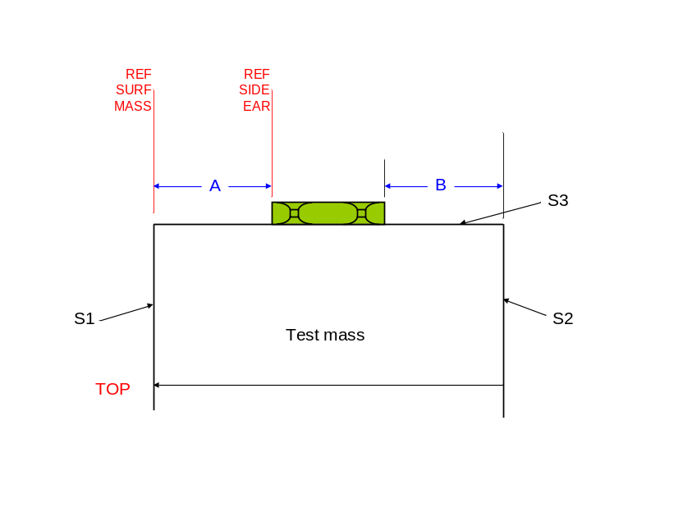  a) Ear on S3 | 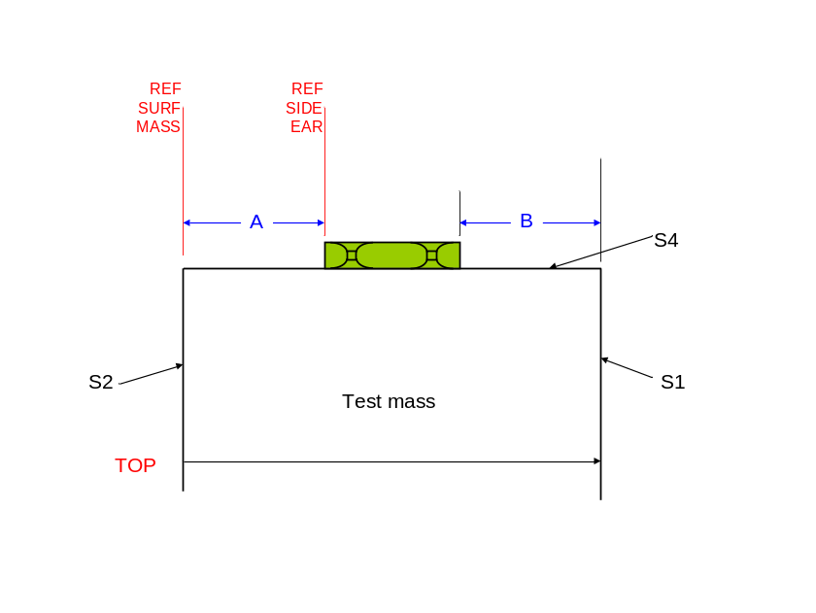  b) Ear on S4
Figure 4.10 Graphical representation of ear position measurements on the test mass

The measurement results for the ear positions on TM ETM02 are shown in Table 4.14.

Table 4.14 Measurements of ear (and prism) positions made using slip gauges on the penultimate masses
Mass | Ear | Flat | A [mm] | B [mm]
TM ETM02 | 38 | S3 | 70.00 | 70.10
TM ETM02 | 43 | S4 | 70.07 | 69.86

Once again there was a more than 0.2 mm offset between the two measurements for ear 43, which made us revisit the measurements and calculations done in March as well. It turned out that the equation used then was incorrect. It should be:
The value z in the jig settings calculation sheet already calculates the average distance of the horns to the left side of the ear, which is the reference face used for the jig settings. Though B gives a position indication, it is in effect a superfluous measurement, as the total width of the ear is in fact unknown.
Table 4.15 shows the calculation of the ear position with respect to the center of mass of all penultimate masses and the test mass that were bonded. Table 4.16 shows the calculated prism positions for PM IMT04.
When looking at the ear position results for the test mass TM ETM02, the off-sets of the ears from the center of mass were marginally within the required tolerance of ±0.1 mm, which also urged us to see if we could find a discrepancy in any of the measurements required to set the jig and get the ear in the correct location. When looking at the remaining measurements all except one of the other ears were within the tolerance with the error in the same order of magnitude but in all cases the error was smaller than the error for the test mass. Also the errors can either cause tilt only or tilt and yaw. The one systematic error that might be observed here is that the errors for all ear bonded onto surface S3 are negative errors indicating that there might be a consistent jig offset. However, for the test mass the left hand side of the jig is set when bonding on the ear, whereas for the penultimate masses the right hand side of the jig is set, which means that the test mass is an exception to this rule. The only difference in bonding situation between bonding ears onto the test mass or the penultimate mass is that the test mass has a wedge. Could that explain the slightly higher error and the opposite offset for the ear on S3? And what can explain the apparently systematic offset for all ears on S3 of the penultimate masses? (FLAG)
One ear was bonded on with an error larger than the required tolerance; ear 94 on S4 of PM ETM04. (FLAG) This ear was the ear on which the incorrect calculation was performed earlier in this report. It is interesting to point out that the ears on PM ETM04 were the only ears bonded on with bonding jig S/N 2. Interestingly the prisms on PM ITM04 were also glued on using bonding jig S/N 2. In Table 4.16 it shows that the error of the prisms position on S3 is larger than the required tolerance. (FLAG) The erronous prism was glued on the other side though using x_{j2} instead of x_{j1} in the jig settings from the erroneous ear so that is odd.

Table 4.15 Calculation of the actual ear positions and effect on mass position
Mass | Ear | Flat | A [mm] | z [mm] | d_{C-CE} [mm] | ½w_{mass} [mm] | |d_{C-CE} – ½w_{mass}| [mm] | Ear closer to S1 than S2? | Tilt/yaw
PM ITM04 | 78 | S3 | 70.09 | 29.97 | 100.06 | 100.087 | 0.027 | - | Tilt only
PM ITM04 | 84 | S4 | 70.02 | 30.12 | 100.14 | 100.087 | 0.053 | - | Tilt only
PM ITM01 | 70 | S3 | 70.06 | 30.03 | 100.09 | 100.098 | 0.008 | - | Tilt and yaw
PM ITM01 | 71 | S4 | 70.00 | 30.035 | 100.035 | 100.098 | 0.063 | + | Tilt and yaw
PM ETM04 | 77 | S3 | 69.95 | 30.05 | 100.00 | 100.04 | 0.04 | - | Tilt and yaw
PM ETM04 | 94 | S4 | 69.80 | 30.06 | 100.86 | 100.04 | 0.18 | - | Tilt and yaw
PM ETM03 | 87 | S3 | 70.05 | 29.96 | 100.01 | 100.058 | 0.048 | - | Yaw and tilt
PM ETM03 | 89 | S4 | 70.02 | 29.96 | 99.98 | 100.058 | 0.060 | + | Yaw and tilt
TM ETM02 | 38 | S3 | 70.00 | 29.89 | 99.89 | 99.96 | 0.070 | - | Tilt and yaw
TM ETM02 | 43 | S4 | 70.07 | 29.975 | 100.045 | 99.96 | 0.085 | - | Tilt and yaw

Table 4.16 Calculation of the actual prism positions and effect on mass position
Mass | Prism | Flat | C [mm] | w_{p}/2 [mm] | d_{S2-centerear} [mm] | ½w_{mass} [mm] | |d – ½w_{mass}| [mm] | Ear closer to S1 than S2? | Tilt/yaw
PM ITM04 | 39 | S3 | 92.5 | 7.43 | 99.93 | 100.087 | 0.157 | - | Tilt only
PM ITM04 | 40 | S4 | 92.5 | 7.50 | 100.00 | 100.087 | 0.087 | - | Tilt only

It was decided to remeasure the relevant dimensions on both jigs again to check that no error had been made in September 2010. The jig dimensions were measured using a digital height gauge in September 2010. It had taken a bit of time to get consistent measurements then, but in the end we had succeeded. In April 2011 the measurements were conducted using slip gauges instead. The slip gauge total widths were then checked using digital calipers. The results are shown in Table 4.17.

Table 4.17 Measurement results for jigs in September 2010 and April 2011
 | Measured September 2010 |  | Measured April 2011 |  | Difference
Jig S/N | x_{j1} [mm] | x_{j2} [mm] | x_{j1} [mm] | x_{j2} [mm] | δx_{j1} [mm] | δx_{j2} [mm]
1 | 72.997 | 132.943 | 72.94 | 132.89 | 0.057 | 0.053
2 | 73.159 | 132.948 | 73.03 | 132.90 | 0.129 | 0.048

In all cases the measurement results in September 2010 were in the order of tens of microns or even larger than the results found in April 2011. If the April values had been used in all cases this would have led to the ears moving further away from surface S1 which would have made the error larger in almost all cases so this does not explain the offsets. (This statement needs checked)

To-do list after
- Teflon support trays under the V-blocks – Gerardo (change of plan)
- Clean the 3rd V-block (the one that came from LASTI) – Gerardo
- Update bonding procedures – Mariëlle
- Measure jigs and ear and prism positions again - Gerardo

Conclusions and discussion
Ears and prisms were bonded and glued respectively to five penultimate masses and one test mass.
A number of observations were made during this work which flagged for improvement or further investigation:
- The initial prism holders (for gluing prisms to the penultimate masses would benefit from some small design changes to make handling easier and more reliable. This work has been completed. New drawings have been uploaded to the DCC and parts have been made, cleaned and sent to LHO.
- Dirt and discoloration was noticed of the magnet flag counter bore holes of the penultimate masses. The dirt was removed, the yellow discoloration does not appear to be removable.
- The ears have a tendency to drift if the bonding flag is not horizontal or slightly slanting towards the reference edge of the bonding jig. The solution is to make a note of this in the procedures (E1000277 and E1000278). This has not been done yet. (Action: Mariëlle)
- Working on four masses in one week is too intensive for two people and increases risk of error. Advise to limit scheduling bonding to two masses per week maximum.
- Scratches found on the barrel near the chamfers of ETM02. The presence of these scratches was noted by Margot Phelps and flagged to the COC team. Subsequently this has been flagged with the polishing vendor as well. It is unknown at this point where these scratches are created (polishing vendor or coating vendor). (Action: GariLynn)
- Width measurements of all (test) masses is required on site as the vendor does not provide this information with the required accuracy. This has been confirmed more recently with ITM04 as well. These measurements and a procedure will need to be included in the bonding procedures (E1000277 and E1000278). (Action: Mariëlle)
- The jig settings calculations are done using an Excel programme, but need to be checked manually and independently always by two people to confirm no error is made. Currently the checking rests with Glasgow personnel only. This should also be done by LIGO staff. (Action: LIGO staff)
- Ear and prism positions were measured using slip gauges to confirm they are centred. A procedure of this check should be included in the bonding procedures (E1000277 and E1000278) (Action: Mariëlle)
- It was found that the position error of the ears was within the required accuracy for most ears and prisms. It was noted that the error has a predominant tendency to be in the direction of surface S2. It is not understood why.
- One ear (94 on PM ETM04) and one prism (39 on PM ITM04) seem to be bonded/glued on with a larger error than the required 0.1 mm. Coincidentally both have been bonded with jig 2 though with opposite sides. One of the dimensions on jig 2 appears to be incorrect after re-measurement. The required action is to re-measure ear positions on PM ETM04, prism positions on PM ITM04, and jig 2 to check if the position errors reported here are indeed of this magnitude and see if we can understand partly where they came from. (Action: Gerardo/Betsy)

