LIGO Laboratory / LIGO Scientific Collaboration

LIGO-E1100684-v1 LIGO 7/19/11

Surface figure measurement of ETM04

G. Billingsley

Distribution of this document:
LIGO Scientific Collaboration

This is an internal working note
of the LIGO Laboratory.

California Institute of Technology  LIGO Project – MS 18-34  1200 E. California Blvd.  Pasadena, CA 91125  Phone (626) 395-2129  Fax (626) 304-9834  E-mail: info@ligo.caltech.edu | Massachusetts Institute of Technology  LIGO Project – NW22-295  185 Albany St  Cambridge, MA 02139  Phone (617) 253-4824  Fax (617) 253-7014  E-mail: info@ligo.mit.edu
LIGO Hanford Observatory  P.O. Box 159  Richland WA 99352  Phone 509-372-8106  Fax 509-372-8137 | LIGO Livingston Observatory  P.O. Box 940  Livingston, LA 70754  Phone 225-686-3100  Fax 225-686-7189
http://www.ligo.caltech.edu/

Introduction
The purpose of this note is to memorialize the results of figure measurement of ETM04.

Method
This is the average of eight measurements taken every 45 degrees, the optic under test is rotated. See T1100370-v2 for more detail.

Uncertainty
The final uncertainty in the measurement of ETM04 is estimated to be of order 0.4nm rms over 300mm and 0.1nm rms over 160mm. This uncertainty is the combination of environmental and RDF errors. See T1100370-v2.

Results
ETM04 is measured every 45 degrees in 8 orientations. The final map is the average of all 8 datasets rotated to one orientation (arrow up.) The RDF is subtracted from each data set before averaging. While the error found in this analysis is sufficient for analysis of ETM04, we expect the RDF to be refined by further measurement. A key to the coefficients listed on data images is found in figure 1; for instance coef 4 corresponds to term# 4 in the list of Zernike polynomials.

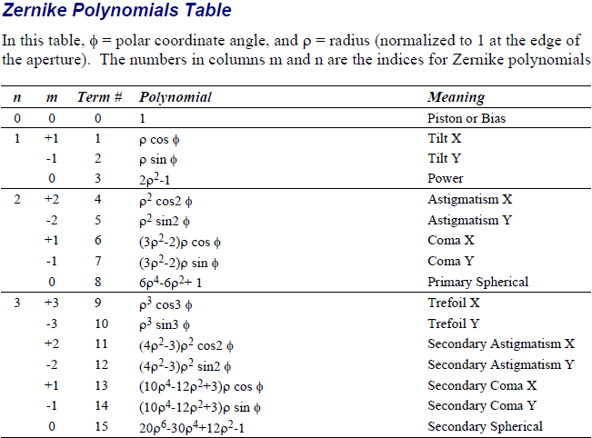

High Frequency data
Data have been taken at 0.4mm/pixel (full aperture), 0.192mm/pixel, 0.047mm/pixel and 0.023mm/pixel. As of this writing there is no calibration file in place for these apertures, these data will be post processed when a calibration file is available.

