LIGO Laboratory / LIGO Scientific Collaboration

LIGO- E1100849 LIGO Sept 24, 2013

aLIGO BSC-ISI, Pre-integration Testing report,
Phase II (before and after cartridge install)
E1100849 – V2

Sebastien Biscans, Jim Warner, Hugo Paris

Distribution of this document:
Advanced LIGO Project

This is an internal working note
of the LIGO Laboratory

California Institute of Technology  LIGO Project – MS 18-34  1200 E. California Blvd.  Pasadena, CA 91125  Phone (626) 395-2129  Fax (626) 304-9834  E-mail: info@ligo.caltech.edu | Massachusetts Institute of Technology  LIGO Project – NW22-295  185 Albany St  Cambridge, MA 02139  Phone (617) 253-4824  Fax (617) 253-7014  E-mail: info@ligo.mit.edu
LIGO Hanford Observatory  P.O. Box 1970  Mail Stop S9-02  Richland WA 99352  Phone 509-372-8106  Fax 509-372-8137 | LIGO Livingston Observatory  P.O. Box 940  Livingston, LA 70754  Phone 225-686-3100  Fax 225-686-7189

Table of contents:

1. Phase II-a 4
1. Hardware changes 4
1. CPS – E1100369 4
2. GS13 – E1100740 4
3. L4C – E1100740 4
4. T240 – E1100740 4
5. Cables – E1100822 4
6. Misc 4
2. Electronic Inventory 4
3. Models Modifications 4
4. Mass distribution 5
5. Basic functionalities just after installing the BSC-ISI on the teststand 6
1. Pressure sensors 6
i. Spectra 6
ii. Actuators-cables resistance 6
iii. Offsets CPS Unlocked vs locked 7
iv. Offset local drive 7
v. Offset Cartesian drive 9
vi. Range of motion 10
vii. Linearity test 10
6. Transfer functions and Comparison with measurements done in the staging building. 12
1. At the end station 12
i. Comparisons with measurements in the staging building 16
7. Conclusion Phase II-a 21

Introduction

The BSC-ISI testing is performed in three phases:
1) BSC-ISI, Pre-integration Testing, Phase I (post-assembly, in the staging building)
2) BSC-ISI, Pre-integration Testing, Phase II: Final tests done before insertion in the chamber
3) BSC-ISI, Integration Phase Testing: Procedure and results related to the commissioning in the chamber.

The ISI-BSC9 was moved from the Staging building to the VEA test stand July 2013.

This document presents results of tests (Phase II) performed on the ISI-BSC9 (ETMX) before installation in the chamber.

All results are posted on the SVN at:
https://svn.ligo.caltech.edu/svn/seismic/BSC-ISI/H1/ETMX/

The following type of document can be found in the SVN:
- Excell spreadsheet (.xls)
- Data location
- Figures location
- Masses distribution scheme (ppt)

Phase II-a

Hardware changes

CPS – E1100369
CPS have not been replaced since phase I testing in the staging building.

GS13 – E1100740
GS13 have not been replaced since phase I testing in the staging building.

L4C – E1100740
L4C have not been replaced since phase I testing in the staging building.

T240 – E1100740
T240 have not been replaced since phase I testing in the staging building.

Cables – E1100822
The cables installed on ISI-BSC3 are reported in the table below. Further information can be found in E1100822.

Misc
No hardware changes since phase I testing in the staging building.

Electronic Inventory
This table reports the electronic equipment used in the LVEA.

Models Modifications
The model was updated and recompiled since MEDM screens were modified

Mass distribution
Here is the payload distribution of the ISI. SUS-QUAD and TMS are installed.

Stage 1
Location | Weight (lb)
Corner 1 | 59.5
Corner 2 | 54
Corner 3 | 19.5
Total | 133
Table 1 - Payload Stage 1

Stage 1 payload is unchanged since first installation in the staging building.

Stage 2 - 2612lb - 5% = 2481lb
Mass Budget - Mass type | Quantity | Weight | Unit | Weight (lb)
D1003136 | 12 | 50 | lb | 600
D1003161 | 7 | 47.4 | lb | 332
type 0 | 1 | .6 | lb | 4.8
type 1 | 5 | 1.1 | lb | 13.2
type 2 | 0 | 2.2 | lb | 2.2
type 3 | 4 | 4.5 | lb | 9
type 4 | 8 | 7.9 | lb | 39.5
type 5 | 2 | 15.6 | lb | 78
type 6 | 6 | 27.2 | lb | 163.2
 |  |  |  | 1193.9
Table 2 - Payload Stage 2

This is the Stage 2 Seismic payload. Add ~900 lbs for a quad and ~450 for the TMS and the total payload is 2591lb.

There is a 12lb difference with the payload installed in the staging building.

Test result: Passed: X Failed: . W Waived: __

Basic functionalities just after installing the BSC-ISI on the teststand

Pressure sensors
All pressure sensors are working.
https://svn.ligo.caltech.edu/svn/seismic/BSC-ISI/H1/ITMX/Data/Static_Tests/
- H1_ISI_ETMX_Pressure_Sensors_Check_Calibrated_2020_09_19_3 0:6:.mat

 | Pressure (kPa)
Sensors | Corner 1 | Corner 2 | Corner 3
ST1-L4C-P | -.01913 | .2 | -.9
ST1-L4C-D | 99.5777 | 99.3 | 100.9
ST1-GS13-P | .4876 | .1044 | .98549
ST1-GS13-D | 100.041 | 100 | 102
ST1-T240-P | 100.4 | 101.2 | 100.75
Table 3 - Geophones Pressure sensors

Test result: Passed: X Failed: . W Waived: __

Spectra
Spectra of the instrument can be found in the SVN at:
seismic/BSC-ISI/H1/ETMX/Data/Spectra/Undamped/
- H1_ISI_ETMX_ASD_m_LOC_CPS_T240_L4C_GS13_2020_09_20_3 6:7:.mat

https://svn.ligo.caltech.edu/svn/seismic/BSC-ISI/H1/ETMX/Data/Figures/Spectra/Undamped/
H1_ISI_ETMX_ASD_m_LOC_CPS_T240_L4C_GS13_2020_09_20_36:7:.fig

Figure 1 - Spectra inboard instruments - ISI Unlocked

Test result: Passed: X Failed: . W Waived: __

Actuators-cables resistance

Test result: Passed: Failed: . W Waived: X__
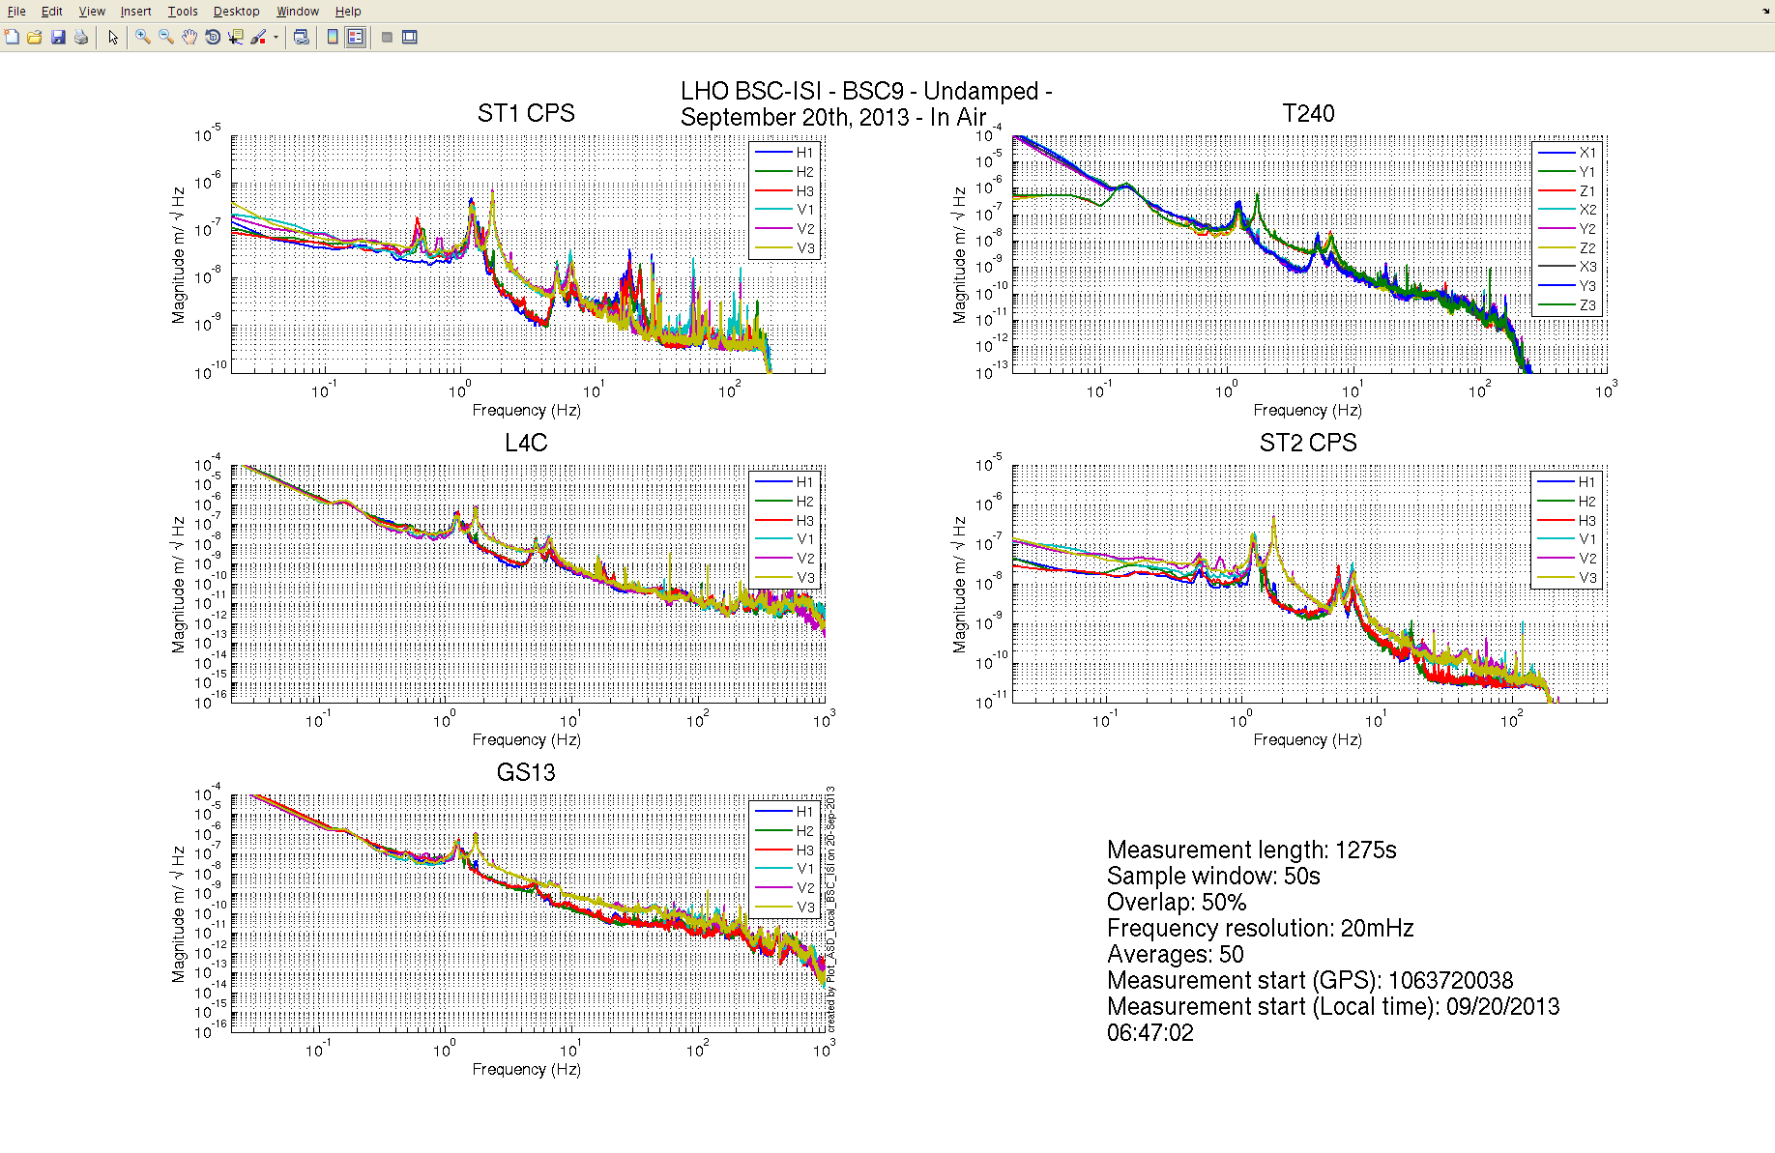

Offsets CPS Unlocked vs locked

Table 4 - Locked vs Unlocked Position

Test result: Passed: Failed: . W Waived: X__

Offset local drive

Results of this test can be found in the SVN at:
https://svn.ligo.caltech.edu/svn/seismic/BSC-ISI/H1/ETMX/Data/Static_Tests/
- H1_ISI_TST_Offset_Local_Drive_20130923.mat

 |  | Sensors
 |  | ST1 - H1 | ST1 - H2 | ST1 - H3 | ST1 - V1 | ST1 - V2 | ST1 - V3
Actuators | ST1 - H1 | 3956 | 1591 | 1592 | 30 | 7.2 | -2.7
 | ST1 - H2 | 1579 | 3947 | 1582 | -.7 | 34.7 | -12.4
 | ST1 - H3 | 1587 | 1599.4 | 3946 | -2.8 | 2.1 | 19
 | ST1 - V1 | .3 | -150.3 | 68.4 | 3031.2 | -501.5 | -478.4
 | ST1 - V2 | 73.8 | 16.8 | -147 | -481.2 | 3067.2 | -501.7
 | ST1 - V3 | -144.7 | 78.5 | 39.5 | -515 | -488.2 | 3047
Table 5 - Static Tests – Local to Local - Stage 1

 |  | Sensors
 |  | ST2 - H1 | ST2 - H2 | ST2 - H3 | ST2 - V1 | ST2 - V2 | ST2 - V3
Actuators | ST2 - H1 | 2251 | 350 | 335 | 6 | -4 | 9
 | ST2 - H2 | 327 | 2231 | 343 | 13 | -5 | -14
 | ST2 - H3 | 327 | 336 | 2240 | 2 | 16 | 12
 | ST2 - V1 | 73 | 107 | -174 | 2698 | 358 | 33
 | ST2 - V2 | -177 | 73 | 115 | 44 | 2660 | 339
 | ST2 - V3 | 112 | -184 | 72 | 364 | 30 | 2686
Table 6 - Static Tests – Local to Local - Stage 2

Test result: Passed: X Failed: . W Waived: __

Offset Cartesian drive
Tests in the Cartesian basis were not performed. Disregard.

Range of motion
The range of motion of the table is measured by pushing on the table in a direction collinear to the CPS. The Static tests results can be found on the SVN at:
https://svn.ligo.caltech.edu/svn/seismic/BSC-ISI/H1/ETMX/Data/Static_Tests/

Sensor readout (counts) | Negative drive | no drive | Positive drive | Amplitude count | mil
ST1 - H1 | -14540 | 802 | 17629 | 32169 | 38
ST1 - H2 | -15877 | 53 | 16166 | 32043 | 38
ST1 - H3 | -15811 | -467 | 16336 | 32147 | 38
ST1 - V1 | -13259 | -260 | 12755 | 26014 | 31
ST1 - V2 | -12273 | 839 | 13933 | 26206 | 31
ST1 - V3 | -13369 | -103 | 13143 | 26512 | 32
ST2 - H1 | -8903 | 737 | 10348 | 19251 | 6
ST2 - H2 | -8240 | 1218 | 10686 | 18926 | 6
ST2 - H3 | -9601 | -75 | 9426 | 19027 | 6
ST2 - V1 | -10684 | 824 | 12289 | 22973 | 7
ST2 - V2 | -10732 | 627 | 11969 | 22701 | 7
ST2 - V3 | -9055 | 2381 | 13799 | 22854 | 7
Table 7 - Range of motion - Actuator drive in the LVEA

Test result: Passed: X Failed: . W Waived:

Linearity test
The test was performed on Sept 23, 2013.
The data of the linearity test can be found on the SVN at:
seismic/BSC-ISI/H1/ETMX/Data/Linearity_Test/
- H1_ISI_TST_Linearity_test_20130923.mat

The figures of the linearity test can be found on the SVN at:
seismic\BSC-ISI\H1\ETMX\Data\Figures\Linearity_Test\
- H1_ISI_TST_Linearity_test_20130923.fig
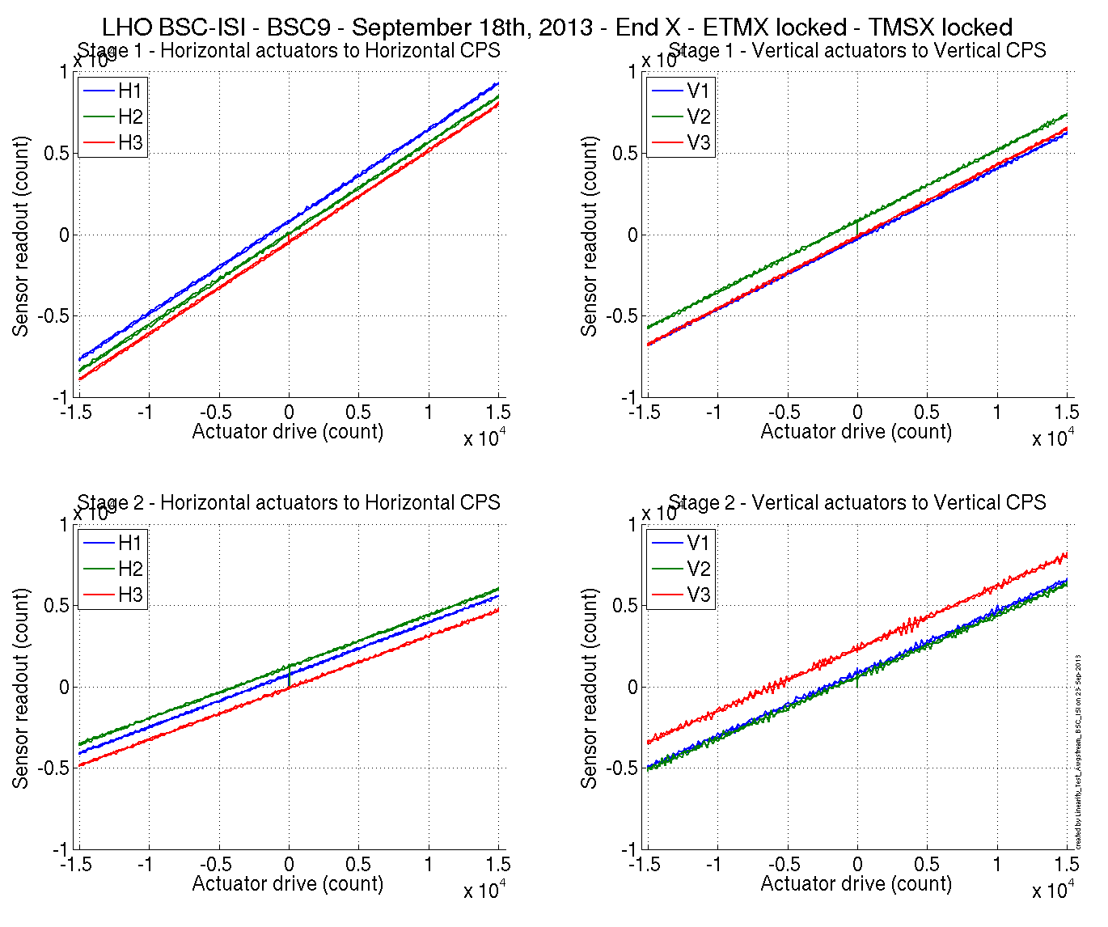
Figure 2 - Linearity test – TMSY - ETMY – At the end station
 |  | Slope | Offset | Average slope | Variation from  average(%)
Stage 1 | ST1 - H1 | .565 | 817 | .563 | .3
 | ST1 - H2 | .561 | 64 |  | -.3
 | ST1 - H3 | .563 | -454 |  | -.01
 | ST1 - V1 | .433 | 264 | .437 | -.96
 | ST1 - V2 | .436 | 834 |  | -.11
 | ST1 - V3 | .441 | -121 |  | 1.08
Stage 2 | ST2 - H1 | .322 | 738 | .319 | .89
 | ST2 - H2 | .317 | -1230 |  | -.56
 | ST2 - H3 | .318 | -73 |  | -.33
 | ST2 - V1 | .383 | 803 | .382 | .42
 | ST2 - V2 | .379 | 607 |  | -.64
 | ST2 - V3 | .382 | 2348 |  | .22
Table 8 - Slope – Offset Linearity test

Note:

Test result: Passed: X Failed: . W Waived:

Transfer functions and Comparison with measurements done in the staging building.

At the end station
The parameters for the measurements at the end station are slightly different from those in the staging building. It may be explained by the relative proximity of the cleanroom fans as well as the weaker power delivered by the actuators due to the longer in-air cables.

Measurements data can be found in the SVN at:
SeiSVN/seismic/BSC-ISI/H1/ETMX/Data/Transfer_Functions/Measurements/Undamped:
- H1_ISI_TST_Data_L2L_100mHz_700mHz_ST1_ST2_20130922-040310.mat
- H1_ISI_TST_Data_L2L_700mHz_10Hz_ST1_ST2_20130922-232931 .mat
- H1_ISI_TST_Data_L2L_10Hz_100Hz_ST1_ST2_20130921-161730.mat
- H1_ISI_TST_Data_L2L_100Hz_500Hz_ST1_ST2_20130922-180440.mat\
- H1_ISI_TST_Data_L2L_500Hz_1000Hz_ST1_ST2_20130922-134412.mat

Once the data are processed, they can be found in the SVN at:
/seismic/BSC-ISI/H1/ETMX/Data/Transfer_Functions/Simulations/Undamped/
- H1_ISI_TST_TF_L2L_Raw_2013_09_23.mat

The transfer functions can be found in the SVN at:
seismic/BSC-ISI/H1/ETMX/Data/Figures/Transfer_Functions/Measurements/Undamped/
- H1_ISI_TST_TF_L2L_Raw_from_ST1_ACT_to_ST1_CPS_2013_09_23.fig
- H1_ISI_TST_TF_L2L_Raw_from_ST1_ACT_to_ST1_L4C_2013_09_23.fig
- H1_ISI_TST_TF_L2L_Raw_from_ST1_ACT_to_ST1_T240_2013_09_23.fig
- H1_ISI_TST_TF_L2L_Raw_from_ST1_ACT_to_ST2_CPS_2013_09_23.fig
- H1_ISI_TST_TF_L2L_Raw_from_ST1_ACT_to_ST2_GS13_2013_09_23.fig
- H1_ISI_TST_TF_L2L_Raw_from_ST2_ACT_to_ST1_L4C_2013_09_23.fig
- H1_ISI_TST_TF_L2L_Raw_from_ST2_ACT_to_ST1_T240_2013_09_23.fig
- H1_ISI_TST_TF_L2L_Raw_from_ST2_ACT_to_ST2_CPS_2013_09_23.fig
- H1_ISI_TST_TF_L2L_Raw_from_ST2_ACT_to_ST2_GS13_2013_09_23.fig

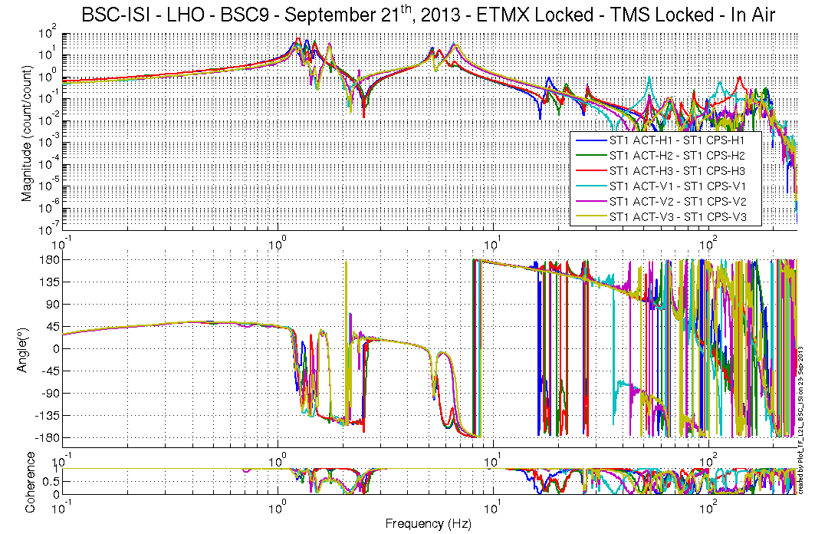
Figure 3 - TF ST1 ACT to ST1 CPS
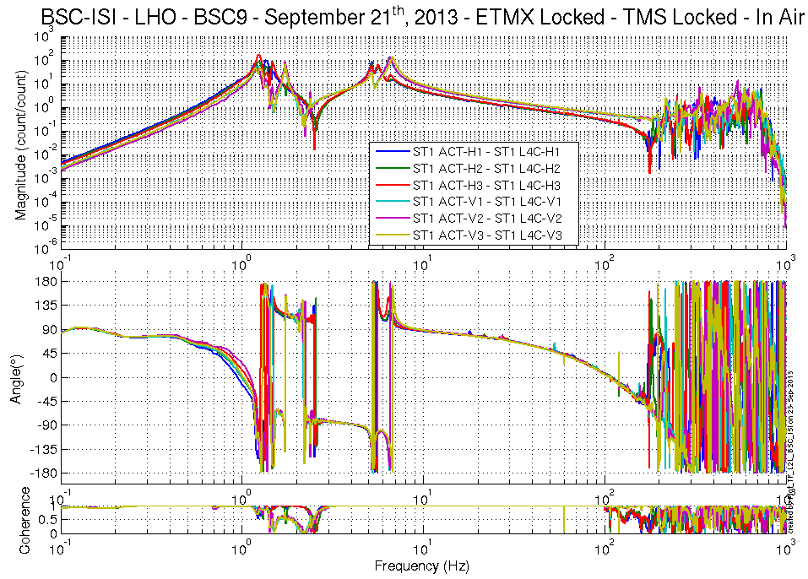
Figure 4 - TF ST1 ACT to ST1 L4C

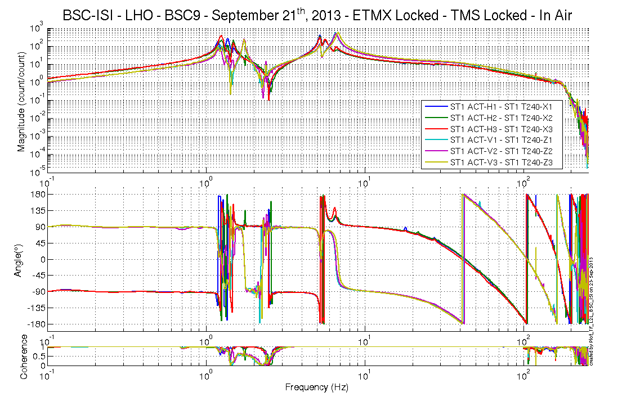
Figure 5 - TF ST1 ACT to ST1 T240
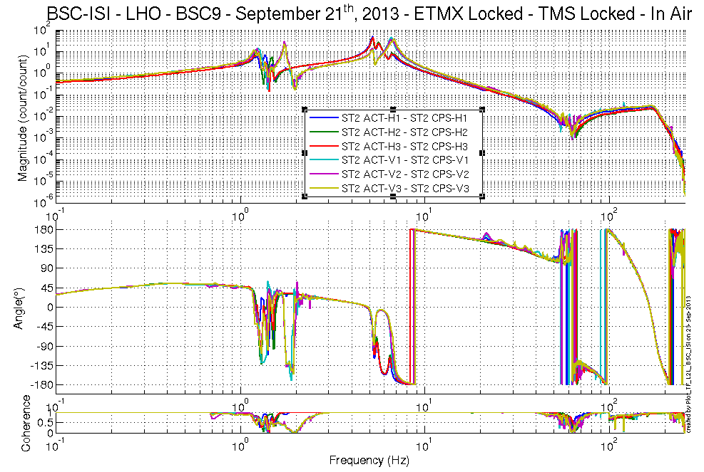

Figure 6 - TF ST2 ACT to ST2 CPS

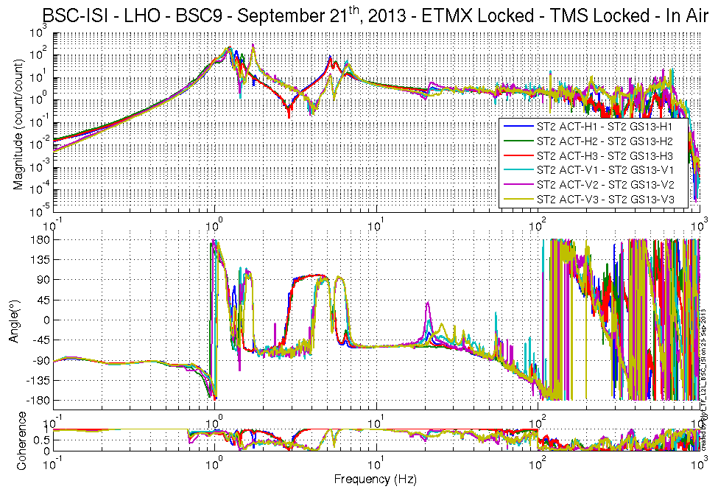
Figure 7 - TF ST2 ACT to ST2 GS13

Comparisons with measurements in the staging building
The script used to compare transfer function can be found in the SVN at:
SeiSVN/seismic/BSC-ISI/H1/ETMX/Scripts/Misc
- Comparison_TF_L2L_H1_ISI_ETMX.m

The figure that shows the comparison between the transfer functions of the staging building and the LVEA are located in the SVN at:
SeiSVN/seismic/BSC-ISI/H1/ETMX/Data/Figures/Transfer_Functions/Measurements/
Comparison/L2L/
- H1_ISI_ITMX_Comparison_TF_L2L_ST1_ACT_H_to_ST1_CPS_H_20130309_vs_20130921.fig
- H1_ISI_ITMX_Comparison_TF_L2L_ST1_ACT_H_to_ST1_L4C_H_20130309_vs_20130921.fig
- H1_ISI_ITMX_Comparison_TF_L2L_ST1_ACT_V_to_ST1_CPS_V_20130309_vs_20130921.fig
- H1_ISI_ITMX_Comparison_TF_L2L_ST1_ACT_V_to_ST1_L4C_V_20130309_vs_20130921.fig
- H1_ISI_ITMX_Comparison_TF_L2L_ST2_ACT_H_to_ST2_CPS_H_20130309_vs_20130921.fig
- H1_ISI_ITMX_Comparison_TF_L2L_ST2_ACT_H_to_ST2_GS13_H_20130309_vs_20130921.fig
- H1_ISI_ITMX_Comparison_TF_L2L_ST2_ACT_V_to_ST2_CPS_V_20130309_vs_20130921.fig
- H1_ISI_ITMX_Comparison_TF_L2L_ST2_ACT_V_to_ST2_GS13_V_20130309_vs_20130921.fig
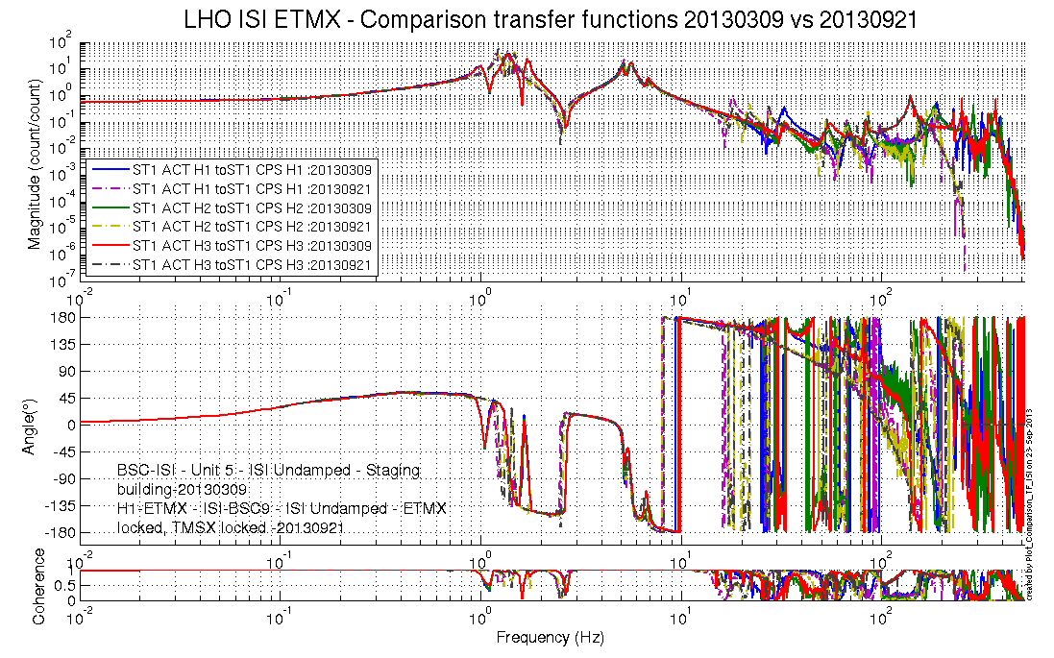
Figure 8 - Transfer functions comparison - ST1 ACT H to ST1 CPS H

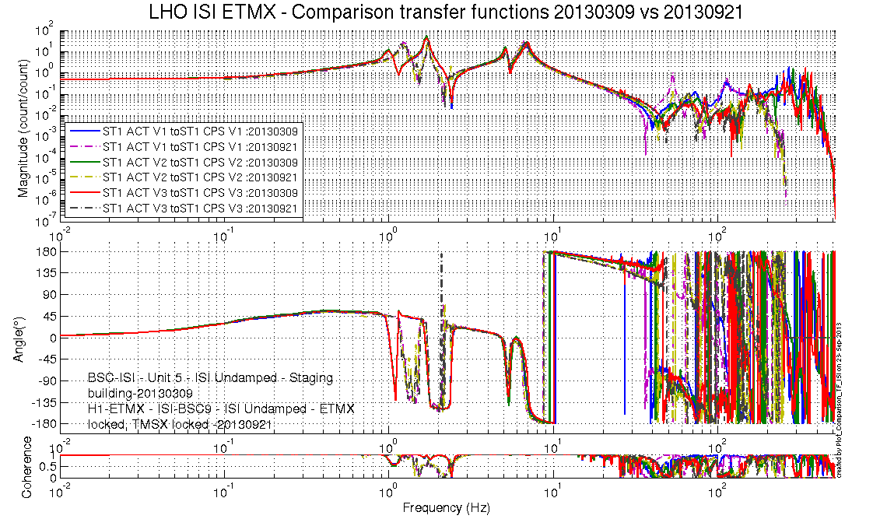
Figure 9 - Transfer functions comparison - ST1 ACT V to ST1 CPS V
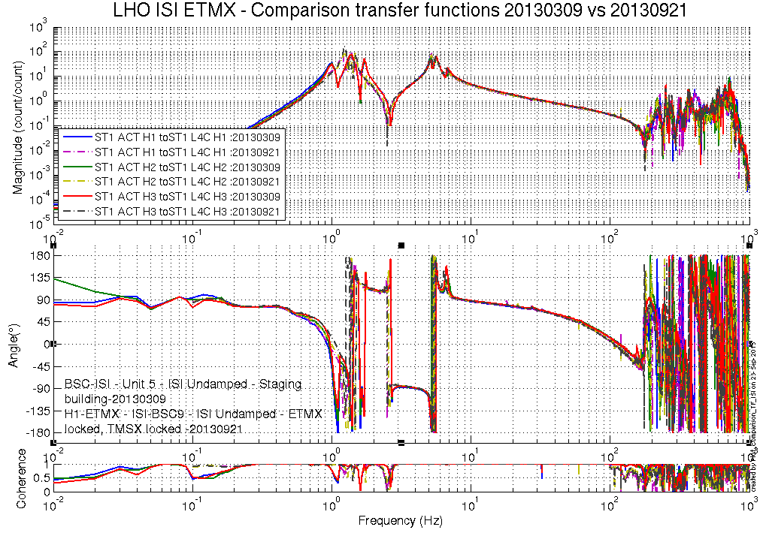
Figure 10 - Transfer functions comparison - ST1 ACT H to ST1 L4C H

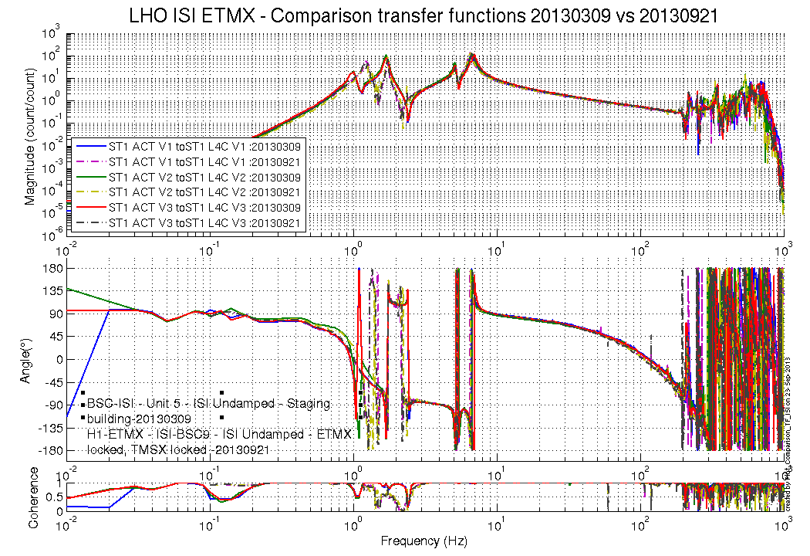
Figure 11 - Transfer functions comparison - ST1 L4C V to ST1 L4C V

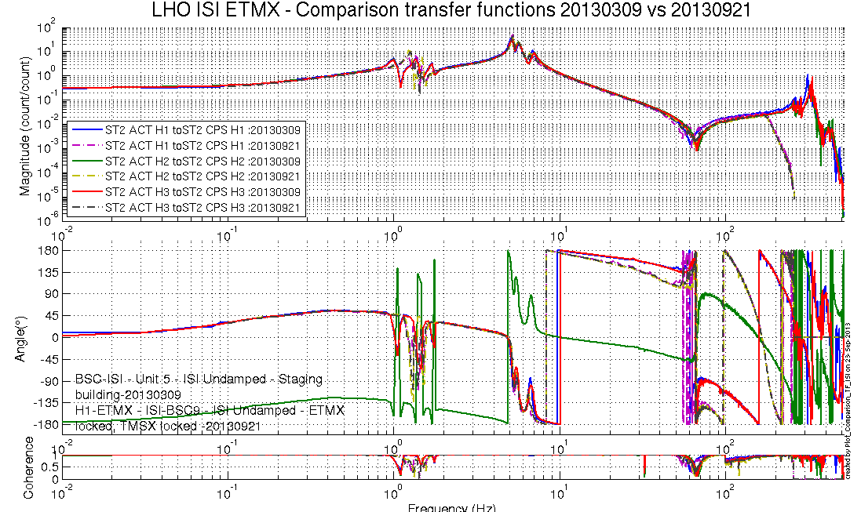
Figure 12 - Transfer functions comparison - ST2 ACT H to ST2 CPS H

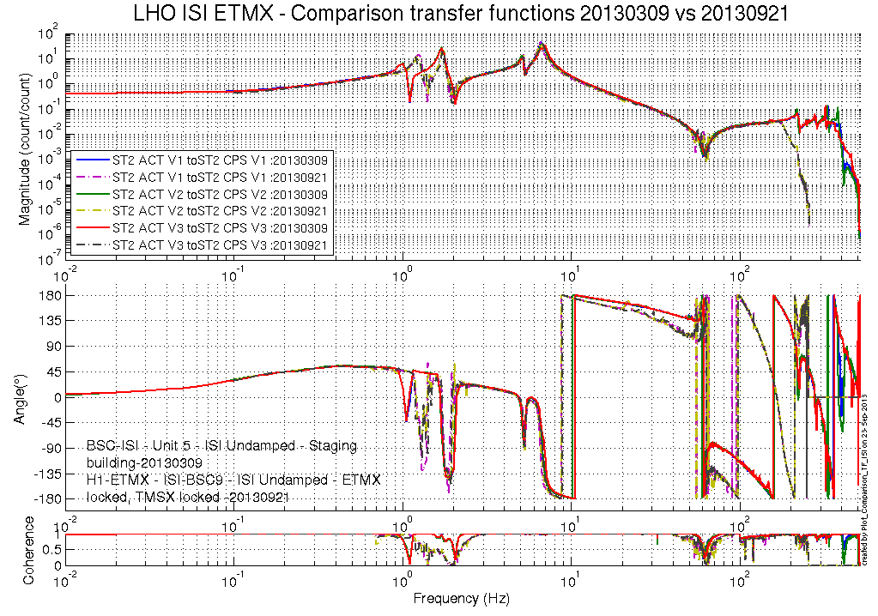
Figure 13 - Transfer functions comparison - ST2 ACT V to ST2 CPS V

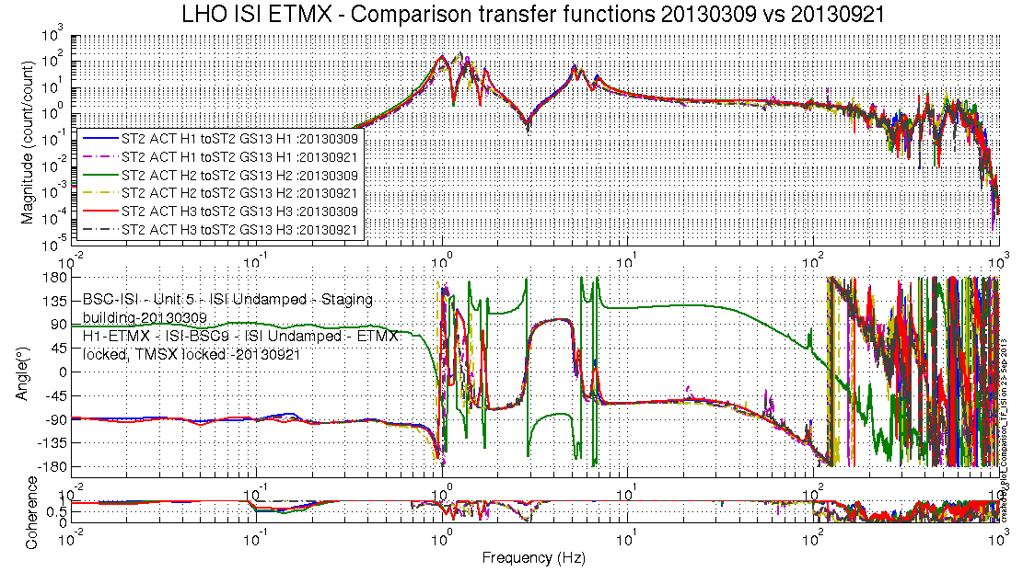
Figure 14 - Transfer functions comparison – ST2 ACT H to ST2 GS13 H

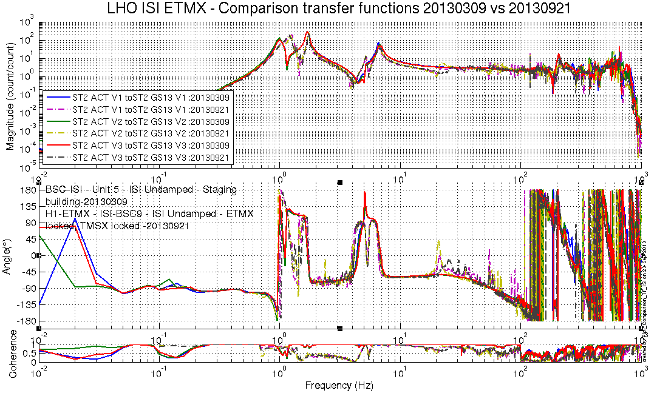
Figure 15 - Transfer functions comparison – ST2 ACT V to ST2 GS13 V

There seems to be an issue with some of the old data, where the phase on two of the sensors is out by 180 degrees. This is the same (old) data used for the BSC3 LVEA comparison, which did not show this issue.

Test result: Passed: X Failed: . W Waived: __

Conclusion Phase II-a
Tests performed during Phase II-a don’t show any anomalies on ISI-BSC9.

Test result: Passed: X Failed: . W Waived: _

Phase IIb Tests after Cartridge Install
Basic Functionality after Cartridge Installation
    - Pressure Sensors
All pressure sensors are working.
https://svn.ligo.caltech.edu/svn/seismic/BSC-ISI/H1/ETMX/Data/Static_Tests/
LHO_ISI_BSC9_Pressure_Sensors_Check_Calibrated_2012_03_29_115020.mat

 | Pressure (KPa)
Sensors | Corner 1 | Corner 2 | Corner 3
ST1-L4C-P | 99 | 99 | 101
ST1-L4C-D | 0 | .4 | -.3
ST1-GS13-P | 100 | 100 | 102
ST1-GS13-D | .4 | .1 | 1
ST1-T240-P | 100 | 101 | 101
Table 9 - Geophones Pressure sensors

Test result: Passed: X Failed: . W Waived:

    - Spectra
Spectra of the seismometers can be found in the svn at:
seismic/BSC-ISI/H1/ETMX/Data/Spectra/Undamped/
H1_ISI_ETMX_ASD_m_LOC_CPS_T240_L4C_GS13_2020_11_04_3 0:7:.mat

https://svn.ligo.caltech.edu/svn/seismic/BSC-ISI/H1/ETMX/Data/Figures/Spectra/Undamped/
H1_ISI_ETMX_ASD_CT_LOC_CPS_T240_L4C_GS13_2020_11_03_3 3:8:.fig

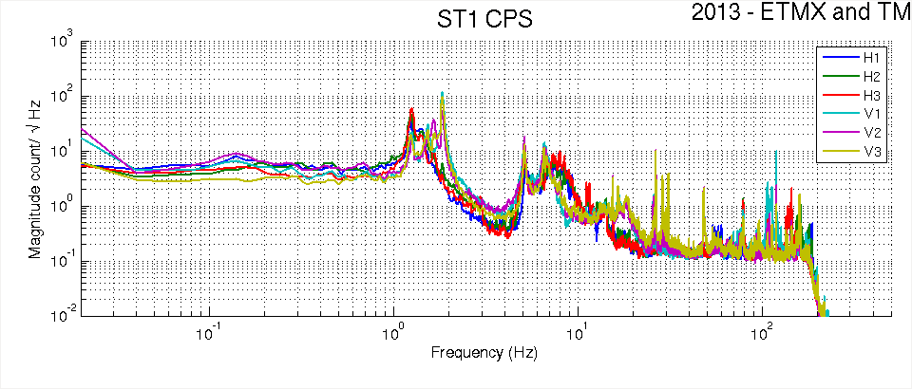
Figure 16 - St1 CPS Power Spectra
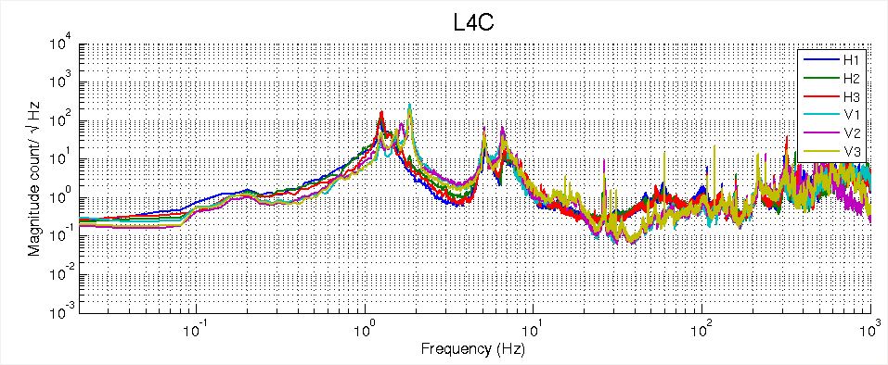
Figure 17 - St1 L4C Power Spectra
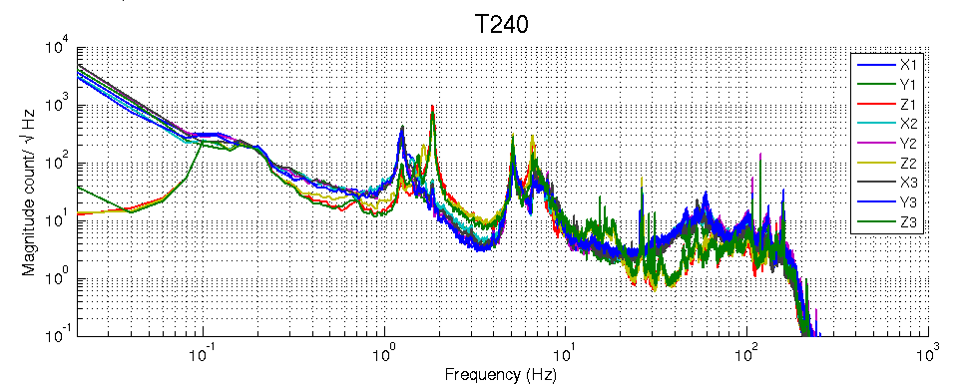
Figure 18 - St1 L4C Power Spectra

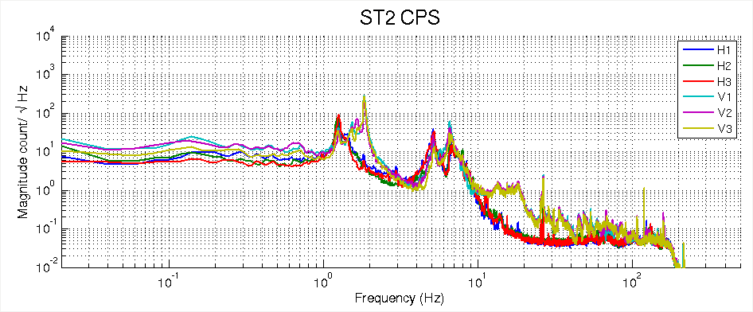
Figure 19 - St2 CPS Power Spectra
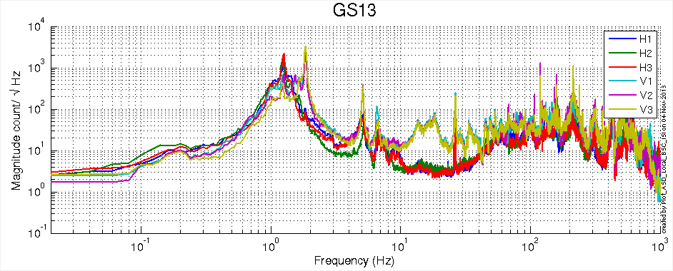
Figure 20 - St2 GS13 Power Spectra

All the seismometers are functioning normally.

Test result: Passed: X Failed: . W Waived:

    - Lock Unlock Shifts
Table 10 - Lock/Unlock Shifts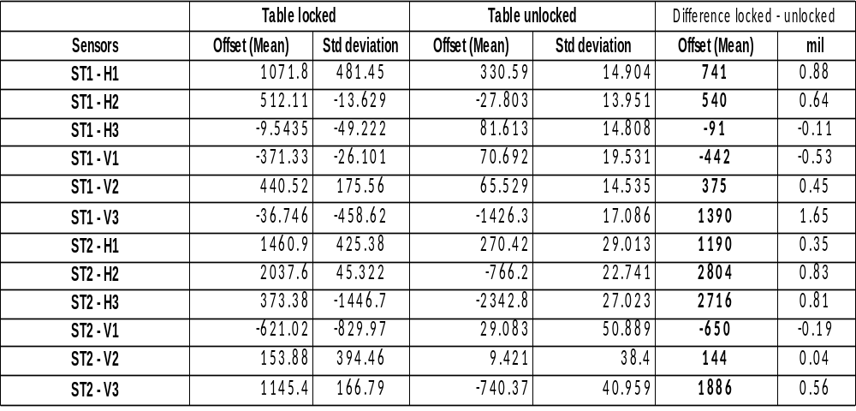.
Locker shifts are within spec.

Test result: Passed: X Failed: . W Waived:

    - Range of motion
Table 11 - 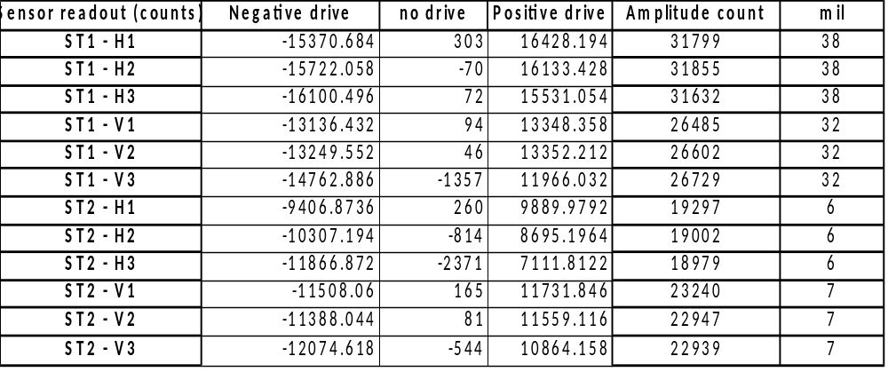Range of motion under actuator drive
Range of motion is within spec.
Test result: Passed: X Failed: . W Waived:

    - CPS Linearity Test
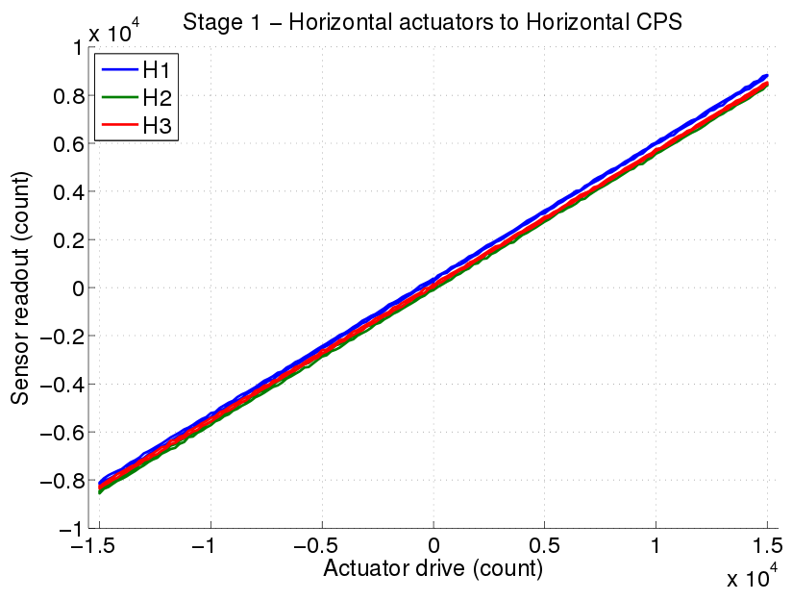
Figure 21 St1 Horizontal Sensor

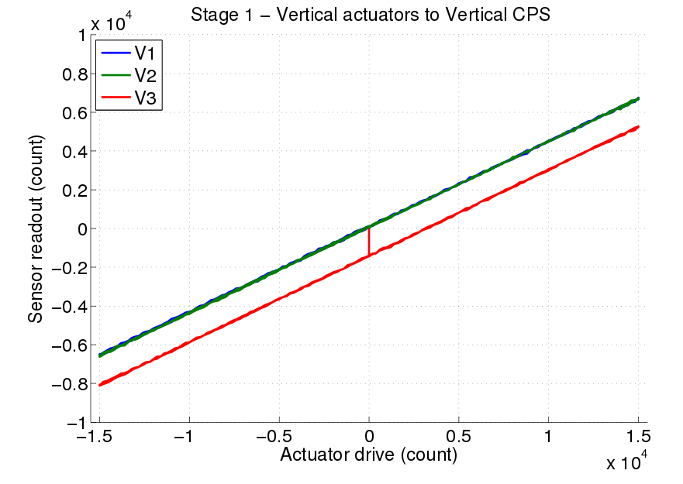
Figure 22 St1 Vertical
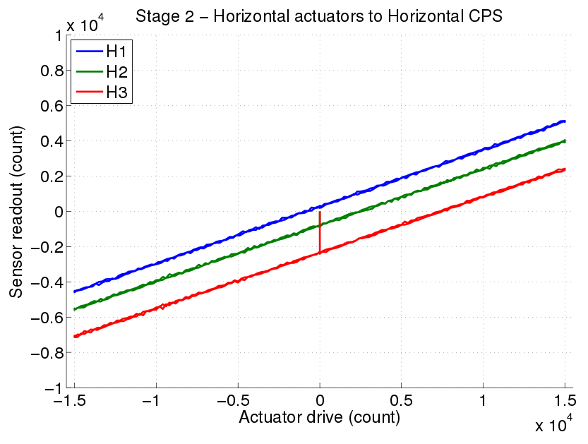
Figure 23 Stage 2 Horizontal
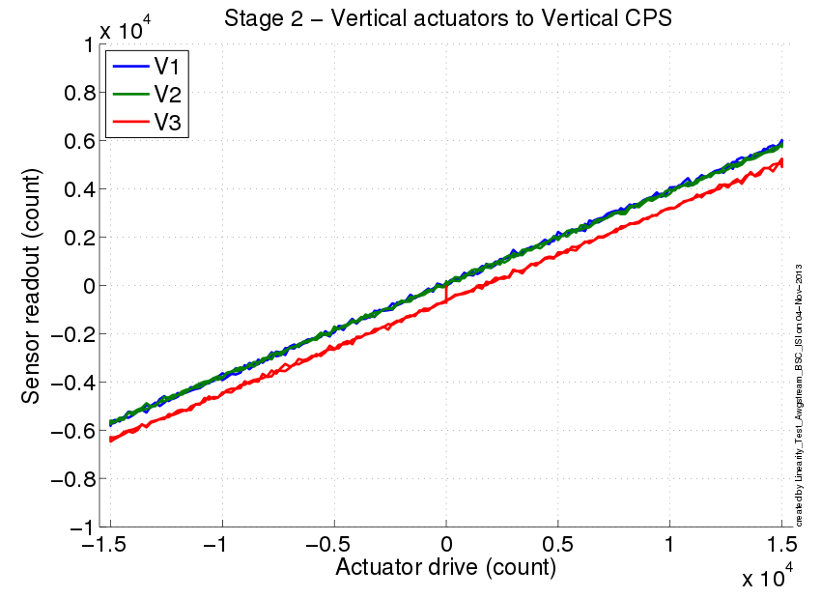
Figure 24 Stage 2 Vertical

CPS linearity is within spec.

Test result: Passed: X Failed: . W Waived:
 |  | Slope | Offset | Average slope | Variation (%)
Stage 1 | ST1 - H1 | .564 | 337 | .562 | .5
 | ST1 - H2 | .562 | -33 |  | .06
 | ST1 - H3 | .559 | 88 |  | -.56
 | ST1 - V1 | .440 | 97 | .443 | -.51
 | ST1 - V2 | .442 | 73 |  | -.05
 | ST1 - V3 | .445 | -1408 |  | .56
Stage 2 | ST2 - H1 | .322 | 265 | .319 | .98
 | ST2 - H2 | .318 | -782 |  | -.27
 | ST2 - H3 | .317 | -2333 |  | -.71
 | ST2 - V1 | .386 | 70 | .384 | .56
 | ST2 - V2 | .382 | 56 |  | -.42
 | ST2 - V3 | .384 | -650 |  | -.14
Table 12 - Slope – Offset Linearity test

Test result: Passed: X Failed: . W Waived:

  - Transfer Functions after Cartridge Install

Reference transfer functions L2L with ETMX, TMSX, ACB and all ISI viton damping elements.

Transfer Functions are located in the SVN at:

/SeiSVN/seismic/BSC-ISI/H1/ETMX/Data/Transfer_Functions//Undamped/
-H1_ISI_ETMX_Data_L2L_700mHz_10Hz_ST1_ST2_20131101-164416.mat
-H1_ISI_ETMX_Data_L2L_10Hz_100Hz_ST1_ST2_20131101-222314.mat
-H1_ISI_ETMX_Data_L2L_100Hz_500Hz_ST1_ST2_20131104-103756.mat
-H1_ISI_ETMX_Data_L2L_500Hz_1000Hz_ST1_ST2_20131104-124252.mat

L2L concatenated
/SeiSVN/seismic/BSC-ISI/H1/ETMX/Data/Transfer_Functions/Simulations/Undamped/
-H1_ISI_ETMX_TF_L2L_Raw_2013_11_04.mat

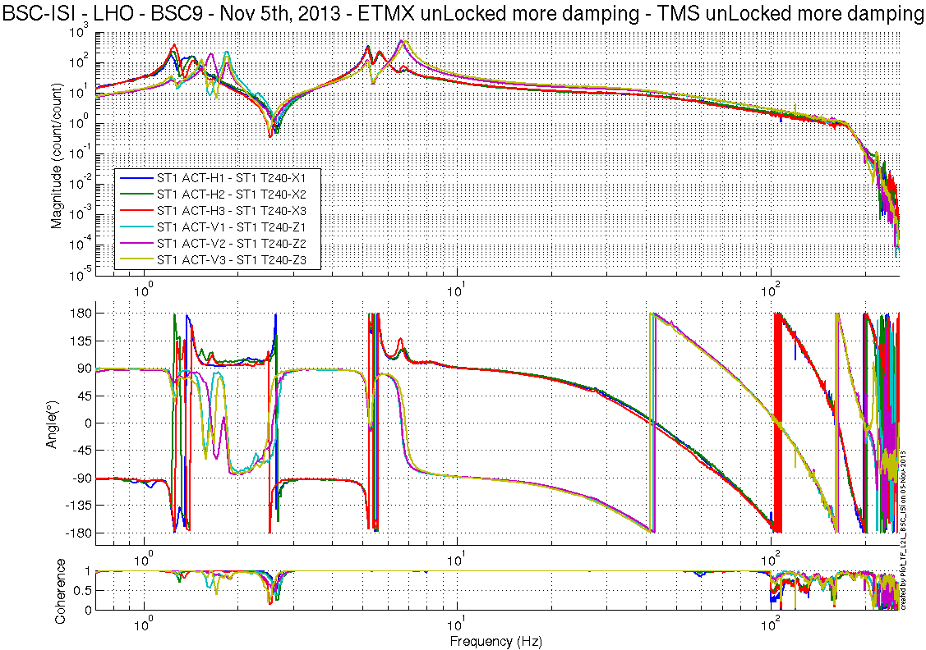
Figure 25 St1 Act to T240

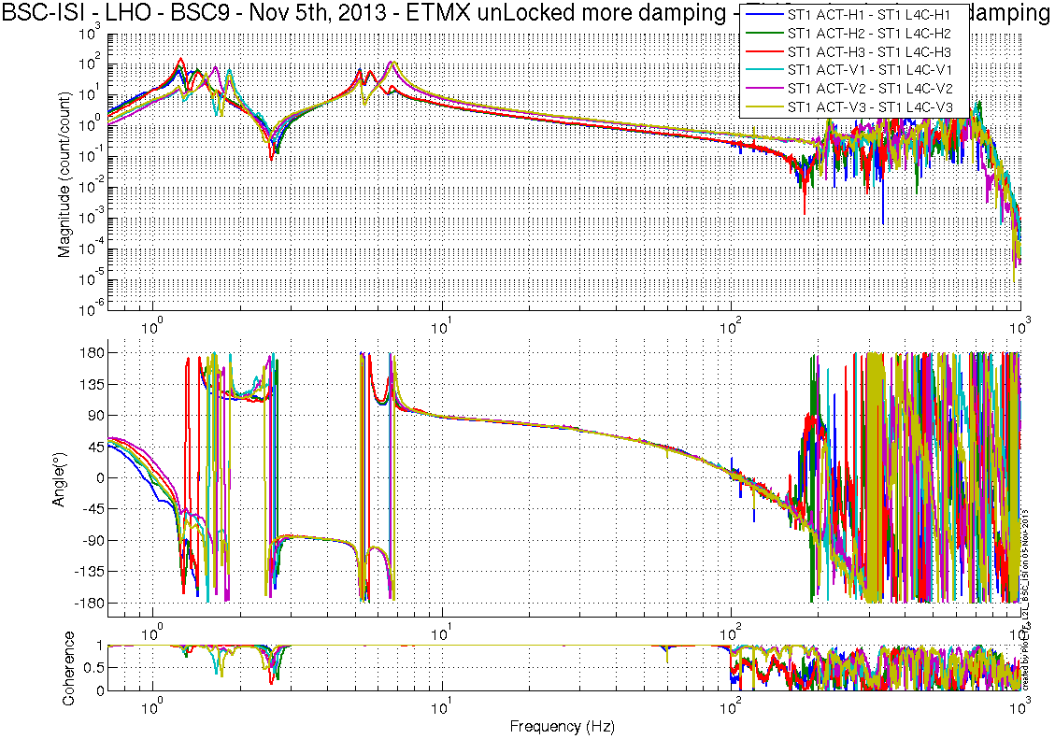
Figure 26 St1 Act to L4C
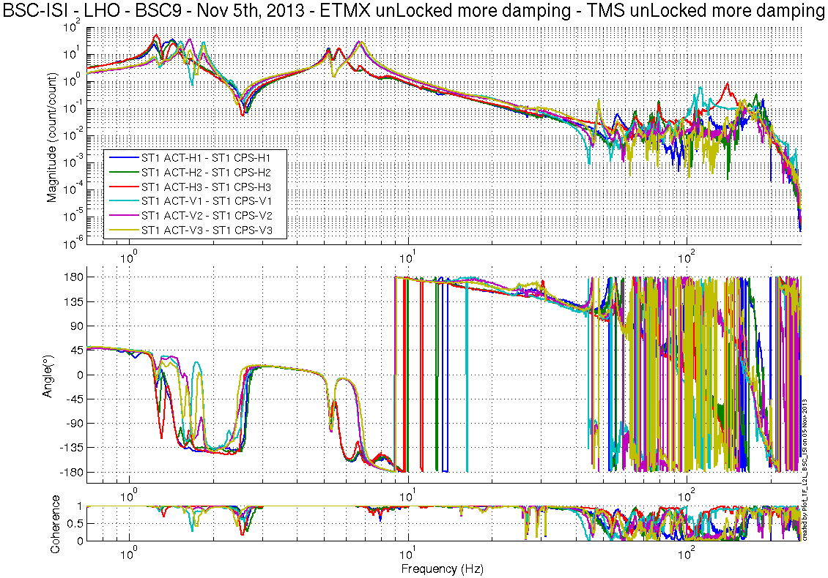
Figure 27 St1 Act to St1 CPS

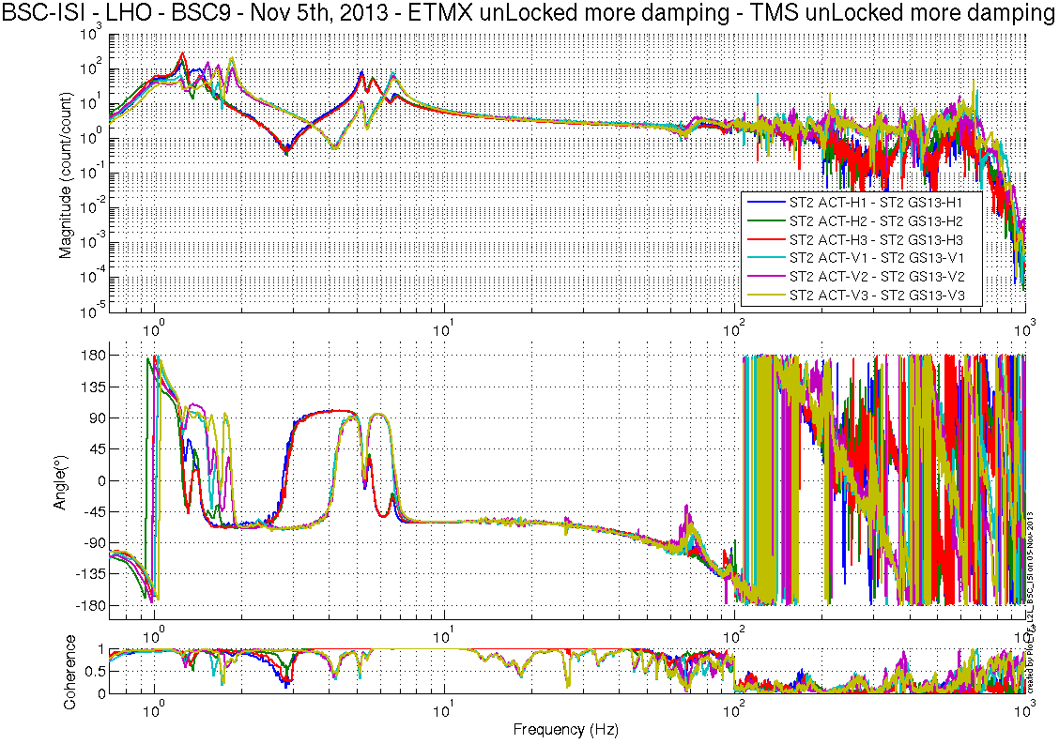
Figure 28 St2 Act to GS13
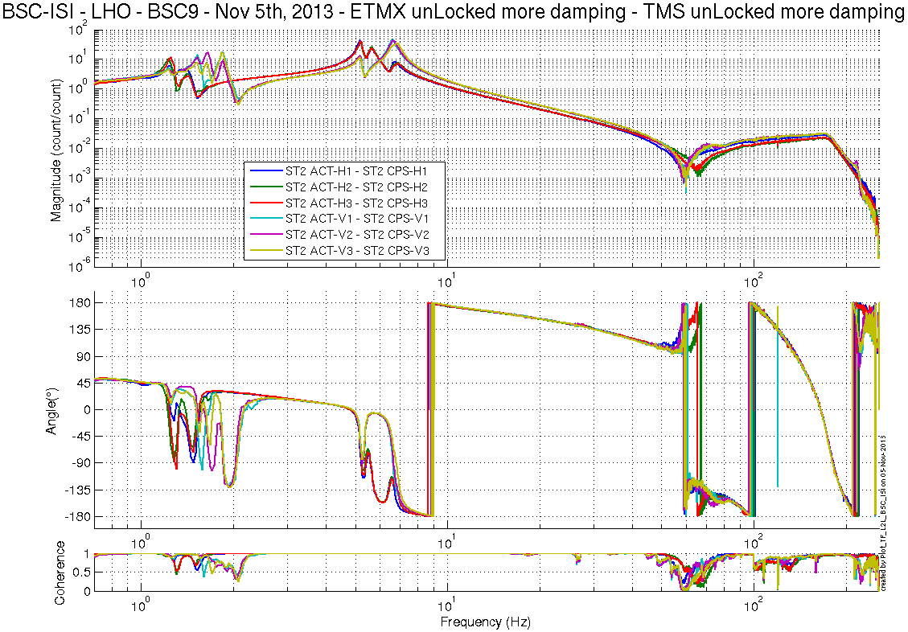
Figure 29 St2 Act to St2 CPS

Transfer functions look healthy.

Test result: Passed: X Failed: . W Waived:

Conclusion Phase II-b
Tests performed during Phase II-b don’t show any anomalies on ISI-BSC9.

Test result: Passed: X Failed: . W Waived: _

