LIGO-T1100486-v1
In order to protect the LT1021-5s on the Trillium Pressure board, we should install a bidirectional transient voltage suppressor (TVS) at the input. The current schematic looks like this:
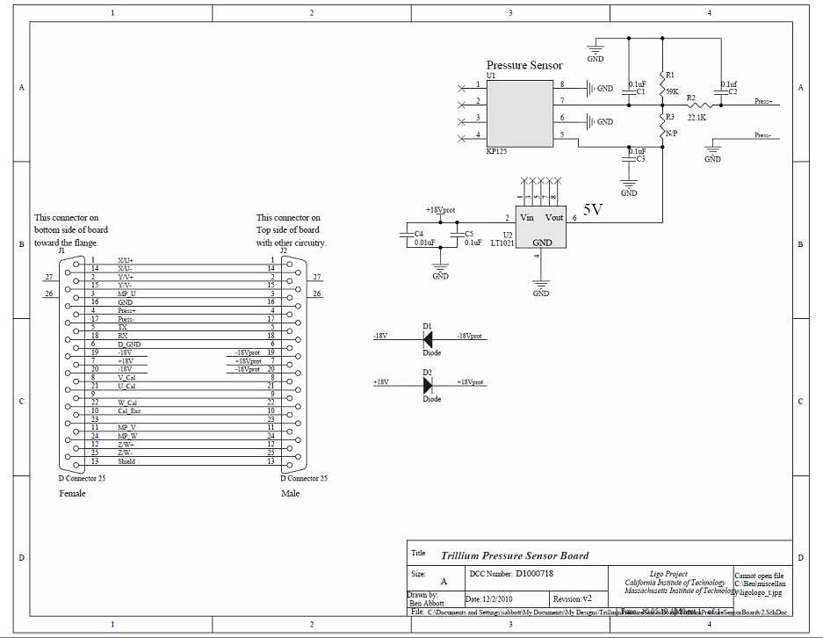
And the voltage we’re trying to regulate is labeled +18Vprot, because it is protected from polarity flip by the input diode, D2. That diode doesn’t care about input voltage spikes, however, so we should protect against those, as well. The most convenient place to put the TVS is across C4. The whole process, including pictures takes about 1 minute, 20 seconds (the pictures really slowed me down). Here are some pictures of how to go about doing that:

Here’s the board, and you can see that C4 is the thinnest capacitor (note the timestamp in the picture).
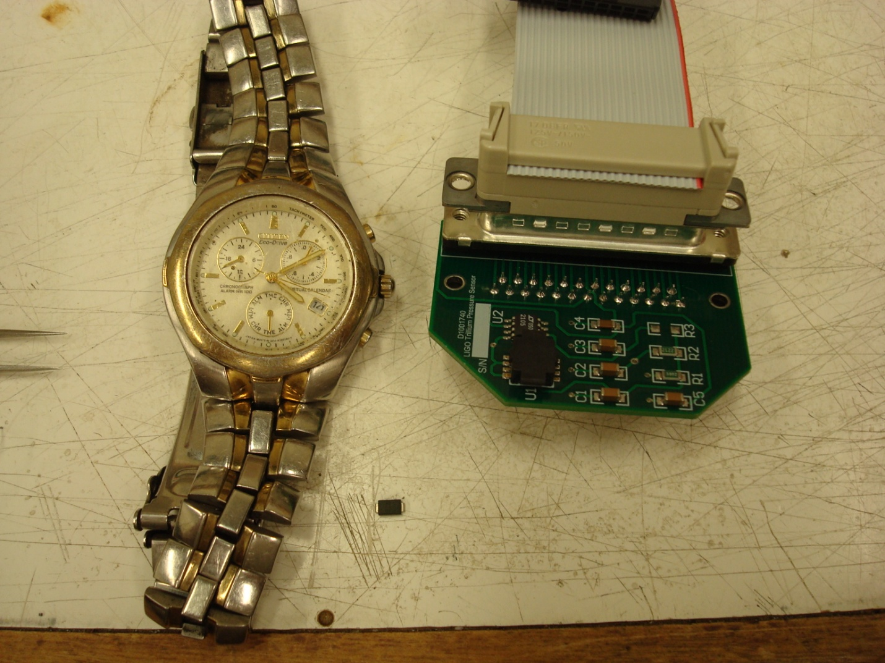

A closeup of C4. Notice that I added extra solder to the right side of C4 in preparation for soldering the TVS on:
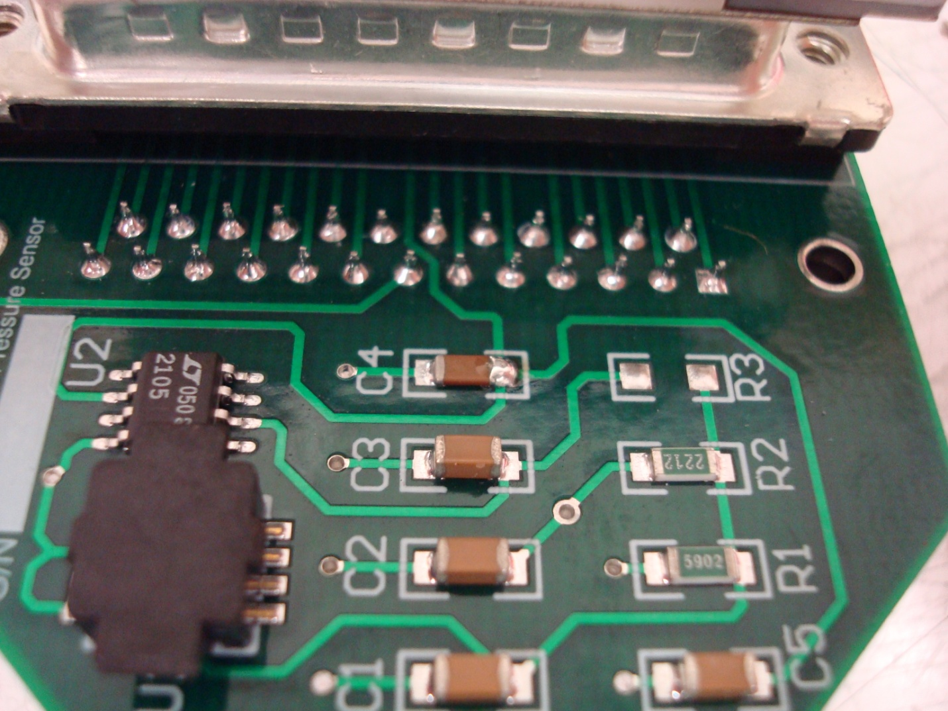

Here’s the TVS in place hunkering over C4 with both sides soldered:
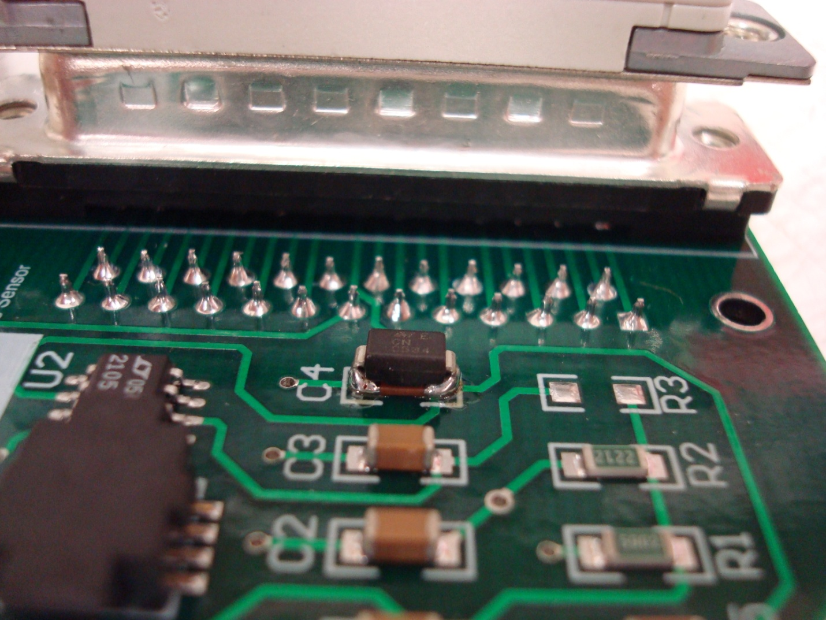

Process finished (again, notice timestamp):
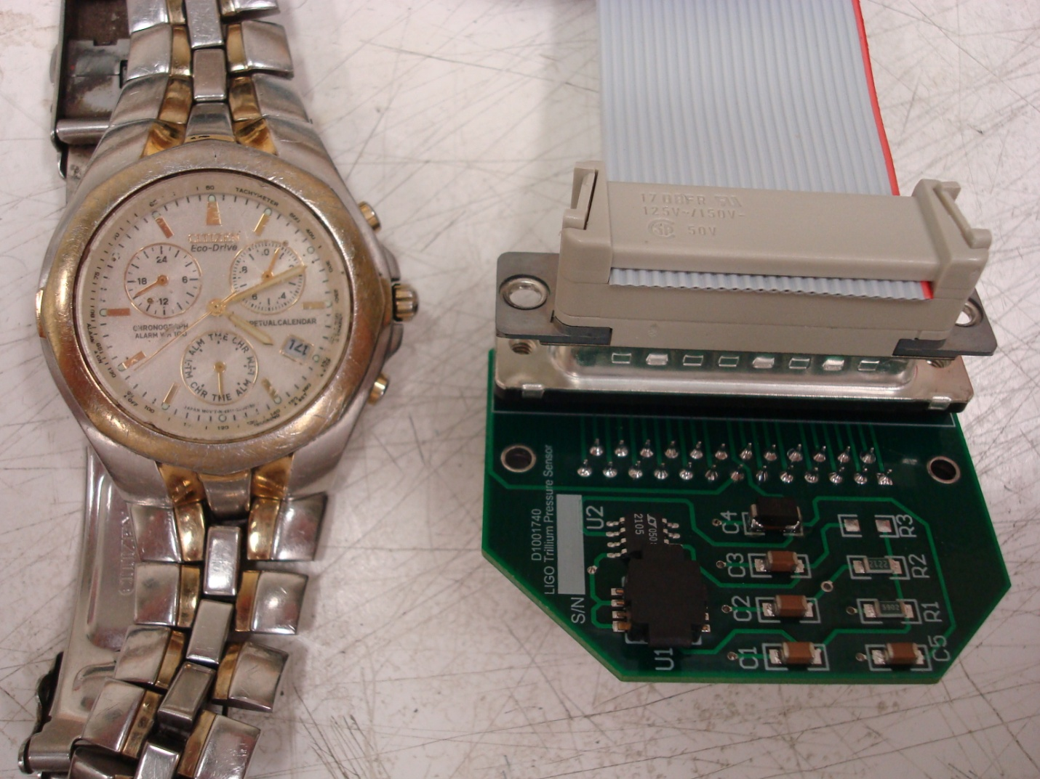
Good luck!

Parts list:
TVS: Digikey P/N SMBJ20CABCT-ND.

