LIGO Corner Station showing landscaped areas (outlined).
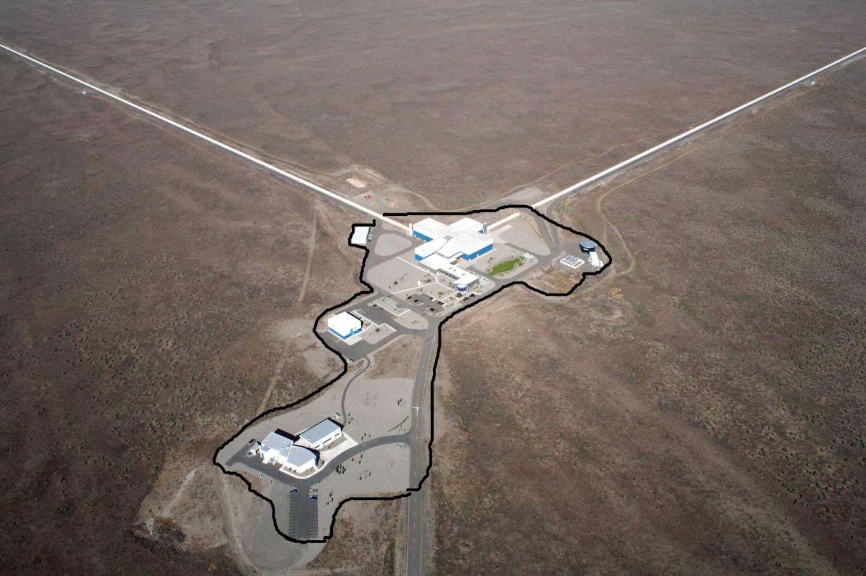
LIGO End Station Y arm (Four similar buildings).
