LIGO Laboratory / LIGO Scientific Collaboration

LIGO-T1100549-v1 Advanced LIGO Date:November 28, 2011

Diffraction in the aLIGO ITM HWS probe beams

Author: Aidan Brooks
Distribution of this document:
LIGO Scientific Collaboration

This is an internal working note
of the LIGO Laboratory.

California Institute of Technology  LIGO Project – MS 18-34  1200 E. California Blvd.  Pasadena, CA 91125  Phone (626) 395-2129  Fax (626) 304-9834  E-mail: info@ligo.caltech.edu | Massachusetts Institute of Technology  LIGO Project – NW22-295  185 Albany St  Cambridge, MA 02139  Phone (617) 253-4824  Fax (617) 253-7014  E-mail: info@ligo.mit.edu
LIGO Hanford Observatory  P.O. Box 159  Richland WA 99352  Phone 509-372-8106  Fax 509-372-8137 | LIGO Livingston Observatory  P.O. Box 940  Livingston, LA 70754  Phone 225-686-3100  Fax 225-686-7189
http://www.ligo.caltech.edu/

Introduction
The purpose of this document is to quantify the level of diffraction in the ITM HWS probe beams.

Background
The optical layout for the ITM HWS probe beams is described in [T1000179 - aLIGO Hartmann Sensor Optical Layouts (H1, L1, H2): Input Test Masses]. The in-vacuum layout is shown in Figure 1.
The probe beam passed through several baffles in the interferometer. In several instances, the diameters of these apertures are smaller than the nominal beam diameter of the HWS probe beam. The baffles and their apertures are listed below in Table 1.

Table 1: Baffle location, aperture diameter and probe beam diameter
Aperture location/name | Aperture diameter (mm) | Probe beam nominal diameter (mm) | Aperture min. diameter/beam diameter ratio | Fraction of power outside aperture
ITM_HR | 340 mm | 304.5 mm | 1.12 × | 8.1%
BS_AR | 210 × 260 mm | 304.5 mm | 0.690 × | 24.1%
SR3 – H1-HWS X | 190 × 265 mm | 304.5 mm | 0.624 × | 27.6%
SR3 – H1-HWS X | 190 × 265 mm | 274.1 mm | 0.693 × | 21.0%
SR3 – H1-HWSY | 265 mm | 304.5 mm | 0.87 × | 22%
SR2 scraper – HWS X [T1100445] | 72 mm | ~40 mm | 1.8 × | 0.15%
SR2 scraper – HWS Y [T1100445] | 72 mm | ~40 mm | 1.8 × | 0.15%
HAM table baffle | 60 mm | ~30 mm | 2.0 × | 0.03%

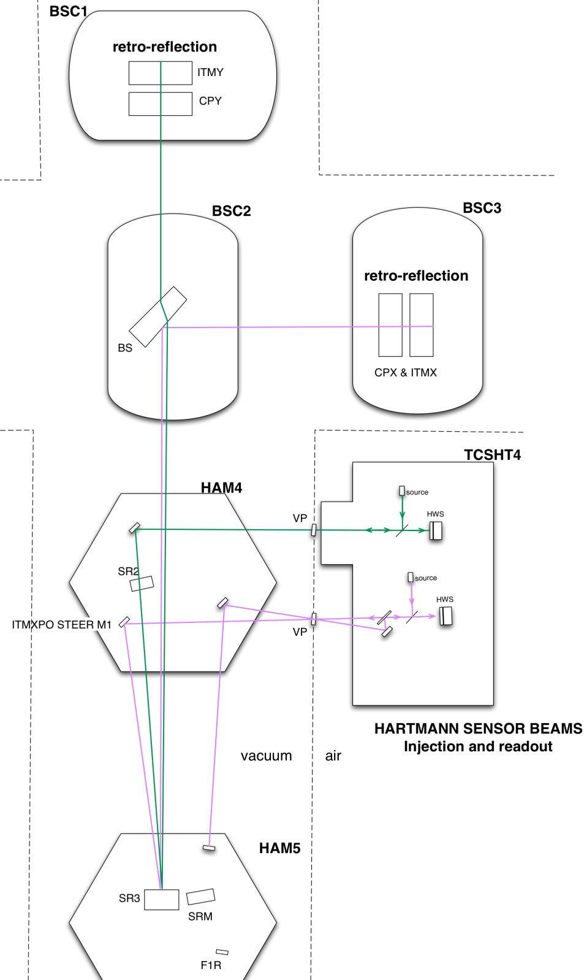
Figure 1: The H1/L1 Hartman probe beams are injected into the interferometer to measure the thermal lenses in the compensation plates and ITMs. The layout is conceptually the same for H2. Reviewer’s note: show the ITM Elliptical Baffle in fig. 1.

H1/L1 ITM-HWSX and H2 ITM-HWSY
The probe beams that reflect off the BS_AR surface are displaced horizontally on SR3 by the wedge in BS_AR. The displacement is approximately 49mm. The resulting aperture is shown in Figure 2.
Figure 2: (left) the overlap of the SR3 (black) and BS baffle (red) apertures for the H1/L1 ITM-HWSY and H2 ITM-HWSX probe beams and (right) the overlap of the SR3 and BS baffle apertures for the H1/L1 ITM-HWSX and H2 ITM-HWSY probe beams reflected off BS_AR.

This presents two problems:
- The effective aperture for the BS_AR beams is reduced by 10%. The zeroth order nominal compensation for this is to reduce the probe beam size by ~10% to around 8.0mm (although the modeling below used a beam size of 7.7mm).
- Additionally, the two apertures are located at different positions in the SRC. It is impossible to image both of them at the same time.

Diffraction
The limiting aperture, the BS baffle (ITM Elliptical Baffle), in the optical system is elliptical and is narrower in the horizontal direction. Therefore, the analysis below examines the central horizontal cross-section of the HWS beam.
The ITM-HWSY and ITM-HWSX probe beams with all the apertures was modeled using the physical optics propagation module in ZEMAX to determine the effects of diffraction.

SR2 transmitted probe beams (H1/L1 HWSY and H2 HWSX)

Intensity cross-section with diffraction
The horizontal cross-sections of the intensity distributions modeled by ZEMAX for the HWS system with no apertures with the nominal HWS probe beam size (r = 8.7mm), all apertures with the nominal HWS probe beam size and all apertures with a HWS probe beam size that gives 10% of the peak intensity at the edge of the HWS CCD (r = 5.8mm), are shown in Figure 1.
Figure 3: Horizontal intensity cross-section for ITM HWSY probe beam sampled at the pixel resolution, 12 μm, of the HWS.

Static optical path distortion (OPD) with diffraction
The static OPD error, , in the HWS beam due to diffraction, that is, the OPD of the probe beam with apertures, , minus the OPD of the probe beam with no apertures, , is shown in Figure 4. Also shown is the 1.3 nm sensitivity requirement of the HWS.
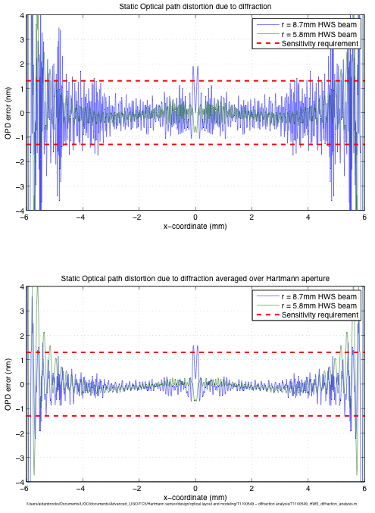
Figure 4: The static OPD error due induced on the probe beam: (upper) sampled at 12 μm, (lower): a rolling average over the width of a Hartmann aperture (~150um)

Differential optical path distortion with diffraction
The HWS operates in a differential mode. Therefore, to truly quantify the effect of diffraction on the wavefront error, we need to plot the differential, or residual, OPD error. That is, the difference between the OPD with no apertures with and without a realistic thermal lens, , and the OPD with all apertures with and without a realistic thermal lens, . To clarify, what is shown is:
Equation 1
,
where the starred elements are those with a thermal lens present.
The realistic thermal lens was modeled using the Hello-Vinet formalism for 400mW absorbed power in the coating of the ITM. The resulting OPD, when imaged onto the HWS, is shown in Figure 5.
Figure 5: OPD, imaged to the HWS, from a 400mW-absorbed-in-the-coating-thermal-lens.
The difference between the OPD measured with no apertures present and with apertures present in the optical system, the value in Equation 1, is plotted in Figure 6. The residual OPD error is below the required noise floor except at the very center of the beam.
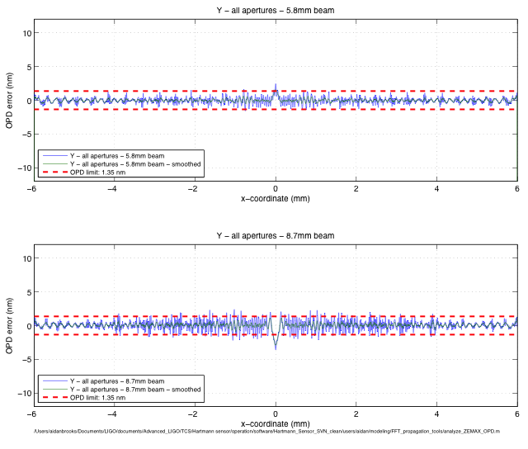
Figure 6: Residual wavefront error in the presence of a 400mW-absorbed power induced thermal lens.

BS_AR reflected probe beams (H1/L1 HWSX and H2 HWSY)
As described in Section 2.1, there are two limiting apertures at different planes along the optical axis for the probe beams reflected off the BS_AR surface. The first is the BS baffle (ITM Elliptical Baffle) and the second is one edge of the SR3 mirror. There are several options for reducing the effect of diffraction:
- Reduce the HWS probe beam size. This reduces diffraction, but increases the time required to acquire a HWS measurement of sufficient precision across the entire aperture.
- Move the conjugate plane of the HWS closer to the limiting apertures. This reduces diffraction but decreases the sensitivity of the HWS to very large, high spatial frequency thermal lenses (typically strong point absorbers present when the interferometer is running at very high powers).
As such, the modeling below shows the results for beams:
- of nominal size, 7.7mm, and imaging the ITM HR surface
- of nominal size and imaging a plane half way between SR3 and BS
- of small beam size, 4.8mm, (with 20x peak to edge intensity ratio) and imaging the ITM HR surface
- of small beam size, 4.8mm, and imaging a plane half way between SR3 and BS

Intensity cross-section with diffraction
The results for the intensity cross-sections for the BS_AR reflected HWS beams are shown in Figure 7.
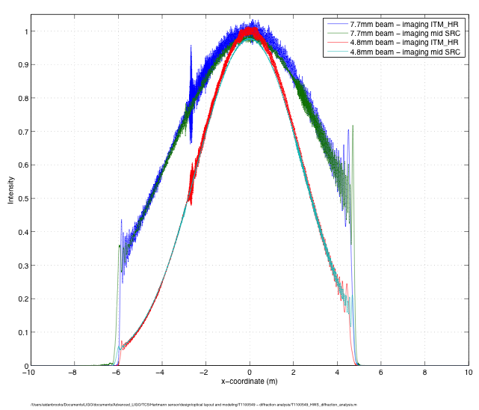
Figure 7: The intensity cross-sections for different ITM HWSX probe beams sampled at 3μm = ¼ of HWS CCD pixel diameter.

Static OPD with diffraction
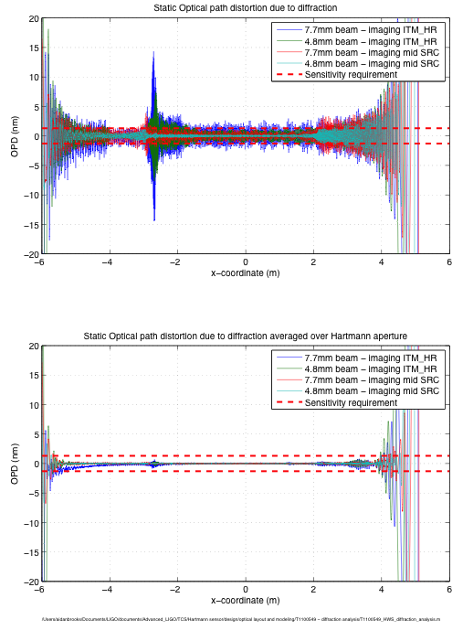

HWSX - Differential OPD with diffraction
The analysis in Section 3.1.3 is repeated for the ITM-HWSX probe beam. The results are presented in Figure 8. The best case is that of a 7.7mm beam imaged onto the ITM where the residual OPD error in the presence of a large OPD is less than +/- 1.3 nm for r > 1.5 mm on the HWS (r > 26.3mm on the ITM) and less than approximately +/- 4nm for r <= 1.5 nm.
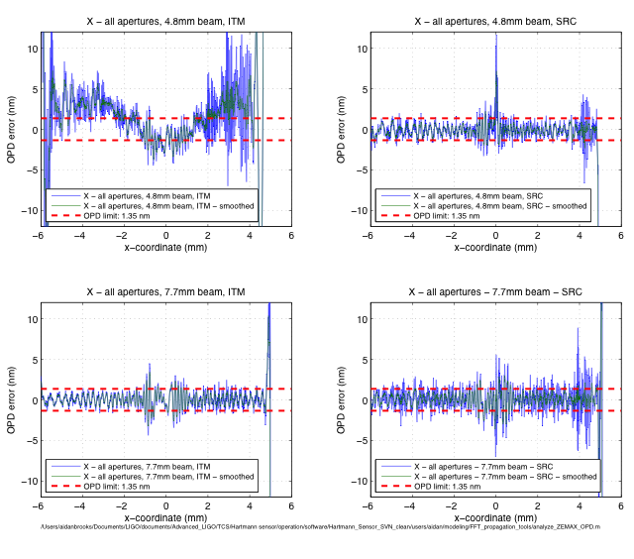
Figure 8: Residual OPD error for different HWSX optical configurations

Conclusion
There are two main points to note:
- The presence of diffraction does reduce the sensitivity of the HWS when operated in a differential mode. However, the sensitivity of the HWS is reduced by a factor of ~ 2.5x over a small fraction of the measured aperture. The original requirement for the HWS was that the sensitivity should be 10x smaller than the required correction (λ/47 ~ 13.5nm) to allow for some headroom in the sensitivity. Therefore, the decrease in the sensitivity to ~4nm over a small fraction of the sensor should not reduce the ability of the TCS to correct to better than 13.5nm.
- The aperture of H1:HWSX has been reduced by the displacement of the Hartmann probe beam on the SR3 mirror. The resulting ellipse spans a region of X: [-105mm, 83.5mm], Y: [-105mm, 105mm]. The total percentage of interferometer TEM00 power outside this region is 0.2%. If we interpolate the OPD a further +7.5mm in the +X-direction outside the HWS aperture, this is reduced to the target level of 0.1% (see T0600968 - Estimate of TCS sensor requirements).

- The aperture of H1:HWSY is defined by the BS baffle ellipse (X: [-105mm, 105mm], Y: [-130mm, 130mm]) and the square aperture of the HWS (X: [-107mm, 107mm], Y: [-107mm, 107mm] when projected onto the ITM). The percentage of interferometer TEM00 power outside this region is 0.026%

Due to the wedge on the BS, the center beam of the HWS probe beam that reflects off the BS_AR surface (H1/L1-HWSX, H2-HWSY) is offset horizontally by ~49mm from the center of SR3. See Section 2.1
Due to the 10% decrease in aperture size on SR3, we are considering

