Analysis of Diode Element Position
LIGO T1000639-v1
Richard Abbott, Stephen Baker
Caltech, 22 December, 2011

- Overview
The aLIGO DC readout uses a 3mm active area, InGaAs photodetector (Excelitas Part Number C30665) as the primary readout element in the DC photodetector. As part of the construction of the aLIGO OMC, it is required that the DC photodiode be positioned in a form of holder. This holder has the ability to adjust the position of the photodiode to accommodate manufacturing variations associated with the physical location of the diode chip within the metal TO5 can. This note documents the deviation from perfect centering of the active 3mm portion of the diode within the circular aperture of the glass window for a sample of 21 diodes.

The active area region of the photodiode can be seen as a dark circle centered within the clear glass window of the photodiodes shown in Figure 1.

Figure 1
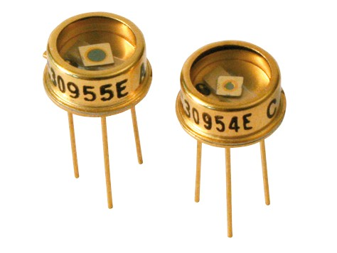

- Method
A USB microscope was used to take images of each photodiode. The photodiodes each have a unique serial number on the side of the metal can. The images were imported into AutoCAD and circles were fit to the active area and the innermost boundary of the glass-to-metal aperture. By looking at the offset of the inner circle to the outer circle, a table of data was taken that describes the offset in X and Y of the center of the active area within the glass window aperture.
In order to get position offsets in millimeters, scaling data was taken from the inner circle with the knowledge that the active area is 3mm in diameter. Figure 2 shows a representative image taken with the USB camera.

Figure 2
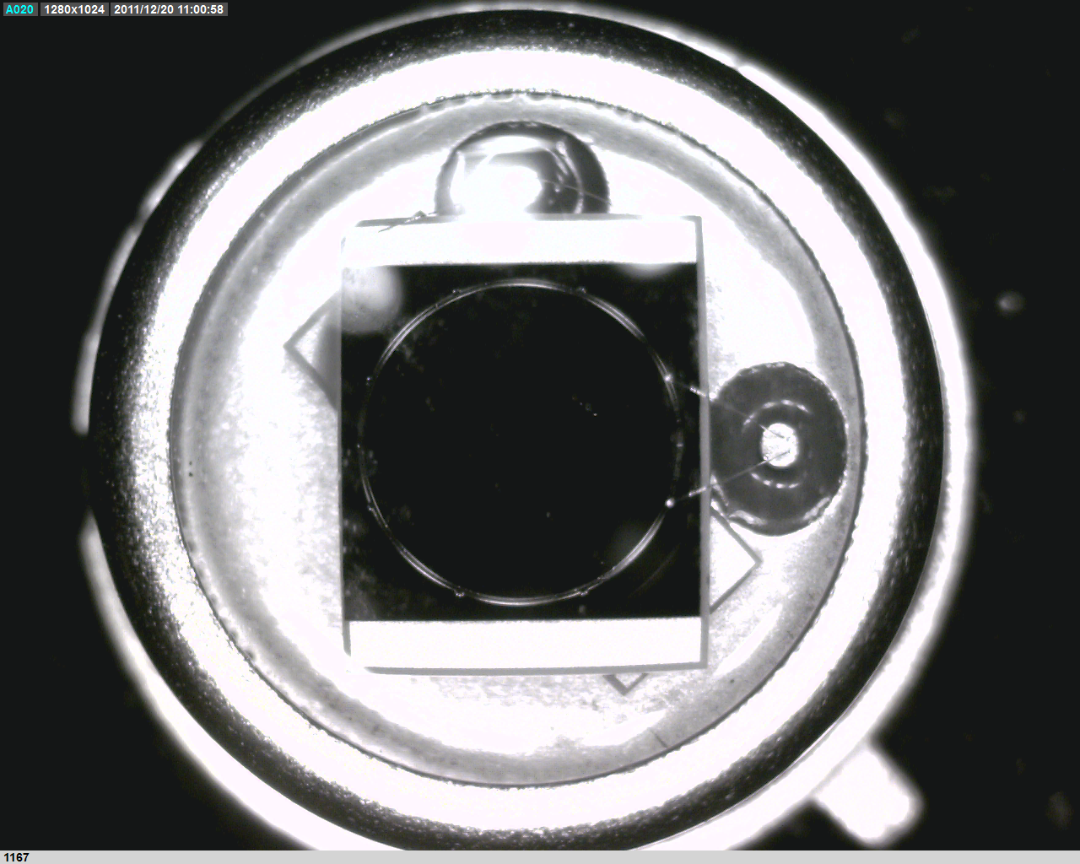

- Data
The data in Table 1 shows the offset of each diode element and some summary statistics.

Table 1
Diode Serial Number | X offset (mm) | Y offset (mm) | Deviation from center (mm)
792 | 0.048 | 0.097 | 0.11
793 | 0.044 | 0.096 | 0.11
787 | 0.114 | 0.035 | 0.12
790 | 0.114 | 0.036 | 0.12
791 | 0.083 | 0.018 | 0.09
1148 | 0.042 | 0.089 | 0.10
1149 | 0.057 | 0.072 | 0.09
1150 | 0.019 | 0.068 | 0.07
1152 | 0.087 | 0.062 | 0.11
1154 | 0.058 | 0.069 | 0.09
1155 | 0.004 | 0.119 | 0.12
1160 | 0.027 | 0.101 | 0.10
1161 | 0.003 | 0.006 | 0.01
1163 | 0.016 | 0.034 | 0.04
1166 | 0.024 | 0.079 | 0.08
1167 | 0.035 | 0.020 | 0.04
1171 | 0.043 | 0.027 | 0.05
1173 | 0.059 | 0.019 | 0.06
1174 | 0.004 | 0.076 | 0.08
1179 | 0.069 | 0.094 | 0.12
1180 | 0.060 | 0.008 | 0.06
Maximum center offset (mm) | 0.12
Average offset (mm) | 0.08
Standard Deviation (mm) | 0.03

