AUTHOR(S) | DATE | Document Change Notice, Release or Approval
Eric James | 9 July, 2012 | see LIGO DCC record Status
This document is intended to serve as a description of this assembly until a real assembly drawing can be made.

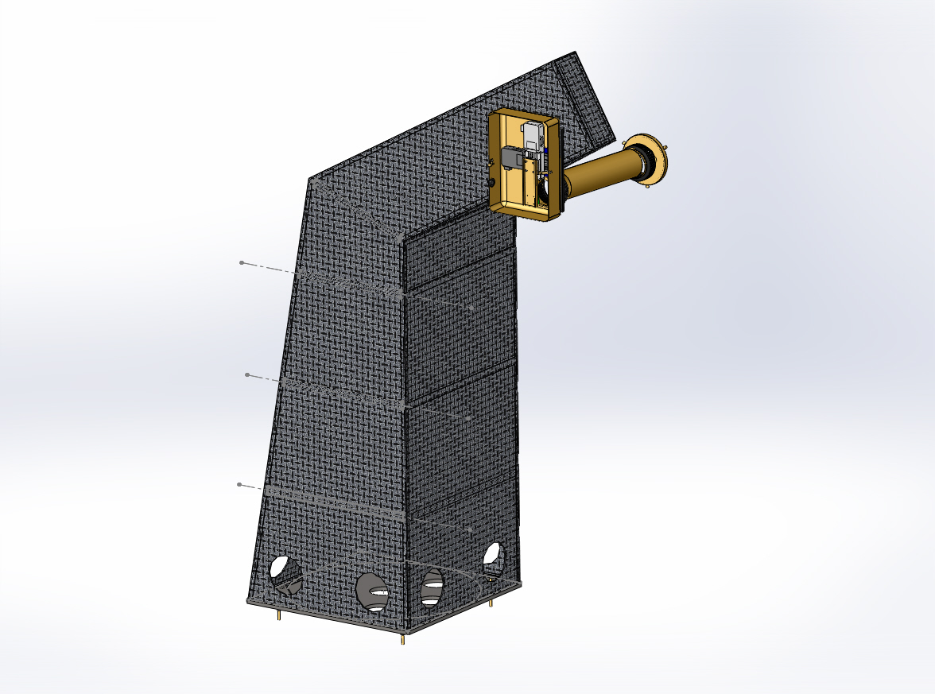

Figure 1: PR3 Receiver Pier Assembly. Right-hand giraffe shown with cover removed.

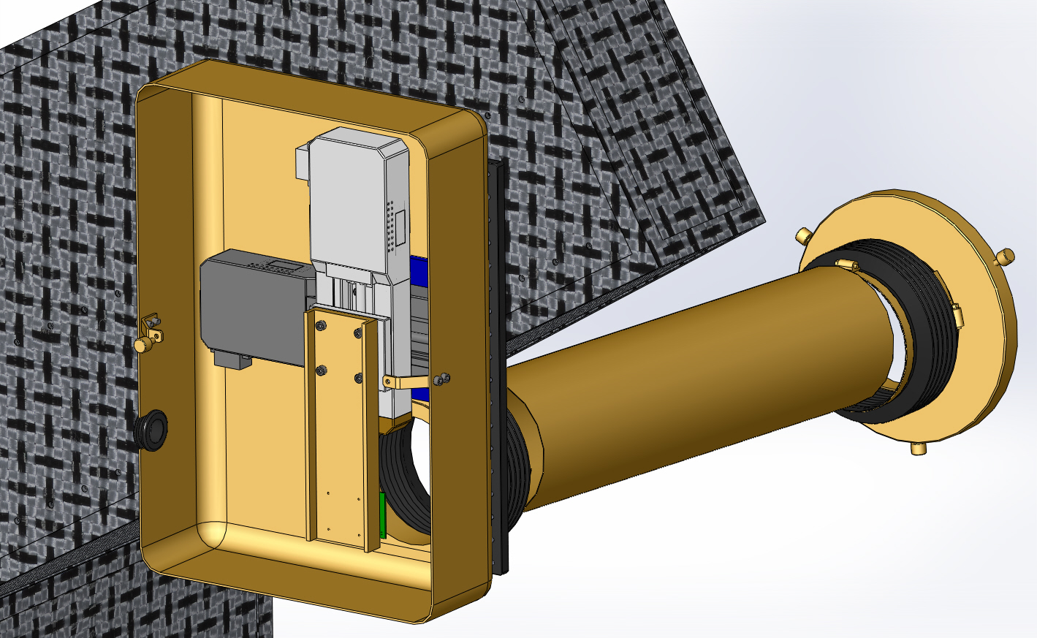
Figure 2: Close-up of Receiver with cover removed.

Bill of Material
Item | Part number | Description | Quant.
1 | D1101802 | Pier "Giraffe" (right-hand version) | 1
2 | D1101823 | Pier Base Plate | 1
3 | D1101824 | Clamp | 4
4 | D1200819 | PR3/SR3 Rx Breadboard (RH version) | 1
5 | D1001510 | Stage Adapter | 1
6 | SGSP33-50 | OptoSigma X-Y Stage | 1
7 | D1100617 | PCB Carrier | 1
8 | D1200820 | QPD Support | 1
9 | D1100290 | QPD Board Assembly | 1
10 |  | 15-pin M-M, Photodiode Board Cable | 1
11 | D1200821 | Receiver Enclosure Assembly | 1
12 | D1200827 | Bellows Mounting Ring | 1
13 | D1200622 | 6-inch Reducer | 1
14 | CT-6 | Gortiflex 6" Rubber Bellows | 2
15 | 45945K37 | McMaster-Carr 6" Band Clamp | 4
16 | 2561K12 | McMaster-Carr 6" Dia. x 24" SS. Duct | 1
17 |  | 1/2-20 x 1.5" Hex head cap screw | 12
18 |  | 1/4-28 x 5/8" SHCS | 7
19 |  | 1/4" X 1/8" Thick Flat Washer | 7
20 |  | 1/4-20 x 3/4" SHCS | 8
21 |  | M5 x 12 SHCS | 8
22 |  | M6 x 12 SHCS | 4
23 | 92421A540 | McMaster-Carr #4-40 x 5/8" SHCS | 4
24 | 92421A540 | McMaster-Carr 1/4-20 x 3/4" Brass Thumb Screw | 3
25

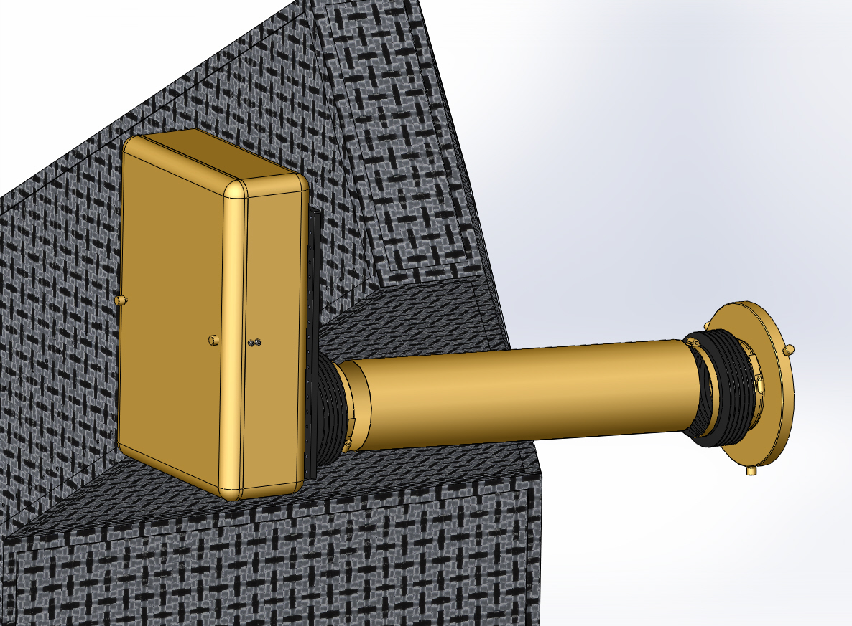
Figure 3: Optical Lever Receiver Enclosure
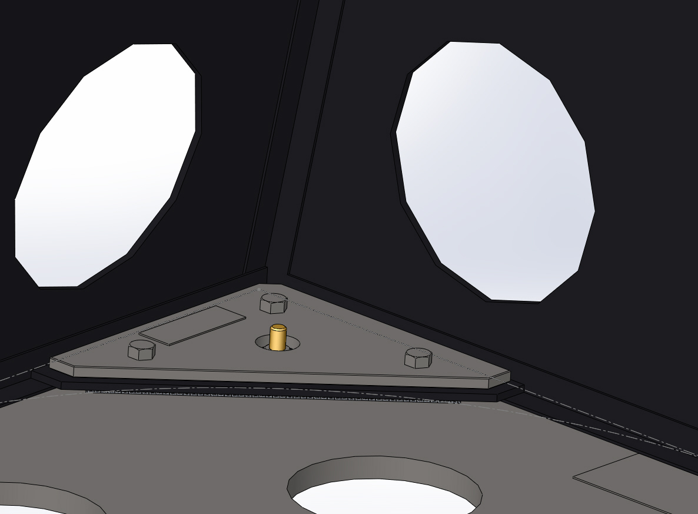
Figure 4:Base plate details

