Author: | Alexa Staley
Refer to: | LIGO-E1200086-v3
Date: | March 5, 2014

Common Mode Summing Node Test Procedure

Test Preparation
Enter Name, Date, and Board Serial Number. Indicate if the board has passed or failed the test.
Test Engineer: | Board Serial Number: | Date: | Pass:

Required Test and Ancillary Equipment

- 2 – Summing Node Board D1300788-v1 Tester
- 1 – Tektronix AFG 3101 Signal Generator or equivalent
- 1 – Tektronix TDS 210 Oscilloscope or equivalent
- 1 – Fluke Multimeter or equivalent
- 1 – HP 4395A Network analyzer (1Hz to 10MHz) or equivalent
- 1 – Stanford Research Systems Signal Analyzer Model SR785
- 1 – GPIB to Cat5 adapter
- 1 – Cat5 cable
- 1 – Laptop CPU using Windows operating system
- 1 – Folder containing Test File Scripts
- 2 – DC Power Supplies (Five Channels Required. Continuous Supply Voltages: +/- 24VDC, +/- 17VDC, and +5VDC)
- 1 – 17VDC Power Cable
- 1 – 24VDC Power Cable
- 1 – 5VDC Power Cable (Banana Plug to Banana Plug Cable and Jumper)
- 1 – custom cable adapting the DB9 Monitor port on the D0901781 front panel into three BNCs. (Refer to Common Mode Board: DAQ, Number D040180 Rev E, Sheet 17 of 17 for DB9 pinout detail)
- 3 – BNC Female to Female Adapters (Barrels)
- 1 – BNC Tee Connector
- 3 – BNC Female to Double Stacking Banana Plugs
- 1 – BNC Male to Mini Grabber Test Leads Cable
- 2 – 50 ohm BNC terminations
- 4 – BNC Male to BNC Male Cables
Table of Contents
Test Preparation............................................................................................................................. 1
Required Test and Ancillary Equipment………………………………………………………. 1
Important Notes…………………………………………………………………………………. 3
Tests Part 1………………………………………………………………………………………. 4
Power Board Voltage …………………………………………………………….............. 4
Power Supplies Test………………………………………………………………………. 4
Oscillations………………………………………………………………………………... 5
Check DC Bias…………………………………………………………………………… 6
Signal Gain………………………………………………………………………………... 7
Crossbar Switches……………………………………………………………………… 10
Excitation …...…………………………………………………………………………. 11
Filter/Option…………………………………………………………………………… 12
EPICS Readbacks……………………………………………………………………….. 12
Tests Part 2………………..……………………………………………………………………. 13
Important Notes…….………………………………………………………………… 13
Power Board Noise…….………………………………………………………………... 13
Monitor Channel Filtering…….………………………………………………………… 14
Adjustment Channel Filtering…….……………………………………………………... 15
Distortion Measurement………………………………………………………………….15
Noise Spectra……………………………………………………………………………. 15
Basic Transfer Functions………………………………………………………………… 16
Transfer Functions of Boost Gain Stages………….……………………………………. 17
Transfer Functions of DAQ Channels…………..………………………………………. 18
Transfer Functions of Filters……………………………………………………………. 19
Tests Part 3…………………………………………………………………………………….. 18
High Frequency Transfer Function………..………………………………………… 20

IMPORTANT NOTES:

1. On the Summing Node Tester (D1300789-v1) front panel, all switches must be returned to default positions after each test and/or step, unless otherwise instructed.

2. The default position for most switches is UP
The switch default positions are shown in Picture 1 below.

3. “Left” and “Right” indicate the PCB as viewed from the front of the Summing Node chassis.

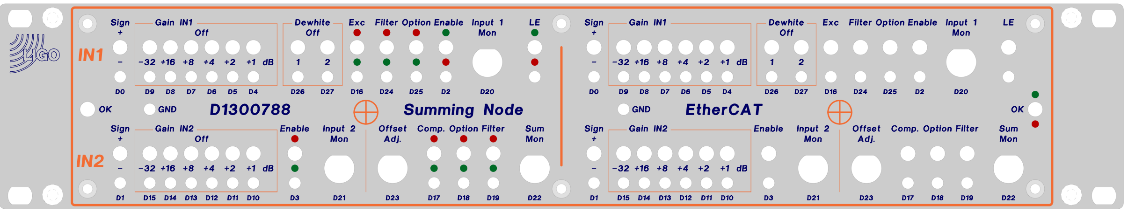
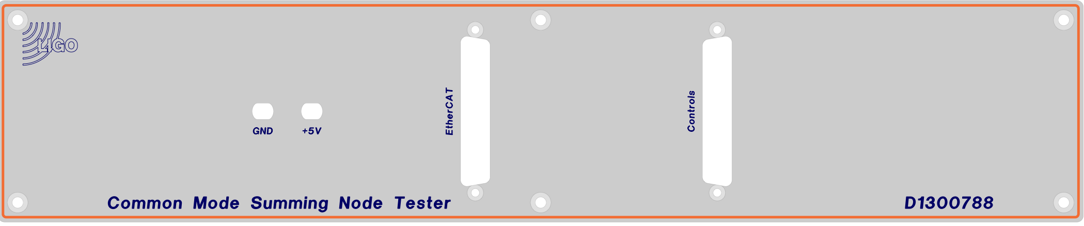
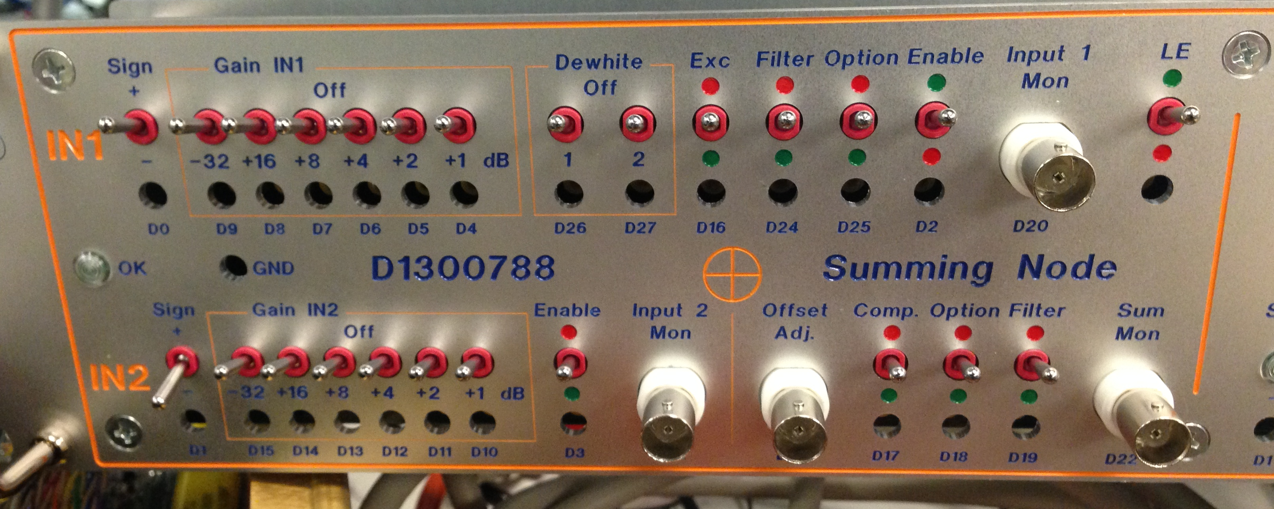
Picture 1
Front and Rear of Summing Node Tester

Tests Part 1.

1) Power Board Voltage (Low Noise Power Circuit Board Assembly D0901846)

Connect +/-17VDC and +/- 24VDC to the Common Mode Summing Node and +5VDC to the Summing Node Tester.

Turn ON Power Supplies.

On the Low Noise Power Circuit Board Assembly, Connect the positive multimeter test lead to the following test points and Connect the negative multimeter test lead to GRD.

Record the observed voltages in the data boxes below.

Turn Off Power Supplies.

TP1 | TP2 | TP3 | TP4 | TP5 | TP6 | TP7 | TP8 | TP9 | TP10 | TP11 | TP12 | TP13
+17V | -17V | GND | GND | +5V | -15V | +24V | GND | -24V | GND | +15V | +VREF | -VREF
** Correct voltage indications are: TP14 ~3VDC and front panel OK light lit.

2) Power Supplies

Turn OFF Power Supplies.

Connect 50 pin Control cables 1 and 2 to corresponding Control Mode Servo Tester and Summing Node rear jacks.

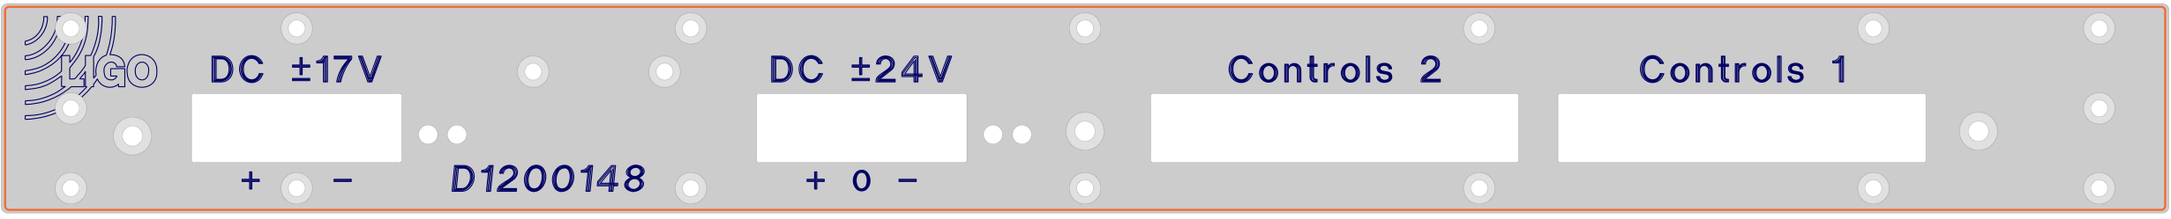 Picture 2
Rear of Common Mode Summing Node Board

Turn ON Power Supplies
.
Check current draw from the ±17V power supply is between 0.3A and 0.6A.

On the front panel of Power Supplies, Observe and Record the amperage displayed.

Power supply | Current (A) | Nominal (A)
+24V |  | 0.02
-24V |  | 0.02
+17V |  | .45
-17V |  | .45

3) Oscillations

Set oscilloscope coupling to AC Coupling.

Connect oscilloscope probe to the following outputs. Ensure no oscillating waveforms are observed.

Use P2 pins 1+2 for I1MON P+N, pins 3+4 for I2MON P+N, pins 4+6 for SMON P+N.
Connect controls output to tester.

Place checkmark in corresponding box below each output.
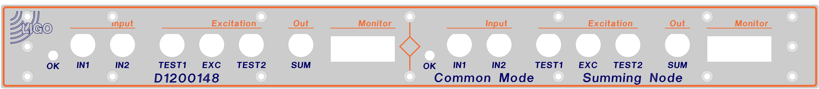
Picture 3
Front of Common Mode Summing Node Board

Right Front Panel Outputs:

Outputs | SUM Out | Test 1 | Test 2
Check Box
Outputs | I1MON | I2MON | SMON
Check Box

Right Rear Panel Outputs:
Outputs | D20  Input 1 Mon | D21  Input 2 Mon | D22  Sum Mon
Check Box

Left Front Panel Outputs:
Outputs | SUM Out | Test 1 | Test 2
Check Box
Outputs | I1MON | I2MON | SMON
Check Box

Left Rear Panel Outputs:
Outputs | D20  Input 1 Mon | D21  Input 2 Mon | D22  Sum Mon
Check Box

4) Check DC Bias

Check DC Bias at the outputs and monitors. Pass if around 0 VDC

Right:
Input Mon 1 (D20) | VDC | Pass/Fail
Input Mon 2 (D21) | VDC | Pass/Fail
Sum Mon (D22) | VDC | Pass/Fail
Sum OUT | VDC | Pass/Fail
I1MON (P2) | VDC | Pass/Fail
I2MON (P2) | VDC | Pass/Fail
SMON (P2) | VDC | Pass/Fail

Left:
Input Mon 1 (D20) | VDC | Pass/Fail
Input Mon 2 (D21) | VDC | Pass/Fail
Sum Mon (D22) | VDC | Pass/Fail
Sum OUT | VDC | Pass/Fail
I1MON (P2) | VDC | Pass/Fail
I2MON (P2) | VDC | Pass/Fail
SMON (P2) | VDC | Pass/Fail

5) Signal Gain

Gain slider IN1:

Connect Input 1 Mon (or Test 1) to the oscilloscope.

Connect Function Generator Output to Common Mode Summing node IN1 jack.

Set Function Generator to frequency 10Hz, Sine wave, and an Amplitude of 1 Vpp.

Inject a 10Hz / 1Vpp Sine wave signal.

Measure the voltage at 0dB (all switches in default position) and Record.

Individually, Toggle each switch down (GND) and Record observed voltage. After each voltage observation, Return the switch to default position.

Continue to Toggle each switch, Record the observed voltage and Return each switch to default position.

** Tolerance is + / - 1.059 V (+/-0.5dB).

Right:
Binary input (Switch Setting) | Measured Vpp | Nominal Vpp
—(0dB) |  | 1
D4 (1dB) |  | 1.12
D5 (2dB) |  | 1.26
D6 (4dB) |  | 1.59
D7 (8dB) |  | 2.51
D8 (16dB) |  | 6.31
D7 & D8 (24dB) |  | 15.9
D9 (-32dB) |  | 0.025
D9 & D7 (-24dB) |  | 0.063
D9 & D8 (-16dB) |  | 0.159
D9 & D8 & D7 (-8dB) |  | 0.398

Left:
Binary input (Switch Setting) | Measured Vpp | Nominal Vpp
—(0dB) |  | 1
D4 (1dB) |  | 1.12
D5 (2dB) |  | 1.26
D6 (4dB) |  | 1.59
D7 (8dB) |  | 2.51
D8 (16dB) |  | 6.31
D7 & D8 (24dB) |  | 15.9
D9 (-32dB) |  | 0.025
D9 & D7 (-24dB) |  | 0.063
D9 & D8 (-16dB) |  | 0.159
D9 & D8 & D7 (-8dB) |  | 0.398

Gain slider IN2:

Connect Input 2 Mon to an oscilloscope.

Set Function Generator to frequency 100Hz, Sine wave and an Amplitude of 1 Vpp.

Connect Function Generator Output to Common Mode Summing Node IN2 jack.

Inject a 100Hz / 1Vpp Sine wave signal into IN2.

Measure the voltage at 0dB (all switches in default position) and Record.

Toggle each switch individually Down (GND) and Record observed voltage. Return the switch to default position.

Continue to Toggle each switch, Record the observed voltage and Return each switch to default position.

** Tolerance is + / - 1.059 V (+/-0.5dB).

Right:
Binary Input (slider gain) | Measured Vpp | Nominal Vpp
— (0dB) |  | 1
D10 (1dB) |  | 1.12
D11 (2dB) |  | 1.26
D12 (4dB) |  | 1.59
D13 (8dB) |  | 2.51
D14 (16dB) |  | 6.31
D13 & D14 (24dB) |  | 15.9
D15 (-32dB) |  | 0.025
D15 & D13 (-24dB) |  | 0.063
D15 & D14 (-16dB) |  | 0.159
D15 & D14 & D13 (-8dB) |  | 0.398

Left:
Binary Input (slider gain) | Measured Vpp | Nominal Vpp
— (0dB) |  | 1
D10 (1dB) |  | 1.12
D11 (2dB) |  | 1.26
D12 (4dB) |  | 1.59
D13 (8dB) |  | 2.51
D14 (16dB) |  | 6.31
D13 & D14 (24dB) |  | 15.9
D15 (-32dB) |  | 0.025
D15 & D13 (-24dB) |  | 0.063
D15 & D14 (-16dB) |  | 0.159
D15 & D14 & D13 (-8dB) |  | 0.398

6) Crossbar switches

Inject a 100Hz/1Vpp Sine wave to IN1. Individually, Toggle each Crossbar switches Down. Using an oscilloscope, Record the voltage states at each SUM Out. Voltage states are either ON or OFF.

Binary input | SUM Out Right | Nominal | SUM Out Left | Nominal
Switches in Default Positions |  | On |  | On
D2 (input 1 disabled) |  | Off |  | Off
D3 (input 2 enabled, input 1 disabled) |  | Off |  | Off

Inject a 100Hz/1Vpp Sine wave to IN2. Record the voltage states at each SUM Out 2 while toggling the switches Down. Voltages states are either ON or OFF.

Binary input | SUM Out Right | Nominal | SUM Out Left | Nominal
Switches in Default Positions |  | Off |  | Off
D2 (input 1 disabled) |  | Off |  | Off
D3 (input 2 enabled, input 1 disabled) |  | On |  | On

7) Excitation:

Inject a 100Hz/1Vpp Sine wave to IN1. Measure and Record the voltage at TEST1 and TEST2. ** Tolerance is +/-0.5dB.

Right:
Binary input | TEST1 | Nominal Vpp | TEST2 | Nominal Vpp
Switches in Default |  | 1.00 |  | -1.00
Left:
Binary input | TEST1 | Nominal Vpp | TEST2 | Nominal Vpp
Switches in Default |  | 1.00 |  | -1.00

Inject a 100Hz/1Vpp Sine wave to EXC. Measure and Record the voltage at TEST2 and Sum OUT while toggling the switches Down. ** Tolerance is +/-0.5dB.

Right:
Binary input | TEST2 | Nominal Vpp | SUM Out | Nominal Vpp
Default |  | Off |  | Off
D16 (exc enable) |  | 1.00 |  | 1.00
D16 & D26 (DW1) |  | 0.10 |  | 0.10
D16 & D27 (DW2) |  | 0.10 |  | 0.10
D16 & D26, 27 (DW1, 2) |  | 0.01 |  | 0.01

Left:
Binary input | TEST2 | Nominal Vpp | SUM Out | Nominal Vpp
Default |  | Off |  | Off
D16 (exc enable) |  | 1.00 |  | 1.00
D16 & D26 (DW1) |  | 0.10 |  | 0.10
D16 & D27 (DW2) |  | 0.10 |  | 0.10
D16 & D26, 27 (DW1, 2) |  | 0.01 |  | 0.01

8) Filter/Option

Inject a 100Hz/1Vpp Sine wave to IN1. Measure and Record the voltage at SUM Out while toggling the switches Down. ** Tolerance is +/-0.5dB.

Right:
Binary input | SUM Out | Nominal Vpp
— |  | 1.00
D17 (SUM comp. enable) |  | 1.00
D18 (SUM filter enable) |  | 1.00
D19 (SUM option enable) |  | 0.00
D24 (IN1 filter enable) |  | 1.00
D25 (IN1 option enable) |  | 0.00

Left:
Binary input | SUM Out | Nominal Vpp
— |  | 1.00
D17 (SUM comp. enable) |  | 1.00
D18 (SUM filter enable) |  | 1.00
D19 (SUM option enable) |  | 0.00
D24 (IN1 filter enable) |  | 1.00
D25 (IN1 option enable) |  | 0.00
Note: D18/D19 are mislabeled on tester.

9) EPICS Readbacks

Inject a 100Hz/1Vpp Sine wave to IN1 or IN2 and Record the observed voltage.

Right:
EPICS readback | 1Hz | Nominal Vpp | 100Hz | Nominal Vpp
D20 (input mon 1) |  | -1.00 |  | 0.080
D21 (input mon 2) |  | -1.00 |  | 0.080
D22 (sum mon) |  | -1.00 |  | 0.080
Left:
EPICS readback | 1Hz | Nominal Vpp | 100Hz | Nominal Vpp
D20 (input mon 1) |  | -1.00 |  | 0.080
D21 (input mon 2) |  | -1.00 |  | 0.080
D22 (sum mon) |  | -1.00 |  | 0.080

Tests Part 2: SR785 Signal Analyzer Tests

Important Notes: 1. Ensure all Summing Node Tester switches are in the default position. 2. Closely Read and follow all On-Screen prompts.

On a Windows operating system laptop, Create and Save a file called TEST_DATA to C: drive. The path is C:\Test_DATA\.

Save Test Scripts in TEST_DATA.

Connect an SR785 Signal Analyzer to the laptop with a GPIB to Cat5 adapter.

From the DOS CMD window, Type cd.., Enter, Type cd.., Enter and Type cd SummingNode_TEST_DATA.

Type and Run 'setgpib.bat' and Enter the adapter's IP address (which should be labeled on the adapter).

Reset the SR785's settings with 'resetSR785.bat'. If the SR785 resets when the script is run, the SR785 is properly connected to the PC.

10) Power Board Noise (SR785PowerBoardNoise.bat)

One pair of probes (MiniGrabbers) are required to check the noise levels at 140Hz on the low noise power board.

In the DOS CMD window, Type SR785PowerBoardNoise.

Read and Follow the On-Screen prompts for proper test equipment configuration and procedure.

Record the collected On-Screen data in the boxes below.

** Test values must be less than the values indicated in the table below.

TP11 | < [nV/√Hz] | TP12 | < [nV/√Hz] | TP13 | < [nV/√Hz] | TP6 | < [nV/√Hz]
 | 30 |  | 20 |  | 30 |  | 30

Note: TP11, TP12, TP13, TP6 indicate the noise performance of P15V, VREF, NREF, and N15V respectively, which are the voltages we are regulating.

11) Monitor Channel Filtering (SR785MonitorTFs.bat)

In the DOS CMD window, Type SR785MonitorTFs

Read and Follow the On-Screen prompts for proper test equipment configuration and procedure.

Measure test transfer functions at 100Hz to 1Hz on IN1 to the indicated monitor channels on the tester and Record the data in the table below.

** Tolerances for Lowpass filtering are +/-1dB and +/-5deg from nominal.

Right:
Boost # | @1Hz | Nominal | @10Hz | Nominal | @100Hz | Nominal
Input Mon 1 (D20) |  | -0.1dB  173deg |  | -4.1dB  129deg |  | -22dB  95deg
Sum Mon (D22) |  | -0.1dB  173deg |  | -4.1dB  129deg |  | -22dB  95deg
Left:
Boost # | @1Hz | Nominal | @10Hz | Nominal | @100Hz | Nominal
Input Mon 1 (D20) |  | -0.1dB  173deg |  | -4.1dB  129deg |  | -22dB  95deg
Sum Mon (D22) |  | -0.1dB  173deg |  | -4.1dB  129deg |  | -22dB  95deg

Measure test transfer functions at 100Hz to 1Hz on IN2 to the indicated monitor channels on the tester and Record the data in the table below.

Toggle D2 down (off), and Toggle D3 down (on).

** Tolerances for Lowpass filtering are +/-1dB and +/-5deg from nominal.
Right:
Boost # | @1Hz | Nominal | @10Hz | Nominal | @100Hz | Nominal
Input Mon 2 (D21) |  | -0.1dB  173deg |  | -4.1dB  129deg |  | -22dB  95deg
Sum Mon (D22) |  | -0.1dB  173deg |  | -4.1dB  129deg |  | -22dB  95deg

Left:
Boost # | @1Hz | Nominal | @10Hz | Nominal | @100Hz | Nominal
Input Mon 2 (D21) |  | -0.1dB  173deg |  | -4.1dB  129deg |  | -22dB  95deg
Sum Mon (D22) |  | -0.1dB  173deg |  | -4.1dB  129deg |  | -22dB  95deg

Return all summing node tester switches to the default position.

12) Adjustment Channel Filtering (SR785AdjustmentTFs.bat) **NOT Applicable, unless input is connected.

Type SR785AdjustmentTFs

Test the transfer functions at 10kHz to 1Hz on the indicated adjustment channels on the tester to Sum Out. Verify filtering of at least -60dB at 100Hz and Record level below in the box below.

Right:
Default

Left:
Default

13) Distortion (SR785DistortionMeasurement.bat)

Type SR785DistortionMeasurement.

Inject a 1kHz/Vrms sine wave into IN1. Use a spectrum analyzer to measure the harmonic components at Sum Out. One the SR785, press Marker to display the THD level. Repeat the measurement for IN2 (Toggle D2, D3 down). Record the measurements in the boxes below.

Return toggle switches to default position.

 | INI Left | IN1 Right | SUM Out | IN2 Left | IN1 Right | SUM Out
Total Harmonic Distortion (THD) |  |  | <-70dB |  |  | < -70dB

14) Noise Spectra (SR785NoiseMeasurements.bat)

Type resetSR785 and Allow the SR785 to reset. Type SR785NoiseMeasurements

Terminate IN1 and IN2 using 50 Ohm terminations. Measure the noise density at each SUM Out. Record the values at 100Hz, 1kHz, and 10kHz in the table below.

Frequency | SUM Out Left | < [nV/√Hz] | SUM Out Right | < [nV/√Hz]
100Hz |  | 40 |  | 40
1kHz |  | 30 |  | 30
10kHz |  | 30 |  | 30

15) Basic Transfer Functions (SR785BasicTFs.bat)

Type SR785BasicTFs

Sweep the frequency from 100kHz down to 1Hz with 100mV source amplitude and Measure the transfer function from IN1 to SUM Out, and from IN2 to SUM Out for each side. Record the values at 10Hz, 100Hz, 1kHz, and 10kHz in the table below.
** Tolerances must be within 1dB and 5deg of nominal.
Right:
SUM Out/IN1 | dB | Nom | deg | Nom
1Hz |  | 0.0dB |  | 180deg
10Hz |  | 0.0dB |  | 180deg
100Hz |  | 0.0dB |  | 180deg
1kHz |  | 0.0dB |  | 180deg
10kHz |  | 0.0dB |  | 175deg

Toggle D2, D3 down
Ensure Sign “-“ for IN2 (swapped sign relative to IN1)

SUM Out/IN2 | dB | Nom | deg | Nom
1Hz |  | 0.0dB |  | 180deg
10Hz |  | 0.0dB |  | 180deg
100Hz |  | 0.0dB |  | 180deg
1kHz |  | 0.0dB |  | 180deg
10kHz |  | 0.0dB |  | 175deg

Return toggles switches to default positions

Left:
SUM Out/IN1 | dB | Nom | deg | Nom
1Hz |  | 0.0dB |  | 180deg
10Hz |  | 0.0dB |  | 180deg
100Hz |  | 0.0dB |  | 180deg
1kHz |  | 0.0dB |  | 180deg
10kHz |  | 0.0dB |  | 175deg

Toggle D2, D3 down
Ensure Sign “-“ for IN2 (swapped sign relative to IN1)

SUM Out/IN2 | dB | Nom | deg | Nom
1Hz |  | 0.0dB |  | 180deg
10Hz |  | 0.0dB |  | 180deg
100Hz |  | 0.0dB |  | 180deg
1kHz |  | 0.0dB |  | 180deg
10kHz |  | 0.0dB |  | 175deg

Return toggles switches to default positions.

16) Transfer Functions of Boost Gain Stages (SR785BoostGainTFs.bat)

Type SR785BoostGainTFs

Note: 1. Switch D9 must be Down (low) for all measurements.
2. All other switches are in default unless prompted otherwise

** Tolerances must be within 1dB and 5deg of nominal.
Right:
Boost # | @10Hz | Nom | @100Hz | Nom | @1kHz | Nom
Common Comp.  (D17) |  | -32dB  180deg |  | -32dB  180deg |  | -32dB  180deg

Left:
Boost # | @10Hz | Nom | @100Hz | Nom | @1kHz | Nom
Common Comp.  (D17) |  | -32dB  180deg |  | -32dB  180deg |  | -32dB  180deg

17) Transfer Functions of DAQ Channels (SR785DAQTFs.bat)

Type SR785DAQTFs

Measure the transfer function from SR785 CH1 A to Monitor jack (DAQ channels). Sweep the frequency from 10kHz down to 1Hz at 1mV source amplitude. Record the values at 1Hz and 10kHz in the table below.
** Tolerances must be within 1dB and 5deg of nominal.

Note: If you only have one PCB, you will need a breakout board to attach to P2 (see D1200151 for pin breakdown). If you have two PCBs, attach right front panel P2, P3 to left front panel P4, P2.

Right:
Frequency | 1Hz | Nominal | 10kHz | Nominal
I1MON |  | 5dB, 0deg |  | 46dB, 0deg
I2MON |  | 5dB, 0deg |  | 46dB, 0deg
SMON w/ IN1 |  | 5dB, -170deg |  | 46dB, -180deg
SMON w/ IN2 |  | 5dB, -170deg |  | 46dB, -180deg

Left:
Frequency | 1Hz | Nominal | 10kHz | Nominal
I1MON |  | 5dB, 0deg |  | 46dB, 0deg
I2MON |  | 5dB, 0deg |  | 46dB, 0deg
SMON w/ IN1 |  | 5dB, -170deg |  | 46dB, -180deg
SMON w/ IN2 |  | 5dB, -170deg |  | 46dB, -180deg

18) Transfer Functions Filters (SR78FilerTF.bat)

Type SR785FilterTF

Measure the transfer function from EXC to SUM Out with the dewhitening filters enabled from 7mHz to 1kHz with a source amplitude of 1V.

Confirm pole/zero at 1Hz/10Hz.
Right:
Check box
Left:
Check box

Measure the transfer function from IN1 to SUM Out with each filter on (D24, D18) from 1Hz to 100kHz with a source amplitude of 1V. Ensure unity gain.

Right:
 | Measured (dB) | Nominal (dB)
IN1 Filter (D24) |  | 0 dB | Pass/Fail
Sum Filter (D18) |  | 0 dB | Pass/Fail
Left:
 | Measured (dB) | Nominal (dB)
IN1 Filter (D24) |  | 0 dB | Pass/Fail
Sum Filter (D18) |  | 0 dB | Pass/Fail

Tests Part 3: 4395A Network/Spectrum Analyzer

Connect the 4395A in a similar fashion to the SR785, with a GPIB to Cat5 adapter.

19) High Frequency Transfer Function (AG4395AHighFreqTF.bat)

Type AG4395AHighFreqTF

Use a network analyzer to measure the transfer function from IN1/2 to Sum Out. Sweep the frequency from 10MHz down to 10kHz with –20dBm source. To remove cable delays first measure the transfer function against a BNC barrel and use as a reference. Record the displayed values at 100kHz, 300kHz and 1MHz in the table below. Nominal values are given.

** Tolerances are within 1dB and 5deg of nominal.

Right:
Frequency | SUM Out/IN1 [dB] | Nominal | SUM Out/IN1 [deg] | Nominal
100kHz |  | -5dB |  | 170deg
300kHz |  | -5dB |  | 160deg
1MHz |  | -5dB |  | 130deg

Frequency | SUM Out/IN2 [dB] | Nominal | SUM Out/IN2 [deg] | Nominal
100kHz |  | -5dB |  | 170deg
300kHz |  | -5dB |  | 160deg
1MHz |  | -5dB |  | 130deg

Left:
Frequency | SUM Out/IN1 [dB] | Nominal | SUM Out/IN1 [deg] | Nominal
100kHz |  | -5dB |  | 170deg
300kHz |  | -5dB |  | 160deg
1MHz |  | -5dB |  | 130deg

Frequency | SUM Out/IN2 [dB] | Nominal | SUM Out/IN2 [deg] | Nominal
100kHz |  | -5dB |  | 170deg
300kHz |  | -5dB |  | 160deg
1MHz |  | -5dB |  | 130deg

