AUTHOR(S) | DATE | Document Change Notice, Release or Approval
E.Sanchez, Calum Torrie | 04 Nov 2014 | see LIGO DCC record Status
Instructions on the use of this document:
- Keep this document, and its linked documents, available on a cleanroom compatible computer or Lenovo at all times during installation.
- Use this document as a checklist. Check off each step as it is completed. There is a green box at the end of each subsection to record the name of the person(s) who completed and/or approved the work, date, and any comments or notes. In particular, note any discrepancies or deviations and augment with any missing information. If additional notes are too cumbersome to include within the body of this document, then electronically attach them to the completed procedure.
ALL NOTES MUST BE RECORDED IN THE COMPLETED VERSION OF THIS DOCUMENT (NOT IN OTHER NOTEBOOKS OR FILES).
- Once completed, file the document in the LIGO Document Control Center (DCC) as a new version of the procedure. Add a note that this is a completed procedure.
- File any significant notes or data from the completed procedure in the electronic logbook (such as any deviations). As a minimum, note in the electronic logbook that the installation was completed in accordance with this procedure (cite document number and revision).
Contents
1 APPLICABLE DOCUMENTS 2
2 SCOPE 4
2.1 Major Subsystem Assemblies 5
3 EQUIPMENT LIST 9
4 WARNING 10
5 PREREQUISITES 10
6 CHAMBER PREPARATION 11
7 HAM ISI ASSEMBLY 11
7.1 ISI Assembly Installation 11
7.2 SEI Phase II Testing 12
8 PAYLOAD INSTALLATION 12
8.1 Prerequisites 13
8.2 Weigh Major Payloads 13
8.3 Install Fiducials and HAM Arm 14
8.4 Install OMC 14
8.5 Install ISC components 15
8.6 Install Remaining Payload Components 16
8.7 ISI Testing and Table Re-balancing (as required) 16
8.8 Align Optics 16
9 CLEANING 16
9.1 Optics and Viewports 16
9.2 Optical Table and Chamber 17
10 FINAL OPERATIONS 17

APPLICABLE DOCUMENTS
All of the documents required for the installation of LHAM6 are listed below. Background and reference materials have been excluded to streamline the use of this installation procedure. Users may fill in the revision numbers of documents in the table.
Documents have been subdivided into the following categories:
- aLIGO Systems, HAM6-L1 Top Level Chamber Assembly
- HAM Systems Level Supplementary Chamber-Level Build Documents
- aLIGO Installation Procedures (from sub-systems)
- aLIGO Safety Procedures (associated with install)
- aLIGO Test Procedures (associated with install)
- aLIGO Alignment Procedures (associated with install)
- HAM STRUCTURE LIFT ASSEMBLY, aLIGO, SUS
Table 1 LHAM6 Document List
DOCUMENT | REV | TITLE
D0901811 |  | aLIGO Systems, HAM6-L1 Top Level Chamber Assembly
E1101160 |  | HAM6-L1 Top Level Chamber Assembly BOM
D0901812 |  | AdvLIGO VE HAM6-L1, Vacuum Equipment Assembly
D1100979 |  | AdvLIGO SEI HAM6-L1, XYZ Local CS for ISI Table
D1000514 |  | HEPI ASSEMBLY, HAM, aLIGO SEI
D1300077 |  | AdvLIGO SUS HAM6-L1, XYZ Local CS for Output Mode Cleaner Suspension
D1000342 |  | AdvLIGO HAM6 ISC Block Diagram
D1201021 |  | aLIGO HAM6-L1 ISI Table, Payload & Suspended Mass Assembly
D1002890 |  | Flange Layout - L1 Horizontal Access Module 6 (HAM 6)
D1300122 |  | CABLE HARNESS ROUTING CONFIGURATION, HAM 6
F1100030 |  | HAM Systems Level Supplementary Chamber-Level Build Documents
D1101296 |  | aLIGO, AOS, HAM Chamber, Optical Table, Hole Tabulation
E1000403 |  | HAM Optics Table Heights for Advanced LIGO
T1000228 |  | HAM SUSPENSION SPACER THICKNESSES
E1100411 |  | Interface Control Document on HAM table dog clamps including detailed layout and hardware on HAM ISI tables
T1100180 |  | HAM Optics Table Dog Clamp Chart H1, H2 & L1
D1101775 |  | aLIGO, ELECTRICAL FEEDTHROUGH TYPES, TYPICAL SUBFLANGES, AND PORT CONFIGURATIONS
D0901811 |  | LHAM6 – Chamber Coordinates Definition
E1100742 |  | aLIGO Detailed Mass Properties-CG Report HAM Tables (LLO)
T070076 |  | Optical Layout for Advanced LIGO
E1200924 |  | aLIGO HAM Install Procedures (associated with install)
M1000362 |  | LLO HAM Access Door Removal Procedure
E040011 |  | Installation Specification - HEPI Assembly and Installation Procedures
E070271 |  | OMC SUS Installation Procedure
E080012 |  | HAM ISI Installation into HAM Chamber: Installation Procedure
E1100484 |  | Assembly & Installation Specification for the aLIGO, High Quality,Viewports
E1200445 |  | LLO Viewport Assembly Status
T1100174 |  | Weighing ALL assemblies that are mounted to a HAM isolation table, BSC isolation table or a BSC stage 0
E1200923 |  | aLIGO HAM Safety Procedures (associated with install)
E0900042 |  | aLIGO OMC Hazard Analysis
E1300537 |  | Addendum to E0900042 aLIGO OMC Hazard Analysis
E1100246 |  | Viewport Installation Hazard Analysis
T080145 |  | Viewport Safety Protocols
G1200070 |  | Ideal Order/Contents of aLIGO Triple SUS Testing/Commissioning
E1100994 |  | aLIGO HAM-ISI Testing Procedure, Phase II: Integration Process
T1400588 |  | HAM6 Alignment Procedure
E1300822 |  | ECR Fast Shutter and Beam Dump Reposition within HAM6
D1101674 |  | aLIGO, SUS, BSC/HAM INSTALLATION TOOLING
E1100520 |  | Key safety information associated with the FMP supplied Genie's, lifts and carts
D1100886 |  | MODIFIED GENIE LIFT FORKS
D1001664 |  | HAM STRUCTURE LIFT ASSEMBLY, aLIGO, SUS
E1100831 |  | HAM Installation Arm User Guide
D1200482 |  | aLIGO Spreader Bar, HAM / BSC Repair Arm

SCOPE
This document covers the installation of interferometer components and assemblies into the Livingston HAM6 chamber, shown in Figure 1 and Figure 2.

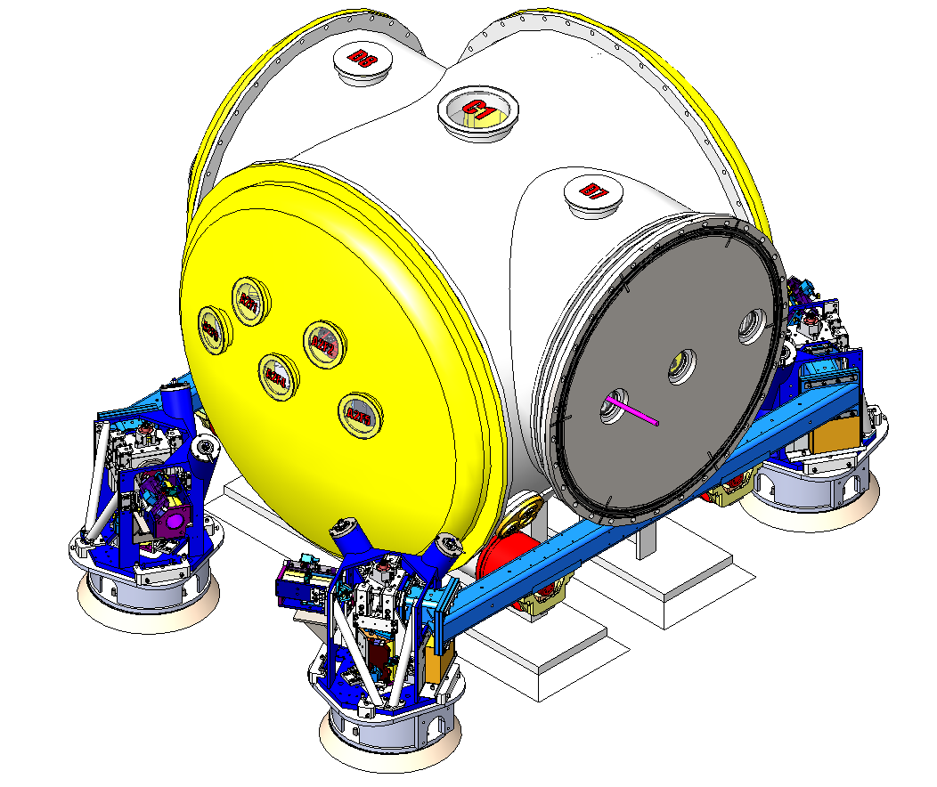
Figure 1. LHAM6 with vacuum equipment, HEPI, and ISI support frame
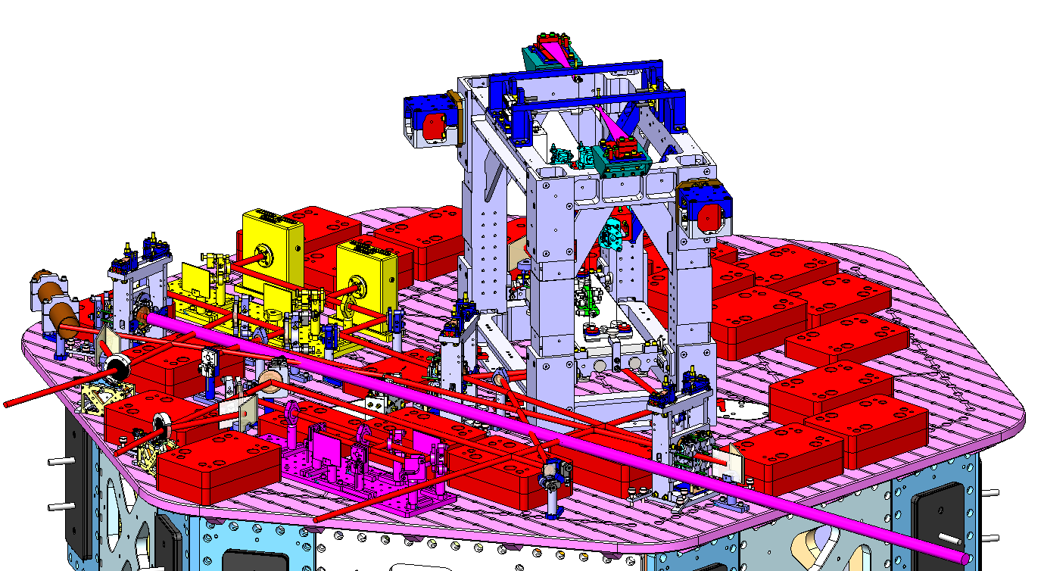

Figure 2. LHAM6 without vacuum equipment, HEPI, and ISI support frame

Major Subsystem Assemblies
This installation includes the following major assemblies.
Note: red-lines in subassembly section do not affect install.

Table 2. LHAM6 Subsystem Assemblies
Sub-system | Assy Dwg | Subassembly | Image
INS | D1000514 | HEPI HAM Chamber Level Assembly
SEI | D1100979 | LHAM6-ISI assembly including: | 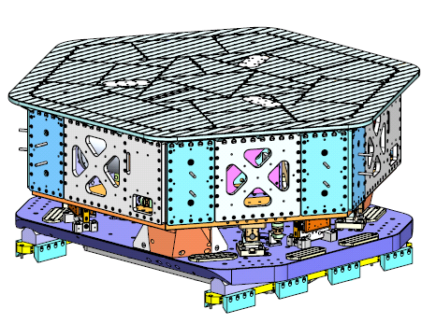
SUS | D1300077 | OMC assembly including:  OMC SUS, D0900295  Vibration Absorbers, D1002424  Dog Clamps, D1100640 | 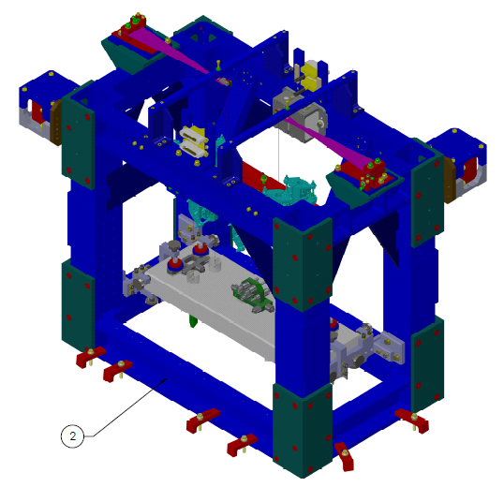
ISC | D1000342 | ISC Block Diagram. Please see below for assembly sequence. | 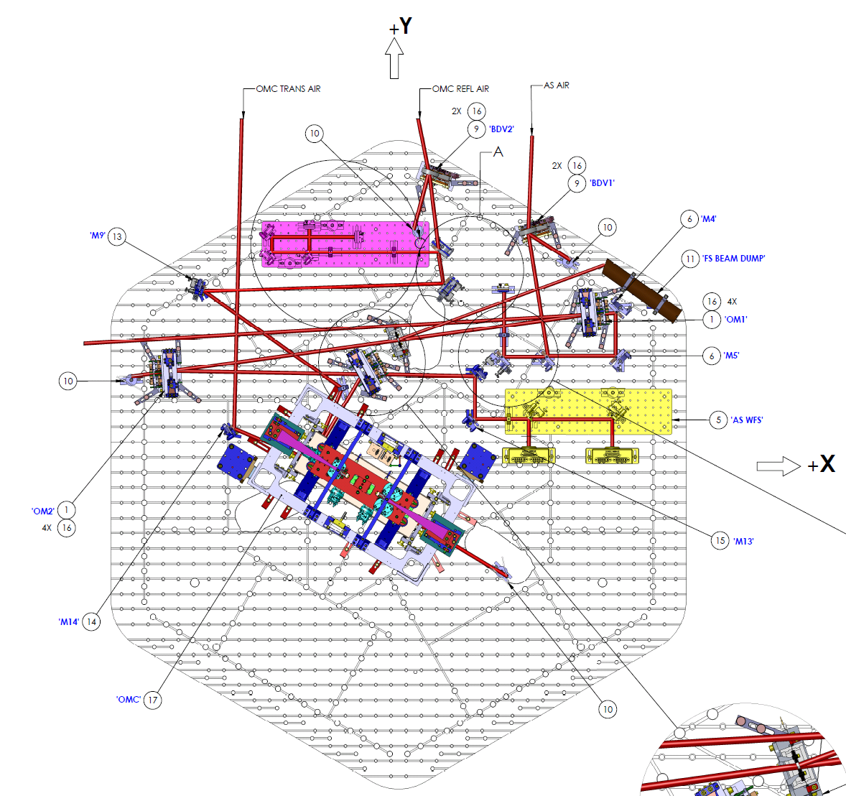
Please Refer to D1000342 for details.
SEI | D1201021 | AdvLIGO Systems HAM6-L1 ISI Table, Balance Masses Assembly  Including viton pads under some masses and screws for “picket fence” protection of some masses. | 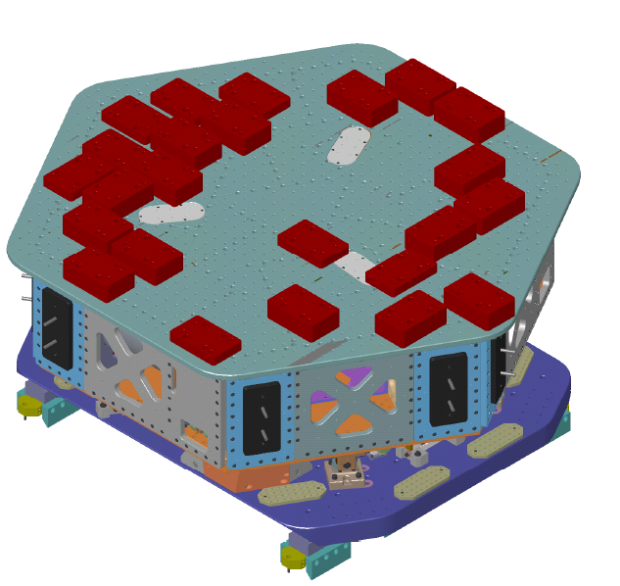
SEI/ SYS | D1101775  D1300122  D1002890 | Electrical Feedthrough Types  Cable Routing Configuration  Flange Layout | 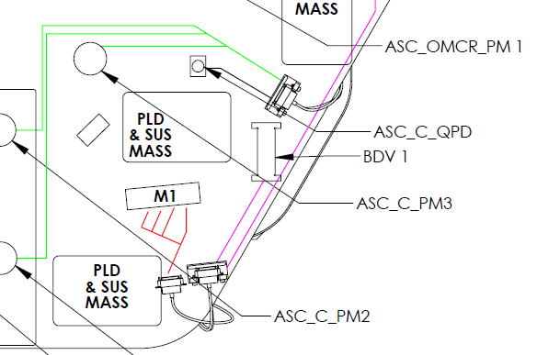
AOS/ SLC | T1100292  T1000746 E1200445 | Viewport Source List  (T1000746 for pictures)  LLO Viewport Assembly Status | 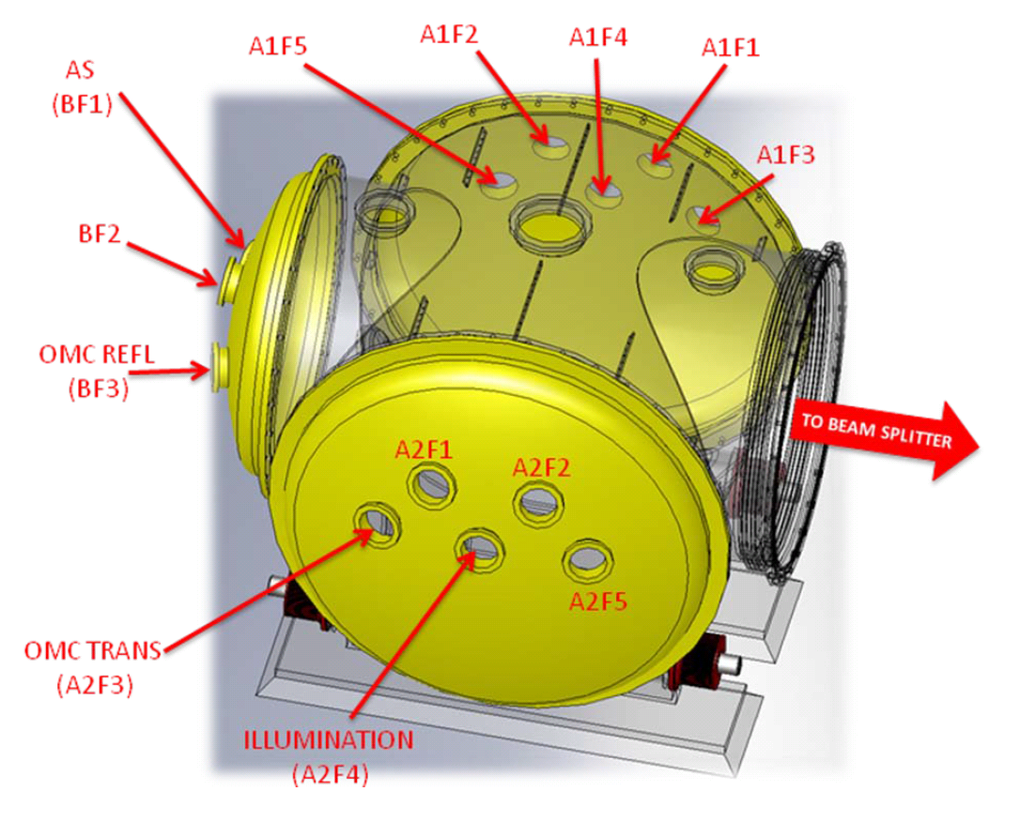
Rack and cable tray layout | D1003141 | Rack and Cable Tray Layout, LVEA, L1  Group of these at Rack and Cable Tray Layouts (D1003142)

EQUIPMENT LIST
The referenced documents call out the equipment and parts/assemblies required to complete a given procedure. To assist with setting up for installation, a general list of required equipment is given below.
Transportation:
- BSC/HAM Installation Tooling (D1101674) – info on transporting the HLTS (page 4), HSTS (page 5), and OMC / OFI (page 6).
  - Genie SLA-10 Lift
  - Genie Adapter Plate D1100515. The old iLIGO lift table was used at LLO.
Installation:
- HAM Installation Arm User Guide (E1100831) – main document to refer to for HAM install, including the most up to date information.
  - HAM Installation Arm Assembly (D1101854):
    - HAM Arm (D1002052) - Reference only, refer to E1100831.
    - HAM Lift Assembly (D1001664)
      - OMC Lifting Bracket Clamp (D1001793)
      - OMC Lifting Bracket (D1001792)
    - HAM arm being assembled to HAM Lift (D1101674, page 11), also shows surgeon’s table option
    - HAM Flange (D1001994)
  - Spreader Bar (D1200482) – used between arm and forklift to mount arm to flange.
Safety:
- HAM Installation Arm Hazard Analysis (E1000252).
- Key safety info associated with Genies (E1100520). (In process of migrating to D1101674 load limits for genie and height/load transfer restrictions).

WARNING
Every chamber entry should be treated as a serious threat to suspended optics. To provide reasonable assurance against the inadvertent introduction of contaminants into chamber:
- All personnel entering chambers should be familiar with the LIGO Contamination Control Plan E0900047, and LIGO Clean and Bake Methods and Procedures E960022. Vacuum Compatibility and Qualifications was part of E960022, but will be a new document. Should that doc be listed here instead?
- All components should be vacuumed or wiped down before installation in chamber to mitigate contamination created/accrued during assembly. Ex: Use vacuum to blow off dust generated from turning screws.
- Wiping and vacuuming (sucking) should be used throughout the integration process.
- Great care should be taken to preclude touching the optics table, anything on the optics table, and the seismic stacks.
- When working near the optics, qualified personnel should carefully engage earthquake stops on each optic.
- Lens caps should remain on the optics whenever possible.
- Particle count measurements should be taken prior to each incursion into chamber. Record measurements in the green comment boxes in this document.

PREREQUISITES
- Ensure Support Tubes are in nominal position. See T1100194, T1100187 & E1200625 leveling them to 0.4mrad. In LHAM2 install doc, this is at the end of Section 4.1. Extra notes on IAS group asking for tables to be aligned to 100 micro-radians in angle and 1.0mm in position.
- Install HEPI per E040011 and E1100094. Leave HEPI actuators disconnected.
- Vent the vertex vacuum volume and set the purge gas flowing per procedure M1000360.
- Follow the Lockout-Tagout procedure M990190.

Completed, approved, or checked by:
Date:
Comments (optional):

CHAMBER PREPARATION
- Install the output septum plate, D1002462.
- Install cable tray around the LHAM6 chamber per D1003141.
- Install HAM Chamber Cleanrooms around the LHAM6 chamber and clean the chamber exterior and the region around the chamber per E0900047 & E1201035
- Install dial indicators on the HAM support tube ends.
- Take an initial particle count measurement outside chamber door, and record in green comment box at the end of this section. See T1400024
- Remove chamber doors per procedure M1000362.
- Take particle count in chamber to test purge air.
- Install the electrical feed-throughs listed in D1002892 into LHAM6 per procedure M990173.
- Install the field cabling from the electrical feed-through to the electronics racks. Field-route cables as necessary.
Note: The field cabling can be installed later, but must be done after the cable trays are in place, yet before the ISI is installed. For LLO, the field cabling was required for chamber-side testing but it was not necessary to connect it to the chamber prior to ISI installation. LHO installed cable trays after the ISI as it was found that the cable trays could interfere with the SEI dial indicators. Use caution when working around the SEI dial indicators.
- Install the viewports, T1100292, per E1100484 and Septum Viewport Installation, E1200995, and per Conflat flange assembly procedure M990173. Follow Viewport Safety Protocols, T080145 and Viewport Installation Hazard Analysis, E1100246
Note: Viewports can be installed later in the sequence.

Completed, approved, or checked by:
Date:
Comments (optional):

HAM ISI ASSEMBLY

ISI Assembly Installation
- Install ISI assembly into the vacuum chamber per E080012.
- Install ISI dummy mass per E1000328.
- Float HEPI per E040011.
- Level ISI table to ±0.1 mrad and elevate to ±1mm per E1000403 and E1100784 (section 6.1.2).
- Align X, Y, and yaw (about Z) of ISI optical table and adjust with HEPI per E1100784 (section 6.1.3).
- Install HEPI Actuators. If Dial Indicators indicate too much motion, check the table alignment.
- Complete Install all SEI in-vacuum cabling per D1300122.
Note: During install, check quality of cables and watch out for grounding as discussed in T1200266 (this doc is specific to suspensions, but offers good guidance which can be applied to all cables).
WARNING: Clamping cables too tightly can cause failure.

Completed, approved, or checked by:
Date:
Comments (optional):

SEI Phase II Testing
- Perform the phase II testing associated with HAM-ISI installation prior to attaching payload to the optics table, (i.e. perform Step 6 in E1100994).
- Lock HEPI per E040011.
- Lock ISI
- Remove Dummy Payload Mass.

Completed, approved, or checked by:
Date:
Comments (optional):

PAYLOAD INSTALLATION
The LHAM6 assembly is depicted in Figure 3.
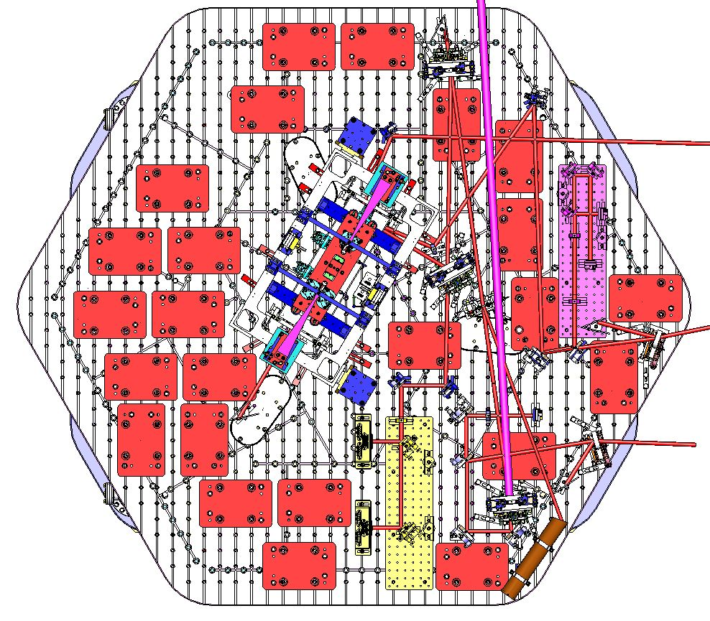

+Y

+X

Figure 3. LHAM6 Assembly (D0901812). Refer to DCC for latest version.

Prerequisites
None.

Weigh Major Payloads
- Using T1100174, weigh the following and record in Table 3.
  - Full OMC
  - ISC Components
Note: If the measured weight is greater than the mass budget in E1100742 contact Systems immediately.

Table 3 Payload Weight
Payload | Mass Budget (kg) | Measured Mass (kg) | Comments/caveats
ISC Components | 24.67
OMC | 53.53

Completed, approved, or checked by:
Date:
Comments (optional):

Install Fiducials and HAM Arm
- Install the Fiducial Kit, D1300364, into the designated holes using D1101296 as a guide.
- Install HAM installation arm on –X, +Y chamber corner.
Note: Refer to section 3 of this document for tooling documentation including user guide. HAM arm can and should also be used as support for smaller items. “Surgeon’s table” is available with HAM Arm Vertical Lift, D1001664 and D1101674 (page 11).

Completed, approved, or checked by:
Date:
Comments (optional):

Install OMC
- Install the pre-installation plate for OMC (D1300120) per D1300077.
- Move OMC into position using the HAM installation arm.
- Clamp OMC to the table per D1300077.
- Remove pre-installation plate for OMC.
- Install any outstanding Vibration Absorbers that have not already been installed on OMC as per D1300077, and remove locker pins.
- Remove temporary cable ties, and install cable brackets onto the table per D1300122. Coil excess quadrapuss cables and secure to table near base of suspension with Aluminum strips. Route SRS cables across table and down ISI to flange.
Note: This step can be performed at a later time.
- Check grounding and fix any if found.
Note: First check cabling on suspension structure. If none is found, next check across table (quadrapuss and SRS cables). Use Rich Abbot’s testing setup per T1200203 and T1200131.
- Remove optic shielding and suspend OMC (as required).
- Perform SUS Phase 3a Testing of OMC as per G1200070 (as required).
- Perform B&K Hammer Testing of OMC per T1000606 (as required).
- Lockdown OMC (as required).
- Install
- Optional (based on time constraints) – For the first instance of the addition of a major assembly to the optics table, the table will be re-balanced, floated, and SEI will take transfer function measurements in order to help identify (at a later time after post-processing) any troublesome modes.

Completed, approved, or checked by:
Date:
Comments (optional):

Install ISC Components
- Install ISC components as per D1000342.
  - Tip-Tilt Mirrors
  - QPD Sleds
  - Fast shutter
  - Fast shutter beam dump
  - ISC Rotary Beam Diverters
  - Fixed Optics
  - Transmon Beam Dump
  - Pico Motor

Completed, approved, or checked by:
Date:
Comments (optional):

Install Remaining Payload Components
- Install balance masses per D1201021. Add viton pads, per bug 577, including picket fence screws to protect balance masses.
- Re-balance optical table, D1101781

Completed, approved, or checked by:
Date:
Comments (optional):

ISI Testing and Table Re-balancing (as required)
- Unlock OMC.
- Perform HAM-ISI Phase II Testing as per E1100994 if required.
- Re-do ISI balance masses (if required) as per D1101781, and balance table.

Completed, approved, or checked by:
Date:
Comments (optional):

Align Optics
- If large errors require significant adjustment in the suspension, re-check TFs as per Phase 2b testing G1200070.
- Remove any IAS fixturing.

Completed, approved, or checked by:
Date:
Comments (optional):

CLEANING

Optics and Viewports
- Lock suspended optic.
- Inspect suspended optic surfaces and re-clean as needed per T1200321. First Contact procedure, if required is E1300017
Special Note: Per T1200321 (pages 4, and 6-8). After the final clean and pull of the First Contact, if there is more work to be done before closing the chamber, then re-apply First Contact after:
  - Level 2 = 1 week in air
  - Level 4 = 2-3 weeks in air
These timeframes are flexible depending on the work that needs to be done. If heavy install work has to be carried out or planned work is expected to take more than 3 weeks, please contact COC (GariLynn Billingsley).
Optics might be harder (or impossible) to access for cleaning after installation in chamber. Talk to COC/SYS group.
- Inspect viewports, and clean if necessary per E1201035 (page 6).

Completed, approved, or checked by:
Date:
Comments (optional):

Optical Table and Chamber
- Inspect optical table and components for particulate contamination, and clean if required as per E1201035.
- Inspect and clean below the ISI table top and beyond as per E1201035.

Completed, approved, or checked by:
Date:
Comments (optional):

FINAL OPERATIONS
- Remove all optic covers.
- Remove any TFE SUS Earthquake stop fixturing.
- Remove locker pins from vibration absorbers if not already done.
- Remove First Contact from suspended optic as per T1200321 and E1000079, if not already done.
- Set all SUS Earthquake Stop gaps to 0.75mm gap (0.6 turns of screw).
- Lock all SUS Earthquake Stop nuts.
- Confirm the suspension controller is working properly, and examine OSEM alignment and adjust if necessary.
- Check optic table balance.
- Add (2) 2” Silicon witness wafers and (2) 1” witness optic to the table in the following configuration:
  - (2) 2” Silicon witness wafers lying flat
  - (1) 1” optic placed with HR side pointing up
  - (1) 1” optic placed on its side, as close to an optic as possible.
Note: Refer to T1300014 for more information.
- Perform a final wipe down using isopropanol-wetted Alpha 10 wipes for areas recently used/accessed.
- If mobility experiment are in progress then fix/adjust/align camera and illumination at viewports and ensure silicon wafers can be seen by camera per E1201035.
- Confirm all cabling is properly secured and free of the beam path.
- Perform chamber inspection for tools, loose items, etc.
- Take final configuration pictures and data (count PEEK components).
- Close doors.
- Perform SEI Phase III Testing and SUS Phase 3b Testing as per G1200070.

Completed, approved, or checked by:
Date:
Comments (optional):

