LIGO Laboratory / LIGO Scientific Collaboration

LIGO-T1200072 Advanced LIGO 8 April 2011

ETM: Hartman Sensor Power Supply
Test Procedure

Steve O’Connor

Distribution of this document:
LIGO Scientific Collaboration

This is an internal working note
of the LIGO Laboratory.

California Institute of Technology  LIGO Project – MS 18-34  1200 E. California Blvd.  Pasadena, CA 91125  Phone (626) 395-2129  Fax (626) 304-9834  E-mail: info@ligo.caltech.edu | Massachusetts Institute of Technology  LIGO Project – NW22-295  185 Albany St  Cambridge, MA 02139  Phone (617) 253-4824  Fax (617) 253-7014  E-mail: info@ligo.mit.edu
LIGO Hanford Observatory  P.O. Box 1970  Richland WA 99352  Phone 509-372-8106  Fax 509-372-8137 | LIGO Livingston Observatory  P.O. Box 940  Livingston, LA 70754  Phone 225-686-3100  Fax 225-686-7189
http://www.ligo.caltech.edu/

Overview
This test procedure applies to the ETM: Hartman Sensor Power Supply LIGO-D1002851. The Chassis receives +18V and provides a regulated 13 V for the Hartmann Camera and 5.5V for the fiber optic data link. The Micrel regulator has a max junction temperature of 125 C and a junction to ambient thermal resistance of 1.5 C/Watt. The camera has a max current of 1.2A and the data link has a max current of 0.5A. The 10 ohm test load will give 1.3 amps for the 13 volt supply and .55 amps for the 5.5V supply.

Upper Heater Segment

9 Pin D Conn

RTD

9 Pin D Conn

Lowe
V2

I

V

T

T

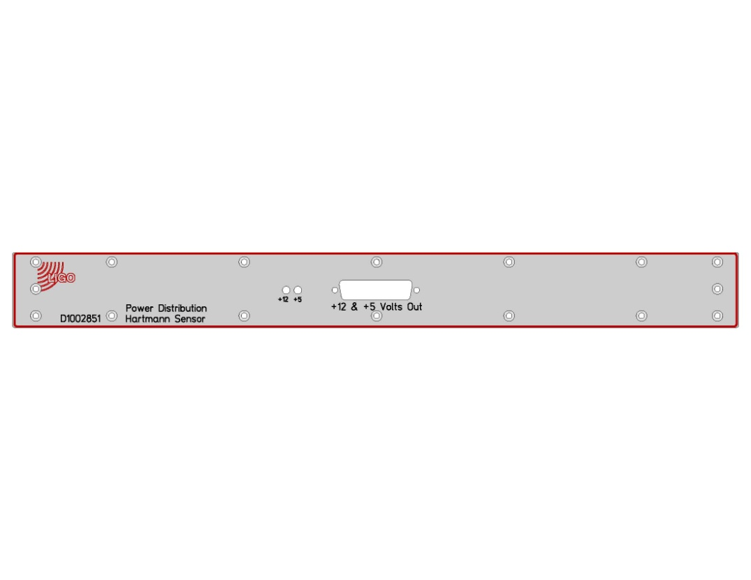
10 ohms
10 ohms
GND
5.5V
13 V

Front Panel of Ring Heater

Setup
A power supply capable of supplying 18 V and 3 Amps is connected to the power connector. Ten ohms is connected between the 12 volt pin and ground and another 10 ohms between the 5 V pin and ground as shown above.

Requirements
With loads attached the output voltage should be 13 V (+/- 0.1)
5.5V (+/- 0.1)
After 1 hour the highest temperature near the regulator should be less than 60 C
With power switched on the +18, +12, and +5 LED should be on

 |  | Measured | Requirement
 | 5 volt output |  | 5.5 +/- 0.1
 | 12 volt output |  | 13 +/- 0.1
 | Temperature |  | <60 C
 | 18V LED |  | On
 | 12V LED |  | On
 | 5V LED |  | On

