|  |  |  |
| --- | --- | --- |
| **AUTHOR(S)** | DATE | Document Change Notice, Release or Approval |
| Jason Oberling, Doug Cook, Dennis Coyne, Eric James | 10 Mar 2014 | see LIGO DCC record Status |

*Instructions on the use of this document:*

*1) Use, and complete, this document on a laptop computer while the work is proceeding. When operating in a cleanroom, use a cleanroom compatible laptop. This procedure must be available at all times during the alignment process. In addition, all of the applicable documents must also be available for reference during the procedure from the laptop computer.*

*2) Use this alignment procedure as a check list for preparation and during the alignment; As each step is completed, enter the name of the person completing the work (or approving or checking the step), as well as the date and any comments or notes. In particular, note any discrepancies or deviations and augment with any missing definition. ALL NOTES MUST BE RECORDED IN THE COMPLETED VERSION OF THIS DOCUMENT (NOT IN OTHER NOTEBOOKS OR FILES). If the additional notes are too cumbersome to include within the body of this completed procedure, then electronically attach them to the completed procedure.*

*3) Once completed, file the document in the LIGO Document Control Center (DCC) as the next highest version of the procedure and add a note that this is a completed/finished procedure.*

*4) File any significant notes or data from the completed procedure in the electronic logbook (such as any deviations); as a minimum note in the electronic logbook that the alignment was completed in accordance with this procedure (cite document number and revision).*

Contents

1 SCOPE 3

2 APPLICABLE DOCUMENTS 3

3 COORDINATE SYSTEMS/REFERENCES 4

3.1 BSC Chamber 4

3.2 Mechanical Test Stand 4

4 PREREQUISITES FOR CARTRIDGE ALIGNMENT 4

5 REQUIRED EQUIPMENT LIST 5

6 PROCEDURE FOR CARTRIDGE ASSEMBLY ALLIGNMENT 5

6.1 Basic approach 8

6.2 Cartridge set-up 9

6.2.1 Check optics table level on the BSC mechanical test stand 9

6.2.2 Approximately align the Cartridge Assembly element with the template. 10

6.3 L1 Beam Splitter (BS) 10

6.3.1 Setup the BS Retro-reflector Assembly 10

6.3.2 Setup SET IIB – AR Side 12

6.3.3 Setup SET1X – HR Side 12

6.3.4 Set the PLX Lateral Transfer Hollow Periscope (LTHP) 12

6.3.5 Set the BS longitudinal position 13

6.3.6 Set the BS horizontal position 13

6.3.7 Coarse Align the BS Yaw 14

6.3.8 Iterate/re-Check 14

6.3.9 Check the BS vertical position 14

6.3.10 Fine Align the BS Yaw 15

6.3.11 Align the BS pitch 15

6.4 Install and align the BS Elliptical Baffle, AR side 16

6.4.1 Set the BS Elliptical Baffle horizontal position 16

6.4.2 Set the BS Elliptical Baffle vertical position 16

6.5 Set up for aligning the BS Elliptical Baffle, HR side 17

6.5.1 Set the Total Station 17

7 ALIGN THE CARTRIDGE ASSEMBLY IN THE BSC CHAMBER (IN SITU) 17

7.1 In Chamber Alignment 17

7.1.1 Level the Optics Table and set its vertical position 17

7.1.2 Set up Equipment for Position Measurements 18

7.1.3 Measure the BS longitudinal position 18

7.1.4 Measure the BS Lateral and Vertical Positions 19

7.1.5 Set up the Total Station, Laser Autocollimator and LTHP 19

7.1.6 Measure BS Pitch & Yaw Errors 20

7.1.7 BS Fine Pitch & Yaw Error Correction 21

8 ALIGN ITM ELLIPTICAL BAFFLE ASSEMBLIES 21

# SCOPE

The scope of this procedure is alignment of the optical elements of the LBSC2 chamber, which includes alignment of the following optical elements:

1. L1 Beam Splitter (BS) (part of the triple suspension assembly, ([D0900431](https://dcc.ligo.org/cgi-bin/private/DocDB/ShowDocument?.submit=Number&docid=d0900431&version=))
2. L1 Beam Splitter Elliptical Baffle assembly ([D1200750](https://dcc.ligo.org/cgi-bin/private/DocDB/ShowDocument?.submit=Number&docid=d1200750&version=)).
3. ITM Elliptical Baffles ([D0900525](https://dcc.ligo.org/cgi-bin/private/DocDB/ShowDocument?.submit=Number&docid=d0900525&version=)). LBSC2 has two of these.

(Note: need to add a monument to the pipe bridge shelf for the BS beam line. Check the visible transmission and reflection of the optic using the Theodolite while on the test stand to better determine whether we will see the targets).

This procedure starts with the preliminary alignment of the optical payload elements of the LBSC2 chamber in the “cartridge assembly” and then proceeds to the alignment of these same optical payload elements within the LBSC2 chamber. The “cartridge assembly” is comprised of the BSC ISI system with all of the payload elements (which are capable of fitting onto the test stand) integrated onto the optics table and the stage 0 structure of the BSC-ISI. The cartridge assembly is integrated and aligned while on the BSC mechanical test stand. The cartridge is then lifted, flown to the chamber and lowered into position onto the BSC support tubes.

This procedure does not cover the procedures for installing assemblies onto the BSC-ISI platform or for balancing and leveling the BSC-ISI optics table; these procedures are defined in separate documentation.

# APPLICABLE DOCUMENTS

Listed below are all of the applicable and referenced documents for the initial alignment procedures. This list gives the latest revisions of the documents; Within the alignment steps, only the document number (and not the revision) is quoted.

|  |  |
| --- | --- |
| **Document No.** | **Document Title** |
| [E0900047](https://dcc.ligo.org/cgi-bin/private/DocDB/ShowDocument?.submit=Number&docid=e0900047&version=) | LIGO Contamination Control Plan |
| [T1000230](https://dcc.ligo.org/cgi-bin/private/DocDB/ShowDocument?.submit=Number&docid=t1000230&version=) | AOS Initial Alignment Requirements Final Design Document |
| [T080307](https://dcc.ligo.org/cgi-bin/private/DocDB/ShowDocument?.submit=Number&docid=T080307&version=) | Initial Alignment System Design Requirements Document |
| [D0900428](https://dcc.ligo.org/cgi-bin/private/DocDB/ShowDocument?docid=1267) | aLIGO Systems, BSC2-L1 Top Level Chamber Assembly |
| [D0900431](https://dcc.ligo.org/cgi-bin/private/DocDB/ShowDocument?.submit=Number&docid=d0900431&version=) | aLIGO SUS BSC2-L1, XYZ Local CS for BS HR |
| [D0900525](https://dcc.ligo.org/cgi-bin/private/DocDB/ShowDocument?.submit=Number&docid=d0900525&version=) | aLIGO SUS BSC2-L1 Local CS for Elliptical Baffle (ITMX, ITMY) |
| [D0900431](https://dcc.ligo.org/cgi-bin/private/DocDB/ShowDocument?.submit=Number&docid=d0900431&version=) | See Sheet 3 for Template Layout, BSC-2 |
| [E1100374](https://dcc.ligo.org/cgi-bin/private/DocDB/ShowDocument?.submit=Number&docid=e1100374&version=) | Survey Data for LLO |
| [T1100318](https://dcc.ligo.org/cgi-bin/private/DocDB/ShowDocument?.submit=Number&docid=t1100318&version=) | Total Station modifications for stabilizing unit when Laser Autocollimator is Attached |
| [D1200076](mailto:https://dcc.ligo.org/cgi-bin/private/DocDB/ShowDocument?docid=78483) | Alignment Monument Layout, LHO Y-End Station, BSC Mechanical Test Stand |
| [T080230](https://dcc.ligo.org/DocDB/0008/T080230/001/T080230-v1.pdf) | Quad Pendulum Structure Pushers |
| [M1100068](https://dcc.ligo.org/cgi-bin/private/DocDB/ShowDocument?docid=57864) | BSC Door Removal and Installation Procedure |
| [E1200485](https://dcc.ligo.org/cgi-bin/private/DocDB/ShowDocument?docid=91446) | AOS IAS - Initial Alignment Document Tree |

# COORDINATE SYSTEMS/REFERENCES

## BSC Chamber

The local BSC chamber coordinate system origin is the point where the horizontal, cylindrical axes of the main access portals meet. The local BSC chamber coordinate system axes are aligned to the local gravity vector. Z is vertical (+Z is up). X and Y are both horizontal and approximately aligned to the global coordinate axes (as defined in [T980044](https://dcc.ligo.org/cgi-bin/private/DocDB/ShowDocument?docid=2366)). The local BSC chamber coordinate system origin is nominally located 1742 mm below the BSC-ISI optics table surface.

## Mechanical Test Stand

The local mechanical test stand coordinate system origin is located 1742 mm below the BSC-ISI optics table surface and centered between the row of mounting holes which interface to the BSC-ISI stage-0 structure (and represent the support tubes installed into the BSC chambers). The local mechanical test stand coordinate system axes are aligned to the local gravity vector. Z is vertical (+Z is up). X and Y are both horizontal and approximately aligned to the global coordinate axes.

# PREREQUISITES FOR CARTRIDGE ALIGNMENT

* The BSC mechanical test stand must be set so that the interface plane with the BSC-ISI stage 0 is horizontal.
* The features of the BSC mechanical test stand which interface to the BSC-ISI platform shall be used to establish a centerline and two offset lines with alignment monuments/references in the floor, as depicted in the [E1100374](https://dcc.ligo.org/cgi-bin/private/DocDB/ShowDocument?.submit=Number&docid=e1100374&version=) (see also ).
* An appropriate clean room should be installed over the test stands.

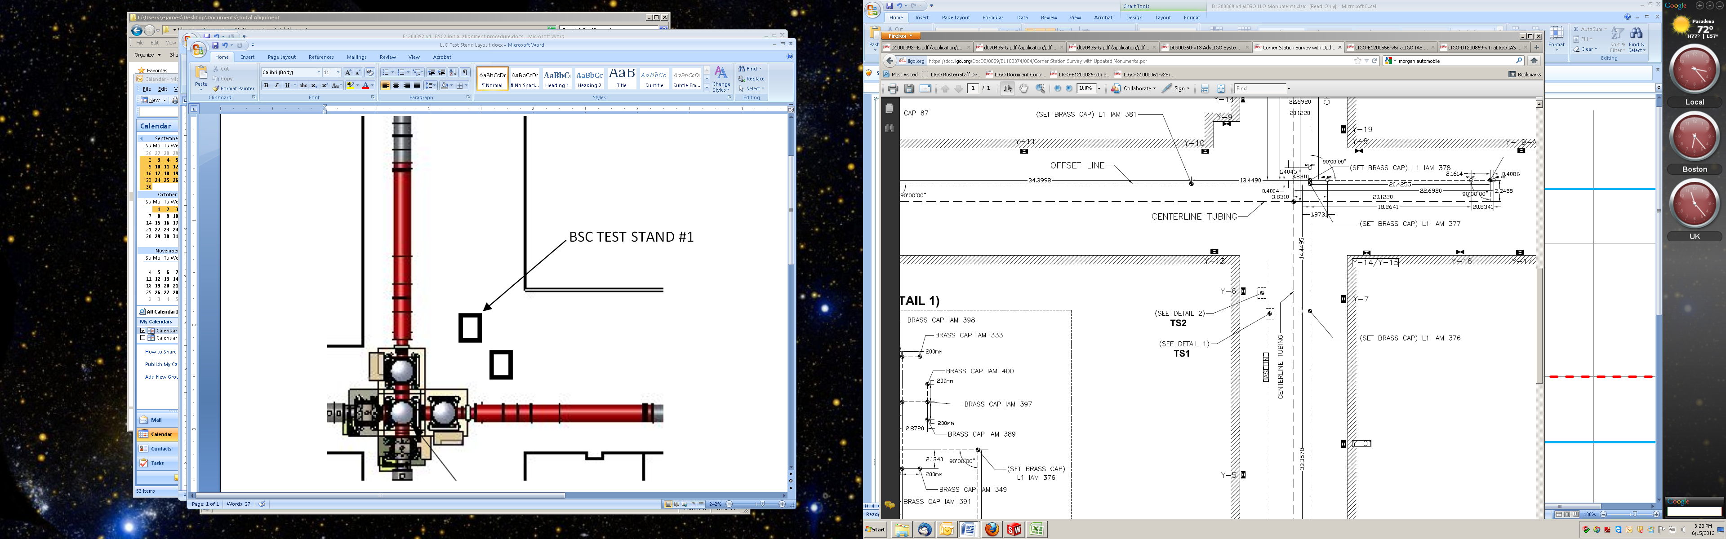

Figure 1: Test Stand location within the Corner Station VEA

* All payload assemblies must be acceptance tested (to the extent possible and planned) prior to integration into the cartridge assembly.
* The BS suspension must be capable of being electronically damped while on the test stand and later when in the chamber.
* All IAS operations on the cartridge assembly are to be made with the BSC ISI in its locked mode. Verify that the ISI is locked.

*completed, approved or checked by:   
date:   
comments (optional):*

# REQUIRED EQUIPMENT LIST

* + Total station (either a Sokkia Set2BII or a Sokkia SetX1 modified per [T1100318](https://dcc.ligo.org/cgi-bin/private/DocDB/ShowDocument?.submit=Number&docid=t1100318&version=)) with tripod stand
  + Laser autocollimator (Newport LDS Vector and LDS1000 controller)
  + Optical level (Sokkia B2o AutoLevel with micrometer option, or equivalent) with tripod stand
  + Precision bubble level
  + Optical Transit Square (Brunson model 75-H) with stand
  + Mechanical locating templates for BS suspension ([D1101048](https://dcc.ligo.org/cgi-bin/private/DocDB/ShowDocument?.submit=Number&docid=d1101048&version=) -9 and -10), cleaned to Class B per [E0900047](https://dcc.ligo.org/cgi-bin/private/DocDB/ShowDocument?.submit=Number&docid=e0900047&version=) and E960022)
  + Precision pushers ([D060052](https://dcc.ligo.org/cgi-bin/private/DocDB/ShowDocument?.submit=Number&docid=d060052&version=), cleaned to Class B per [E0900047](https://dcc.ligo.org/cgi-bin/private/DocDB/ShowDocument?.submit=Number&docid=e0900047&version=) and [E960022](https://dcc.ligo.org/cgi-bin/private/DocDB/ShowDocument?.submit=Number&docid=e960022&version=))
  + Mover assemblies ([D1100018](https://dcc.ligo.org/DocDB/0030/D1100018/002/LIGO-D1100018-v2.pdf), cleaned to Class B per [E0900047](https://dcc.ligo.org/cgi-bin/private/DocDB/ShowDocument?.submit=Number&docid=e0900047&version=) and [E960022](https://dcc.ligo.org/cgi-bin/private/DocDB/ShowDocument?.submit=Number&docid=e960022&version=))
  + Retro reflector assembly ([D1200124](https://dcc.ligo.org/LIGO-D1200124), cleaned to Class B per [E0900047](https://dcc.ligo.org/cgi-bin/private/DocDB/ShowDocument?.submit=Number&docid=e0900047&version=) and [E960022](https://dcc.ligo.org/cgi-bin/private/DocDB/ShowDocument?.submit=Number&docid=e960022&version=))
  + Depth Gauge with plastic probe tip (and sufficient range to measure the distance from the optic to the retro-reflector)
  + BSC table height target (D1101611).
  + Various optical or tripod stands

# PROCEDURE FOR CARTRIDGE ASSEMBLY ALLIGNMENT

Only the BS Optic and the BS AR and HR Elliptical Baffles are aligned while the cartridge assembly is on the test stand.

The LBSC2 cartridge assembly is to be assembled on LLO Mechanical Test Stand #1 (TS1), which is the test stand to the southeast (see [E1100374](https://dcc.ligo.org/cgi-bin/private/DocDB/ShowDocument?.submit=Number&docid=e1100374&version=) and figure 1). The support tubes are oriented in the Y-direction, or north-south direction. The LBSC2 cartridge has been placed on the test stand rotated 90 degrees clockwise from the orientation it will have in LBSC2. The reference monuments for the cartridge assembly on test stand #1 are given in [E1100374](https://dcc.ligo.org/cgi-bin/private/DocDB/ShowDocument?.submit=Number&docid=e1100374&version=) and in Figure 3 for convenience.

The LBSC2 cartridge assembly is depicted in . The major optics assembly integrated into the LBSC2 cartridge is the Beam Splitter, a part of the suspension assembly ([D1000392](https://dcc.ligo.org/cgi-bin/private/DocDB/ShowDocument?docid=9458)). The two Elliptical Baffles ([D0900525](https://dcc.ligo.org/cgi-bin/private/DocDB/ShowDocument?.submit=Number&docid=d0900525&version=)) are not installed on the cartridge assembly while it is on the test stand due to interference with the test stand structure. They will be installed after the cartridge is installed in the chamber. The positions and Lines Of Sight (LOS) for the LBSC2 cartridge assembly alignment are depicted in Figure 3.

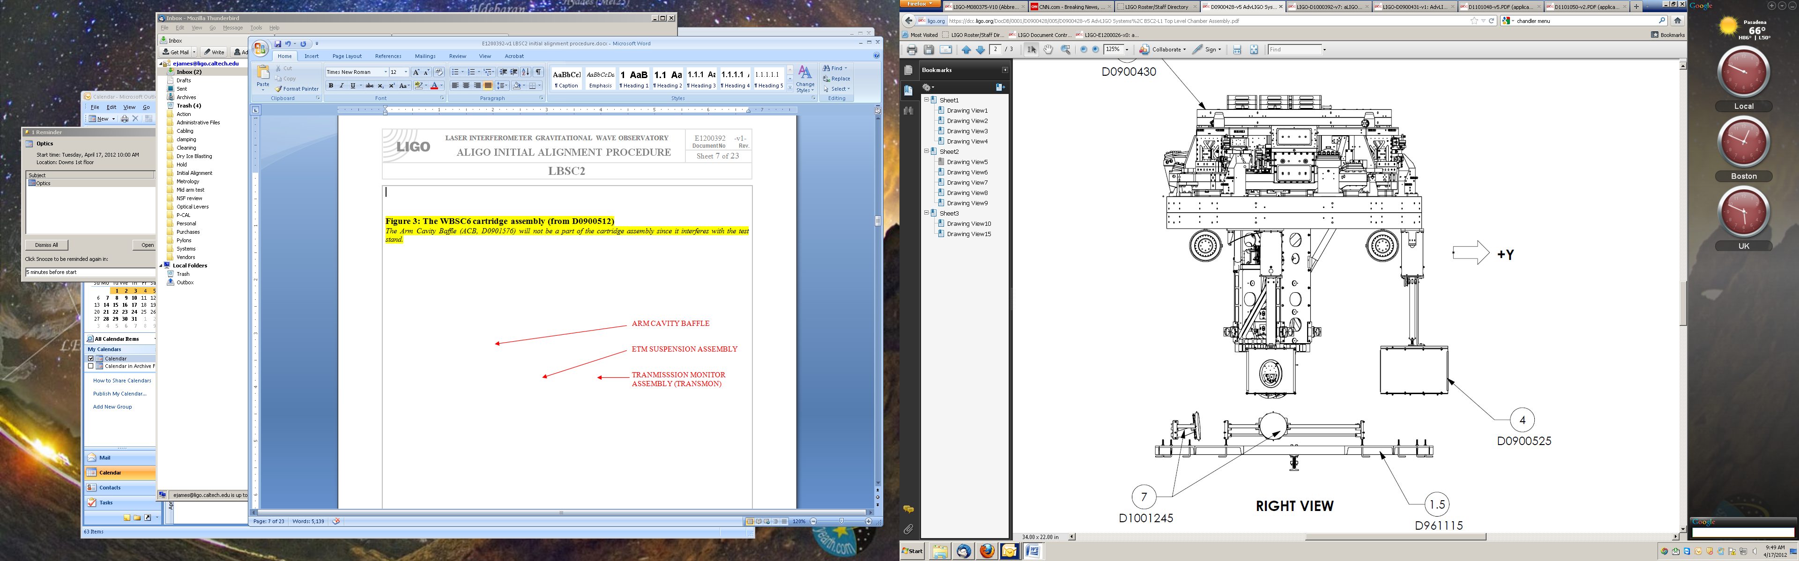

BS SUSPENSION ASSY

ELLIPTICAL BAFFLES

CO2 STEERING MIRRORS

Figure 2: The LBSC2 cartridge assembly (from D0900428)

*The Elliptical Baffles (D0900525) will not be a part of the cartridge assembly as they interfere with the test stand. The CO2 Steering Mirrors (D1101851) are not part of the cartridge assembly.*

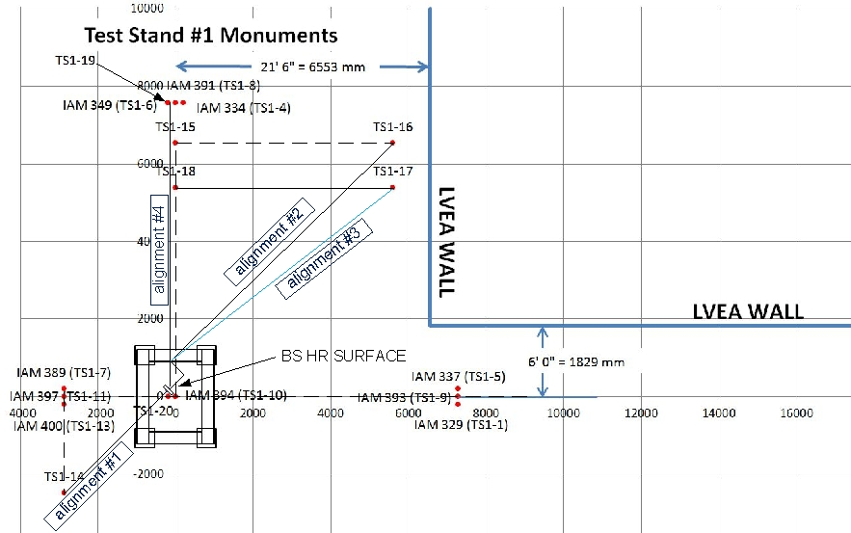

Figure 3: IAS Instrument Positions and Lines Of Sight (LOS) for the LBSC2 Cartridge Assembly Alignment

## Basic approach

Since the HR surface is mostly obscured by the test stand leg, we will align the BS from the AR side which is unobscured. From the same setup we can align the BS Elliptical Baffle, AR side.

Set up SET IIB Theodolite on AR.

In order to position the HR side of the BS Elliptical Baffle, a target is attached to the baffle and the baffle is viewed looking in the +X-direction on the beamline, as shown in Figure 4. The removable target (to be provided by SLC) allows IAS to position the HR BS Elliptical Baffle left/right and up/down so that it is centered on the optic.

Remove and replace First Contact – Baffles should relocate to aligned position.

|  |  |
| --- | --- |
| view in the +X direction, showing the HR face of the BS optic and the HR BS elliptical baffle (without the target) | view in the +X direction, showing the HR face of the BS optic and the HR BS elliptical baffle with a conceptual target (to be provided by SLC) |

Figure : View of the BS in the +X-direction showing the use of the target on the HR BS Elliptical Baffle

At this point the BS optic and both the HR and AR BS Elliptical Baffles have been aligned on the test stand.

## Cartridge set-up

### Check optics table level on the BSC mechanical test stand

Datum: Local gravity

Equipment: Optical level on tall tripod and targets on invar rods suspended from the optics table

Accuracy: ± 100 microrad (0.1 mm differential height)

Procedure:

* Attach 3 invar rods with targets to the table (equal lengths sufficient to be seen by optical level on tripod). Position the rods so that all 3 can be observed from a single optical level position.
* Place optical level on a tall tripod and sight the relative difference in target heights to determine level of optics table.
* Adjust ISI trim/balance mass per [E0900357](https://dcc.ligo.org/cgi-bin/private/DocDB/ShowDocument?.submit=Number&docid=e0900357&version=) (v20, section 1.84)
* Record table level:

|  |  |
| --- | --- |
| ISI Level | 0.1 mm |

### Approximately align the Cartridge Assembly element with the template.

Datum: Bolt holes in optical table.

Equipment: Alignment templates ([D1101048](https://dcc.ligo.org/cgi-bin/private/DocDB/ShowDocument?.submit=Number&docid=d1101048&version=) -9 and -10). Each suspension has two sets of templates. Either set may be used but not both.

Accuracy: Clearance in bolt holes

Procedure:

* Install [D1101048](https://dcc.ligo.org/cgi-bin/private/DocDB/ShowDocument?.submit=Number&docid=d1101048&version=) -9 or -10) template per [D0900431](https://dcc.ligo.org/cgi-bin/private/DocDB/ShowDocument?.submit=Number&docid=d0900431&version=), sheet 3.
* If needed, install precision pushers ([D060052](https://dcc.ligo.org/cgi-bin/private/DocDB/ShowDocument?.submit=Number&docid=d060052&version=)) per [T080230](https://dcc.ligo.org/DocDB/0008/T080230/001/T080230-v1.pdf) adjacent to ETM structures opposite of the templates.
* Push BS structure to contact the templates per [T080230](https://dcc.ligo.org/DocDB/0008/T080230/001/T080230-v1.pdf).
* Lock down suspension structures.
* Remove all templates.

## L1 Beam Splitter (BS)

### Setup the BS Retro-reflector Assembly

Datum: Optical axis of the test mass.

Equipment: Retro-reflector assembly (D1200124), depth gauge

Accuracy: ± 0.2 mm

Procedure:

* Attach the retro-reflector assembly to the structure in front of the BS AR face.
* Use the depth gauge to measure the offset distance from the retro-reflector assembly reference plate (square plate behind corner cube retro-reflector) to the BS HR face. Do this on the right and left side of the plate and average two values to get the offset distance.

Take care to clean the depth gauge, especially the contact feature. Contact the optic either on the outer perimeter of the HR face where there is no First Contact ™ film or in the interior but only on the First Contact™ film and be sure to contact very gently. 

* Record the Offset (Y-distance).

|  |  |
| --- | --- |
| Offset distance from the BS HR face to the Reflecting Plane of the Retro-reflector | 62.4 mm |

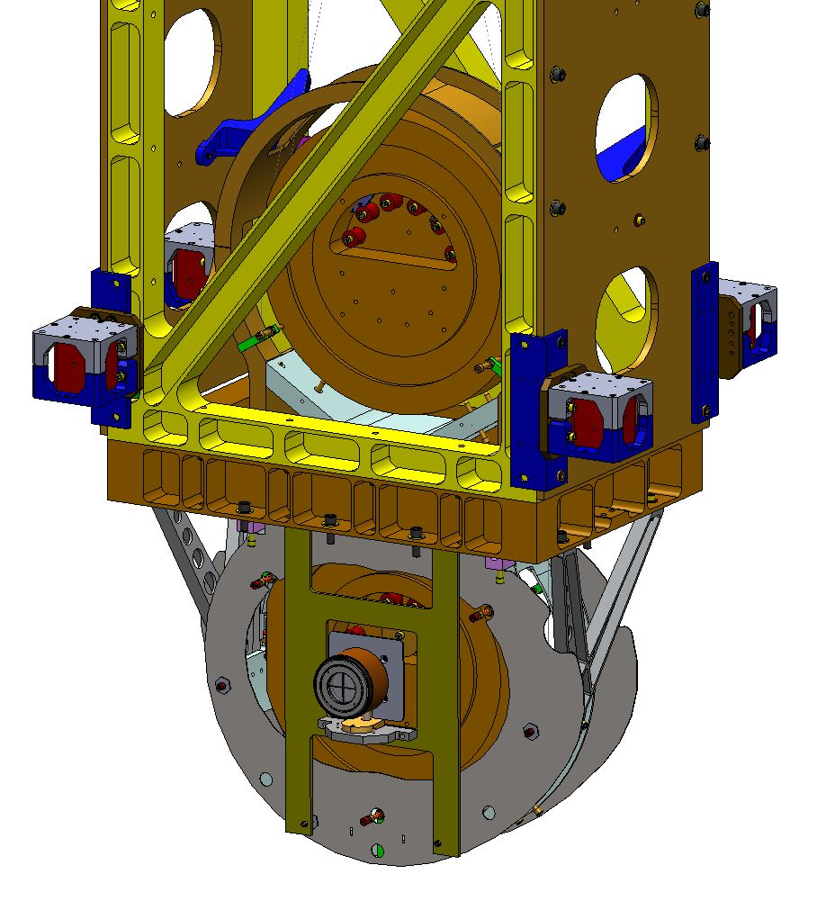

Figure 5: Retro-reflector Assembly attached to BS Structure over the BS Elliptical Baffle

### Setup SET IIB – AR Side

Datum: Monument TS1-14, ISI table surface as referenced by height target.

Equipment: Total station, height target (D1101611).

Accuracy: ±1 mm, ±10 microradians

Procedure:

* Set the total station over TS1-14 at beam height (1016 mm above the floor)
* Set the total station to back sight from monument TS1-21
* Attach the height target to the optics table near the table edge toward the total station
* Yaw the total station to sight the height target and adjust total station height to match height target. The total station is now at the height of the BS (1742 mm rod and scale)
* Yaw the SET IIB total station 45° 5' 46". The total station is now on the beam line towards the center of the AR surface of the BS

### Setup SET1X – HR Side

Datum: Monument TS1-16, ISI table surface as referenced by height target.

Equipment: Total station, height target (D1101611).

Accuracy: ±1 mm, ±10 microradians

Procedure:

* Set the total station over TS1-16 at beam height (1016 mm above the floor).
* Set the total station to back sight from monument TS1-15.
* Attach the height target to the optics table near the table edge toward the total station.
* Yaw the total station to sight the height target and adjust total station height to match height target. The total station is now at the height of the BS (1742 mm rod and scale).
* Yaw the SET1X total station -44° 58' 26" (SET1X reading of 315° 1’ 34”). The total station is now on the beam line towards the center of the HR surface of the BS (via the LTHP).

### Set the PLX Lateral Transfer Hollow Periscope (LTHP)

Datum: Optical axis as established by the total station.

Equipment: Newport laser autocollimator mounted on HR Total station, PLX LTHP mounted on a tripod.

Accuracy: ±1 mm, ±10 microradians

Procedure:

* Set the LTHP at approximately the same height as the laser autocollimator mounted on the total station, in approximately the position shown in Figure 3
* Adjust the LTHP position, both laterally and vertically, until the laser autocollimator beam is centered in the input aperture
* Yaw the LTHP until the beam cleanly exits and is incident on the BS
* Repeat the above two steps until the laser autocollimator beam is both centered in the LTHP and passes through cleanly with no clipping

### Set the BS longitudinal position

Datum: Optical axis established with the Total Station

Equipment: Total station

Accuracy: ±3 mm

Procedure:

* Use total station EDM to set position to 3728.2 mm (remember to account for the offset distance from the retro-reflector to the optic AR face)
* Record position

|  |  |  |  |
| --- | --- | --- | --- |
|  | Trial 1 | Trial 2 | Trial 3 |
| Retro-reflector to AR face offset | 3667.0 mm | 3666.0 mm | 3665 mm |
| EDM Distance | 62.4 mm | 62.4 mm | 61.75 mm |
| Sum = BS HR longitudinal distance | 3729.4 mm | 3728.4 mm | 3726.75 mm |

### Set the BS horizontal position

Datum: Optical axis as established by the total station.

Equipment: total station, pusher assembly (D060052).

Accuracy: ± 1mm

Procedure:

* With the Total Station at zero pitch angle, sight the left edge of the optic. Record the yaw angle (this is the yaw angle as measured from the line perpendicular to the center of the AR face of the BS set in step 6.3.2 above).
* Sight the right edge of the optic. Record the yaw angle.
* Calculate the center error distance (formula in table below)
* If necessary, use the pusher assemblies to shift the suspension structure until the required accuracy is met

|  |  |  |  |
| --- | --- | --- | --- |
|  | Trial 1 | Trial 2 | Trial 3 |
| Left optic edge  (-A) | 49.887 mrad | 49.611 mrad | 49.403 mrad |
| Right optic edge (+B) | 49.194 mrad | 49.538 mrad | 49.688 mrad |
| Center error angle  E = (A+B)/2 | 346 microrad | 36.7 microrad | -142.2 microrad |
| Center error distance  L * E | +1.3 mm | +0.1 mm | -0.5 mm |

### Coarse Align the BS Yaw

Datum: Optical axis as established by the SET1X total station.

Equipment: Laser autocollimator mounted on top of the SET1X total station

Accuracy: ±1 milliradians goal

Procedure:

* Use the laser autocollimator to measure the BS optic yaw error
* If necessary, use the pusher assemblies to reduce the yaw error to as close to zero as possible (< 1 mrad)
* Reiterate until the required accuracy is met
* Record residual yaw error

|  |  |
| --- | --- |
| BS yaw error | 675 microrad CCW |

### Iterate/re-Check

Datum: Local gravity, optical axis as established by the total station.

Equipment: Optical level on tall tripod and targets on invar rods suspended from the optics table, total station

Accuracy:

levelness: ±100 microrad (0.1 mm differential height)

lateral position: ±1 mm

longitudinal position: ±3mm

yaw: ±160 microradians

Procedure:

* Re-check table level
* Re-check the lateral & longitudinal position and yaw and iterate until all are within required accuracy.
* Remove the retro-reflector and mount assembly from the BS.

Once this step has been completed, the BS “frame” has been set; All further adjustments to the BS are on the suspension chains.

### Check the BS vertical position

Datum: Optical axis as established by the total station.

Equipment: SETIIB Total Station

Accuracy: ± 1mm

* With the Total Station at zero yaw angle, sight the bottom edge of the optic. Record the pitch angle.
* Sight the top edge of the optic. Record the pitch angle.
* The optic height was set during the SUS assembly and should be correct. However, if it is out of tolerance, then use the SUS procedure in E#?, (shim blades), add section ?, to adjust the test mass height until it is within the required accuracy.

|  |  |  |  |
| --- | --- | --- | --- |
|  | Trial 1 | Trial 2 | Trial 3 |
| Bottom optic edge  (-A) | 49.232 mrad | 49.548 mrad | mrad |
| Top optic edge (+B) | 49.251 mrad | 48.976 mrad | mrad |
| Center error angle  E = [(A+B)/2] – 0.213 | 9.6 microrad | -286.2 microrad | microrad |
| Center error distance  L * E | +0.4 mm | -1.1 mm | mm |

### Fine Align the BS Yaw

Datum: Optical axis as established by the total station.

Equipment: Laser autocollimator

Accuracy: ±100 microradians (limited by air buffeting in the test stand/cleanroom environment)

Procedure:

* Measure the BS yaw with the laser autocollimator
* Use the suspension top blade adjusters to further reduce the residual yaw error, using the SUS procedures, until the required accuracy is met
* Record the yaw error

|  |  |  |  |
| --- | --- | --- | --- |
|  | Trial 1 | Trial 2 | Trial 3 |
| BS yaw error | 0.675 millirad CCW | 0.025 millirad CW | millirad |

### Align the BS pitch

Datum: Optical axis as established by the SET 1X total station.

Equipment: SET 1X total station, PLX LTHP

Accuracy: ±100 microradians (limited by air buffeting in the test stand/cleanroom environment)

Procedure:

* Set the total station pitch to 213 microradians (44 arcsec or 0° 0’ 44”) up. Using the LAC, measure the pitch error

|  |  |
| --- | --- |
| Initial BS pitch error | +545 microradians |

* If the pitch error is < 100 microradians, record the error
* If > 100 microradians, then adjust the upper intermediate mass pitch balance per SUS procedures

|  |  |
| --- | --- |
| Final BS pitch error | -20 microradians |

## Install and align the BS Elliptical Baffle, AR side

Note: Also see [E1200556-v7](https://dcc.ligo.org/DocDB/0091/E1200556/007/E1200556-v7%20aligo%20IAS%20alignment%20solutions.pdf) for further explanations.

### Set the BS Elliptical Baffle horizontal position

This procedure is nearly identical to the procedure used to set the BS alignment and uses the same SET IIB Total Station setup. However, the baffle is moved with respect to the BS suspension structure. The BS suspension structure itself is not moved.

Datum: Optical axis as established by the total station.

Equipment: Total Station

Accuracy: ± 0.5mm

Procedure:

* Sight on the right hand edge of the baffle aperture. Record the yaw angle
* Sight on the left-hand edge of the baffle aperture. Record the yaw angle
* Adjust the horizontal position so that the left and right-hand yaw angles are equal

|  |  |  |  |
| --- | --- | --- | --- |
|  | Trial 1 | Trial 2 | Trial 3 |
| Right yaw angle | 59.26 mrad | mrad | mrad |
| Left yaw angle | 58.84 mrad | mrad | mrad |

### Set the BS Elliptical Baffle vertical position

This procedure is nearly identical to the procedure used to set the BS vertical position. However, the baffle is moved with respect to the BS suspension structure. The BS suspension structure itself is not moved.

Datum: Optical axis as established by the total station.

Equipment: Total Station

Accuracy: ± 0.5mm

Procedure:

* With the Total Station at zero yaw angle, sight the bottom edge of the baffle opening. Record the pitch angle
* Sight the top edge of the baffle opening. Record the pitch angle
* Adjust vertical position to the correct readings

|  |  |  |  |
| --- | --- | --- | --- |
|  | Trial 1 | Trial 2 | Trial 3 |
| Bottom pitch angle | 30.84 mrad | mrad | mrad |
| Top pitch angle | 30.85 mrad | mrad | mrad |

## Set up for aligning the BS Elliptical Baffle, HR side

### Set the Total Station

Datum: Monument TS1-19, TS1-20, (TS1-19 shares monument TS1-6 with 183.9 mm separation in the -X direction), ISI table surface as referenced by height target (1742 mm).

Equipment: SET 1X total station, height target (D1101611) (ref 1742 mm).

Accuracy: ±1 mm, ±10 microradians

Procedure:

* Attach the height target to the optics table near the table edge toward the total station.
* Set the total station over TS1-19.
* Yaw the total station to sight the height target and adjust total station height to match height target. The total station is now at the height of the BS.
* Attach the HR baffle alignment target to baffle.
* Using the total station back sight to TS1-20.
* Adjust the baffle to place the HR baffle crosshairs in line with the total station cross hairs.

# ALIGN THE CARTRIDGE ASSEMBLY IN THE BSC CHAMBER (IN SITU)

Once in the chamber, IAS must align:

* the BS Optic in {x,y,z, yaw} by moving the entire cartridge assembly with HEPI as a rigid body
* the BS Optic in pitch, by adjusting the suspension
* the ITMy Elliptical Baffle
* the ITMx Elliptical Baffle

but not the BS AR & HR Elliptical Baffles, since these baffles were properly located relative to the BS optic on the test stand.

## In Chamber Alignment

### Level the Optics Table and set its vertical position

Datum: Local gravity, BSC-ISI capacitive position sensors

Equipment: Optical Level, 3 metering rods, BSC-ISI capacitive position sensors.

Accuracy: 100 microradians (0.1 mm differential height)

Procedure:

* Make sure all payload and balance/ballast weight is on the BSC-ISI Assembly
* Attach 3 metering rods onto the Optics Table so that all 3 can be viewed from a single Optical Level position, on a tall tripod, through the open BSC door.
* Check the Optics Table levelness optically before unlocking BSC-ISI.
* Check the height of the Optics Table by referencing elevation mark TBD with the Optical Level
* If needed, adjust the table to be level using HEPI static adjustment per procedure [E040011](https://dcc.ligo.org/cgi-bin/private/DocDB/ShowDocument?docid=20879), “HEPI Assembly and Installation Procedures”
* Unlock the BSC-ISI and compare the capacitive position sensors offset values to the offsets measured on the cartridge test stand. If necessary, adjust the balance mass to get the same capacitive position sensor offsets as achieved on the test stand.
* Confirm the Optics Table levelness (again) with the Optical Level

### Set up Equipment for Position Measurements

Datum: Monument AM506

Equipment: SET1X total station

Accuracy: ±1 mm, ±10 microradians

Procedure:

* Set up the Total Station over monument AM506
* Adjust the Total Station height to be -83.1 mm (global coordinate system) using elevation mark Y-14/15. This puts the total station at the height of the BS
* Back sight the total station on monument IAM 379 and zero the yaw reference
* Yaw -89° 58’ 39” (total station reading of 270° 1’ 21”)
* Pitch the total station up by 0° 0’ 55” (total station reading of 89° 59’ 5”) to point at the center of the BS

### Measure the BS longitudinal position

Datum: Optical axis established with the Total Station

Equipment: Total station, retro-reflector

Accuracy: ±3 mm

Procedure:

* Install the retro-reflector mounted at 45 degrees to the BS optic, facing in the -X direction
* Measure the offset distance from the retro-reflector to the BS HR face using a depth gauge
* Use total station EDM and HEPI to set position to 1655.5 mm (remember to account for the offset distance from the retro-reflector to the optic HR face)
* Record position

|  |  |  |  |
| --- | --- | --- | --- |
|  | Trial 1 | Trial 2 | Trial 3 |
| Retroreflector to HR face offset | 68.5 mm | 68.5 mm | mm |
| EDM Distance | 1580.7 mm | 1586.5 mm | mm |
| Sum = BS HR longitudinal distance | 1649.2 mm | 1655.0 mm | mm |

### Measure the BS Lateral and Vertical Positions

Datum: Monument AM506

Equipment: Total Station, Target attached to BS HR elliptical baffle

Accuracy: ±1 mm

Procedure:

* Mount the BS elliptical baffle target to the BS HR elliptical baffle
* Site on the target fixed to the BS Elliptical Baffle.
* Use HEPI to minimize the errors until the required accuracy is met
* Record the horizontal and vertical errors, converted from the angle measurement given by the total station:

|  |  |
| --- | --- |
| BS horizontal error | +0.89 mm |
| BS vertical error | -0.6 mm |

### Set up the Total Station, Laser Autocollimator and LTHP

Datum:

1. Monument AM507
2. Elevation mark Y-14/15

Equipment: Total Station; Newport Electronic Visible Laser Autocollimator (LAC); 8” diameter Flat Mirror on a Newport Gimbal Mount and Tripod, Lateral Transfer Hollow Periscope (LTHP).

Accuracy: ±1 mm, ±40 microradians rss, alignment reference transfer (see [T1000230](https://dcc.ligo.org/cgi-bin/private/DocDB/ShowDocument?docid=11150)-v6, section 17)

Procedure:

* Remove the spool between LBSC2 and LHAM3.
* Set the LTHP on its stand so that it is approximately normal to the BS and positioned so that one line of site can see the BS surface and the other can see out the BSC door. See .
* Set the Total Station over monument AM507
* Adjust the Total Station height to be -236.1 mm (global coordinate system) using elevation mark Y-14/15. This puts the LAC at the height of the BS
* Setup the large Flat Mirror with gimbal mount/tripod with an unobstructed view of, and a few meters from, the Total Station/LAC
* Co-boresight the Total Station and LAC with the Flat Mirror
* Back sight the total station on monument
* Yaw the Total Station precisely -44° 58' 26" (total station reading of 315° 1’ 34”).
* Pitch the total station up by 0° 0’ 44” (total station reading of 89° 59’ 16”); the Total Station is now pointing along a vector which is normal to the beam splitter and offset from the vertical center by 400 mm to account for the LTHP

|  |  |
| --- | --- |
|  |  |

Figure : Drawing showing equipment setup for BS pitch/yaw alignments

* Align the LTHP as done previously in step 6.3.4 so that the input beam is collinear with the Total Station (see Figure 7).

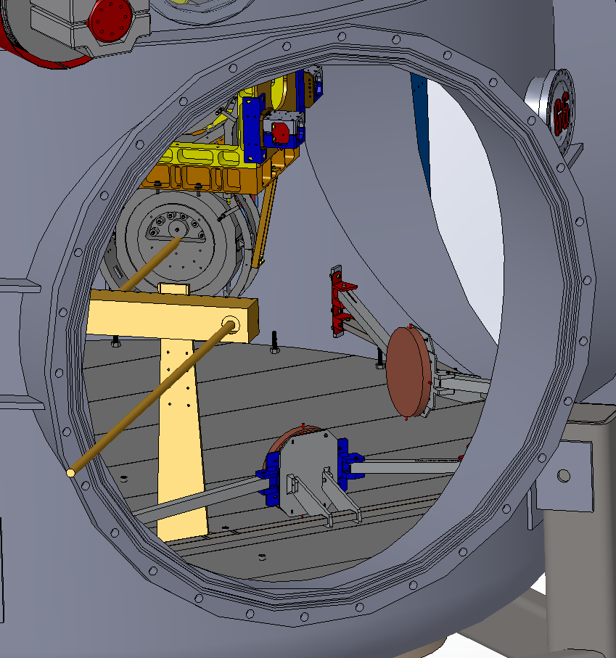

Figure : Conceptual drawing showing aligned LTHP

### Measure BS Pitch & Yaw Errors

Datum: Optical axis as established by the total station.

Equipment: Newport Electronic, Visible Laser Autocollimator (LAC)

Accuracy:

Pitch: ±55 microradians

Yaw: ±190 microradians

Procedure:

* Insure that the optics and masses, of the main suspension chain, are free (not ‘clamped’ or on the mechanical stops or earthquake stops)
* Engage damping controls for the BS suspension
* Use the LAC to measure the BS optic pitch and yaw error angles. All personnel should exit the chamber, purge air flow should be off or minimized, and electronic damping should be active for the suspension. If necessary, use a low pass filtering amplifier and display the pitch and yaw on an oscilloscope with trace persistence and cursors to get the average angles
* If the yaw error is > than the allowed error, then use HEPI (per procedure [E040011](https://dcc.ligo.org/cgi-bin/private/DocDB/ShowDocument?docid=20879), “HEPI Assembly and Installation Procedures”) to adjust the BSC-ISI yaw angle.
* If the pitch error is > than the allowed error, then use the SUS procedure ([E1000686](https://dcc.ligo.org/cgi-bin/private/DocDB/ShowDocument?.submit=Number&docid=e1000686&version=), section 7.1, “BS Assembly and Alignment Procedure”) to adjust the pitch error.
* Record the pitch and yaw errors:

|  |  |  |  |
| --- | --- | --- | --- |
|  | Trial 1 | Trial 2 | Trial 3 |
| Yaw error | +800 microrad | -25 microrad | microrad |
| Pitch error | 630 microrad CCW | 162 microrad CW | microrad |

### BS Fine Pitch & Yaw Error Correction

Datum: Monument AM507

Equipment: BS Suspension actuation (BOSEMs), Newport Electronic Visible Laser Autocollimator

Accuracy: ±10 microradians goal

Procedure:

* Use the Laser Autocollimator to measure the BS optic pitch and yaw angles. All personnel should exit the chamber, purge air flow should be off or minimized, and electronic damping should be active for the suspension. If necessary, use a low pass filtering amplifier and display the pitch and yaw on an oscilloscope with trace persistence and cursors to get the average angles
* Use the BS Suspension controls interface to set pitch and yaw bias values to correct the residual errors
* Record the pitch and yaw bias values:

|  |  |
| --- | --- |
| Pitch bias | counts |
| Yaw bias | counts |

*Note: Did not align with bias values*

# ALIGN ITM ELLIPTICAL BAFFLE ASSEMBLIES

Datums: Optical axis as established by the total station

Equipment: Total station, pusher assembly ([D060052](https://dcc.ligo.org/DocDB/0017/D060052/000/D060052-A.pdf)), mover assembly ([D1100018](https://dcc.ligo.org/DocDB/0030/D1100018/002/LIGO-D1100018-v2.pdf)).

Accuracy: ±7mm

Procedure:

* Install and suspend the Elliptical Baffle from stage-0 of the ISI using procedure [E1101021](https://dcc.ligo.org/cgi-bin/private/DocDB/ShowDocument?docid=73486), “AOS SLC ITM Elliptical Baffle Installation Procedure”.
* Install front and rear targets.
* Set a SET1X total station over monument AM506 as done in step 7.1.2
* Check alignment by using the Total Station to sight on front and rear targets.
* If vertical positional error is < 7mm, then proceed to next step. Otherwise, reposition by adjusting vertical threads in suspension rod.
* If pitch angle error is <7mm (relative displacement between front and rear targets) adjust counter weights to correct error.
* If yaw angle error is <7mm (relative displacement between front and rear targets) use pusher assembly ([D060052](https://dcc.ligo.org/DocDB/0017/D060052/000/D060052-A.pdf)), mover assembly ([D1100018](https://dcc.ligo.org/DocDB/0030/D1100018/002/LIGO-D1100018-v2.pdf)) to rotate baffle suspension to correct error.