IMG_0170 - Mechanical room main input panel - where CTs would have to be placed
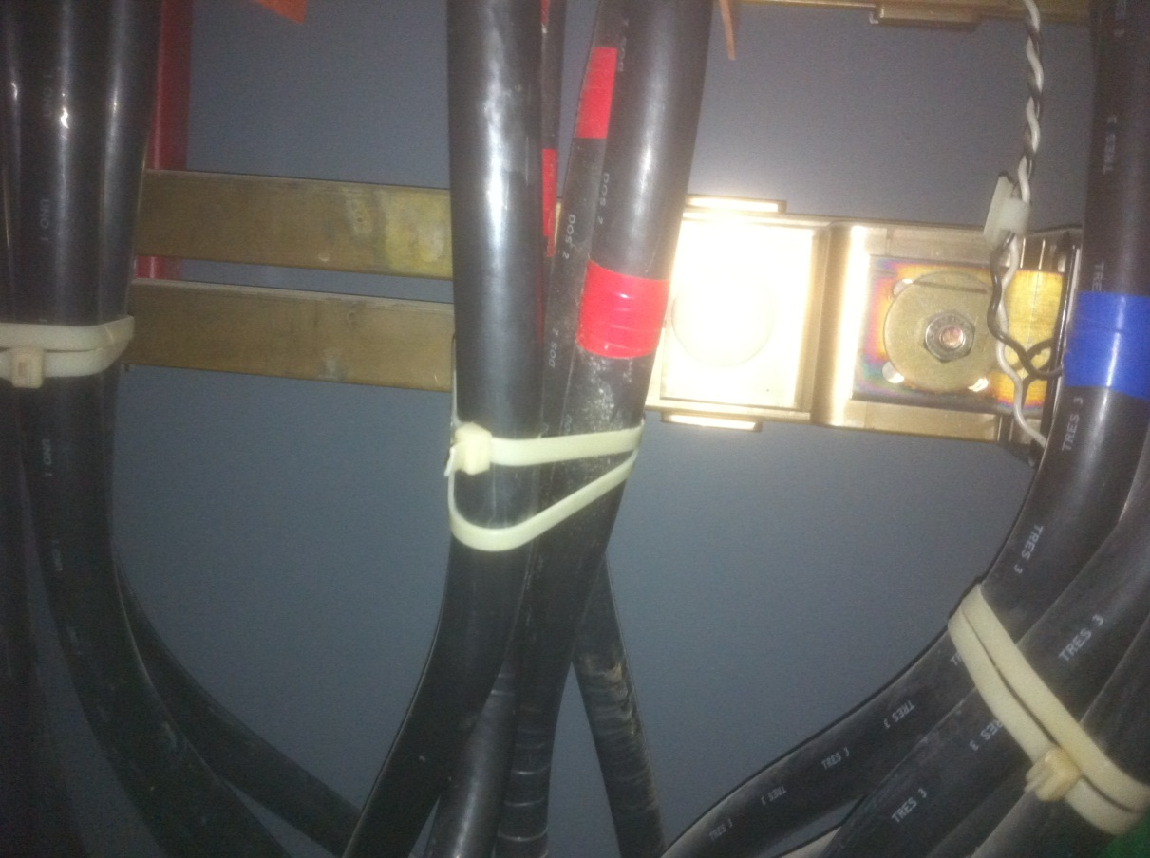

IMG_0171 - Mechanical room main input panel front
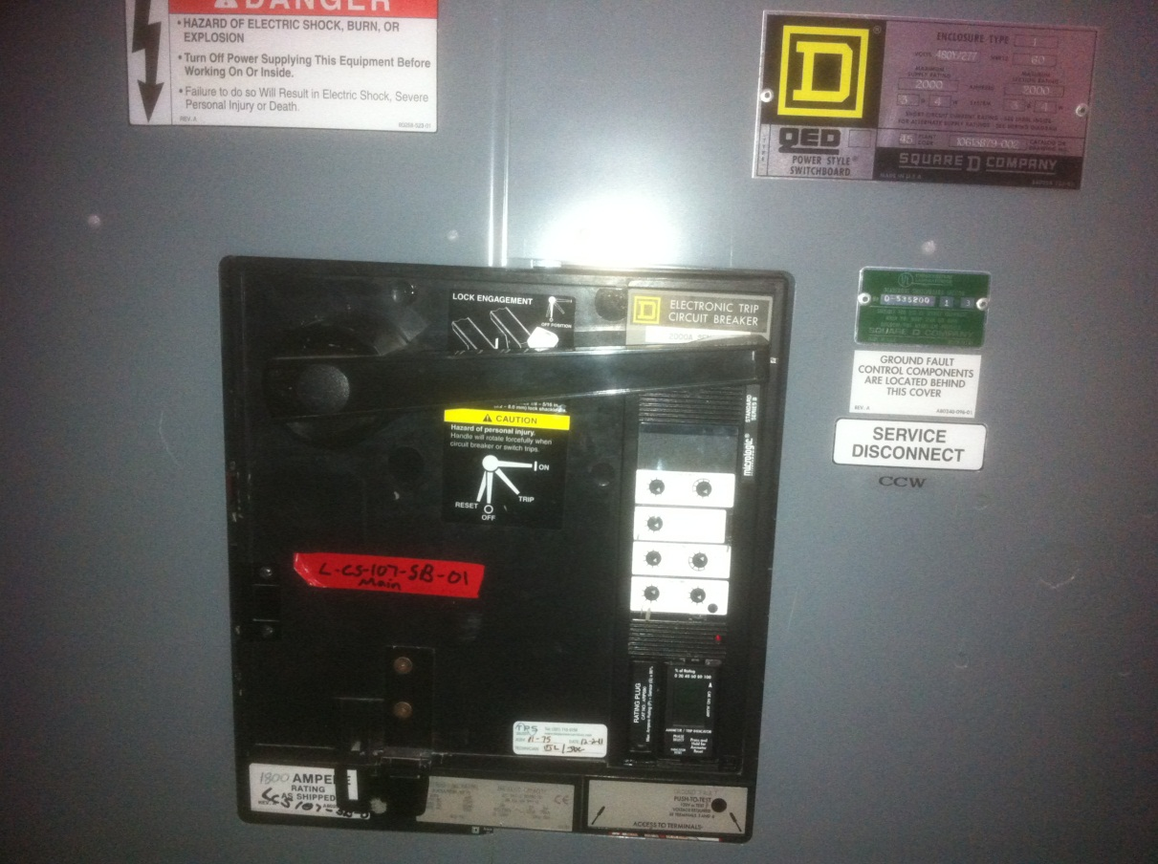

IMG_0172 - Mechanical room main panel - Square D meter that we don't know much about (shot 1)
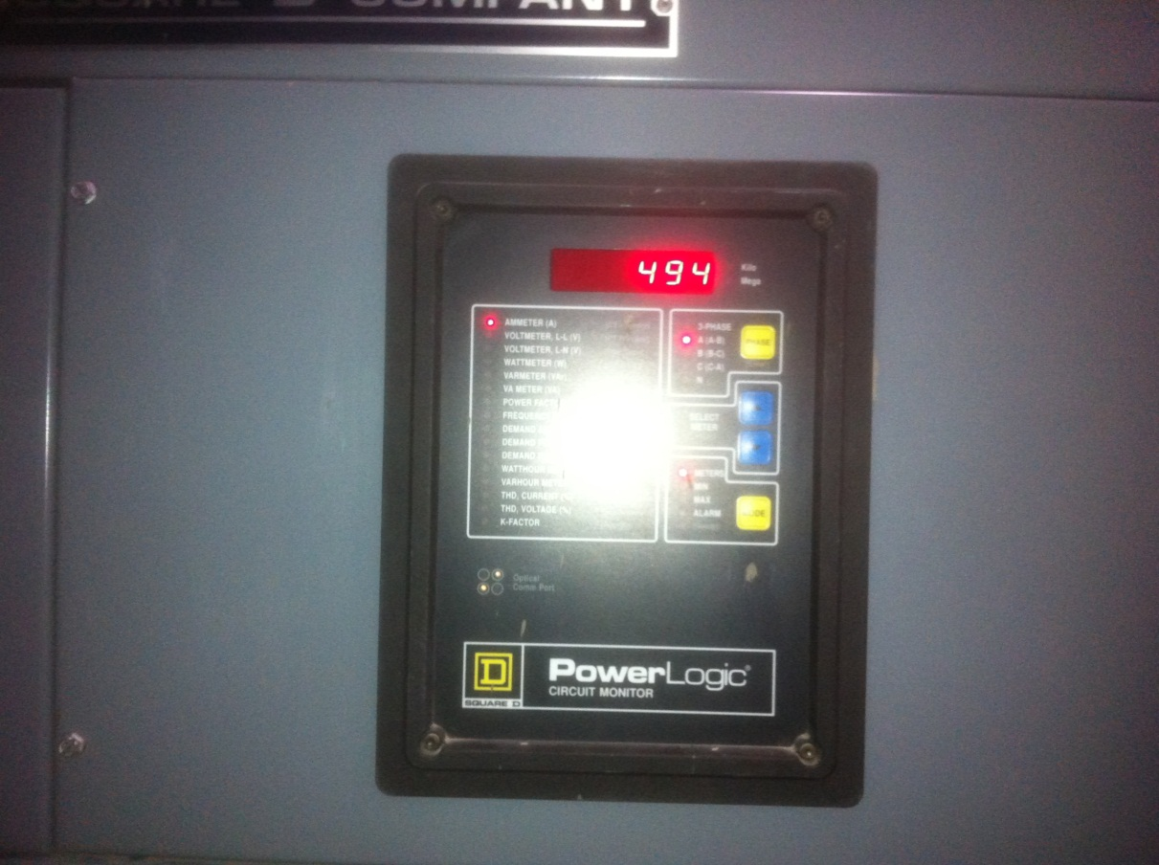

IMG_0173 - Mechanical room main panel - Square D meter that we don't know much about (shot 2)
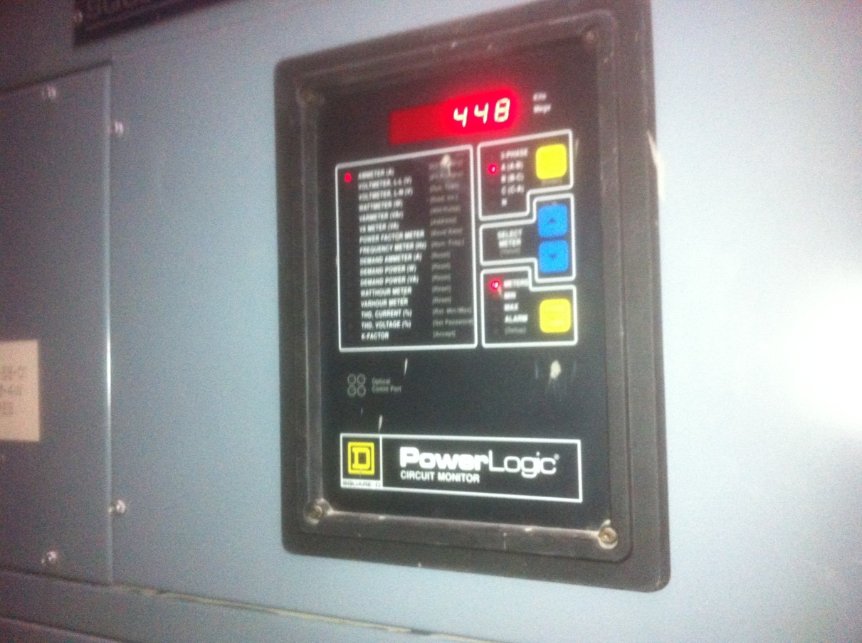
IMG_0174 - Mechanical room secondary panel - where smaller CTs would have to be placed
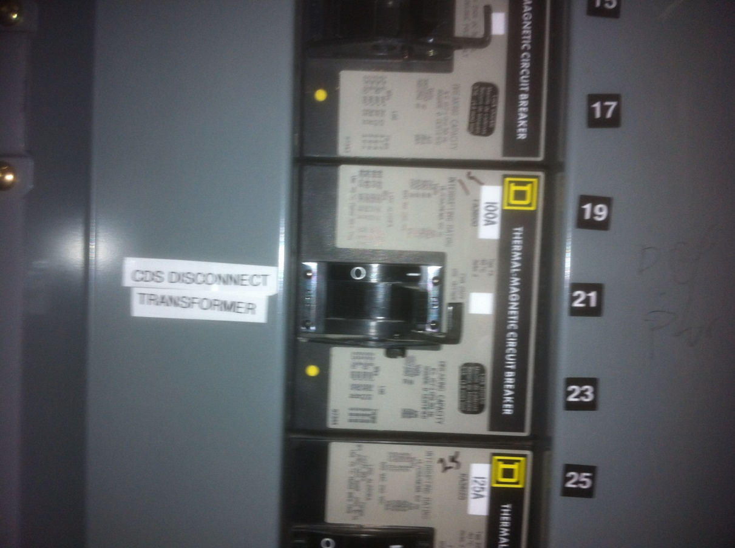

Photo 1 - Upper part of panel where CT’s would need to go
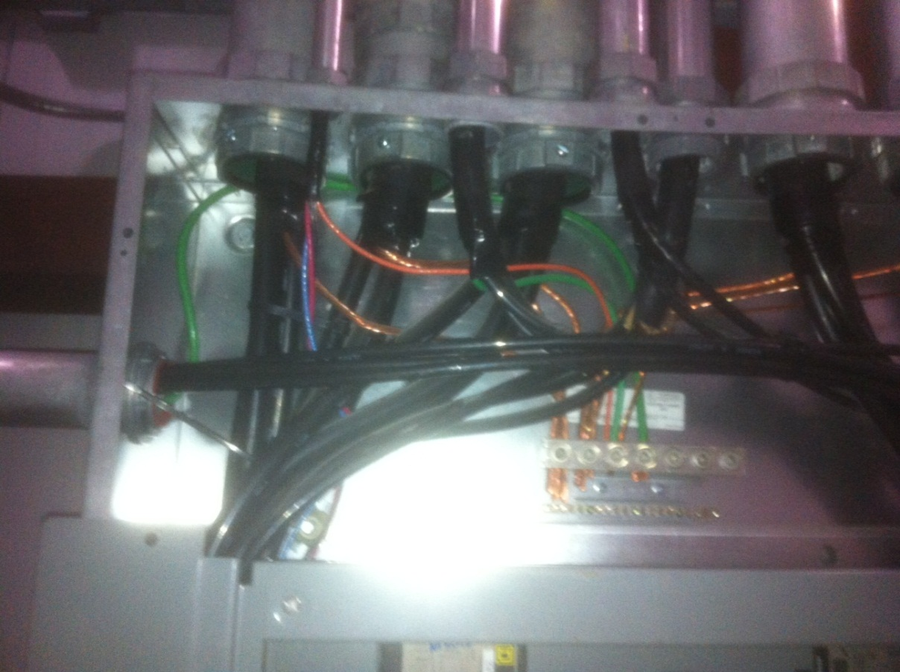

IMG_0175 - West End Station - 800A Service panel (shot 1)
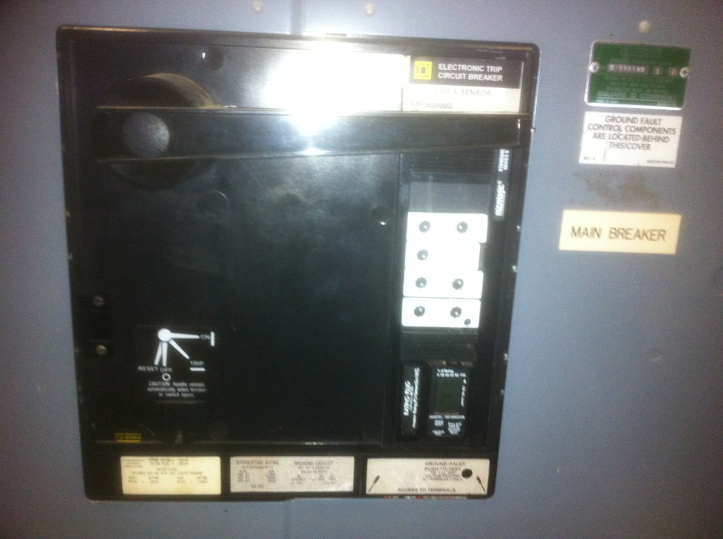

IMG_0176 - West End Station - 800A Service panel (shot 2)
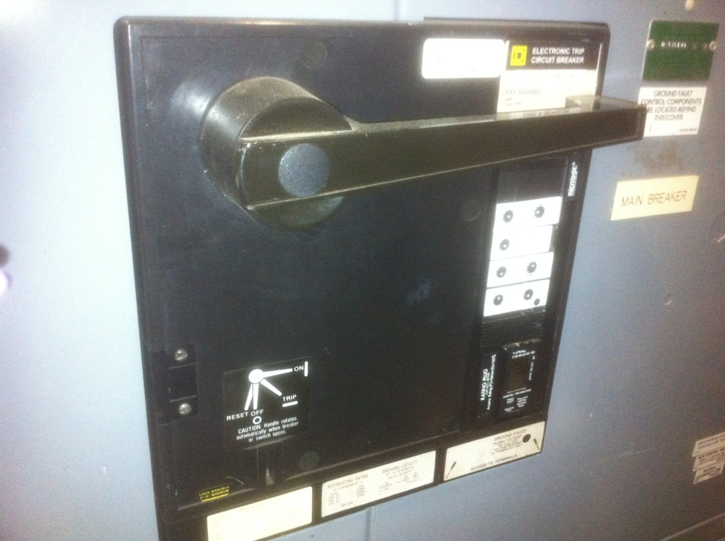

Photo 2 - Lower part of X-End panel where CT’s (800:5) tie into CT’s (5:0.1) exist – 800:5 shown
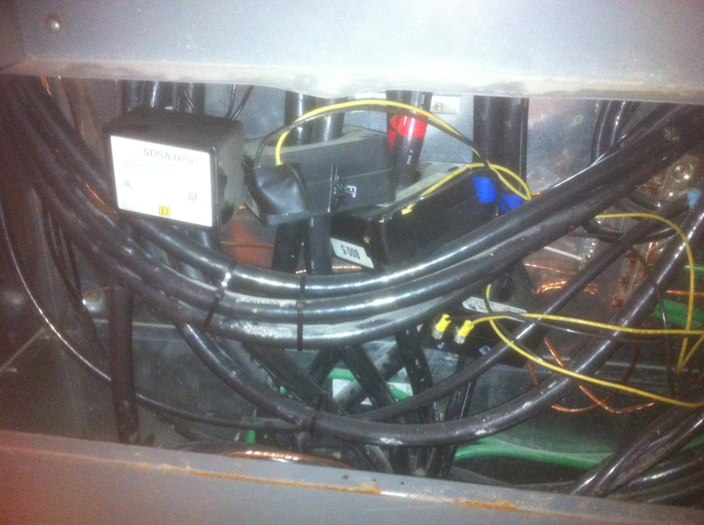

Photo 3 - Lower part of X-End panel where CT’s (800:5) tie into CT’s (5:0.1) exist – 5:0.1 shown
