LIGO Laboratory / LIGO Scientific Collaboration

LIGO-T1200266-v3 LIGO May 21, 2012

Ground Loop Hunting on HXTS Suspensions at LLO

Kate Gushwa
Nichole Washington

Distribution of this document:
LIGO Scientific Collaboration

This is an internal working note
of the LIGO Laboratory.

California Institute of Technology  LIGO Project – MS 18-34  1200 E. California Blvd.  Pasadena, CA 91125  Phone (626) 395-2129  Fax (626) 304-9834  E-mail: info@ligo.caltech.edu | Massachusetts Institute of Technology  LIGO Project – NW22-295  185 Albany St  Cambridge, MA 02139  Phone (617) 253-4824  Fax (617) 253-7014  E-mail: info@ligo.mit.edu
LIGO Hanford Observatory  P.O. Box 159  Richland WA 99352  Phone 509-372-8106  Fax 509-372-8137 | LIGO Livingston Observatory  P.O. Box 940  Livingston, LA 70754  Phone 225-686-3100  Fax 225-686-7189
http://www.ligo.caltech.edu/

Introduction
Ground loops attributed to in-vacuum cables were reported on HAM2 suspensions at Livingston in April 2012. In May, all remaining cabled triple suspensions at Livingston were inspected to determine the prevalence and source of ground loops. The main focus of the investigation was the Teflon insulated LIGO-D1000234 “quadrapuss” cables, and the likelihood of different routing methods shorting to ground.
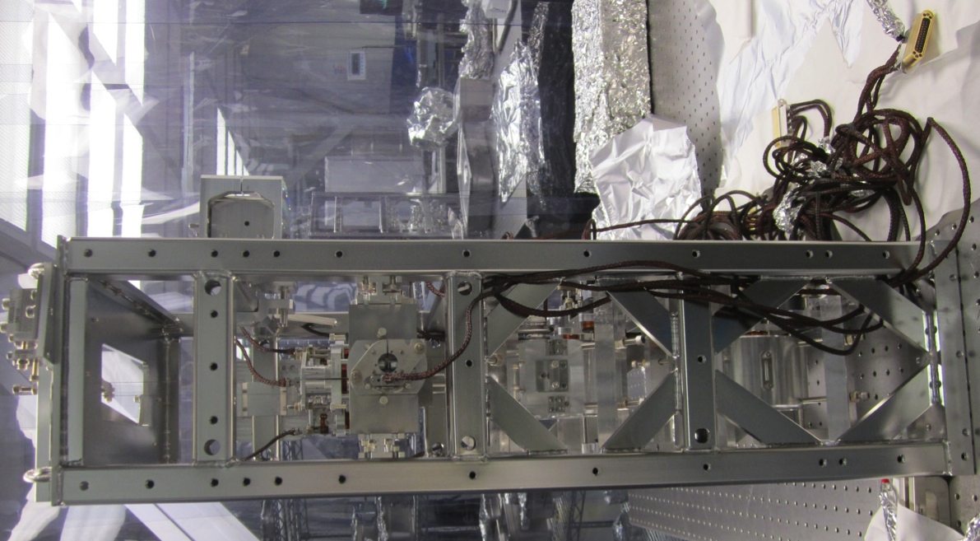
Sharp notch
Copper strand
Figure 1. MC3 Left Side (+Y)

Ground Loop Hunting on Individual Suspensions
An ohmmeter was used to check for connections between cable backshells and suspension structures. Starting from the bottom, routing to each suspension stage was tested. When a cable or chain of cables shorted to ground, a section of the routing would be manipulated in an attempt to break the connection between the inner copper braid and suspension or table. This method was repeated until a change in cable position stopped grounding. If a suspension was not grounded, attempts were made to create ground loops by wiggling and pressing cables at various points in order to identify potential grounding hazards.
The method for identifying causes of shield shorts varied depending on the status of the suspension. MC3, PRM, and SR2 were located in the LBR. Quadrapusses had been routed up MC3 and PRM, while SR2 cabling had not yet begun. MC1 and PR3 had already been moved to the LVEA chamber-side testing area, and had their lower metal masses replaced with optics. Quadrapusses on chamber-side suspensions were mated to Seismic Responsible Suspension (SRS) LIGO-D1000225 cables, which go to the cable bracket on the table and the vacuum flange.

MC3
MC3, located in the LBR, was the first suspension tested for ground loops. It had been cabled using the lacing method (weaving cables through gusset holes in the suspension). All wire and aluminum foil used to bundle quadrapusses for transportation was removed. Sections of the cables going across the table were placed on cleanroom wipes to isolate the routing up the suspensions for testing.
Only the top quadrapuss was grounded. Its legs were pulled away from the first gusset used for lacing (the entry point), so they would not be in contact with the structure or other cables at that location. When manipulating the quadrapuss in that region had no effect, the method was repeated going from the entry point toward the BOSEMs 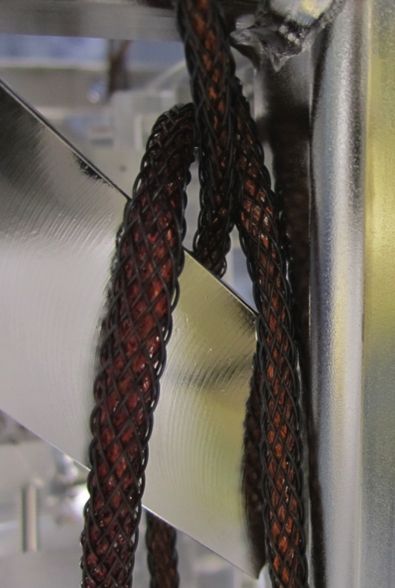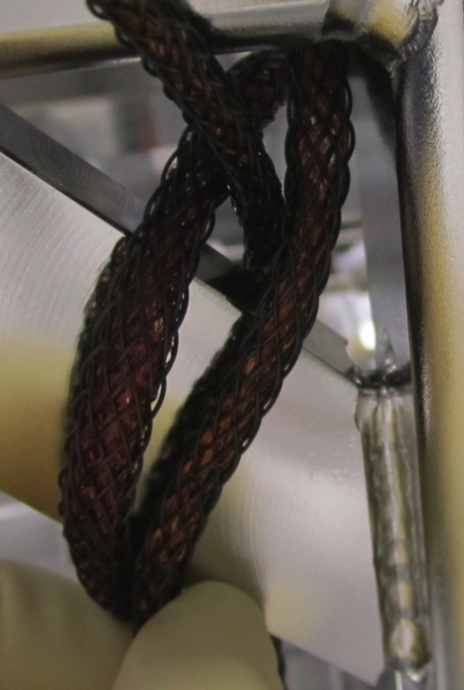until the connection between the backshell and suspension was broken. On the Left Side (+Y) of the suspension, near the third gusset on the right leg, a stray strand of copper was found sticking through the PEEK overbraid. The initial placement of the quadrapuss made it impossible to see the protruding hair, which was sandwiched between the cable and the structure. Pulling the quadrapuss leg away from the suspension, and turning it slowly against a light backdrop (glove or wipe) made the tiny and highly reflective copper strand easier to find.
Figure 5. Top cable grounded by sharp notch in gusset
Figure 6. Grounding stops when cable pulled out of notch
Figure 4. Strand unwound from leg
Figure 3. Cable pulled away and rotated to find strand
Figure 2. Location of the protruding copper strand

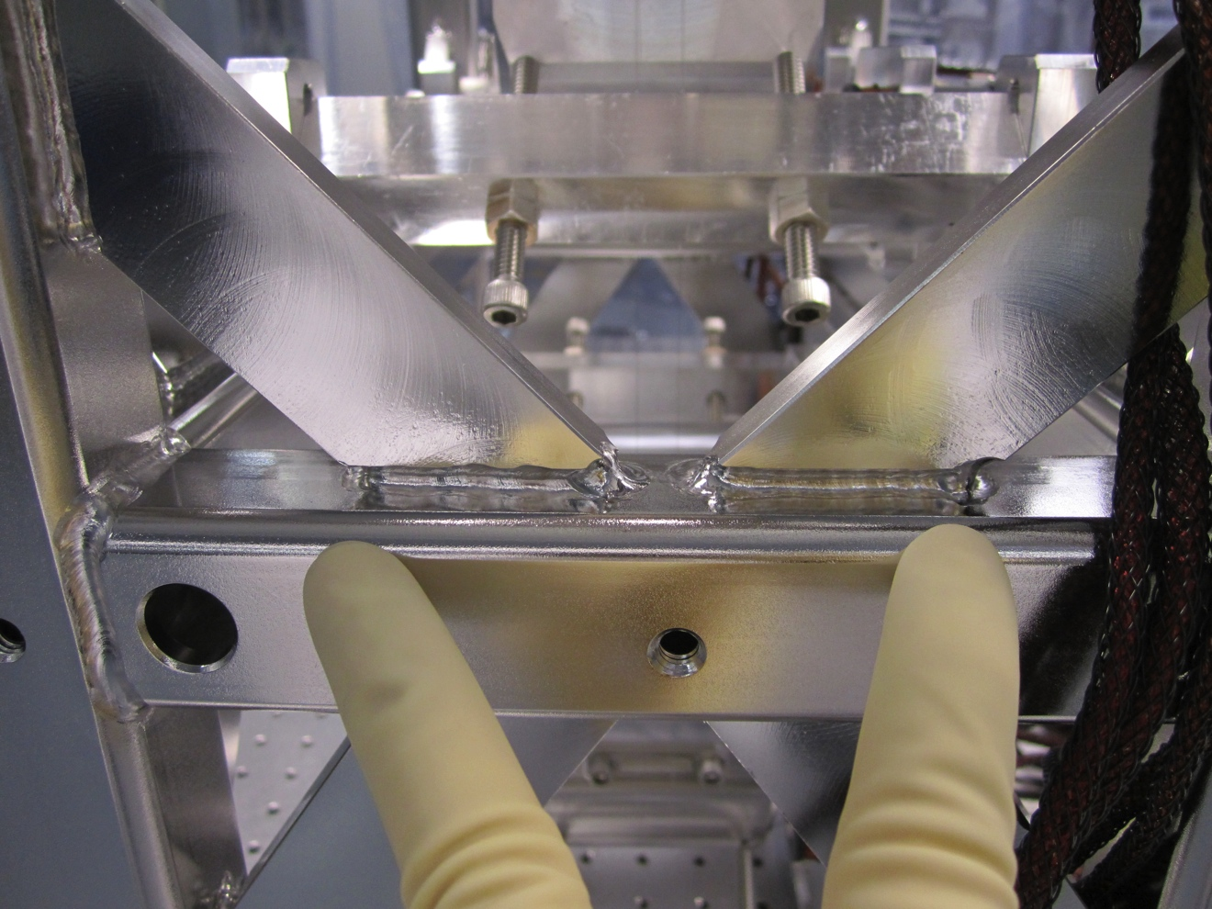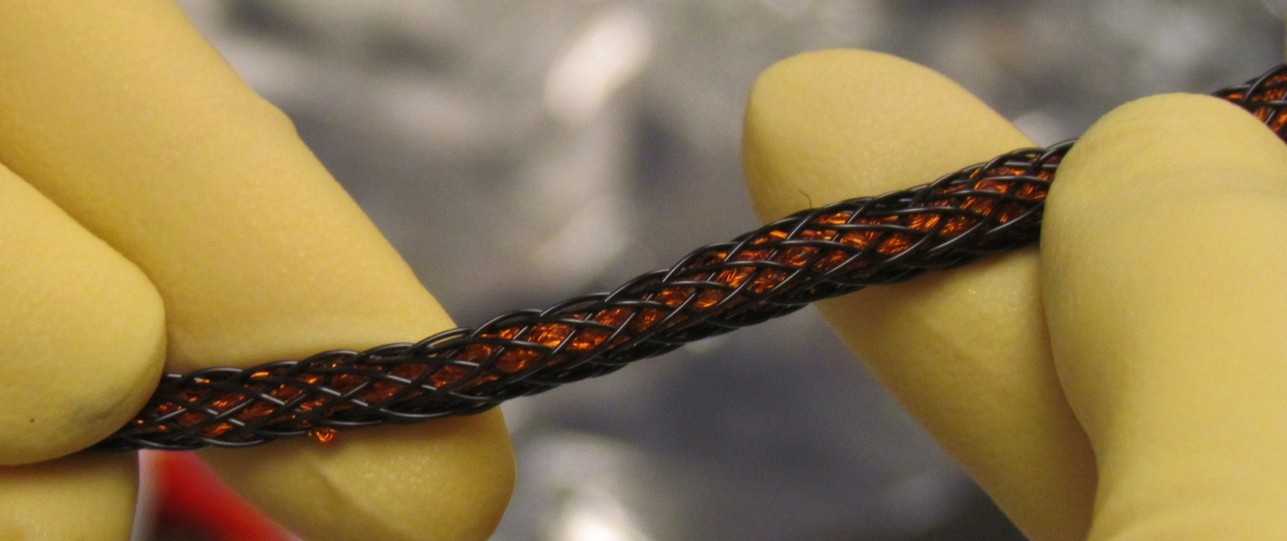The strand was snipped, but grounding continued. Wiggling the top cable near where the copper strand was found would start and stop grounding of the cable to the suspension. The movement would pull the cable into and out of a notch on the Left Side (+Y) where the top right gusset and suspension leg meet. All cables were pulled away from that sharp notch.
Not sharp
Sharp
Figure 7. MC3 Left (+Y) – notch in third right gusset is much sharper than notch in third left gusset
Stray strand
Copper loop
Figure 8. MC3’s top shared quadrapuss
Did not ground
When grounding had been corrected, cables were gently pulled and prodded to induce a ground loop. Moving the cables around emphasized flaws in the top shared quadrapuss. Stray copper hairs were snipped, and protruding loops of copper were gently pushed under the PEEK overbraid with tweezers. Even when pressed against the edge of a gusset with more force than they should normally encounter during routing, the quadrapusses did not ground to the structure. However, the top cable frequently wedged back into the problematic notch when handled. As an experiment, a strip of aluminum was molded over that notch to prevent contact with the cable’s copper shield. The quadrapuss could not be grounded to the structure while the strip was in place. This was captured in a video, LIGO-T1200216.
If the Left Side’s (+Y) top left gusset had a sharp notch, it seemed likely that its top right gusset would also have a sharp notch or that the corresponding legs on the Right Side (-Y) would cause grounding. This was not true. Not every notch is sharp, and not every notch would cause grounding. MC3’s gussets are not symmetrical, so the location of potentially hazardous notches was variable. This observation led to the grounding mitigation techniques described in Section 3.
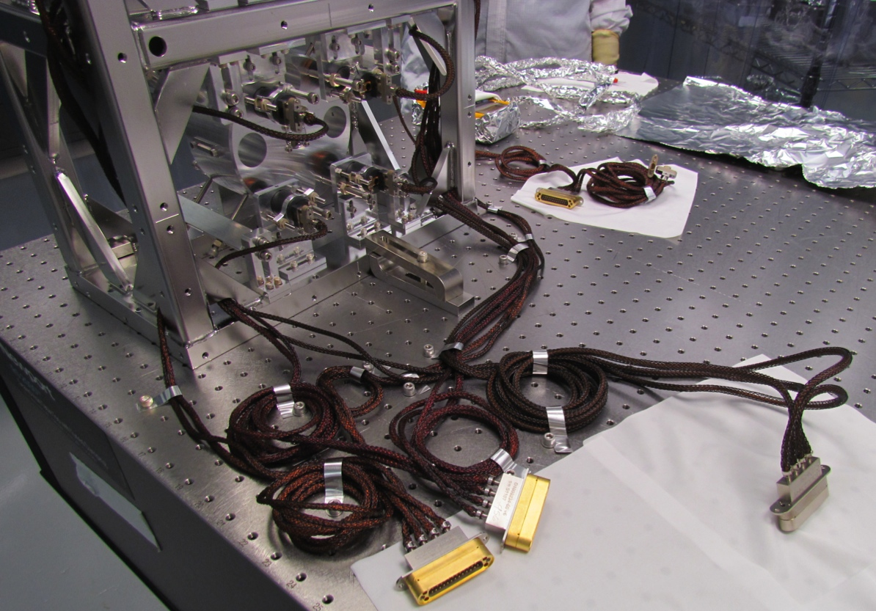Routing cables along the table, especially the bundling of excess length near the cable brackets, was thought to be partially to blame for ground loops. After identifying and correcting the causes of shield shorts in the lacing up MC3, the in-chamber routing along the table was simulated. Aluminum strips were tried out for the first time as a replacement for PEEK clamps. The strips can be circled around cables and fastened to the table by using a screw in pre-cut holes. The available strips were not pre-cut, and the hole-punch only worked on one strip before failing. As a temporary fix, the edges of the strips were held down with washers and screws. The issues with the hole punch have since been resolved.
Al strip with punched hole
Al strip without hole
Memory prevents laying flat
Figure 9. MC3’s quadrapusses routed on table
Even when pushing down on, and shifting the quadrapusses on the table, there was no evidence of grounding. It is important to note that the edge of the aluminum strips could slip through a cable’s PEEK overbraid and make contact with the shield if not used properly.

PRM
Like the other HSTS’s, PRM was cabled using the lacing method. Its quadrapusses were connected to Class B test cables in the LBR. All cables on the table, including test cables, were placed on cleanroom wipes to limit testing to the cabling up the suspension. PRM was quickly tested, and no ground loops were found. There was not enough time to try to identify sharp gusset notches, stray copper strands, or other issues. This should be done for the routing up the suspension and along the table before PRM goes into chamber.

SR2
SR2 had not been cabled prior to ground loop hunting. This provided an opportunity to check each cable after lacing, and more quickly isolate the affected cables. Each quadrapuss was bundled at the base of the suspension so the lacing would not loosen with handling, snag on other objects, or be difficult to route in chamber.
The estimated required length was 60” for the bottom, intermediate, and top shared cables. There were none on site, so 55” and 66” quadrapusses were used instead. The 55” bottom and intermediate cables had hairy snouts and loose double band-its. Due to time constraints and limited cable inventory, these issues were not corrected. The cables need to be refurbished or replaced.
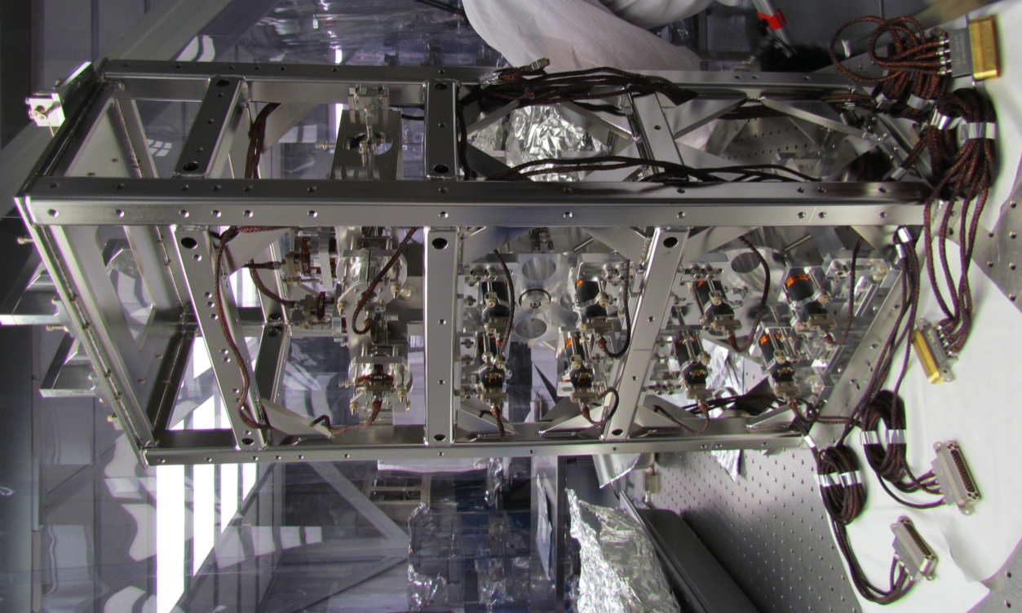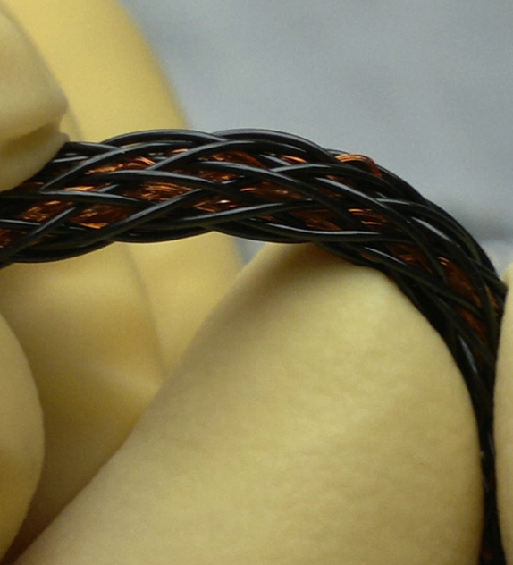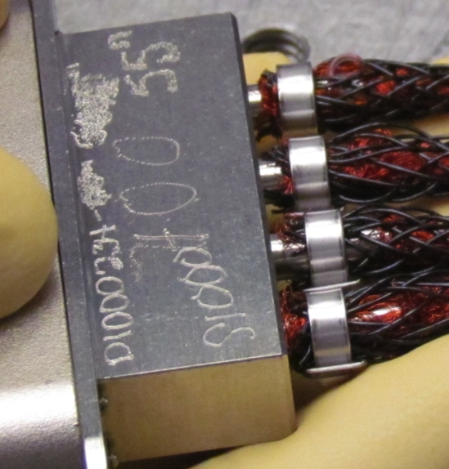The top quadrapuss was routed last, and was the only cable to cause ground loops. Many stray hairs and tiny copper loops were found protruding through the PEEK overbraid. The copper shield on the top quadrapuss was very loose, and had a “spiderwebby” appearance when held up to a light. Those copper loops poked into other quadrapuss legs, creating shield-to-shield contact between multiple cables. Numerous attempts were made to locate and correct the sources of grounding on the top quadrapuss. Ultimately, the top cable was removed from the suspension, and the three remaining quadrapusses no longer shorted to ground.
Figure 10. SR2 AR Side/Back (-X) – Right (-Y)
Figure 12. Copper loop on 78” cable
Figure 11. Shaggy 55” quadrapuss
Shaggy
Teflon wire
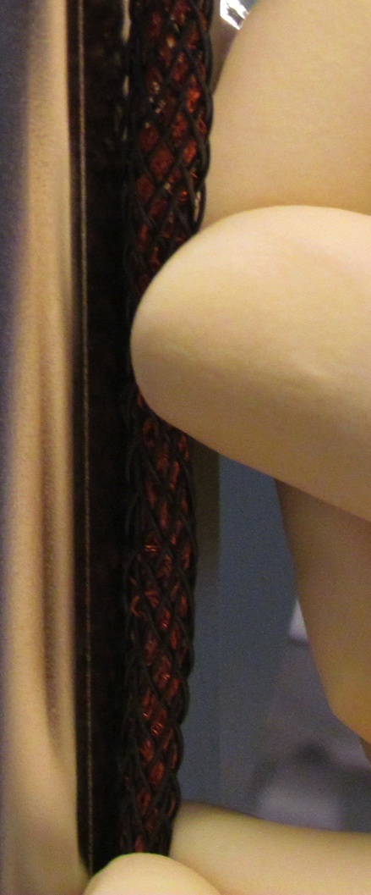All six of the 78” quadrapusses on site had a spiderwebby copper shield. When gently laid on the table, the cables would immediately become grounded. The best-looking 78” cable was selected, routed on SR2, and created ground loops in all the cables. After many tries to correct the problem, all but the top shared cable were grounded to the suspension. Additional 78” quadrapusses were shipped to Livingston so SR2’s top cable could be replaced.
Figure 13. Spiderwebby 78” quadrapuss
Copper loop grounded cable
Stuart Aston mentioned a broken piece of music wire had stuck to a magnet on an HSTS at Livingston, and was curious to see if a stray copper strand might do the same. A small piece of copper shielding was unaffected by the magnets.

MC1
The lacing up MC1 had noticeably loosened, and the cables on the table were a jumbled mess. The SRS D1000225 cables had shrunken PEEK overbraid, gaps in copper shielding, and visible Kapton wires. There was concern these attributes might lead to grounding or shorting. The SRS cables plug into a fake vacuum feedthrough bolted to the table in the chamber-side testing area. While plugged in, the cables were grounded. One SRS cable was disconnected at a time, and its J1 connector (to the flange) was laid on a cleanroom wipe. The quadrapuss and SRS cables were allowed to rest directly on the table so grounding along the entire D1000234 – D1000225 chain could be tested.
The bottom chain, the first to be tested, was grounded. When the SRS cable was lifted off the table, preventing it from coming in contact with everything except the quadrapuss DB25 connector, grounding continued. The quadrapuss was then lifted off the table, and grounding continued. Starting at the entry gusset, the quadrapuss legs were prodded and wiggled. The cause of the shield short was traced back to the bottom gussets on the Right Side (-Y). The quadrapuss took an S-shaped path between those two gussets, and easily lodged into their notches when pulled. Nudging a quadrapuss leg away from the notches stopped grounding.
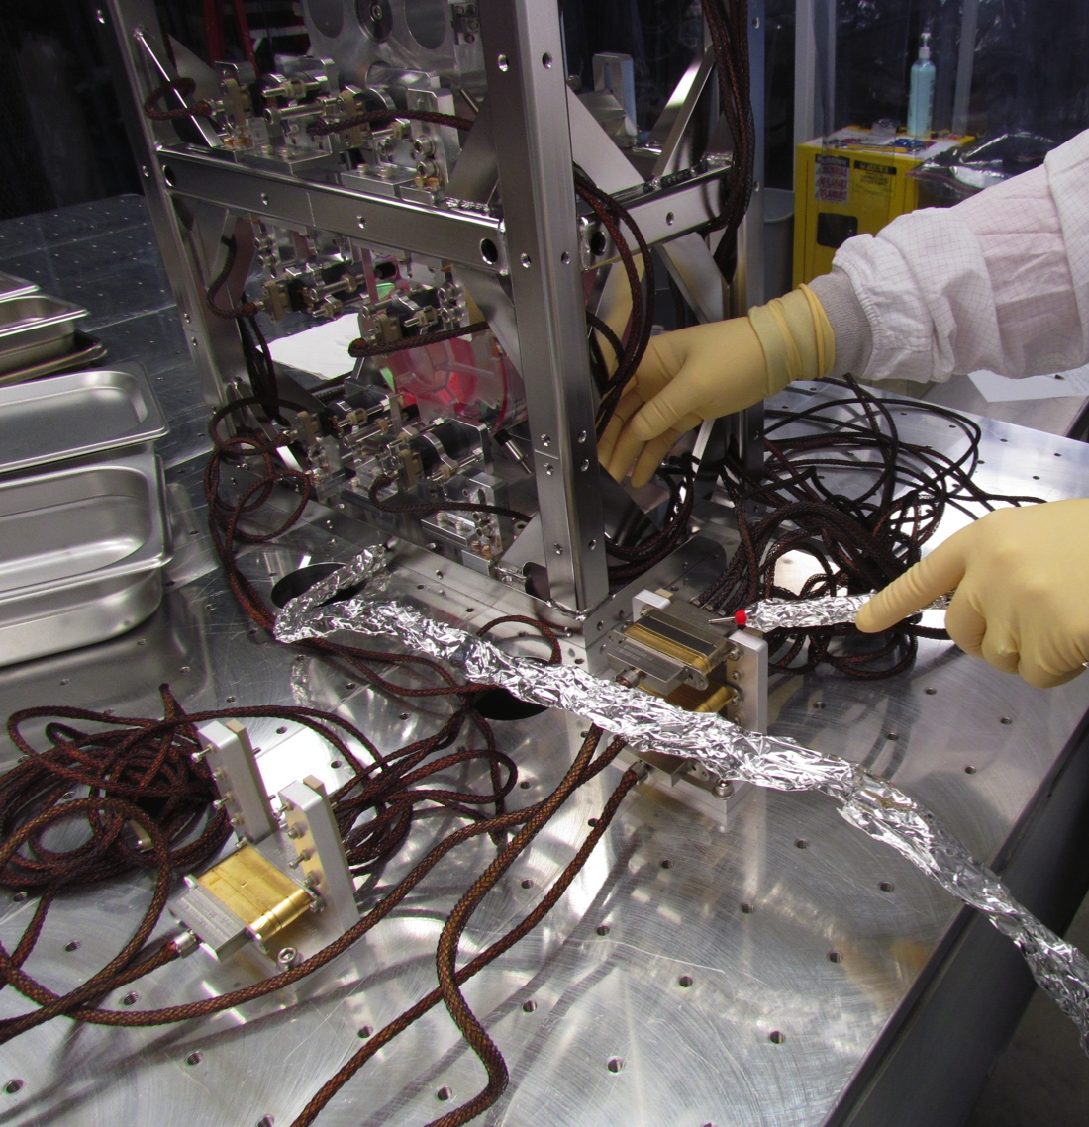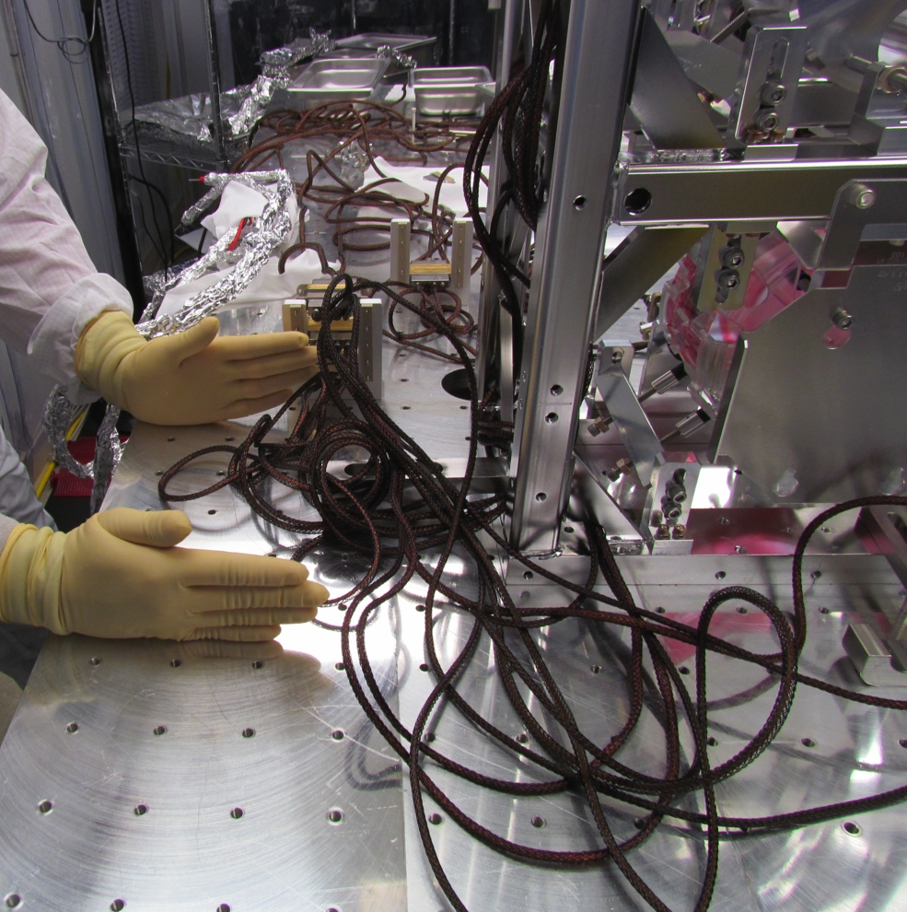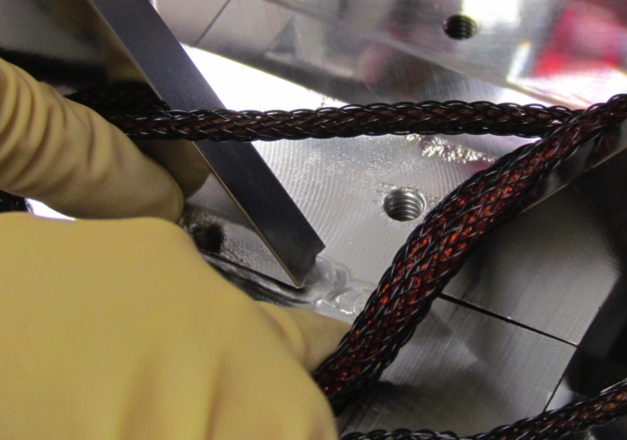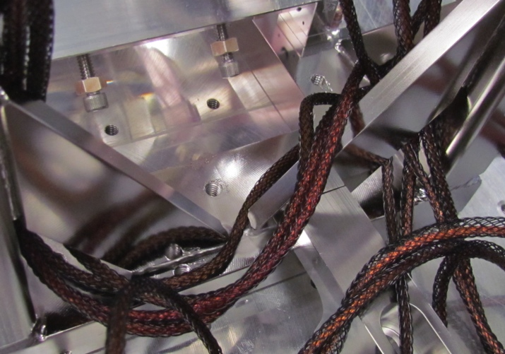Repositioning the bottom SRS and quadrapuss cables, or pushing them against the table did not create a ground loop. However, pressing them into the sharp edge of a dog clamp, AOSEM Alignment Assembly (LIGO-D0902208), or Barrel EQ Stop Assembly (LIGO-D0902201) did cause grounding. The intermediate and top shared quadrapusses were not grounded, but would be if their legs became wedged into certain notches. The top cable was not grounded either, and a ground loop was difficult to force in the routing up the suspension. The first few inches of the top cable routing along the table did ground when pressed down. This area should be re-checked before MC1 is moved into HAM2.
Figure 14. Ground loop hunting on MC1
Figure 17. Portion of MC1’s top cable that grounded to the table when pressed
Figure 16. Close-up of sharp notch
Figure 15. Cable stuck between notches

PR3
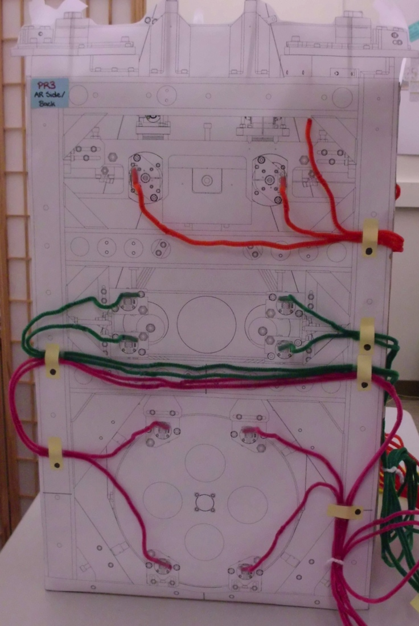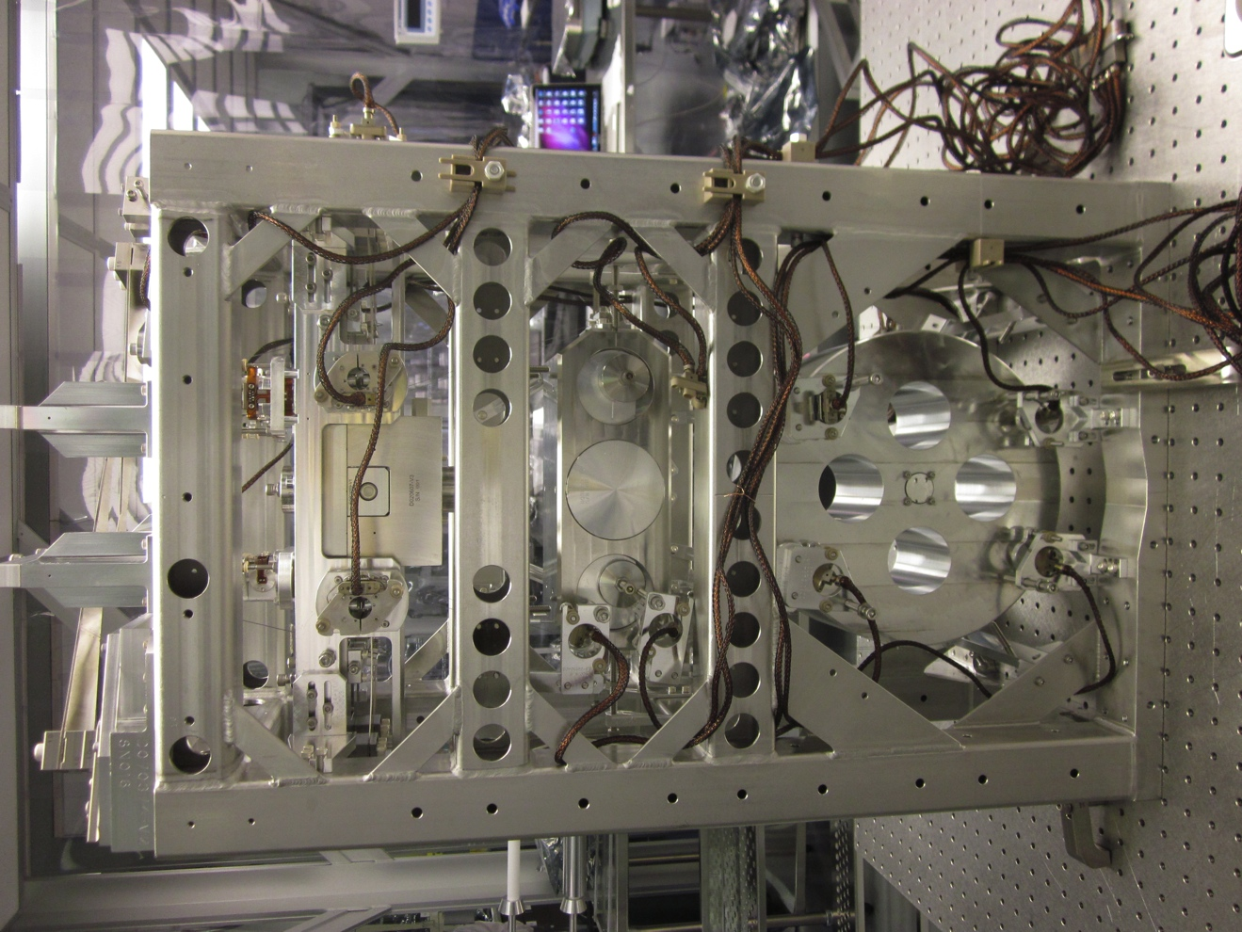Figure 18 shows the model for the intended external cable routing for PR3. The memory of the quadrapusses used for PR3 was difficult to work with, and might have caused cables to curl into the path of the laser beam. A combination of lacing and routing along the outside of the structure was used to compensate for memory, as shown in Figure 19. PR3 was the only HLTS inspected for ground loops at Livingston, and the only triple suspension with a mix of the two routing methods.
Figure 18. Quadrapusses routed externally on PR3 “dollhouse”
Figure 19. PR3 Back (+X) in LBR
None of PR3’s cables were initially grounded. It was difficult to force grounding because the structure did not have any sharp gusset notches like the HSTS’s. Also, the quality of the quadrapusses was fairly good, aside from the memory. Just like MC1, the quadrapuss overbraids were flexible and loose, and few copper hairs were found.
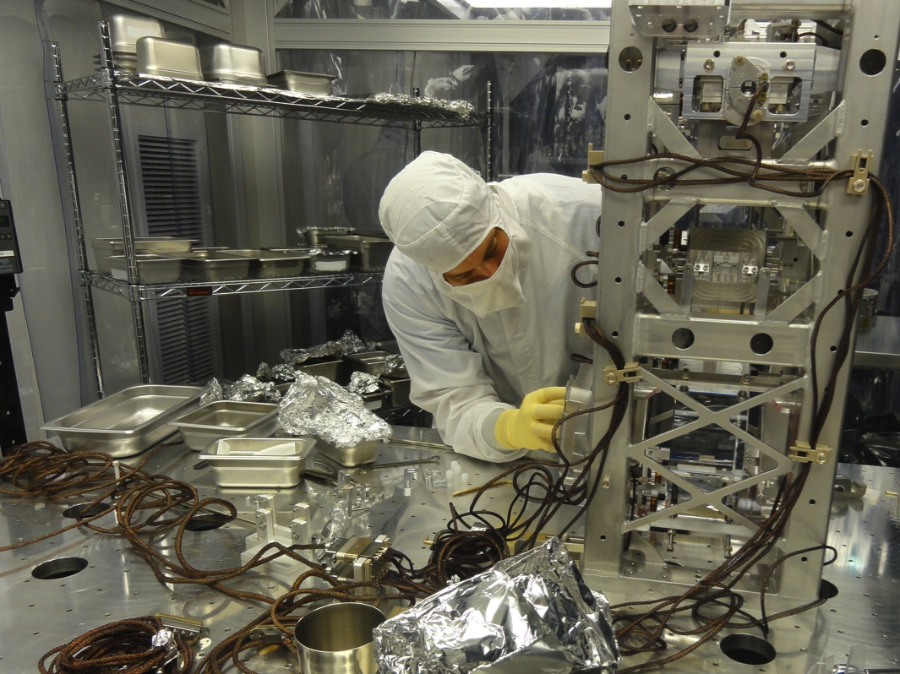The cables were loosely guided, not crushed, by PEEK cable clamps (LIGO-D0900004). When two clamp pieces were pushed closer together, the quadrapuss legs between them were squished into each other and became grounded to the structure. A small hair jutting away from the copper braid did not poke through the PEEK overbraid and make contact with the suspension until the cable was clamped too tightly. Shield-to-shield contact between two quadrapusses occurred when their legs were held with a single tight clamp.
Figure 20. PR3 Right (-Y) after move chamber-side

Mitigating Grounding by Sharp Notches
There are only two remaining triple suspensions at Livingston that need to be cabled. Ideally, devising band-aid solutions to correct grounding issues for the existing routing on the other seven suspensions would prevent further delays in schedule. SRM, the last cable-free HSTS at LLO, was a perfect test. SRM had gusset notches that could cause grounding just like the other HSTS’s, though they were noticeably fewer and duller than MC3’s. The location of “bad” notches on parallel sides of a small triple did not match up because the gussets and welding are asymmetrical. Irregularities within an HSTS, and between all the HSTS’s at Livingston make it impossible to accurately predict which areas will be hazardous.
Some gusset holes are not large enough for a 9-pin quadrapuss connector to pass through. The red dots in Figure 21 denote gusset corners that quadrapusses may touch on an HSTS. Cables may be laced through the same gusset holes in the Front Side (+X) as the Back Side (-X). This is also true for the Left (+Y) and Right (-Y). Figure 21 is a summary of routing for all the HSTS’s. Quadrapusses will not touch every spot highlighted in red on a single suspension.
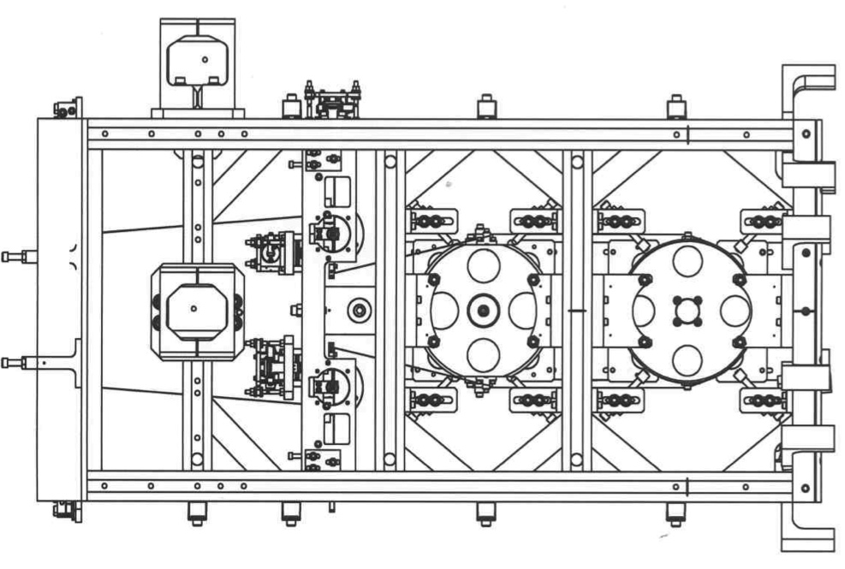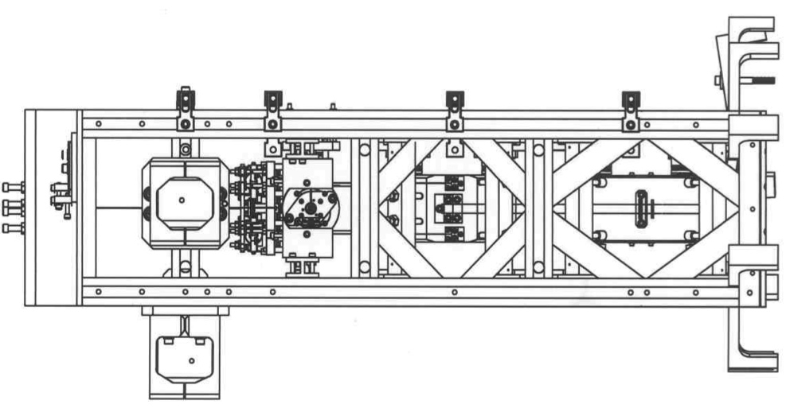Two quadrapusses were pulled from storage to check areas on SRM that are commonly used for routing. To stop contact between a quadrapuss’ copper shielding and a sharp notch:

Figure 21. HSTS Front (+X) and Left (+Y) gusset corners that laced quadrapusses may contact on an HSTS
- The legs have to be pulled away
- Or the notch edge must be blunted.
PEEK cable ties were used to cover notches. Even when tightened down as much as possible, there was a gap between the tie and suspension. PEEK ties can slip off the notch edge and slide along the gusset, making them an ineffective tool.
The next trial was with the aluminum strips meant to replace PEEK cable clamps. The aluminum was less malleable post-bake, and a bit difficult to shape on more angled gusset notches. These characteristics were attributed to one batch of strips, and have since been corrected. Like PEEK ties, the strips also had a tendency to slide. Cutting the strips in half, to roughly the height of a notch, made the aluminum much easier to work with. With a little effort, the strips could be molded around and kept flush with the gusset. Tying the strip while keeping it tight could be challenging. If the strip is too loose, it could potentially ground cables just like a notch.
An attempt to use a band-it tool to tighten and tie off an aluminum strip failed miserably. The strip and tool were not compatible. Small band-its were also tested, but could not be pulled tight enough. Ultimately, the half-size aluminum strip was the best tool to cover notches. The technique is shown in more detail in LIGO-T1200226. Quadrapusses could be held away from the notches using the aluminum strips as well.
Tying cables to the suspension in addition to blunting notches is the most effective way to avoid grounding due to sharp notches. Both methods are demonstrated in LIGO-T1200226.
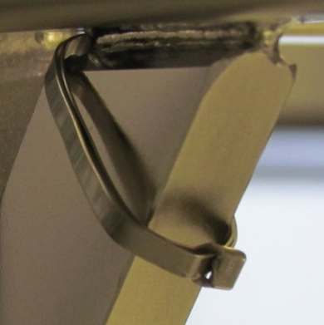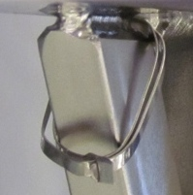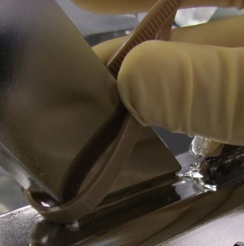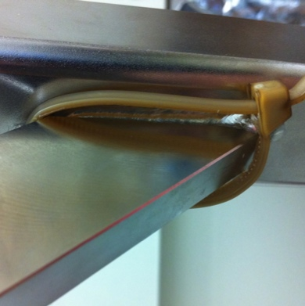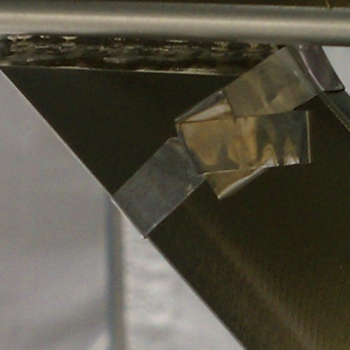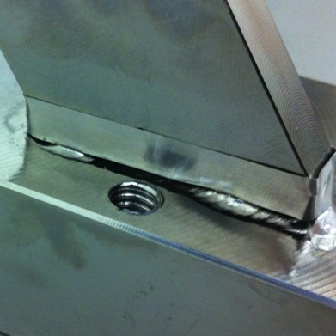
Figure 23. a) and b) Covering notches with band-its
Figure 22. a) and b) Covering notches with PEEK ties
Figure 24. a) and b) Covering notches with Al strips

Summary and Analysis of Observations
Though every suspension and cable is unique, observations for the five triple suspensions investigated at Livingston can be generalized. A summary of findings, the conclusions drawn from them, and recommendations (in blue) are detailed below:
- Shorts to ground were initially found in quadrapusses on 3 out of 5 suspensions.
It can be surmised that SUS ground loops are prevalent at Livingston, though not quite as widespread as feared.
Table 1. Ground Loop Hunting Results by Suspension and Stage
 | Bottom | Intermediate | Top | Top Shared
MC3 | Not Grounded | Not Grounded | Grounded | Not Grounded
PRM | Not Grounded | Not Grounded | Not Grounded | Not Grounded
SR2 | Grounded | Grounded | Grounded | Grounded
MC1 | Not Grounded | Not Grounded | Not Grounded | Grounded
PR3 | Not Grounded | Not Grounded | Not Grounded | Not Grounded
- Kapton insulated SRS D1000225 cables were not grounded.
Kapton cables with loose, misshapen copper shielding and oddly bunched or tight PEEK overbraids are unattractive, but should not be replaced.
- Grounding was caused by:
- The inner copper braid sticking out of the PEEK overbraid, and making contact with the suspension, table, or other cable. Examples:
- Copper hairs – A thin strand breaks at one point in the braid. This is a common occurrence, and frequently appears in otherwise good cables.
Thoroughly inspect cables for protruding copper before routing. It is easier to find small hairs using a glove or wipe as a backdrop. Snip hairs as short as possible.
- Copper loops – The copper braid is loose or distorted. It expands into what should be a gap between the copper and PEEK braids, and sticks through the open weave of the PEEK overbraid.
Gently push copper loops back under the PEEK overbraid with tweezers. If the overbraid is too tight and shrunken to do so, or if there are too many copper loops to fix, then use a different cable. Note the issues in ICS.
- Shrunken PEEK overbraid – The overbraid shrinks in size during bake, contracting into what should be a gap between the copper and PEEK braids, forcing the copper past the surface of the overbraid.
Avoid using cables with shrunken overbraids when possible.
- 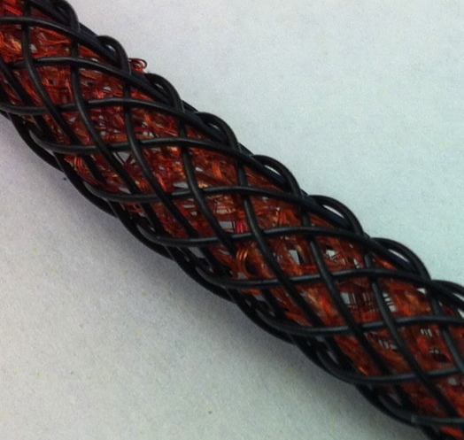Squished overbraid – Tight routing or clamping can reduce the gap between the braids, forcing the copper past the PEEK overbraid.
Figure 25. Spiderwebby quadrapuss with copper loops protruding past PEEK overbraid
Figure 26. Shrunken overbraid and stray hair on quadrapuss
Copper hair
Figure 27. Quadrapuss overbraids are slightly compressed by PEEK clamp
Figure 28. Copper hairs could stick out if overbraid is squished down
Copper Hair
Allow for slack in the routing. Cables should be guided, not crushed, on the suspensions and table. Use aluminum strips instead of PEEK cable clamps.
- A sharp edge spearing through the open weave in the PEEK overbraid, and making contact with the copper shield. Examples: gusset notches and dog clamps.
Use aluminum strips to secure cables away from sharp objects. See #6.

- Slight shifts in a quadrapuss’ position can create or break ground connections.
Movement can bring a flaw in the cable (hair or copper loop) into contact with a grounded surface, or can pull a cable into a sharp gusset notch. Transportation and handling will inevitably jostle the quadrapusses around.
To reduce their freedom of movement, it is recommended that cables be tied to suspensions with aluminum strips. A ground-loop-free suspension should be re-checked for shorted shields after being transferred to a new testing area or into the chamber.
- HSTS’s manufactured by GNB have sharp gusset notches that can cause shorts to ground.
Potentially hazardous notches capable of grounding cables were found on the remaining HSTS’s at Livingston, all of which were made by GNB. Not all gussets notches will cause grounding. There was no clear pattern in the quantity, jaggedness, or location of these bad notches. Quadrapusses are more likely to wedge into a bad notch when tugged on or routed too tightly.
IMP manufactured Hanford’s HSTS’s and the HLTS’s for both sites. PR3 did not have gusset notches, so it is likely that none of the other HLTS’s do either.
The HSTS’s at Hanford, and HLTS’s at both sites must be checked for notches.
- Grounding by sharp notches can be corrected by using aluminum strips to blunt the notches AND to hold quadrapusses away from the area.
The alternatives are unlacing quadrapusses and re-routing them externally (which may not stop grounding), or accepting ground loops.
The proposed fix (see LIGO-T1200226) is quick, easy, and can be implemented immediately. Care should be taken because improper use of the aluminum strips could cause grounding instead of correcting it.
- There is no evidence that shield shorts occur more often in laced versus externally routed quadrapusses.
The lacing method was believed to be a major source of grounding issues. It was thought that the machined edge of a gusset crossed a cable’s PEEK overbraid at the same angle as the weave of the braid, creating contact with the inner copper braid. This proved to be untrue for most cables. Quadrapusses with shrunken overbraids or protruding copper loops shorted to ground when pushed against the gusset edge with moderate force. The same cables grounded when pressed against a flat leg of the structure.
Laced quadrapusses are susceptible to shield shorts due to sharp notches. Externally routed cables are not. This is only an issue for HSTS’s, and possibly only at Livingston.
Contact between the cable and suspension is minimized by the lacing method, and maximized by external routing. Given the pervasiveness of stray hairs and copper loops, the more quadrapusses come into contact with the suspensions, the greater the probability of grounding. The quadrapusses snaking back and forth inside the quads touch parts less than either type of routing in the triple suspensions, and consequently ground less.
The only example of external routing inspected at Livingston was on an HLTS, which also had laced cables. To determine whether lacing or externally routing cables is more likely to cause shield shorts, both methods should be tried on the same suspension with the same cables.
Continue to use the lacing method.
- At the end of the investigation, quadrapusses were grounded on 1 out of 5 suspensions.
It is possible to improve grounding.
Replacing the three SR2 cables that are currently grounded would turn Table 2 completely green (i.e. there would be no short shields on any of these five triples).
Table 2. Grounding after Investigation
 | Bottom | Intermediate | Top | Top Shared
MC3 | Not Grounded | Not Grounded | Not Grounded | Not Grounded
PRM | Not Grounded | Not Grounded | Not Grounded | Not Grounded
SR2 | Grounded | Grounded | Grounded | Not Grounded
MC1 | Not Grounded | Not Grounded | Not Grounded | Not Grounded
PR3 | Not Grounded | Not Grounded | Not Grounded | Not Grounded
- Some quadrapusses will always short to ground.
Certain cables have too many problems, and simply cannot be fixed. The 78” quadrapusses with loose copper braids and countless protruding loops used for SR2 are an example. Unless there is a way to float really problematic quadrapusses between the OSEMs to the L-brackets without touching any conductors or other cables, there will be shield shorts no matter what mitigation tools are used. Bad cables should not be used at all if possible.
Unfixable cables should not be used if better cables are available. If bad quadrapusses must be used, follow these guidelines where possible:
- Use on TMS and small triples (HSTS, HLTS) before quad (ETM, ITM) and BS.
- For triples, use on top mass before intermediate mass and optic.
- For quad (ETM, ITM), use on top mass before lower stage.

