AUTHOR(S) | DATE | Document Change Notice, Release or Approval
Eric James | 19 Jan 2012 | see LIGO DCC record Status
This document is intended to serve as a description of this assembly until a real assembly drawing can be made.

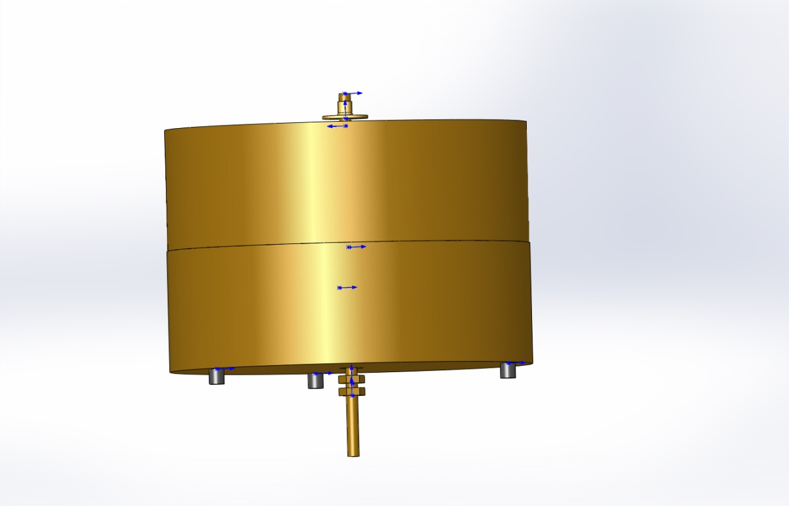
This assembly is made from the following parts purchased from McMaster Carr:

Item | Part number | Description | Quantity
1 | 90385K46 | 23 lb lead weight | 2
2 | 95412A460 | 1/4-20 x 6" threaded rod | 1
3 | 9029K12 | 1/4" diam. Viton cord x 1/4" long | 2
4 | 91841A195 | 1/4-20 Hex Nut | 2
5 | 90860A107 | 1/4-20 Weld Nut | 1

