LIGO Laboratory / LIGO Scientific Collaboration

LIGO- E200632-v2 Advanced LIGO 8/2/2012

TwinCAT Library for the
ALS Laser

Alexa Staley, Daniel Sigg

Distribution of this document:
LIGO Scientific Collaboration

This is an internal working note
of the LIGO Laboratory.

California Institute of Technology  LIGO Project – MS 18-34  1200 E. California Blvd.  Pasadena, CA 91125  Phone (626) 395-2129  Fax (626) 304-9834  E-mail: info@ligo.caltech.edu | Massachusetts Institute of Technology  LIGO Project – NW22-295  185 Albany St  Cambridge, MA 02139  Phone (617) 253-4824  Fax (617) 253-7014  E-mail: info@ligo.mit.edu
LIGO Hanford Observatory  P.O. Box 159  Richland WA 99352  Phone 509-372-8106  Fax 509-372-8137 | LIGO Livingston Observatory  P.O. Box 940  Livingston, LA 70754  Phone 225-686-3100  Fax 225-686-7189
http://www.ligo.caltech.edu/

Library
Title | ALSLaser
Version | 1
TwinCAT version | 2.11
Name space | –
Author | Alexa Staley, Daniel Sigg
Description | Monitors the ALS Laser  Controls the crystal and doubler temperature  A slow feedback servo is implemented to offload the fast PZT feedback to the slow temperature controls. It implements the following equation:  $u_{i}=u_{i-1}+g×\left\{\begin{matrix}e_{i} & h≤0 \\ (e_{i}-e_{i-1})/h & h>0\end{matrix}\right.$ with  $g=πf_{ugf}∆t$ and $h= πf_{Pf}∆t$.  $∆t$: sampling interval,  $f_{ugf}$: unity gain frequency of integrator,  $f_{Pf}$: Knee frequency of proportional gain.  A negative $f_{ugf}$ reverses the sign of the feedback.
Error codes | 0x0001 – Safety interlock engaged  0x0002 – Laser diode 1 guard alarm  0x0004 – Laser diode 2 guard alarm  0x0008 – Laser diode 1 current out-of-range  0x0010 – Laser diode 2 current out-of-range  0x0020 – Laser crystal TEC error signal out-of-range  0x0040 – Doubler crystal TEC error signal out-of-range  0x0080 – Laser diode 1 TEC error signal out-of-range  0x0100 – Laser diode 2 TEC error signal out-of-range  0x0200 – Noise eater readback signal out-of-range  0x0400 – Unity gain frequency too high  0x0800 – Proportional gain knee frequency too high  0x1000 – Temperature feedback limit exceeded
Library dependencies | ReadADC, WriteADC, SaveRestore, Error

Hardware Input Type
TYPE ALSLaserInStruct :
STRUCT
LaserDiode1PowerMonitor: INT;
LaserDiode2PowerMonitor: INT;
LaserCrystalTECErrorSignal: INT;
DoublingCrystalTECErrorSignal: INT;
LaserDiode1TECErrorSignal: INT;
LaserDiode2TECErrorSignal: INT;
NoiseEaterMonitor: INT;
LaserDiode1TempGuard: BOOL;
LaserDiode2TempGuard: BOOL;
InterLock: BOOL;
END_STRUCT
END_TYPE
Type name | ALSLaserInStruct
Description | Structure of the hardware input that are wired up for the ALS laser
Definition | STRUCT
Element | Name: LaserDiode1PowerMonitor  Type: INT  Description: Laser diode 1 power monitor
Element | Name: LaserDiode2PowerMonitor  Type: INT  Description: Laser diode 2 power monitor
Element | Name: LaserCrystalTECErrorSignal  Type: INT  Description: Laser crystal, TEC error signal
Element | Name: DoublingCrystalTECErrorSignal  Type: INT  Description: Doubling crystal, TEC error signal
Element | Name: LaserDiode1TECErrorSignal  Type: INT  Description: Laser diode 1, TEC error signal
Element | Name: LaserDiode2TECErrorSignal  Type: INT  Description: Laser diode 2, TEC error signal
Element | Name: NoiseEaterMonitor  Type: INT  Description: Noise eater monitor
Element | Name: LaserDiode1TempGuard  Type: BOOL  Description: Laser diode 1, temp guard
Element | Name: LaserDiode2TempGuard  Type: BOOL  Description: Laser diode 2, temp guard
Element | Name: InterLock  Type: BOOL  Description: InterLock

Hardware Output Type
TYPE ALSLaserOutStruct :
STRUCT
CrystalTemperature: INT;
DoublerTemperature: INT;
END_STRUCT
END_TYPE
Type name | ALSLaserOutStruct
Description | Structure of the hardware output that are wired up for the ALS laser
Definition | STRUCT
Element | Name: CrystalTemperature  Type: INT  Description: Crystal Temperature
Element | Name: DoublerTemperature  Type: INT  Description: Doubler Temperature

User Interface Type
TYPE ALSLaserFrequencyControlsStruct:
STRUCT
On: BOOL;
Enabled: BOOL;
Run: BOOL;
Reset: BOOL;
Low: LREAL;
High: LREAL;
Range: BOOL;
Ugf: LREAL;
P: LREAL;
END_STRUCT
END_TYPE
Type name | ALSLaserFrequencyControlsStruct
Description | Structure used in the user interface that are used for the slow temperature controls
Definition | STRUCT
In/out Tag | Name: On  Type: BOOL  Description: On/Off button for temperature feedback
Output Tag | Name: Enabled  Type: BOOL  Description: Enabled by the autolocker
Output Tag | Name: Run  Type: BOOL  Description: Servo is running
In/out Tag | Name: Reset  Type: BOOL  Description: Reset the integrator and zero the output
In/out Tag | Name: Low  Type: LREAL  Description: Low limit for feedback controls in Hz
In/out Tag | Name: High  Type: LREAL  Description: High limit for feedback controls in Hz
Output Tag | Name: Range  Type: BOOL  Description: Feedback controls exceeds range
In/out Tag | Name: Ugf  Type: LREAL  Description: Unity gain frequency of temperature servo in Hz
In/out Tag | Name: Pf  Type: LREAL  Description: Knee frequency of proportional feedback in Hz; zero is none

User Interface Type
TYPE ALSLaserStruct :
STRUCT
Error: ErrorStruct;
LaserDiode1PowerMonitor: LREAL;
LaserDiode2PowerMonitor: LREAL;
LaserDiodePowerNominal: LREAL;
LaserDiodePowerTolerance: LREAL;
LaserCrystalTECErrorSignal: LREAL;
DoublingCrystalTECErrorSignal: LREAL;
LaserDiode1TECErrorSignal: LREAL;
LaserDiode2TECErrorSignal: LREAL;
TECTolerance: LREAL;
NoiseEaterMonitor: LREAL;
NoiseEaterNominal: LREAL;
NoiseEaterTolerance: LREAL;
LaserDiode1TempGuard: BOOL;
LaserDiode2TempGuard: BOOL;
InterLock: BOOL;
CrystalTemperature: LREAL;
CrystalCalibration: LREAL;
CrystalFrequency: LREAL;
FrequencyControl: ALSLaserFrequencyControlsStruct;
PZTTuningCoefficient: LREAL;
PZTFrequency: LREAL;
DoublerTemperature: LREAL;
END_STRUCT
END_TYPE
Type name | ALSLaserStruct
Description | Structure of the user interface tags that are used to control the ALS Laser
Definition | STRUCT
Output Tag | Name: Error  Type: ErrorStruct  Description: For error handler
Output Tag | Name: LaserDiode1PowerMonitor  Type: LREAL  Description: Laser diode 1 power monitor in A
Output Tag | Name: LaserDiode2PowerMonitor  Type: LREAL  Description: Laser diode 2 power monitor in A
Input Tag | Name: LaserDiodePowerNominal  Type: LREAL  Description: Laser diode power nominal in A
Input Tag | Name: LaserDiodePowerTolerance  Type: LREAL  Description: Laser diode power tolerance in A
Output Tag | Name: LaserCrystalTECErrorSignal  Type: LREAL  Description: Laser crystal, TEC error signal in C
Output Tag | Name: DoublingCrystalTECErrorSignal  Type: LREAL  Description: Doubling crystal, TEC error signal in C
Output Tag | Name: LaserDiode1TECErrorSignal  Type: LREAL  Description: Laser diode 1, TEC error signal in C
Output Tag | Name: LaserDiode2TECErrorSignal  Type: LREAL  Description: Laser diode 2, TEC error signal in C
Input Tag | Name: TECTolerance  Type: LREAL  Description: TEC error signal tolerance in C
Output Tag | Name: NoiseEaterMonitor  Type: LREAL  Description: Noise eater monitor in V
Input Tag | Name: NoiseEaterNominal  Type: LREAL  Description: Noise eater nominal value in V
Input Tag | Name: NoiseEaterTolerance  Type: LREAL  Description: Noise eater tolerance in V
Output Tag | Name: LaserDiode1TempGuard  Type: BOOL  Description: Laser diode 1, temp guard, high is alarm
Output Tag | Name: LaserDiode2TempGuard  Type: BOOL  Description: Laser diode 2, temp guard, high is alarm
Output Tag | Name: InterLock  Type: BOOL  Description: InterLock, high represent an interlock

In/out Tag | Name: CrystalTemperature  Type: LREAL  Description: Crystal Temperature in C or V
Output Tag | Name: CrystalCalibration  Type: LREAL  Description: Crystal temperature coefficient at 1064nm in MHz/C; nominal -3000 MHz/C
In/out Tag | Name: CrystalFrequency  Type: LREAL  Description: Laser frequency as set by crystal temperature in MHz; updating the CrystalFrequency will update the CrystalTemperature and vis versa
In/out Tag | Name: FrequencyControl  Type: ALSLaserFrequencyControlsStruct  Description: Controls parameters for slow temperature feedback network
Output Tag | Name: PZTTuningCoefficient  Type: LREAL  Description: PZT tuning coefficient at 1064nm in MHz/V; nominal 1.5 MHz/V
Output Tag | Name: PZTFrequency  Type: LREAL  Description: Laser frequency as set by the PZT actuator in MHz
Input Tag | Name: DoublerTemperature  Type: LREAL  Description: Doubler Temperature

Function Block
FUNCTION_BLOCK ALSLaserFB
VAR_INPUT
ALSLaserIn: ALSLaserInStruct;
END_VAR
VAR_OUTPUT
ALSLaserOut: ALSLaserOutStruct;
END_VAR
VAR_IN_OUT
ALSLaser: ALSLaserStruct;
END_VAR
Name | ALSLaserFB
Description | Monitors the ALS laser and computes the slow controls feedback
Input argument | Name: Request  Type: SaveRestoreEnum  Description: Request for save or restore
Input argument | Name: ALSLaserIn  Type: ALSLaserInStruct  Description: Input hardware structure
Input argument | Name: ControlsEnable  Type: BOOL  Description: Enables the slow controls feedback  Default: FALSE
Input argument | Name: PZTVoltage  Type: LREAL  Description: PZT controls voltage in V (error signal for slow controls feedback)  Default: 0
Output argument | Name: ALSLaserOut  Type: ALSLaserOutStruct  Description: Output hardware structure
In/out argument | Name: ALSLaser  Type: ALSLaserStruct  Description: User Interface structure

Visual

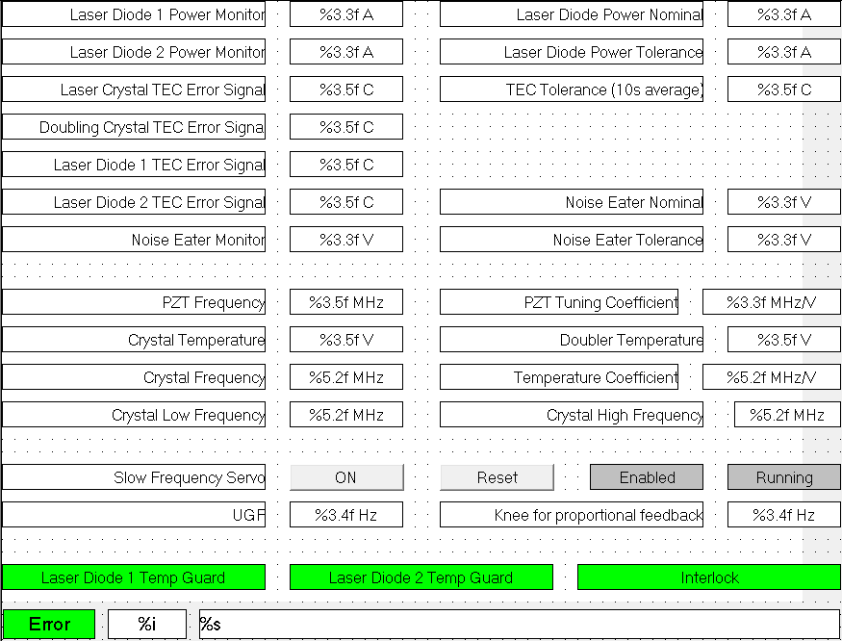

Name | ALSLaserVis
Description | Displays power monitors, TEC error signals, noise eater status, crystal temperatures, slow temperature controls parameters, and alarms for temperature guards, interlock and error.
Placeholder | Name: ALSLaser  Type: ALSLaserStruct  Description: ALS laser structure

