LASER INTERFEROMETER GRAVITATIONAL WAVE OBSERVATORY
-LIGO-
CALIFORNIA INSTITUTE OF TECHNOLOGY
MASACHUSETTS INSTITUTE OF TECHNOLOGY
LIGO- E1200660-v1 6/28/12

AOS SLC BS Elliptical Baffle

Installation Procedure
Michael Smith, Lisa C. Austin

LIGO Hanford Observatory LIGO Livingston Observatory
P.O. Box 1970; Mail Stop S9-02 19100 LIGO Lane
Richland, WA 99352 Livingston, LA 70754
Phone (509) 37208106 Phone (225) 686-3100
Fax (509) 372-8137 Fax (225) 686-7189
E-mail: info@ligo.caltech.edu E-mail: info@ligo.caltech.edu

California Institute of Technology Massachusetts Institute of Technology
LIGO – MS 100-36 LIGO – MS NW22-295
Pasadena, CA 91125 Cambridge, MA 01239
Phone (626) 395-2129 Phone (617) 253-4824
Fax (626) 304-9834 Fax (617) 253-7014
E-mail: info@ligo.caltech.edu E-mail: info@ligo.mit.edu

CHANGE LOG

Date, version | Summary of Changes

Table of Contents
1 Scope 4
1.1 BS Elliptical Baffle Installation Summary 4
2 Installation Preparation 5
2.1 Requirements for Installation 5
2.2 Items required for installation 5
2.3 Tools required for Installation 5
3 Installation Procedure 5
3.1 Installation Set-up 5
3.2 Baffle Installation 6
3.3 Baffle Alignment 6
5 Removal of Fixtures and Tooling 7
Table of Tables
No table of figures entries found.
Table of Figures
Figure 1: Model of BS Elliptical Baffles Installed on the BS SUS 4

Scope
This document describes the installation and alignment procedures for the BS Elliptical Baffle.

BS Elliptical Baffle Installation Summary

A model of the Installed BS Elliptical Baffle is shown in Figure 1.

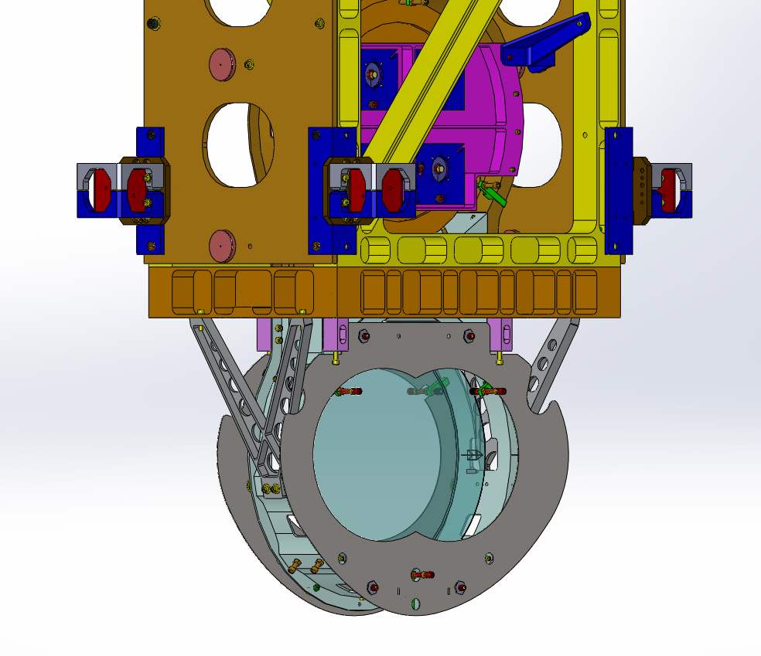
Figure 1: Model of BS Elliptical Baffles Installed on the BS SUS

The 5 lb BS Elliptical Baffle (both baffles plus hardware) is attached to the BS SUS lower frame, as shown in Figure 1. Installation and alignment will occur on the Cartridge assembly.
The Baffles will be attached, using special mounting hardware, after the BS mirror and suspension structure have been installed and aligned on the BSC ISI optical platform.
The IAS theodolite, aligned perpendicular and centered on the BS mirror, will sight on the crosshairs of the alignment target mounted at the center of the BS Elliptical Baffle elliptical hole; the Baffle will be translated within the oversize mounting holes until the target is aligned with the Theodolite.

Installation Preparation

Requirements for Installation

BS mirror must be aligned on the Cartridge assembly.

BS SUS and BS mirror must be secured and protected (ask SUS) –
at least the penultimate and final masses should be on their stops.

Place a protective barrier between the BS surface and the BS Elliptical Baffle.

Items required for installation

2, Pre-assembled BS X ELLIPTICAL BAFFLE (D1200703) and BS Y ELLIPTICAL BAFFLE (D1200704), with the following mounting hardware loosely attached—BS ELLIPTICAL BAFFLE SPACER (D1200748); HEX NUT #3/8-16 X .257 SIVER PLATED, UC CO. (N-3816-A); FLAT WASHER, 3/8, MS15795-814, MC#98019A399 (98019A399)

SLC FM ELLIPTICAL BAFFLE STANDOFF ADAPTER #8-32 (D1001049) with HELI-COIL INSERT #8-32 X 1 DIA (1185-2EN 164), NITRONIC 60

4, HEX NUT #8-32 SIVER PLATED; UC CO. (N-832-A), Ag Plated 18-8 SSTL

BS Elliptical Baffle Alignment Tool Assy (D1200901)

Tools required for Installation

1 – 7/64 Hex L-Key tool for 6-32 SHCS

1 – 9/64 Hex L-Key tool for 8-32 SHCS

1 – 11/32 Wrench for 8-32 Hex Nut

1 – 11/16 Wrench for 3/8-16 Hex Nut

1 – Emhart # 7551-2 Helicoil Insertion Tool for 8-32 Helicoil

Installation Procedure

Installation Set-up

Pre-assemble the items in Section 2.2 per D1200750 and D1200901.

Verify that IAS has completed the BS mirror alignment and has removed the alignment corner cube and any attachment hardware that uses the shared holes in the BS SUS to which the BS Elliptical baffle will be attached.

Baffle Installation

Place each pre-assembled Baffle against the BS SUS and insert the SLC FM ELLIPTICAL BAFFLE STANDOFF ADAPTER #8-32 (D1001049) with HELI-COIL INSERT #8-32 X 1 DIA (1185-2EN 164), NITRONIC 60 into the tapped hole or through the clearance hole in the BS SUS. Fasten the standoff adapter into the tapped hole with the prescribed torque value; fasten the HEX NUT #8-32 SIVER PLATED; UC CO. (N-832-A), Ag Plated 18-8 SST to the standoff adapters that pass through the clearance holes in the BS SUS with the prescribed torque value. Note: the 3/8-16 nuts should be loose at this stage so that the baffle can be moved freely within the mounting clearance holes.

Baffle Alignment
- Mount the BS Elliptical Baffle Alignment Tool Assy (D1200901) temporarily to the center of the Baffle using the available mounting holes.
- Move the Baffle horizontally and vertically within the mounting clearance holes until the alignment target is centered on the alignment theodolite.
- After alignment, secure the Baffle to the BS SUS frame by firmly tightening the 3/8-16 nuts with the prescribed torque value.
- Remove the alignment target.
- In the event that access is needed for maintenance of the BS mirror, the Baffles will be removed together with the STANDOFF ADAPTERs and mounting HEX NUT #8-32.

NOTE! DO NOT LOOSEN THE 3/8-16 NUTS WHEN REMOVING THE BAFFLE!

- After repair of the BS mirror, the Baffle will be re-installed, without the need for subsequent alignment, by re-fastening the FM ELLIPTICAL BAFFLE STANDOFF ADAPTERs to the BS SUS.

Removal of Fixtures and Tooling
After installation and alignment of the BS Elliptical Baffle, check that all fixtures and tools are removed from the Cartridge.

