RFPD Laser Calibration Source
17 January, 2013
Richard Abbott, LIGO, Caltech
T1201258-v2

- Summary
  - The following describes the aLIGO RFPD Laser Calibrator, and serves as the pictorial source of documentation. The unit is self-explanatory for the most part. An RF input can be applied to the SMA connector on the black laser head. A laser diode (visible in Figure 1) emits light that is AM modulated by the RF input. The usable bandwidth is 1 MHz to several hundred MHz, but has not been characterized to date. Certainly, the unit performs well over the range from 9MHz to 100MHz as encountered in the aLIGO RF modulation schemes. At time of writing, the units are adjusted to provide 4mW of optical power. The nominal laser wavelength is 980nm. The divergence angle of the laser diode is 10 degrees and 25 degrees minimum in the horizontal and vertical planes.

- Images
Figure 1, front panel and calibrator head
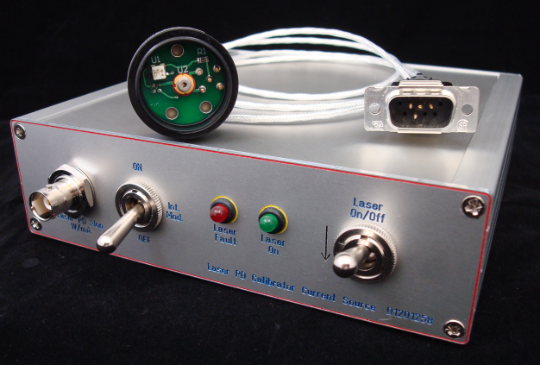

Figure 2, rear panel
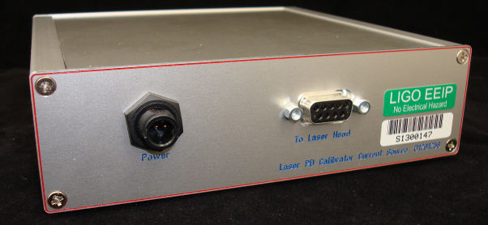

Figure 3, internal view
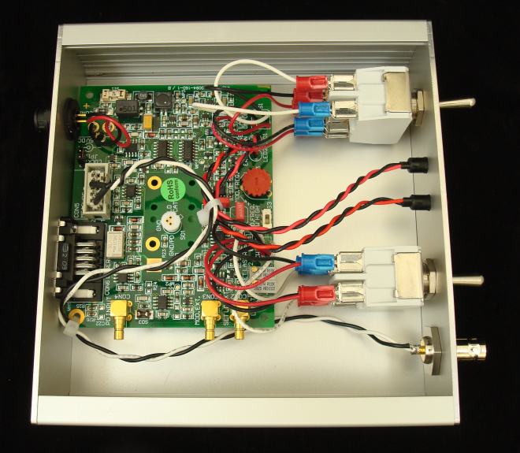

Figure 4, rear view of laser diode head showing bias and RF modulation inputs. The 1.85mW power is residual from a previous laser diode, and is not applicable to this design.
