LIGO-T1200433-v4 H1 HAM3 Gouy Telescope Preparation
D. Jones, C. Gray and K. Kawabe
Dec/21/2012

References
- S. Waldman, “ISC In-Vacuum Gouy Phase telescopes”, LIGO-T1000247 (https://dcc.ligo.org/cgi-bin/private/DocDB/ShowDocument?docid=11582)
- S. Waldman and V. Frolov, “L1 HAM3 Gouy Telescope Preparation”, LIGO-T1200040 (https://dcc.ligo.org/cgi-bin/private/DocDB/ShowDocument?docid=86271)
- L. Barsotti, “aLIGO ISC Optics: Super-polished Lenses”, LIGO-E1000845-V1 (https://dcc.ligo.org/cgi-bin/private/DocDB/ShowDocument?docid=26509)
- Nicholas Smith, ALM mode matching and beam propagation solutions for MATLAB (https://github.com/nicolassmith/alm)
- As-built pictures of H1 HAM3 QPD sled in resource space, https://ligoimages.mit.edu/?c=1182

As-built dimensions
Experimental apparatus as well as as-built dimensions are shown in Figure 1. A beam with a known mode shape (see below for details) was injected into the first lens. The first steering mirror after the second lens was removed, and the mode shape downstream of the second lens was measured using Coherent ModeMaster. The lens spacing (nominally 275mm [1]) was adjusted so that the beam downstream of the lens best matches the mode shape predicted by a nominal lens spacing and the source beam parameters. The steering mirror was then reinstalled and the distance from the second lens to the two QPDs were measured and set using a ruler.
According to our analysis which is described later, the most critical parameter, i.e. the lens spacing, was 0.09mm shorter than nominal using horizontal dimension data, and 0.27mm longer than nominal using vertical dimension data, which is excellent.

Figure 1: As-built dimensions as well as the experimental setup.
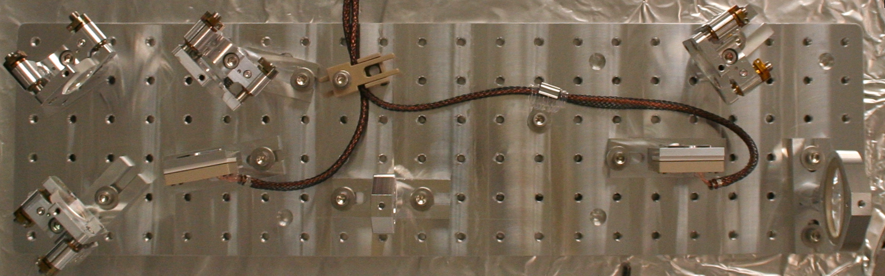Figure 2: As-built picture of the completed H1 HAM3 QPD sled.

Setup and Adjustment Details
The 2” lens (assumed f=333mm in Reference [1], actual spec f=333.6mm for 1064nm light [3]) was set up such that the curved surface of the optic faces upstream toward the incoming light. As for the 1” lens (assumed f=-56mm, actual spec -55.6mm) it was opposite, i.e. the curved surface faces downstream. In both of the lens holders, the PEEK retainer ring comes downstream.
The source produced a beam with slight astigmatism (vertical waist radius 2.49 mm at 10.85 m upstream of the last telescope lens, horizontal waist radius 2.62 mm at 7.02 m upstream, see the next section). No attempt was made to correct this astigmatism nor, unlike in the case of LLO, to mimic the IFO beam in the QPD path. Instead, we injected the beam as is and measured the transmission beam shape using Coherent ModeMaster. The last lens of the telescope was placed 747 mm away from the front surface of the lens holder of the first lens on the QPD sled.
A matlab script (HAM3_updated.m, attached in the same DCC entry as this document) propagates the source beam parameter to the ModeMaster position based on the knowledge about the optical path (i.e. location and focal length of the lenses, distance from the source to ModeMaster etc.), and calculates the overlap integral between the source beam and the beam that was actually measured by the ModeMaster. It then maximizes the overlap integral by changing the lens spacing, and finally tells the user the current lens spacing using horizontal and vertical measurements. The user then adjusts the lens spacing so the output of the script becomes equal to the nominal spacing. (Note that , empirically, if the overlap integral is smaller than 0.9, there should be something seriously wrong with the measurement, the beam quality, or both.)
This procedure eliminates the trouble of measuring “effective distance” between the lenses taking into account the position of the curved surface in relation to the lens mount and optical thickness of the substrate. This also has the benefit that small error in the focal length is automatically taken care of, to some extent, by folding such errors into the lens spacing.
Though this is not necessary as the error in QPD placement is only about 2 degree/cm for both of the QPDs (see matlab scripts in Reference [1]), the distance from the 1” lens mount to the downstream components was determined such that the distance from the downstream surface of the lens mount to the two QPDs were close enough to the nominal distances minus 8.1 mm. The 8.1 mm offset comes from the thickness of the lip of the upstream face of the mount (measured 1.6mm), mount thickness (0.5”), thickness of the lens (6.35mm) and sagitta (3.35mm), see Figure 3 for details.
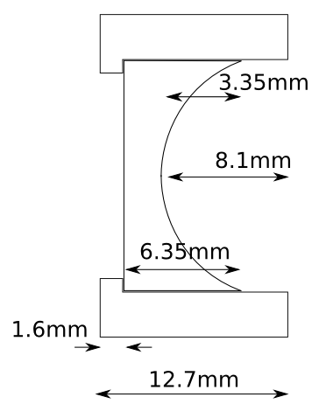Figure 3: Dimensions for f=-56mm lens and its mount.

Measured source beam parameters
The fiber-coupled laser beam, after the beam expander assembly, was indirectly measured using a plano-concave lens with the focal length of -1145.6mm (PLCC-50.8-515.1-UV) due to a technical difficulty measuring the beam as is (large Gamma factor error from ModeMaster software). The lens was placed 585mm downstream of the beam expander lens mount, and the ModeMaster head was placed 90mm downstream of the lens.
The measurement was repeated 5 times automatically and we obtained the following:
[EXTERNAL RESULTS]
Min Max Mean Std Dev Dim
-------------------------------------------------------------------------------------------------------------------
Mx 0.98 0.99 0.98 0.005 -
My 1.00 1.04 1.02 0.016 -
Mr 0.99 1.02 1.01 0.010 -
2Wox 0.256 0.258 0.257 0.0007 mm
2Woy 0.267 0.279 0.272 0.0044 mm
2Wor 0.263 0.269 0.265 0.0025 mm
2Wex 6.231 6.268 6.249 0.0177 mm
2Wey 6.143 6.165 6.152 0.0096 mm
2Wer 6.187 6.210 6.201 0.0086 mm
Zox -1.200 -1.204 -1.202 -0.0019 m
Zoy -1.209 -1.214 -1.212 -0.0023 m
Zor -1.204 -1.209 -1.207 -0.0021 m
Zrx 0.049 0.050 0.049 0.0002 mm
Zry 0.053 0.055 0.054 0.0009 mm
Zrr 0.051 0.052 0.052 0.0005 mm
Divergencex 5.17 5.21 5.19 0.020 mr
Divergencey 5.06 5.09 5.07 0.013 mr
Divergencer 5.12 5.15 5.13 0.015 mr
Astigmatism(Zoy-Zox)/Zrr -19.9 -15.9 -17.7 1.44 %
Waist Asymmetry(2Woy/2Wox) 1.044 1.081 1.059 0.0144
Divergence Asymmetry Thetay/Thetax 0.973 0.981 0.977 0.0031

Horizontal (X) measurement looks somewhat suspicious in that M² was constantly smaller than 1, but no effort was made to correct this.
After the lens effect was taken into account (see sourceMM.m in the same DCC number), the source parameters were determined as follows:
Waist radius = 2.619mm at 7.020 m upstream of the last beam expander lens for Y,
waist raduis = 2.486 mm at 10.847 m upstream of the last beam expander lens for X.

Measured beam parameters after the QPD Gouy telescope
After some adjustment, we obtained this:
[EXTERNAL RESULTS]
Min Max Mean Std Dev Dim
-------------------------------------------------------------------------------------------------------------------
Mx 1.10 1.13 1.11 0.010 -
My 1.01 1.02 1.01 0.004 -
Mr 1.06 1.07 1.07 0.003 -
2Wox 0.623 0.639 0.628 0.0057 mm
2Woy 0.638 0.641 0.639 0.0012 mm
2Wor 0.632 0.641 0.635 0.0032 mm
2Wex 1.816 1.840 1.828 0.0097 mm
2Wey 1.724 1.739 1.731 0.0069 mm
2Wer 1.777 1.784 1.781 0.0024 mm
Zox -0.714 -0.719 -0.717 -0.0023 m
Zoy -0.746 -0.753 -0.750 -0.0027 m
Zor -0.730 -0.733 -0.731 -0.0013 m
Zrx 0.259 0.267 0.262 0.0029 mm
Zry 0.296 0.301 0.298 0.0017 mm
Zrr 0.276 0.283 0.279 0.0023 mm
Divergencex 2.39 2.41 2.40 0.009 mr
Divergencey 2.13 2.16 2.15 0.010 mr
Divergencer 2.26 2.28 2.27 0.008 mr
Astigmatism(Zoy-Zox)/Zrr -13.9 -10.0 -11.9 1.48 %
Waist Asymmetry(2Woy/2Wox) 1.002 1.025 1.018 0.0084
Divergence Asymmetry Thetay/Thetax 0.891 0.900 0.896 0.0041

M² for the X measurements was not excellent but again no effort was made to correct this, as the beam was centered on the lenses and no excessive tilt of the lenses was present.
Matlab script HAM3_updated.m calculates that the equivalent lens spacing in a thin lens approximation was 274.91mm with 99.1% overlap integral using the data for horizontal dimension, and 275.27mm/99.9% for vertical, as opposed to the nominal distance of 275mm (Figure 4 and 5).
With an error of 0.6mm in the lens spacing, the Gouy separation between QPD1 and QPD2 will be 85 degrees, which is still excellent (see Calcuate_POP_DC2.m).
Figure 4: Measurement result for horizontal direction. This is not to be confused with the propagation of the IFO beam, which is found in Reference [1].

Figure 5: Measurement results for vertical direction. This is not to be confused with the propagation of the IFO beam, which is found in Reference [1].

