AUTHOR(S) | DATE | Document Change Notice, Release or Approval
Jason Oberling, Doug Cook, Dennis Coyne, Eric James | 2 June 2014 | see LIGO DCC record Status
Instructions on the use of this document:
1) Use, and complete, this document on a laptop computer while the work is proceeding. When operating in a cleanroom, use a cleanroom compatible laptop. This procedure must be available at all times during the alignment process. In addition, all of the applicable documents must also be available for reference during the procedure from the laptop computer.
2) Use this alignment procedure as a check list for preparation and during the alignment; as each step is completed, enter the name of the person completing the work (or approving or checking the step), as well as the date and any comments or notes. In particular, note any discrepancies or deviations and augment with any missing definition. ALL NOTES MUST BE RECORDED IN THE COMPLETED VERSION OF THIS DOCUMENT (NOT IN OTHER NOTEBOOKS OR FILES). If the additional notes are too cumbersome to include within the body of this completed procedure, then electronically attach them to the completed procedure.
3) Once completed, file the document in the LIGO Document Control Center (DCC) as the next highest version of the procedure and add a note that this is a completed/finished procedure.
4) File any significant notes or data from the completed procedure in the electronic logbook (such as any deviations); as a minimum note in the electronic logbook that the alignment was completed in accordance with this procedure (cite document number and revision).

Contents
1 SCOPE 3
2 APPLICABLE DOCUMENTS 3
3 COORDINATE SYSTEMS/REFERENCES 4
3.1 BSC Chamber 4
3.2 Mechanical Test Stand 4
4 PREREQUISITES FOR CARTRIDGE ALIGNMENT 4
5 REQUIRED EQUIPMENT LIST 5
6 PROCEDURE FOR CARTRIDGE ASSEMBLY ALLIGNMENT 5
6.1 Cartridge set-up 8
6.1.1 Check optics table level on the BSC mechanical test stand 8
6.1.2 Approximately align the Cartridge Assembly elements with the templates. 8
6.2 L1 ETMx 8
6.2.1 Setup the ETM Retro-reflector Assembly 8
6.2.2 Setup Total Station and Laser Autocollimator 10
6.2.3 Set the ETM longitudinal position 10
6.2.4 Set the ETM horizontal position 10
6.2.5 Coarse Align the ETM Yaw 11
6.2.6 Iterate/re-Check 11
6.2.7 Check the ETM vertical position 12
6.2.8 Fine Align the ETM Yaw 13
6.2.9 Align the ETM pitch 13
6.2.10 Check the CP to ETMy Gap 13
6.3 Transmission Monitoring Assembly (Transmon) 14
6.3.1 Set up Total Station for Transmon Alignment 14
6.3.2 Install Transmon Alignment Targets 15
6.3.3 Align the Transmon Horizontal/Vertical Position 15
6.3.4 Align the Transmon Pitch/Yaw 15
6.3.5 Iterate/re-check 16
7 ALIGN THE CARTRIDGE ASSEMBLY IN THE BSC CHAMBER (IN SITU) 16
7.1 In-Chamber Alignment 16
7.1.1 Level the Optics Table and set its vertical position 16
7.1.2 Setup the Total Station and Laser Autocollimator 17
7.1.3 Measure Axial Position Error of ETMx 18
7.1.4 Measure Lateral Position Error of ETMx 18
7.1.5 Measure Vertical Position Error of ETMx 19
7.1.6 Measure Pitch & Yaw Errors 19
7.1.7 Translate Cartridge with HEPI to Correct Axial, Lateral, Vertical and Yaw Errors 20
7.1.8 Correct Pitch Error 20
7.1.9 Fine Pitch & Yaw Error Correction 20
8 Align Arm Cavity Baffle (ACB) Assembly 21
9 Align Pcal Periscope Assembly 21

SCOPE
The scope of this procedure is alignment of the optical elements of the LBSC4 chamber, which includes alignment of the following optical elements:
- L1 ETMx (part of the quad suspension assembly, D0901346)
- Arm Cavity Baffle (ACB; D0901376)
- Transmission Monitoring Assembly (D0901880)

This procedure starts with the preliminary alignment of the optical payload elements of the LBSC4 chamber in the “cartridge assembly” and then proceeds to the alignment of these same optical payload elements within the LBSC4 chamber. The “cartridge assembly” is comprised of the BSC ISI system with all of the payload elements (which are capable of fitting onto the test stand) integrated onto the optics table and the stage 0 structure of the BSC-ISI. The cartridge assembly is integrated and aligned while on the BSC mechanical test stand. The cartridge is then lifted, flown to the chamber and lowered into position onto the BSC support tubes.

This procedure does not cover the procedures for installing assemblies onto the BSC-ISI platform or for balancing and leveling the BSC-ISI optics table; these procedures are defined in separate documentation.

This procedure does not cover internal alignment of the Transmission Monitoring Assembly (Transmon) components with respect to each other or to the Transmon structure. This procedure is limited to aligning the Transmon Assembly with respect to the BSC4 cartridge.

APPLICABLE DOCUMENTS
Listed below are all of the applicable and referenced documents for the initial alignment procedures. This list gives the latest revisions of the documents; within the alignment steps, only the document number (and not the revision) is quoted.

Document No. | Document Title
E0900047 | LIGO Contamination Control Plan
T1000230 | AOS Initial Alignment Requirements Final Design Document
T080307 | Initial Alignment System Design Requirements Document
T1000447 | Flow Chart AOS/IAS H1, H2 & L1 ETMs Alignment
D0900471 | aLIGO Systems, BSC4-L1 Top Level Chamber Assembly
D0901346 | aLIGO SUS Quad Assembly Top Level
E1100537 | Transmission Monitor Telescope Suspensions Final Design
T1100318 | Total Station modifications for stabilizing unit when Laser Autocollimator is Attached
E1100374 | Survey Data for LLO
T080230 | Quad Pendulum Structure Pushers
M1100068 | BSC Door Removal and Installation Procedure

COORDINATE SYSTEMS/REFERENCES

BSC Chamber
The local BSC chamber coordinate system origin is the point where the horizontal, cylindrical axes of the main access portals meet. The local BSC chamber coordinate system axes are aligned to the local gravity vector. Z is vertical (+Z is up). X and Y are both horizontal and approximately aligned to the global coordinate axes (as defined in T980044). The local BSC chamber coordinate system origin is nominally located 65.421 in [1661.7 mm] below the BSC-ISI optics table surface.

Mechanical Test Stand
The local mechanical test stand coordinate system origin is located 65.421 in [1661.7 mm] below the BSC-ISI optics table surface and centered between the row of mounting holes which interface to the BSC-ISI stage-0 structure (and represent the support tubes installed into the BSC chambers). The local mechanical test stand coordinate system axes are aligned to the local gravity vector. Z is vertical (+Z is up). X and Y are both horizontal and approximately aligned to the global coordinate axes.

PREREQUISITES FOR CARTRIDGE ALIGNMENT
- The BSC mechanical test stand must be set so that the interface plane with the BSC-ISI stage 0 is horizontal
- The features of the BSC mechanical test stand which interface to the BSC-ISI platform shall be used to establish a centerline and two offset lines with alignment monuments/references in the floor, as depicted in the D1200076 (see also Figure 1)
- An appropriate clean room should be installed over the test stand (see Figure 1)

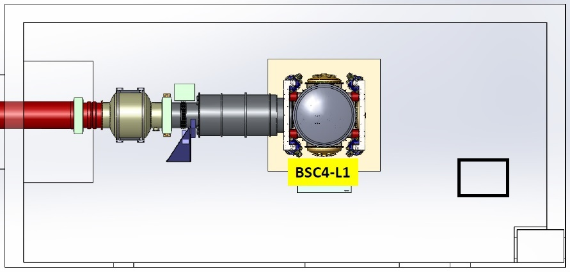
BSC TEST STAND
Figure 1 Test Stand location within the X-End Station VEA

- The BSC-ISI must be placed, and bolted, to the test stand, offset from the center of the test stand by -179.0 mm in the x-direction. This allows the TMSx to be integrated into the cartridge assembly while on the test stand
- All payload assemblies must be acceptance tested (to the extent possible and planned) prior to integration into the cartridge assembly
- The ETMx suspension must be capable of being electronically damped while on the test stand and later when in the chamber
- All IAS operations on the cartridge assembly are to be made with the BSC ISI in its locked mode. Verify that the ISI is locked
completed, approved or checked by:
date:
comments (optional):

REQUIRED EQUIPMENT LIST
  - Total station (either a Sokkia Set2BII or a Sokkia SetX1 modified per T1100318) with tripod stand
  - Laser autocollimator (Newport LDS Vector and LDS1000 controller)
  - Optical level (Sokkia B2o AutoLevel with micrometer option, or equivalent) with tripod stand
  - Precision bubble level
  - Optical Transit Square (Brunson model 75-H) with stand
  - Mechanical locating templates for ETMY suspension and TMS assembly (D1101050 -5 through -8, cleaned to Class B per E0900047 and E960022)
  - Precision pushers (D060052, cleaned to Class B per E0900047 and E960022)
  - Mover assemblies (D1100018, cleaned to Class B per E0900047 and E960022)
  - Retro reflector assembly (D1101340, cleaned to Class B per E0900047 and E960022)
  - Depth Gauge with plastic probe tip (and sufficient range to measure the distance from the optic to the retro-reflector)
  - BSC table height target (D1101611).
  - Various optical or tripod stands

PROCEDURE FOR CARTRIDGE ASSEMBLY ALLIGNMENT
The reference monuments for the cartridge assembly on the test stand are given in E1100374, and in Figure 2, for convenience.
The LBSC4 cartridge assembly is depicted in Figure 3. The major optics assemblies integrated into the LBSC4 cartridge are the X End Test Mass (ETMx) and End Reaction Mass (ERMx), both parts of the suspension assembly (D0901346). The Arm Cavity Baffle which is destined for the LBSC4 chamber is not part of the cartridge assembly as it interferes with the test stand, it will be installed separately.
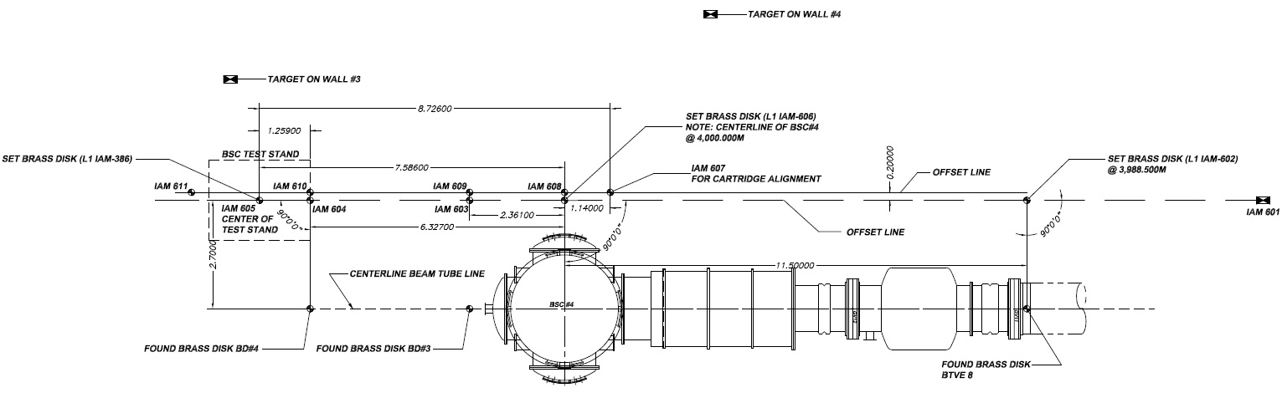
Figure 2: Monument Layout for X-End Station Test Stand (from E1100374)

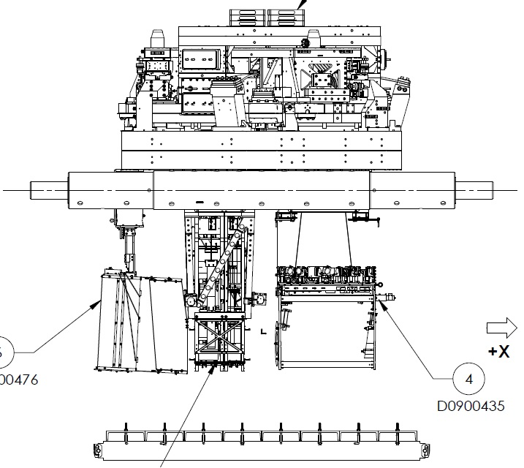
ARM CAVITY BAFFLE

ETM SUSPENSION ASSEMBLY

TRANMISSSION MONITOR ASSEMBLY (TRANSMON)
Figure 3: The LBSC4 cartridge assembly (from D0900471)
The Arm Cavity Baffle (ACB, D0901576) will not be a part of the cartridge assembly since it interferes with the test stand.

Cartridge set-up

Check optics table level on the BSC mechanical test stand
Datum: Local gravity
Equipment: Optical level on tall tripod and targets on invar rods suspended from the optics table
Accuracy: ±100 microrad (0.1 mm differential height)
Procedure:
- Attach 3 invar rods with targets to the table (equal lengths sufficient to be seen by optical level on tripod). Position the rods so that all 3 can be observed from a single optical level position
- Place optical level on a tall tripod and sight the relative difference in target heights to determine tip and tilt of optics table
- Adjust ISI trim/balance mass per E0900357 (v20, section 1.84)
- Record table levelness:
Level | mm

Approximately align the Cartridge Assembly elements with the templates.
Datum: Bolt holes in optical table per D1101260
Equipment: Alignment templates (D1101050). Each suspension has two sets of templates. Either set may be used but not both
ETMY Suspension: Use either D1101050-19 or D1101050-20
Transmission Monitoring Suspension: Use either D1101050-21 or D1101050-22
Accuracy: Clearance in bolt holes
Procedure:
- Install D1101050-19 or D1101050-20 template per D1101260
- Install D1101050-21 or D1101050-22 template per D1101260
- If needed, install precision pushers (D060052) per T080230 adjacent to ETM structures opposite of the templates
- Push ETM and Transmon structures to contact the templates per T080230
- Lock down suspension structures
- Remove all templates

L1 ETMx

Setup the ETM Retro-reflector Assembly
Datum: Optical axis of the test mass
Equipment: Retro-reflector assembly (D1101340), depth gauge with plastic contact
Note: This is the old retro-reflector assy; need D# for new assy
Accuracy: ± 0.2 mm
Procedure:
- Attach the retro-reflector assembly to the quad structure in front of the ETM HR face
- Use the depth gauge to measure the offset distance from the retro-reflector assembly reference plate (square plate behind corner cube retro-reflector) to the ETM HR face. Do this on the right and left side of the plate and average two values to get the offset distance.
Take care to clean the depth gauge, especially the contact feature. Contact the optic either on the outer perimeter of the HR face where there is no First Contact ™ film or in the interior but only on the First Contact™ film and be sure to contact very gently.
- Record the Offset (X-distance)
Offset distance from the ETM HR face to the Reflecting Plane of the Retro-reflector | 46.0 mm

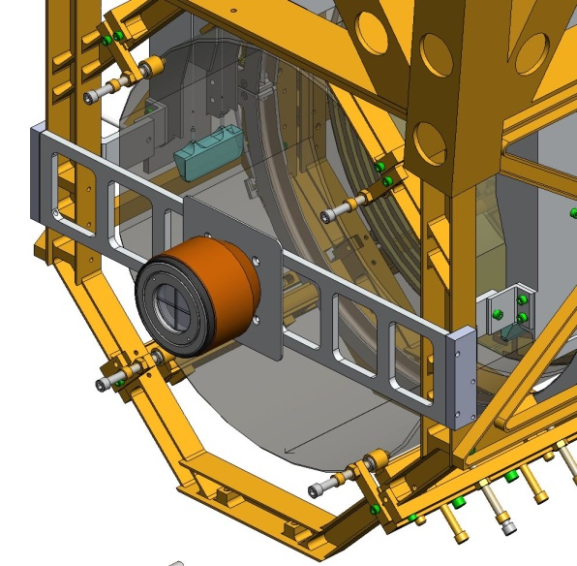
Figure 6: Retro-reflector Assembly attached to Quad Suspension Structure

Setup Total Station and Laser Autocollimator
Datum: Monuments IAM 607 and IAM 611 – axis 200 mm shifted from the centerline; Height target is placed on the precision length rod (D1101611) to set target to optic height below the optics table
Equipment: Sokkia SET1X total station, Newport Laser Autocollimator (mounted on top of Total Station), height target (D1101611)
Accuracy: ±1 mm, ±40 microradians rss, alignment reference transfer (see T1000230-v6, section 17)
Procedure:
- Set the SET1X to approximately 973 mm above the floor
- Set the SET1X on IAM 607 and sight IAM 611 to define zero yaw angle
- Attach the height target to the optics table on a hole which is set back from the edge of the table toward the total station about the same amount as the front (HR) face of the ETMy optic
- Set the SET1X pitch up at 315 microradians (0° 1’ 5”); this is a SET1X reading of 89° 58’ 55”
- Yaw the total station to sight the height target and adjust total station height to match the height target. The total station is now at a height such that its projected beam centerline should intersect the center of the HR face of the ETM (i.e. -80 mm Z)

Set the ETM longitudinal position
Datum: SET1X EDM, Retro-reflector and offsets to the HR face (determined in section 6.2.1)
Equipment: Sokkia SET1X Total station, retro-reflector
Accuracy: ±3 mm
Procedure:
Use the SET1X EDM to set the ETM position to L = 8224.0 mm (remember to account for the offset distance)
- Lock-down the optics and masses, of both suspension chains, with the earthquake stops according to the SUS procedure
- Measure the ETMx longitudinal position (accounting for the offset)
- If the error in position is greater than ±3 mm, then use the use the “mover assemblies” (D1100018) and “pusher assemblies” (D060052) to shift the longitudinal position of the quad structure as needed
- Record the final position
Retro-reflector to HR face offset (+) | 46.0 mm
EDM distance (+) | 8177.0 mm
Sum = L (ETM longitudinal position) | 8223.0 mm

Set the ETM horizontal position
Datum: Optical axis as established by the total station
Equipment: Sokkia SET1X total station, pusher assembly (D060052), mover assembly (D1100018)
Accuracy: ±1 mm
Procedure:
- With the SET1X at a 1’ 5” elevation angle, sight the left edge of the optic. Record the yaw angle (left optic edge = 360° – angle sighted).
- Sight the right edge of the optic. Record the yaw angle (right optic edge = angle sighted).
- Calculate the Center Error Distance (formula given in table below)
 | Trial 1 | Trial 2 | Trial 3
Left optic edge (A) | 19.665 mrad | 19.940 mrad | mrad
Right optic edge (B) | 20.090 mrad | 19.853 mrad | mrad
Center error angle  E = (A-B)/2 | -212.5 microrad | 43.5 microrad | microrad
Center error distance  L * E | -1.75 mm | +0.36 mm | mm
- Use the “mover assemblies” (D1100018) and “pusher assemblies” (D060052) to shift the lateral position of the quad structure as needed, so that the retro-reflector center is centered in the theodolite (Total Station)

Coarse Align the ETM Yaw
Datum: Optical axis as established by the total station
Equipment: Laser autocollimator mounted on top of the Total Station
Accuracy: ±1 milliradians goal (limited by the repeatability in the pusher and clamping method)
Procedure:
- Use yaw bias commands to the SUS reaction chain (so as not to be confused with reaction chain reflected beams)
- Insure that the optics and masses, of the main suspension chain, are free (not clamped or on the mechanical or earthquake stops)
- Use the laser autocollimator to measure the TM optic yaw angle
- Use the pusher assemblies to reduce the yaw angle to as close to zero as possible (< 1 mrad), using the SUS procedures. Note that the optics and masses should be clamped before attempting to move the Suspension frame/assembly on the optics table.
- Record residual yaw error
 | Trial 1 | Trial 2 | Trial 3
ETM yaw error | 0.045 mrad CW | mrad | mrad

Iterate/re-Check
Datum: Local gravity, optical axis as established by the total station
Equipment: Optical level on tall tripod and targets on invar rods suspended from the optics table, total station
Accuracy:
levelness: ±100 microrad (0.1 mm differential height)
lateral position: ±1 mm
longitudinal position: ±3 mm
yaw: ±1 milliradians
Procedure:
- Re-check table level
- Re-check the lateral & longitudinal position and yaw and iterate until all are within required accuracy (coarse accuracy for the yaw)
- Remove the retro-reflector and mount assembly from the ETM
Once this step has been completed, the ETM “frame” has been set; all further adjustments to the ETM are on the suspension chains.

Check the ETM vertical position
Datum: Optical axis as established by the total station
Equipment: Sokkia SET1X Total Station
Accuracy: ±1 mm
Procedure:
- With the SET1X at zero yaw angle, sight the bottom edge of the optic. Record the pitch angle (bottom optic edge = angle sighted - 89° 58’ 55”).
- Sight the top edge of the optic. Record the pitch angle (top optic edge = 89° 58’ 55” – angle sighted).
- Calculate the Center Error Distance (formula given in table below)
 | Trial 1 | Trial 2 | Trial 3
Bottom optic edge  (A) | 20.750 mrad | 20.824 mrad | mrad
Top optic edge (B) | 20.677 mrad | 20.652 mrad | mrad
Center error angle  E = (B-A)/2 | -36.5 microrad | -86 microrad | microrad
Center error distance  L * E | -0.3 mm | -0.7 mm | mm
- The optic height was set during the SUS assembly and should be correct. However, if it is out of tolerance, then use the SUS procedure in E#?, section ?, to adjust the test mass height until it is within the required accuracy

Fine Align the ETM Yaw
Datum: Optical axis as established by the total station
Equipment: Laser autocollimator
Accuracy: ±100 microradians (limited by air buffeting in the test stand/cleanroom environment)
Procedure:
- Use yaw bias commands to the SUS reaction chain (so as not to be confused with reaction chain reflected beams)
- Insure that the optics and masses, of the main suspension chain, is free (not clamped or on mechanical or earthquake stops)
- Then use the top blade adjusters to reduce the residual error further, using the SUS procedures
- Record the yaw error
 | Trial 1 | Trial 2 | Trial 3
ETM yaw error | 0.045 mrad CW | mrad | mrad

Align the ETM pitch
Datum: Optical axis as established by the total station
Equipment: Total station
Accuracy: ±100 microradians (limited by air buffeting in the test stand/cleanroom environment)
Procedure:
- Use yaw bias commands to the SUS reaction chain (so as not to be confused with reaction chain reflected beams)
- Set the total station pitch to 315 microradians (1’ 5”) UP. Using the LAC, measure the pitch error
Initial ETM pitch error | microradians
- If the pitch error is < 100 microradians, record and re-adhere First Contact™ using fresh/wet First Contact™ and the procedure in E1000079
- If > 100 microradians, then adjust the upper intermediate mass pitch balance per SUS procedures
Final ETM pitch error | 20 microradians down

Check the CP to ETMy Gap
Datum: The ETMy AR face and the opposing face of the CP
Equipment: Keyance System and Laser Autocollimator
Accuracy: ±0.25 mm average/center distance, and ±1.47 milliradians parallelism (corresponding to ±0.238 mm over the diameter of the optic)
N.B.: The gap spec is driven by the EQ stops on the ERM (see T080128). The parallelism spec is driven by a combination of the EQ stops (since the parallelism will affect the gap spacing) and the avoidance of back reflections. The EQ stops mandate a gap setting tolerance of ±0.25mm, which leads to a parallelism spec of ±1.47 mrad. Back reflection avoidance is not an issue for the ERM (per T1200452). It must be noted though that the parallelism will affect the gap. What this means is that if both the gap and parallelism are at the edge of tolerance, there will be spots between the ETM and ERM that are out of spec. Therefore both gap and parallelism should be adjusted as close to their targets as possible, not just “good enough.” For a step-by-step guide to performing this portion of the alignment see E1200823.
Procedure:
- Measure & record the gap distance between the ETMx AR face and the opposing face of the ERMx with the Keyance System. This should be done as close to the center of the ETMx as possible
- If the gap is not within the allowed tolerance of the nominal 5 mm, then adjust per SUS procedures
- Measure the parallelism between the surfaces and if not within the allowed tolerance, then adjust per SUS procedures
- Record the final gap parameters
Gap Distance | 5.01 mm
Gap Parallelism | Pitch | 0.0145 milliradians
 | Yaw | 0.0145 milliradians

Transmission Monitoring Assembly (Transmon)

Set up Total Station for Transmon Alignment
Datum: Optical axis (yaw and pitch) defined by the ETMx; Height defined by the height target (D1101611); lateral position defined by monument IAM 607
Equipment: Sokkia SET1X total station, height target (D1101611)
Accuracy: ± 1mm
Procedure:
- Set up the SET1X total station directly above the IAM 607 monument
- Attach the height target to the optics table on a hole near the table edge toward the IRLAC
- Peel back (or remove) the First Contact™ coating on the HR face of the ETM so that the center of the optic is exposed
- Back-off the EQ stops so that the ETM is free
- Engage ETM damping controls
- Yaw the SET1X to sight the height target and adjust height to match target height. The SET1X is now at a height so that its retro-reflected beam will intersect the center of the test mass (i.e. -80 mm Z)
- Sight monument IAM 611 and zero the SET1X yaw reference
- With the SET1X at 0° yaw angle, pitch it up by 0° 1’ 5” (SET1X reading of 89° 58’ 55”). The SET1X is now on the optical axis and can be sighted through the ETMx into the TMSx telescope

Install Transmon Alignment Targets
Datum: Optical axis as established by the SET1X
Equipment: Transmon alignment targets (D1200252)
Accuracy: ±1 mm
Procedure:
- Lightly lock Transmon suspension
- Install the large Transmon alignment target in the entrance aperture of the Transmon telescope
- Install the small Transmon alignment target in the exit aperture of the Transmon telescope (small hole in the table between the two periscope mirrors)

Align the Transmon Horizontal/Vertical Position
Datum: Optical axis as established by the SET1X
Equipment: Sokkia SET1X total station, pusher assembly (D060052), mover assembly (D1100018)
Accuracy: ±6 mm
Procedure:
- Sight the large alignment target mounted in the input aperture of the Transmon telescope
- Adjust the Transmon horizontal and vertical position until the target crosshair is in line with the SET1X
- Record angles to sight target crosshair with SET1X (residual position error)
 | Trial 1 | Trial 2 | Trial 3
Horizontal Position | +1.1 mm | mm | mm
Vertical Position | +3.9 mm | mm | mm

Align the Transmon Pitch/Yaw
Datum: Optical axis as established by the SET1X
Equipment: Sokkia SET1X total station, pusher assembly (D060052), mover assembly (D1100018).
Accuracy: ±100 microradians
Procedure:
- Sight the small alignment target mounted in the output aperture of the Transmon telescope
- Adjust the Transmon pitch and yaw until the target crosshair is in line with the SET1X
- Record angles to sight target crosshair with SET1X (residual angle error)
 | Trial 1 | Trial 2 | Trial 3
Yaw Angle | 0 microrad | microrad | microrad
Pitch Angle | 102 microrad down | microrad | microrad

Iterate/re-check
Datum: Optical axis as established by the SET1X
Equipment: Sokkia SET1X total station
Accuracy:
vertical position: ±6 mm
horizontal position: ±6 mm
yaw: ±100 microradians
pitch: ±100 microradians
Procedure:
- Repeat steps 6.3.3 and 6.3.4 until both crosshairs are in line with the SET1X
- Remove the Transmon alignment targets from the Transmon assembley

ALIGN THE CARTRIDGE ASSEMBLY IN THE BSC CHAMBER (IN SITU)
Once in the chamber, IAS must align:
- the ETMx optic in {x,y,z, yaw} by moving the entire cartridge assembly with HEPI as a rigid body
- the ETMx optic in pitch, by adjusting the suspension
- the ETMx Arm Cavity Baffle

In-Chamber Alignment

Level the Optics Table and set its vertical position
Datum: Local gravity, BSC-ISI capacitive position sensors
Equipment: Optical Level, 3 metering rods, BSC-ISI capacitive position sensors.
Accuracy: ±100 microradians (0.1 mm differential height)
Procedure:
- Make sure all payload and balance/ballast weight is on the BSC-ISI Assembly
- Attach 3 metering rods onto the Optics Table so that all 3 can be viewed from a single Optical Level position, on a tall tripod, through the open BSC door.
- Check the Optics Table levelness optically before unlocking BSC-ISI.
- Check the height of the Optics Table by referencing elevation mark #4 with the Optical Level
- If needed, adjust the table to be level using HEPI static adjustment per procedure E040011, “HEPI Assembly and Installation Procedures”
- Unlock the BSC-ISI and compare the capacitive position sensors offset values to the offsets measured on the cartridge test stand. If necessary, adjust the balance mass to get the same capacitive position sensor offsets as achieved on the test stand.
- Confirm the Optics Table levelness (again) with the Optical Level

Setup the Total Station and Laser Autocollimator
Datum:
- Monuments IAM 614, IAM 612, IAM 605 (as defined in D1100291) – axis 200 mm shifted in the -Y direction from the X centerline
- Elevation mark #4
Equipment: Total Station; Newport Electronic Visible Laser Autocollimator (LAC); Initial Alignment Tooling Stand (D980429 through D980434); Brunson Optical Square; Metering Rods/Targets; 8” diameter Flat Mirror on a Newport Gimbal Mount and Tripod
Accuracy: ±1 mm, ±40 microradians rss, alignment reference transfer (see T1000230-v6, section 17)
Procedure:
- Remove the LA-1A Spool (on the X-manfold adjacent to the LGV12 Gate Valve) per procedure M1000357, “Spool Manifold Removal Procedure”
- Set the Initial Alignment Tooling Stand in the space vacated by the Spool, over monument IAM 614
- Setup the Brunson Optical Square
  - Set the Brunson directly over monument IAM 612
  - Sight elevation mark #4 and set the height to +71.1 mm (local coordinate system)
  - Sight monument IAM 605 to get alignment parallel to the X global axis
- Set up the Sokkia SET1X total station
  - Setup the SET1X on the Initial Alignment Tooling Stand at approximately 1810 mm above the floor directly over IAM 614
  - Mount the LAC to the top of the Total Station
  - Sight elevation mark #4 and set the SET1X/LAC height to -81.9 mm (local coordinate system)
  - Setup the large Flat Mirror with gimbal mount/tripod with an unobstructed view of, and a few meters from, the SET1X/LAC
  - Bore sight the SET1X and LAC using the Flat Mirror
- Set the SET1X to be square to the Brunson Optical Square using the LAC
- Zero the yaw reference on the SET1X
- Yaw the SET1X precisely -90° 0’ 0” (SET1X reading of 270° 0’ 0”)
- Pitch the Total Station 315 microradians (0° 1’ 5”) up. The Total Station is now pointing to the desired location of the center of the ETMx HR face

Measure Axial Position Error of ETMx
Datum: Monument IAM 614
Equipment: Retro-Reflector Assembly (D1101340), Total Station, Depth Gauge
Accuracy: ±3 mm
Procedure:
- Mount the Retro-Reflector Assembly to the ETMx Suspension Assembly structure
- Measure the distance from the Retro-Reflector reference plane to the ETMx HR face using a depth gauge
Take care to clean the measurement tool, especially the contact feature, (b) contact the optic either on the outer perimeter of the HR face where there is no First Contact ™ film or in the interior but only on the First Contact™ film and (c) contact very gently.
- Record the depth gauge measurement as well as the Retro-Reflector (corner cube) offset constant:
Retro-Reflector-to-HR face distance | 46.0 mm
Retro-Reflector (corner cube) offset constant | 30.0 mm
- Do not remove or adjust the Retro-Reflector or the mount until after the last Electronic Distance Measurement (EDM) has been completed with the Total Station.
- Use Total Station EDM to measure the axial (X) position of the ETMx HR face (remember to account for the offset distance from the retro-reflector to the optic HR face). Record the distance (desired distance is L = 5920.0 mm):
 | Trial 1 | Trial 2 | Trial 3
Retro-reflector to HR face distance | 46.0 mm | 46.0 mm | mm
EDM distance | 5874.0 mm | 5875.2 mm | mm
Sum = L (ITM HR longitudinal distance to Total Station) | 5920 mm | 5921.2 mm | mm

Measure Lateral Position Error of ETMx
Datum: X-Arm Axis derived from IAM 614
Equipment: Total Station
Accuracy: ±1 mm
Procedure:
- With the Total Station at a 1’ 5” elevation angle, sight the left edge of the optic. Record the yaw angle (left optic edge = 90° – angle sighted).
- Sight the right edge of the optic. Record the yaw angle (right optic edge = angle sighted - 90°).
- Calculate the lateral Center Error Distance (formula in table below)
 | Trial 1 | Trial 2 | Trial 3
Left optic edge (A) | 27.048 mrad | 27.489 mrad | mrad
Right optic edge (B) | 28.046 mrad | 27.683 mrad | mrad
Center error angle  E = (A-B)/2 | -499 microrad | -97 microrad | microrad
Center error distance  L * E | -3.0 mm | -0.57 mm | mm

Measure Vertical Position Error of ETMx
Datum: X-Arm Axis derived from IAM 614
Equipment: Total Station
Accuracy: ±1 mm
Procedure:
- With the Total Station at zero yaw angle, sight the bottom edge of the optic. Record the pitch angle (bottom optic edge = angle sighted - 89° 58’ 55”).
- Sight the top edge of the optic. Record the pitch angle (top optic edge = 89° 58’ 55” – angle sighted).
- Calculate the Center Error Distance (formula given in table below)
 | Trial 1 | Trial 2 | Trial 3
Bottom optic edge (A) | 29.132 mrad | 28.842 mrad | mrad
Top optic edge (B) | 28.556 mrad | 28.662 mrad | mrad
Center error angle  E = (B-A)/2 | -288 microrad | -90 microrad | microrad
Center error distance  L * E | -2.6 mm | -0.53 mm | mm

Measure Pitch & Yaw Errors
Datum: Optical axis as established by the total station
Equipment: Newport Electronic, Visible Laser Autocollimator (LAC)
Accuracy: ±50 microradians yaw goal, ±50 microradians pitch goal
Procedure:
- Insure that the optics and masses, of the main suspension chain, are free (not ‘clamped’ or on the mechanical stops or earthquake stops)
- Use the Laser Autocollimator to measure the TM optic yaw angle. All personnel should exit the chamber, purge air flow should be off or minimized, and electronic damping should be active for the suspension. If necessary, use a low pass filtering amplifier and display the pitch and yaw on an oscilloscope with trace persistence and cursors to get the average angles
- Record the pitch and yaw errors:
 | Trial 1 | Trial 2 | Trial 3
Yaw error | 1030 microrad CCW | 12 microrad CCW | 5 microrad CW
Pitch error | 180 microrad up | microrad | microrad

Translate Cartridge with HEPI to Correct Axial, Lateral, Vertical and Yaw Errors
Datum: Optical axis as established by the total station
Equipment: HEPI static adjusters, Total Station, Retro-Reflector Assembly, Newport Electronic Visible Laser Autocollimator
Accuracy: ±50 microradians yaw with HEPI, ±1 mm transverse, ±1 mm vertical, ±3 mm axial
Procedure:
- Use the HEPI static adjustment procedure (per procedure E040011, “HEPI Assembly and Installation Procedures”) to correct the axial, lateral, vertical and yaw errors until the residual errors are within the allowed tolerance.
- After, or during, HEPI adjustments measure the axial, lateral, vertical and yaw errors to guide the HEPI adjustment.

Correct Pitch Error
Datum: Optical axis as established by the total station
Equipment: ETM Suspension pitch adjuster, Newport Electronic Visible Laser Autocollimator
Accuracy: ±50 microradians
Procedure:
- Use the Laser Autocollimator to measure the TM optic pitch angle. All personnel should exit the chamber, purge air flow should be off or minimized, and electronic damping should be active for the suspension. If necessary, use a low pass filtering amplifier and display the pitch and yaw on an oscilloscope with trace persistence and cursors to get the average angles
- Use the TM Suspension static pitch adjustment procedure (E1000006-v20, section 5, “Quad Suspension Metal-Build Assembly Procedure”) to reduce the residual pitch errors to within the allowed tolerance
- Record the residual pitch error:
 | Trial 1 | Trial 2 | Trial 3
Pitch error | 180 microrad up | 8 microrad down | microrad

Fine Pitch & Yaw Error Correction
Datum: Optical axis as established by the total station
Equipment: ETM Suspension actuation (BOSEMs), Newport Electronic Visible Laser Autocollimator
Accuracy: ±10 microradians
Procedure:
- Use the Laser Autocollimator to measure the TM optic pitch and yaw angles. All personnel should exit the chamber, purge air flow should be off or minimized, and electronic damping should be active for the suspension. If necessary, display the pitch and yaw on an oscilloscope with cursors to get the average angles
- Use the TM Suspension controls interface to set pitch and yaw bias values to correct the residual errors
- Record the pitch and yaw bias values:
Pitch bias | N/A counts
Yaw bias | N/A counts
N.B.: Not aligned with bias counts.

Align Arm Cavity Baffle (ACB) Assembly
Datums: Optical axis as established by the total station
Equipment: Total station, pusher assembly (D060052).
Accuracy: ±2 mm
Procedure:
- Install and suspend the ACB from stage-0 of the ISI using procedure E1100810, “Arm Cavity Baffle Installation Procedure”
- Re-level table using HEPI (see section 7.1.1)
- Set up the total station as done in section 7.1.2
- Install the ACB Alignment Target (D1201560) into the ACB opening and secure with the provided clamps
- Sight the top crosshair of the ACB Alignment Target (this crosshair will put the ACB in the correct position when the weight of the alignment target is removed)
- If both vertical and horizontal positional errors are < 2mm, then the baffle is aligned. Otherwise, reposition using the pusher assemblies (D060052) per procedure T080230 until the positional errors are within tolerance

Align Pcal Periscope Assembly
Datum: Optical axis as established by the total station
Equipment: Total Station
Accuracy:
Longitudinal: ±6 mm
Lateral: ±2 mm
Vertical: ±2 mm
Pitch: ±5 mrad
Yaw: ±5 mrad
Procedure:
- Set the total station over monument IAM EX-T2 as done in section 7.1.2
- Align the P-Cal periscope assembly as described in Section 2.5 of E1300477

