LIGO LABORATORY
MS 100-36
PASADENA CA 91125

TEL: 626.395.2129
FAX: 626.304.9834

MEMORANDUM

DATE: Monday April 23rd 2014 (8:45am)
TO: | David Shoemaker (aLIGO Project Leader),  Carol Wilkinson (aLIGO Project Manager),  Dennis Coyne (aLIGO Chief Engineer)
FROM: | Technical Review Board (TRB):  Calum Torrie (chair)  Rodica Martin Norna Robertson Michael Smith Peter Fritschel  GariLynn Billingsley Eric Gustafson (observer)
NOTE:  SUBJECT: | Only names highlighted in bold above met individually via telephone for v5.  Technical Review Board (TRB) Report:  Recommendation and options for going forward related to the discrepancy between COC & SUS plans to make a single version of the quad ITM suspensions and the optical layout which calls for a left and right handed version of the ITM suspensions.
cc: | Need to add in CC list
Refer to: | LIGO-L1200291-v5

- Charge

  - Copy of Charge from LIGO-L1200290-v1

An Engineering Change Request (ECR LIGO-E1200943-v1) has been submitted for review and disposition. The ECR addresses the apparent need to change the orientation of the wedge angle of the Compensation Plate (CP) for the ITMy quad suspension. Clearly there is a discrepancy between COC & SUS plans to make a single version of the quad ITM suspensions and the optical layout which calls for a left and right handed version of the ITM suspensions. This Technical Review Board (TRB) has been formed to make recommendations regarding the proposed ECR. Specifically the TRB is charged to consider any and all factors in making recommendations on the following issues:

1) It has been suggested (L1200282-v3) that in order to separate the x and y ALS green beams, we need the wedge angle of CPy to be rotated 180 degrees from its current position in the ITMy suspension. Confirm or refute this finding, i.e. must the CPx and CPy wedge angle orientations be different?
2) If the CP wedge orientations must be different, then what is the best approach for accomplishing this change?, e.g. a. make new CPy optics, or
b. determine a rework design to use a CPx optic in an ITMy suspension (e.g. longer cable which attaches at top and runs down CP barrel to connect at bottom)
3) If the CP wedge orientations do not need to be different, then what is the best approach for altering the optical layout to be consistent with a common CP wedge orientation?
4) How best to proceed in the interim with installation & test, given likely time frames for accomplishing the required changes?

Time is of the essence on this issue. Please provide a written report with the TRB’s recommendations to aLIGO management by no later than 2 November 2012. However the technical issues must carefully considered. If the TRB thinks that more time is required to responsibly come to technical closure on viable options, then they are requested to inform aLIGO management, as soon as this is clear.

- TRB Report
  - Introduction

The TRB met three times via teleconference on the 22nd, 24th and 26th of October 2012. In the first meeting the TRB discussed the fundamental questions, factors to consider and determined what additional information was needed to make a recommendation. Tasks were then assigned to the team. In the second meeting this additional information was reviewed. In the 3rd meeting the committee (discussed and) agreed on the recommendations in this report.

In response to question 1 in the charge the TRB has confirmed from the Zemax models and associated report (refer to LIGO-L1200282-v4) that in order to separate the x and y ALS green beams, we need the wedge angle of CPy to be rotated 180 degrees from its current position in the ITMy suspension. However, there is an option to handle this lack of spatial separation of the green beams separately. Therefore all options will be kept alive and outlined in detail below.

After careful consideration and discussion with on-site teams at both LLO and LHO the baseline (unless stated differently below) is that all options assume that both installation and testing continues with the layout drawings that we have now and the actual single CP’s i.e. with a known mistake. All and any changes required will be handled via retrofit / switch outs / moves at later dates.

  - Options available to aLIGO management

The first 3 options below assume we would go to a left and right handed version of the ITM suspensions i.e. different CP’s.

    - Rework a CPx optic in an ITMy suspension

If we change to a left and right handed version of the ITM suspensions one option would be to re-work 2 of the existing CP’s (we currently have two on the shelf at CIT) into CPx’s for use in the ITMy suspensions. This would involve re-works to the gold pattern on the barrel of the CP and re-works to the cabling associated with the ESD. In more detail, one scenario would be to bond a new longer version ESD cables (with pad) at the “new” 12 o’clock position and run 2 of the 5 cables round the barrel of the CP barrel to connect at the 3 and 9 o’clock positions. This would take on the order of 8 weeks or 40 business days.
Assuming as stated above that installation and testing continues with the existing layout and with the single CP’s i.e. with a known mistake then this option would also involve (at some later date, estimated at least 35 days from now) the following: -
- Switch out of the CP in LBSC1 (ITMy) in chamber (utilizing existing FMP tooling i.e the BSC repair arm) – 10 days
- Switch out of the CP in WBSC1 (ITMy) in chamber (utilizing *new* and existing FMP tooling i.e the BSC repair arm) – 10 days

    - Make new CPy optics
If we change to a left and right handed version of the ITM suspensions another idea would be to make “new” CPy optics. Advanced LIGO has 9 CP’s for 3 interferometers. Currently 2 are uncoated and 7 are plated for use in the single type ITM Suspension (CPx). It costs $30,000 to strip and re-coat one optic. We have 2 which would be free i.e. they have not been plated yet. Timeframe is 60 days, through to metrology. It should also be noted that if this route is chosen that we will cut down on the number of spares available.
Again, assuming as stated above that installation and testing continues with the existing layout and with the single CP’s i.e. with a known mistake then this option would also involve (at some later date, estimated at least 80 days from now including bonding of new ESD cables and shipping) the following: -
- Switch out of the CP in LBSC1 (ITMy) in chamber (utilizing existing FMP tooling i.e the BSC repair arm) – 10 days
- Switch out of the CP in WBSC1 (ITMy) in chamber (utilizing existing FMP tooling i.e the BSC repair arm) – 10 days

    - Flip CP ITMy (without ESD available)

One further idea to consider if we change to a left and right handed version of the ITM suspensions would be to flip the CP in both ITMy assemblies (BSC1) but in this option not to re-work the gold on the barrel and the ESD connectors i.e. we would cut the ESD cables at the flex-circuit on the barrel, disconnect the cable at the other end and then remove the remaining cable. We would therefore have the CP in the correct orientation but would not have the ESD available. How big a deal is it not to have ESD available in the ITM’s? Not a big deal as really only needed in ETM’s at least for now.
It should be noted that this option would not need a re-work to the prisms as they are on the center-line. Furthermore the remaining ESD pad and cables could stay on the optic, now at the 6 o-clock position. It would however need some careful effort in terms of maintaining alignment and balance. This option would of course need us to consider either option 2.2.1 or 2.2.2 at a later date i.e. 35 to 80 days depending on which option is chosen.
Again as above in both 2.2.1 and 2.2.2 this retrofit would require in chamber work utilizing *new* and existing FMP tooling – 3 days (as no ESD re-connect).

If this option was selected now it could be done on the test stand at both sites utilizing the ergo-arm and some snips – 1 day.

The following 2 options assume we would stay with a single type of ITM suspension.

    - Handle green beams

If the CP continues as a single version as SUS / COC currently have it then ISC would need to handle the close proximity of the green beams in HAM1 and there would need to be changes to the layout. This would involve: -
- ISC devising a method to handle the close proximity of the green beams in HAM1 (via polarizing)
- The BS assembly moving 5 mm in the +X direction
- The SR3 assembly (and the baffles associated with it) moving 27 mm in the +X direction on HAM5 (see appendix below)
- Other items to be determined from Zemax model co-ordinate comparison between single CP layout and current dual CP layout. – Action on Calum.

The ISC team have explored the possibility of using polarization to separate the ALS beams. They think the technical risk of this not working is very small.
For the layout, both of the known relocations appear to be feasible after a quick look in the SolidWorks integrated chamber assemblies. Further work in SolidWorks is required, see below. Note that the BS move is not just on paper, but would require a move of the L1 BS in situ and a move of the H1 BS on the test stand. In terms of the move it would involve utilizing the “pushers and movers” for which we already have both HAM and BSC types which have already been used by teams on-site. The BSC ones can be seen at LIGO-D1100018-v3 and in use on page 8 of 8 in LIGO-D0900431-v3.
To handle this overall change we would probably also need to manufacture additional dog clamps. The one area of concern right now is the ability to balance the BS again as a result of this move, looking at the crowded picture in the appendix below gives some sense of why this is a concern. This is the reason that for this option the committee suggests that more investigation work is required here. The proposal is that O/T is increased for both Ed Chavez and Eddie Sanchez in w/b 29th October and that Calum Torrie work with both of them on the details of the proposed moves in BSC2 and HAM4.
As stated before this option would allow us to continue with installation and testing with the current layout and then move both the BS and SR3 (and any other items) at a later date, when we have the updated layouts complete and when there is an appropriate time in the schedule. As already stated this choice requires the additional effort by ISC to handle the close proximity of the green beams, see detail above.

Note - Could the 5mm BS move be done by HEPI, Calum to re-ask SEI?

Note - Could we also offer sub-option on this one where the BS is not moved now or in the near future i.e. could we get past lock with BS in current location? If so could the angular change be handled by HEPI?

    - Flip BS

Another option involving continuing with the CP as a single version would involve flipping the BS (from horizontal one way to horizontal the other way). This would involve the following: -

- Addition of new secondary prisms to existing BS optics
- Work in chamber with FMP tooling to remove / re-work then replace BS optic (this effort also involves removal of spool pieces)
- Replace wires in suspension in chamber
- Re-do of Hartmann layout in HAM4/5

Both Mike Smith and Aidan Brooks have reported that the re-layout of the Hartmann would cause severe problems to the optical layout in both HAM4/5. Mike stated in an e-mail on 10/24/2012 “If the BS wedge is reversed (thick side in -X, -Y direction), the Hartmann X beam misses SR3 and cannot be collected at SR2.”
This is therefore really not a valid option in the opinion of the committee.

    - Flip Cpx

*New* Flip Cpx. Mike Smith has been asked to look at this in Zemax 10/26/2012.

    - Putting ITMy into ITMx

*New* Putting ITMy into ITMx. Calum has agreed to look at this from a layout point of view in terms of how much movement would be needed.

- Recommendation

We the TFB recommend to aLIGO management the following: -

For LLO: - Due to the fact that the CP ITMy was already installed (Oct 2012) we will flip CP ITMy in-situ and cut ESD cabling this making the ESD un-available *. That we then leave LLO ITMy as is without ESD available for duration of project. This can occur as it is not known if ESD is needed on the ITM’s.

For LHO and 3rd IFO: -
Due to the fact that the H1 ITMy is not installed and 3rd IFO ITMy is yet to be built we will create another version of the Compensation Plate (CP) with the wedge angle flipped 180 degrees, so that there is a left-handed and a right-handed version, and implement this new CP version in the ITMy quad suspensions for LHO ** and 3rd IFO. Originally there was one version of the CP.

*The author notes that this flip is now complete at LLO.
**The author notes that this is now in the plan for the upcoming switch-out at LHO (June 2014).
- Summary of options
# | Title | Notes | Work  (Our Staff time *) | Vendor Cost / Time | Schedule Disruption (each site) | Risk | Additional Notes | Rank
1 | Handle Green Beams | See section 2.2.1 | 20-30 days on layout  plus effort on ISC side days? | 10 days for new dog clamps  New ISC Optic days? | Continue with install but need to stop and fix at later date 10 days per site | Lot of layout work required.
2 | Rework a CPx optic in an ITMy suspension | See section 2.2.2 | 20 days total | 20 days | Continue with install but need to stop and fix at later date 10 days per site
3 | Make new CPy optics | See section 2.2.3 | 20 days | 60 days | Continue with install but need to stop and fix at later date 10 days per site | Cuts down on spares
4a | Flip CP ITMy (without ESD available) | If wait until in chamber, see section 2.2.4 | See schedule | Tooling | 3 days (each site) – with further work later see option 2 or 6 | Tooling to support effort a TBD, assuming pick medium path described here ** | Must also consider options 2 or 3 in addition at a later date
4b | Flip CP ITMy (without ESD available) | If done now on test stand, see section 2.2.4 | See schedule | Zero | 1 day (each site) – with further work later see option 2 or 6 | Not done before | Must also consider options 2 or 3 in addition at a later date
5 | Flip BS | See section 2.2.5 | N/A | N/A | N/A | Committee does not consider this a viable option |  | N/A
6 | Flip CPx | See section 2.2.6 |  |  |  | Zemax work not done at this point
7 | Putting CPy into ITMx | See section 2.2.7 |  |  | Stop gap for now still need to address what to do for ITMy | New item not thought through
* Unless stated this is not INS Staff time. It is time to create e.g. new layouts, design tooling, design parts, try new optical schemes, generate new cable layouts, etc …
** There is another option not considered here in terms of flipping the CP i.e. splitting the chains and removing the suspension to chamber side which would be 10 days per site

- Appendix
LBSC1
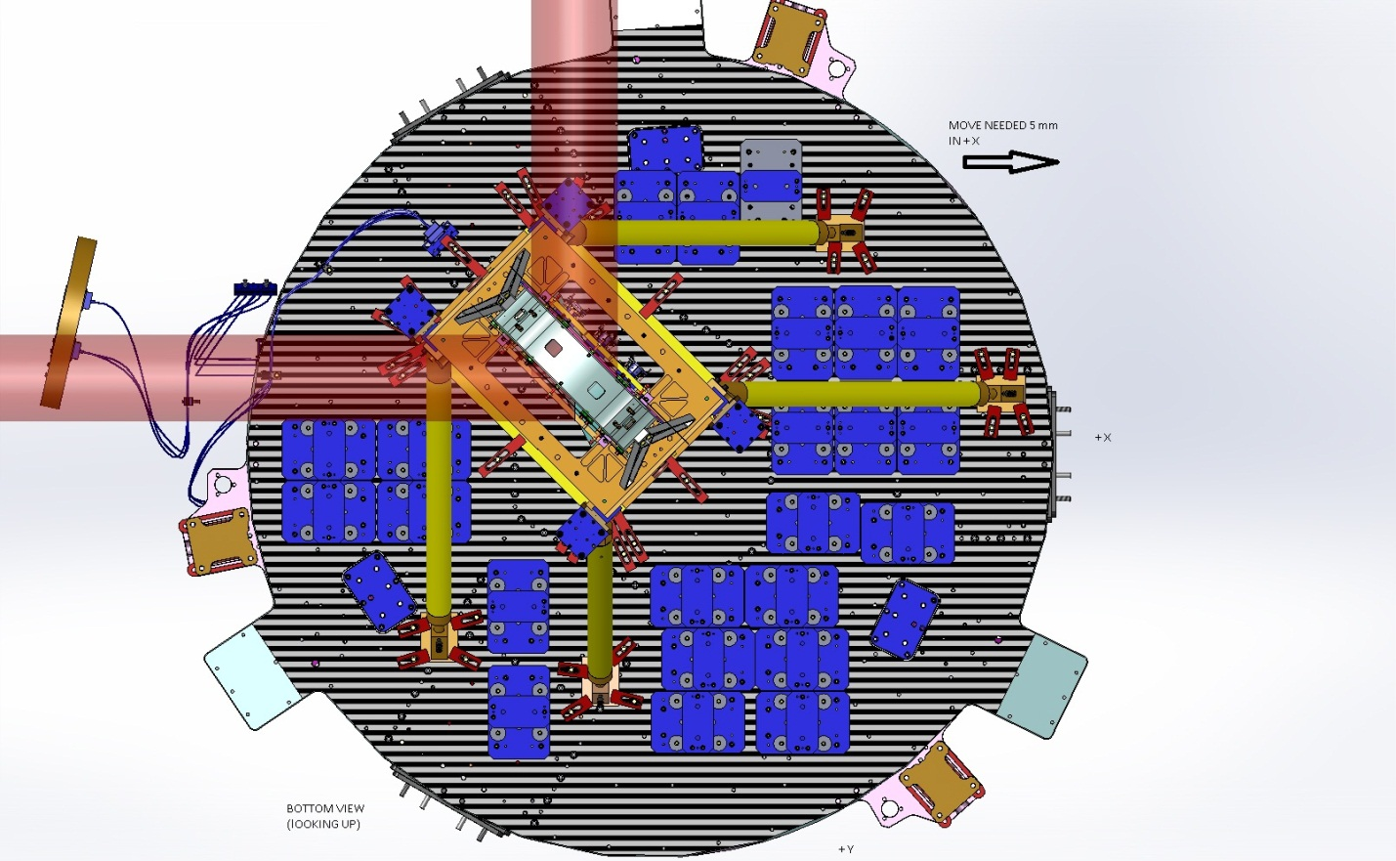

LHAM5

