In-vacuum Flexible Circuit Materials
Richard Abbott
7 November, 2012
T1200493-v2

- Overview – Flexible electronic printed circuit boards made using DuPont Kapton films are increasingly common in the LIGO vacuum system. In order to standardize on the materials and methods, a description of specific materials and methods is given.

- Description – As seen in the example flexible circuit board shown in Figure 1, there are different areas of interest that comprise this interesting assembly. The design shown (D1102368-v1) was used on the aLIGO in-vacuum beam diverter. The three gaps in between the thickened areas are points at which this circuit board was bent to follow the shape of the surface to which it was attached. The exposed copper areas are bare copper. A better implementation would be to ask for gold plating in this area to facilitate soldering (ENIG in the circuit board industry parlance).

Figure 1 Example Flexible Circuit
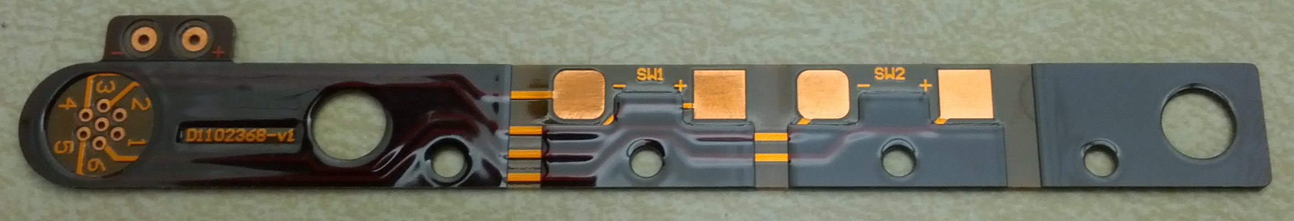

- Description of methods and materials–
  - In the LIGO DCC under the same file card as this note, there is an Excel spreadsheet from DuPont detailing the available options and part numbers for the Kapton film based product line. This will allow different final thicknesses per the design requirements
  - DuPont AP-8555R is the base material (carries the top and bottom copper layers), it is .005” thick Kapton between the two copper sheets.
  - DuPont LF-0110 is the cover layer (.001”adhesive/.001” Kapton) that performs the same function as solder mask in traditional circuit board manufacture. Don’t make the cover layer much thicker than that indicated, or else the cover layer will be taller than the copper pads.
  - The thick built-up areas (used in the successful implementation of Hughes Circuits Inc., LOT#20214, PN D1102368, Beam Diverter Circuit Board) are LF-0131(.001”adhesive/.003”kapton/.001” adhesive) + LF-0150(.001” adhesive/.005”kapton).
  - The LIGO vacuum approved adhesive is DuPont Pyralux. This film based adhesive cures at elevated temperatures and is clamped to achieve sufficient pressure for optimal adhesion.

- Example Readme Files – Shown below is an example of a readme file created during the ordering process of a flexible circuit board. The designer may elect to use different CAD layers to represent the overall board structure, but regardless of the particular choices equivalent information will be needed. For some reason, the details of the choice of cover layer material are not conveyed in this readme file. It would seem prudent to detail this cover layer as shown in the text of section 3, subsection d.

READ ME FILE
Name of PCB – Dxxxxxxx-v1
Please produce (insert quantity) PCB’s from these Gerber files.
Number of layers - two layers (2)
Number of holes - (insert quantity)
The board shape is on the mechanical layer.

Layer Description
Top overlay Layer (Polyimide top stiffener)
Top Layer (copper layer)
Polyimide Core ~ 0.005”
Bottom Layer (copper layer)
Bottom overlay Layer (Polyimide bottom stiffener)
Thickness of board ~ 0.033”

File Description and Layer order for building board:
*.GTO FOR BOTH top overlay (TOP STIFFENER)
*.GTL 0.014” top layer (copper)
*.GM1 0.005” CORE (BOARD OUTLINE)
*.GBL FOR BOTH bottom layer (copper)
*.GBO 0.014” bottom overlay (BOTTOM STIFFENER)
*.TXT NC drill file

READ ME FILE for 2012 aLIGO OMC QPD
Name of PCB – D1201311‐v1
Please produce (20) PCB’s from these Gerber files.
Number of layers ‐ two layers (2)
Number of holes ‐ (22)
The board shape is on the mechanical layer.
All exposed copper to be gold plated (ENIG)

Layer Descriptions
Top cover Layer (DuPont LF-0110)
Top Layer (copper layer)
Polyimide Core ~ 0.016”
Bottom Layer (copper layer)
Bottom cover Layer (DuPont LF-0110)
Desired Finished Thickness of board ~ 0.020”

File Description and Layer order for building board:
*.GTS top cover layer
*.GTL top layer (copper)
*.GM1 CORE (BOARD OUTLINE)
*.GBL bottom layer (copper)
*.GBS bottom cover layer
*.TXT NC drill file

Please don't forget to gold plate exposed copper. Absolutely no other materials can be used other than DuPont Kapton films, DuPont Pyralux adhesive, copper for board traces,
and gold plating over copper. This circuit board is for use in an ultra-clean environment where materials and outgassing properties are critical.

