AUTHOR(S) | DATE | Document Change Notice, Release or Approval
Dennis Coyne, Calum Torrie, Kate Gushwa | Feb 13, 2014 | See LIGO DCC Record

Table of Contents
1 USEFUL REFERENCES 1
2 INTRODUCTION 2
3 PARTS LIST 2
4 CARBON CONDUCTIVE ADHESIVE TABS (FBI Kits) 4
4.1 When to Use 4
4.2 About the Carbon Tabs 4
4.3 Approval for Use 4
4.4 Cleaning 4
4.5 Instructions for Use 5
5 SILICON WITNESS WAFERS 9
5.1 When to Use 9
5.2 Cleaning 9
5.3 Instructions for Use 9
6 1” OPTICS 12
6.1 When to Use 12
6.2 Cleaning 12
6.3 Instructions for Use 12
7 PHOTOGRAPHING METHOD 14
8 SHIPPING SPECIMENS 15
8.1 FBI Kits 15
8.2 4” Wafers & 1” Optics 15

USEFUL REFERENCES
- http://www.impublications.com/subs/books/T01_0113.pdf
- LIGO-E1201035: aLIGO Chamber Entry & Exit Guidelines
- LIGO-F1200021: Advanced LIGO Particulate Sample Form
- LIGO-E960022: LIGO Clean and Bake Methods and Procedures
- Refer to LIGO-T1300014: Aligo, BSC Flooring + HAM ISI, Witness Sample Placement Guidelines.

INTRODUCTION
This document covers techniques for collecting particulate samples using the following methods:
- Carbon Conductive Adhesives Tabs (FBI Kits)
- Wafers
- 1” Optics
Any and all surfaces can be sampled (in-vacuum, out of vacuum, metal, etc.). HOWEVER, the technique is not to be used on optical surfaces until approved by the Systems lead. Collected samples will be inspected with a Scanning Electron Microscope and an optical microscope at Caltech. Refer to LIGO-T1300014: Aligo, BSC Flooring + HAM ISI, Witness Sample Placement Guidelines.

PARTS LIST
Table 1. Parts List
Part | Manufacturer | P/N | Purchasing Responsibility
Specimen Mounts for Scanning Electron Microscope (aluminum slotted head) | Electron Microscopy Sciences | 75220 (100/pack) | CIT (Calum) to supply initially.  Sites to re-order and clean as required.
Ultra Smooth Carbon Adhesive Tabs, 12mm diameter | Electron Microscopy Sciences | 77827-12 | CIT (Calum) to supply initially.  Sites to re-order and clean as required.
EM Single Mount Storage Tube (plastic tube & plug) | Electron Microscopy Sciences | 76530-10 | CIT (Calum) to supply initially.  Sites to re-order and clean as required.
4” Wafers | Wafer Net | 100mm Test 10-20 | LHO purchased first 100.  CIT buying second 100 (March 2013).
Wafer tweezers | Ted Pella | 5049-SV | Sets at both sites.  Sites to re-order and clean as required. Bake at 150C.
Wafer carriers | Graphene Supermarket | SKU1752211 | Small inventory at both sites.  Sites to re-order and clean as required.
1” Optics |  |  | 100 on order via COC (Margot). Contact COC for inventory.
1” Optics containers | Safe-Guard Optics Packaging Containers | EW1.00-01500350 | 100 being cleaned by COC (Margot). Contact COC for inventory.
1” Optic holder (default) for HAM and BSC | Machine Shop and McMaster Carr | D1300512-v3 | McMaster-Carr P/N 92949A191 Screw, 8-32 x 5/16  McMaster-Carr P/N 93785A400 #8 Flat washer
4” Wafer Holders (default) for HAM and BSC | Machine Shop and e.g. McMaster Carr | D1300275-v3 | MS24671-1 Screw, 4-40 x .25 Lg.  MS16995-18 Screw, 6-32 x .50 Lg.  1185-06EN207 Helicoil, 6-32  1185-04EN168 Helicoil, 4-40  D1300521 Shim.
4” Wafer holders – HAM chambers (alternative) |  | D1300026 | From Cheryl. Sets at both sites.  Sites to order and clean as required. Not essential.
4” wafer holders – BSC horizontal chambers (alternative) |  | D1300026 | From Cheryl. Recommended to prevent people from standing on the wafers.  Sets at both sites.  Sites to order and clean as required.
Cameras for photographing/ filming pump down |  |  | CIT (Calum) to supply.
Dust Camera | Nikon | CoolPix S8200 16.1 MP | CIT (Calum) to supply.
Flashlights | Fenix | LD22 | CIT (Calum) to supply.
Flashlight holder assembly |  | D1300223
Digital microscope |  |  | CIT (Calum) to supply, except for laptop which should be supplied by sites.
Pelican cases | Pelican Cases |  | CIT (Calum) to supply to begin with and borrow from FTIR.  Going forward, sites to buy.
Really Useful Containers | Office Depot  Or online using key words “really useful boxes” |  | CIT (Calum) to supply to begin with and borrow from FTIR.  Going forward, sites to buy.

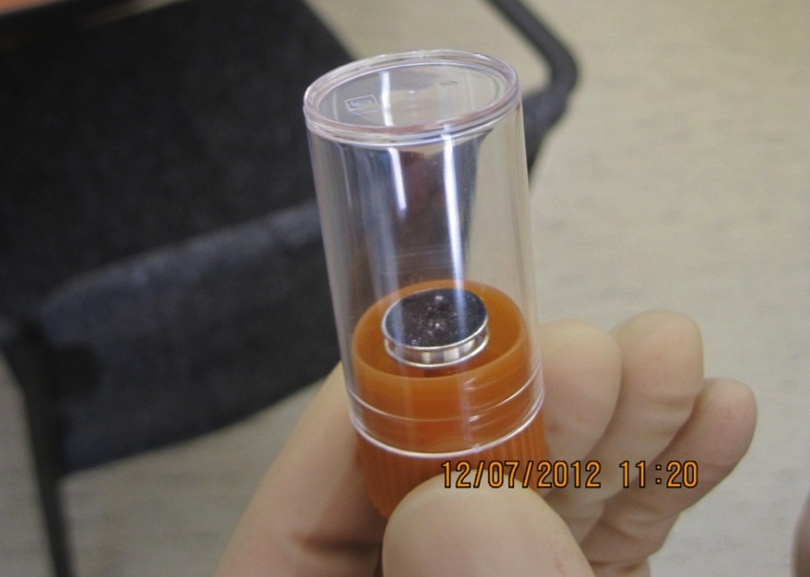
CARBON CONDUCTIVE ADHESIVE TABS (FBI Kits)
Figure 1. Assembled FBI Kit
Carbon Adhesive Tab
Specimen Mount
Plug
Tube

When to Use
The Carbon Conductive Adhesive Tabs should be used to gather samples of potentially troublesome particulates. Since sampling costs are low, sampling is encouraged.
Note: This is a change to previous statements from Systems. To clarify the change in advice, it is the analysis of the samples that is expensive, not the sampling itself. To ensure a good zoology of samples and to reiterate the statement above – SAMPLING IS ENCOURAGED.

About the Carbon Tabs
The tabs are formed by two sides of thick conductive adhesive (45 µm on each side), and a center conductive core film (35 µm). The tabs are protected with white liners.
Refrigeration will increase shelf life, so tabs should be stored in a refrigerator if possible. (Calum to find out about shelf life and temp to store at). (When and if we start using refrigerated tabs they will need to be removed from the fridge 2 hours before use). The service temperature is up to 60ºC (140ºF). The adhesive can be removed by ethyl acetate, ethanol, isopropyl alcohol, or alcohols. The recommendation is to use Spectra-grade isopropyl. For more information, refer to the vendor’s website.

Approval for Use
Though several chemicals can be used to remove the adhesive, the recommended removal method is Spectra-grade isopropyl. Dennis Coyne approved this method on December 7, 2012. FTIR tests were started on the same day to ratify the approval. FTIR test results will be included in a future release of this document. In the meantime, if you have any questions contact Dennis Coyne or Calum Torrie.

Cleaning
Class B clean the aluminum parts per LIGO-E960022: LIGO Clean and Bake Methods and Procedures. Prior to use, the aluminum should be wiped down with acetone.
The plastic storage tube and plug must be cleaned in DI water and Liquinox for 20 minutes, rinsed with DI water for 10 minutes, then fan dried in a hepafilter oven at room temperature. The plastic is then cleaned in a 50/50 mixture of DI water and IPA, and allowed to air-dry.

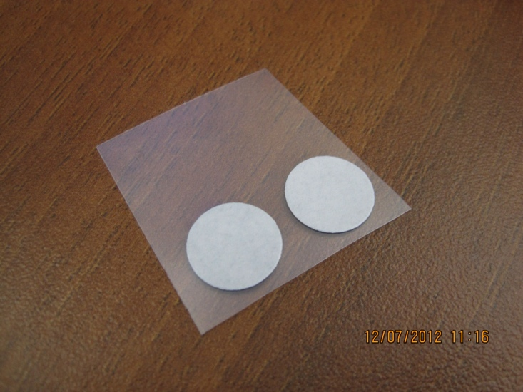
Instructions for Use
Figure 2. Carbon Adhesive Tabs
Cut here
The following steps describe how to prepare, collect, and store a sample:
- Reserve a new DCC “T” number.
- Add the DCC number to the list of related documents for LIGO-T1300198: Grouping of “FBI” Carbon Adhesive Tab Specimens. This is done by changing the metadata. Do not create a new revision.
- Put on gloves.
- Identify the 12mm diameter Ultra-Smooth Carbon Adhesive Tabs on acetate, shown in Figure 2 with the white tab side facing up. Cut the acetate in half to separate the tabs.
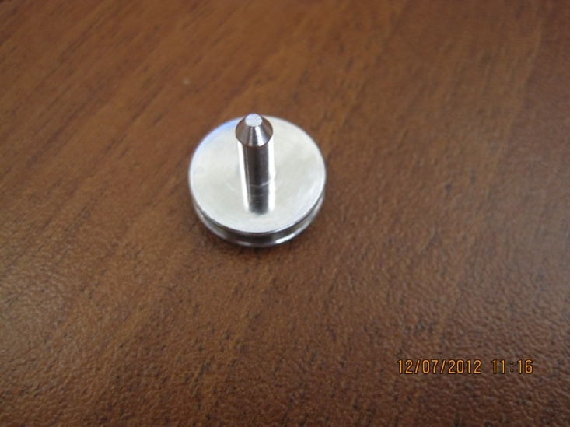
- Scribe a fiducial on the Specimen Mount for the Scanning Electron Microscope (aluminum mount slotted head) with a vibratory tool or equivalent. Wipe with acetone to remove any dust generated from scribing.
Figure 3. Specimen Mount for SEM
Mark fiducial
- Insert the Specimen Mount into the Storage Plug, as shown in Figure 4 and Figure 5.
- Wipe Specimen Mount with acetone.
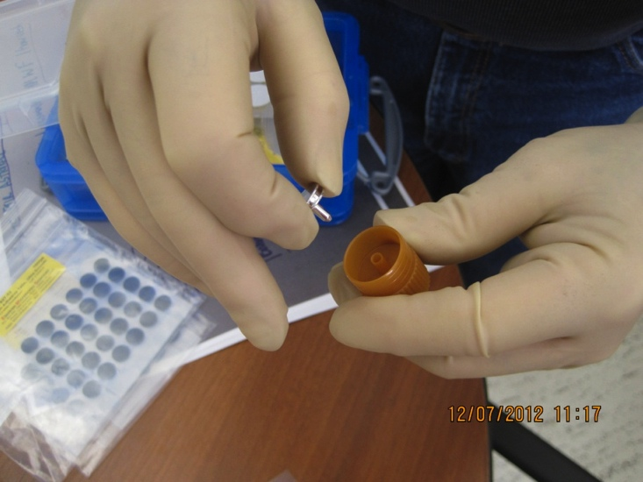
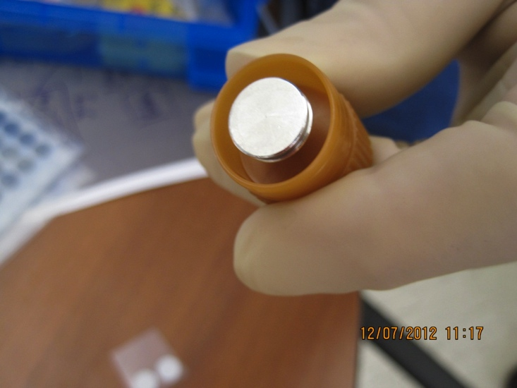
Figure 4. Inserting Specimen Mount into Storage Plug
Figure 5. Specimen Mount attached to Storage Plug
- Peel acetate away from Carbon Adhesive Tab (using tweezers if necessary).
- Holding the white tab, stick the Carbon Adhesive Tab onto the Specimen Mount.
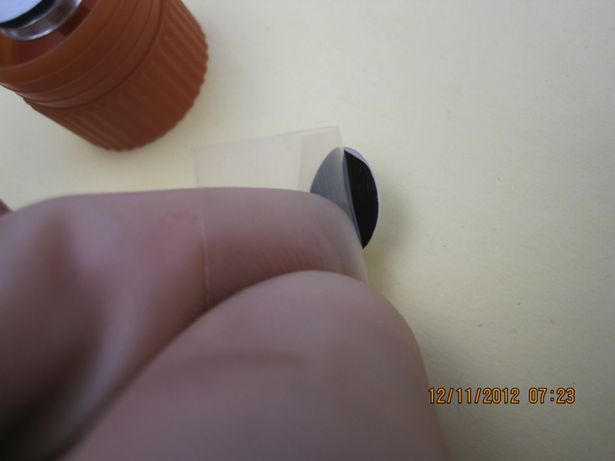
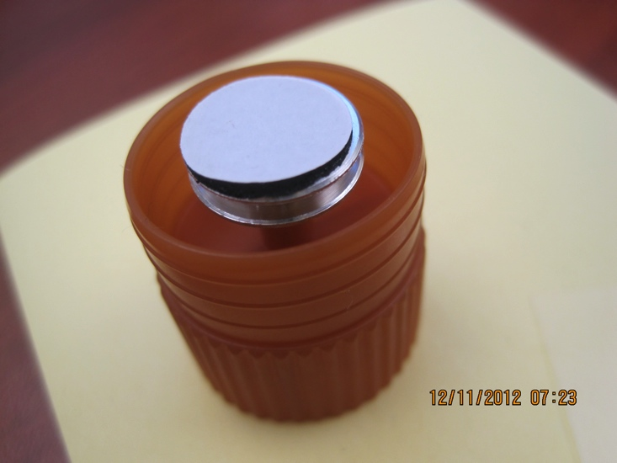
Note: If the tab is damaged during this step, clean the Specimen Mount with acetone again prior to re-using.
Figure 6. Peeling back acetate
Figure 7. Tab stuck on Specimen Mount
- Photograph the area that will be sampled. See Section 7 for more information on photographing contamination in chamber.

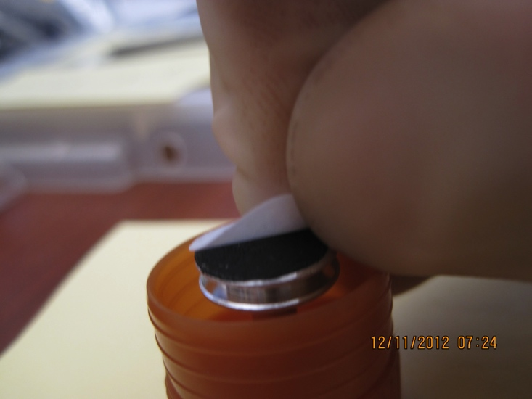
- When ready to collect a dust sample, remove the white tab (with gloved hands).
Figure 8. Removing white tab for sampling
- While holding the Storage Plug, press the Carbon Adhesive Tab onto the desired sample area.
- Remove FBI Kit vertically from sample area. Do not try to peel off sideways.
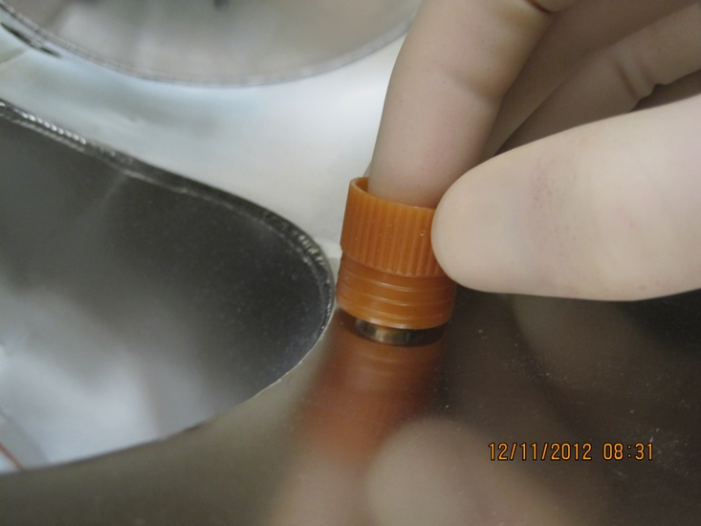
Note: Only press the tab down once per sample collection.
Figure 9. Pressing tab over sample area
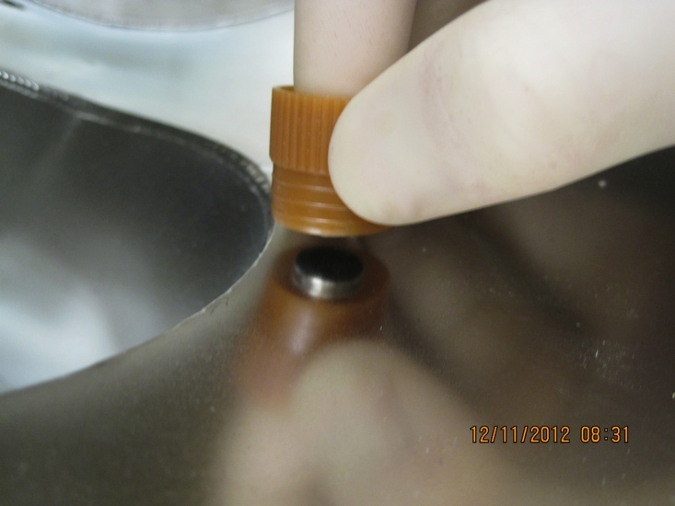
- Place the plastic tube over the sample, and push into the plug.
Figure 10. Removing tab from sample area
- Store sample facing up in a Very Useful Box as shown in Figure 11.
- Wipe the area where the sample was taken with Spectra-grade isopropyl to remove any residue left by the tab.
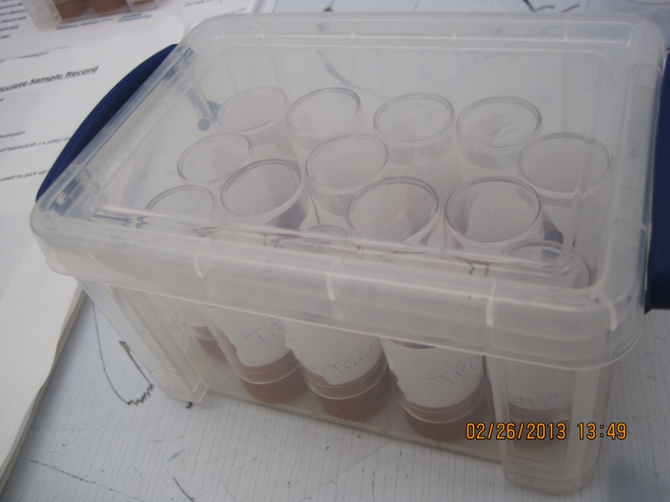
- Mark the DCC number on the bottle with a sharpie or equivalent.
Figure 11. FBI Kit samples stored in Very Useful Box
- Fill out the LIGO-F1200021: Particulate Sample Form, and post it to the DCC.
Note: Alternatively, this information can be noted in an aLOG if it is linked to the DCC entry.

SILICON WITNESS WAFERS

When to Use
Two 4” silicon wafers should be placed in each chamber on or adjacent to the beam centerline (as viewed from above). The default should be to place one the wafers vertically as close to the core-optics as possible. The second wafer can be placed horizontally on the ISI table in HAM chambers, and horizontally on the flooring in BSC chambers. Left hand image below shows vertical wafer attached to a ETM suspension and right hand image shows vertical wafer mounted on a HAM-ISIS adjacent to a HXTS. In both cases wafers are mounted in LIGO-D1300275-v3 (Vertical Wafer Holder).
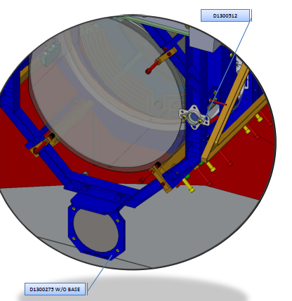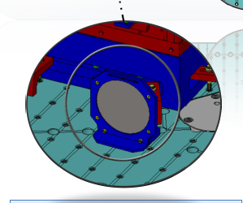
Always refer to LIGO-T1300014: Aligo, BSC Flooring + HAM ISI, Witness Sample Placement Guidelines.

Cleaning
The 4” wafers come from the vendor clean.
The wafer containers are sent to the sites dirty. They must be sonicated for 10 minutes in 1% Liquinox the rinsed with DI water. The containers are then air-baked at 50C for 24 hours.

Instructions for Use
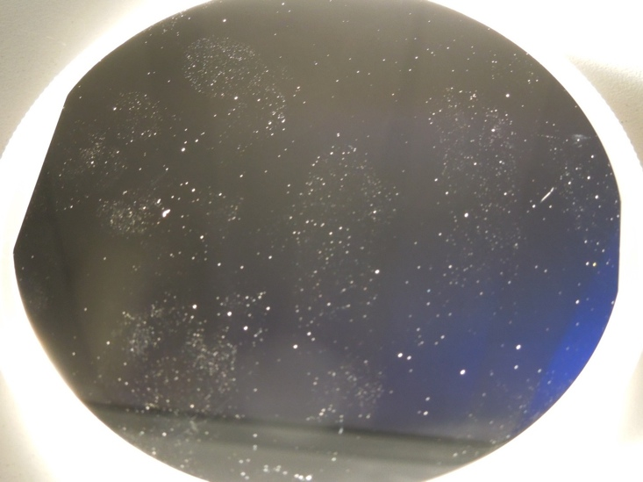
The following steps describe how to prepare, collect, and store a sample:
Figure 12. Glove prints on wafer
- Reserve a new DCC “T” number.
- Add the DCC number to the list of related documents for LIGO-T1300196: Grouping of 4 Inch Wafer Specimens. This is done by changing the metadata. Do not create a new revision.
- Put on gloves.
- Gently place wafer on HAM-ISI/ BSC flooring per LIGO-T1300014 with the shiny side facing up.
Note: Even clean gloves leave behind noticeable prints, as seen in Figure 12. Touch the shiny side of the wafer as little as possible.
- Photograph the wafer and note the initial placement on a drawing of the chamber (ex: LIGO-T1300103). See Section 7 for more information on photographing contamination in chamber.
- Photograph wafer again before removal.

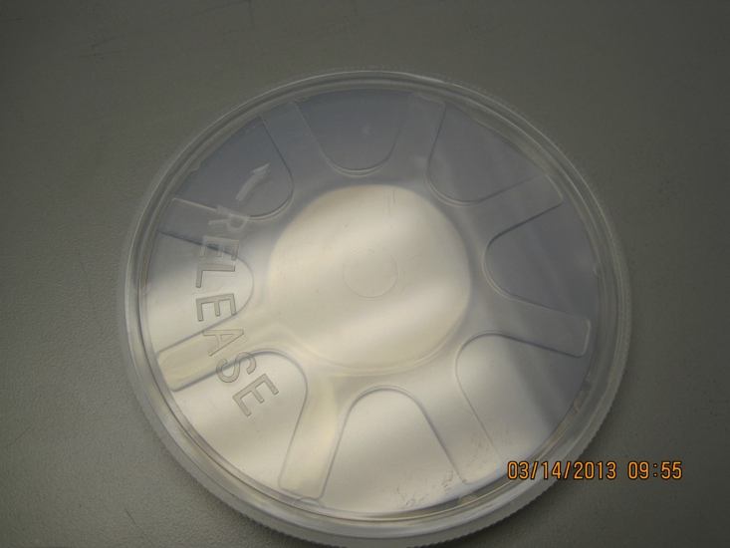
Star shaped piece
Container base
Figure 13. Bottom of wafer container
- Have an open wafer container ready.
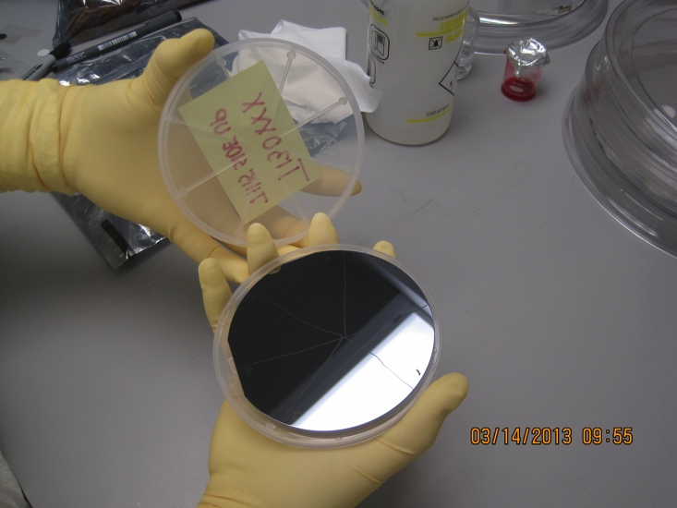
Note: The container can be tricky to open. Identify the lid and the base. “RELEASE” is imprinted on the smooth base piece. Turn the lid to the right to open (goes against the lefty loosey righty tighty rule).
Star shaped piece
Lid
Base
Figure 14. Wafer container configuration
- Use tweezers to carefully remove the silicon wafer from chamber, and place in a wafer carrier. Keep the wafer horizontal during transfer so that none of the collected particulates are lost.
Note: The star shaped piece seperates the wafer from the container base. The shiny side of the wafer should be facing up (i.e. should not be touching the star shaped piece).
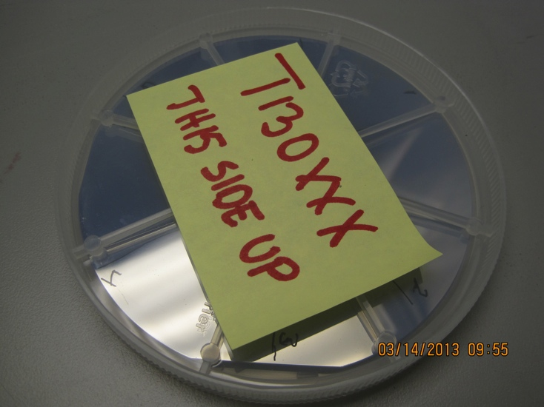
- Close the wafer container, and tape it shut.
Figure 15. Labeled wafer container
- Add a label to the lid with the DCC number.
- Store the wafer carrier inside an Ameristat bag with its label facing up. Avoid flipping wafer over, which can displace collected particles.
- Store the bagged wafer face up in a plastic box with desiccant.
- Fill out the LIGO-F1200021: Particulate Sample Form, and post it to the DCC.
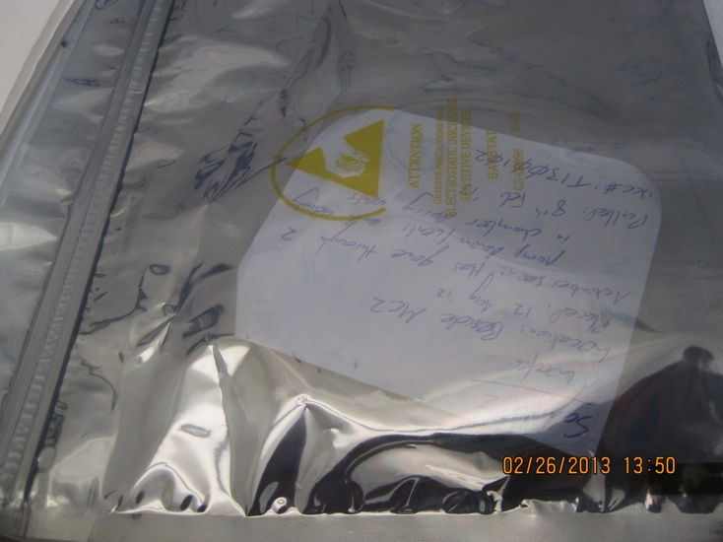
- Repeat these steps for the second silicon wafer.
Figure 16. Labeled container in Ameristat bag

1” OPTICS

When to Use
One 1” optic is placed horizontally on the HAM-ISI table or BSC flooring with the pair of silicon witness wafers. A second 1” optic (more important) should be set up vertically near an optic using either PEEK cable clamps or PEEK clamp LIGO-D1300512-v3 (shown on right hand image below). Always Refer to LIGO-T1300014: Aligo, BSC Flooring + HAM ISI, Witness Sample Placement Guidelines. These 1” optics are for absorption post-analysis.
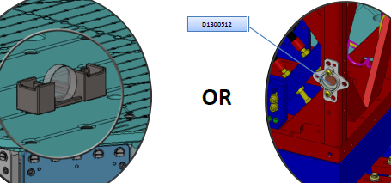
Figure 17. 1” optic between cable clamps

Cleaning
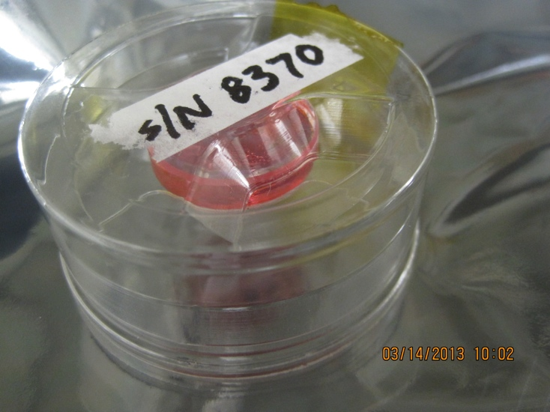
First Contact and PEEK tabs are applied to both sides of the 1” optics at Caltech. They will be shipped to the sites in a PET G container.
Figure 18. 1” optic with First Contact in PET-G container
The PET-G 1” optic containers are sent to the sites Class B. The containers are rinsed in DI water for 5 minutes, sonicated in DI water and 2% Liquinox for 10 minutes, rinsed in a 50/50 solution of DI water and isopropyl alcohol, and then allowed to air-dry for 2 hours. If the containers seem slightly dirty upon arrival at the sites, they can be wiped down with IPA. NEVER wipe with acetone, wipe with methanol, or bake. All of these will destroy the PET-G.

Instructions for Use
The following steps describe how to prepare, collect, and store a sample:
- Reserve a new DCC “T” number.
- Add the DCC number to the list of related documents for LIGO-T1300197: Grouping of 1 Inch Optic Specimens. This is done by changing the metadata. Do not create a new revision.
- Put on gloves.
- Remove the First Contact (no ion gun required) from both faces of a 1” optic.
- Place the optic in chamber horizontally with the HR side facing up per LIGO-T1300014.
Note: There is an arrow on the barrel pointing to the HR side.
- Photograph the initial placement of the optic, and note its serial number (scribed on the barrel). Section 7 for more information on photographing contamination in chamber.
- Photograph 1” optic again before removal.
- Remove the 1” optic from chamber, and place in an optic container. Keep the optic horizontal so that none of the collected particulates are lost.
- Seal the container shut with tape, and label the top of the container with the DCC number.
- Store the 1” optic inside an Ameristat bag with its label facing up. Avoid flipping optic over, which can displace collected particles.
- Store bagged optics face up in a plastic box with desiccant.
- Fill out the LIGO-F1200021: Particulate Sample Form, and post it to the DCC.
Note: Alternatively, this information can be noted in an aLOG if it is linked to the DCC entry.
- Repeat these steps for the second 1” optic.
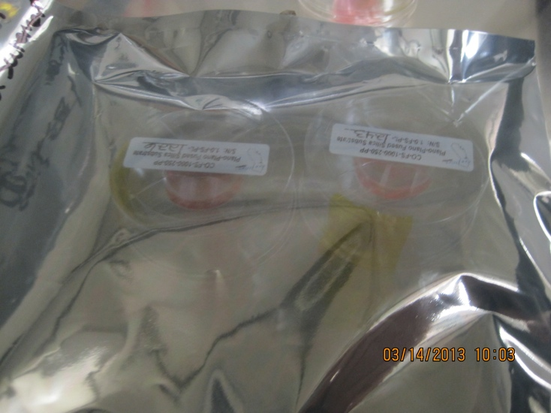
Figure 19. Optic container in Ameristat bag

PHOTOGRAPHING METHOD
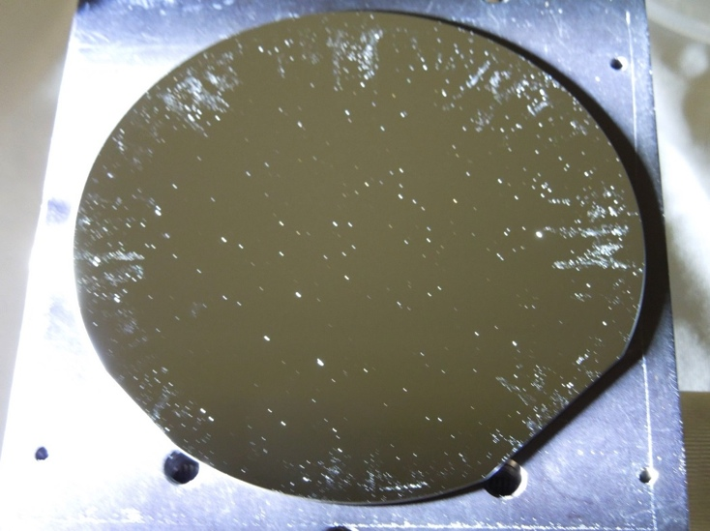
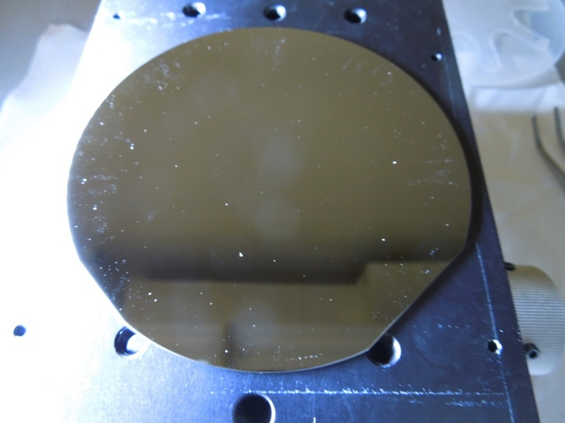
Even though Figure 20 and Figure 21 are pictures of the same wafer, the number of visible particles is dramatically different. These images demonstrate the importance of taking a high quality picture. Due to the poor quality of many of the pictures to date, the method for photographing contamination on samples and surfaces in chamber has been standardized.
Figure 20. Image taken with standardized photographing method
Figure 21. Image not taken with standardized method
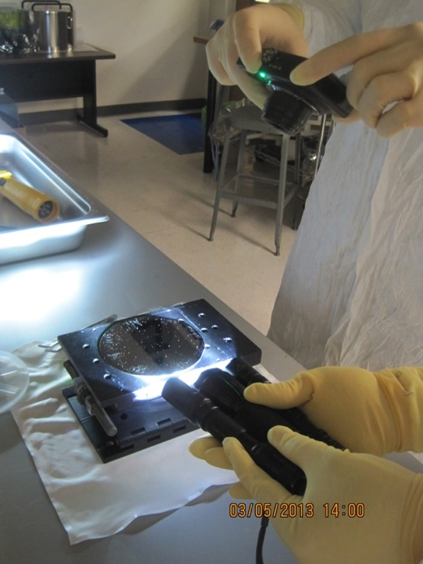
Illumination has the largest impact on the ability to see particles. Hold the flashlight assembly (LIGO-D1300223) at a low grazing angle approximately 2” from the wafer or area being photographed, as shown in Figure 22. Hold the camera about 12” away, and zoom in 2X.
Figure 22. Photographing method

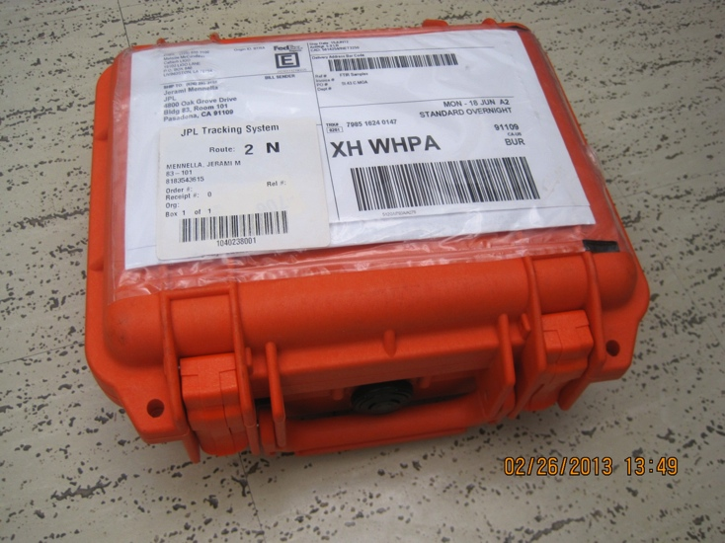
SHIPPING SPECIMENS
Figure 23. Pelican case
All specimens must be sent to Caltech in a Pelican case, like the one shown in Figure 23. A printed copy of the completed Particle Sample Forms (LIGO-F1200021) must be included in the case. It is essential that all samples be shipped right side up. Think of specimen as pizza in a pizza box.
Figure 24. Think of specimen as pizza

FBI Kits
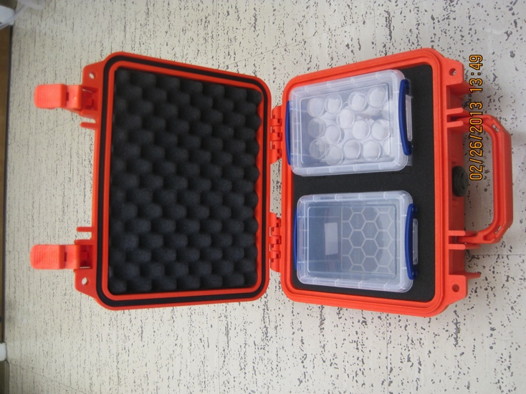
Carbon adhesive tabs are shipped just like they are stored – in Very Useful Boxes. If a box is not completely full, specimens will fall over when jostled. When shipping less than a full box of FBI Kits, add padding (such as cleanroom wipes) keep the samples upright.
Figure 25. Shipping FBI Kits

4” Wafers & 1” Optics
Wafers and optics in their respective containers and bags are placed in Pelican cases, as shown in Figure 26.

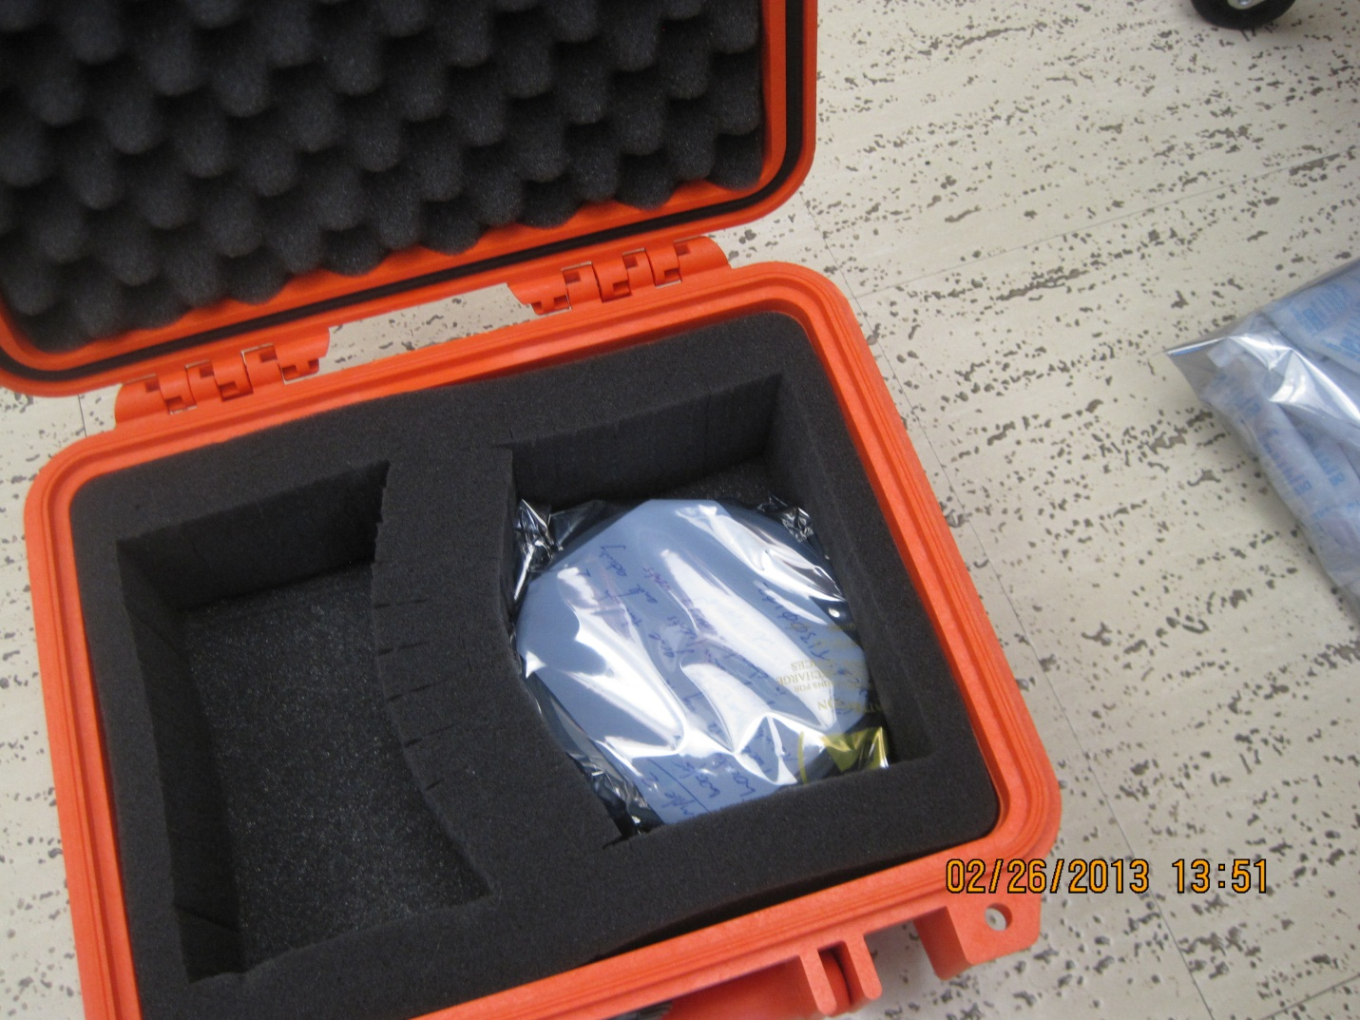
Figure 26. Shipping wafer

