LIGO-T1200555-v2 H1 HAM1 REFL WFS Gouy Telescope Preparation
C. Gray, M. Evans, L. Barsotti and K. Kawabe
Dec/21/2012

References
- D. Jones, C. Gray and K. Kawabe, “H1 HAM3 Gouy Telescope Preparation”, LIGO-T1200433 (https://dcc.ligo.org/cgi-bin/private/DocDB/ShowDocument?docid=96299)
- S. Waldman, “ISC In-Vacuum Gouy Phase telescopes”, LIGO-T1000247 (https://dcc.ligo.org/cgi-bin/private/DocDB/ShowDocument?docid=11582)
- S. Waldman and V. Frolov, “L1 HAM3 Gouy Telescope Preparation”, LIGO-T1200040 (https://dcc.ligo.org/cgi-bin/private/DocDB/ShowDocument?docid=86271)
- L. Barsotti, “aLIGO ISC Optics: Super-polished Lenses”, LIGO-E1000845-V1 (https://dcc.ligo.org/cgi-bin/private/DocDB/ShowDocument?docid=26509)
- Nicholas Smith, ALM mode matching and beam propagation solutions for MATLAB (https://github.com/nicolassmith/alm)
- As-built pictures of H1 HAM3 QPD sled in resource space, https://ligoimages.mit.edu/?c=1182

As-built dimensions
Experimental apparatus as well as as-built dimensions are shown in Figure 1. A fiber coupled IR laser with known beam geometry [1] was used as a light source. The steering mirror downstream of the second lens was removed to measure the beam parameters downstream of the lenses using Coherent ModeMaster. The lens spacing (nominally 203 mm [2]) was adjusted so that the beam downstream of the lens best matches the mode shape predicted by a nominal lens spacing and the source beam parameters. The steering mirror was then reinstalled and the distance from the second lens to the two QPDs were measured and set using a ruler.
According to our analysis which is described later, the most critical parameter, i.e. the lens spacing, was 0.35mm shorter than nominal using horizontal dimension data, and 0.13mm shorter than nominal using vertical dimension data, which is excellent.
Two Wave Front Sensors (WFSs) should be placed 367mm and 736mm downstream of the second lens. Using the numbers in Figure 1, this means that the first WFS is to be placed 137mm downstream of the beam splitter, and the second WFS 138mm downstream of the last steering mirror. In reality WFSs are placed just outside of the sled. Exact placement of WFS is not important as the Gouy phase error is about 1.5 to 1.7 degrees per 10mm for both of the WFSs (see Calculate_REFL.m [2]).
Figure 1: As-built dimensions as well as the experimental setup.
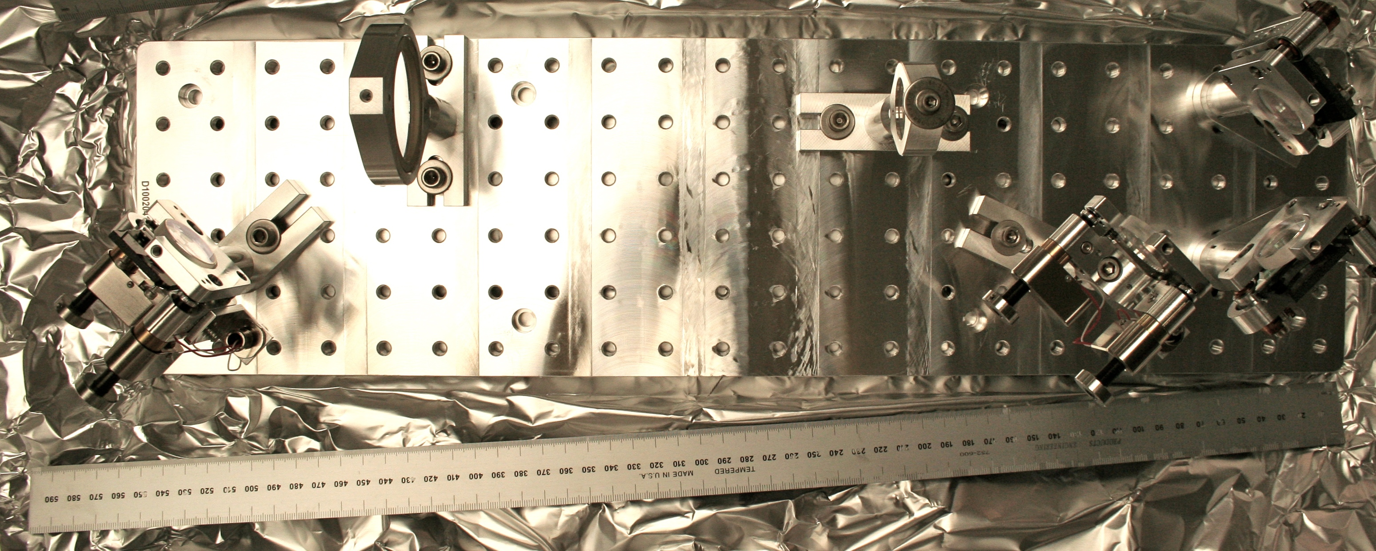Figure 2: As-built picture of the completed H1 HAM1 WFS sled.

Setup and Adjustment Details
The 2” lens (assumed f=333mm in [2], actual spec f=333.6mm for 1064 nm light [3]) was set up such that the curved surface of the optic faces upstream toward the incoming light. As for the 1” lens (assumed f=-167mm, actual spec f=-166.8mm) it was opposite, i.e. the curved surface faces downstream. In both of the lens holders, the PEEK retainer ring comes downstream. The last lens of the beam expander telescope was placed 1.4m away from the upstream face of the first lens holder on the sled. ModeMaster head was placed 474.5 mm downstream of the downstream face of the first lens holder. The lens holder itself is ½ inches thick. The second lens was at first placed 203mm away from the first lens, measured between the center of the lens holders.
The matlab script (HAM1.m, attached in the same DCC number as this document) propagates the known source beam parameter to the ModeMaster position based on the knowledge about the optical path (i.e. location and focal length of the lenses, distance from the source to ModeMaster etc.), and calculates the overlap integral between this source beam and the beam that was actually measured by the ModeMaster. It then maximizes the overlap integral by changing the lens spacing, and finally tells the user how much longer or shorter the lens spacing is than what it should be. The user then adjusts the lens spacing accordingly. (Note that , empirically, if the overlap integral is smaller than 0.9, there should be something seriously wrong with the measurement, the beam quality, or both.)
This procedure eliminates the trouble of measuring “effective distance” between the lenses taking into account the position of the curved surface in relation to the lens mount and optical thickness of the substrate. This also has the benefit that small error in the focal length is automatically taken care of, to some extent, by folding such errors into the lens spacing.

Measured source beam parameters
The source parameters are as follows [1]:
Waist radius = 2.619mm at 7.020 m upstream of the last beam expander lens for Y,
waist raduis = 2.486 mm at 10.847 m upstream of the last beam expander lens for X.

Measured beam parameters after the WFS Gouy telescope
After some adjustment, we obtained this:
[STATISTICS SETTINGS]
No. of files 6

[EXTERNAL RESULTS]
Min Max Mean Std Dev Dim
-------------------------------------------------------------------------------------------------------------------
M2 0.99 0.99 0.99 0.000 -
M2 0.96 0.97 0.96 0.001 -
M2 0.98 0.98 0.98 0.001 -
2Wox 0.369 0.372 0.371 0.0010 mm
2Woy 0.355 0.357 0.356 0.0009 mm
2Wor 0.362 0.365 0.364 0.0010 mm
2Wex 1.368 1.371 1.369 0.0011 mm
2Wey 1.403 1.405 1.403 0.0006 mm
2Wer 1.386 1.387 1.386 0.0004 mm
Zox 0.366 0.363 0.364 -0.0010 m
Zoy 0.371 0.369 0.370 -0.0007 m
Zor 0.368 0.366 0.367 -0.0008 m
Zrx 0.102 0.103 0.103 0.0006 mm
Zry 0.097 0.098 0.097 0.0004 mm
Zrr 0.099 0.100 0.100 0.0005 mm
Divergencex 3.61 3.63 3.62 0.010 mr
Divergencey 3.66 3.68 3.67 0.007 mr
Divergencer 3.63 3.65 3.64 0.008 mr
Astigmatism(Zoy-Zox)/Zrr 5.0 6.3 5.9 0.52 %
Waist Asymmetry(2Woy/2Wox) 0.958 0.961 0.960 0.0010
Divergence Asymmetry Thetay/Thetax 1.012 1.015 1.014 0.0010

According to the script, the equivalent lens spacing in a thin lens approximation was 202.65mm (0.35mm shorter than nominal) with 99% overlap integral for X, and 202.87mm (0.13mm shorter) with 99.9% overlap for Y (Figures 3 and 4).
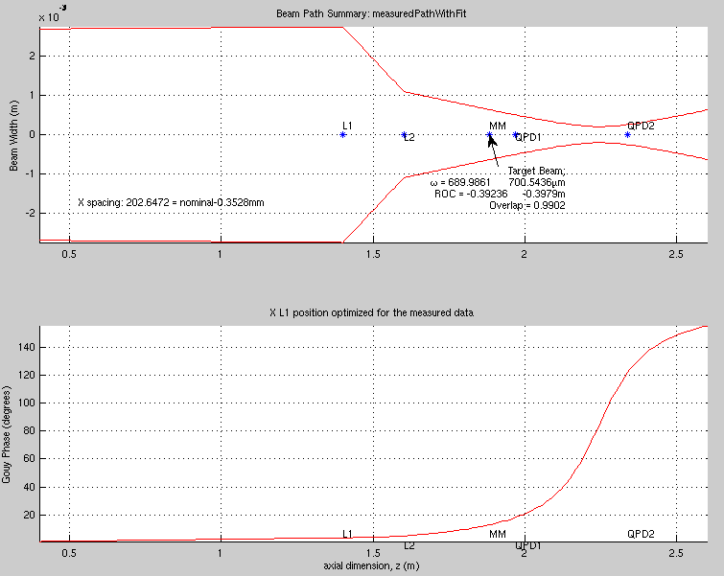Figure 3: Adjustment results, X. This is not to be confused with the propagation of the IFO beam, which is found in Reference [2].

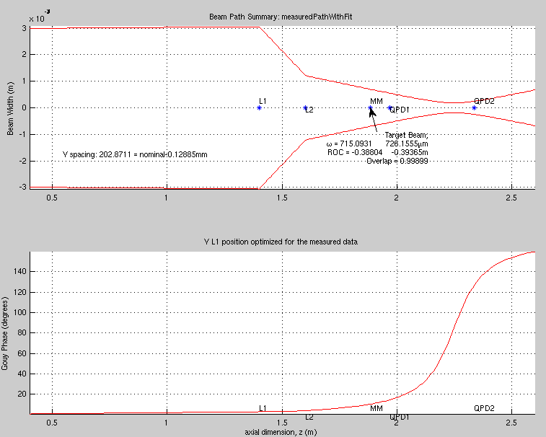Figure 4: Adjustment results, Y. This is not to be confused with the propagation of the IFO beam, which is found in Reference [2].

