*LIGO Laboratory / LIGO Scientific Collaboration*

LIGO- **T1300043** -v1 *LIGO* 1/17/13

Arm Cavity Baffle Shift with

Alignment Target

Michael Smith

Distribution of this document:

LIGO Scientific Collaboration

This is an internal working note

of the LIGO Laboratory.

|  |  |
| --- | --- |
| **California Institute of Technology**  **LIGO Project** | **Massachusetts Institute of Technology**  **LIGO Project** |
| **LIGO Hanford Observatory** | **LIGO Livingston Observatory** |

http://www.ligo.caltech.edu/

Table of Contents

1 Introduction 3

2 Calculation 3

2.1 Parameters 3

2.2 Horizontal Shift 4

2.2.1 Torque Balance 4

2.3 Vertical Shift 6

3 Maximum Target Weight 8

3.1 Horizontal Displacement 8

3.2 Vertical Displacement 10

3.3 Maximum Target & Counter Weight 10

3.4 ACB Balance Weight Accuracy 10

3.5 Mounting Location of Target Counter Weight 11

4 Proposed Balance Weights for As-built ACB Blades 11

Figure 1: Parameters used for Calculation 3

Figure 2: ACB Target Offset for ITM X and ITMY arms 8

Figure 3: Mounting Position for Target Counter Weight 11

Table 1: Summary of Proposed ACB Balance Weights 12

# Introduction

The purpose of this technical note is to calculate the offset of the Arm Cavity Baffle (ACB) when a target is placed in the center of the beam hole opening. A counter weight will be added to the opposite side of the target to partially offset the lateral motion due to the induced hanging tilt. The combination of the target and counter weight cause the ITMY ACB to shift down and to the left, as viewed from the ITM viewport adapter; the shift is down and to the right for the ITMX ACB. Therefore, to account for the offset caused by the target and counter weight, the target cross-hairs must be off-set up and to the right for the ITMY ACB, and up and to the left for the ITMX ACB.

# Calculation

## Parameters

The parameters used in the calculation are shown in the diagram below

.

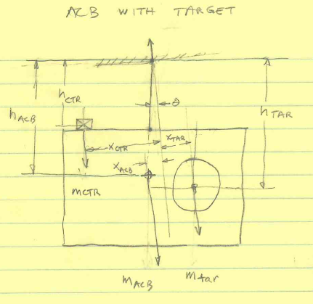

Figure : Parameters used for Calculation

The height and weight values are shown below.

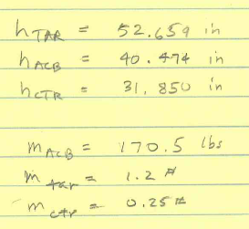

## Horizontal Shift

### Torque Balance

The offset load of the ACB target and counter weight will cause the baffle to pivot about the top of the flexure rod by an angle theta, resulting in the horizontal positions of the CG of the Baffle, the target, and the counter weight to shift. The torque balance about the pivot point uniquely defines the vertical tilt angle.

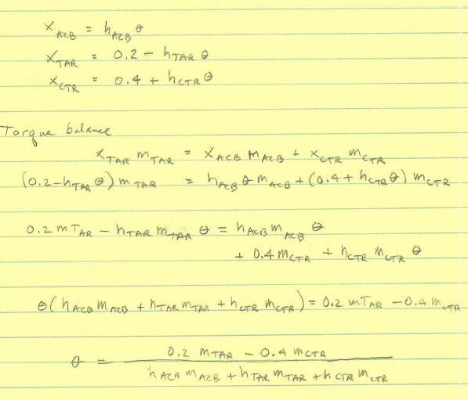

ACB target, lbs



ACB target ctrwt, lbs



ACB, lbs



horiz. distance from ACB SUS to target m



horiz. distance from ACB SUS to ctrwt m



vertical height of target from SUS point, m



vertical height of ACB CG from SUS point, m



vertical height of ctr weight from SUS point, m



tilt angle of unbalanced ACB with target, rad





horizontal displacement of ACB, m





## Vertical Shift

The added weight of the target and counterweight causes the blade spring to deflect in the vertical direction proportionally to the effective spring constant and the added mass.

vertical distance blade moves, in





vertical resonant frequency based on blade depression, Hz





effective spring constant, N/m





height change due to  target-ctrwt, m





The figure below shows the shift of the ACB with respect to the initial alignment, which was centered on the ITM behind the baffle.

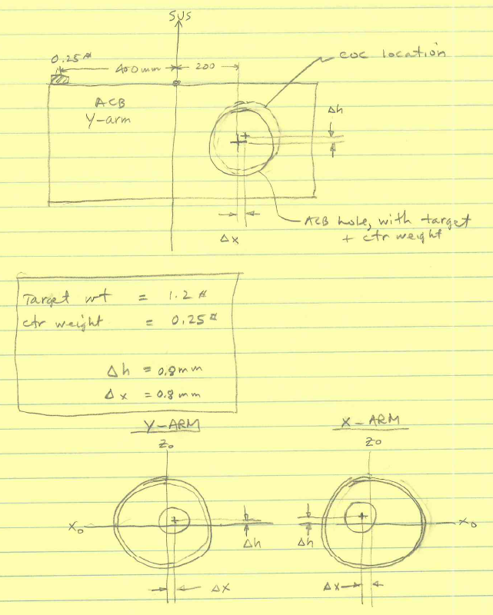

Therefore, to account for the offset caused by the target and counter weight, the target cross-hairs must be off-set--up and to the right for the ITMY ACB, and up and to the left for the ITMX ACB.

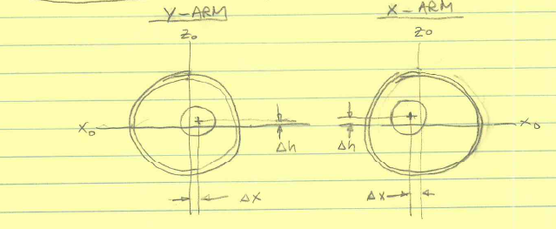

Figure : ACB Target Offset for ITM X and ITMY arms

# Maximum Target Weight

The target weight must be small enough so that the ACB does not hit the earth quake stops in the vertical direction or in the horizontal direction during the alignment procedure.

## Horizontal Displacement

The offset target weight causes the ACB to tilt and swing in the horizontal direction.

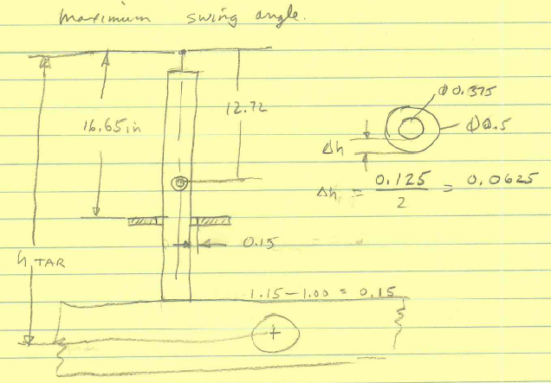

The lower earthquake stop rod defines the limiting swing angle.

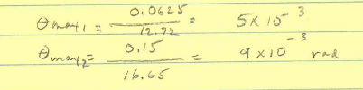

The horizontal motion of the ACB target at the maximum swing angle is



## Vertical Displacement

The maximum allowed vertical displacement before the ACB hits the earthquake stop is equal to the radial spacing between the earthquake stop rod and the hole in the down tube, as shown below, 0.062 in.



## Maximum Target & Counter Weight

The smallest practical weight for the target is 1.2 lbs, and a 0.25 lb counter weight will be placed at the distance 400 mm from the center of the baffle to partially off-set the horizontal shift caused by the target. The total weight of the combined target is 1.45 lbs.

The result is a maximum shift of approximately 0.8 mm in both the horizontal and vertical direction.

## ACB Balance Weight Accuracy

The ACB must be initially balanced to a height accuracy of 0.031 in; this is equivalent to an absolute balanced weight accuracy of < 1.3 lbs.

height change with added weight, m



balance weight increment to cause

0.031 in deflection, lb





## Mounting Location of Target Counter Weight

The 0.25 lb target counterweight, shown in green in the figure below, will be fastened with a bolt through the available hole in the top plate of the ACB, approximately 400 mm from the center of the ACB.

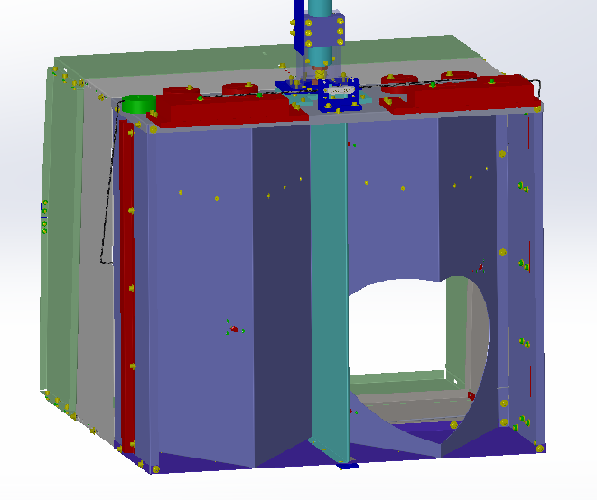

Target counter weight

Figure : Mounting Position for Target Counter Weight

# Proposed Balance Weights for As-built ACB Blades

The balanced ACB weight will be within 0.3 lbs of the measured blade support weight with the proposed variable balance weights shown in the table. This meets the required initial balance accuracy.

Table : Summary of Proposed ACB Balance Weights

|  |  |  |  |  | Variable Balance Weights, lbs |  |  |  |  |  |
| --- | --- | --- | --- | --- | --- | --- | --- | --- | --- | --- |
| **S/N** | **total measured weight, lbs** | **blade thickness, in** | **bare baffle wt, lbs** | **ctr wt slider, lbs** | **2** | **1.5** | **1.25** | **0.5** | **total balanced baffle wt, lbs** | **balance error** |
| 1 |  |  |  |  |  |  |  |  |  |  |
| 2 |  |  |  |  |  |  |  |  |  |  |
| 3 | 171.2 | 0.2342 | 122.6 | 39.90 | 4 |  |  | 2 | 171.5 | -0.3 |
| 4 | 169.2 | 0.2345 | 122.6 | 39.90 | 2 | 2 |  |  | 169.5 | -0.3 |
| 5 | 169.2 | 0.2345 | 122.6 | 39.90 | 2 | 2 |  |  | 169.5 | -0.3 |
| 6 | 167.41 | 0.2343 | 122.6 | 39.90 |  |  | 4 |  | 167.5 | -0.09 |
| 7 | 169.41 | 0.234 | 122.6 | 39.90 | 2 | 2 |  |  | 169.5 | -0.09 |
| 8 | 167.41 | 0.2336 | 122.6 | 39.90 |  |  | 4 |  | 167.5 | -0.09 |
| 9 | 167.41 | 0.2334 | 122.6 | 39.90 |  |  | 4 |  | 167.5 | -0.09 |
| 10 | 170.41 | 0.2337 | 122.6 | 39.90 | 4 |  |  |  | 170.5 | -0.09 |
| 11 | 167.41 | 0.2334 | 122.6 | 39.90 |  |  | 4 |  | 167.5 | -0.09 |
| 12 | 167.41 | 0.2338 | 122.6 | 39.90 |  |  | 4 |  | 167.5 | -0.09 |
| 13 |  |  |  |  |  |  |  |  |  |  |
| 14 | 167.41 | 0.2336 | 122.6 | 39.90 |  |  | 4 |  | 167.5 | -0.09 |
| 15 | 167.41 | 0.234 | 122.6 | 39.90 |  |  | 4 |  | 167.5 | -0.09 |
| 16 | 167.41 | 0.2335 | 122.6 | 39.90 |  |  | 4 |  | 167.5 | -0.09 |
| 17 | 167.41 | 0.2338 | 122.6 | 39.90 |  |  | 4 |  | 167.5 | -0.09 |
| 18 | 167.41 | 0.2336 | 122.6 | 39.90 |  |  | 4 |  | 167.5 | -0.09 |
| 19 | 170.41 | 0.2343 | 122.6 | 39.90 | 4 |  |  |  | 170.5 | -0.09 |
| 20 | 167.41 | 0.2335 | 122.6 | 39.90 |  |  | 4 |  | 167.5 | -0.09 |