Test Date | April 19-20, 2013
Author(S) | Liyuan Zhang, Margot Phelps, GariLynn Billingsley
Approval(s)
Specification Doc. | LIGO-E0900068 | Specification | < 0.5 ppm
Procedure Doc. | LIGO-E1000863 | Mean ± Error | 0.3 ± 0.1
Conclusion | Qualified.

Discussions and Comments:
Four radial scans were carried out along X+- and Y+- with the arrow of barrel at Y+ direction, as shown in Fig.1. The calibration was done by a contamination cavity HR mirror (1” in dia.), of which the HR absorption was measured to be 0.6 ppm in the optical contamination test.

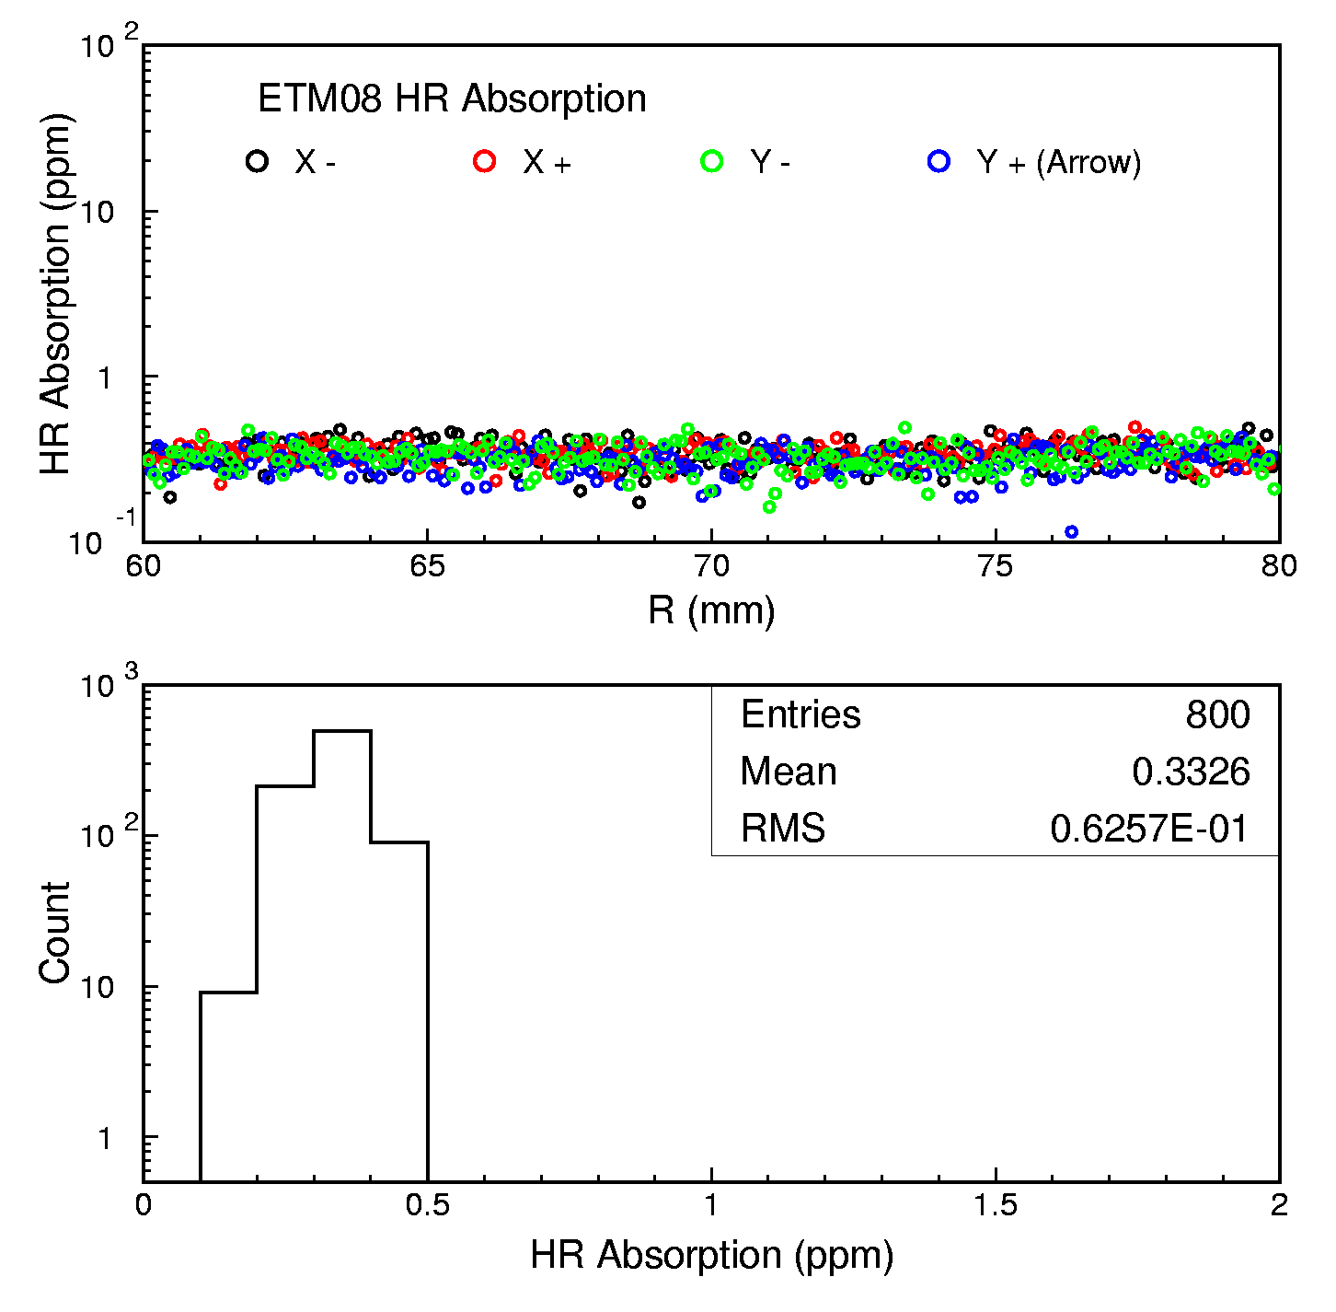
Fig.1 ETM08 HR absorption radial scans along 4 directions outside 120 mm aperture.

