Test Date | May. 3-6, 2013
Author(S) | Liyuan Zhang, Margot Phelps, GariLynn Billingsley
Approval(s)
Specification Doc. | LIGO-E0900068 | Specification | Not specified in LIGO-E0900068
Procedure Doc. | LIGO-E1000863
1st Scan (Mean ± Error*) | 8.8 ± 2 ppm
2nd Scan (Mean ± Error*) | 9.3 ± 2 ppm
Conclusion | Qualified.
*An estimated systematic error from previous multiple measurements with one LIGO-1 mirror.
Discussions and Comments:
Two TIS scans are carried out. One is of full coverage over central 48 mm in diameter with the beam and step sizes of 0.3 mm and other a sampling scan over central 160 mm in diameter with the same beam size and a step of 1.0 mm, as shown in Figs. 1 and 2 respectively.

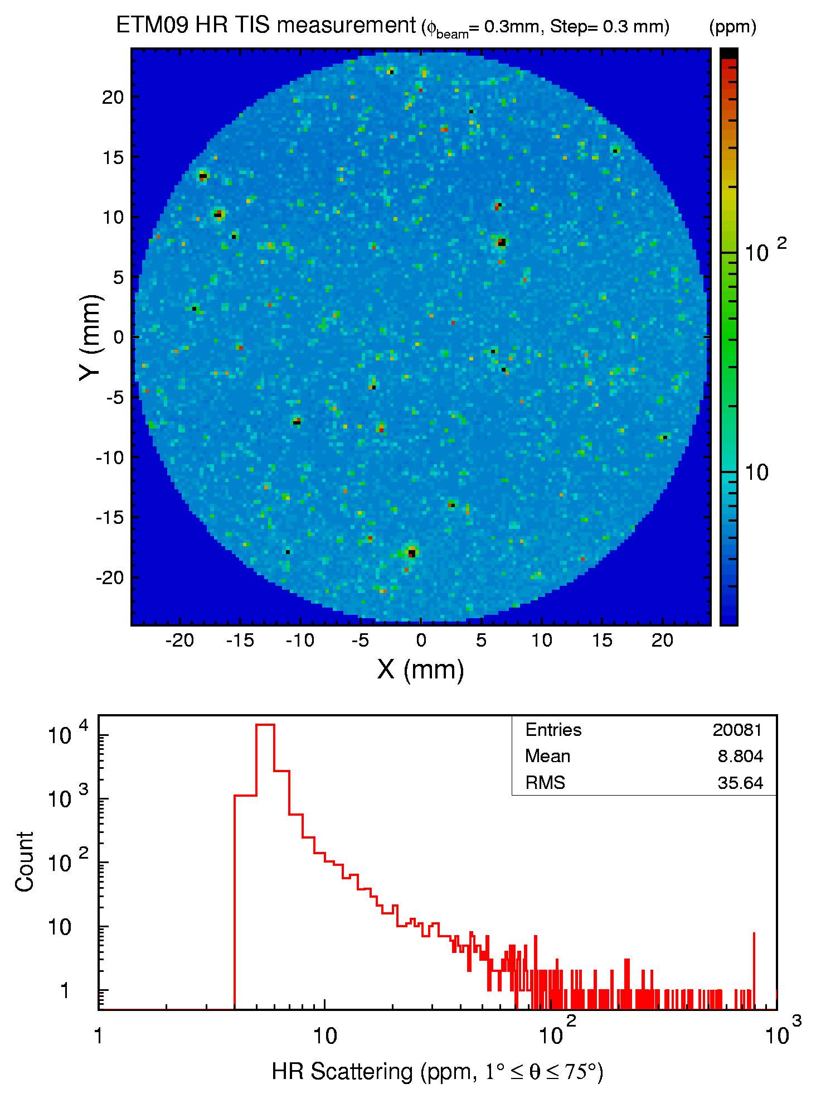
Fig. 1 ETM09 TIS full coverage scan over central 48 mm diameter aperture.

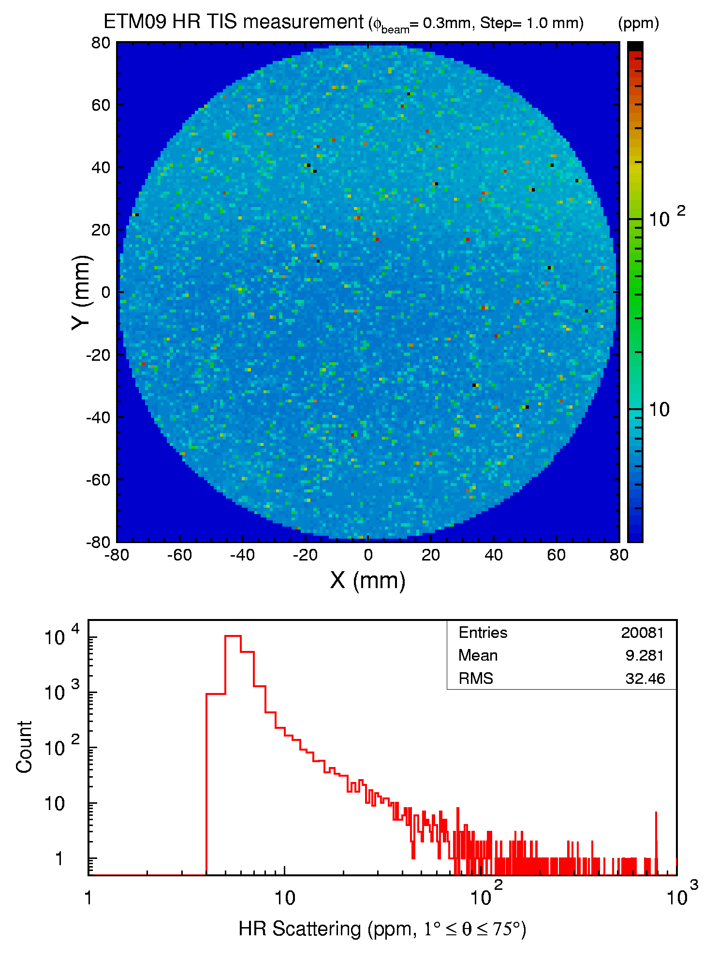
Fig. 2 ETM09 TIS sampling scan over central 160 mm diameter aperture.

