LIGO Laboratory / LIGO Scientific Collaboration

LIGO- E1300392-v1 LIGO 5/14/13

Install Signal Recycling Cavity Baffles LLO HAM5 Test
Michael Smith

Distribution of this document:
LIGO Scientific Collaboration

This is an internal working note
of the LIGO Laboratory.

California Institute of Technology  LIGO Project – MS 18-34  1200 E. California Blvd.  Pasadena, CA 91125  Phone (626) 395-2129  Fax (626) 304-9834  E-mail: info@ligo.caltech.edu | Massachusetts Institute of Technology  LIGO Project – NW22-295  185 Albany St  Cambridge, MA 02139  Phone (617) 253-4824  Fax (617) 253-7014  E-mail: info@ligo.mit.edu
LIGO Hanford Observatory  P.O. Box 159  Richland WA 99352  Phone 509-372-8106  Fax 509-372-8137 | LIGO Livingston Observatory  P.O. Box 940  Livingston, LA 70754  Phone 225-686-3100  Fax 225-686-7189
http://www.ligo.caltech.edu/

1 Introduction 5
2 Acceptance Tests 5
2.1 Location of Baffles 5
2.2 HAM5 Signal Recycling Cavity Baffles Installation Test & Exit Check List 7

Abstract
This document presents the data for the LLO HAM5 Signal Recycling Cavity Baffles Installation Acceptance Test.

Introduction
This document presents the data for the LLO HAM5 Signal Recycling Cavity Baffles Installation Acceptance Test.

Acceptance Tests

Location of Baffles

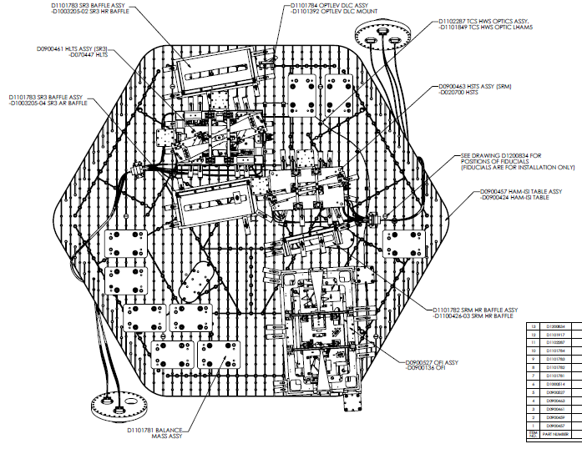
Figure 1: SR3 HR Baffle, SR3 AR Baffle, and SRM HR Baffle on HAM5

HAM5 Signal Recycling Cavity Baffles Installation Test & Exit Check List

